소셜블레이드



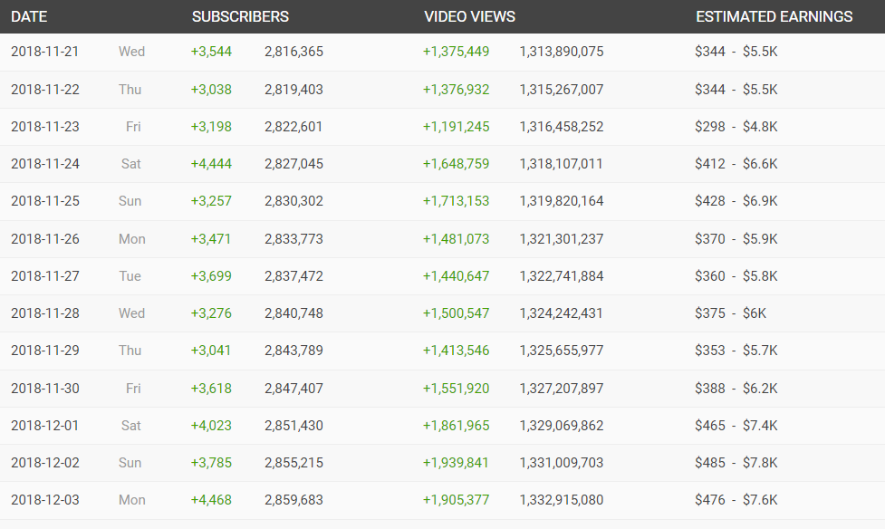

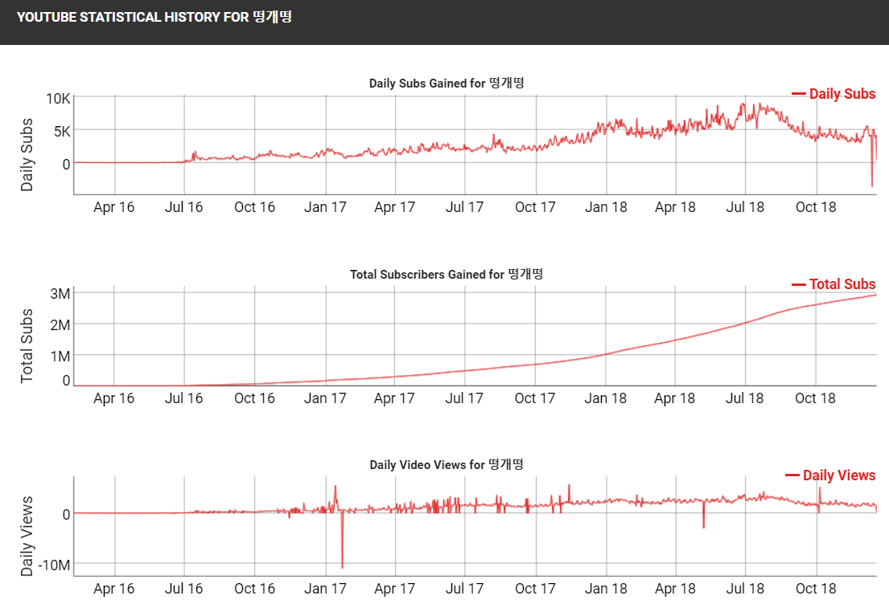

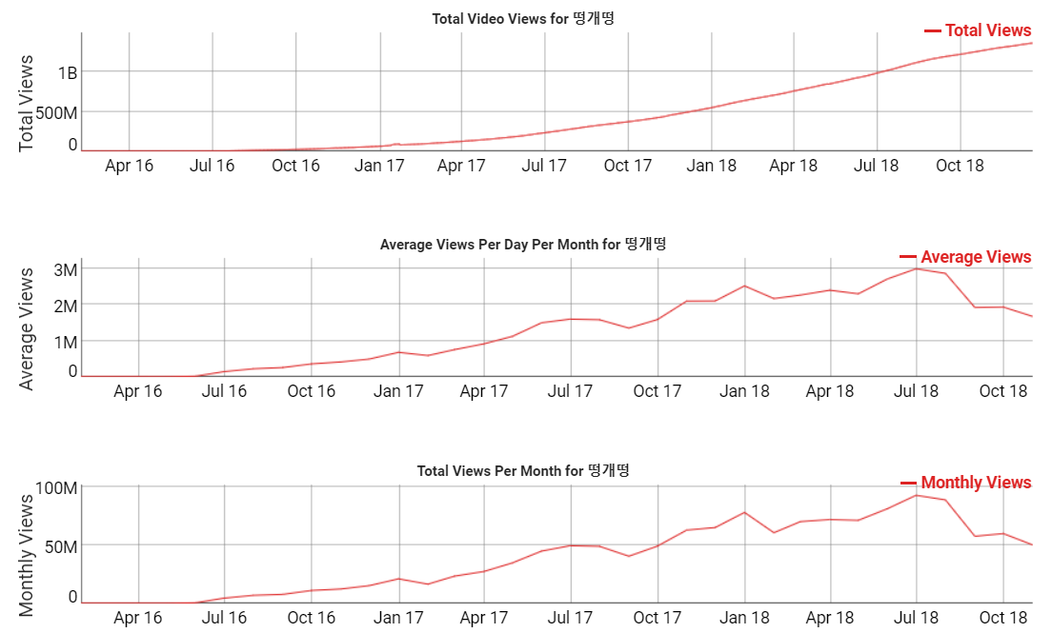

추정 구독자수

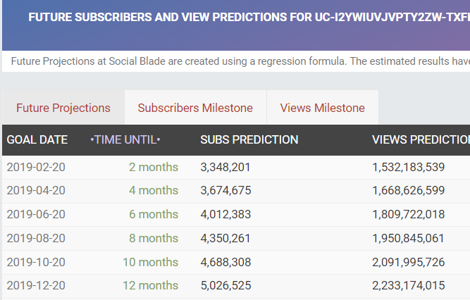

비슷한 숫자의 구독자를 가진 유튜버수

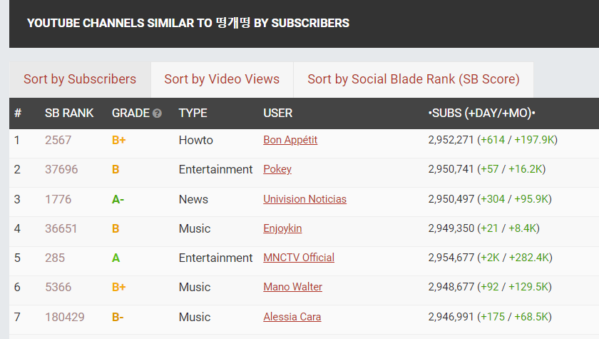

초마다 갱신되는 구독자수



트위치 - 1주일간 방송중 시청자수 변화 그래프, 해당 시간 했던 컨텐츠

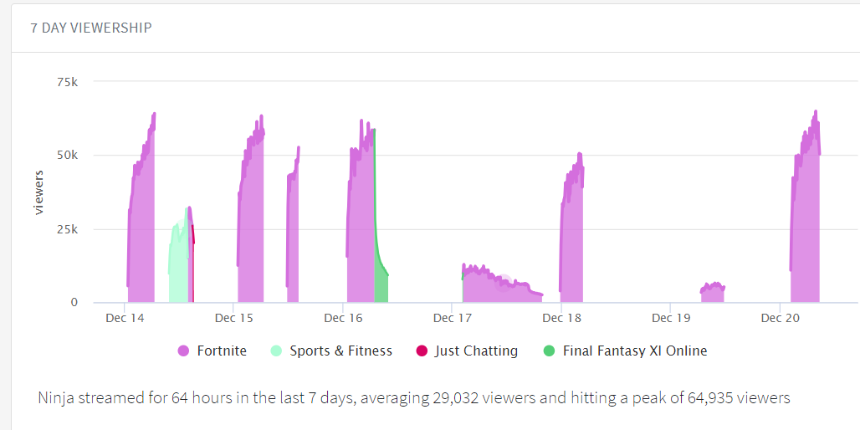

평균 시청자수 성장 추세 90일기준

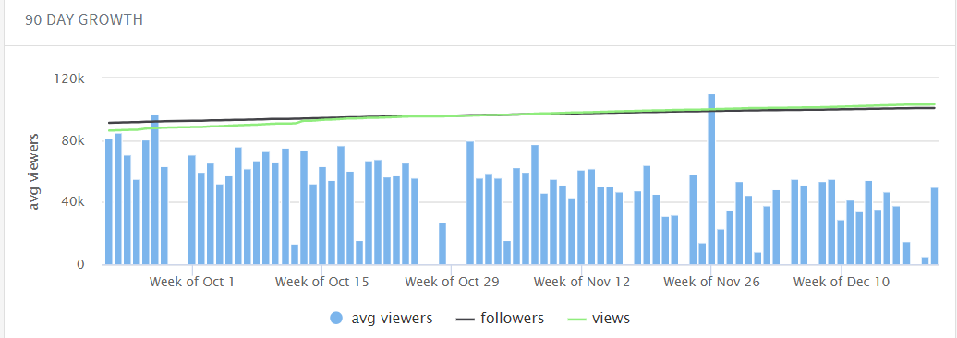

방송시간대 히트맵

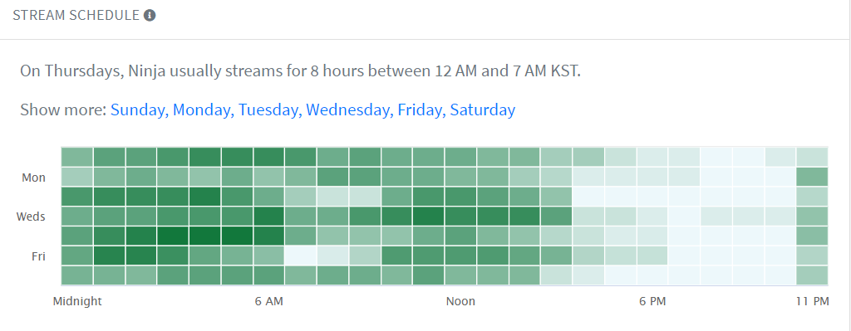

방송 히스토리 기간별

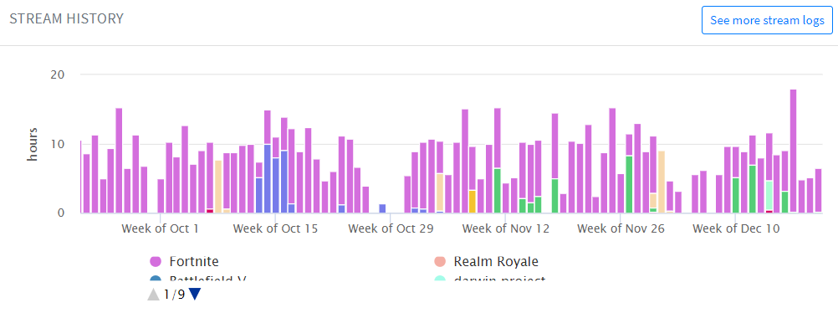

스트리머들 그냥 총량

* 애드본드 사용 현황등에 대입 가능

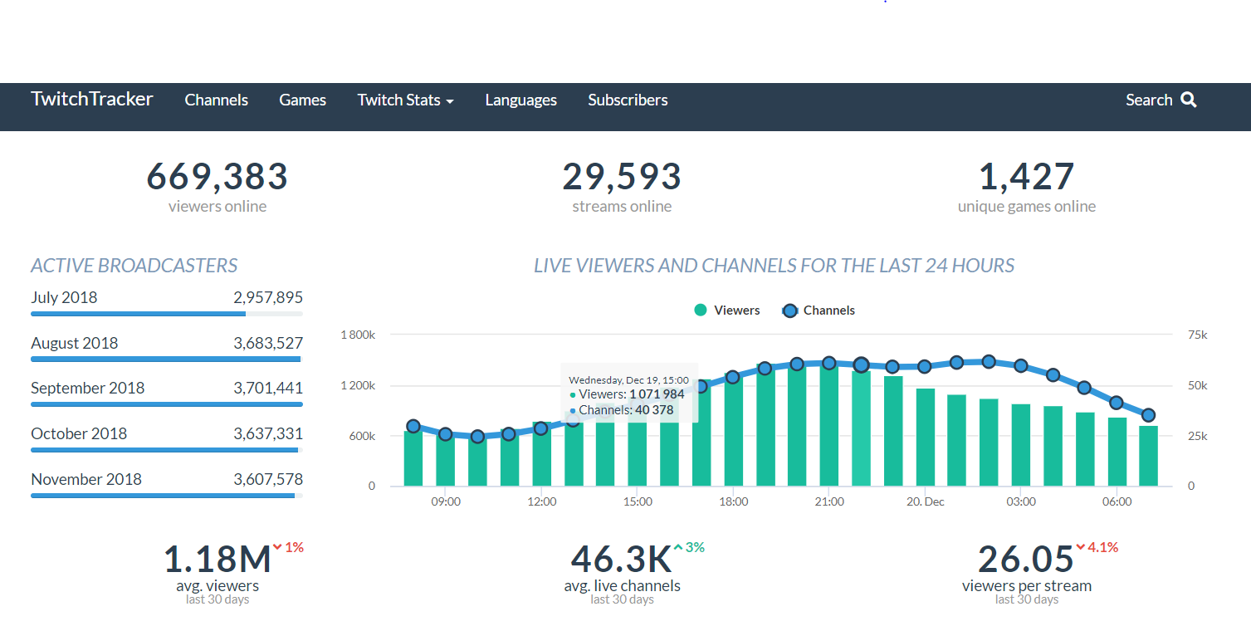

게임종류 분류(트위치에 이미 되어있음)

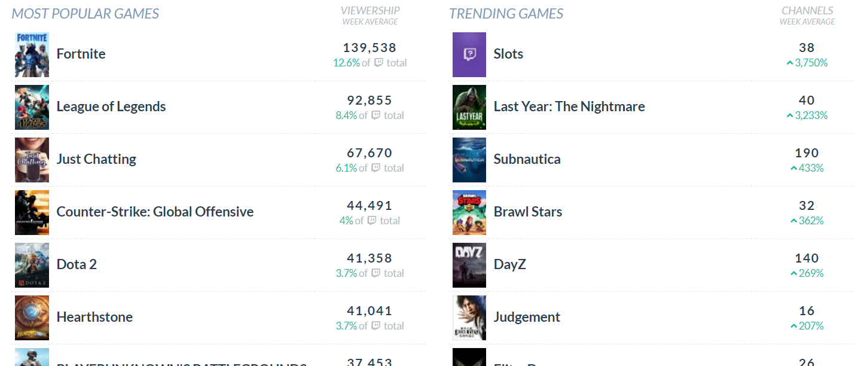

트위치 트랙커 아이디 검색시 제공 통계량

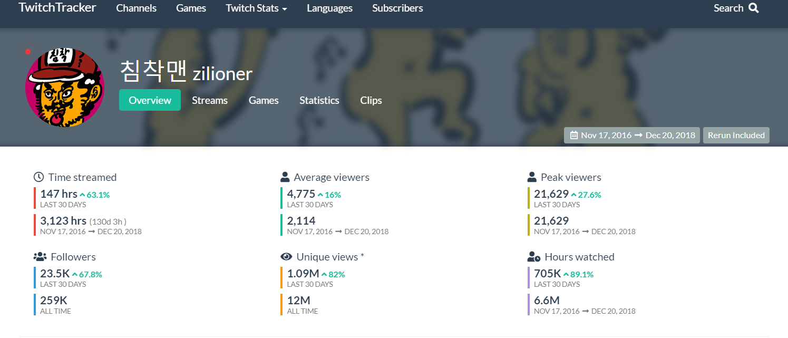

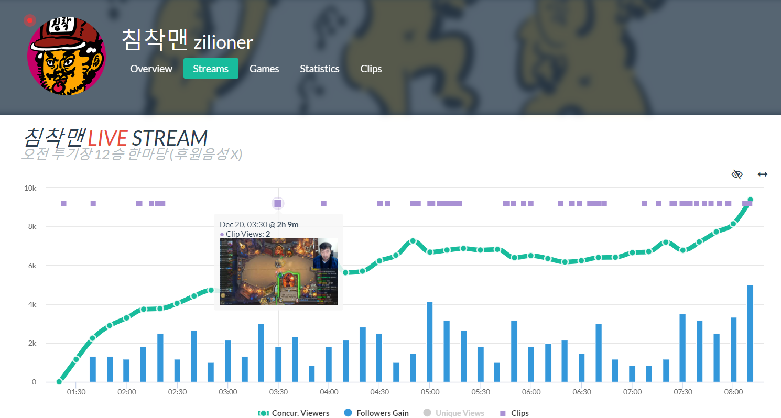

해당 시점 영상 컷 보여줌.

해당 스트리밍에 대한 다양한 정보들

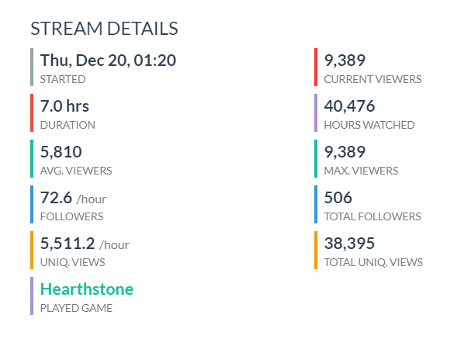

아이디 생성이후 다 쌓인 통계지표

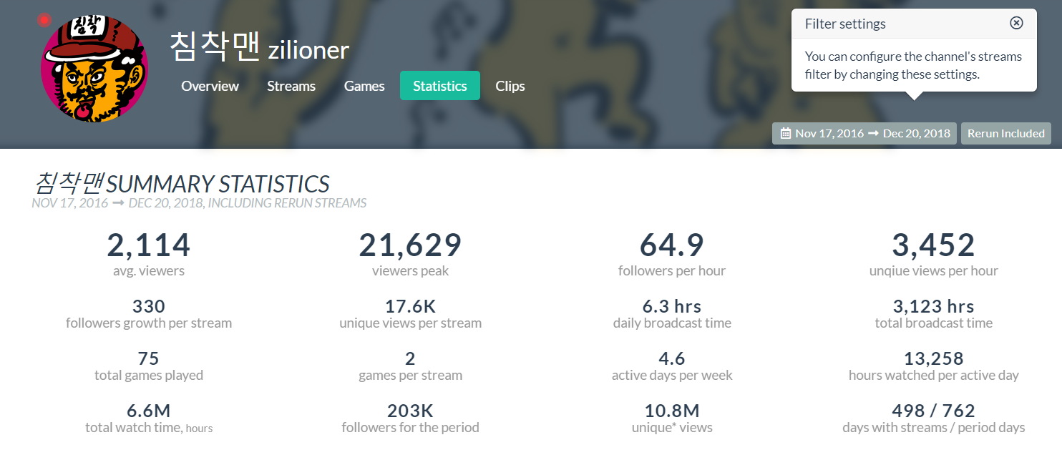

시각화된 성장 추이

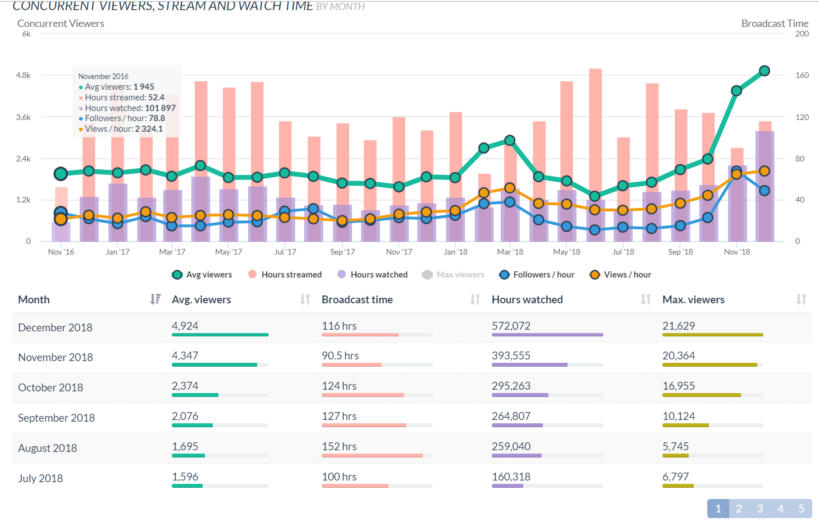

활동 시간대 히트맵

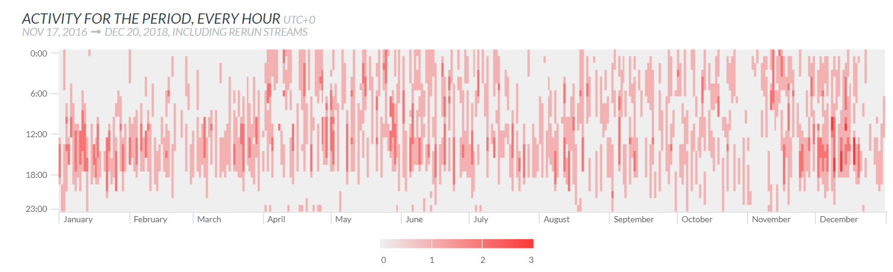

뭔지?

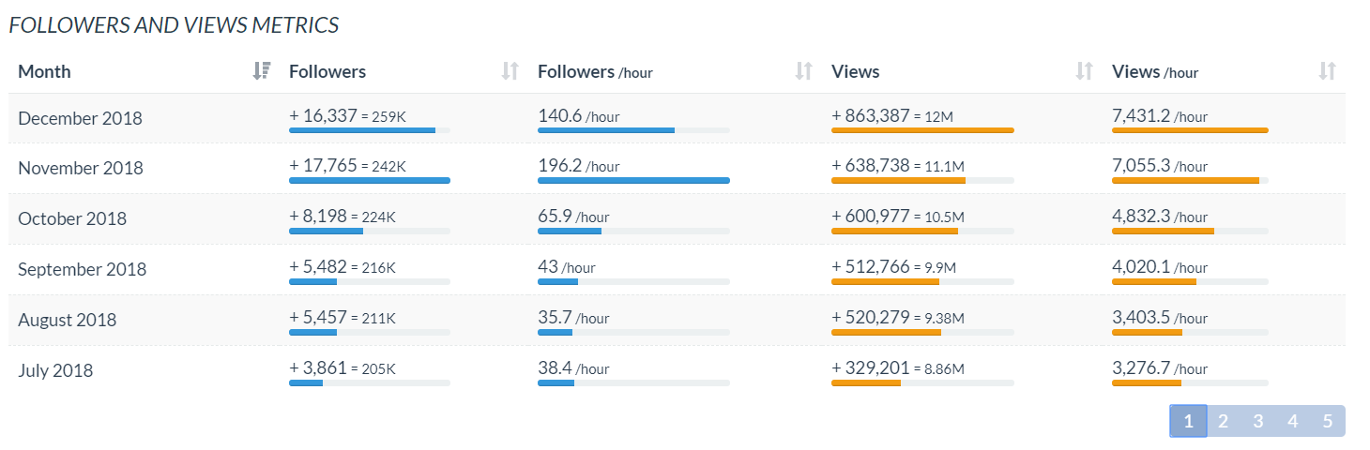

# Google Analytics: Page Views Vs. Unique Views

If you use Google Analytics for your business or organization website, you will find that it provides various reports. Within the Google Analytics interface and reports, you will see data relating to visits to your site, including information about the visits and the visitors themselves. Page views and unique page views are among the most valuable analytics information types to understand if you want to gain a clear picture of how your site is performing.

**Visitors**

To understand the different types of views for your site, you need to think about the ways in which your visitors access each page on it. When a visitor arrives at your site they have either entered the site address into their browser address bar (or bookmarks) or followed a link from another site such as a search engine or directory. Once they are on your site, they may move from one page to another, clicking menu links and even returning to the same page more than once.

**Sessions**

The idea of a session is key to site visits. A session is a concept used primarily in Web development, normally meaning a single visit to a site, including all pages viewed. For example, if a user visits your site and moves between a few different pages over a period of a few minutes, then leaves it and closes their browser, this is a single session. If they visit the site again after closing the browser, this will typically be classified as a new session. Sessions are associated with user IP addresses. Although there is no exact measurement for how long a single session lasts in general, for Google Analytics a session ends 30 minutes after the last page view.

**Page Views**

In Google Analytics, a page view is a single viewing of a Web page. This means that any time the page is loaded by the user's browser, the number of page views is incremented. If a user visits the same page multiple times within a single session, each viewing of the page will add to its page view count. Also, if the user refreshes the page in their browser, this counts as a new page view. For this reason, page views are sometimes seen as being of limited significance. For example, if the same user views the same page five times as part of a single session, this is different from five users viewing that page independently.

**Unique Views**

Unique page views provide a useful alternative to basic page views. With unique page views, you eliminate the factor of multiple views of the same page within a single session. If a user views the same page more than once in a session, this will only count as a single unique page view. For this reason, unique views can be understood as user sessions per page, with each session potentially representing multiple views of the page but a minimum of one view per session.