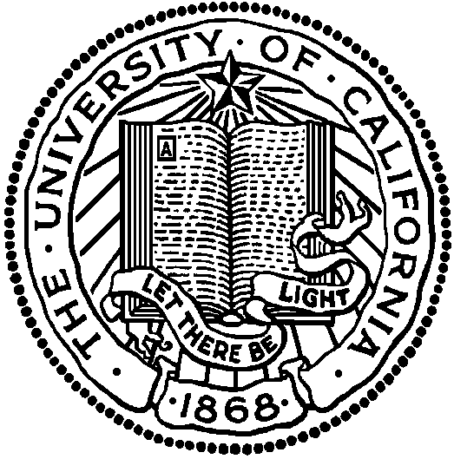

SAN FRANCISCO • SANTA BARBARA • SANTA CRUZ

BERKELEY • DAVIS • IRVINE • LOS ANGELES • MERCED • RIVERSIDE • SAN DIEGO

UNIVERSITY OF CALIFORNIA AT BERKELEY