

FACULTY OF COMPUTER ENGINEERING INFORMATICS & COMMUNICATIONS
DEPARTMENT OF COMPUTER SCIENCES
WORK RELATED LEARNING PLERIMINARY REPORT

Full NAME: BLESSED N MWEDZI
REGISTRATION NUMBER: R2110094
LEVEL: 3.2
ORGANIZATION: CHIRUMANZU RURAL DISTRICT COUNCIL
Attachment Period: aUGUST 2024 – AUGUST 2025
WORK SUPERVISOR: MR. A. MAHORE
DEPARTMENT : INFORMATION & technology DEPARTMENT

Contents
TABLE OF FIGURES 3
ACKNOWLEDGMENTS 4
EXECUTIVE SUMMARY 5
CHAPTER 1: INTRODUCTION 6
CHAPTER 2: OVERVIEW OF CHIRUMANZU RDC 7
2.1 Chirumanzu Rural District Council Background 7
2.2 Geographical Location and Statistical Data 8
2.3 Services Provided by Chirumanzu RDC 9
2.4 Mission 10
2.5 Vision 10
2.6 Core Values 11
2.7 Objectives of CRDC 12
2.8 COMPANY’S ORGANIZATIONAL STRUCTURE 13
CHAPTER 3: DUTIES AND RESPONSIBILITIES 14
3.1 Relevance of computer science (information technology) in local governance and community service 14
3.2 Work roles and responsibilities undertaken by the student in the it department 15
3.3 Applicability of tasks and duties to computer science and public service management. 22
3.4 Ways in which the department seeks to achieve the organisation objectives. 24
3.5 Sociological understanding that help me execute my duties at CRDC 25
CHAPTER 4: OVERALL EVALUATION OF WORK RELATED LEARNING EXPERIENCE 26
4.1 Strength and weaknesses 26
4.1.1Strengths 26
4.1.2 Weaknesses 26
CHAPTER 5: CONCLUSION AND RECOMMENDATIONS 27
5.1 Conclusion 27
5.2 Recommendations to the organization 27
REFERENCES 29

TABLE OF FIGURES

Figure 1:Stand 14 Napier RD, Mvuma, Zimbabwe 7
Figure 2:Chirumanzu RDC Organizational Structure 12
Figure 3: Email accounts 16
Figure 4:Email accounts 17
Figure 5 LAN MANAGEMENT 18
Figure 6 LAN CONFIGURATION 18
Figure 7 WAN IP address 19
Figure 8 LADS EMPLOYEE DETAILS 20
Figure 9 Encryption key missing 20
Figure 10 Code for encryption key 21

ACKNOWLEDGMENTS

This reflection serves as a testament to the profound impact of my internship at Chirumanzu Rural District Council. The opportunity to contribute within a practical IT environment has been instrumental in solidifying my theoretical knowledge and advancing my career trajectory. This period has provided an invaluable learning curve, significantly enhancing my technical acumen and problem-solving capabilities.
My sincere gratitude is extended to Mr. T. Tsoka, Executive Officer Human Resource and admin, whose strategic guidance and support were critical in navigating the complexities of the internship, ensuring its successful completion. I am equally indebted to Mr. A. Mahore for his consistent mentorship throughout the year. His astute professional insights and personal advice were pivotal in shaping my approach to challenges and fostering a deeper understanding of industry best practices. The dedication and expertise demonstrated by both individuals were exemplary and profoundly valued. Furthermore, I acknowledge the unwavering support from my family, which provided the essential foundation and freedom to pursue this academic and professional endeavor without reservation.
This comprehensive learning experience represents a significant turning point in my professional development, establishing a robust foundation for my future in the IT sector. I am fully committed to leveraging the newly acquired skills and comprehensive understanding gained from this internship to strategically pursue and achieve my defined career objectives. The practical application of knowledge, coupled with exposure to operational workflows, has equipped me with a distinguished competitive edge.
I wish to express my deepest appreciation to the entire Chirumanzu Rural District Council for providing an environment conducive to professional growth, mentorship, and profound shaping. The guidance received has been crucial in my development into a professional who is now exceptionally well-prepared to contribute meaningfully within the finance and auditing industry, particularly in areas leveraging IT solutions.

EXECUTIVE SUMMARY

With an emphasis on my contributions to the Information and Technology Department, this paper describes my internship experience at Chirumanzu Rural District Council. It lists the precise duties performed as well as the information and abilities gained throughout the internship. This report highlights all of the tasks the student undertook while working at Chirumanzu RDC, taking into account the knowledge and abilities picked up along the way.

The paper aims to provide information on Chirumanzu RDC as an organization, including information about its history, goals, structure, and place in the Zimbabwean financial sector. The report also includes a testimonial part that details the work done at Chirumanzu RDC during the internship period, providing further insight into all of the experiences, challenges faced by the student and the means adopted for exploiting and overcoming these during the attachment.

CHAPTER 1: INTRODUCTION

This report is on the work-related learning period that was done during the third year of Honours Degree in Artificial Intelligence and Machine Learning. The purpose of this internship was to expose and test the theoretical skills and knowledge that the student had acquired during the first two years of the degree program. The aim of the report is therefore to show the relevance of the theory to the practical side and to point out which key skills should students require for them to perfectly fit within the industry after completion of their degree program.

This report is therefore going to give an overview of the experience and skills acquired during the period mentioned. The internship was done at Chirumanzu Rural District Council. Both normal and non-routine duties were completed by the student while working in the department. Regular tasks included data capturing and maintenance; regular backups; IT help desk; systems update.

Industrial attachment provides the exposure to practice and apply the acquired knowledge “hands-on” in the working environment. The writer, was able to integrate the theoretical knowledge that had gained from the University of Zimbabwe (UZ) program and apply it to the organization in a way that improved the analytical skills, research skills, and interpersonal skills.

This report is organized in chapters: Chapter two consists of the background and structure of Chirumanzu Rural District Council, Chapter three covers the work roles and responsibilities being undertaken by the student, Chapter four, an evaluation of theory learnt at the institution to practice, Chapter five describes the challenges faced and the attempts made to resolve the challenges faced, and Chapter six includes the recommendations and conclusions.

CHAPTER 2: OVERVIEW OF CHIRUMANZU RDC

This chapter gives an overview of Chirumanzu Rural District Council. It highlights the company background, its mission, vision and values to the society. It further mentions the goals and objectives aimed by the organization for it to achieve.

2.1 Chirumanzu Rural District Council Background
After independence, the local government system of Zimbabwe changed. African Councils were abolished and fifty-seven (57) District Councils were established (Massimo 2010). In 1988, there was the birth of the bipartite local government system in place today, that is, Rural District Councils and Urban Councils. In 1995 there was the introduction of a more accountable system which established executive mayors who were full time mayors elected by the populace. In 1996, the Urban Councils Act (Chapter 29:15) and the Rural District Act (Chapter 29:13) were revised to upgrade the local government system of Zimbabwe. The historical development of Chirumanzu Rural District Council can be traced back to the colonial era when the British Southern African Company (BSAC) came to settle in the country in search of minerals. The growth of its urban centres (Mvuma and Lalapanzi) was largely influenced by the existence of mines which are now operating under the names Duration Gold Mine and ZIMASCO.

Chirumanzu Rural District Council was established through Proclamation No .1 of 1993 which amalgamated Takawira District Council and Charter Rural Council and established new boundaries for the district. Before the amalgamation of 1993, Takawira District Council had the communal area under its jurisdiction and Charter Rural District Council had the commercial farming area under its jurisdiction. Mvuma town was under the administration of Mvuma Town Management Board. After the amalgamation, Chirumanzu Rural District Council had the communal area, resettlement and three urban areas namely Mvuma, Lalapanzi and Charandura under its jurisdiction.

The district is composed of twenty- five wards with twelve wards in the communal area, three in Mvuma, one in Lalapanzi and nine covering the resettlement areas. The local authority has seven operational committees namely Town Board Committee, Human Resource Development Committee, Social Services Committee, Agriculture and Natural Resources Management Committee, Finance Committee, Roads, Works and Planning Committee and Audit Committee. Current structure of the Ministry of Local Government and Public Works is that, there are now 32 Urban Councils, which have been accorded different status such as Local Boards, Town Councils, Municipal Councils and City Councils, and 60 Rural District Councils that have been established throughout the country.

2.2 Geographical Location and Statistical Data
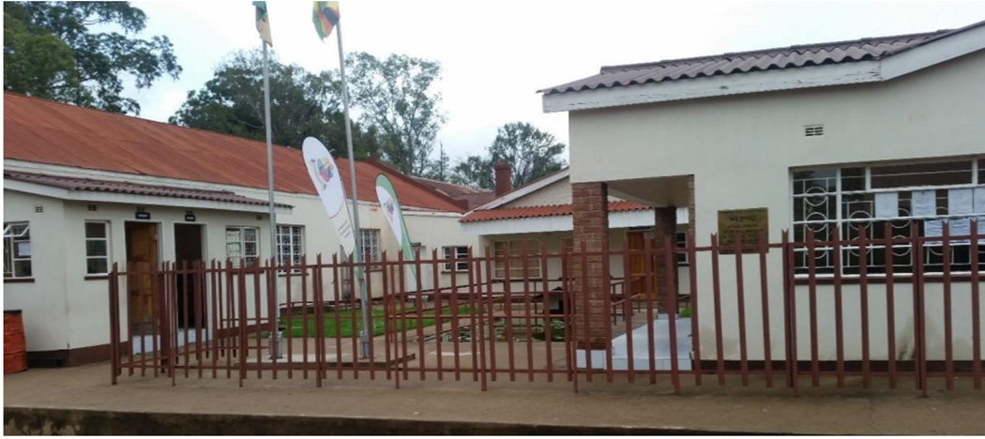
Figure 1:Stand 14 Napier RD, Mvuma, Zimbabwe

Chirumanzu Rural District Council (Mvuma) is situated at the centre of Zimbabwe along the Harare-Beitbridge Road. Its head office is located in Mvuma town. It is 200km to the south of Harare along Masvingo-Beitbridge road and 80km to the east of Gweru along Mutare road. The council manages three major service centres namely Mvuma, Lalapanzi and Charandura with sub-offices in each one of them.

Mvuma is arguably the fastest growing town in Zimbabwe since the multicurrency era and is home to an estimated population of plus or minus 10 000 people. Lalapanzi, also once a ghost mining town is the second largest service centre in the District. It is arguably the busiest mining activity in the country and holds an estimate 5000 inhabitants. Charandura handles an average of 6000 to 7000 people and is a fairly big service centre by its standards. Chirumanzu Rural District Council like any other local authority in Zimbabwe is mandated to provide its residents with local government services such as education, health, water distribution and sanitation, fire and ambulance, road and street lighting, and town planning services.

Chirumanzu district is in the Midlands Province and it borders with Mashonaland West to the north, Mashonaland East to the east, Masvingo Province to the south then Shurugwi and Gweru districts to the west that are in Midlands Province. Chirumanzu communal lands occupy the southern part of Chirumanzu district. Chirumanzu consists of 25 wards with 25 elected councilors. The council currently employees forty-five permanent workers and sixty-three casual workers who are working at Mvuma office as well as eight in Charandura other eight at Msena irrigation.

2.3 Services Provided by Chirumanzu RDC
Primary Healthcare: The council operates seven clinics Mapiravana, Chengwena, Guramatunhu, Hama, Doroguru and Lalapanzi, and currently, there are two clinics being constructed, Chapwanya and Msena. There is a staff establishment of two registered nurses, one nurse aid and one general hand at each clinic. The clinics are facing drugs shortages. Grants received from the government are not enough to purchase drugs and other essentials for use at clinics. These clinics are to provide health facilities and services in local communities.

Sewage Drainage: It is the responsibility of the council to dispose and treat sewage or storm water. The council uses ponds to treat sewage effluent. A number of houses are operating without functional toilets hence, putting the lives of residents at risk as the people use nearby bushes for toilet services, thus the council is responsible for sewer systems.

Housing and Planning: Chirumanzu Rural District Council provides houses for renting as well as residential and commercial stands. The waiting list is huge and there is a backlog in servicing the stands due to lack of funds.

Issuing Trade Licensing and Permits: The council issues out licenses in a bid to integrate the informal sector and improve local development. For the service, the council is trying its best and has put in measures for those who do not want to acquire licenses, for instance, locking the shops of those operating without licenses through its Risk Management Department (security).

Refuse collection: The Works Department has a refuse section operating with two tractors and a tipper truck to collect refuse on a daily basis. The tractors are not designed for refuse collection hence, a lot of refuse dropping on the way to the dumping site. The tractors are old and this is compounded by lack of service making refuse collection an ambition than a reality for the council. Furthermore, the refuse is deposited in a pit created by people extracting gravel hence, were not properly sited, protected and lack of proper treatment. This exposes young children to diseases as they frequent visit the dumpsite in search of toys. Therefore, there is need to properly site the dumpsite.

Infrastructure Development: Chirumanzu RDC is responsible for infrastructure Development in Districts. This includes Commercial buildings, hospitals and clinics, road development and maintenance, graveyards maintenance, borehole drilling for proper water sanitation in rural areas.

2.4 Mission
The Mission of CRDC is “To provide services and alleviate poverty in urban, communal and resettlement areas. A mission statement is a written declaration of an organization’s core purpose and focus that normally remain unchanged over time or a brief description of why a company exists (Hawthorne 2018). Chirumanzu Rural District (CRDC) is committed to economic, efficient and effective service delivery to the public in urban, communal and resettlement areas by tapping and making proper use of available resources in order to sustain and raise living standards of its people through good governance and enlightened stakeholder approach.

2.5 Vision
The Vision of CRDC is “A prosperous community by 2030”. A Vision statement is a declaration of an organization’s objectives intended to guide its internal decision-making or an aspirational description of what the organization would want to achieve in future, according to Hawthorne (2018). An organizational vision is not merely a dream but something that is yet to be fulfilled in near future meaning that an organization should focus its activities towards fulfilling that vision which act as winning point. Without it, an organization is like a ship whose campus is not functional. Governance is exercise of political, economic and administrative authority or power to manage a nation’s affairs at all levels. Governance means the process of participation in the handling of social, economic, and political affairs of a state or local community through structures and values that reflect society (Farazmand 2004). Sound local governance is efficient in managing a nation’s affairs through cooperation of the central government, private sector and civil society. A quality-built environment refers to man-made environment that provides the setting of human activity, ranging in scale from buildings to cities and beyond.

2.6 Core Values
These are fundamental beliefs of an organization or guiding principles to determine if the organization is on the right path to fulfil its goals.
- Team work: coordination, cooperation and commitment. Coordination means the ability of all departments to work together efficiently. Cooperation is the process of working together to the same end and commitment means the quality of being dedicated to an activity. The organization’s department’s works together to ensure the delivery of quality services. The student evidenced this during the Audit visits, the Finance department was working on receipts and previous files ensuring that everything was up to date and correcting any errors. The student worked with attaches from various department for two weeks in the Finance department learning to number payment vouchers correctly and filing documents. This means that all the departments at Chirumanzu RDC are committed to the fulfilment of the organization’s objectives.

- Innovativeness: dedication to divergence and creativity. Creativity entails the use of imagination/original ideas to create or invent something and this include the bringing in of new ideas. The new technology systems were introduced which keep track record of a user’s activity while assessing the network resources including the amount of time spent in the network as well as services accessed while there. This means that the organization is dedicated in doing work that matters.

- Transparency: openness with zero tolerance to corruption. Usually, the recruitment and finance sectors are determined to be corrupt in many organizations. During the period the student was attached at Chirumanzu Rural District Council no cases of corruption were recorded. When any employee in a local authority is found to be corrupt, they use the law to solve the case.

- Accountability: building trust through responsibility. The organization has the responsibility to deliver services to the citizens, to ensure that people are not allocated stands to build houses in wet and state lands. This means that the Council is hold accountable if anything goes wrong in terms of development.
- Client orientation: this implies serving with diligence and courtesy. The student recognized that the workers at the organization showed politeness and good humor to clients who come to enquire what they want. The student was also treated in the same manner and this helps in dealing with clients too.

2.7 Objectives of CRDC
- To alleviate poverty in communal and resettlement areas
- To improve service delivery in Chirumanzu district.
- To promote investment in Mvuma
- To develop Estates around Chirumanzu, among others

2.8 COMPANY’S ORGANIZATIONAL STRUCTURE

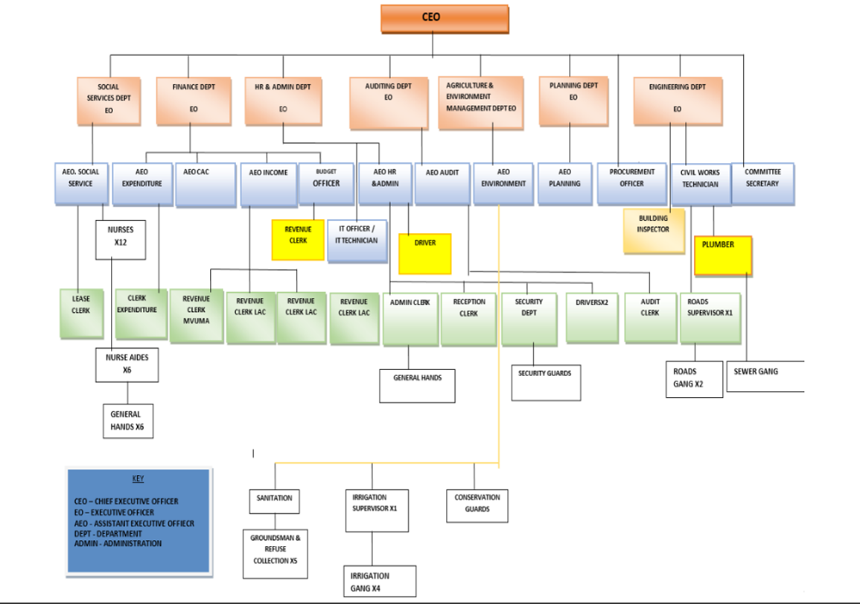
Figure 2:Chirumanzu RDC Organizational Structure
Chirumanzu Rural District Council is a corporate body enacted through RDC Act (Chapter 29.13). The Act was revised (2008) through the Local Government Laws Amendment Act. The corporate body is composed of twen0.ty-five councilors. The councilors conduct their business in standing committees of council provide for by the RDC Act (Chapter 29.13).

CHAPTER 3: DUTIES AND RESPONSIBILITIES

3.1 Relevance of computer science (information technology) in local governance and community service
Computer Science plays a crucial and ever-growing role in the IT department of local city councils, especially in places like Zimbabwe, where e-governance and digital transformation are becoming increasingly important for improved service delivery. It also plays a pivotal role in enhancing the efficiency, transparency and service delivery of rural district councils. Its strategic importance is increasingly recognized as local governments adopt digital solutions to meet community needs and operational challenges. Computer science students gains valuable hands-on experience by assisting in various tasks at councils especially in the IT department.

An important aspect is the underunderstanding of organizational and power dynamics. Schein defines organizational culture as a pattern of shared basic assumptions that the group learned as it solved its problems of external adaptation and internal integration. Schein, E.H (1992). It is also a dynamic process, which is shaped by interactions between members, and it is learned through shared experiences and adapted to address internal and external challenges, which are faced, by employers and employees.
Huber (1990), suggest that IT is a variable that can be used to enhance the quality and timeliness of organizational intelligence and decision making, thus promoting organizational performance.
Facilitating efficient service delivery is also another important actor which clearly indicates the importance of computer science to the organization. The IT department enables the automation and digitization of various administrative processes, leading to quicker and more accessible services for residents. For example, online platforms for permit applications, bill payments, and service requests reduce physical visits and streamline workflows). This is particularly vital in rural settings where geographical barriers can impede service access. This will also help in keeping accurate and up to date records and database of the organization.
Another important factor which shows the importance of the information technology department is improving data management and decision-making. Effective data management facilitated by the IT department allows councils to collect, analyse, and utilize data for informed decision-making. Geographic Information Systems (GIS) are often employed to map resources, plan development projects, and manage land use efficiently. Accurate data supports sustainable planning and resource allocation tailored to community needs.
Enhancing Transparency and Citizen Engagement is also another factor which helps in explaining the importance and relevance of the IT department to the organization. Digital platforms and social media managed by the IT team foster transparency and promote citizen participation. E-governance initiatives enable residents to access information, provide feedback, and engage with council activities remotely, fostering accountability). In rural areas, this bridges the information gap and encourages community involvement.
Supporting Internal Operations and Collaboration
The IT department provides essential infrastructure such as network systems, communication tools, and cybersecurity measures that facilitate internal communication and collaboration among departments. Cloud-based solutions enable remote work and data sharing, which became relevant during the COVID-19 pandemic (World Bank, 2020).
Promoting Digital Inclusion and Development
By implementing inclusive digital solutions, the IT department helps bridge the digital divide in rural communities. Initiatives like community Wi-Fi, digital literacy programs, and mobile applications support social and economic development (ITU, 2020). This contributes to broader goals of sustainable development and poverty reduction.

3.2 Work roles and responsibilities undertaken by the student in the it department

During my attachment at the IT department of Chirumanzu Rural District Council, I was assigned a variety of roles and responsibilities aimed at supporting the department’s daily operations and gaining practical experience in public sector IT functions. These roles included:

- Troubleshooting and Assisting in Network Maintenance
I helped the IT staff keep an eye on the wide area network (WAN) and local area network (LAN). This required resetting switches and routers, identifying connectivity problems, and making sure that internet access was uninterrupted throughout the different council offices.

- Software Installations and Hardware Supporting
I took part in setting up new printers, computer systems, and other accessories. I gained a better understanding of how to configure and integrate hardware with current systems thanks to this task.

- Database Management and Data Entry
I was in charge of using the designated software to update and maintain the council's data records. My knowledge of data security, accuracy, and the value of structured data management in administrative tasks has improved as a result of this experience.

- Software Updates and Security Checks Assistance
To protect against potential threats, I carried out basic security checks and supported regular software updates. The importance of cybersecurity procedures in government agencies was highlighted by this position.

- User Support and Training
I gave council employees basic technical support, assisting them in resolving typical problems and advising them on how to use common applications. My ability to effectively communicate technical information and my communication skills both improved as a result.

- Documenting IT Procedures and Maintenance Logs
In order to effectively manage and troubleshoot IT, I helped to record maintenance activities and procedures for future reference.

- Learning and Applying Basic Networking Concepts
I was able to connect my theoretical knowledge with practical applications during the attachment by gaining hands-on experience with network configurations, IP addressing, and fundamental security measures.

- Website Development for public engagement
Oversaw the creation and continuous upkeep of the council's official website for community engagement, which acts as a key online forum for encouraging openness, diversity, and engaged citizenry in local government. made sure that everyone in the community, regardless of technical proficiency, could easily access council services and information by designing and implementing user-centric front-end interfaces that are accessible, simple to use, and compatible with a variety of devices and browsers.

- Management of Corporate Emails.
I was in charge of overseeing the company's corporate email system. Among my responsibilities were helping to set up and configure new hires' email accounts, and managing email distribution lists. In order to encourage professional communication standards throughout the company, I also put best practices for email usage into effect. I also worked with the IT security team to put spam and malware protection procedures in place and assisted in troubleshooting email-related problems like delivery failures and spam filtering.


Figure 3: Email accounts

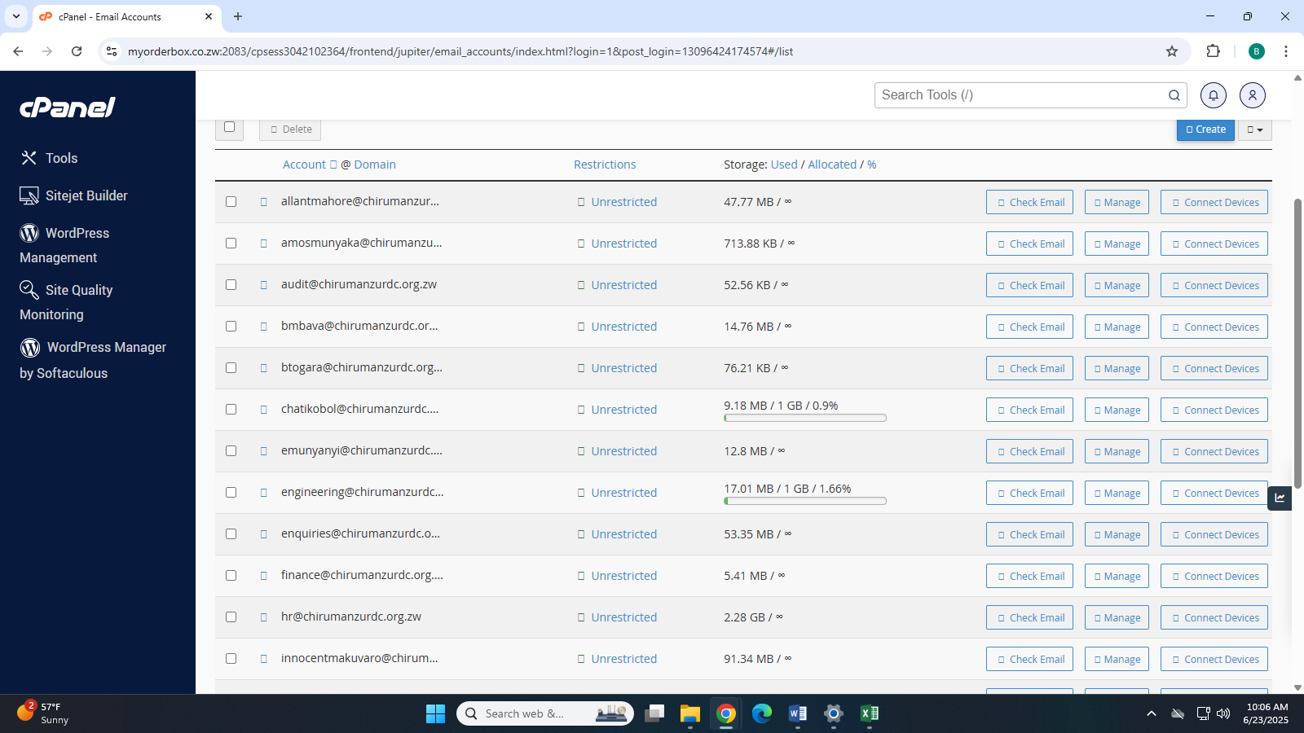
Figure 4:Email accounts

- Management and Maintenance of Organization’s Networks
As part of my duties, I helped configure and troubleshoot network equipment like switches, routers, and access points to guarantee peak network performance. In order to detect and fix connectivity problems and guarantee little downtime, I assisted in monitoring network traffic. In order to protect the network infrastructure, I also backed the deployment of security measures like firewall configurations and access controls. In order to support organizational growth, I also took part in regular network audits, documented network topology, and helped upgrade and expand LAN and WAN infrastructure.
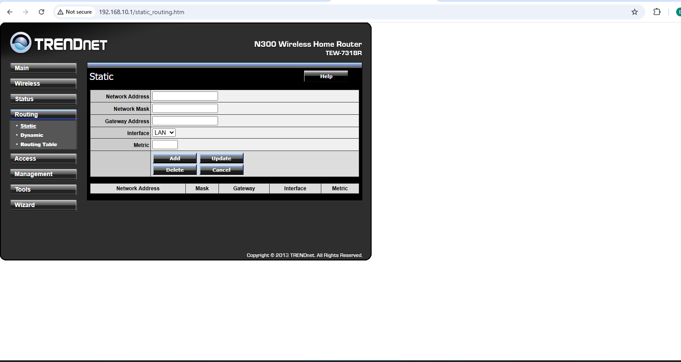
Figure 5 LAN MANAGEMENT

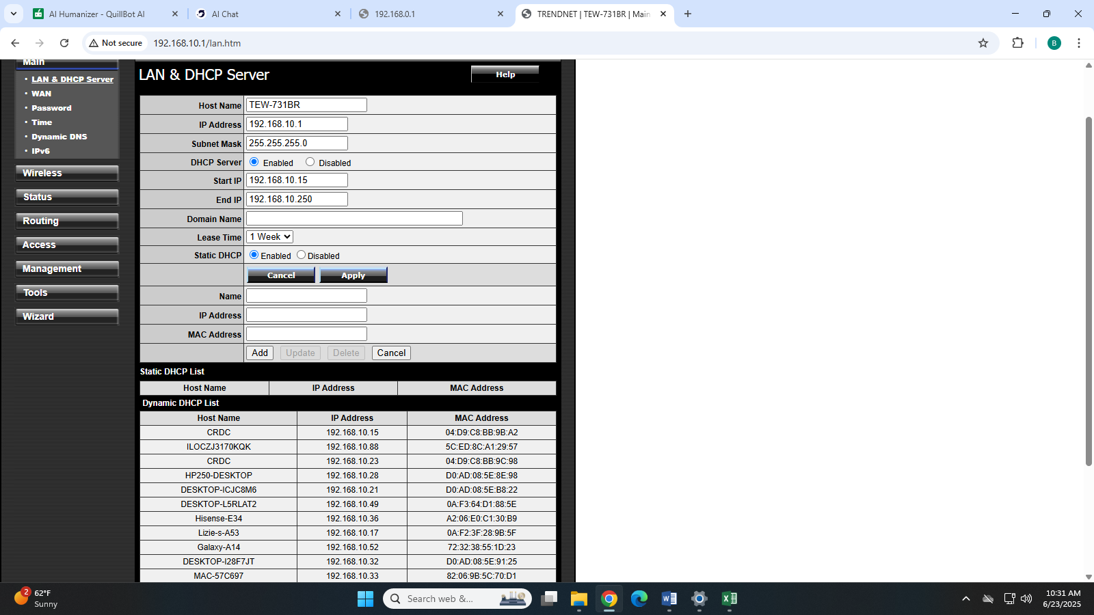
Figure 6 LAN CONFIGURATION

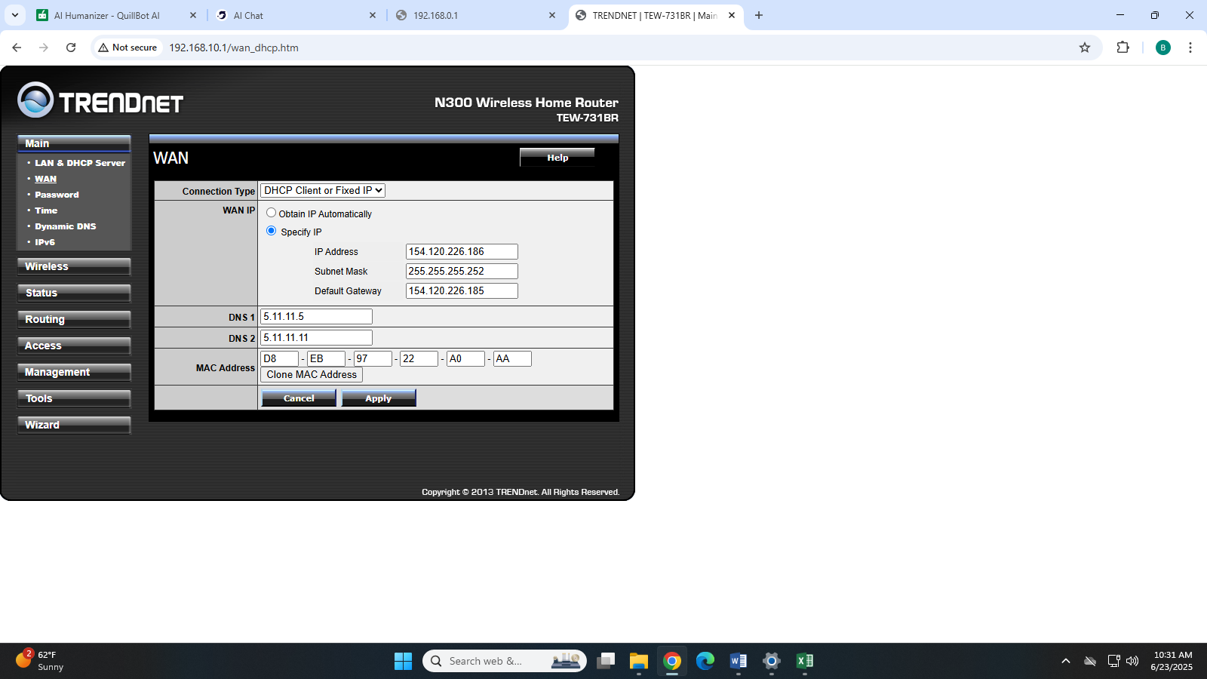
Figure 7 WAN IP address

I had the opportunity to work closely with the LADS team as a super user in addressing and resolving housing-related issues. My responsibilities included resolving user-related system issues, offering technical assistance, and making sure housing management software ran smoothly.

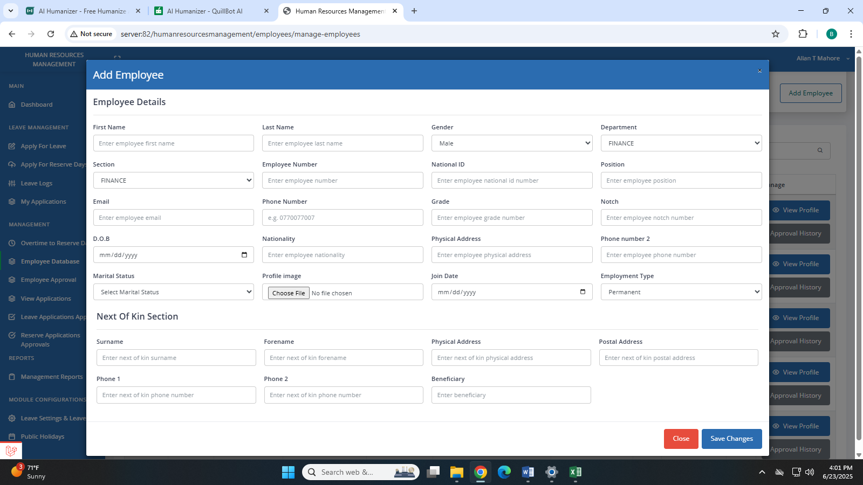
Figure 8 LADS EMPLOYEE DETAILS

Missing Encryption key:
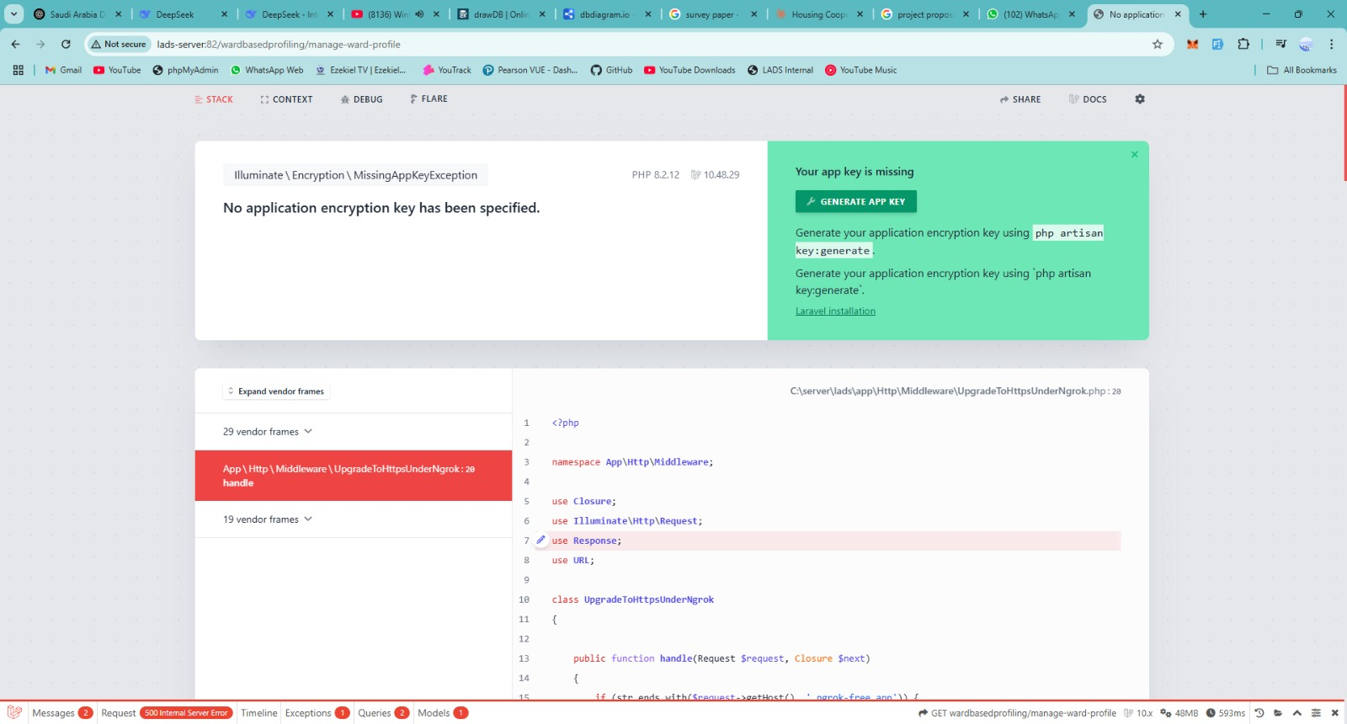
Figure 9 Encryption key missing


Figure 10 Code for encryption key

3.3 Applicability of tasks and duties to computer science and public service management.

- Network Support and Troubleshooting
Modules that are pertinent include Internet of Things (IoT), programming fundamentals, and data structures and algorithms.
Understanding network protocols, IP addressing, and fundamental security measures was necessary to support network maintenance. These concepts are in line with the ideas covered in Data Structures and Algorithms and the Internet of Things in Physical Computing. Network troubleshooting strengthened the problem-solving abilities learned in Programming Fundamentals.

- Hardware and Software Installation
Electrical and Electronic Principles, Web and Mobile Development are pertinent modules.
Understanding electrical and electronic principles as well as device interfaces was necessary for configuring hardware and installing software. Additionally, installing and configuring applications gave me hands-on experience related to web and mobile development.

- Data Entry and Database Management
Modules that are pertinent include Database Design and Development and Information Digital Skills.
Understanding database structures, data normalization, and data security—all of which are closely related to database design and development—was necessary for managing council data. The digital literacy skills learned in Information Digital Skills were improved by this experience.

- Security Checks and Software Updates
Modules that are pertinent include machine learning, expert systems, and artificial intelligence.
Understanding cybersecurity principles is necessary to perform security checks and updates. These principles relate to the automated security systems and anomaly detection concepts taught in Artificial Intelligence modules.

- User Support and Communication
Language Acquisition is a pertinent module. French for Intercultural Communication
Supporting employees necessitated having strong communication skills, including intercultural communication, which is essential for comprehending user needs and working in diverse teams.

- Documentation and Maintenance Logs
Modules that are pertinent include Game Development and Basic Programming.
Procedure documentation ensures maintainability and collaboration, much like the significance of unambiguous code documentation in game development and programming.

- Website Development for Public Engagement
Creation and management of a website that promotes community involvement.
Modules that are pertinent include Database Design and Development, Web and Mobile Development, and Programming Fundamentals.
Database integration, user experience design, and front-end and back-end development skills were all used in the creation and maintenance of the website

3.4 Ways in which the department seeks to achieve the organisation objectives.
Strategic Management: The IT Department makes sure that the council's overall goals are supported by its technological strategies and systems. In order to improve service delivery and investment promotion, this involves implementing digital platforms for service delivery, data analytics tools for well-informed decision-making, and communication channels to facilitate stakeholder engagement.
Enhancing Service Delivery: The IT Department improves service delivery by creating digital platforms that make government services more accessible to residents. Online portals for payments, reporting issues, and accessing information reduce bureaucratic delays and make services more convenient. Remote access tools ensure even those in remote areas can benefit from efficient and timely government support, aligning with the district’s aim to improve service delivery.

Improving governance: Transparent online platforms for public information access and safe data management are key components of strong governance. The IT department creates systems that encourage accountability and lower the risk of corruption. Transparency and trust are fostered by these digital governance tools, which are essential to good governance and public trust in the council's operations.

Enhancing Social Services: By developing databases and mobile applications that expedite the distribution of assistance and social programs, the IT department assists social services. Targeted interventions are made possible by data analytics, which identify underserved populations. In line with the objective of improving social welfare, these digital tools guarantee that social services more efficiently reach those in need.

Operational efficiency: To lessen operational burdens, the IT Department deploys integrated management systems, automates administrative procedures, and maintains dependable IT infrastructure. This guarantees adherence to pertinent laws and policies, improves data security, and streamlines workflows. These efficiencies allow the council to better distribute funds, fund initiatives aimed at reducing poverty, and enhance overall service provision.

Supporting Capacity Building and Employee Development: The department creates and offers training courses to improve employees' ability to use new IT tools and systems. The IT Department helps the council achieve its objectives of effective estate and investment management and efficient service delivery by enhancing technical proficiency and digital literacy.

3.5 Sociological understanding that help me execute my duties at CRDC

Understanding social structures: It has been crucial to comprehend social structures. The interdependent relationships and hierarchies that people within an organization create are referred to as social structures. According to Giddens (1984), these structures have an impact on organizational dynamics, communication, and behavior. I became aware of how the council's policies, procedures, and constitutional frameworks influence authority, decision-making, and operational workflows by examining them. This knowledge has aided me in negotiating power dynamics, making sure that hierarchical procedures are followed, and encouraging productive dialogue within the council.

Social exchanges and connections: In order to promote cooperation and teamwork in my work, effective social interactions are essential. Empathy, active communication, and conflict resolution abilities are necessary for establishing solid bonds with coworkers, stakeholders, and community members. According to Katzenbach and Smith (1993), accomplishing organizational objectives requires cooperation and group effort. Knowing interpersonal dynamics has helped me build trust, clear up misunderstandings, and encourage a cooperative atmosphere that improves service delivery, whether I'm serving as a stakeholder consultant or coordinating with other departments.

Organizational Change and Development
In order to adjust to new technological advancements and process enhancements, the sociological perspective on organizational change has proven crucial. I've been able to approach this process more thoughtfully because I understand how change affects stakeholders, employees, and the community. I have helped create strategies that improve productivity, promote employee well-being, and satisfy community needs by putting ideas from theories like Fredrick Taylor's scientific management to use. This sociological knowledge guarantees the seamless implementation of organizational reforms and technology advancements while taking social and human factors into account.

CHAPTER 4: OVERALL EVALUATION OF WORK RELATED LEARNING EXPERIENCE

4.1 Strength and weaknesses

4.1.1Strengths
- Practical technical skills: I improved and fortified my technical skills in database administration, network infrastructure support, and GIS tool use during my placement. My confidence and proficiency in IT operations in a rural local government setting have grown as a result of this practical experience.
- Adaptability and problem-solving: I had to be flexible and resourceful to work in a setting with limited resources. I improved my problem-solving abilities by learning how to come up with creative answers to technical problems, frequently with little funding.
- Understanding of sociological dynamics: I was able to promote teamwork, negotiate organizational hierarchies, and interact with coworkers and community stakeholders by utilizing sociological insights. My capacity to collaborate and interact with others was enhanced by this realization.
- Commitment and community development: My desire to align my technical expertise with social impact and use technology to promote community development, service delivery, and transparency was strengthened by the experience.

4.1.2 Weaknesses

- Limited exposure to advanced technologies: Due to the scope of the placement and available resources, I had limited opportunities to work with the latest and more advanced IT systems and emerging technologies.
- Time management challenges: I found it difficult to effectively arrange and allocate time to various tasks, sometimes this meant very tight deadlines or stuff left undone. This shows that higher productivity can and must be achieved through better management of time, as only then can we get our work done in an orderly fashion. I am making on efforts to improve in the area of planning and setting crystal clear priorities.
- Communication with non-Technical stakeholders: While I developed some communication skills, I found it challenging to effectively engage and collaborate with diverse stakeholders, including community members and non-technical staff.
- Experience in Strategic Planning: My involvement was more operational than strategic; gaining experience in long-term planning and policy development would be beneficial for future roles.

CHAPTER 5: CONCLUSION AND RECOMMENDATIONS

5.1 Conclusion

My work-based learning placement at Chirumanzu Rural District Council has been enlightening and rewarding, and it has greatly improved my comprehension of how technology aids in the operations of the public sector. I was able to apply my technical expertise to actual administrative procedures as an IT student, obtaining hands-on experience in areas like data handling, office automation, system management, and assisting with digital communication initiatives.
Throughout this placement, I gained a greater understanding of how information technology can streamline government operations, enhance record-keeping, and promote efficient internal communication. Additionally, I saw how technology infrastructure affects government decision-making, service delivery, and transparency.

While encountering challenges such as limited technological resources, infrastructure gaps and adapting to bureaucratic procedures, these obstacles provided valuable learning opportunities. They taught me resilience, problem-solving, and the importance of innovative thinking in resource-constrained environment.

Overall, the placement has strengthened my technical skills and highlighted the critical role of IT in enhancing governance and public service delivery. It has inspired me to continue honing my skills in utilizing technological solutions to solve administrative problems and enhance community development projects.

5.2 Recommendations to the organization
For the organization of CRDC to realize maximum efficiency and achieve its stated mission and objectives the following recommendations need to be implemented:

- There is need to communicate regularly with employees and seek their input on issues that affect them. This promotes motivation to employees.
- Organizations should adopt current information technologies to communicate with its various publics. There is need to invest in modern hardware, reliable internet connectivity and updated software systems to improve efficiency.
- There must be proper utilization of financial resources to reduce the funding gap between community needs and available resources.
- The local authority should develop public-private partnerships and should also consider making some twinning arrangements with some local authorities outside the country to better up its services
- Chirumanzu RDC should implement robust cybersecurity protocols to protect sensitive information and prevent data breaches, ensuring public trust and compliance with data protection standards.

REFERENCES

Huber, G (1990) Theory of advanced information technologies on organizational design, intelligence and decision making
Katzenbach, J.R., and Smith, D. K. (1993). The Wisdom of Teams
Schein, E.H (1992). Organizational Culture and Leadership. (2nd Edition). San Francisco: Jossey-Bass
Rural District Council’s Act (1996) [Chapter 29:13]
Urban Council Act (Chapter 29:15)

