Prepositions in
Our
Zimbabwean Heritage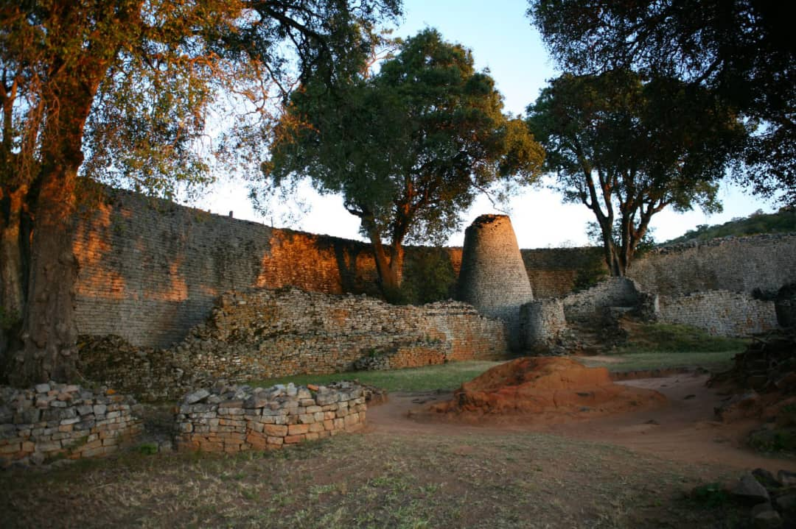
A Handbook on Four Types of Prepositions

AUTHORS
KASAMBA MELISA R & Ruzvidzo ledonna
30/033/2023. 30/087/2023.

Table of Contents
Introduction 3
CHAPTER 1: Prepositions of Place 4
CHAPTER 2: Prepositions of Time 6
CHAPTER 3: Prepositions of Movement 8
Chapter 4: Prepositions of Manner 10
Conclusion 12
References 13

Introduction
Prepositions are essential grammatical tools that show relationships between words in a sentence indicating place, time, direction, or manner. According to Yule (2020), prepositions serve as "function words that link nouns, pronouns, or phrases to other words within a sentence." This handbook aims to explain four key types of prepositions using relatable examples from Zimbabwean culture, daily life, and heritage sites. By grounding grammar in local context, learning becomes meaningful, memorable, and engaging for primary learners. As noted in the Zimbabwe Ministry of Education's Heritage-Based Education Curriculum (2015), "Language instruction should connect to learners' lived experiences and cultural knowledge." This booklet follows that principle by integrating Shona and Ndebele cultural references with grammatical instruction. This handbook is designed for teachers and student teachers as a resource to teach prepositions creatively and culturally, aligning with competency-based education approaches.

CHAPTER 1: Prepositions of Place

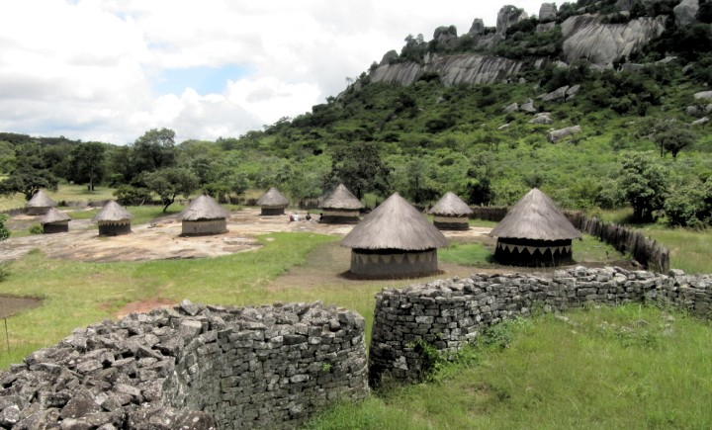
picture showing a traditional village
Definition:
Prepositions of place indicate the location or position of a person, object, or event in relation to another. According to Quirk and Greenbaum (1973), place prepositions answer the question "Where?" and establish spatial relationships between entities. These include words such as in, on, under, beside, between, near, above, and behind.
Local Examples & Cultural Context:
1. In – "The mbira is kept in the wooden case."
Context: The mbira, a traditional thumb piano sacred in Shona culture, is carefully stored when not in use during ceremonies or family gatherings. As Berliner (1993) documents in The Soul of Mbira, the instrument has spiritual significance and is treated with respect.
2. On – "The clay pot sits on the three-legged hearthstone."
Context: In Shona and Ndebele kitchens, cooking pots are placed on hearthstones arranged in a triangle over the fire. This traditional cooking method is documented in Zvarevashe's (1998) study of indigenous culinary practices.
3. Between – "The village well is located between the school and the chief's homestead."
Context: Water sources are often central community landmarks, situated between key communal spaces to serve all households equitably, a practice noted in rural settlement patterns studied by Mamvura (2012).
4. Near – "The muchakata tree stands near the burial grounds.
Context: In many Zimbabwean cultures, certain trees like the muchakata (Parinari curatellifolia) are considered sacred and are protected near spiritual sites. Gundani (2001) notes their role as sites of communication with ancestors.

Engaging Task
Draw a map of your school or village compound. Label at least five locations using prepositions of place (e.g., "The headmaster's office is beside the staffroom"). Share your map with a partner and describe the spatial relationships.

CHAPTER 2: Prepositions of Time

[Image: A circular "Cultural Calendar" showing months with traditional activities: January (harvesting), April (mapfihwa ceremony), August (mapira rituals), December (rainmaking ceremonies). Clock icons show temporal relationships.]
Definition:
Prepositions of time indicate when an action occurs. They help situate events in temporal context. As defined by Huddleston and Pullum (2002), time prepositions establish "temporal relations between situations" and include before, after, during, at, in, on, since, and until.

Local Examples & Cultural Context:
1. Before – Children fetch water before sunrise.
Context: In rural communities, daily chores align with natural rhythms. Fetching water early avoids heat and ensures availability for morning routines, a practice documented in rural livelihood studies by Moyo (2015).
2. During – Folktales are told during the full moon.
Context: Oral storytelling traditions are often tied to lunar cycles, particularly bright nights when communities gather outdoors. Chiwome (1996) notes this timing in A Social History of the Shona Novel, explaining how moonlight gatherings facilitated cultural transmission.
3. After – "Harvest celebrations occur after the first rains.
Context: Agricultural cycles dictate cultural events. The first rains mark the planting season's beginning, while harvest follows several months later, structuring the annual ritual calendar described by Aschwanden (1987) in Karanga Mythology.
4. At – The village court convenes at dusk.
Context: Evening is a traditional time for community gatherings and conflict resolution. The dare system, documented by Holleman (2013), typically meets as daytime work concludes, allowing full community participation.
Engaging Task:
Create a weekly timetable of your family's routines using prepositions of time. Include both modern activities (e.g., "after school") and traditional ones (e.g., "during evening prayers"). Compare with a classmate's timetable and discuss differences.

CHAPTER 3: Prepositions of Movement

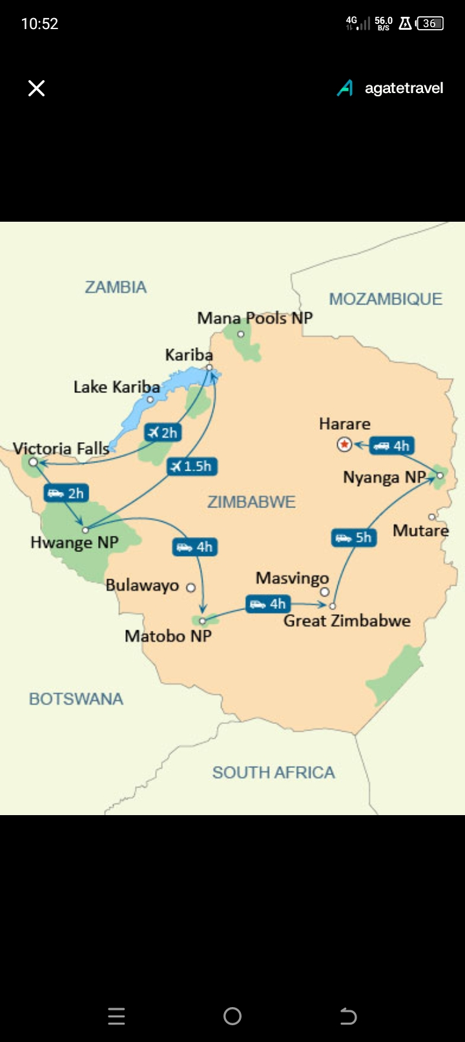
A map of Zimbabwe showing arrows indicating movement between cultural sites: from Harare to Great Zimbabwe, through Eastern Highlands, across Zambezi River, to Victoria Falls.

Definition:
Prepositions of movement show direction or motion from one place to another. They include to, from, through, across, into, toward, up, down, and along. According to Yule (2020), movement prepositions often follow action verbs and indicate "path or trajectory through space."

Local Examples & Cultural Context:
1. To – Pilgrims walk to Njelele Shrine for spiritual guidance and rainmaking ceremonies.
Context: Njelele in the Matobo Hills is a sacred site for traditional worship, mentioned in historical records since the 19th century. Ranger (1999) documents its continued importance in Voices from the Rocks, noting annual pilgrimages by various ethnic groups.
2. Through – The Zambezi River flows through six countries before reaching the Indian Ocean.
Context: The river is a vital geographical and cultural landmark in Southern Africa, supporting communities along its course. Scudder's (2005) research on river basin communities documents traditional fishing and transportation practices along the Zambezi.
3. Across – Traders travel across the border to Mozambique for goods like capulana fabrics.
Context: Cross-border trade is common in towns like Mutare, reflecting historical trade networks documented by Pikirayi (2001) in The Zimbabwe Culture, which traces pre-colonial trade routes across the region.
4. From...to – People migrate from rural areas to Harare for employment opportunities.
Context: Urbanization trends reflect socio-economic movements in Zimbabwe. Potts (2010) analyzes these patterns in Circular Migration in Zimbabwe, noting that many maintain connections to rural homes despite urban relocation.

Engaging Task:
Describe a journey from your home to a local market or significant community site using at least five prepositions of movement. Include the mode of transportation and what you pass along the way. Draw a simple map to accompany your description.

Chapter 4: Prepositions of Manner

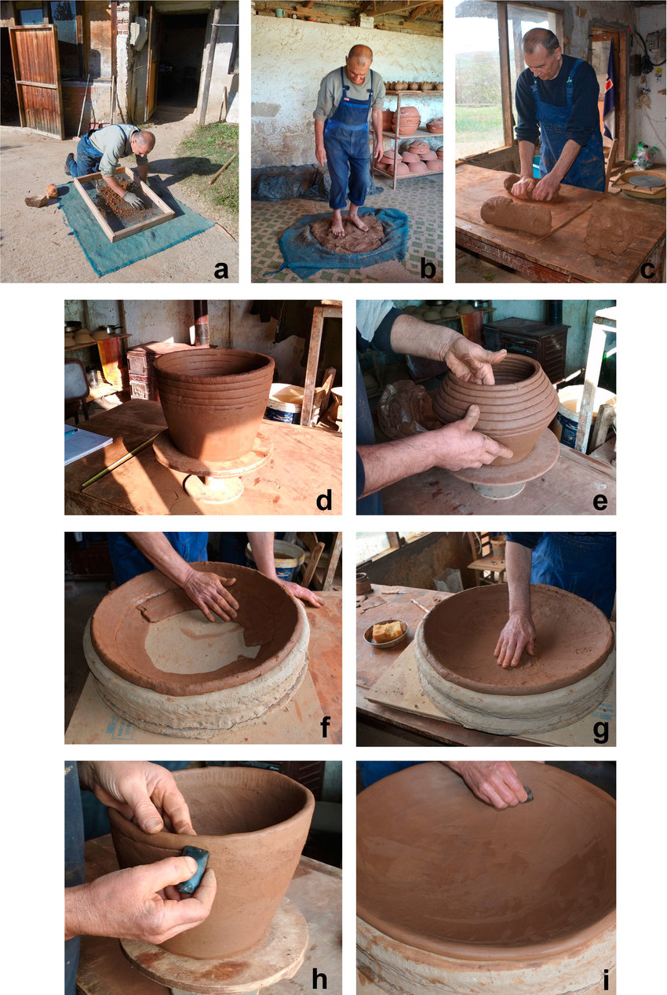
photos showing pottery making: shaping "by hand," decorating "with a tool,"

Definition:
Prepositions of manner describe how an action is performed. They include with, by, like, in, without, and through. According to Carter and McCarthy (2006), manner prepositions modify verbs to express "style, method, means, or attitude" accompanying an action.
Local Examples & Cultural Context:
1. With – The hosho (maracca) is played with a shaking motion during mbira performances.
Context: Musical instruments in traditional ensembles require specific techniques. The hosho provides rhythmic foundation for mbira music, as described by Gwenyambira (2018) in Zimbabwean Traditional Music Pedagogy.
2. By – Clay pots are made by hand using the coiling method.
Context: Pottery remains an important craft in communities such as those in the Mazowe Valley. Zimbili (2003) documents these techniques in Indigenous Zimbabwean Crafts, noting that coil building allows for large, symmetrical vessels without a wheel.
3. Like – "She dances like a mbende (traditional dancer) during the harvest ceremony.
Context: Dance styles are often compared to cultural archetypes in praise and storytelling. The mbende (jerusarema) dance, recognized by UNESCO as intangible cultural heritage, has specific movements that trained dancers replicate precisely.
4. In - "Stories are told in a call-and-response style to engage listeners."
Context: Oral narratives involve audience participation, a key feature of Shona and Ndebele storytelling. As Chiwome (1996) notes, this interactive style ensures cultural knowledge is collectively remembered and validated.

Engaging Task:
Choose a traditional skill (e.g., cooking sadza, weaving, carving). Write a step-by-step guide using prepositions of manner to explain how it's done. For example: "Mix the mealie-meal WITH water. Stir IN a clockwise direction. Cook OVER a medium fire."

Conclusion
This handbook has explored prepositions of place, time, movement, and manner through the lens of Zimbabwean heritage. By connecting grammatical concepts to familiar cultural practices—from homestead organization to seasonal ceremonies, from pilgrimage routes to craft techniques—learners can internalize language structures meaningfully. The integration of local examples with academic references demonstrates how grammar instruction can be both culturally responsive and academically rigorous. As the Competency-Based Curriculum Framework (Ministry of Education, 2015) emphasizes, "Education should develop competencies while affirming cultural identity."
Teachers are encouraged to:
1. Use local environments as learning resources
2. Invite community knowledge holders to share examples
3. Create interactive tasks that connect grammar to students' experiences
4. Develop assessments that value cultural knowledge alongside linguistic accuracy
Language learning becomes transformative when it validates students' cultural worlds while expanding their communicative capacities. Through approaches like those illustrated here, prepositions move from abstract rules to living connections between people, places, times, and actions in students' lives.

References
Academic & Linguistic Sources:
1. Carter, R., & McCarthy, M. (2006). Cambridge Grammar of English: A Comprehensive Guide. Cambridge University Press.
2. Huddleston, R., & Pullum, G. K. (2002). The Cambridge Grammar of the English Language. Cambridge University Press.
3. Quirk, R., & Greenbaum, S. (1973). A University Grammar of English. Longman.
4. Yule, G. (2020). The Study of Language (7th ed.). Cambridge University Press.

Cultural, Historical & Zimbabwean Sources:

1. Aschwanden, H. (1987). Karanga Mythology. Mambo Press.
2. Berliner, P. (1993). The Soul of Mbira: Music and Traditions of the Shona People of Zimbabwe. University of Chicago Press.
3. Bourdillon, M. F. C. (1998). The Shona Peoples (3rd ed.). Mambo Press.
4. Chiwome, E. M. (1996). A Social History of the Shona Novel. Juta Zimbabwe.
5. Ferguson, J. (1999). Expectations of Modernity: Myths and Meanings of Urban Life on the Zambian Copperbelt. University of California Press.
6. Gundani, P. (2001). The Spiritual Significance of the Land in Zimbabwe. University of Zimbabwe Publications.
7. Gwenyambira, T. (2018). Zimbabwean Traditional Music Pedagogy. University of Zimbabwe Press.
8. Holleman, J. F. (2013). Shona Customary Law. Oxford University Press.
9. Mbiti, J. S. (1990). African Religions and Philosophy (2nd ed.). Heinemann.
10. Ministry of Primary and Secondary Education, Zimbabwe. (2015). Curriculum Framework for Primary and Secondary Education 2015-2022.
11. Moyo, S. (2015). Rural Livelihoods in Zimbabwe. SAPES Trust.
12. Pikirayi, I. (2001). The Zimbabwe Culture: Origins and Decline of Southern Zambezian States. AltaMira Press.
13. Potts, D. (2010). Circular Migration in Zimbabwe & Contemporary Sub-Saharan Africa. James Currey.
14. Ranger, T. (1999). Voices from the Rocks: Nature, Culture & History in the Matopos Hills of Zimbabwe. James Currey.
15. Samkange, S., & Samkange, T. M. (1980). Hunhuism or Ubuntuism: A Zimbabwe Indigenous Political Philosophy. Graham Publishing.
16. Scudder, T. (2005). The Future of Large Dams: Dealing with Social, Environmental and Political Costs. Earthscan.
17. Zimbili, T. (2003). Indigenous Zimbabwean Crafts: Techniques and Traditions. National Museums and Monuments of Zimbabwe.
18. Zvarevashe, I. M. (1998). Shona Culinary Traditions. College Press.

