Title: Learning with Technology:
A Heritage-Based Journey for Grade 2

---

Table of Contents
EVERYDAY TECHNOLOGY 3
Educational Software 11
Games and Stories 11
ROBOTICS AND CODING 17
Coding 17
Word Bank 21
Fun Activities to Do at Home 22

EVERYDAY TECHNOLOGY
Technological devices
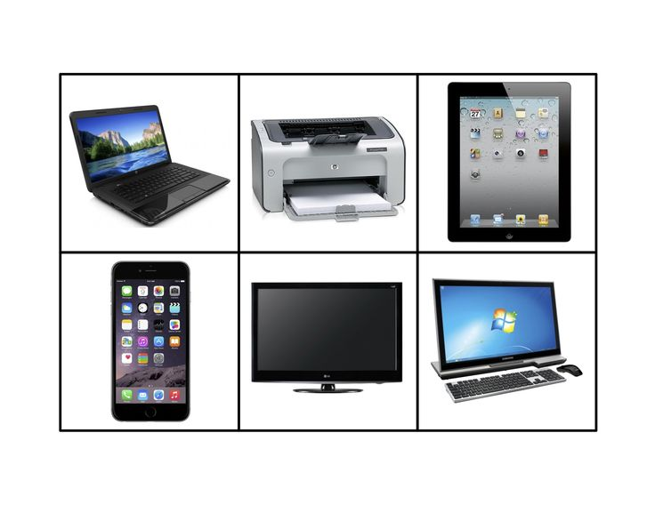
Tablets
A tablet is a flat, thin device with a screen you can touch. It is like a small computer you can hold in your hands.
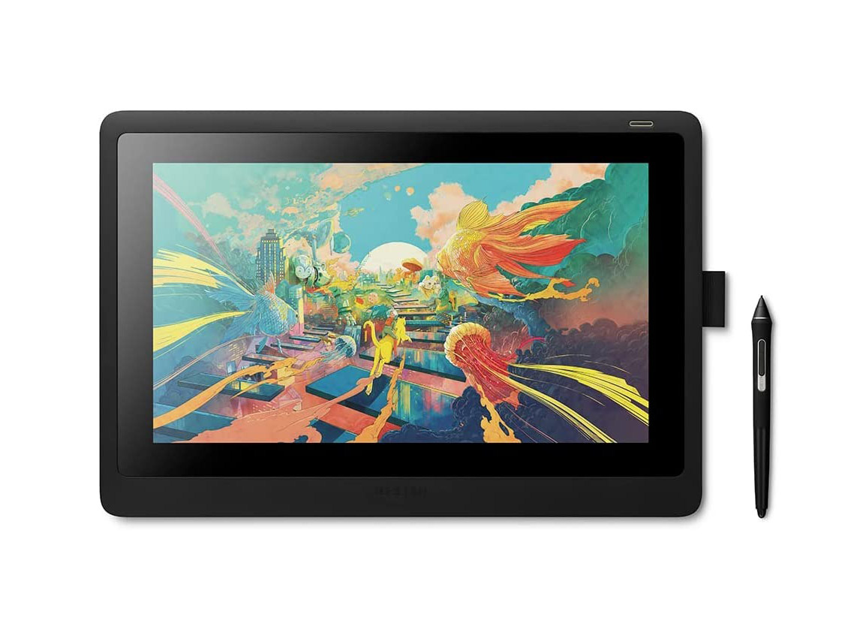

Look at this picture:

· What shape is the tablet?
· Can you see the screen?
On a tablet, we can watch videos that teach us about our traditional dances, like the Jerusarema or Mbende!

Smartphones

A smartphone is a phone that can do many things. It can make calls, take pictures, and help us learn.

Parts of a smartphone:

· Screen
· Camera
· Buttons

Activity: Point to the screen. Point to the camera.

Uses: We use smartphones to call our grandparents, take photos of our friends, and listen to music.

Computers
A computer is a machine that helps us learn, write, draw, and play educational games.

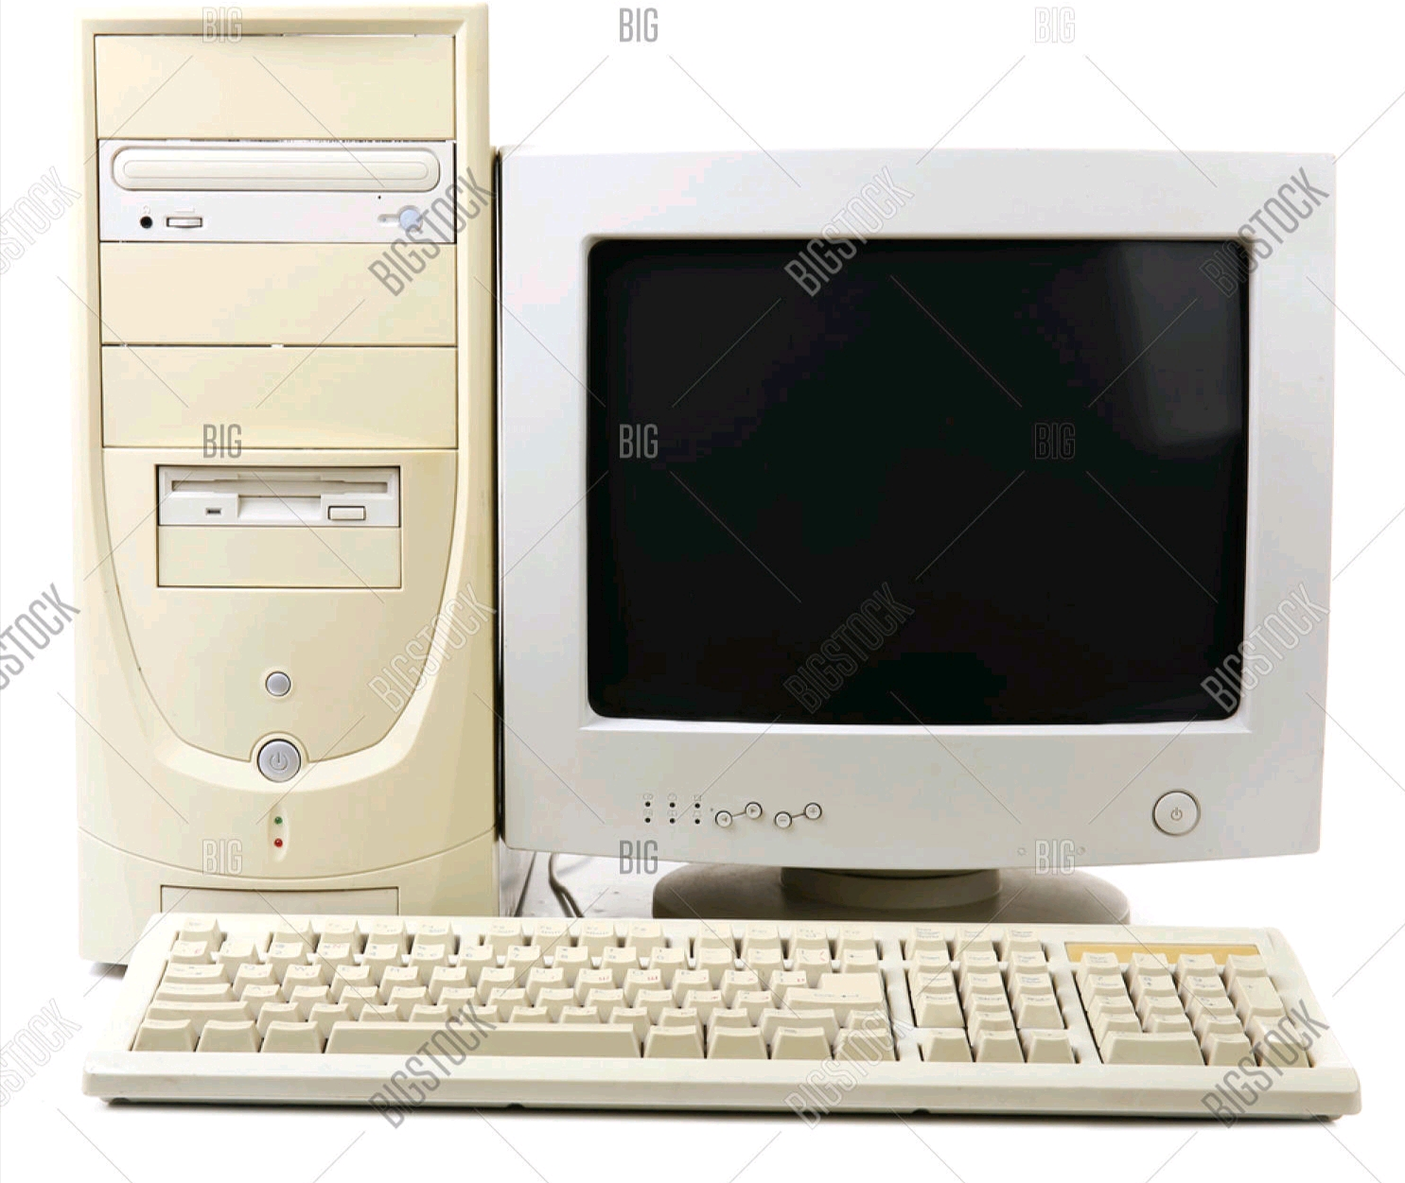

Parts of a computer:
· Monitor/Screen:
Where we see pictures and words.
· Keyboard:
Where we type.
· Mouse:
Helps us click on things.
· CPU:
The brain of the computer!

We can use a computer to type stories about our village and our heroes.

Uses of Technological Devices
Every technological device has a job to do. These are called uses.

Match the device to its use:

Device Use
Tablet (Picture: child watching a story)
Smartphone (Picture: child talking to grandmother)
Computer (Picture: child typing a story)
Radio (Picture: family listening to news)

Discuss: What other uses can you think of?

---
Naming Common Technological Devices

Naming Common Technological Devices

Let's name these devices together!

1. _______________
2. _______________
3. _______________
4. _______________
5. _______________

Page 7: Discussing Technological Devices and Their Uses

Discussing Common Technological Devices and Their Uses

Talk with a friend about these questions:

1. Tablet: What do you like to do on a tablet? (Play games? Watch stories?)
2. Smartphone: Who do you like to call on a smartphone? (Mother? Father? Gogo?)
3. Computer: What do you learn on a computer at school? (Numbers? Reading?)

(Insert a picture of two children talking and pointing at pictures of devices)

Share your answers with the class!

Storytelling Sessions Using Technology in Positive Ways

Read this story:

Every evening, Rudo and her brother Taku sit with their mother. Mother takes out her tablet and says, "Let's watch a story!" They watch a traditional tale about a clever hare and a lazy lion. After the story, they talk about what they learned.

Technology helps us enjoy stories in new ways!

(Insert a picture of a mother and two children watching a tablet together, smiling)

Activity: Draw a picture of your favourite story. How could you watch it on a device?

---
Constructing Model ICT
ICT means Information and Communication Technology. This includes devices like computers, tablets, and phones.

Let's build a model!

You will need:
· Cardboard boxes
· Bottle tops
· Paper
· Glue
· Markers

Instructions:

1. Use a small box to make a computer screen.
2. Use bottle tops for buttons.
3. Use paper to make a keyboard.
4. Glue everything together.
5. Decorate your model!

(Insert a picture of children holding their model ICT devices made from cardboard)

---

Educational Software

Educational software are special programs that help us learn. They are like teachers on a screen!

(Insert pictures of different educational software/app icons)

:

Some educational software teaches us about Zimbabwe - our flag, our animals, and our languages!

Games and Stories
Educational software includes fun games and stories that teach us while we play and read.

Look at these examples:

(Insert pictures of educational game screens)

Type What It Does
Counting Game Helps us practice numbers 1-10
Animal Matching Game Teaches us names of animals
Traditional Story App Reads us stories in Shona/Ndebele
Puzzle Game Helps us solve problems

Which one would you like to try?
Uses of Educational Software
How do we use educational software?

(Insert pictures showing each use)

To learn new things Learning the names of birds
To practice skills Counting practice
To enjoy stories Listening to folktales
To play and learn Educational puzzle games
To be creative Drawing and colouring apps

Discuss what have you learned from educational software?

---

Identifying Age-Appropriate Educational Apps and Software
"Age-appropriate" means the app is just right for how old you are. Grade 2 learners need apps that are not too hard and not too easy.

Which apps are good for Grade 2?

(Insert pictures of app icons with check marks or X marks)

App Good for Grade 2?
Counting 1-20 Game ✅ Yes!
Reading Simple Words App ✅ Yes!
Animal Names Game ✅ Yes!
University Maths App (very hard) ❌ No, too hard!

Always ask your teacher or parent to help you find the right apps!

---
: Discussing How Technologies Enhance Learning

Discussing How Technologies Enhance Learning Through Interactive Games and Stories

Technologies enhance learning - that means they make learning better!

How?

(Insert pictures showing each point)

1. Games make learning fun! We want to play and learn at the same time.
2. Stories come alive! We can see and hear the characters.
3. We can touch and move things on the screen (interactive).
4. We can try again if we make a mistake.

Talk about it: What is your favourite learning game? Why do you like it?

---

Page 15: Manipulating Digital Devices

Manipulating Digital Devices

Manipulating means using our hands to work with something. When we use digital devices, we manipulate them.

How do we manipulate digital devices?

(Insert pictures showing each action)

Device How We Manipulate It
Tablet Tap, swipe, touch the screen
Smartphone Tap icons, swipe up/down
Computer Click mouse, type on keyboard
Projector Press buttons to turn on/off
Speakers/Earpieces Plug in, adjust volume

Practice: Show how you tap a tablet screen!

---

Page 16: Demonstrating Use of Educational Software

Demonstrating Use of Educational Software

Let's learn how to use an educational app!

Follow these steps:

1. Turn on the device. (Ask an adult for help!)
(Picture: child turning on tablet)
2. Find the app icon. It might look like a colourful picture.
(Picture: tablet screen with app icons)
3. Tap the icon to open the app.
(Picture: finger tapping icon)
4. Follow the instructions in the app.
(Picture: child looking at screen)
5. Have fun learning!
(Picture: child smiling at tablet)

---

Page 17: Developing Robotics Toys

Developing Robotics Toys

Developing robotics toys means creating or building toys that can move and follow instructions.

(Insert pictures of children building simple robotics toys)

We can develop robotics toys by:

1. Building them with blocks or kits.
2. Programming them (giving them instructions).
3. Playing with them to see what they can do.

Our Heritage: Imagine building a robot toy that looks like an animal from our folktales - a hare, a lion, or a tortoise!

---

ROBOTICS AND CODING

Robotics Scratch-Tinker
Scratch and Tinker are ways we can learn about robotics.
Scratch is a way to code by connecting picture blocks together.
· Tinker means to build and explore how things work.

(Insert pictures of Scratch blocks or Tinker toys)

Look at these pictures:

· Colourful coding blocks (Scratch)
· Building pieces you can put together (Tinker)

Activity: When you play with building blocks, you are tinkering!

Coding
Coding means giving instructions to a computer or robot to tell it what to do.

Think of coding like giving directions:

(Insert picture of a path with arrows)

· → means go forward
· ↑ means go up
· ↓ means go down
· ← means go back
When you put these arrows together, you have written a code!
Example Code:
→ → ↑ → →

This code tells a robot to move forward twice, go up, then forward twice.

Identifying Robotics Toys
Robotics toys are toys that act like robots. They can move, make sounds, or light up when we press buttons or give them instructions.

Can you identify these robotics toys?

(Insert clear pictures of simple robotics toys)

Picture Name of Toy
(Bee-Bot picture) _______________
(Robot car picture) _______________
(Robot dog picture) _______________
(Build-a-robot kit) _______________

Discuss: Have you seen any of these toys before? Where?

Page 21: Demonstrate How Robots Work

Demonstrate How Robots Work

Let's see how robots work!

(Insert pictures showing a teacher or child demonstrating a robot toy)

Follow along:

1. Look at the robot toy. What buttons does it have?
(Picture: child looking at robot car)
2. Press a button. What happens? Does it move forward?
(Picture: child pressing button)
3. Press another button. Does it turn? Does it make a sound?
(Picture: robot moving)
4. Give it instructions. Press buttons in a sequence.
(Picture: sequence of buttons - forward, forward, turn)

The robot follows your instructions! That's how robots work!

---

Coding Robotic Toys and Games

Coding Robotic Toys and Games That Involve Problem-Solving Tasks

Coding robotic toys means giving them instructions to complete a task. This is a problem-solving task because we have to think carefully!

Try this problem:

The robot car needs to get to the village. Help code its path!

Start (Robot)
🌳 Tree (blocked)

Village (End)

My Code:

1. Move Forward → ___
2. Move Forward → ___
3. Turn Right → ___
4. Move Forward → ___
5. Move Forward → ___
6. Move Forward → ___

---

Word Bank

Word Meaning
Coding -Giving instructions to a computer or robot
Computer -A machine that helps us learn and work
Digital devices -Electronic tools like phones and tablets
Educational software - Programs that teach us
Games and stories - Fun ways to learn on devices
ICT -Information and Communication Technology
Manipulating - Using hands to work with devices
Problem-solving tasks -Activities that make us think carefully
Robot - A machine that follows instructions
Robotics toys - Toy robots that help us learn coding
Scratch-tinker Building and coding with blocks
Smartphone - A phone that can also do computer things
Tablet -A small computer with a touch screen
Technological devices -Machines and tools made by technology

Fun Activities to Do at Home

1. Name That Device: Find 3 technological devices at home. Write their names and what they do.
2. Story Time: Ask an adult to help you watch a traditional story on a tablet or phone. Tell the story to your family.
3. Build a Model: Use cardboard and bottle tops to build a model smartphone or tablet.
4. Be a Robot: Teach your brother or sister to be a robot. Give them instructions (coding) to walk to the door and back.
5. Find Educational Software: Ask your teacher or parent to show you one learning app. What did you learn?
6. Draw a Robot: Draw a robot that could help your family with chores. What would it do?

---

