PHP 程序练习
- 设计一表单程序，表单输入的内容为：姓名、书籍单价、选购书籍数量，单击计算总金额后，下一页显示：今天日期、姓名、消费总金额。（程序的显示界面参见程序运行后的界面）。
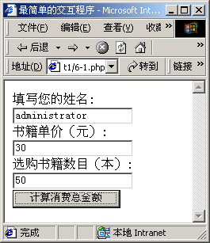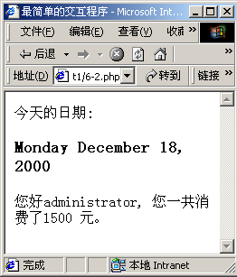
参考答案：
phpEx1_1.php
<HTML>
<HEAD>
<TITLE>最简单的交互程序</TITLE>
</HEAD>
<BODY>
<FORM ACTION=" phpEx1_2.php " METHOD="post">
填写您的姓名:
<INPUT TYPE="text" NAME="YourName"><BR>
书籍单价（元）:
<INPUT TYPE="text" NAME="CostOfOneBook"><BR>
选购书籍数目（本）:
<INPUT TYPE="text" NAME="NumbersOfDaysBuying"><BR>
<INPUT TYPE="submit" value="计算消费总金额">
</FORM>
</BODY>
</HTML>

phpEx1_2.php
<?
$Today = date("l F d, Y");
?>
<HTML>
<HEAD>
<TITLE>最简单的交互程序</TITLE>
</HEAD>
<BODY>
今天的日期:
<?
print("<H3>$Today</H3>\n");
print("您好$YourName, 您一共消费了");
print($CostOfOneBook * $NumbersOfDaysBuying);
print(" 元。<BR>\n");
?>
</BODY>
</HTML>

2.理解字符串与数字转换的程序。
程序：

<HTML>
<HEAD>
<TITLE>字符串和数字之间的转换</TITLE>
</HEAD>
<BODY>
<?
print(("1+1=").(1 + "1") . "<BR>\n");
print(("1+2=").(1 + " 2") . "<BR>\n");
print(("1+|3|=").(1 + "3extra") . "<BR>\n");
print(("1+4.5e6=").(1 + "4.5e6") . "<BR>\n");
print(("1+a7=").(1 + "a7") . "<BR>\n");
?>
</BODY>
</HTML>

- 解算术运算符
<?php
$a=8;
$b=5;
$c=$a+$b;
echo "$c<p>";
$c=$a-$b;
echo "$c<p>";
$c=$a*$b;
echo "$c<p>";
$c=$a/$b;
echo "$c<p>";
$c=$a%$b;
echo "$c<p>";
$c=++$a;
echo "$c<p>";
$c=--$a;
echo "$c<p>";
$c=$b++;
echo "$c<p>";
$c=$b--;
echo "$c<p>";
?>

- 理解赋值运算
<?php
$a=5;
echo "$a<p>";
$a+=5;
echo "$a<p>";
$a-=5;
echo "$a<p>";
$a*=5;
echo "$a<p>";
$a/=5;
echo "$a<p>";
$a%=5;
echo "$a<p>";
$a="PHP";
$a.="程序设计";
echo "$a<p>";
?>
- 求1+2+3…+100的值。
<?php
$sum=0;
$i=1;
while ($i<=100)
{
$sum=$sum+$i;
$i++;
}
echo "$sum<p>";
?>
- 算术函数
abs函数
<?php
$a=-12.3;
$b=0;
$c=23;
$a=abs($a);
$b=abs($b);
$c=abs($c);
$d=abs("12abcde12");
$e=abs("abcde");
echo "\$a=$a<p>";
echo "\$b=$b<p>";
echo "\$c=$c<p>";
echo "\$d=$d<p>";
echo "\$e=$e<p>";
?>
max函数
<?php
$a=array(12,34.5,23,100);
$b=256;
$c="134acd";
$a1=max($a);
$b1=max($b,$c);
$c1=max($b,$c,1000.5);
$d1=max($a,$b,$c);
echo "\$a1=$a1<p>";
echo "\$b1=$b1<p>";
echo "\$c1=$c1<p>";
echo "\$d1=$d1<p>";
?>
round函数
<?php
$foo1=round(3.4);
$foo2=round(3.5);
$foo3=round(3.6);
echo "round(3.4): ".$foo1."<br>\n";
echo "round(3.5): ".$foo2."<br>\n";
echo "round(3.6): ".$foo3;
?>

