**GR6613 BT chip UART to I2C update FW Function for 9706 Pen**

**日期20230322 V2**

* 新增3.1 UART TX和RX之間各CMD的執行時間 參考

1. **UART to I2C Bridge 流程說明**
2. **Bridge CMD Format**
3. **Bridge AP CMD Flow**
4. **驗證功能**
5. **UART to I2C Bridge 流程說明**

UART 0

RX

TX

GR6613

Host

UART TX

RX

Baud rate: 3000000

SIS Pen

RX

TX

UART Format

Convert to

I2C Format

I2C Format

Convert to

UART Format

I2C Master

SCK (GPIO15)

SDA(GPIO16)

Reset(GPIO4)

I2C Clock: 300KHz

Address : 0x5C

Write

Read

I2C Slave

SCK

SDA

Reset

UART 1

TX

RX

UART

RX

TX

Send set I2C Slave Message

Baud rate: 3000000

Parser GR UART TX output Header (OP code)

UART RX Done

OP code compare?

Mapping below op code (SIS CMD) to execute process:

(SISPEN_BRIDGE_INIT(Only I2C read ) ,

SISPEN_BRIDGE_I2C_W_R )

UART Date convert to I2C Write Format

Then execute I2C Write

Yes

No

I2C Write Done (ptyEventI2CWriteDone)

Is I2C status error?

Yes

No

Execute I2C Read

I2C Read Done (ptyEventI2CReadDone)

Is I2C status error?

Yes

No

I2C Read Date convert to UART RX Format

Then execute Send UART RX(ACK BE EF)

Then execute Send UART RX(NACK DEAD )

UART TX Done

Mapping below op code (Bridge CDM) to execute process:

(SISPEN_BRIDGE_HW_RESET

SISPEN_BRIDGE_DEBUG_DIS , SISPEN_BRIDGE_DEBUG_EN

SISPEN_BRIDGE_I2C_DIS_EN)

UART TX Done

Then execute Send UART RX

Parser GR UART TX output Header (OP code)

UART RX Done

OP code compare?

Yes

No

Bridge to SIS PEN AP CMD

GR Bridge AP CMD

1. **Bridge CMD Format**

**Uart TX CMD**

|  |  |  |  |  |  |  |  |  |  |
| --- | --- | --- | --- | --- | --- | --- | --- | --- | --- |
| Type | byte 0 | byte 1 | byte 2 | byte 3 | byte 4 | byte 5 | byte 6 | byte 7 | byte 8~ 64 |
| TX Output | UART CMD ID | OP Code LSB | OP Code MSB | Length field LSB | Length field MSB | Reprot ID (0x09) | CRC16 | CMD | PAYLOAD |

**I2C Write CMD**

|  |  |  |  |  |  |  |  |  |  |
| --- | --- | --- | --- | --- | --- | --- | --- | --- | --- |
| TYPE | byte 0 | byte 1 | byte 2 | byte 3 | byte 4 | byte 5 | byte 6 | byte 7 | byte 8 ~ 63 |
| OUTPUT | Output Register (LSB) | Output Register (MSB) | Length field (LSB) | Length field (MSB) | Report ID | Reserved (0x0) | CMD | CRC 16 | PAYLOAD |

GR6613 Uart header ( Byte0~4 ) ，Length = Reprot ID(byte5)+CRC16(byte6)+CMD(byte7)+PAYLOAD(byte8~64)， CRC16 = CMD + PAYLOAD

SIS Pen I2C CRC 16 = CMD + PAYLOAD ，Length = 2(Length) + 4(byte4~7) + payload

**I2C Read CMD**

|  |  |  |  |  |  |  |  |  |  |
| --- | --- | --- | --- | --- | --- | --- | --- | --- | --- |
| TYPE | byte 0 | byte 1 | byte 2 | byte 3 | byte 4 | byte 5 | byte 6 | byte 7 | byte 8 ~ 63 |
| INPUT | Length field (LSB) | Length field (MSB) | Report ID | CRC 16 | PAYLOAD | | | | |

**Uart RX CMD**

|  |  |  |  |  |  |  |  |  |  |  |
| --- | --- | --- | --- | --- | --- | --- | --- | --- | --- | --- |
| Type | byte 0 | byte 1 | byte 2 | byte 3 | byte 4 | byte 5 | byte 6 | byte 7 | byte 8 | byte 9~ 64 |
| RX Input | UART Event ID | Event OP Code | Length field LSB | Length field MSB | OP Code LSB | OP Code MSB | UART Status | Reprot ID (0x0A) | CRC16 | PAYLOAD |

GR6613 Uart header( Byte0~6 ) ，Length = OP Code LSB(byte4)+OP Code MSB(byte5)+Status(byte6)+ Rprot ID(byte7) + CRC16(byte8)+PAYLOAD(byte9~64)

CRC16 = PAYLOAD

SIS Pen I2C CRC 16 = PAYLOAD，Length = 2(Length) + 2(byte2~3) + payload

注:參考GR6613_Bridge_SiS9706_Cmd_Table_V02.xls

1. **Bridge AP CMD Flow**
2. SISPEN_BRIDGE_DEBUG_DIS (OP code 0x8005) for bridge (Update FW Start , BT will control the Pen no sleep)
3. SISPEN_BRIDGE_I2C_DIS (OP code 0x8008, CMD 0x00 I2C Disable) for bridge
4. SISPEN_BRIDGE_HW_RESET (OP code 0x8007) for bridge
5. Delay 400ms (wait for the SIS Pen I2C master to switch to slave after reset)
6. SISPEN_BRIDGE_I2C_EN (OP code 0x8008, CMD 0x01 I2C Enable) for bridge
7. SISPEN_BRIDGE_INIT (OP code 0x8001) for bridge (Check I2C transmission is normal)
8. SISPEN_BRIDGE_I2C_W_R (OP code 0x8004) for SIS Pen AP CMD
   1. 85 51 09
   2. 85 21 01
   3. 83/84/85/86 CMD
   4. 85 20 01
   5. 85 50 09
9. SISPEN_BRIDGE_I2C_DIS_EN (OP code 0x8008, CMD 0x00 I2C Disable) for bridge
10. SISPEN_BRIDGE_HW_RESET (OP code 0x8007) for bridge
11. SISPEN_BRIDGE_DEBUG_EN (OP code 0x8006) for bridge(Update FW End, BT will release control the Pen can sleep)

SISPEN_BRIDGE_DEBUG_DIS (OP code 0x8005) for bridge

Start

Is ACK (BE EF) ?

Use SISPEN_BRIDGE_I2C_W_R (OP code 0x8004) to transfer

SIS Pen AP CMD (81/82/83/84/85/86)

參考注2

Yes

No

End

SISPEN_BRIDGE_HW_RESET (OP code 0x8007) for bridge

SISPEN_BRIDGE_INIT (OP code 0x8001) for bridge

SISPEN_BRIDGE_DEBUG_EN (OP code 0x8006) for bridge

Disable GR Print(UART 0) function

Enable GR Print(UART 0) function

Update FW End, BT will release control the Pen can sleep

Use GPIO 4 to pull the signal high(10ms) to reset the SiS Pen

Initialize the I2C setting

Confirm the sis pen is ready ,using I2C Read

Pen I2C is ready ,

Can use SIS Pen AP CMD (81/82/83/84/85/86) to transfer data

Delay 400ms

Delay 10ms

SISPEN_BRIDGE_I2C_DIS (OP code 0x8008,

CMD 0x00 I2C disable)for bridge

Disable GR I2C master function

Wait for the SIS Pen I2C master to switch to slave after reset

SISPEN_BRIDGE_I2C_EN (OP code 0x8008,

CMD 0x01 I2C Enable)for bridge

Enable GR I2C master function

SISPEN_BRIDGE_I2C_DIS (OP code 0x8008,

CMD 0x00 I2C disable)for bridge

Disable GR I2C master function

SISPEN_BRIDGE_HW_RESET (OP code 0x8007) for bridge

Use GPIO 4 to pull the signal high(10ms) to reset the SiS Pen

注1: CMD 通訊保持1Write(TX) 1Read(RX)的流程，CMD之間delay time >1ms

注2: Update Pen FW Flow可以參考文件SiS_I2C_Update Firmware flow_7501說明.pptx

**3.1 UART TX和RX之間各CMD的執行時間 參考**

0x81 CMD

UART TX~RX (Time stamp A1~A2)約160ms左右

I2C W~R(Time stamp B1~B2)約159ms左右

I2C R wait to ready(Time stamp C1~C2)約157ms左右

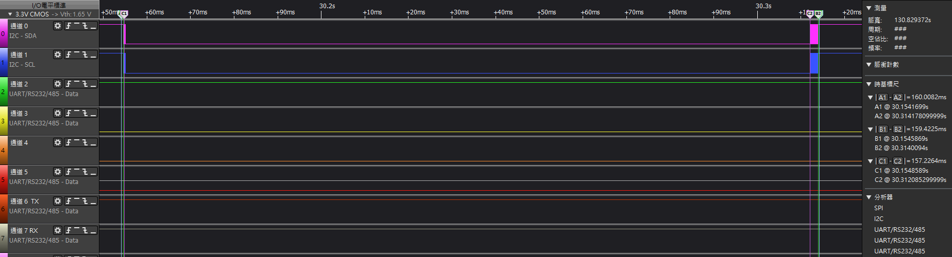

0x82 CMD

UART TX~RX (Time stamp A1~A2)約25ms

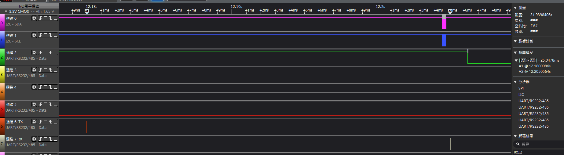

0x83CMD

UART TX~RX (Time stamp A1~A2)約8ms~9ms

I2C W~R(Time stamp B1~B2)約7ms~8ms

I2C R wait to ready(Time stamp C1~C2)約5ms~6ms

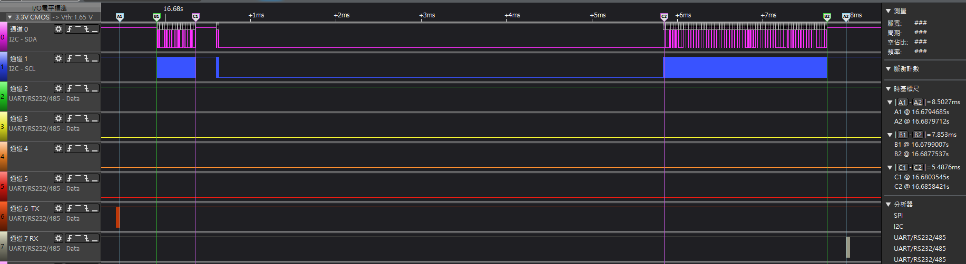

0x84 CMD

UART TX~RX (Time stamp A1~A2)約5ms~6ms

I2C W~R(Time stamp B1~B2)約4ms~5ms

I2C R wait to ready(Time stamp C1~C2)約1ms左右

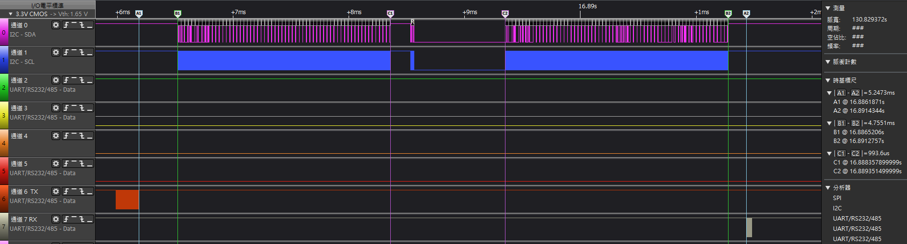

0x85 CMD

UART TX~RX (Time stamp A1~A2)約3ms左右

I2C W~R(Time stamp B1~B2)約2ms~3ms

I2C R wait to ready(Time stamp C1~C2)約0.2ms左右

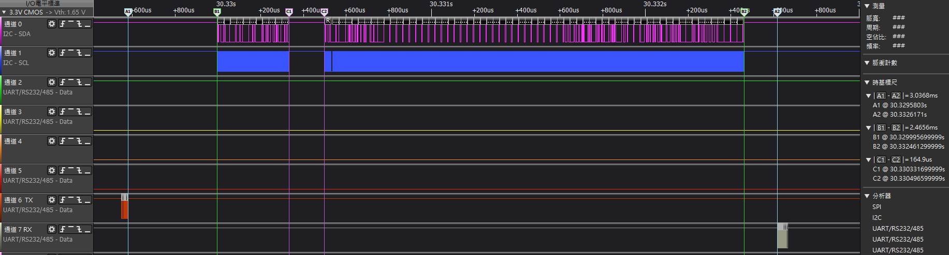

0x86 CMD

UART TX~RX (Time stamp A1~A2)約7ms~8ms

I2C W~R(Time stamp B1~B2)約6ms~7ms

I2C R wait to ready(Time stamp C1~C2)約4ms左右

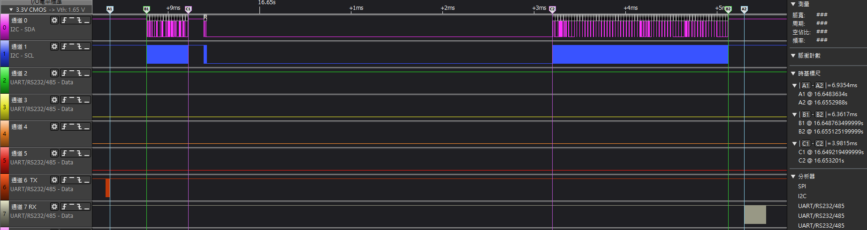

Bridge init I2C read

UART TX~RX (Time stamp A1~A2)約490ms左右

UART TX ~I2C R(Time stamp B1~B2)約477ms左右

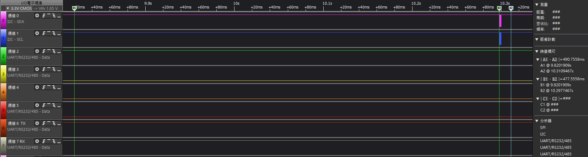

Bridge HW Reset CMD

UART TX~RX (Time stamp A1~A2)約11ms左右

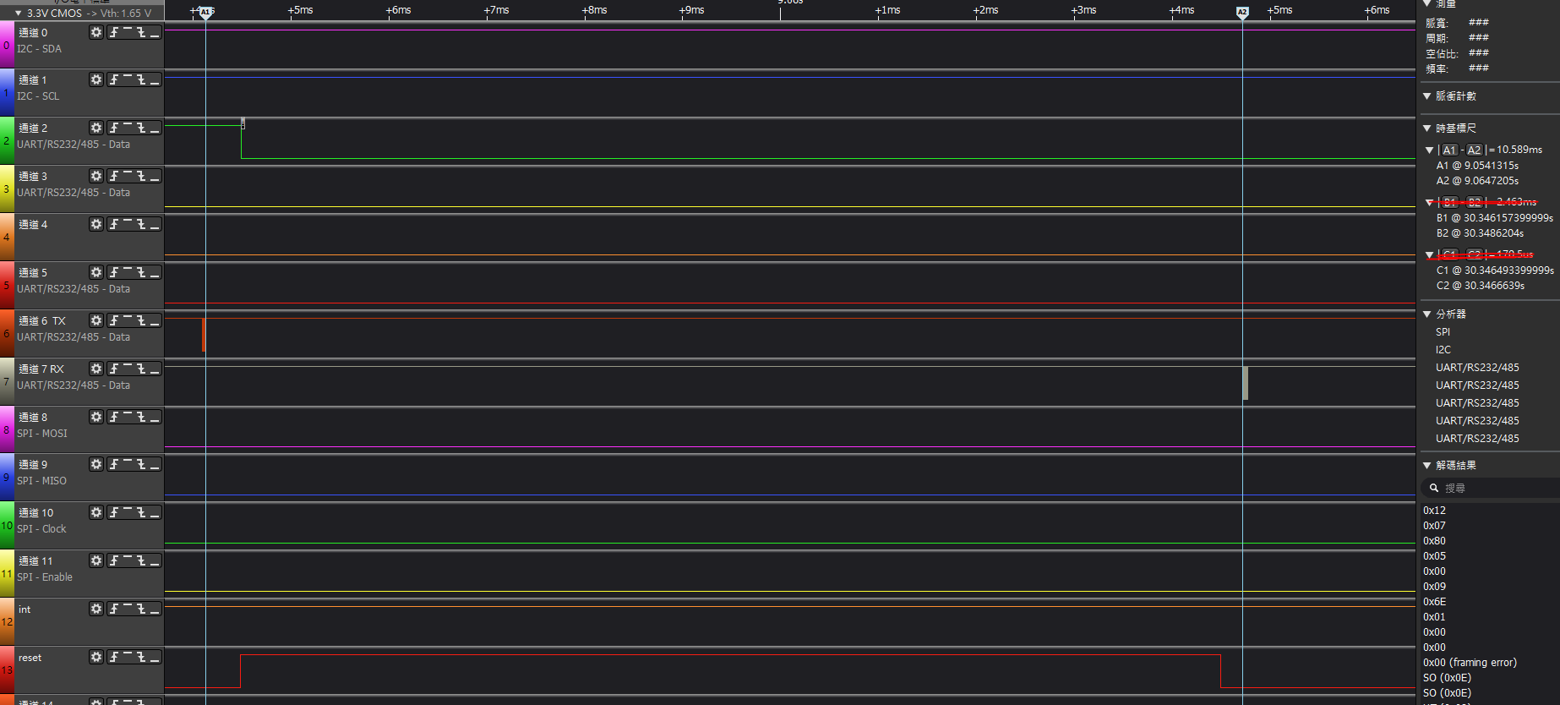

Bridge CMD

UART TX~RX (Time stamp A1~A2)約0.5ms左右

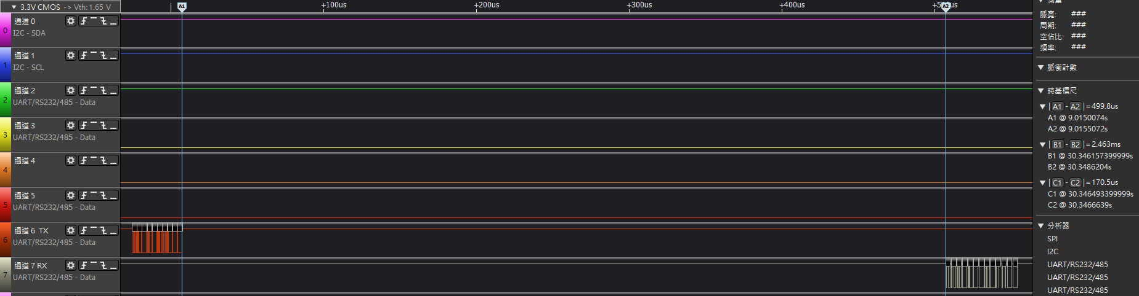

1. **驗證功能**

GR6613 + 6496C

Step1 Boot Flag clear 0x0001E000 ~ 0x0001EFFF

Step2 Burn FW bin to ROM 0x00004000 ~ 0x0001DFFF

Step3 Boot Flag Write 0x0001E000 ~ 0x0001EFFF

Step4 Compare ROM and FW bin 0x00004000 ~ 0x0001EFFF

進行驗證正常。

GR6613 + 7501

Step1 Boot Flag clear 0x0001E000 ~ 0x0001EFFF

Step2 Burn FW bin(4Kbyte) to ROM 0x00004000 ~ 0x0001DFFF

/ Burn FW bin(8Kbyte) to ROM 0x00004000 ~ 0x0001DFFF

Step3 Boot Flag Write 0x0001E000 ~ 0x0001EFFF

Step4 Read ROM data and compare with FW bin 0x00004000 ~ 0x0001EFFF

進行驗證正常。

1. GR6613 BT FW:

新增UART to I2C bridge function:

* + 1. 看相關文件，環境設定，build code & download FW (一個星期內)
    2. 熟悉目前GR6613 code base (二個星期)
    3. Study Free RTOS document (1個月)
    4. 新增Uart Task code :包含Task init/create/delete/manage, data sync, message queue (0.5個月)
    5. 新增I2C Task code: 包含Task init/create/delete/manage, data sync, message queue (0.5個月)
    6. 整合Uart to I2C bridge功能和AP CMD format convert (2個禮拜)
    7. 測試Uart to I2C bridge功能和debug (1個禮拜)

1. 看相關文件，環境設定，build code & download FW (一個星期內)
2. 熟悉目前GR6613 code base和看GR6613 user guide I2C/UART/Program guide (二個星期)
3. 使用Uart API set 去組合實現UART傳輸功能 (二個星期01/20~02/03)

使用UART0時，要把debug print（資料加密）功能關閉，不然透過UART 0的資料都會被加密和混成一起，和一直收到Debug message，開需求Disable debug print 功能的API，GR說目前沒有這個功能，有提出是否可以新增。Gr6613有設定沒有接電池就power off 功能，造成沒有UART功能。

1. 定義UART CMD Format (二天02/01~02/02)
2. 使用I2C API set 去組合實現I2C傳輸功能 (二個星期02/03~02/17)
3. 整合Uart to I2C bridge功能和AP CMD format convert (二個星期02/24~03/10)
4. 測試Uart to I2C bridge功能和debug (一個星期03/10~03/17)

Free RTOS章節 :

1. Free RTOS基礎認識
2. Task (init Task, Task Create & delete, Task priority)
3. Task manage(task delay/suspend/resume)
4. Task notify / Message queue / Event
5. Mutex / semaphore
6. 使用AP tool + GR6613 + 9706 Pen平台進行 update FW測試