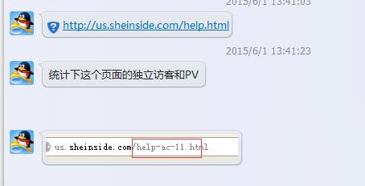
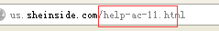
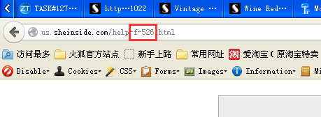
select dt,count(distinct cookie_id),count(1) pv_all from dw_sheinside_fact_log_detail where dt >= '20150527' and dt <=20150601 and site_from = 'us'
and request_body rlike'^/help-[a-z]+-[0-9]+.*' and request_type = 'GET' group by dt;

