

**PROGRAMMATION AVANCÉE ET ALGORITHMIQUE**

*-Travaux Pratique 7-*

***Réalisé par :***

Chao PAN

***Encadrée par :***

M. Renaud Marlet et M. Pascal Monasse

***Novembre 2019***

TP7

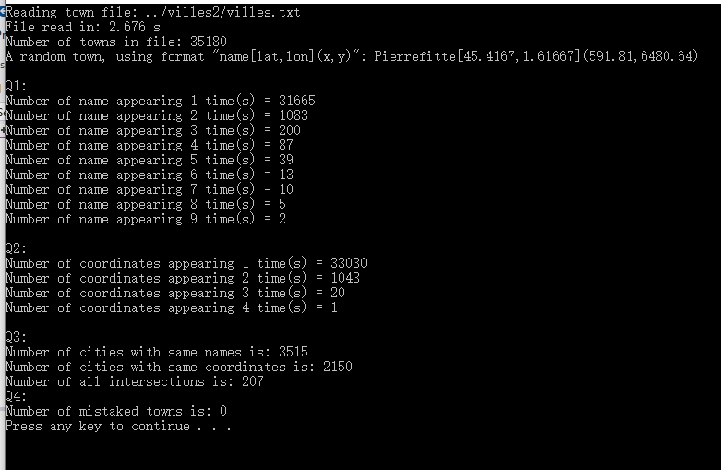

1.

Number of names appearing 1 time = 31665

Number of names appearing 2 times = 1083

Number of names appearing 3 times = 200

Number of names appearing 4 times = 87

Number of names appearing 5 times = 39

Number of names appearing 6 times = 13

Number of names appearing 7 times = 10

Number of names appearing 8 times = 5

Number of names appearing 9 times = 2

2.

Number of coordinates appearing 1 time = 33030

Number of coordinates appearing 2 times = 1043

Number of coordinates appearing 3 times = 20

Number of coordinates appearing 4 times = 1

3.

The number of cities with same names is: 3515

The number of cities with same coordinates is: 2150

The number of all intersections is: 207

4.

On ne se trompe pas en entendant parler d’une ville A toute proche d’une ville B, parce qu’il n’y a pas d’ambiguïtés sur là-bas.

.

5.

En comparant à l'approche naïve, c’est efficace de uniquement chercher dans l’ensemble d’intersection de question 3. De plus, sa complexité est 2074.