Review on Intelligent Spectacles to Prevent Road Accident

|  |  |  |
| --- | --- | --- |
| Madhuri Pal1  [madhuridec09@gmail.com](mailto:madhuridec09@gmail.com)  *Professor, Department of Computer Science and Engineering*  *J D College of Engineering and Management, Nagpur, India* | Sagar Kadwe2  [skadwe9@gmail.com](mailto:skadwe9@gmail.com)  *Student, Department of Computer Science and Engineering*  *J D College of Engineering and Management, Nagpur, India* | Nakul Gopal3  [nakulgopal13@gmail.com](mailto:nakulgopal13@gmail.com)  *Student, Department of Computer Science and Engineering*  *J D College of Engineering and Management, Nagpur, India* |
| Tejas Jaiswal4  [tejasjaiswal972@gmail.com](mailto:tejasjaiswal972@gmail.com)  *Student, Department of Computer Science and Engineering*  *J D College of Engineering and Management, Nagpur, India* | Mithun Chide5  mithunchide03[@gmail.com](mailto:harshalbhoyar830@gmail.com)  *Student, Department of Computer Science and Engineering*  *J D College of Engineering and Management, Nagpur, India* | Yash Paunikar6  [yashpaunikar474@gmail.com](mailto:yashpaunikar474@gmail.com)  *Student, Department of Computer Science and Engineering*  *J D College of Engineering and Management, Nagpur, India* |

***Abstract*— To overcome the problem of writing code efficiently the {NAME} is designed. The {NAME} uses deep learning approach known as Natural Language Processing. Which is used to learn and generate the code snippets from natural language description. The model will enable a developer to write efficiently just by providing the description in natural language (English). This paper describes the different techniques adopted in this era of AI. Additionally, it includes the objective, the scope of advancement and the approach for implementation for reducing developer’s efforts. {NAME} is a machine learning model that provide source code for given problem statements by using self-attention based transformer architecture. Although we didn’t aim to achieve 100% accuracy because the natural language is very ambiguous and has very rich set of vocabulary. One such approach can give rise new era of development. We are proposing a potential research direction of creating a model by combining various inputs.**

Keywords— Augmented reality, Field of Vision, Intelligent Spectacles

# Introduction

With our developing technologies, there must be digitalization necessary. Digitalization is mostly done for time consumption and faster development. The developing intelligent spectacles can be one of the approaches towards digitalization. The spectacles that we use for protecting our eyes can be used differently. In today’s world human wants everything digitalized. That is not because humans are lazy, but it has become a need for everyday life. Digitalization is not only reducing the efforts of humans but also giving the possibilities for the future. All the objects that we see in our daily life are mostly digital, for example, some objects like watches, refrigerators, pens, the lightning system at home, etc. All the objects that we use in our daily lives are getting digital, which is necessary too. Then why don’t we digitalize the spectacles that we can wear not only for protection and fashion but also for more productive and efficient use?

In the beginning, spectacles were normally used to prevent strain on eyes due to sun rays and lights with high intensity. Some spectacles were being used only for fashion while some were to fulfill the purpose of clear vision. With the developing technologies, the digitalization has taken place. The idea for digitalizing the spectacles is not coined today, it is already under development in big companies like Google. Many of the features were introduced in the working of spectacles like time and weather display, voice assistant, etc. are few approaches towards its implementation.

Among such intelligent spectacles, Google Glass is the best example that resembles the advancements in digitalization of the glass. It was introduced in the year 2012, with many innovative features. It is one of the optical head-mounted display device boards on the wearable technology also called the project glass for the other development of the feature, the google collaborated with Luxottica. In 2014 Nepal government adopted google glass for tackling poachers of wild animals and herbs. As the days passed, many more features added. Now, it provides Wi-Fi, Bluetooth, micro USB connectivity, and storage capability. Because of these, it can be now used for messaging, capturing images and processing information also. Other features are voice assistance, google search, navigation, object detection, and image manipulation. It will provide the navigation to the user by synchronization with the google map, by producing the image output on the screen. It can be used for traveling purposes and can also detect objects, as well as gestures. It can accept voice input via microphone for various operations like calling and navigation. It can also provide information regarding the medical, sports, health care, industry, education, construction, and cultural fields. Other than these, there is a scope for more advancement in Google Glass. There are certain situations, where using smartphones can be inconvenient. One such situation can be accessing a smartphone while driving. As it is a wearable device, so there should be no need to think about how to handle it.

People need Google Glass because of many aspects. Some of the aspects are listed below:

* Google Glass can capture images and videos by simply saying, “OK Google, record a video.” It will take the images and video. The advantage is that we can never miss the moment.
* Google Glass provides a search engine that relies on Wi-Fi or any Smartphone data connectivity.
* It provides step-by-step navigation by displaying direction right in the user's field of vision.
* It also provides text translation for translating the text dynamically.
* It supports both voice calls and video chats, including messaging and e-mails.

Nowadays, road accident rates of automobiles are increasing due to various reasons. After a thorough study, we found that most of the road accident is happening because of the absence of enough light or in some cases the excess light. We have also found that some accidents occurred due to the highly intensified light of motile automobile, over speeding, wrong side driving, tail gaiting, etc. Keeping all this in mind, we are preparing model with all such advanced features majorly focusing on avoiding such life-threatening road accidents. To process the information from the user's field of vision, image recognition and object detection will be used. There have been many good frameworks developed for object detection. Retinanet is one such framework that uses the concept of Focal Loss Function. As the target dataset including pedestrians, potholes, night vision etc. is not available, we will have to manually collect the different datasets to form one. There is a chance that the dataset will be biased, to avoid the replications of biasedness, Retinanet framework will be useful. Because Retinanet framework uses the Focal Loss function for avoiding biased results. Other frameworks lie YONO uses the Cross Entropy function which is a classification function used for classifying the dataset objects.

# Awareness

In this Digital Era, many of the digital devices have been developed. At the time throughout the day, we were using electronic appliances as it became part of our daily life but still, we were unaware of many such devices. Some of the common devices we are familiar with are Digital Watches, Video Games, Smartphones, etc. that we use regularly in our daily life. As the world is moving in a digital era, all the technical appliances are being developed which saves time, reduces efforts and makes work easy. Using Video Games children can entertain themselves whereas smartphones which are the electronic handheld devices made life easier. People purchase many products but are unaware of features included in that because only some of the features are used by them. The technical world is progressing fast and normal people are unaware of all these technologies and rely on traditional methods. The majority of problems encountered are because of interacting usage. Many devices which are useful in certain cases are difficult to interact with. Any online portal forms a new and environment for common and new user. It is true in almost every case. The product needs not only to be efficient but also should provide an easy and simplistic interactive environment for the end-user. The development pace is increasing rapidly, and a lot of the products are being developed but because of unawareness many of them are failing to sustain in the market and being unsuccessful.

One of the products is Google Glass. It is very popular because of its advanced features and adopted by most of the countries. Their features are so advanced & cost price is so high that the Glasses can only be used by economy class. Whereas in a country like India, such an economy class is hard to find and it is the main reason, such technology is not spreading far. Moreover, people can use Smartphones rather than using smart glasses which are more useful than glasses. Some of the major areas which use the technology of google glass are industry, medical field, the business sector where time is highly valued. Till 2018, 21 million units of google glasses were expected to sold as forecasted by Google. The statistics have not been disclosed yet by Google though. Looking at the current market scenario, it is hard to even say that Google may have achieved the forecasted goal.

Most of the people are unaware of:

* Many devices are in development but are not as handy as Google Glass
* Google glass supports the trend towards the passive consumption of content and technologies that fulfil the people's need
* It gives immediate notification to people regarding search operations and other Google services
* Almost all of the Google Glass features are available in smartphones, but it cannot be used every time and everywhere
* Google Glass has the features to get reservations, appointments, the reminders for important dates and events

Google is the first to move towards the digitalization of spectacles. Many products have been developed and some are still in development. Many have features which are difficult to handle in certain conditions like while driving, it can be dangerous to use smartphones. In digitalization, one of the approaches to solve similar problems is to use a head-mounted wearable device, so it can be easily accessible without having any problem. All that being said, after our research, we found that this technology can be really useful in avoiding road accidents if it is implemented the right way. To overcome this, we are preparing a module to overcome the problems that occurs in already developed modules.

# Objectives

Spectacles are developed with many more advanced technologies. Having an interest in digitalization we are planning to develop intelligent spectacles with the following objectives in mind:

* + To reduce the road accidents because of intensified headlights and unclear vision at night
  + To provide voice assistance for navigation and image processing
  + To provide uncertain potholes, speed breakers and pedestrian detections
  + To keep the product development feasible

# Tools and data collection

When the google glass was introduced, it had very few and specific features. But after further development, the smart glasses first appeared in the year 2002 by Google brought various possibilities in this area. With developing technology, there came many possibilities for advancements. The features like below can be improved with the aid of new technologies as well.

1. Image Recognition & Object Detection:- In the field of Image Recognition, development is still undergoing to improve efficiency. Many novel algorithms have been developed. There are many applications of object detection and image recognition like security or information gain.
2. Voice Assistance:- Google glass has the feature of a voice assistant. For the best accuracy and recognition, the voice commands are carefully turned and designed. This improves interaction with a product.
3. Navigation:- Google Glass provides the navigation feature also for travelers and presents directions on the display in front of the glass frame. It can be used at the time of traveling when directions for destination are unknown. Navigation can be provided by the reference of google map.
4. Google Search:- It also provides the search engine which operates with voice and works on the internet.

# Research methodolgy

The intelligent spectacle will be used to prevent road accidents. The time delay must be avoided. The major problems are the high processor usage for efficiency and keeping the expenditure nominal. Other than these two, heavy processor usage will cause major battery drain and the storage requirement will be also high. APIs are usable in this case to move data between cloud and spectacle. The cloud also brings the possibility of high GPUs. Many cloud services provide environments with high GPUs. APIs will speed up the data transfer process. Both these techniques are heavily used today in various applications. It will also resolve the problem of battery drainage.

# Process description

As the spectacle is going to be used while driving, the entire process must be efficient. The product will work on various models to facilitate the user with various helpful features. The voice command from the user will act as an input which in turn will trigger the specific model to commence working on that input. Then the output will be produced and will be dictated to the user. There are various algorithms developed for object detection, speech recognition. Our major objective is to train one of these algorithms as per our product’s requirement, using various data analysis techniques like feature extraction and data preprocessing. Most of the Machine Learning models need a high GPU requirement for smooth and fast processing. Various cloud services provide the environment with high GPUs. The Cloud Service Platforms like IBM Watson, Amazon Sagemaker, etc are mostly used for such tasks. Using this service in our spectacle will demand the prime need for High-Speed Internet Connectivity.

# Algorithm

## Training/Development Phase

Select Necessary and Efficient Models

Train the models on High GPU Environment

Deploy the trained models on embedded system directly OR Deploy the trained models on server & access via REST API on embedded system

## After Training/Deployment of Models Phase

READ(voice_input)

Fuction1(voice_input){

Process the voice input on GMM/HMM and fetch the text data

return voice_text

end

}

Function2(voice_text){

Switch(voice_text):

Case objectDetection:

Run model for Object Detection

Case nightVision:

Run model for Night Vision

Case navigation:

Run model for Navigation

Case notificationsAndUpdates:

Run model for Weather Updates and Mobile Notifications

}

Function3(output){

Process the output and present it in form of voice

return voice_output

}

The entire process is divided into 2 phases. The training phase will include the data collection, its analysis, models implementation, their training and deployment. The later phase is the part of deployment process which presents how the user will access the trained models based on various inputs and commands.

If ‘m’ is average time assumed for generating output by each model

In worst case the time complexity would be O(3m + 4).

In best case it would be Ω(3m + 1).

# Mathematical model

The model is going to use RetinaNet framework whose mathematical working is explained. The inputs, weights, nodes and outputs form a neural network.

Most basic neural model would look like:

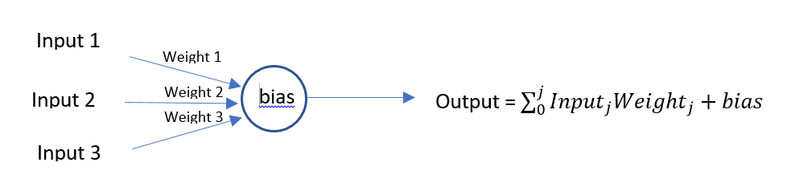

RetinaNet introduced the Focal Loss Function for improvement in Object Detection Algorithm. This Focal Loss Function is used over Cross Entropy Function. It is given by:

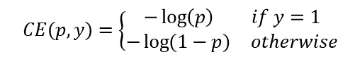[2]

Simplified as:

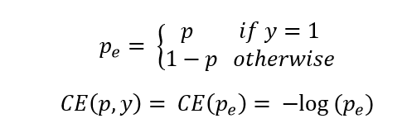 [2]

Where (p,y) is the set of probability ‘p’ of predicted class ‘y’

Most of the time in Machine Learning, the datasets we have are imbalanced. To generate an unbiased result, it is important for the datasets to be unbiased.

For example:

We have a dataset including 10000 images of cars, 10 images of bikes

Such dataset is biased towards cars and may not give accurate predictions.

To balance the datasets, we can either increase the weights of classes present in minority or lower the weights of classes present in majority. The Focal Loss Function uses the later one.

C:\Users\Avinash Barve\AppData\Local\Microsoft\Windows\INetCache\Content.MSO\34D7BD64.tmp

Where γ is the weighing parameter used for balancing.

# Working Model

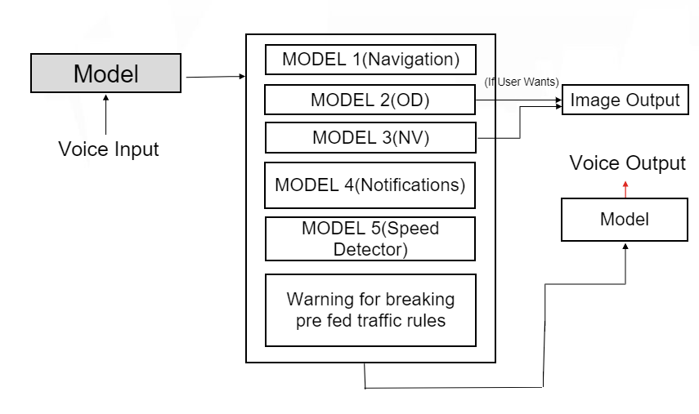

Figure 1

# Working Model Explaination

The voice command will be fetched from user using speech recognition which will trigger one of the listed models. The first model is for providing navigation instructions to user whereas second model is for object detection model which will help in detection of potholes, pedestrians, breakers, and vehicles. Model 3 will be trained for night vision and Model 4 for fetching notifications from user mobile. Model 5 will get triggered if the user exceeds the speed limit and the last one will warn before breaking any traffic rules.

# Future scope & Conclusion

Google Glass has many possibilities for future development. It can be implemented for a specific area or field. The intelligent spectacle is a futuristic device. Finding a generic solution for any query is one of the possibilities. The problems of battery consumption, high processing can be resolved with the development of upcoming technologies. Many algorithms are still being improved to increase efficiency, which can greatly help in forming an ideal product. The deployment of this product will be very helpful for people who drives daily. It has the potential to reduce the road accident rate.

# References

1. Yingfeng Cai, Xiaoqiang Sun, Hai Wang, Long Chen, and Haobin Jian, Night-Time Vehicle Detection Algorithm Based on Visual Saliency and Deep Learning
2. Tsung-Yi Lin, Priya Goyal, Ross Girshick, Kaiming He, Piotr Dollar, Focal Loss for Dense Object Detection, 2018
3. Tsung-Yi Lin, Priya Goyal, Ross Girshick, Kaiming He, Piotr Dollar.et al. Feature Pyramid networks for Object Detection, 2017
4. S Harsha, G Bhavya, *Google Glass*, International Journal of Advance Research, Ideas, And Innovations in Technology, (Volume: 4, Issue: 3, 2018)
5. Jufisan Boksha, Asoke Nath. Scope and Challenges in Smart Glasses: A comprehensive study on present scenario International Journal of Computer Sciences and Engineering, (Volume: 7, Issue: 1, Jan. 2019)
6. Umair Rehman and Shi Cao, Expanded Reality-Based Indoor Navigation: A Comparative Analysis of Handheld Devices versus Google Glass*,* IEEE Transactions on Human Machine Systems (Volume: 47, Issue: 1, Feb. 2017)
7. Pooja S. Mankar, Propelled innovation google glass, International Research Journal of Engineering and Technology( Volume: 02, Issue: 01, March 2015 )
8. Lukas Neumann, Michelle Karg, Shanshan Zhang, Christian Scharfenberger et al. Nightowls: A pedestriansat Night Dataset
9. Shie Mannor, Dori Peleg, Reuven Rubinstein, The Cross Entropy method for Classification Machine Learning, Proceedings of the Twenty-Second International Conference (ICML 2005)