Tool Installation and Setup Instructions

AADL Architecture Models for UxAS

Contents

Installing and Working with Git 1

Checkout the Architecture Branch of OpenUxAS 2

Open the Most Recent Installation and Setup Instructions 2

Install Java 2

Install OSATE and Select a Workspace 3

Install Agree, Resolute, and the Z3 Plugin from the Update Site 4

Check Tool Versions Installed 9

Set OSATE Preferences for AGREE 10

Import the UxAS AADL Project 11

(Optional) Create a Sandbox AADL Project 13

# Installing and Working with Git

If you are new to git, a noteable difference from other version control tools like Subversion is that with git you have both a local repository (that only you can see) and a global repository (that everyone in the group can see).

Here are some references for installing git and working with a git repository:

* Git Installation instructions: <https://git-scm.com/book/en/v2/Getting-Started-Installing-Git>
* Git Cheat Sheet: <https://services.github.com/on-demand/downloads/github-git-cheat-sheet.pdf>
* Git Online Documentation: <https://git-scm.com/doc>

The most commonly used commands are:

* git pull (update your local repository)
* git status (compare the status of your working directory to your local repository)
* git add –A (add all your new files to your local repository)
* git commit –a –m “[descriptive message]” (commit all your changes to your local repository)
* git push (push your changes to the global repository—now others can see your changes when they do a pull)

Mantra: “Pull before you push.” This will save you some headaches.

# Checkout the Architecture Branch of OpenUxAS

If you haven’t already done so, first clone the OpenUxAS repository. (You will need to have git installed.)

$ git clone <https://github.com/afrl-rq/OpenUxAS.git>

Next, change to the OpenUxAS directory.

$ cd OpenUxAS/

Then checkout the architecture branch.

$ git checkout architecture

You should see the following message:

Switched to a new branch 'architecture'

Branch architecture set up to track remote branch architecture from origin.

# Open the Most Recent Installation and Setup Instructions

If you opened this document from an up-to-date architecture branch of the OpenUxAS repository, you already have the latest version of the instructions and can skip this section.

If you received this document through some other means (email, Slack, etc.), you should now open the “Tool_Installation_and_Setup_Instructions.docx” document in OpenUxAS/AADL_project/doc to view the latest version of this document.

# Install Java

If you do not have Java 8 or higher installed, download it from the Oracle download site <http://www.oracle.com/technetwork/java/javase/downloads/jre8-downloads-2133155.html>

On a Windows 64-bit machine you will need the 64-bit version of the Java Runtime Environment (JRE).

To check your installation, open a command window and type "java -version" at the command prompt. You should see java version “1.8.0_xx” being displayed, similar to the following figure:

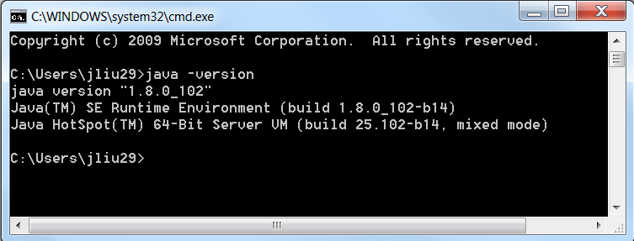

# Install OSATE and Select a Workspace

OSATE 2 is an open-source tool platform to support AADL v2. Download the appropriate OSATE 2.2.2 zip file for your machine from <http://aadl.info/aadl/osate/stable/2.2.2/products/>[1][2].

**On Windows:** Extract the OSATE zip file to a location of your choice. (I put it on my C drive.) Then run osate.exe. (You may wish to pin this item to your start menu.)

**On Ubuntu:** Extract the OSATE tar.gz file to a location of your choice (e.g., try: mkdir -p ~/osate2-2.2.2 && tar -xvzf osate2-2.2.2-vfinal-linux.gtk.x86_64.tar.gz -C ~/osate2-2.2.2 ).

**\*\* Extra step required for Ubuntu 16.04 **:** Apply a fix to osate.ini first before loading osate (there’s an eclipse-Ubuntu 16.04 incompatibility that prevents the GUI interface from updating properly and won’t allow you to do plugin install, otherwise). The two new lines set the correct GTK version for eclipse to use (“--launcher.GTK_version” and “2”). Your updated file should look like:

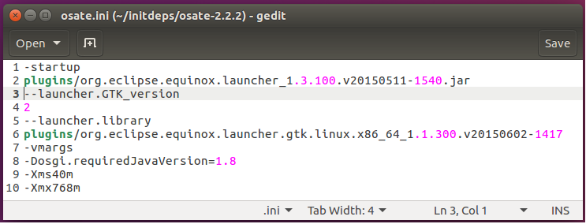

***NEW!!!***

Then run osate ( cd /path/to/my/extracted/files && ./osate ).

**Once the (modified eclipse instance) “AADL - OSATE2” has loaded:** You will be asked to choose a workspace. You can choose an existing workspace or create a new one by providing a location and name.

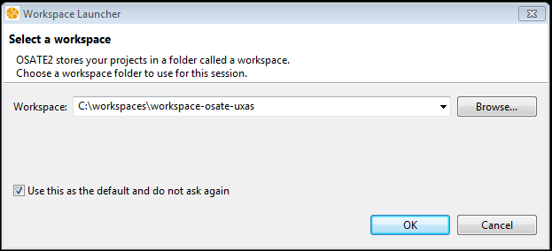

# Install Agree, Resolute, and the Z3 Plugin from the Update Site

**Note:** Versions of AGREE and Resolute come packaged with OSATE 2.2.2; but to get some important bug fixes, you will need to get more recent versions from the update site by following the instructions in this section. The Z3 plugin does not come packaged with OSATE, but it is available via the update site as well.[3]

First uninstall the AGREE and Resolute that come with the OSATE installation, by clicking “Help” -> “Installation Details”, and select “Agree” and “Resolute” from the list of installed software, and click “Uninstall…”.

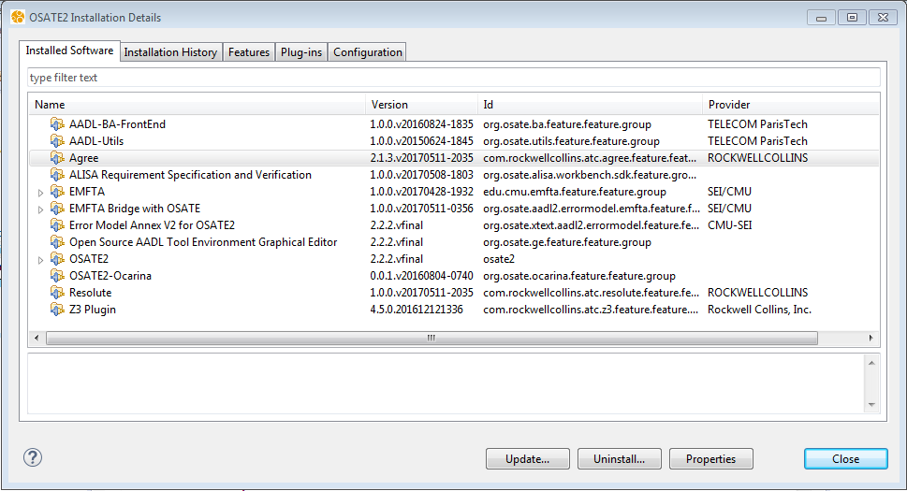

In the Uninstall Details window, confirm to uninstall Agree and Resolute by clicking “Finish”, and click “No” when it prompts to restart OSATE.

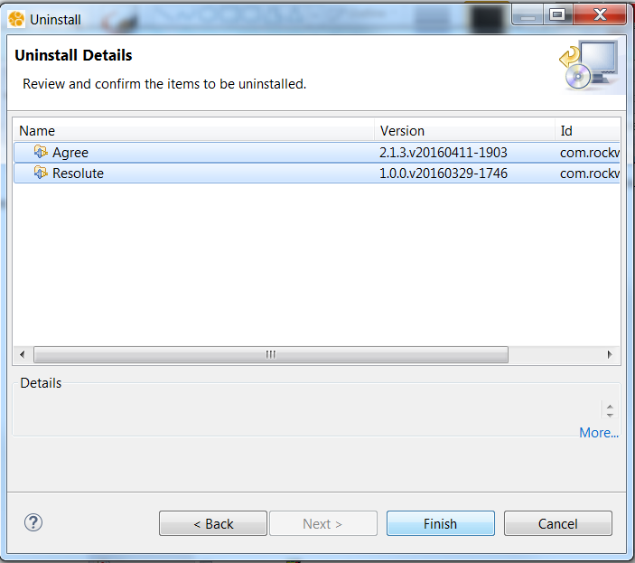

Then in OSATE, click “Help” menu and select “Install New Software…”

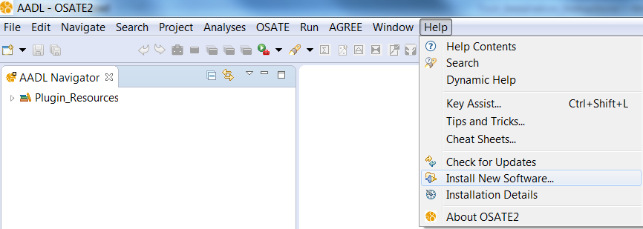

In the Install window, place the following update site link into the “Work with” field, and hit the enter key:

<https://raw.githubusercontent.com/smaccm/update-site/master/site.xml>

If you have trouble, you may need to run OSATE as administrator, or check your PC’s proxy settings in Internet Explorer.

From the drop-down menu under SMACCM, select “Agree,” “Resolute,” and “Z3 Plugin” and click “Next”. Note: If you already have the latest version of one or more of these plugins, it will not appear in the drop-down menu by default. In that case, you don’t need to install those plug-ins.

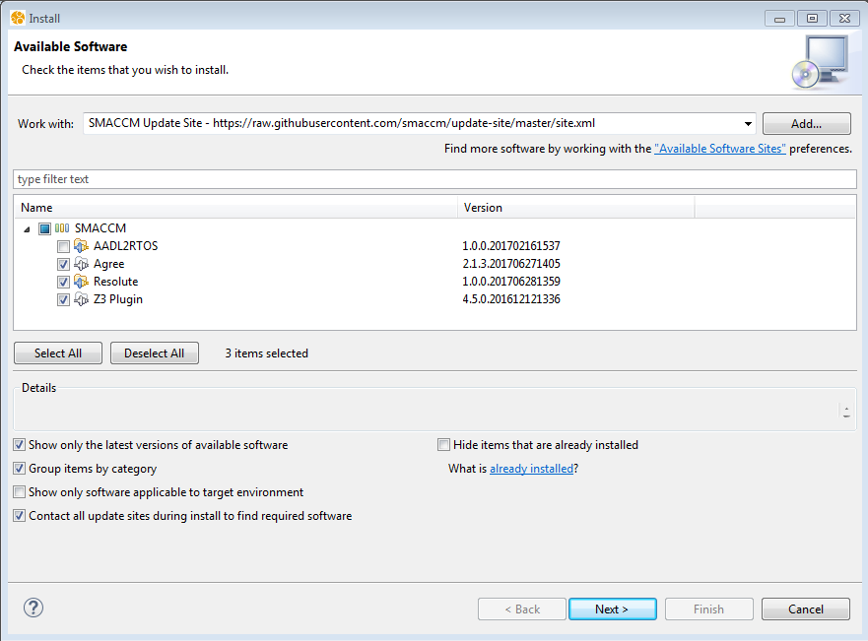

Click “Next>” again when prompted.

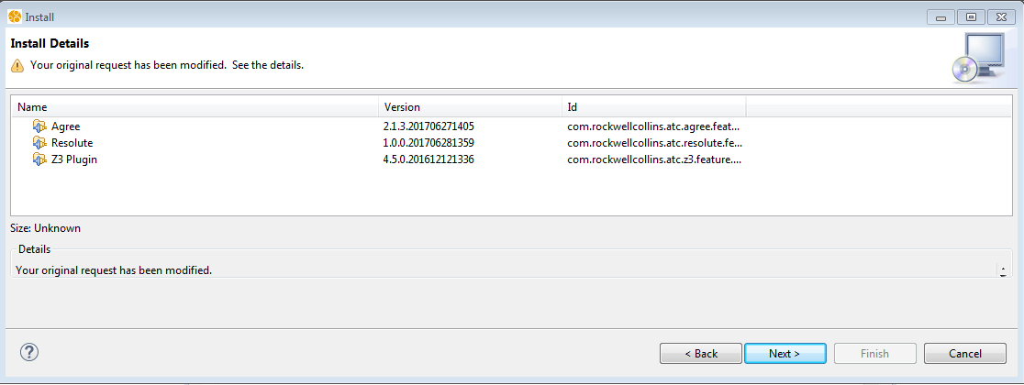

Accept the terms of license agreement for the tools, and click “Finish.”

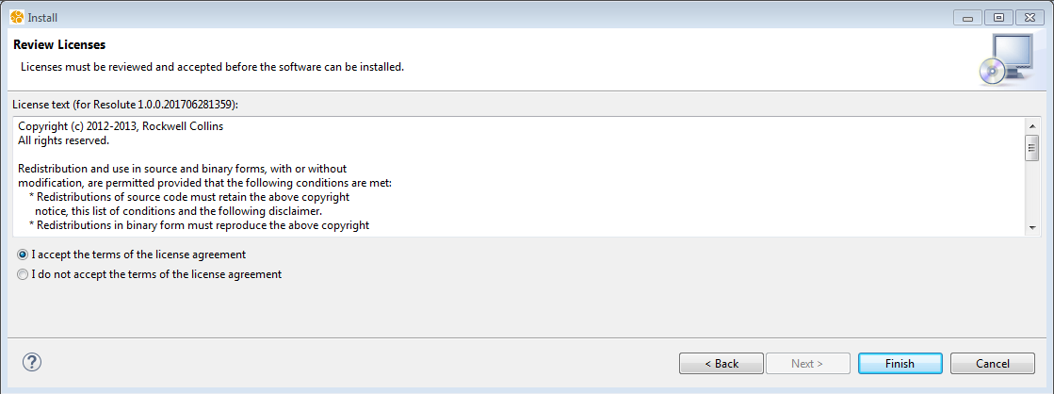

Click “OK” on the Security Warning window about unsigned content, then click “Yes” to restart OSATE.

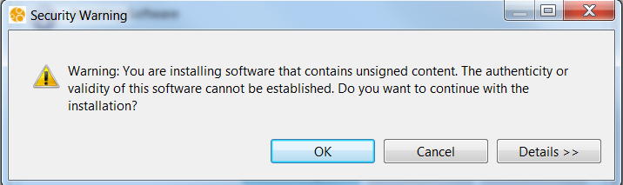

# Check Tool Versions Installed

To view the plug-ins that are installed, select the “Help” -> “Installation Details” from the menu. The list should look similar to the following figure, with the same or more recent version numbers:

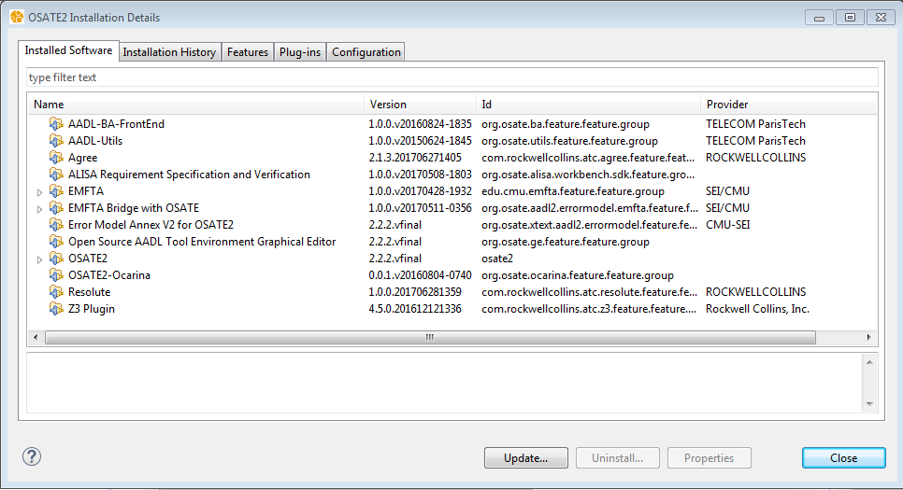

# Set OSATE Preferences for AGREE

In OSATE, select Window -> Preferences -> Agree -> Analysis. In the Analysis panel, the analysis settings should have JKind as the Model Checker Setting. For SMT Solver, select “Z3”. For the “Maximum Number of PDR Instances,” specify "2" if you have more than four cores on your PC, otherwise specify "1."[4] Finally, uncheck “Generate inductive counterexamples.”[5]

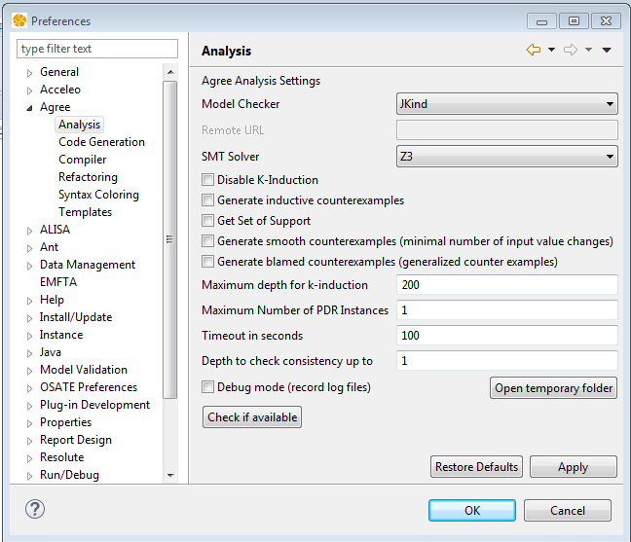

# Import the UxAS AADL Project

In OSATE, go to File -> Import. Select General -> Existing Projects into Workspace. Click “Next >”.

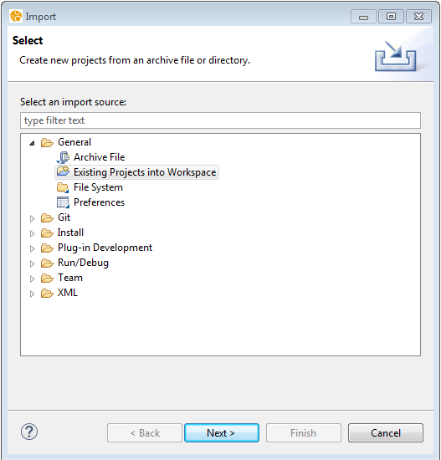

Browse to the AADL_Project directory under the OpenUxAS folder on the architecture branch of the OpenUxAS git repository. Select “UxAS” and click “Finish.”

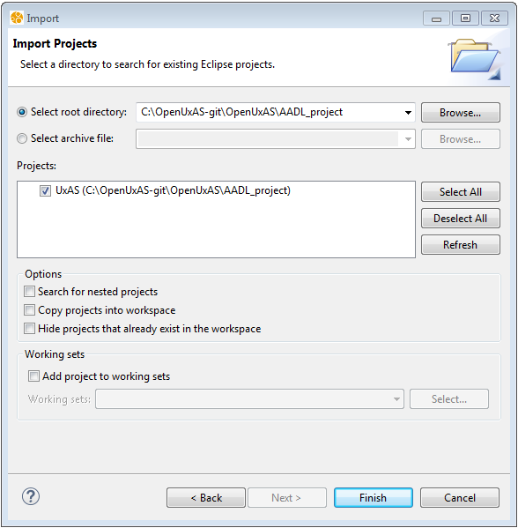

You should now see the UxAS project under the AADL Navigator window on the left-hand-side of OSATE.

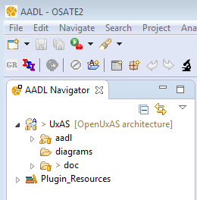

# (Optional) Create a Sandbox AADL Project

If you wish to create your own AADL project to try out an idea under version control without modifying the team’s main AADL project, you can do so in the AADL_sandbox_projects directory. These instructions walk you through how to do that.

Go to File -> New -> Project in the OSATE menu. Select AADL -> AADL Project and click Next>.

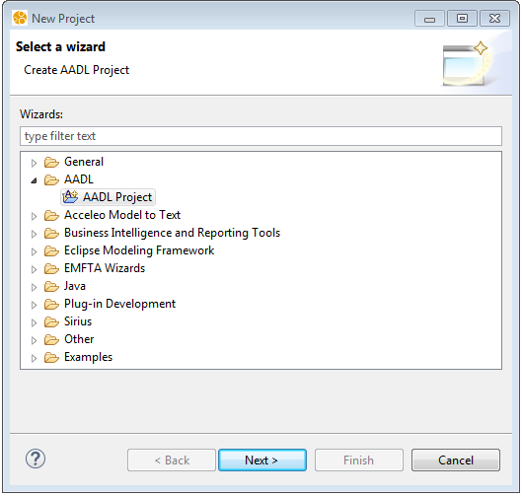

Give your project a name and update the location to be a **new subfolder** under AADL_sandbox_projects, as shown below. For convenience, the new subfolder name can match your new project name. Click “Finish.”

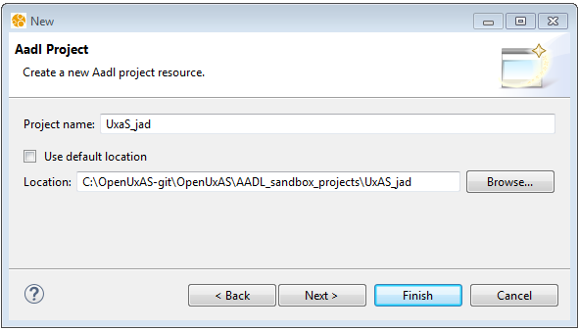

Your new project should now appear in the AADL Navigator window.

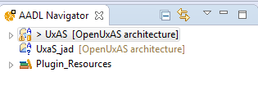

If you want to copy the contents of the main AADL project into your sandbox project, I recommend doing so via Windows Explorer or the command line rather than from inside OSATE. (I got an error when I tried to copy and paste the aadl folder from the main project to my sandbox project.) Note: You don’t want to copy over the instances subfolders. If you do, errors will follow until you delete and regenerate those instance files.

Now you are free to create and make drastic changes in your own sandbox project!

Don’t forget to add, commit, and push your sandbox project to git so that it is under version control!

1. Note: OSATE 2.2.2 is the latest stable release as of May 18, 2017. Additional stable versions of OSATE are available here: <http://aadl.info/aadl/osate/stable/>.
2. Alternatively, if you already have OSATE 2 installed but want to update to the latest nightly build, click “Help” -> “Install New Software …”. In the Install window, place the following update site link for OSATE to the “Work with” field, and hit the enter key: <http://aadl.info/aadl/osate/testing/update-site/>. Select OSATE2 in the list and any features the installation program recommends as necessary. Accept the terms of license agreement for the tools, click “Finish”, and click “OK” on the Security Warning window about unsigned content, then click “Yes” to restart OSATE.
3. Alternatively, if you wish, you can download Z3 directly from <https://github.com/Z3Prover/z3/releases> and put it on your path.
4. Note: Setting the number of PDR instances to the higher number allows coming up with better lemmas to prove properties, thus enabling giving definite answers (valid/invalid) for some properties with previously unknown verification results. However, this can make the verification run slower.
5. Unchecking “Generate inductive counterexamples” will save analysis time. It can easily be turned back on if and when you wish to use them. (This is an advanced user feature.)