**Creation of Redshift cluster**

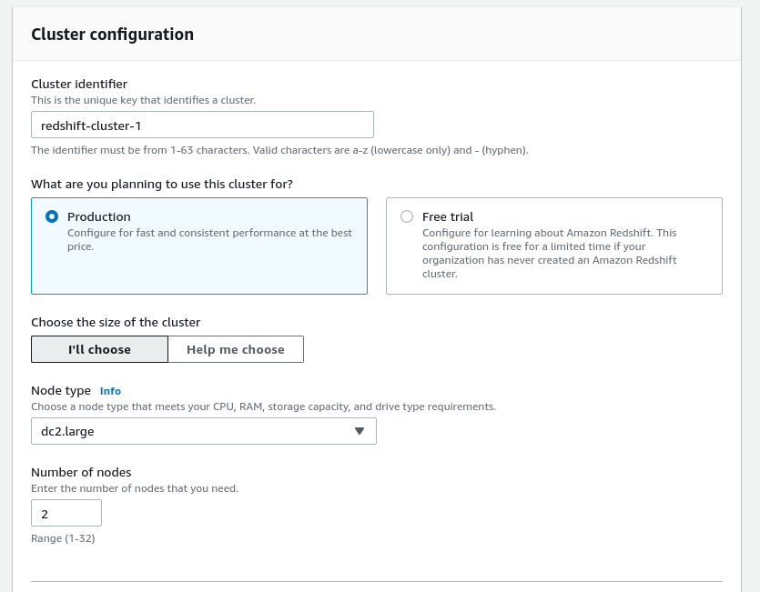

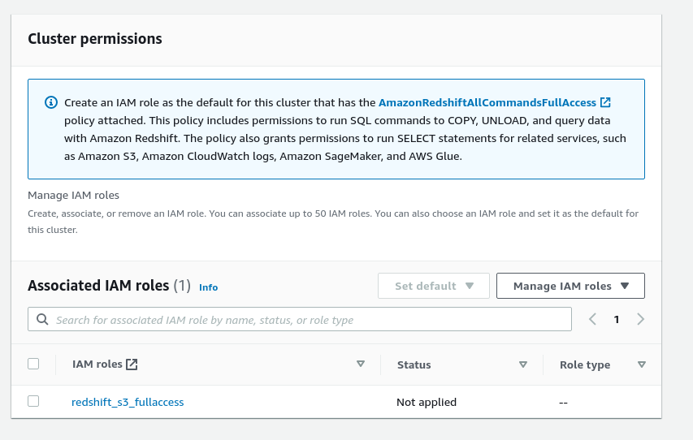

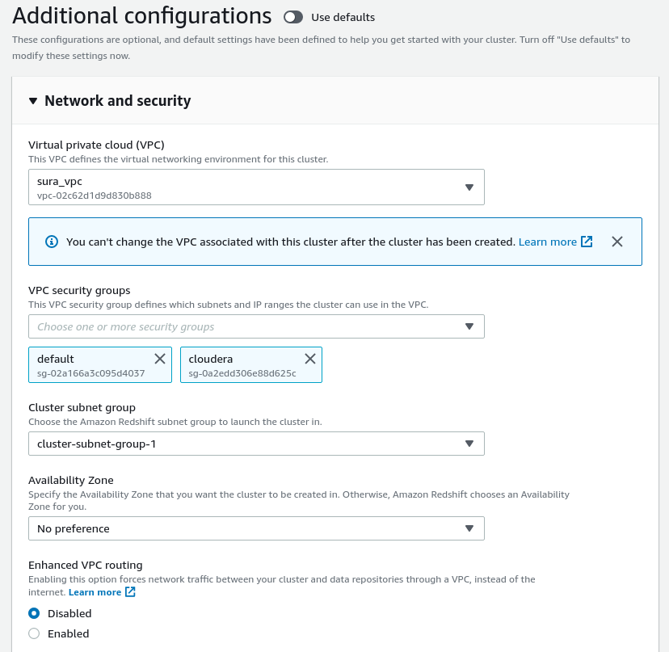

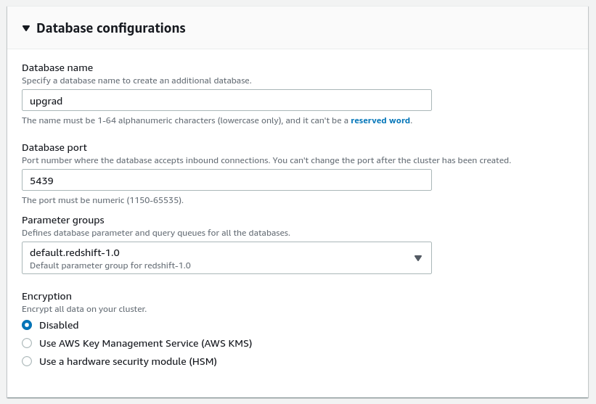

**Setting up a database in the RedShift cluster and running queries to create the dimension and fact tables**

create schema atm_new_trans;

drop table if exists atm_new_trans.dim_date;

create table atm_new_trans.dim_date

(

date_id integer not null,

year integer,

month varchar(20),

day integer,

weekday varchar(20),

hour integer,

full_date timestamp,

constraint PK_dim_date primary key (date_id)

);

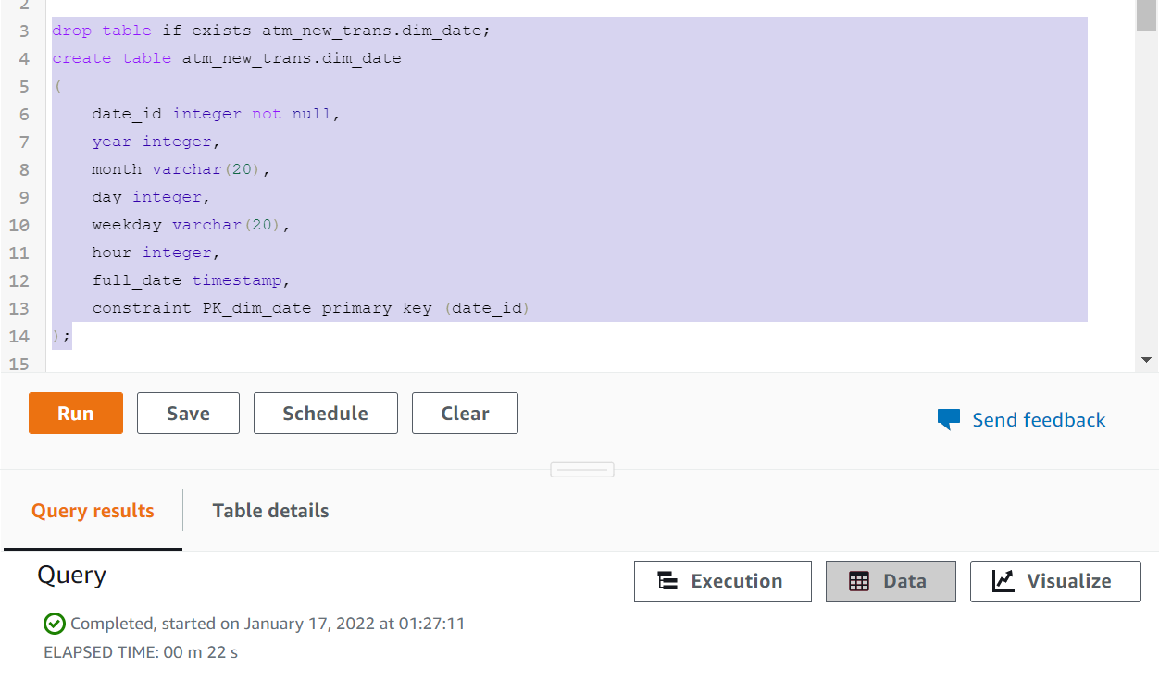

drop table if exists atm_new_trans.dim_location;

create table atm_new_trans.dim_location

(

location_id integer not null,

location varchar(50),

streetname varchar(255),

street_number integer,

zipcode integer,

lat decimal(10, 3),

lon decimal(10, 3),

constraint PK_dim_location primary key (location_id)

);

drop table if exists atm_new_trans.dim_atm;

create table atm_new_trans.dim_atm

(

atm_id integer not null,

atm_number varchar(20),

atm_manufacturer varchar(255),

location_id integer,

constraint PK_dim_atm primary key (atm_id),

constraint FK_dim_atm foreign key (location_id) references atm_new_trans.dim_location(location_id)

);

drop table if exists atm_new_trans.dim_card_type;

create table atm_new_trans.dim_card_type

(

card_type_id integer not null,

card_type varchar(50),

constraint PK_dim_card_type primary key (card_type_id)

);

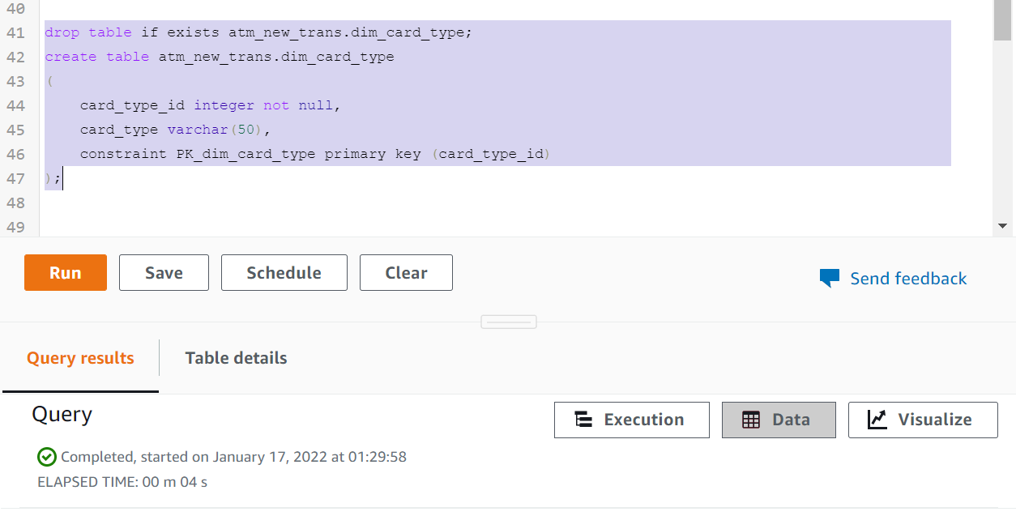

drop table if exists atm_new_trans.transaction_fact cascade;

create table atm_new_trans.transaction_fact

(

trans_id bigint not null,

date_id integer,

atm_status varchar(20),

atm_id integer,

currency varchar(10),

card_type_id integer,

transaction_amount integer,

service varchar(50),

message_code varchar(255),

message_text varchar(255),

weather_loc_id integer,

rain_3h decimal(10, 3),

clouds_all integer,

weather_id integer,

weather_main varchar(255),

weather_description varchar(255),

constraint PK_transaction_fact primary key (trans_id),

constraint FK_atm foreign key (atm_id) references atm_new_trans.dim_atm(atm_id),

constraint FK_card_type foreign key (card_type_id) references atm_new_trans.dim_card_type(card_type_id),

constraint FK_location foreign key (weather_loc_id) references atm_new_trans.dim_location(location_id),

constraint FK_date foreign key (date_id) references atm_new_trans.dim_date(date_id)

);

**Loading data into a RedShift cluster from Amazon S3 bucket**

copy atm_new_trans.dim_atm

from 's3://atmtransdata/atmtrans_v2/dim_atm.csv'

iam_role 'arn:aws:iam::823888918855:role/redshift_s3_fullaccess'

delimiter ',' region 'us-east-1'

CSV;

copy atm_new_trans.dim_location

from 's3://atmtransdata/atmtrans_v2/dim_location.csv'

iam_role 'arn:aws:iam::823888918855:role/redshift_s3_fullaccess'

delimiter ',' region 'us-east-1'

CSV;

copy atm_new_trans.dim_card_type

from 's3://atmtransdata/atmtrans_v2/dim_card_type.csv'

iam_role 'arn:aws:iam::823888918855:role/redshift_s3_fullaccess'

delimiter ',' region 'us-east-1'

CSV;

copy atm_new_trans.dim_date

from 's3://atmtransdata/atmtrans_v2/dim_date.csv'

iam_role 'arn:aws:iam::823888918855:role/redshift_s3_fullaccess'

delimiter ',' region 'us-east-1'

timeformat 'YYYY-MM-DDTHH:MI:SS'

CSV;

copy atm_new_trans.transaction_fact

from 's3://atmtransdata/atmtrans_v2/transaction_fact.csv'

iam_role 'arn:aws:iam::823888918855:role/redshift_s3_fullaccess'

delimiter ',' region 'us-east-1'

CSV;

