|  |  |  |  |
| --- | --- | --- | --- |
| 光電實驗五預報 | | | |
| **組別：**第八組 | **系級：**電機三 | **學號：**B07901042 | **姓名：**趙少緯 |

1. **實驗名稱**

發光二極體量測

1. **實驗目的**

了解發光二極體的電流電壓特性，和電激發光頻譜。

1. **實驗原理**

當在PN二極體上，施加順向偏壓時，電子和電洞會在PN結合處產生光。

1. **實驗架構**

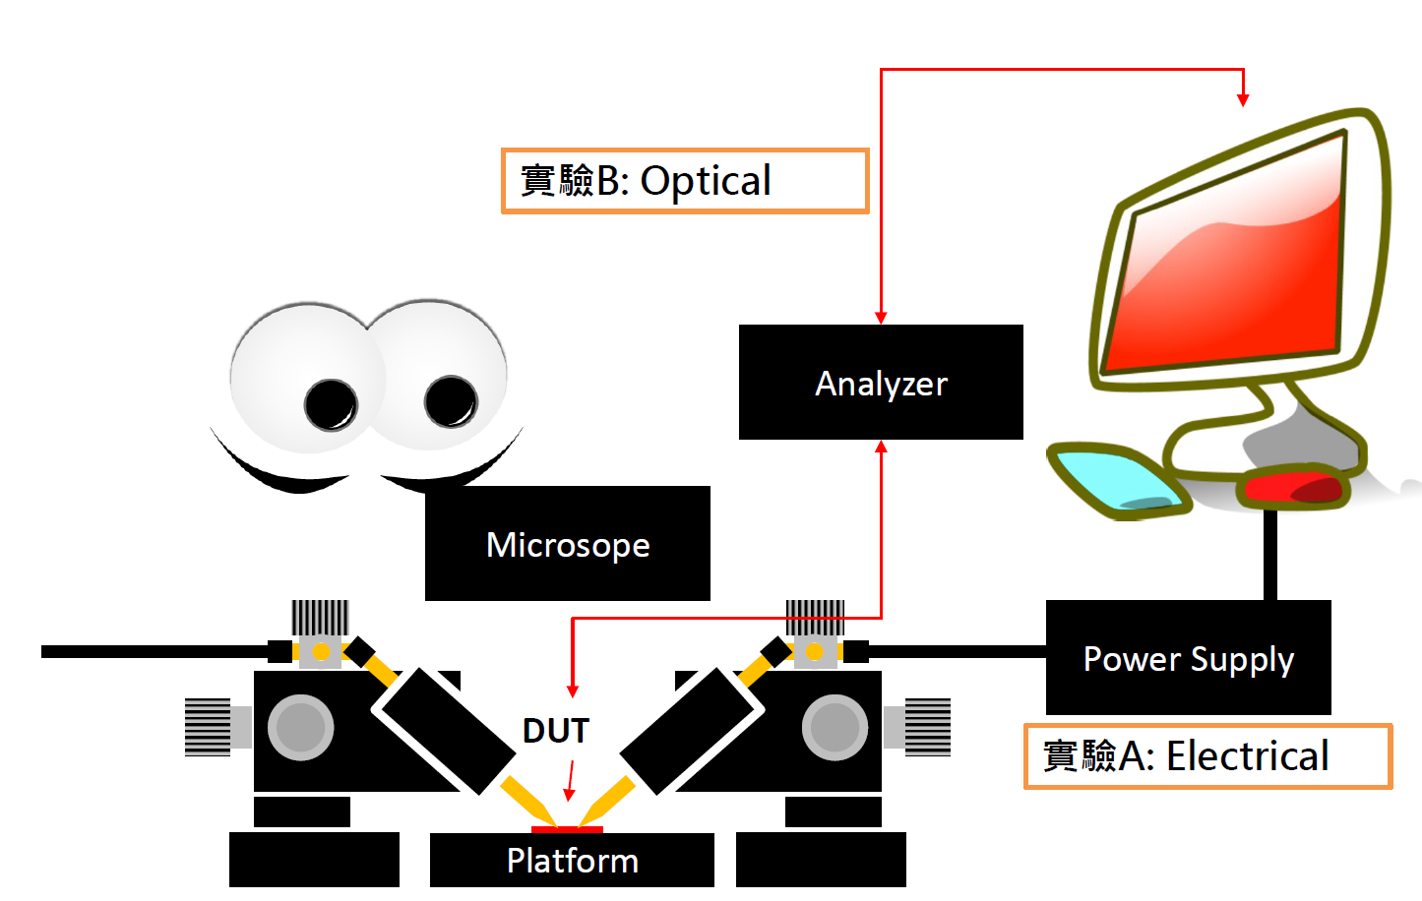

1. **實驗步驟**
2. 繪出藍光LED的I-V Curve
3. 記録藍光LED的起始電壓，是否與材料Band Gap相近
4. 用量測的曲線預估藍光LED的串聯電阻和理想值
5. 量測藍光LED的電激發光頻譜
6. 繪製EQE-I Curve
7. 觀察是否有藍移或紅移的現象
8. **預報問題**
   1. **RGB LED 可用哪些材料系統製作**

紅光：用VPE生長GaAsP在GaAs上

綠光：生長在GaP上

藍光：生長在GaN上

* 1. **以GaN-based LED 為例，試描述LED晶粒的基本結構**

在PN的GaN半導體中，有很多層 ${In}_{x}{Ga}_{1-x}N/GaN$ 量子井，提供電子電洞結合的能隙，並在P端設有電子阻擋層。

* 1. **推導P22的式子**
 $$I=I_{S}e^{\frac{e\left(V-IR_{S}\right)}{nKT}}-I_{S}$$

 $$V=\frac{nKT}{e}\ln\left(\frac{I+I_{S}}{I_{S}}\right)+IR_{S}$$

$$\frac{dV}{dI}=R_{S}+\frac{nKT}{e\left(I+I_{S}\right)}≅R_{S}+\frac{nKT}{eI}$$

$$I\frac{dV}{dI}=R_{S}I+\frac{nKT}{e}$$

2. **描述P30各種Efficiency的定義**

Injection efficiency (IE)

is the ratio of electrons passing through the device to that are injected into the active region.

Internal quantum efficiency (IQE)

is the ratio of all electron-hole recombinations in the active region to that are producing photons.

Extraction efficiency (EE)

is the ratio of photons extracted out from LED to the all the photons born inside.

External quantum efficiency (EQE)

is the ratio of the number of photons emitted from the LED to the number of electrons passing through the device.

* 1. **查詢白光LED的做法**

白光LED可藉由RGB三種LED組合而成，或時利用高能LED（如紫外線或藍光）激發螢光物質。