1. Gaussian Beam - MATLAB

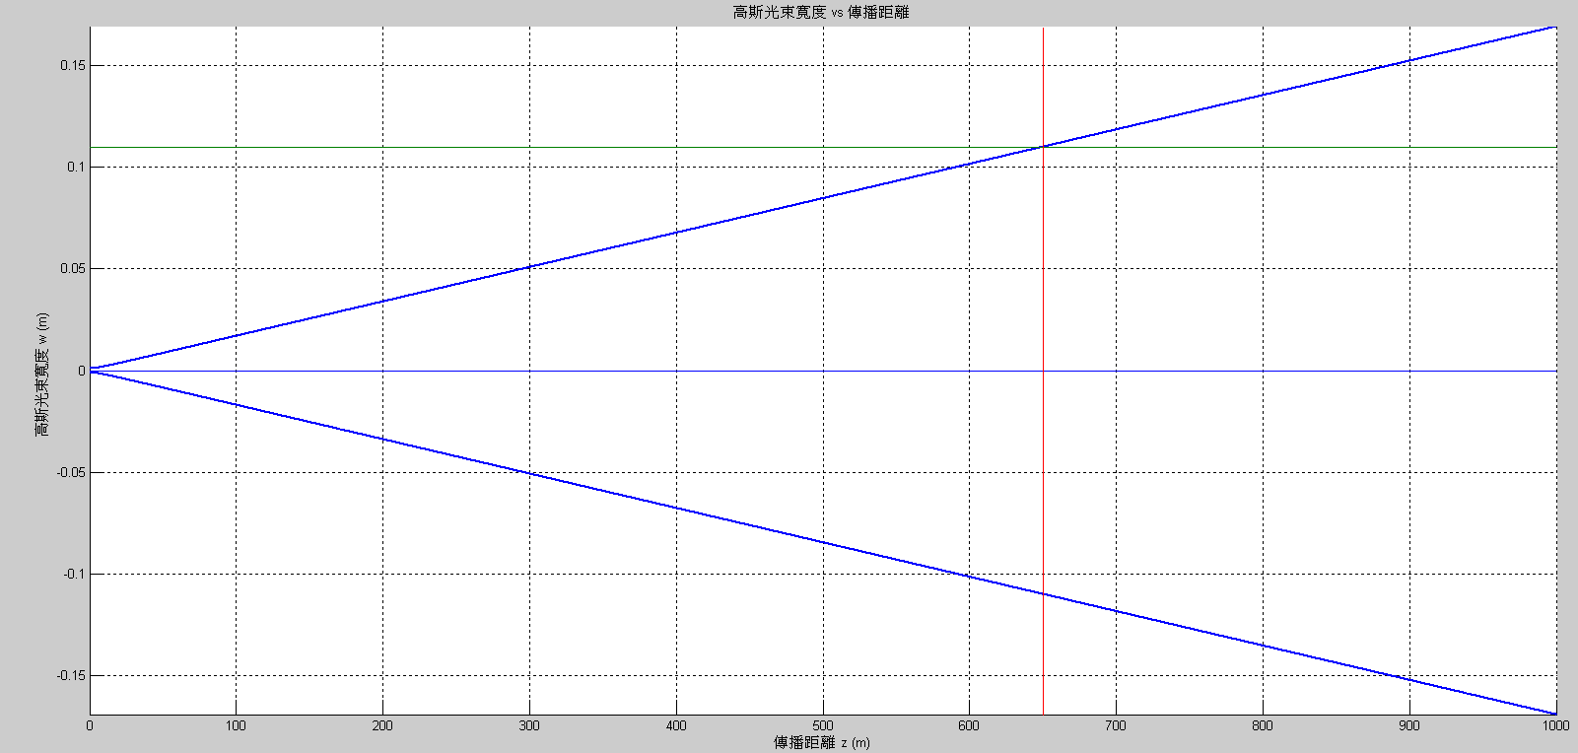

* 1. Because

$$w_{0}=\sqrt{\frac{λz_{0}}{π}}$$

We can get

$$z_{0}=\frac{w_{0}^{2}π}{λ}=5.905\left(m\right)$$

The radius of curvature of the mirror is

$$R\left(650\left(m\right)\right)=650\left[1+{\left(\frac{z_{0}}{650}\right)}^{2}\right]=650.05\left(m\right)$$

And the radius of the mirror is 1(b), which is $0.1101\left(m\right)$

1. Reflection Grating – Gsolver

At $532nm$, $42°$ of incidence will cause the max diffraction efficiency.

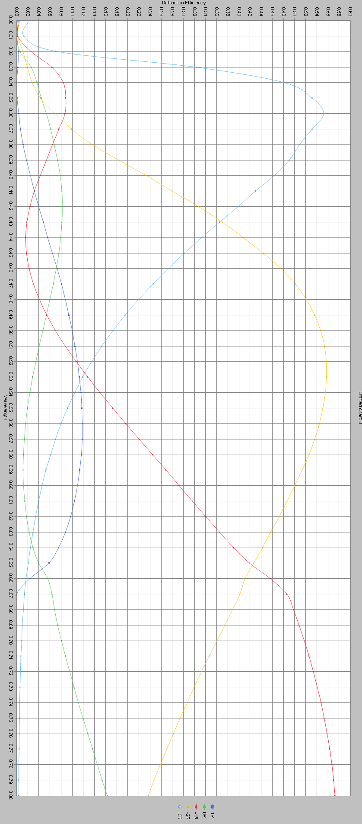

1. Waveguide Coupler – Rsoft

$EO=0.0032$

$EO=0.00223$

$EO=0.001474$

