Cory Nichols – Problem Set Unit 14

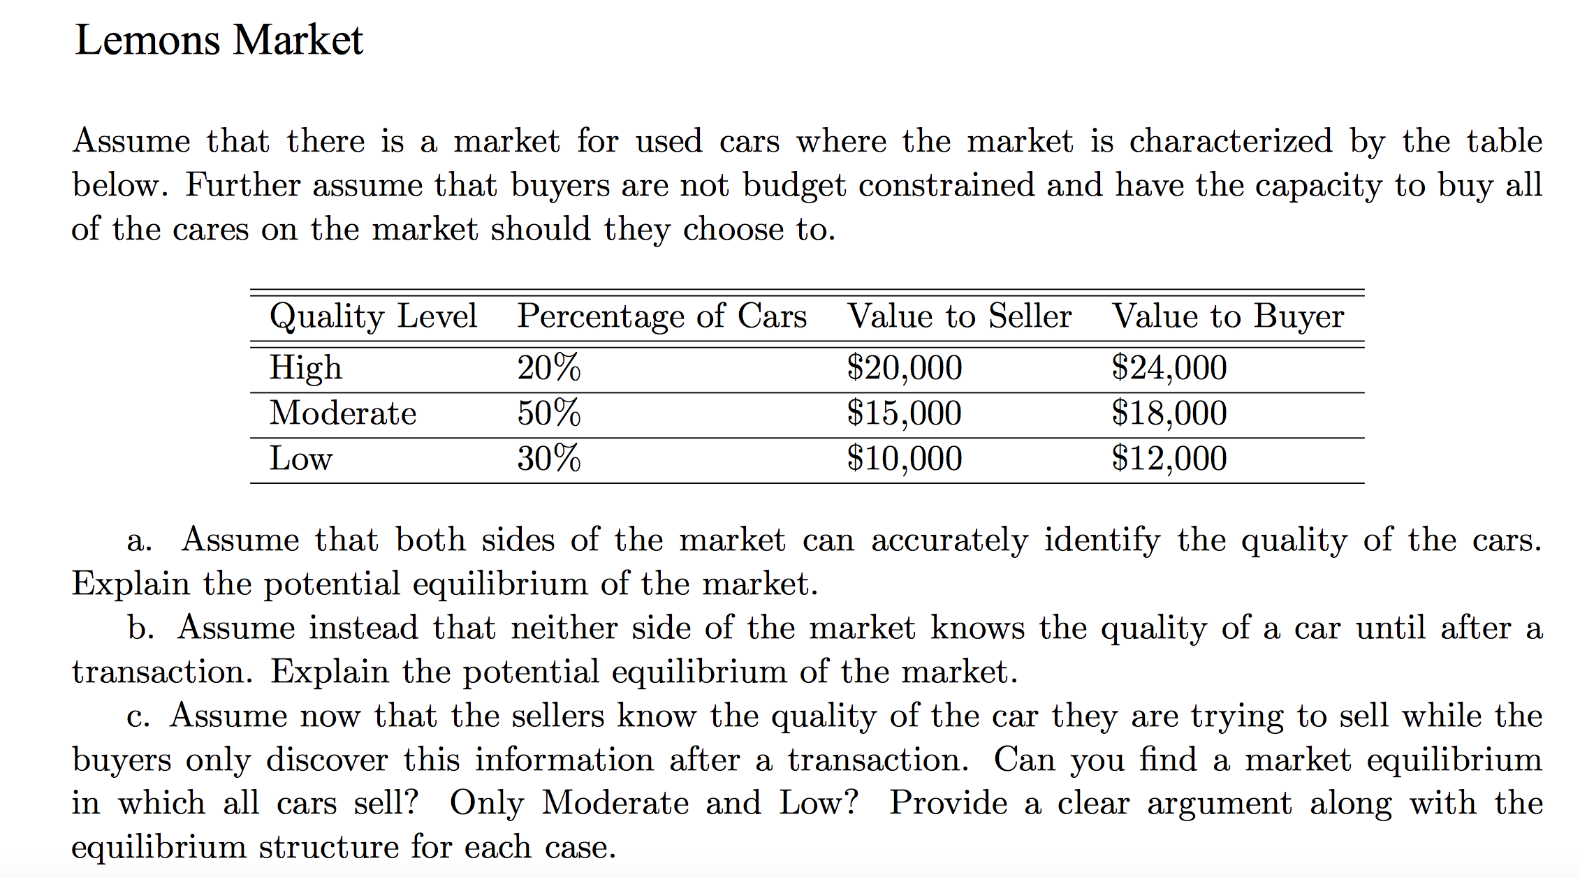

1. This is the perfect information case. Buyers and sellers are fully aware of quality of cars. Thus, they base their offers on their values according to the table above.

This is easily solvable via backward induction. Seller will acquire no signal here because the buyers know the type of car being sold.

Each car should transact from seller to buyer with the highest value allocation.

High quality level cars sell between 20K and 24K

Moderate quality cars sell between 15K and 18K

Low quality cars sell between 10K and 12K

Therefore, in this equilibrium, the seller acquires no signal and all cars are sold between the market prices for each type above.

1. This is the no information case. In this case, we have expected values for each party:

EV(seller) = 0.2(20) + 0.5(15) + 0.3(10) = 14.5

EV(buyer) = 0.2(24) + 0.5(18) + 0.3(12) = 17.4

All cars sell between 14.5K and 17.4K. If car is high value, seller loses money. If car is low value, seller earns a profit.

1. This is the asymmetric information case with the seller holding more information than the buyer.

The supply curve is a stepped at levels of 10K, 15K and 20K. The seller will sell combinations: low quality, low quality and medium quality and all quality cars at these levels, respectively. The buyer will use this pricing information to inform themselves as to the expected value and make decisions based on these expected values.

At a price of 10, seller is selling low quality cars. At a price of 15, they sell low quality and medium quality cars. At a price of 20, they sell all cars.

Buyers calculate beliefs based on price scenarios:

Scenario 1: @ price up to but just under 15K, buyers believe car is low quality with probability 1

Scenario 2: @ price up to but just under 20K, buyers believe cars is low quality with 37.5% probability and medium quality with 62.5% probability

Scenario 3: @ price of >=20, all cars on are on the market, so probabilities above hold. LQ = 20%, MQ = 50% and HQ = 30%.

In scenario 1, buyers are willing to pay 12K for low quality so will pay 10K value of seller for low quality if price is 10K. Buyers will NOT buy in the range of [12K+E,15K-E] where E is a miniscule real number.

In scenario 2, buyers are willing to pay 0.375(12K) + 0.625(18K) = 15.75K. They still purchase at a seller’s price of 15K. Buyers will not purchase in the range of [15.75K+E, 20K-E]. This is because buyers assume low and medium quality cars are in the market based on price.

In scenario 3, at a price of 20K, buyers assume all cars are in the market and calculate an expected value of 0.2(24K) + 0.5(18K) + 0.3(12K) = 17.4K. Thus, the buyer won’t buy at 20K, the seller’s price for high quality cars. The seller will not part with a high-quality car for this price, either.

Thus, supplier only provides low and medium quality cars and the buyers’ decision is buy if P <= 12K else buy if P between 15 and 15.75K.

The seller would be successful in selling high quality cars if they used a signal, such as a warranty.

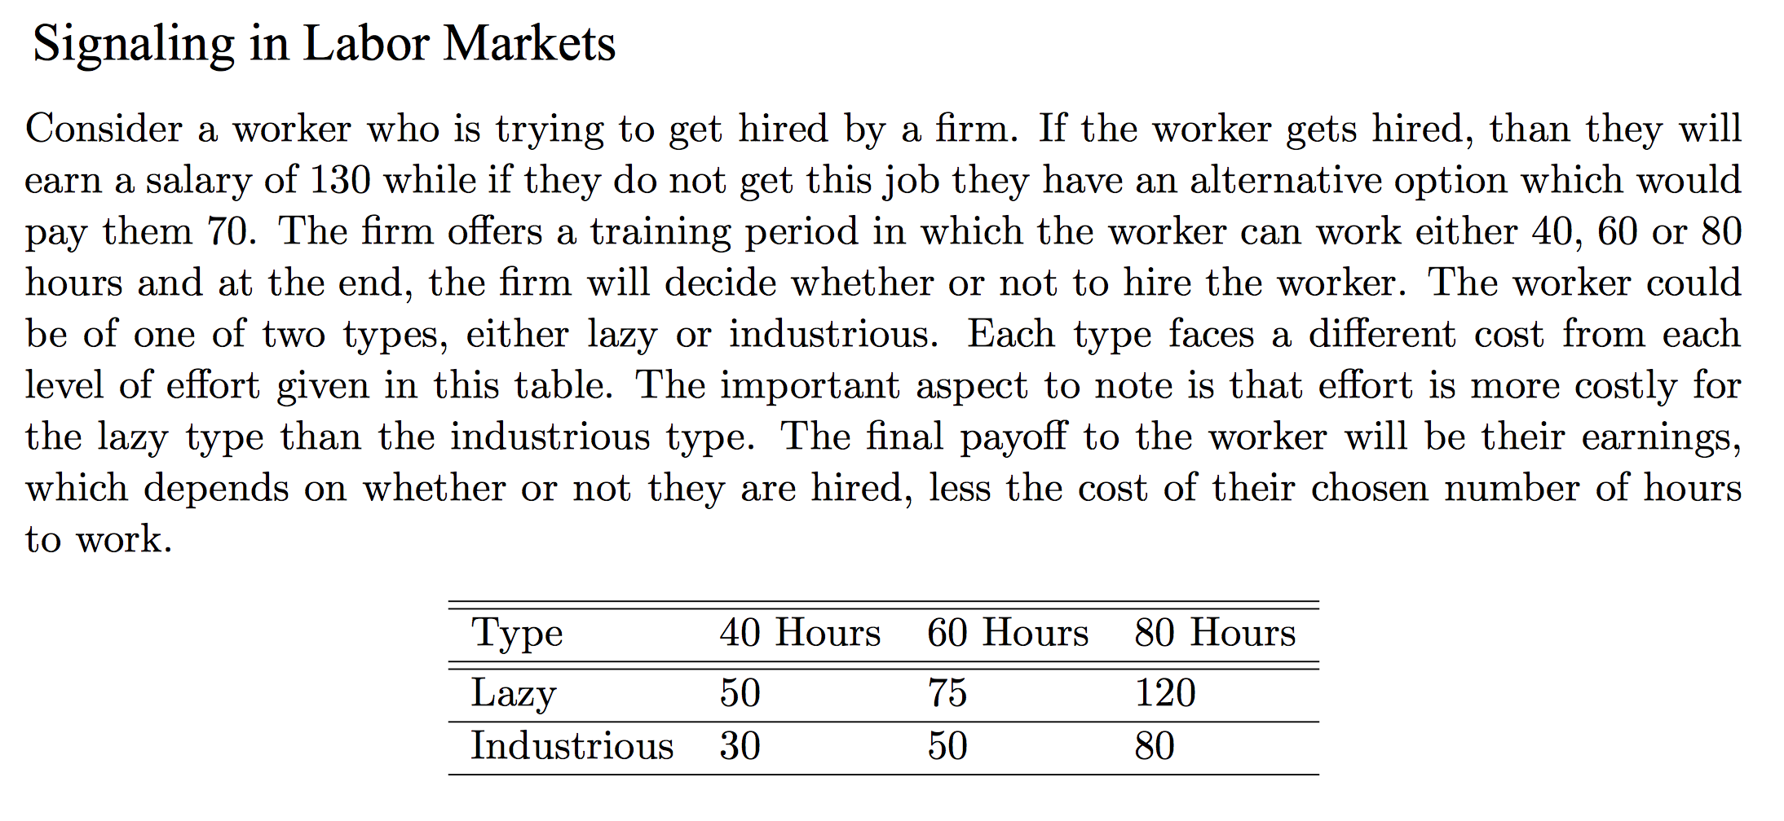

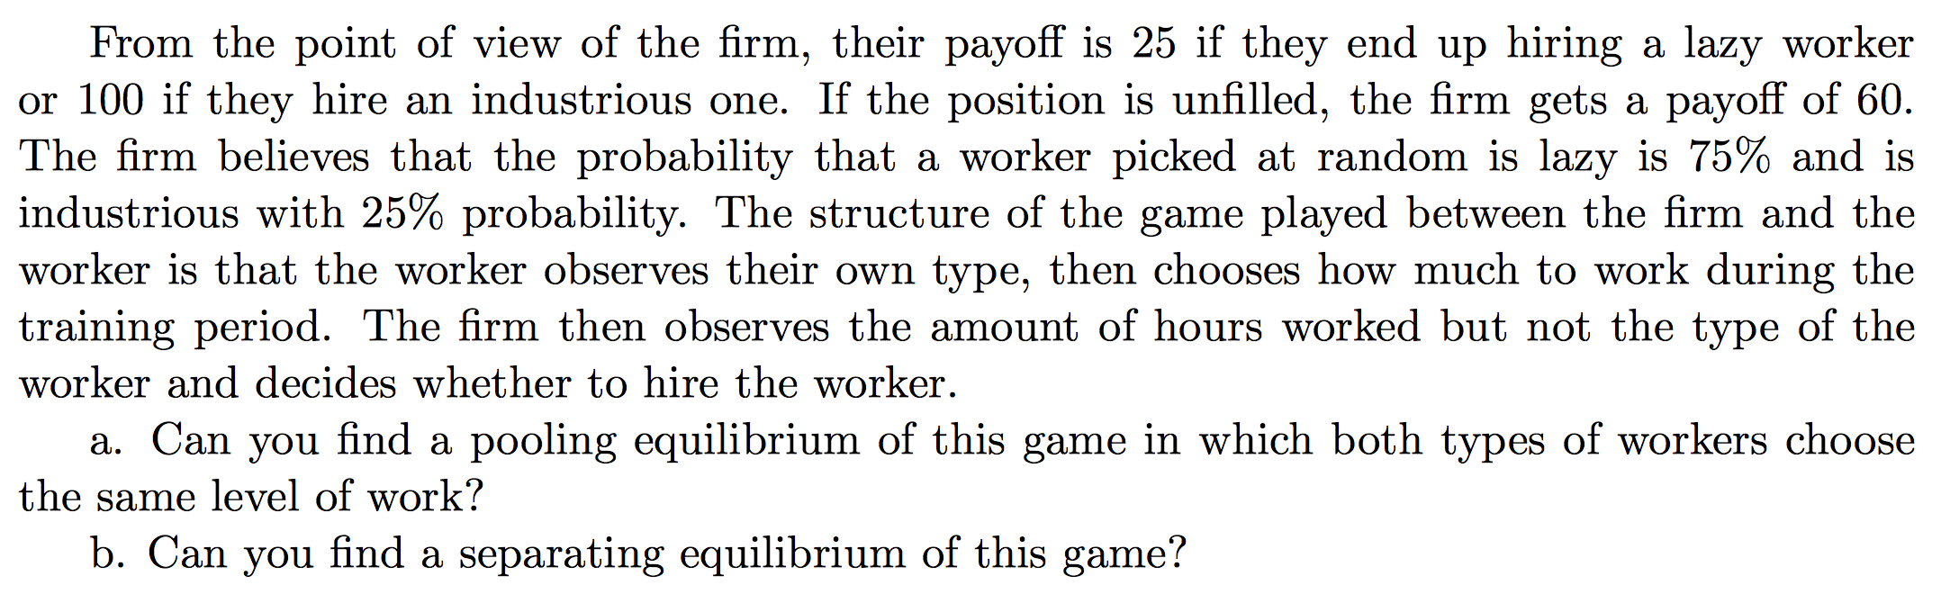

1. In a pooling equilibrium, the low and high types choose the exact same signal. In this case, we have no zero signal; only 40, 60, and 80 hours as required by the employer.

Given expected payoffs of the firm, they would obviously NOT hire a lazy worker if they can gain 60 from leaving the position open.

In the first step the worker would choose t*, his training level. However, this signal would not clarify his productivity type for the firm as it is a pooled signal.

Given the firm does not know the worker type, it must rely on the worker signal. However, in the pooling case, the firm can’t differentiate types of workers, so they must base their assumption in beliefs according to natural probabilities.

Thus, their belief someone is a high productivity worker is P*(t) = 0.25 if t = t*, the training level for high productivity workers. This then begs a payoff question: since the firm cannot separate types, their expected payoff would be 0.25(100) + 0.75(25) = 43.75. This expected payoff is **well below** the payoff of simply staying put and not hiring a worker.

Thus, there really is no pooling equilibrium situation where a worker is hired here, as the firm would expect the worker hired would provide less output than if they just stayed put.

Wages to workers are then 70 as they are not hired in this sort of situation.

1. In the separating equilibrium case, we attempt to derive differing types based on the signal provided by the party with information. In our case, the worker has the information and the firm does not.

We need to establish training level t*(M), belief p*(t) and finally, the wage.

$$t^{*}(M)=\left\{\begin{aligned}t_{h}^{*} if M_{h} \\ t_{l}^{*} if M_{l}\end{aligned}\right.$$

$$p_{t}^{*}=\left\{\begin{aligned}1 if t=t_{h}^{*} \\ 0 if t= t_{l}^{*}\end{aligned}\right.$$

$$w^{*}(t)=\left\{\begin{aligned}130 if t=t_{h}^{*} \\ 0 if t= t_{l}^{*}\end{aligned}\right.$$

In the separating case, we’d expect high productivity workers to train at level t*. The firm would then expect with probability of 1 that a worker is high productivity if t* training is obtained. Wages would then be 130 for a high productivity worker. Still, in the case of low productivity workers, the firm would pay zero here, they would not hire a low productivity worker because they provide a net loss in output. The worker would obtain an outside option salary of 70.

Low productivity workers would always choose the lowest signal in this example, 40 hours. If they choose higher than 40 hours, they are always worse off. In fact, in this case, the low productivity worker would prefer their alternate option of 70 should they choose 60 hours. (130-75) = 55 < 70.

Thus, to separate, we need high productivity to choose something else. Because the firm knows low productivity workers choose 40 hours, they will set wages to zero for workers that select this level of training as they will be assumed to be low productivity based on their signal.

Thus, we have an equilibrium condition we need to satisfy in order to get the high productivity worker to separate. The upper bound is found simply as:

$$130-t_{h}^{*}≥70$$

$$t_{h}^{*}≤60$$

Based on the cost to each worker, the high productivity workers can train 60 hours at a cost of 50 and still be better off than if they took their alternate option of not being hired:

130 – 50 = 80 > 70

On the other hand, the low productivity worker at 60 hours is worse off:

130 – 75 = 55 < 70

Thus, a training requirement of 60 hours would induce separation of the two types of workers.

$$t^{*}(M)=\left\{\begin{aligned}60 if M_{h} \\ 40 if M_{l}\end{aligned}\right.$$

$$w^{*}(t)=\left\{\begin{aligned}130 if t≥60 \\ 0 if t<60\end{aligned}\right.$$

Analyzing these two situations, it is beneficial for the high productivity worker to signal and gain 130-50 = 80 – 70 = 10 additional salary. The low productivity worker gets 70 either way.

**Chapter 16 Question 4:**

Good drivers and bad drivers. Good have 10% of crash and loss, bad 30%. All have wealth of 400, but falls to 100 if crash. Self selection policies available. First policy has a premium of 90 with full coverage. Second policy has a premium of 5 and pays out 50 if loss happens. Who will buy each policy? Will the insurance company make a profit?

Utility function ${(Wealth)}^{0.5}$

|  |  |
| --- | --- |
| Type of Driver | % Crash |
| Good | 10 |
| Bad | 30 |

Good Driver

No insurance: 0.9(400)^0.5 + 0.1(100)^0.5 = 19 utility

Policy 1: (400-90)^0.5 = 17.6 utility

Policy 2: (400-5)^0.5 + 0.1(400-300-5+50)^0.5 = **19.09 utility**

Bad Driver

No insurance: 0.7(400)^0.5 + 0.3(100)^0.5 = 17 utility

**Policy 1: (400-90)^0.5 = 17.6 utility**

Policy 2: 0.7(400-5)^0.5 + 0.3(400-300-5+50)^0.5 = 17.52

This self-selection strategy separates the types of drivers in this case. Good drivers would choose less coverage for a cheaper price and gain 19.09 utility. Bad drivers would choose full coverage and gain 17.6 utility. Both drivers want insurance given their risk profiles.

The insurance company can expect to pay 0.1(50) = 5 for the good drivers and 0.3(300) = 90 for the bad drivers. This matches their premiums charged, so the insurance company would break even.