Cory Nichols

**Chapter 2 Problem Set**

**2.** The Johnson Robot Company’s marketing managers estimate that the demand curve for the company’s robots in 2012 is:

P = 3000 – 40Q

Where P is the price of a robot and Q is the number sold per month

1. Derive the marginal revenue curve for the firm

Marginal revenue = a – 2bQ, therefore

**MR = 3000 – 80Q**

1. At what prices is the demand for the firm’s product price elastic?

Q < a/2b = 3000/80 = 37.5

P = 3000-40(37.5) = 1500

**When prices are > 1500, demand for firm’s product is elastic.**

1. If the firm wants to maximize its dollar sales volume, what price should it charge?

**To maximize revenue, the firm should charge 1500 dollars. This will bring marginal revenue to maximum before having to drop price and lose money.**

**As long as marginal revenue is positive, an increase in sales raises total revenue. At quantities where demand is price elastic, marginal revenue is positive.**

**3.** After a careful statistical analysis, the Chidester Company concludes the following demand function for its product is:

Q = 500 – 3P + 2Pr + 0.1I

Where Q is quantity demanded of its product, P is the price of its product. Pr is the price of its rival product and I is per capita disposable income in dollars. At present, P = 10, Pr = 20 and I = 6000.

1. What is the price elasticity of demand for the firm’s product?

Q = 500 – 3P + 2(20) + 0.1(6000)

Q = 1140 – 3P

Where P is 10, so

Q = 1140 – 30 = 1110

**So price elasticity of demand = -3 * 10/1110 = -0.027**

1. What is the income elasticity of demand for the firm’s product?

Q = 500 – 30 + 40 + 0.1I = 510 + 0.1I

Q = 510 + 0.1(6000) = 1110

**Income elasticity of demand = 0.1 * (6000/1110) = 0.54**

Income can be represented as positive. This means a normal good.

1. What is the cross-price elasticity of demand between its product and its rival’s product?

Q = 500 – 30 + 2Pr + 600 = 1070 + 2Pr

Q = 1070 + 2(20) = 1110

**Cross-price elasticity of demand = 2 * (20/1110) = 0.036**

If cross price elasticity is positive, it means that the products are substitutes. If cross-price elasticity is around zero, the products are independent.

**7.** According to S. Sackrin of the US Department of Agriculture, the price elasticity of demand for cigarettes (yuck) is between -0.3 and -0.4 and the income elasticity of demand is 0.5.

1. Suppose the government imposes a tax on cigarettes that increased prices by 15%. What effect would this have on consumption?

**Since the range of price elasticities of demand is between -0.3 and -0.4, there would be between a 4.5 percent and 6 percent drop in demand for cigarette consumption.**

1. Suppose a brokerage house advised you to buy cigarette stocks because if incomes were to rise by 50% in the next decade, cigarette sales would be likely to increase. What is your reaction to this advice?

**I would invest elsewhere, given the other factors associated with cigarettes, if income is likely to increase, there would most likely be more lucrative investments. The negative health effects, anti-cigarette advertising campaigns and general negative sentiment toward cigarettes will slow cigarette sales relative to other investments. Further, the income elasticity of demand is rather small. A savvy investor would look for goods that are more elastic from an income perspective, particularly goods that have an income elasticity of demand of > 1 like luxury cars.**

1. What is the implicit assumption about population?

That it is held constant. If population increases, typically, demand increases.

**10.** The Schmidt Corporation esimtates that its demand function is

Q = 400 – 3P + 4I + 0.6A

Where Q is the quantity demanded per month, P is the product’s price (in dollars), I is per capita disposable income (in K dollars) and A is the firm’s advertising expenditures (in K dollars). Population is assumed to be constant.

1. During the next decade, per capita disposable income is expected to increase $5,000. What effect will this have on the firm’s sales?

Q = 400 – 3P + 4I + 0.6A

**Income rises 5K, we can expect an additional 20 units, since I is represented in K dollars.**

1. If Schmidt wants to raise its price enough to offset the effect of the increase in per capita disposable income, by how much must it raise its price?

**20/3 = 6.67 dollar increase in price to offset the increase in per capita disposable income**

1. If Schmidt raises its price by this amount, will it increase or decrease the price elasticity of demand? Explain. Make sure answers reflect the fact that elasticity is a negative number.

-3 (Price+6.67) / Q

**It will increase the elasticity of demand since the numerator will be larger due to a price increase and the negative number will become smaller (moving further below -1)**

Ex: -3 * (20/50) = -1.2

-3 * (27/50) = -1.62

**Chapter 3 Questions**

**2.** Bagels: does slope of indifference curve indicate that fresh bagels are preferable to day old bagels when the slope is -1? Would you agree with the assertion that fresh bagels are preferable to day old bagels?

**I do not agree with the assertion, based on the evidence where slope is -1, that day old bagels are less preferable than fresh bagels. The indifference curve slope of -1 indicates a 1:1 relationship between day old bagels and fresh bagels. If fresh bagels were truly preferable to day old bagels, a consumer’s indifference curve slope would be much steeper, in favor of fresh bagels. If fresh bagels were on the x axis, we would expect the slope to be less than -1, indicating a consumer would trade more old bagels for a single fresh bagel.**

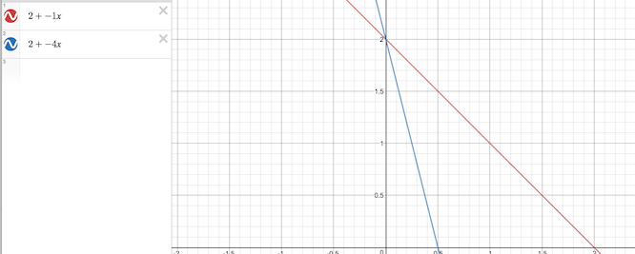

**5.** Suppose Richard has an after-tax income of $500 per week and must spend it on food or clothing. Food is $5 per pound and clothing is $10 per piece. Draw his budget line on a piece of graph paper where the amount of food is on the vertical axis.

5y + 10x = 500

5y = 500 – 10x

**y = 100 - 2x**

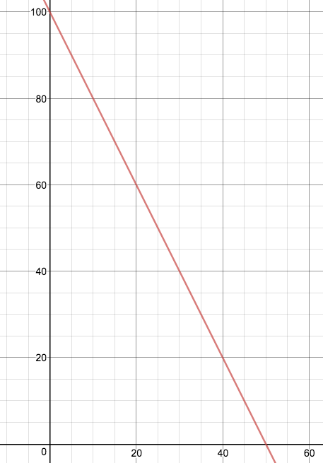

**6.** In the previous problem (problem 5 above), what is the budget line if Richard’s weekly income increases to $600? What is his budget line if his income is $500 but price increases for food to $10 per pound? What is his budget line if his income is $500 but the price of clothing increases to $20 per piece? Draw each budget line.

I am going to label these scenarios A, B, and C in sequential order according to each question above.

1. Income increase to $600 (GREEN)

5y + 10x = 600

5y = 600 – 10x

**y = 120 – 2x**

Income increase shifts out budget line to right

1. Income 500 but price increases for food to $10 per pound? (that’s expensive!!!) (ORANGE)

10y + 10x = 500

10y = 500 – 10x

**y = 50 – x**

intercept shifts down, indicating less affordability for food, slope becomes less steep, indicating a 1:1 trade off from P/Q standpoint.

1. Income is $500 but price of clothing increases to $20 per piece. (PURPLE)

5y + 20x = 500

5y = 500 – 20x

**y = 100 – 4x**

Slope curves inward, becoming steeper, indicating a more severe trade off from a P/Q perspective for food and clothing.

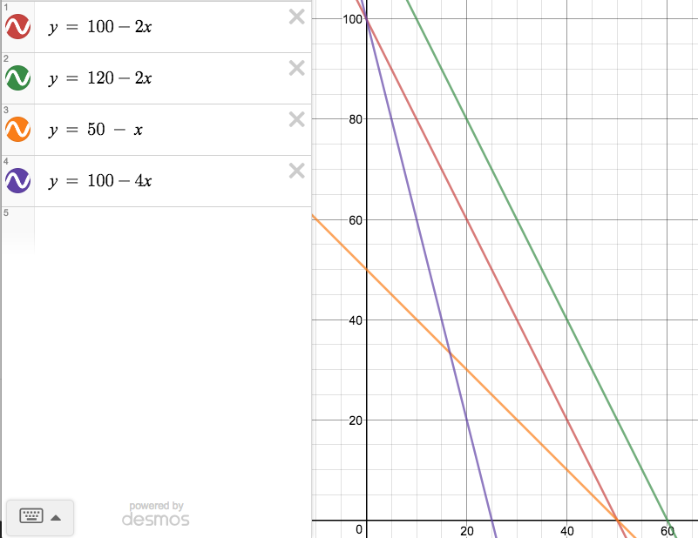

**8.** In the following diagram, we show one of Jane’s indifference curves and her budget line.

(a very poorly drawn indifference curve by me)

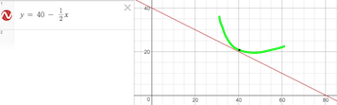

1. If the price of good X is $100, what is her income?

Based on the good X intercept (which is on the Y axis… interesting), Jane’s income is $4,000.

1. What is the equation of her budget line?

The equation of Jane’s budget line is 100(good X) + 50(good Y) = 4000:

GOOD X IS ON THE Y AXIS, so we use “y” and “x” below to indicate respective axes and follow standard mathematical notation instead of representing good x and good y labels:

100y + 50x = 4000 - where y in this case indicates the y axis, which is good x

100y = 4000 – 50x

**y = 40 – 1/2x**

Where the price of good Y is 4000/80 = 50

1. What is the slope of her budget line?

**The slope of her budget line is -1/2**

1. What is the price of good Y?

**The price of good y is $50 because Jane’s income is $4000 and she can afford at most 80 units of product y**

1. What is Jane’s marginal rate of substitution in equilibrium?

Based on the indifference curve tangent to the budget line in the graph, our MRS is -1 times the slope of the budget line:

**(-1)(-1/2) = 1/2**

**Indicating Jane would trade off 1 good x (on y axis) to get 2 good y**