Cory Nichols

**Chapter 5 Problem Set**

**1.** Elwyn Company:

**Q = 300S + 200U – 0.2S^2 – 0.3U^2**

**P(S) = 10**

**P(U) = 5**

**MP(S) =** 300 – 0.4S

**MP(U) =** 200 – 0.6U

1. **Chief engineer recommends firm hire 400 hours of skilled and 100 hours of unskilled labor. Evaluate.**

(300-0.4S)/10 = (200-0.6U)/5

1500-2S = 2000-6U

S = -250 + 3U

**S** = -250 + 3(100) = 50

**U =** 83.33 + 1/3 * (400) = 116.67

Engineers recommendation is not optimal maximize MP. Skilled labor should be 50, engineer recommends 400. This is not a good recommendation.

1. **If they spend $5000 on skilled and unskilled labor, how many hours of each type should they hire?**

**Cost: 10S + 5U = 5000**

10(-250 + 3U) + 5U = 5000

35U = 7500

**U = 214.28 hours of unskilled labor**

10S + 5(214.28) = 5000

**S = 392.86 hours of skilled labor**

1. **Price per unit is $10 and does not vary, how many hours of unskilled labor should they hire? This is not explained well or at all in the book**

10(200-0.6U) = 5

2000 – 6U = 5

-6U = -1995

**U = 332.5**

**2. A consulting firm specializing in agriculture determines combinations of hay and grain consumption per lamb will result in a 25 lb gain for a lamb**

**Lbs Hay Lbs Grain**

**40 130.9**

**…**

**150 93.8**

1. **Firm’s president wants to estimate marginal product of a pound of grain producing lamb. Can he do it with this data?**

No. In order to determine MP of grain, we’ll need to hold hay inputs constant. We don’t have enough information to do this currently.

1. **If constant returns to scale prevail and 100 lbs of hay and 250.2 grain used, what is the total output?**

Given 50 lbs of hay and 125.1 lbs of grain results in 25 lb gain, we would then assume a 100% increase in output gain to 50lbs of lamb if we double hay and grain inputs.

1. **What is the MRTS of hay for grain when between 40 and 50 lbs hay?**

MRTS: -1*(Change in X2(grain) / Change in X1(hay))

Grain given hay: -(130.9-125.1)/(40-50) = 0.58

1. **Advances in tech occur that allows production of 25 lb gain per lamb with less hay and grain than preceding table indicates. If MRTS same after advance, can you draw the new isoquant corresponding to a 25lb gain per lamb?**

No, we do not have enough information for output given the new technology level, however, we would assume that our isoquant would reset at lower input levels and maintain the same height (output).

**5. Q = AL^aK^b where Q is output rate, L is rate of labor input and K is rate of capital input. a = 0.8 and b = 0.3. Firm’s owner claims plant has increasing returns to scale.**

1. **Is the owner correct?**

Yes, a and b are >1, meaning the firm is experiencing increasing returns to scale.

1. **If b were 0.2, would she be correct?**

No, the firm would experience constant returns to scale.

1. **Does output per unit of labor depend only on a and b? Why or why not?**

No, output per unit of labor depends on both L and K given by the marginal product of labor:

aAL^(a-1)K^b

**7. Q = 5LK where Q is output, L is amount of labor, K is amount of capital.**

**P(L) = 1 P(K) = 2**

Which combo should be used to produce 20 units of output per period?

1. What advice would you give him?

MP(L) = 5K

MP(K) = 5L

5K / 1 = 5L / 2

10K = 5L

L = 2K

K = 1/2L

20 = 5(2K)(K)

20 = 10K^2

20 = 10K^2

2 = K^2

**K = 1.414**

**L = 2(1.414) = 2.828**

We should 1.414 units of capital and 2.828 units of labor to optimize output.

1. **Suppose price of labor rises to $2 per unit. What effect will this have on output per unit of labor?**

*Previous output levels: K = 20/1.414 = 14.144 and L = 20/2.828 = 7.07*

5K / 2 = 5L / 2

K = L and L = K

20 = 5LL

5L^2 = 20

L^2 = 4

L = 2

Optimal labor is now 2 units. This makes sense, as labor would be less likely to be used because it costs more and thus the output per unit of labor would rise.

20 / 2 = 10 output is new level of output for labor versus 20 / 2.828 = 7 output units previously.

1. **Is this plant subject to decreasing returns to scale? Why or why not?**

Sum of exponents in this case is > 1.

5(1)(1) = 5

With 1% increase: 5*1.01 = 5.05

With 1% increase to K and L: 5(1*1.01)(1*1.01) = 5.1005

where a 1% increase in K and L results in > 1% increase to original output level of 5

No, this plant is not subject to decreasing returns to scale.

**Chapter 6 Problem Set**

**2. Haverford Company considering three types of plants to make a device. AVC constant so long as output is less than capacity, which is the maximum output of the plant. For output exceeding capacity of a single plant, assume that more than one plant of this type is built.**

**a-c: Derive average costs of producing 100K-400K devices in each plant A, B, C**

I used an excel sheet to speed this process up below:

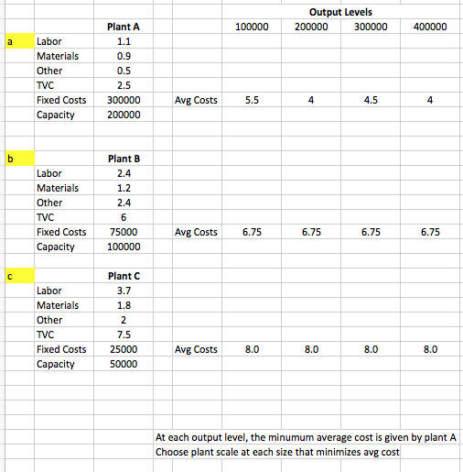

1. **Using results of part a through c plot points on LRAC curve for production of devices at 100-400K units:**

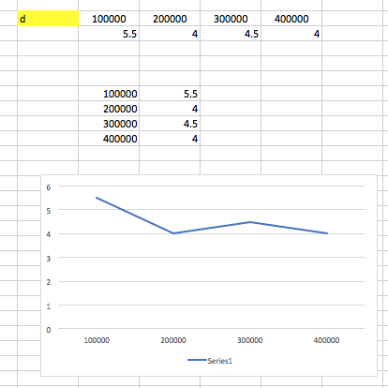

LRAC represented by lowest AC at each output level

**4. Relationship between plant’s fuel costs C and eight-hour output as a percentage of capacity Q:**

**C = 16.68 + 0.125Q + 0.00439Q^2**

1. **When Q increases from 50 to 51 what is increase in cost of fuel?**

16.68 + 0.125(50) + 0.00439(50)^2 = 33.905

16.68 + 0.125(51) + 0.00439(51)^2 = 34.473

There is a .57 increase in cost.

1. **Of what use might the result in a be to plant’s managers?**

In a profit-based strategy, managers should hope that unit prices are greater than the 0.57 increase in costs. Managers could also derive marginal cost, find the minimum based on output and attempt to maximize profits. In this case, average cost is decreasing unit to unit (from 50 to 51), managers are experiencing economies of scale based on this schedule from 50 to 54 units:

|  |  |  |
| --- | --- | --- |
| Q | C | Average Cost |
| 50 | 33.905 | $0.6781 |
| 51 | 34.473 | $0.6759 |
| 52 | 35.05056 | $0.6740 |
| 53 | 35.63651 | $0.6724 |
| 54 | 36.23124 | $0.6709 |

1. **Derive marginal cost curve for this plant and indicate how it might be used by the plant’s managers**

MCf = 0.125 + 0.00878Q

Managers could find the minimum based on output and attempt to maximize profits. MC gives us a glimpse into total variable costs in the short run and how they change with output. Eventually, TVC will become larger and marginal costs will become greater. Managers can use the minimum point of MC to optimize profits. This minimum point will give us our maximum Marginal Product based on MC = W(1/MP)

**6. The Deering Manufacturing Company’s SRAC function in 2012 was**

**AC = 3 + 4Q**

**Where AC is firm’s avg cost in $ per pound of product, and Q its output rate**

1. **Obtain equation for short run TOTAL cost function**

TC = 3Q + 4Q^2 – we simply multiply AC by Q

1. **Does the firm have any fixed costs?**

It does not appear to have fixed costs according to its total cost function, both elements in the equation are adjusted by Q or Q^2.

1. **If the price of Deering Company’s product per pound is $3, is the firm making a profit or loss?**

Total cost per unit is 3(1) + 4(1)^2 = $19 per unit. Pricing at $3 per unit results in major losses for Deering. Further, their AC is always greater than $3 unless they can sell negative units! They might need a new pricing manager because their best option is to sell 0 zero units.

1. **Derive an equation for the firm’s marginal cost function**

MC = 3 + 8Q

**10. The Berwyn Company considering new product. 300K fixed charge, variable cost per unit is $14.**

Direct Labor: $8.20

Direct Materials: $1.90

Other: $3.90

Total: $14.00

1. **Should Berwyn add new product line if it can sell 10K units at $25 each?**

This is a break-even scenario with two scenarios: accounting and economic cost

Economist Decision: Fixed costs are sunk and spent. Don’t consider them. *Yes, add product* line because price > variable cost. (10K*(25-14)) = 110,000

Accounting Decision: *No*, this won’t even cover fixed costs of 300K. 110000-300000 =

-190000. Berwyn would need to sell 300K/(25-14) = 27,273 units.

1. **Should Berwyn add product if it can sell 10K units at $20 each?**

Economist Decision: The price is still greater than variable costs, *yes*. Fixed costs are sunk.

Accounting Decision: This is even worse than A. *No*, Berwyn would need 50K units to break even

1. **Should Berwyn add product if it can sell 10K units at $15 each?**

Economist Decision: *Yes*, price is greater than variable costs and fixed costs in this scenario are sunk and shouldn’t be considered.

Accounting Decision: Even worse than B. *No*, they should not. Profit of $1 per unit means they need 300K units to break even.

1. **What is the min price for new product that will make it worthwhile for Berwyn to add to its product line?**

Economist Decision: P > $14 because fixed costs are sunk to the economist

Accounting: If we are assuming 10K units of demand, then Berwyn needs:

300K/(P-14) = 10000

300000 = 10000P – 140000

10000P = 440000

P > 44 to make a profit, this is because fixed costs are not considered sunk