Cory Nichols

**Chapter 14 Problem Set**

3. Zodiac Company and plastic. Outcome of a research project determines success. No means of estimating university research team’s probability of success. Zodiac’s gains and losses are as follows:

|  |  |  |
| --- | --- | --- |
| Action | Success | Failure |
| Develop Plastic | 50M | -8M |
| Does not develop | 0 | 0 |

On the basis of information given, can you calculate the expected value of information? Why or why not?

No, we cannot calculate the expected value of perfect information. We do not know the probabilities of success and failure.

If there was a 50% chance of success, for instance, we can calculate expected profit with perfect information of:

0.5(50M) + 0.5(0) = 25M

Managers would not invest in developing plastic if they knew they would fail.

versus an expected profit of 0.5(50) + 0.5(-8) = 12.5M

Thus, the expected value of perfect information would be 12.5M. HOWEVER, we do not have these probabilities so we cannot figure out the value.

6. Chief Executive Officer indifferent b/w certainty of 7500 and a gamble of 0.5 chance of 5K and 0.5 chance of 10K. Also indifferent between certainty of 10K and gamble where 0.5 chance of 7.5K and 12.5K.

1. Draw four points on the utility function of this publishing executive:

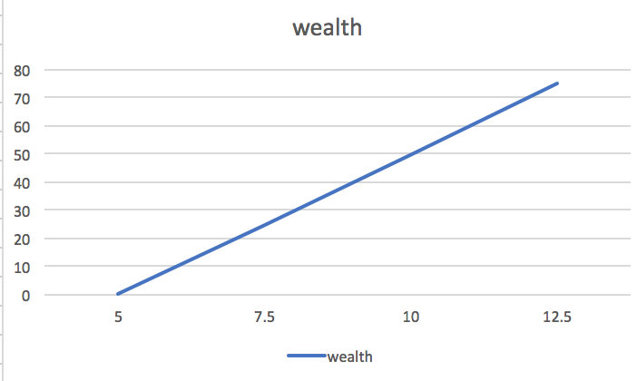

1. Does she seem to be a risk averter, lover or is she risk neutral? Explain

She is risk neutral as given by her linear utility function above U(A) + U(B). This relationship is obviously defined by a constant increase in utility given a level of wealth. I’ve used a scale of 0 (for 5K) to 50 (for 10K) for the first scenario which has resulted in:

U(7500) = 0.5(0) + 0.5(50) = 25

Using this result, we can solve this linear equation for x and find 12.5K:

50 = 0.5(25) + 0.5U(12500)

0.5U(12500) = 37.5

**U(12500) = 75**

0 25 50

5 7.5 10