Midterm Exam

June 20, 2017

Name Cory Nichols

Instructions. Please read all questions carefully, use your time wisely and show your work and final answers clearly. I don’t grade on neatness but if I can’t read it, I can’t give credit for it. Also, algebra mistakes may be forgiven or at least not punished severely but only if you show clearly that you understand how to solve the problem. Your answers should be complete and clear but excessive length should be avoided. Calculators are allowable.

**1. a. A hospital executive looks at the performance review for the divisions of his hospital and sees that in the maternity division last year there were 540 babies delivered at a cost of $3,132,000 with a revenue of $2,754,000. What decision should the administrator make in regard to encouraging the maternity division to increase or decrease the number of babies delivered? If a decision cannot be reached from this information alone, explain what information is needed and what might lead to a choice to increase or a choice to decrease the number of deliveries. (7 points)**

ANSWER:

There are a number of factors driving cost, for which we do not have detail. For example, the hospital could’ve incurred one-time costs during the year, skyrocketing costs above revenues. To give them direction to reduce or increase babies delivered based on the information above would not be a good idea. Further, the costs are not broken down between fixed and variable, so we cannot determine which costs are under the hospital’s control in the long run or short run, or to understand if the firm is covering their variable costs in general.

In order to make an informed decision, one would need a breakdown of fixed and variable costs, as well as marginal revenue and marginal cost detail. If found that the marginal revenue is less than marginal cost, the hospital should attempt to deliver fewer babies. They could assign mothers to different divisions or hospitals. They could also raise price in conjunction with fewer babies being delivered.

Currently, average total costs are $5800 per baby and average total revenue is $5100 per baby. Ultimately, if one more baby delivery results in a larger marginal cost than marginal revenue, the firm should consider dialing back deliveries and/or increasing price.

**b. Your 7-year old self reads that after getting their allowance, most 7-year-olds exhibit behavior consistent with Cobb-Douglas preferences over two goods, candy and ice cream. You get $20 in allowance every week. You remember buying 10 candies and 5 ice creams last week, and you paid $0.90 per candy. However, you cannot remember the price of an ice cream. Yet with the information you recall, you realize that you can figure out the utility function that generated your behavior and recover the price of ice cream. What is the utility function and price of ice cream? (7 points)**

The utility function is the Cobb-Douglas utility function $u\left(x,y\right)= x^{a}y^{b}$

We can determine the fraction of income spent on candies:

$$\frac{\left(10*0.9\right)}{20}=0.45$$

Thus, the fraction of income spent on ice cream is 0.55. We can then solve for price:

$5=0.55*20/P_{icecream}$

5P = 11

$$P_{icecream}=2.2$$

Indeed, this works out to what we consumed: 0.55(20/2.2) = 5

And (extra credit?)☺ their empirical utility is ${10}^{0.45}5^{0.55}=6.83$ taken with a grain of salt because cross price effects could be affecting utility here.

**2. A TV station is considering distributing a promotional video. There are two suppliers who are willing to produce it. Supplier A will charge the station a setup cost of $1,200 and then $2 for each DVD ordered. Supplier B will charge $4 per DVD with no setup charge. The station believes that the demand function will be Q = 1600 − 200P.**

**a. Suppose the station wants to maximize viewership and so wants to give the videos away for *free*. How many videos should the station order to satisfy demand and from which supplier should they be ordered? (8 points)**

**Q = 1600 – 200(0) = 1600**

In this case, price = 0 because the firm is giving these items out for *free*. Since the price is 0, plugging into the demand function results in a quantity ordered of 1600 by the firm. Thus, the firm is considering cost only and should select the firm that is cheaper to use.

Looking at cost, A would cost 1200+(2*1600) = 4400.

B would cost 4*1600 = 6400.

The firm would go with A to save money.

**b. Suppose the station instead wants to maximize profits by selling the videos. What price should it set, how many will they sell and which supplier should they order from? (8 points)**

If the firm were to sell the videos and maximize profits, they would set marginal revenue equal to marginal cost. In the case of each supplier, we can find their respective total and marginal cost functions:

TCa: 1200 + 2Q with MCa = 2

TCb: 4Q with MCb = 4

Total revenue can be represented as P * Q. If we determine the inverse demand function for Q = 1600-200P, we get:

P = 8 – 0.005Q

With total and marginal revenue of:

TR = 8Q – 0.005Q^2

MR = 8 – 0.01Q

We can now determine profit. We’ll consider supplier A first:

8 – 0.01Q = 2

0.01Q = 6

Q = 600

P = 8 – 0.005(600) = 5

Given supplier A’s cost function and the demand function we expect, optimal price is 5 resulting in a quantity of 600. The overall profit using supplier A is thus:

8(600)-0.005(600)^2 – (1200 + 2(600)) = $600 in profit

Now we consider supplier B:

8 – 0.01Q = 4

Q = 400

P = 6

Using supplier B’s cost function, optimal price is 6 and quantity is 400. The profit using B is thus:

8(400)-0.005(400)^2-4*400 = $800 in profit

If the firm were to maximize profits, they would go with supplier B and receive $800 in profit, which is $200 greater than if they went with supplier A.

**3. a. Definition of “indifference curve”; Properties of “indifference curve”; (7 points)**

Indifference curves allow us to represent the utility of consumer preferences. They indicate all of the combinations of goods that yield the same utility. Consumers are indifferent between any two points on an indifference curve. Ultimately, indifference curves allow us to determine how willing a consumer is to tradeoff between two goods.

Curvature and ranking are important as values of indifference curves are ordinal utility.

The properties of indifference curves are:

1. Bowed in
2. Non-overlapping
3. Downward sloping

Indifference curves also rely on assumptions of consumer preferences being complete, reflexive, transitive and continuous. These axioms allow us to construct utility functions. The slope of the indifference curves are represented as –MUx/MUy where MUx is the marginal utility of good x.

**b. Explain the difference between “long run” and “short run” costs. Explain the types of decisions a firm might make that distinguish between these two contexts is important. (4 points)**

Neither refer to a specific time period. Short run costs, though, are the period of time which an input to production is held fixed, typically this is capital. E.g. short run costs typically occur in a period of time it would take to add capacity such as machines, a factory, etc. These costs are considered FIXED in the short run. Typically in the short run, managers will only pay attention to marginal implications and ignore fixed costs. Short run costs consider both fixed and variable costs, however, only variable costs can be changed.

Long run costs are never fixed, everything is variable. All costs can be changed in the long run. E.g. fixed costs in the short run can now be changed in the long run.

A short run decision may be considering how to optimize the amount of labor given a fixed capital input. We can calculate average product of labor and marginal product of labor in the short run. Managers can also profit in the short run in perfectly competitive firms by charging higher prices for highly demanded items.

A long run decision would be optimizing output in the face of variable labor AND capital. We can use isoquant curves to visualize the combinations of capital and labor for a given output level. Given an output level, we could determine the capital AND labor it takes while also considering the isocost curve: our budget. Long run cost functions are typically derived from short run cost functions at different levels of capital. We can make decisions about plant and equipment: long term assets, in the long run. We cant do this in the short run. Firms in perfectly competitive industries are free to enter and exit in the long run, typically they will exit when MR < MC.

The key difference between short run and long run is the ability to change the scale of production as output changes.

**c. Explain the relationship between Average Product Curve and Marginal Product Curve. (4 points)**

Average product is represented by Q/X1 holding the other variable constant. It tells us how many units of output on average each input is responsible for, holding the other input constant. E.g. Average product of labor.

A better measure of efficiency is the marginal product which is the change in quantity produced divided by the change in X1 holding the other input constant. This gives us the incremental change in output created by a small change in input.

The average product MAXIMUM is always intersected by the marginal product line. Average product equals the marginal product when the average product is at a maximum. So long as marginal product is greater than average product, average product is increasing. If MP is decreasing, AP is decreasing.

Thus is marginal product cross the average product curve, we know average product is maximized.

**4. In a competitive market the supply and demand curves are given by**

QD = 70−P

QS =.5P−20

**a. Find the equilibrium price and quantity. (6 points)**

Setting QD = QS will give us the equilibrium price.

70 – P = 0.5P – 20

1.5 P = 90

**P = 60**

**Q = 70 – 60 = 10 units**

**b. Suppose the government subsidizes the producers by paying them $15 per unit produced. Determine what happens to the equilibrium price and quantity. (7 points)**

If the government subsidizes producers, the supply curve will change to:

0.5(P+15) – 20

Setting Qd = Qs:

70 – P = 0.5P - 12.5

1.5P = 82.5

**P = 55**

**Q = 70 – 55 = 15**

Thus, with a subsidy to the producer, equilibrium price drops to 55 and quantity increases to 15.

**c. Evaluate the effects on social welfare from this subsidy. Is it good for producers? Consumers? Society as a whole? Think through your answer carefully and explain why it comes out as it does. (For full credit, provide quantitative answers. Partial credit will be given for accurate graphical arguments. Tip: area of a triangle is .5*base*height.)(15 points)**

Consumers may only be paying $55, however, producers receive an additional $15 from the subsidy, so they receive $70. There is an increase in supply due to a drop in the marginal cost of production.

From the consumer’s standpoint, they gain a $5 per unit surplus. The surplus can be calculated by taking the area of a trapezoid. Since consumer surplus is the area below the equilibrium price in this case, under the demand curve and above the new equilibrium price with subsidy. We have a base of 15 (for the new qty), a ceiling of 10 (for old qty without subsidy) and a height of 5, representing the price difference (60-55). Consumer surplus is then (10+15)/2*5 = 62.5.

We receive the same answer when we take the area of a rectangle plus the area of a triangle visualized below:

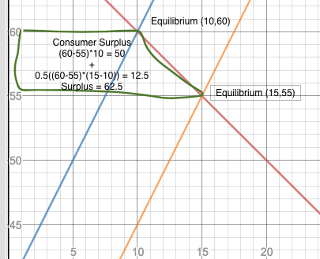

Now, for producer surplus, we know producers receive a price of 55+15 = 70 for their goods because of the subsidy. We can use this to calculate their surplus. The producers receive quite the sizable surplus in this case. Taking the area of a trapezoid where the bottom base is 10 and the top is 15 with a height of 10 (price of 70 – price of 60), we receive a surplus of 125 for producers. We can show this graphically while also proving the area of a rectangle and triangle:

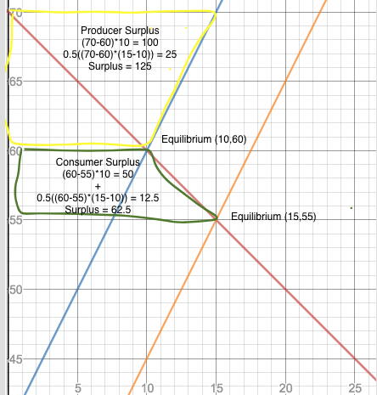

Thus, the producer surplus in this case is two times the consumer surplus. This subsidy looks good for both consumers and producers, producers especially. Total benefit is 125 + 62.5 = 187.5. However, on total welfare, the effect is 187.5 – (15*15) = 225. This means that total welfare is actually harmed at -37.5. Tax payers have to front the government subsidy at (15*15) = 225. This can be represented by the deadweight loss triangle in purple 0.5(15*5) = 37.5. 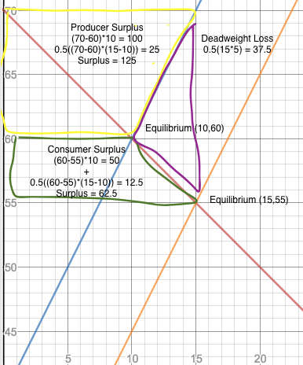

This subsidy can be used more efficiently for other greater benefits. Taxpayers must front this benefit to subsidize producers, in this case the subsidy is very large at $15 per unit. The government does not magically create these subsidies, so we must consider the taxpayer impact and the total impact on society. In this case it is negative and not optimal.

**5. Suppose you are selling a product and know that you face two different types of consumers with inverse demand functions for representative consumers of each type given by**

**p1 =8−2q1**

**p2 =4−.5q2.**

**Assume that marginal cost is 2.**

**a. Find the profit maximizing price and quantity per consumer as well as profit per consumer were you to sell to each group individual items at different prices (i.e. different prices to each group, not different per item). (6 points)**

This question has very interesting wording…..This is a third-degree price discrimination problem since we are considering consumer GROUPS and the same product. There is no indication here of fixed costs, since we are only given a marginal cost of 2. Therefore, we need to set MR1 = MR2 = MC (in this case MC is 2 and represents the cost for producing to both groups).

Let’s look at consumer type 1 first:

To get total revenue and marginal revenue:

TR = (8-2Q1)(Q1) = 8Q1 – 2Q1^2

MR = 8 – 4Q1

8 – 4Q1 = 2 (since MR = 2 and there is no Q involved, we can solve this as normal)

4Q1 = 6

Q1* = **1.5**

P1* = **5**

Profit for Consumer 1: 8(1.5)–2(1.5)^2–2(1.5) = **4.5** assuming no fixed costs

Now for consumer 2:

TR = (4-0.5Q2)(Q2) = 4Q2 – 0.5Q2^2

MR = 4 – Q2

4 – Q2 = 2

Q2* = **2**

P2* = (4-0.5(2)) = **3**

Profit for consumer 2: (4(2) - 0.5(2)^2) – 2(2) = **4** assuming no fixed costs from problem

Total profit would be 8.5.

**b. What if instead of selling single units, you were to only sell units in bundles of 2, 3 or 4 units? Assume you can sell in one of those bundle sizes and then you sell the same bundle size to both groups at the same price. Find the optimal bundle size and profit level. (Hint: This one is tricky and we didn’t do one exactly like it before. If you can’t solve the mathematics fully, provide a clear explanation for how you would find the answer.) (7 points)**

Since we will be offering the SAME PRICE to both groups, we need solve for a combined demand function. First, let’s find the demand function for each consumer:

Q1 = 4 – 0.5P1

Q2 = 8 – 2P2 therefore

Qc = 12 – 2.5P and

Pc = 4.8 – 0.4Q

From this combined inverse demand function, we can find total revenue:

TR = (4.8 – 0.4Q)Q = 4.8Q – 0.4Q^2

MR = 4.8 – 0.8Q

Solving for optimal quantity not considering the bundles:

4.8 – 0.8Q = 2

Q* = 3.5

P = (4.8 – 0.4(3.5)) = 3.4

Without considering the bundle, we know that the optimal combined quantity demanded is 3.5. This results in a profit of (3.4*3.5) – 2*3.5 = 4.9. Now, if we were to sell in bundles, we can use the combined total revenue function and marginal cost above to calculate profit under our different bundling conditions:

2 units profit: (4.8(2) – 0.4(2)^2) – 2(2) = 4

3 units profit: (4.8(3) – 0.4(3)^2) – 2(3) = **4.8**

4 units profit: (4.8(4) – 0.4(4)^2) – 2(4) = **4.8**

Therefore, we could sell in either three or four unit bundles to maximize profit. Obviously, the OPTIMAL profit is 4.9 at 3.5 units as we proved, however, if whole units are required, 3 or 4 unit bundles would suffice. This also considers NO fixed costs as none are given, only variable costs.

**c. The table below shows the value two different types of consumers have for services at a hotel as well as the marginal cost of each service and the number of consumers of each type. Find the price the hotel would sell each service for if the services were separately priced. Calculate total profit. (7 points)**

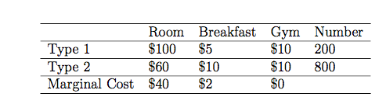



Solving for a separate pricing strategy, the hotel would do the following

First, we look at the room service (wow that’s expensive!!):

The MC is always $40.

At a price of $100, 200 people will buy

At a price of $60, all 1000 people will buy

Let’s look at what’s better:

Price @ $100:100*200 – 40*200 = $12,000 profit

Price @ $60: 60*1000 – 40*1000 **= $20,000 profit**

**Room service should be priced at $60 resulting in $20,000 in profit.**

Next, breakfast:

The MC is always $2

At a price of $5, 1000 people will buy

At a price of $10, 800 people will buy

Given so many people will buy at $10, this is pretty obvious:

Price @ $5 = 5*1000 – 2*1000 = $3,000 in profit

Price @ $10 = 10*800 – 2*800 = **$6,400 in profit**

**Therefore, breakfast service should be priced at $10 resulting in $6,400 in profit.**

Both consumers value gym the same and there is no marginal cost involved. Therefore, gym profit is:

Gym: $10 * 1000 = **$10,000 in profit**

Total profit from a separate pricing strategy is thus $20,000+$6,400+$10,000 = **$36,400 in profit**

**d. Determine what the optimal bundle price would be for combining all three services and determine if the hotel should bundle or sell separately. (7 points)**

 

Since we are not being asked to mixed bundle, we look at pure bundling only.

Using the independence assumption, Type 1 values a bundle of all three services at $115, while type 2 values all three services at $80.

Each bundle costs $42 to produce. We can now solve for the optimal bundle:

At a bundle price of $115, only 200 people will buy the bundle. Thus, the profit would be:

Bundle profit @ $115: $115*200 – $42*200 = $14,600

At a bundle price of $80, all 1000 people will buy the bundle. Thus, the profit would be:

Bundle profit @ $80: $80*1000 - $42*1000 = **$38,000 in profit**

**Thus, the optimal bundle is priced at $80 and results in $38,000 in profit.**

**The optimal bundle profit of $38,000 is GREATER than pricing separately, therefore the hotel should bundle the goods. This is to be expected given the large negative correlation (-1) between the room service and breakfast service for consumer types 1 and 2.**