Equations of motion
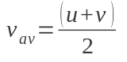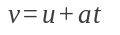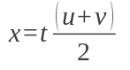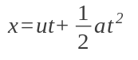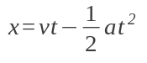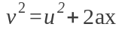

Force as a vector. A force F acting at angle theta to a direction will have components Fcos(theta) parallel to the reference direction and Fsin(theta) perpendicular to the reference direction.

Newtons laws of motion
Inertia: Every object in a state of uniform motion tends to remain in that state of motion unless an external force is applied to it.
When net force is zero, the object will remain in it's state of motion

F = ma (force = mass X acceleration where force is in newtons (N), mass is in kg and acceleration is in ms⁻²

For every action there is an equal and opposite reaction. The force of object A on object B is the opposite of the force of object B on object A. Contact normal force and gravity is not an action-reaction pair as they both act on the same object. The action-reaction pair is the gravity of the object on the earth and the gravity of the earth on the object.

The normal force is a reaction force supplied by a surface at 90 degrees to its plane.

Momentum
p = mv
where p is in kg ms ⁻¹
where m is mass in kg
where v is velocity in ms⁻¹
Change in momentum is proportional to net force applied.

Impulse
Impulse is measured in Newton seconds (Ns)
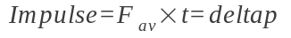
impulse = average force x time = difference in momentum= area under the force time graph.

Conservation of momentum
or
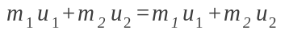

Work
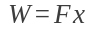
Work is in Joules
Force is in Newtons
X is the magnitude in displacement in metres.
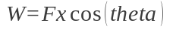
where theta is the angle between the applied force and the direction of motion.
Work = area under the force displacement graph = difference in energy
Kinetic energy
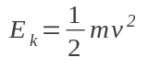

Gravitational potential energy
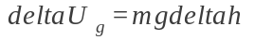Difference in gravitational potential energy is equal to mass times acceleration times by difference in height.

Elastic potential energy
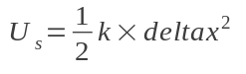k is the stiffness constant in N m⁻¹ and delta x is the extension or compression.

Power
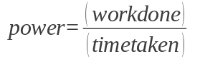power is in watts

Vectors are added tail to head
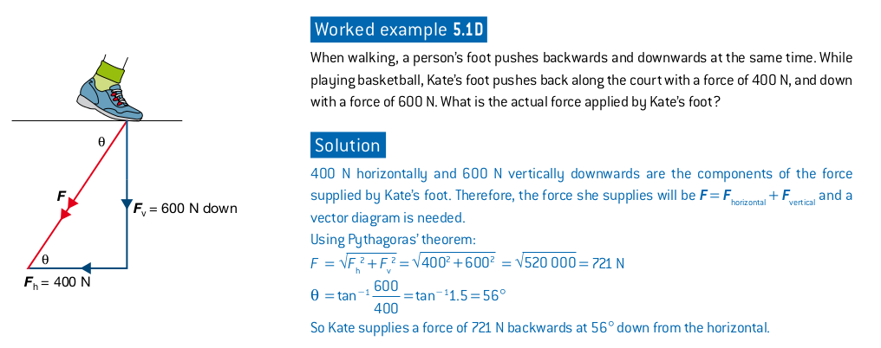
Sig figs
All non-zero digits are significant
Zeros between two non-zero digits are significant
Trailing zeros (after a decimal point) are significant
Trailing zeros in a number without a decimal point are ambiguous
In scientific notation, only the digits expressed are significant
Sig figs are bold, ambiguous digits are italicised.
You cannot have more sig figs in the answer than the lowest amount in the question. (but be careful about rounding too early)
0.00010
0.002406
42000
3.204 x 10^3
Prefixes
Giga (G) | 10^9
Mega (M) | 10^6
Kilo (k) | 10^3
Milli (m) | 10^-3
Mirco (u) | 10^-6
Nano (n) | 10^-9
Snells Law 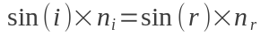
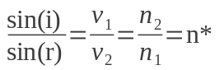where i is the incident angle, and r is the refracted angle, v is the speed the light is going, n is the index of refraction and n* is the relative index of refraction.
Lens/Mirror Formula 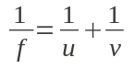
where f is the focal length, u is the object distance and v is the image distance
Magnification 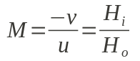
Where H_{i} is the image height, H_{o} is the object height, u is the object distance and v is the image distance.
if M is positive image is upright and virtual, and if it is negative image is upside down and real.

Critical angle 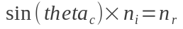or 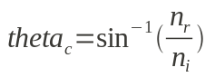where theta_{c} is the critical angle, and n_{i} is the index of refraction of the substance that the incident ray is in and n_{r} is the index of refraction that the refracted angle travels to.
Wave Equation 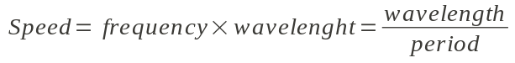
Frequency 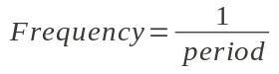
Refraction Slow down = light moves towards normal

f focal length
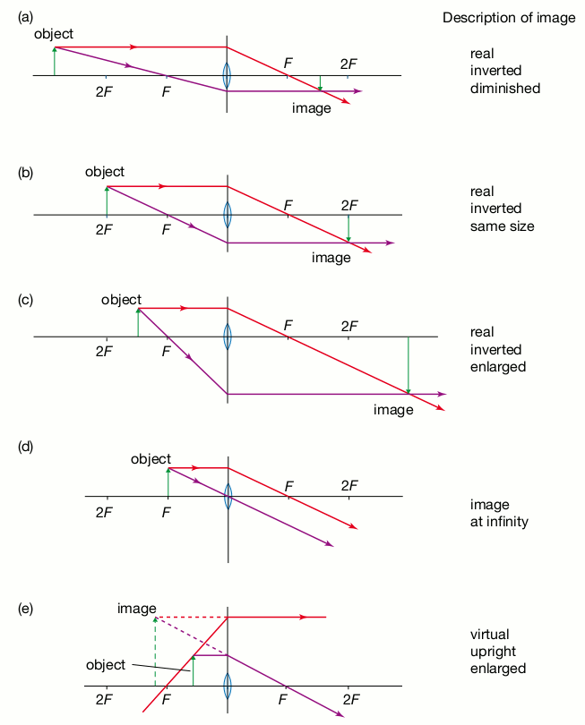
F focal point
P pole or centre of mirror
R radius of circle
C centre of circle

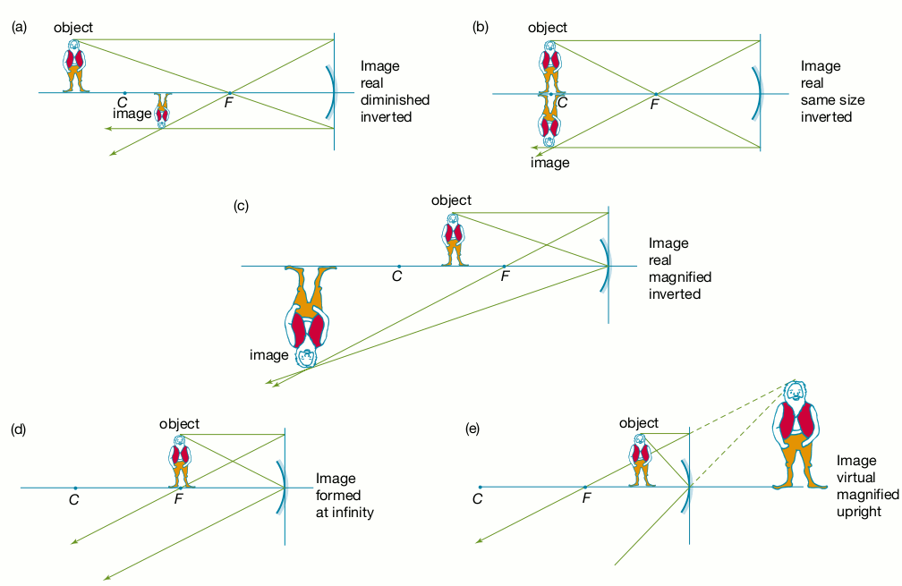

Transparent substances allow light through and do not scatter the light, allowing for image formation.
Translucent substances allow light through and do scatter the light, not allowing image formation.

Polarisation is when the orientation of the transverse wave of a body of light is all in the same direction. In unpolarised light, the orientations are at random. If light goes through a polarisation filter, the amplitude of the resulting wave is related to how big the angle difference between the filter and the traverse wave is.

Waves that come to an unyielding boundary not undergo a phase shift. Waves that come to the free end of a string will undergo a phase shift of half the wavelength. Waves that collide from two different ends of a rope will undergo interference. They will then add together.

Blue light = Higher frequency = Shorter wavelength = Higher energy = More refracted = Slower Speed
Red light = Lower frequency = Longer wavelength = Lower energy = Less refracted = Faster speed

