**MOTION**

**Equations of Motion**

$${v= u + at v}_{avg}=\frac{u+v}{2} x = t × \frac{u+v}{2}$$

$$x = ut + \frac{1}{2}t^{2}=vt -\frac{1}{2}t^{2} v^{2}=u^{2}+2ax$$

$$t = \frac{±\sqrt{u^{2}+2ax}-u}{a}=\frac{±\sqrt{v^{2}-2ax}+u}{a}$$

**Newtons Laws**

Inertia: motion does not change without a force.

F (Newtons) = m (kg) x a (ms-2)

For every action there is an equal and opposite reaction force that acts on another object. IE force obj A on B = force obj B on A IE The pair of Normal force is the force of the obj on the earth  
**Projectile Motion**

Only force on a projectile in the air is gravity

A projectile has two components to its motion

Horizontal is constant velocity

Vertical is constant acceleration  
At peak vertical velocity = 0

**Momentum** p = mv in kgms-1 = kg x ms-1  
∆p α force applied

**Impulse** I = Faverage x t = ∆p = ∫force time graph

**Conservation of momentum**

M1V1 x M2V2 = M1V1 x M2V2

Elastic collisions: Kinetic energy and momentum conserved

Inelastic collisions: only momentum conserved

**Work** W = Fx in J = N x m

W = Fxcosθ

θ is angle between applied force and motion

W= area under force distance graph = ∆E

**Elastic potential energy**

Us=0.5 k(∆x)2

Us = area under force displacement graph

K = slope of force displacement graph

Where k is stiffness constant in Nm-1

Hookes law: force exerted by spring α displacement x force constant

**Power** work done over time in W = J / s  
**Circular motion in the horizontal plane**

*t = time T = period*

Average speed of object with circular path $$v = \frac{dx}{dt}= \frac{2πr}{t}$$

Centripedal acceleration

$$a = \frac{v^{2}}{r}=\frac{4π^{2}r}{T^{2}}$$

Centripedal force $$f= ma = \frac{mv^{2}}{r}=\frac{4π^{2}rm}{T^{2}}$$

**Design Speed -** You will have to show the derivation.

$$F_{n}cosθ=mg AND F_{n}sinθ=\frac{mv^{2}}{r}$$

$$\frac{mg}{cosθ}=\frac{mv^{2}}{rsinθ}$$

$$tanθ=tanθ= \frac{mv^{2}}{rg}$$

$$v = \sqrt{tanθrg} OR θ=\tan^{-1}\left(\frac{v^{2}}{rg}\right)$$

**Circular motion in the vertical plane**

Only worry about top and bottom of circle  
T is an inward force to ensure net force is complete  
can be provided by anything, ie tension etc  
apparent weight is the normal force provided to a human.

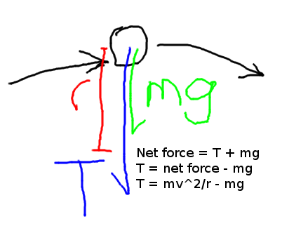

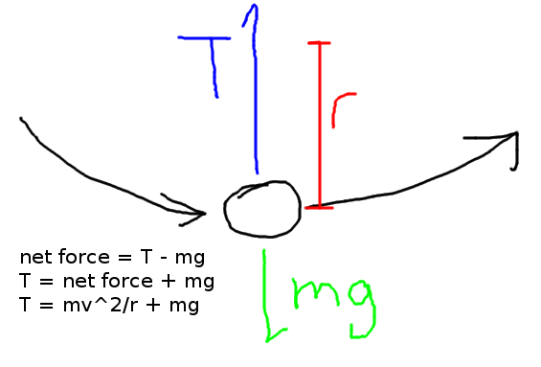

**Gravity and satellites**

Newtons law of unversal gravitation

G = 6.67 x 10-11Nm2kg-2

Speed of satellite

$$v=\frac{Δx}{Δt}=\frac{2πr}{T}$$

Or

$$mg = \frac{mv^{2}}{r}$$

$$g = \frac{v^{2}}{r}$$

$$v = \sqrt{rg}=\sqrt{\frac{GM}{r}}$$

Graviational Force

$$F_{g}=mg=\frac{mv^{2}}{r}=\frac{4π^{2}rm}{T^{2}}=\frac{G×M_{1}×M_{2}}{R^{2}}$$

Keplers Third law

$$\frac{R^{3}}{T^{2}}=\frac{GM}{4π^{2}}$$

Where M is central mass, T is period in seconds

$$T=\sqrt{\frac{4π^{2}R^{3}}{GM}} R = \sqrt[3]{\frac{GMT^{2}}{4π^{2}}}$$

Acceleration of Satellite

$$a=\frac{V^{2}}{R}=\frac{4π^{2}R}{T^{2}}=\frac{GM}{R^{2}}=g$$

Height = Altitude = Radius of orbit – radius of planet

**ELECTRONICS AND PHOTONICS**

**Voltage divider formulas**

$$\frac{V_{out}}{V_{in}}=\frac{R_{2}}{R_{1}+R_{2}}$$

$$R_{2}=\frac{V_{out}×R_{1}}{V_{in}-V_{out}}$$

$$R_{1}=(\frac{V_{in}}{V_{out}}-1)×R_{2}$$

**Resistance, Power and Ohm’s law**

V= IR P=VI P=I2R P=V2/R

Rseries = ∑R

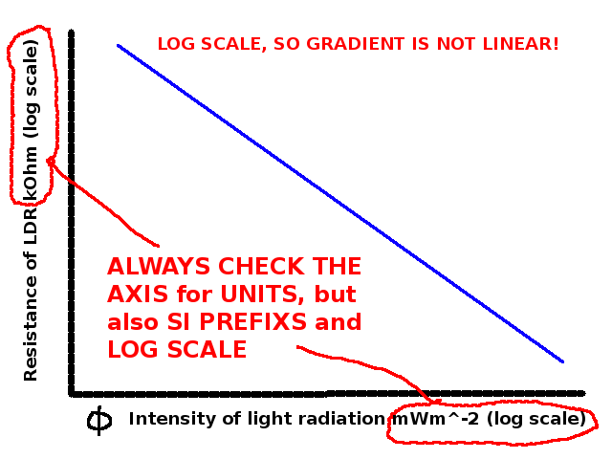 $\frac{1}{R_{paralell}}=\sum_{1}^{n}{\frac{1}{R_{n}}}$

*Short cut for two resistors*

$$R_{T}=\frac{R_{1}×R_{2}}{R_{1}+R_{2}}$$

**Diodes**

Only conduct when forward biased. When then conduct they always drop their switch on voltage. If they don’t conduct they drop the total voltage.

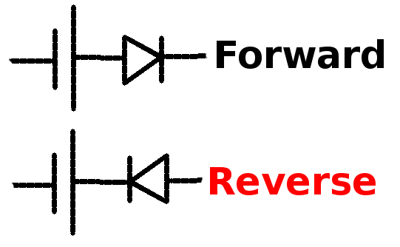

Drops **turn on voltage**

Drops **ALL** **the voltage!**

**AC/DC**

AC cycles positive/negative at a certain voltage. When converted to DC it becomes the *R*oot *M*ean *S*quare voltage $=\frac{peak voltage}{\sqrt{2}}$

**Amplifiers**

Produces output signal of same frequency, different voltage. Based on semiconductor device.

$$A_{v}=\frac{ΔV_{out}}{ΔV_{in}}$$

When calculating gain **make sure the units are the same.**

Amplifiers can be *inverting* or *non-inverting*, and *become non-linear past the cut off/saturation*.

* 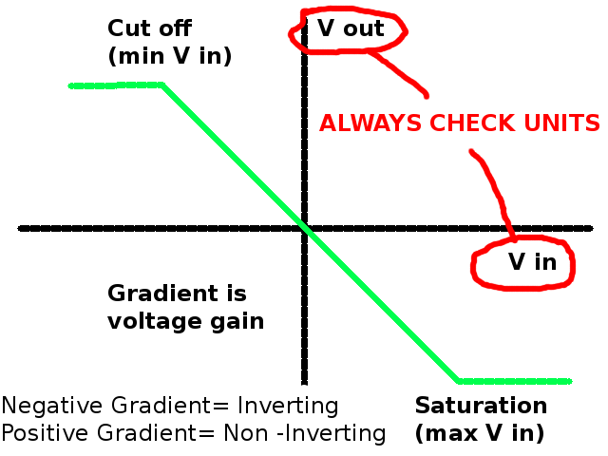Always check for distortion
* Always check for inversion
* Always check the units

For information to be sent over a medium, it must first be **modulated**, combining the signal with the carrier signal. To use the information, it must be **demodulated**, with the carrier signal stripped away.

AM = Amplitude modulation

FM = Frequency modulation

**Modulators**

*LEDs*. Nothing too special here. Amount of current impacts brightness.  
*Laser Diode.* Creates coherent light (all in phase) of high intensity. It’s collimated, so beam maintains same width.

**Demodulators**

*LDR.* Light dependant transistor. Pretty self explanatory. Can be given characteristic graph, *IMPORTANT TO CHECK THE AXIS!*

*Photodiode.*Almost always placed in reverse bias, which is the Photoconductive mode. Has the following IV characteristic.

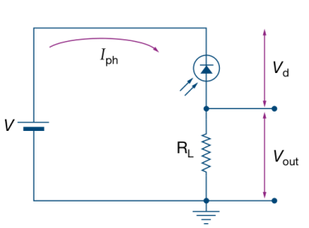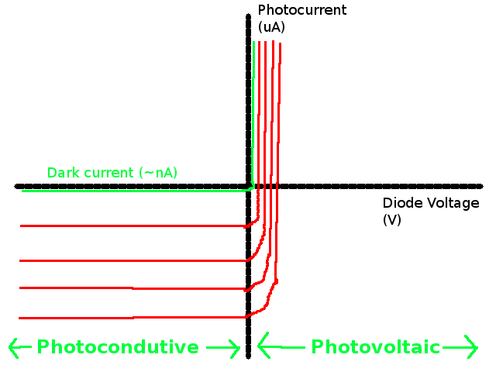

Typical Photodiode circuit.

Load resitor and photodiode may swap places.

*Phototransistor.* Is like a normal transistor, except base current is provided by light.

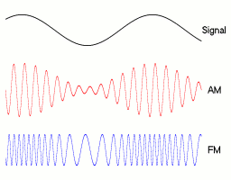

**ELECTRIC POWER + MAGNETS**

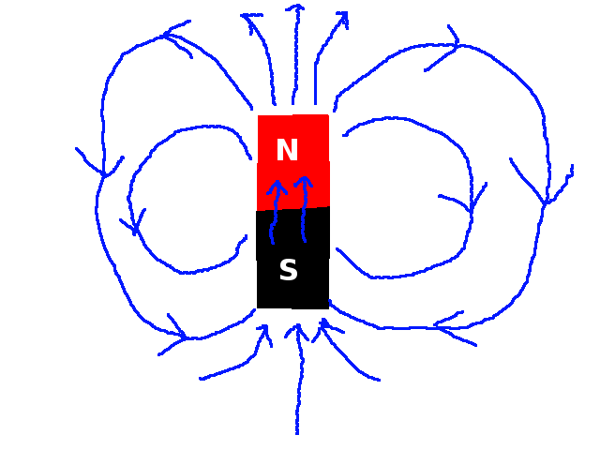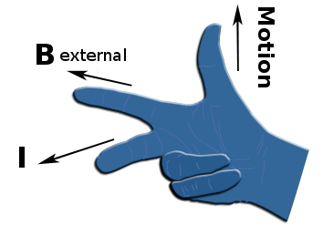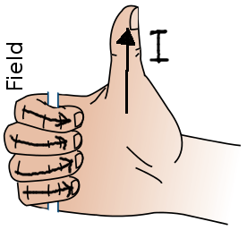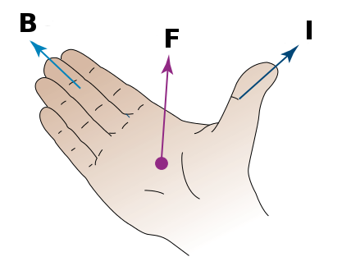

Earths magnetic field is 50uT, with magnetic north in the south

F = BIL in units N = TAM where Tesla’s have the units NA-1M-1

where θ is the angle between L and B.

Force Fq on charge q moving at v velocity in field B is

Fq = qvB or Fq = qvBsinθ where θ is angle between v and B

**Faradays Law**

ΦB=BAcosθ where θ is angle between B and A

I α $\frac{Δϕ_{B}}{Δt}$ ξ=- $\frac{Δϕ_{B}}{Δt}$ ξ= $-N\frac{Δϕ_{B}}{Δt}$

For a straight wire moving in an electric field

ξ=vBL

**Coils!**

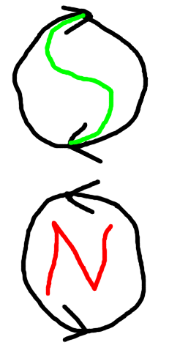A *soft iron core* increases magnetic field strength *x1000*

They are strongest on the inside, and weakest on the outside.

**Lenz’ Law**

LENZ’S LAW states that any induced current in a loop will be in the direction so that the flux it creates will oppose the **CHANGE** in the flux that produced it.

**Transformers**

Transfers power, not current or voltage. The Primary coil is connected to an AC supply, and the secondary coil is connected to the load.

$$\frac{I_{s}}{I_{p}}=\frac{V_{p}}{V_{s}}=\frac{N_{p}}{N_{s}}$$

Ussually around a 1-2% power loss. Improvements:

* Laminate the core (layer it) so eddy currents are minimized
* Keep it cool/still and have low resistance coils

**Motors!**

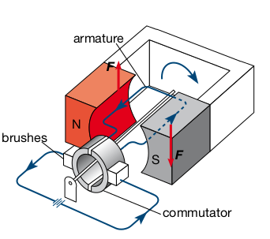

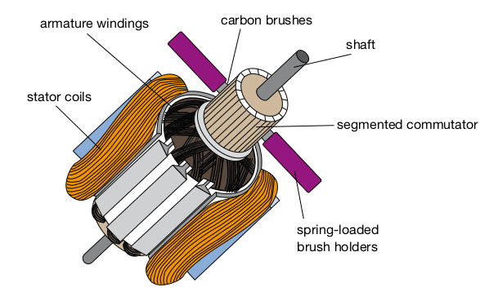

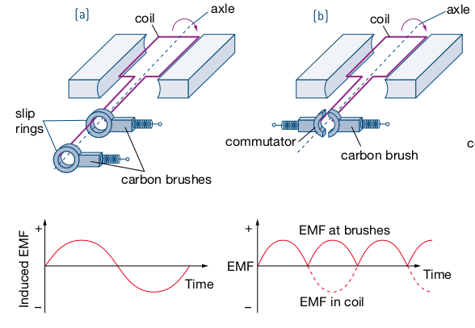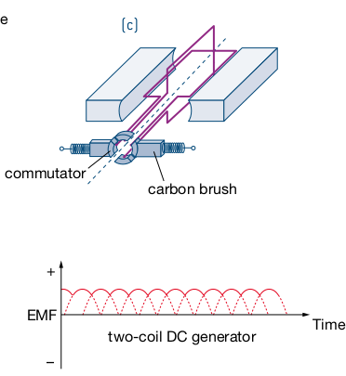

**SOUND**

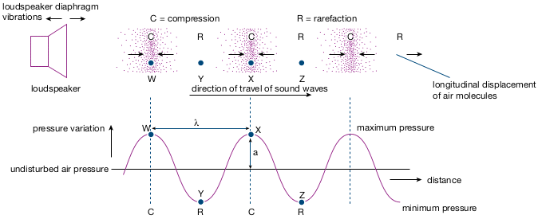

Velocity = frequency x wavelength  
Frequency is the inverse of period

amount of diffraction α wavelength / aperture length where > 1 is 'significant diffraction'  
Higher frequencies (shorter wavelengths) are diffracted less.  
  
Sound Level != Sound Intensity

Decibel Scale Power/Area $L=10\log{\frac{I}{{10}^{-12}}}$

$I={10}^{\frac{L}{10-12}}$ 3db is approximately double the intensity  
Intensity α r -2

k is 1 when there is no other loss of energy within the medium

So if r increases N times, intensity = I / N2

**Wavelengths for standing waves**

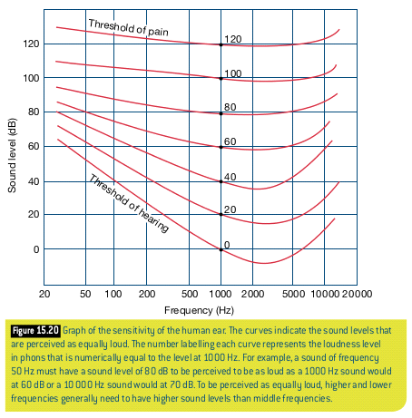Strings and open ended pipes:  
Wavelength n = 2L / n for the nth harmonic  
Frequency n = nv / 2L for the nth harmonic  
  
Fundamental – first harmonic

1st overtone – second harmonic  
2nd overtone – third harmonic

Closed ended pipes – They only have odd numbered harmonics (ie n = [1,3,5...])

Wavelength n = 4L / n for the nth harmonic  
Frequency n = nv / 4L for the nth harmonic

Fundamental – first harmonic

1st overtone – third harmonic  
2nd overtone – fifth harmonic

**Mics and woofers***Dynamic: AKA Moving coil*

Has a diaphragm attached to coil, which surrounds a powerful magnet. Induces current. Used in PA systems, music – it's that typical handheld mic  
*Condenser:*  
Old word for capacitor: it's just two metal plates, with one plate fixed. As the other moves, the voltage drop across changes, thus producing variable current.  
*Crystal:*  
Has a diaphragm which compresses a pizzeo-electric crystal which makes voltage  
*Ribbon:*  
has aluminium ribbon suspended between two magnets, which is vibrates with the air around it, inducing current.

**QUANTUMN MECHANIX**

**Double Slit expiriment**

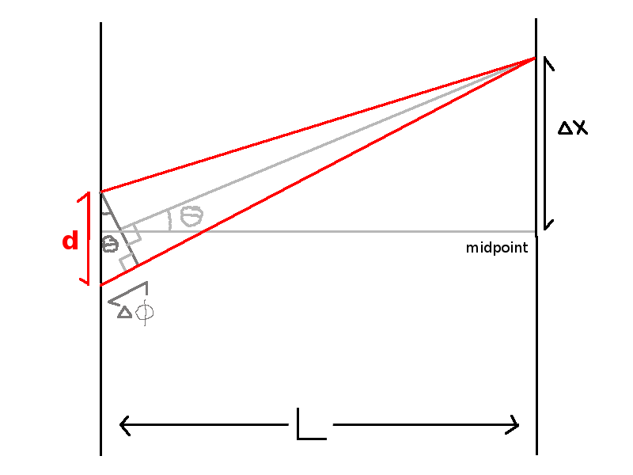

If ∆Φ=nλ it is a bright spot, an antinode (waves in phase)

If ∆Φ=(n-0.5)λ is is a dark sprt, a node (waves out of phase)

∆Φ (path difference) = dsinθ

$$d=\frac{nλ}{sinθ} θ=\sin^{-1}\left(\frac{nλ}{d}\right)$$

**Photoelectric effect**

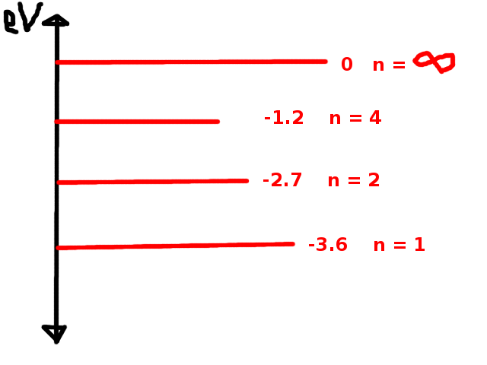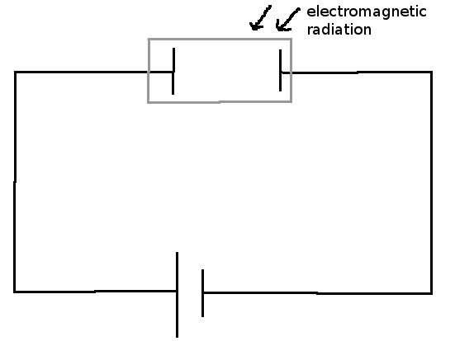Electrons emitted by matter when struck with certain types of electromagnetic radiation. They are called *Photoelectrons.*

1eV is the energy an electron gives up crossing an opposing voltage of 1V

Ek = hf – Φ which is the work function

Each metal has a unique frequency f0 where hf0= Φ

**Graphs**

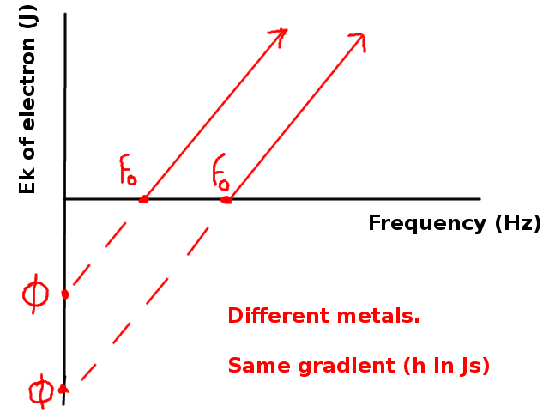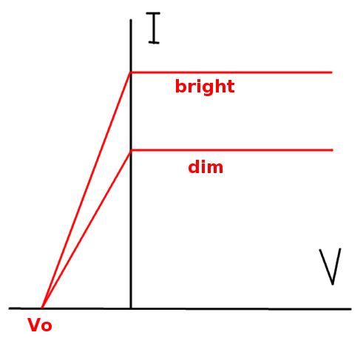

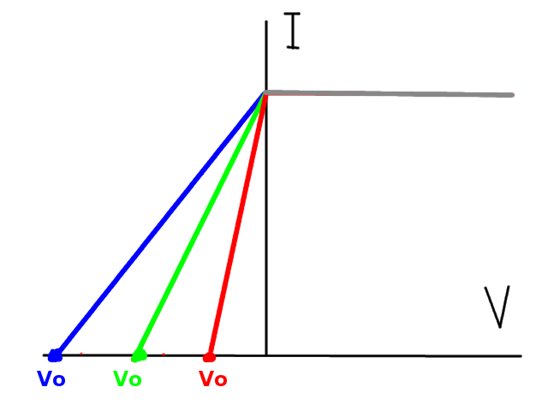

Stuff we haven’t learnt yet…

Momentumn of photon = p = $\frac{h}{λ}$

**Matter waves**

The De Broglie wavelength of a piece of matter is given by $λ=\frac{h}{mv}$ with units $m=\frac{Js}{kgms^{-1}}$ and only really has an effect on the quantumn level.

**Emission Spectra**

Bohrs model – V limited, only really works on H

* Centripedal force on electrons is electrostatic attraction
* Electromagnetic radiation can only be absorbed when E or hf is equal to or greater than size of orbit jump.
* Electromagnetic radiation emitted is exactly the same as energy gained

**Braggs law** describs the location of antinodes when xray is diffracted, given by nλ=2dsinθ

**Energy level diagrams**

Can be zeroed at ionization energy (n=∞) or at ground state (n=0)

Energy levels have an equivalent in standing waves in a pipe open at both ends.

High Frequency = Short λ = High Energy = Blue

Low Frequency = Long λ = Low Energy = Red