“_” 匹配单个字bai符du,”\_”zhi 匹配”_”

“%” 匹配dao任意个字zhuan符,包括零个字符

sql模式下的匹配，缺省是忽略大小shu写的，并且sql模式下的模糊匹配不能使用“=”或”!=”，而使用 like 或 not like.

1、使用比较运算符的子查询  
   
   =、>、<、>=、<=、<>、！=、<=>  
  
   语法结构：  
     
          operand comparision_operator subquery  
  
eg： SELECT AVG(goods_prise) FROM tdb_goods；  
  
2、用ANY、SOME、ALL修饰的比较运算符  
   
   operand comparision_operator ANY (subquery)   //符合一个就行  
   
   operand comparision_operator SOME (subquery)  //符合一个就行  
  
   operand comparision_operator ALL (subquery)   //必须全部符合  
  
eg： SELECT goods_id goods_name goods_prise FROM tdb_goods WHERE   ANY  (SELECT good_price FROM tdb_goods WHERE goods_cate='超极本'）

**MySQL 运算符**

本章节我们主要介绍 MySQL 的运算符及运算符的优先级。 MySQL 主要有以下几种运算符：

* 算术运算符
* 比较运算符
* 逻辑运算符
* 位运算符

**算术运算符**

MySQL 支持的算术运算符包括:

|  |  |
| --- | --- |
| **运算符** | **作用** |
| + | 加法 |
| - | 减法 |
| * | 乘法 |
| / 或 DIV | 除法 |
| % 或 MOD | 取余 |

在除法运算和模运算中，如果除数为0，将是非法除数，返回结果为NULL。

1、加

mysql> select 1+2;

+-----+

| 1+2 |

+-----+

| 3 |

+-----+

2、减

mysql> select 1-2;

+-----+

| 1-2 |

+-----+

| -1 |

+-----+

3、乘

mysql> select 2*3;

+-----+

| 2*3 |

+-----+

| 6 |

+-----+

4、除

mysql> select 2/3;

+--------+

| 2/3 |

+--------+

| 0.6667 |

+--------+

5、商

mysql> select 10 DIV 4;

+----------+

| 10 DIV 4 |

+----------+

| 2 |

+----------+

6、取余

mysql> select 10 MOD 4;

+----------+

| 10 MOD 4 |

+----------+

| 2 |

+----------+

**比较运算符**

SELECT 语句中的条件语句经常要使用比较运算符。通过这些比较运算符，可以判断表中的哪些记录是符合条件的。比较结果为真，则返回 1，为假则返回 0，比较结果不确定则返回 NULL。

| **符号** | **描述** | **备注** |
| --- | --- | --- |
| = | 等于 |  |
| <>, != | 不等于 |  |
| > | 大于 |  |
| < | 小于 |  |
| <= | 小于等于 |  |
| >= | 大于等于 |  |
| BETWEEN | 在两值之间 | >=min&&<=max |
| NOT BETWEEN | 不在两值之间 |  |
| IN | 在集合中 |  |
| NOT IN | 不在集合中 |  |
| <=> | 严格比较两个NULL值是否相等 | 两个操作码均为NULL时，其所得值为1；而当一个操作码为NULL时，其所得值为0 |
| LIKE | 模糊匹配 |  |
| REGEXP 或 RLIKE | 正则式匹配 |  |
| IS NULL | 为空 |  |
| IS NOT NULL | 不为空 |  |

1、等于

mysql> select 2=3;

+-----+

| 2=3 |

+-----+

| 0 |

+-----+

mysql> select NULL = NULL;

+-------------+

| NULL = NULL |

+-------------+

| NULL |

+-------------+

2、不等于

mysql> select 2<>3;

+------+

| 2<>3 |

+------+

| 1 |

+------+

3、安全等于

与 **=** 的区别在于当两个操作码均为 NULL 时，其所得值为 1 而不为 NULL，而当一个操作码为 NULL 时，其所得值为 0而不为 NULL。

mysql> select 2<=>3;

+-------+

| 2<=>3 |

+-------+

| 0 |

+-------+

mysql> select null=null;

+-----------+

| null=null |

+-----------+

| NULL |

+-----------+

mysql> select null<=>null;

+-------------+

| null<=>null |

+-------------+

| 1 |

+-------------+

4、小于

mysql> select 2<3;

+-----+

| 2<3 |

+-----+

| 1 |

+-----+

5、小于等于

mysql> select 2<=3;

+------+

| 2<=3 |

+------+

| 1 |

+------+

6、大于

mysql> select 2>3;

+-----+

| 2>3 |

+-----+

| 0 |

+-----+

7、大于等于

mysql> select 2>=3;

+------+

| 2>=3 |

+------+

| 0 |

+------+

8、BETWEEN

mysql> select 5 between 1 and 10;

+--------------------+

| 5 between 1 and 10 |

+--------------------+

| 1 |

+--------------------+

9、IN

mysql> select 5 in (1,2,3,4,5);

+------------------+

| 5 in (1,2,3,4,5) |

+------------------+

| 1 |

+------------------+

10、NOT IN

mysql> select 5 not in (1,2,3,4,5);

+----------------------+

| 5 not in (1,2,3,4,5) |

+----------------------+

| 0 |

+----------------------+

11、IS NULL

mysql> select null is NULL;

+--------------+

| null is NULL |

+--------------+

| 1 |

+--------------+

mysql> select 'a' is NULL;

+-------------+

| 'a' is NULL |

+-------------+

| 0 |

+-------------+

12、IS NOT NULL

mysql> select null IS NOT NULL;

+------------------+

| null IS NOT NULL |

+------------------+

| 0 |

+------------------+

mysql> select 'a' IS NOT NULL;

+-----------------+

| 'a' IS NOT NULL |

+-----------------+

| 1 |

+-----------------+

13、LIKE

mysql> select '12345' like '12%';

+--------------------+

| '12345' like '12%' |

+--------------------+

| 1 |

+--------------------+

mysql> select '12345' like '12_';

+--------------------+

| '12345' like '12_' |

+--------------------+

| 0 |

+--------------------+

14、REGEXP

mysql> select 'beijing' REGEXP 'jing';

+-------------------------+

| 'beijing' REGEXP 'jing' |

+-------------------------+

| 1 |

+-------------------------+

mysql> select 'beijing' REGEXP 'xi';

+-----------------------+

| 'beijing' REGEXP 'xi' |

+-----------------------+

| 0 |

+-----------------------+

**逻辑运算符**

逻辑运算符用来判断表达式的真假。如果表达式是真，结果返回 1。如果表达式是假，结果返回 0。

|  |  |
| --- | --- |
| **运算符号** | **作用** |
| NOT 或 ! | 逻辑非 |
| AND | 逻辑与 |
| OR | 逻辑或 |
| XOR | 逻辑异或 |

1、与

mysql> select 2 and 0;

+---------+

| 2 and 0 |

+---------+

| 0 |

+---------+

mysql> select 2 and 1;

+---------+

| 2 and 1 |

+---------+

| 1 |

+---------+

2、或

mysql> select 2 or 0;

+--------+

| 2 or 0 |

+--------+

| 1 |

+--------+

mysql> select 2 or 1;

+--------+

| 2 or 1 |

+--------+

| 1 |

+--------+

mysql> select 0 or 0;

+--------+

| 0 or 0 |

+--------+

| 0 |

+--------+

mysql> select 1 || 0;

+--------+

| 1 || 0 |

+--------+

| 1 |

+--------+

3、非

mysql> select not 1;

+-------+

| not 1 |

+-------+

| 0 |

+-------+

mysql> select !0;

+----+

| !0 |

+----+

| 1 |

+----+

4、异或

mysql> select 1 xor 1;

+---------+

| 1 xor 1 |

+---------+

| 0 |

+---------+

mysql> select 0 xor 0;

+---------+

| 0 xor 0 |

+---------+

| 0 |

+---------+

mysql> select 1 xor 0;

+---------+

| 1 xor 0 |

+---------+

| 1 |

+---------+

mysql> select null or 1;

+-----------+

| null or 1 |

+-----------+

| 1 |

+-----------+

mysql> select 1 ^ 0;

+-------+

| 1 ^ 0 |

+-------+

| 1 |

+-------+

**位运算符**

位运算符是在二进制数上进行计算的运算符。位运算会先将操作数变成二进制数，进行位运算。然后再将计算结果从二进制数变回十进制数。

|  |  |
| --- | --- |
| **运算符号** | **作用** |
| & | 按位与 |
| | | 按位或 |
| ^ | 按位异或 |
| ! | 取反 |
| << | 左移 |
| >> | 右移 |

1、按位与

mysql> select 3&5;

+-----+

| 3&5 |

+-----+

| 1 |

+-----+

2、按位或

mysql> select 3|5;

+-----+

| 3|5 |

+-----+

| 7 |

+-----+

3、按位异或

mysql> select 3^5;

+-----+

| 3^5 |

+-----+

| 6 |

+-----+

4、按位取反

mysql> select ~18446744073709551612;

+-----------------------+

| ~18446744073709551612 |

+-----------------------+

| 3 |

+-----------------------+

5、按位右移

mysql> select 3>>1;

+------+

| 3>>1 |

+------+

| 1 |

+------+

6、按位左移

mysql> select 3<<1;

+------+

| 3<<1 |

+------+

| 6 |

+------+

**运算符优先级**

最低优先级为： **:=**。

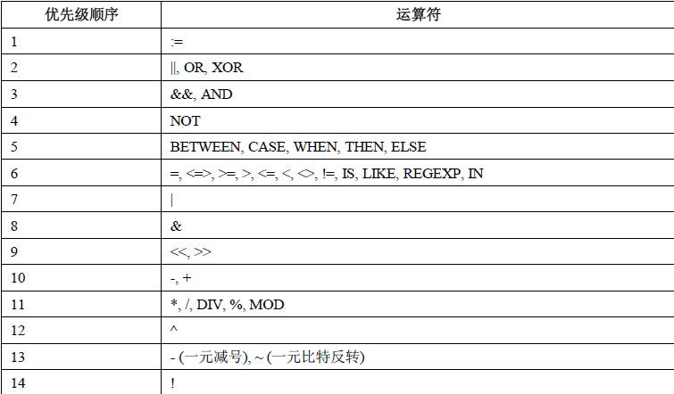

最高优先级为： **!**、**BINARY**、 **COLLATE**。