

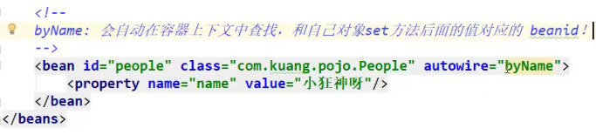

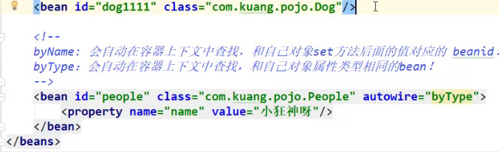

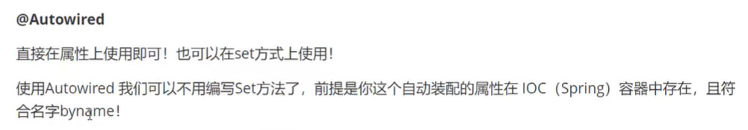



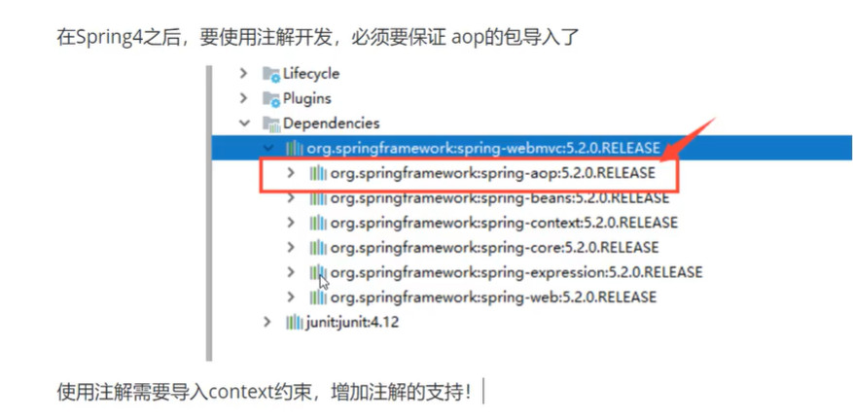

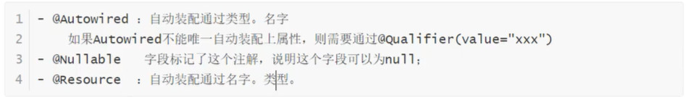

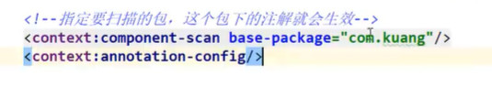

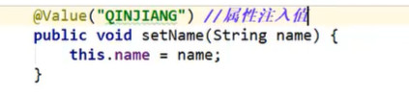

[(3条消息) Spring @Configuration 和 @Component 区别_偶尔记一下 - mybatis.io-CSDN博客](https://blog.csdn.net/isea533/article/details/78072133)

