MPEG-4视频技术当前的发展现状
摘要：MPEG-4承诺能对多媒体技术的传输，存储和处理产生重大的影响。这篇文章将阐述MPEG-4技术的现状和将来的发展前景。当前MPEG-4的热点是检验模型（VM），使他成为全球标准化方向发展。我们要说明包括VM的现状和利用它的技术压缩视频的例子。
- 介绍
MPEG-4的目标是能达到广阔的应用。它的范围从有线电视服务（AV）到高级通信。到最后，MPEG-4会包括许多功能，而现在的标准却没有达到的水平。严格的说，MPEG-4技术已经被应用到现在视频技术的各个方面。在以前，H.261, H.263 和MPEG-2等老标准是视频编码的最基本技术，这些基本编码单元是任意形的物体。因此以前的要求新的信息流是物体的形状和控制它的显示（显示的合成）。这些信息必须是亮度数据和色度数据的结合体，这样才能成为一个高效高质的编码。
为了提供一个普遍的平台给独立的实验室，就需要提供一个很好的编码和解码环境-检验模型（VM）。MPEG-4视频小组最近成功的定义了作为MPEG-4标准过程的的视频制作模型。它的详细规范和视频编码技术最终可以被认为是国际MPEG-4标准（1998年11月）
随着VM的框架随着仿真和核心实验的进行会被出台。在这些仿真实验中，用制定好的VM去代替不同的编码技术。当相应的核心实验证明一种技术能够改进显示或能够更好的执行先前的技术后，这种技术就被引进到VM中了（也许这种技术会很快的被其它新出现的技术代替）。这样VM通过技术标准的进步而不断的改进，不断增加新的功能，也就领导了未来编码技术所要选择的方向。在1996年1月的MPEG的会议上，制定了VM技术的1.0版。这种定义随着核心实验的经行也在不断的编进进步，本文将简述MPEG-4视频VM 2.1版。
在文章的下一段，将简要描述MPEG-4的功能性和应用领域。在这以后我们将阐述VM作为一个编码器和译码器的功能表现。在后来的段落中将讲述VM现在采用的编码技术。他们是以前采用的技术很相似，但是他却包含了编码的最新技术和一些最新信息。一些编码结果会有提供的软件提供。最后，简要的介绍一下MPEG-4正在进行的核心实验。
- MPEG-4的功能特性
MPEG-4在增加了AV编码标准的功能（例如：显示，合成，安全）必须提供之外，更多和进步的功能也加入了。这些功能特性能被应用要求分成3类。
压缩：视频的压缩效率会对AV数据的存储和传输产生直接的影响。MPEG-4能够提供比现在的任何标准都要更好的AV质量（在码率方面），这样就要求提供更好的编码效率，AV的场景会成倍的增加图像和声道（两者必须是同步的）会提出更高要求的多媒体编码数据流技术。这些功能能够使用在娱乐和飞行模拟，等等方面。
通用存储：通用存储包含连个功能这样能确保MPEG-4解码可以获得广泛的传输和存储媒体。在一些不良环境的条件中允许低码率（通过无线网络进入数据库）。MPEG-4能够提供媒体能测量的内容，质量（空间，瞬时清晰度）和复杂性来达到基于内容的可测量性。这是功能对在浏览不同内容等级的数据库，等级，清晰度和质量方面是非常重要的。
可能最让人感兴趣和创新的功能是基于内容的交互。这个类包含杂和自然和综合编码，基于内容处理和流媒体编辑，改进的随机存储和基于内容的多媒体数据处理工具。这些允许用户在有意义的场景产生相互影响。典型的说，这些功能是计算机图像有联系的。而这些图像是相互影响产生的物体。MPEG-4也能够扩展自然视频内容场景的的交互。这些应用将受益于某种形式的基于内容互动包括基于内容的检索数据库, 交互式家庭购物, 家庭电影制造和编辑, 计算机游戏合并自然录影和综合性动画，并且用户控制了数字式作用或字幕。
MPEG-4能够用灵活的还原“真世界”内容的AV画面支持用户交互式支持。对于视频，“真世界”的内容与用户在某些方面发现有趣的内容相符和。比如人类说话，一个移动的物体，一个可移动的图标，等等。最后，一个场景可以由各自独立的视频物体所组成的。每个物体是由相互联系的空间和时间所合成的。提供所需功能的编码对象的组成及其相关资料等,尽可能有效，这些代表作为独立实体的码,以方便用户可在获取和操纵。
- VM的结构
接下来的几段我们解释VM的高层次结构：

3.1 编码结构
VM编码器的工作结构如图1所示，它采用了一种分层编码技术。每个视频物体平面的形状和质量信息是分别编码的，这样能提高工作效率。被编码以后的视频物体平面是是多元的，这样能使每个视频物体平面在比特流中占有独立的片段。虽然在图1中没有说明，但它已经被合成到视频物体平面的信息中了，即被编码和合成到相关的视频物体平面层中了。
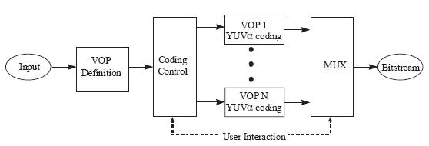
图1 VM编码器的高级水平结构

3.2 编码结构
VM编码器的高级水平结构如图2所示。视频物体平面层中的比特流是被独立编码的。合成块的任务是将被编码的视频物体平面后输出到显示。视频物体平面视频对象平面是一个复合命令是明确指定其相关的"组成信息"。基于α通道的模糊视频物体平面被继承的YUV组件取代两个视频物体平面组件。在多于两个视频物体平面的情况下，将每次的输出作为背景合成过程不断调用，然后合成过程不断调用。
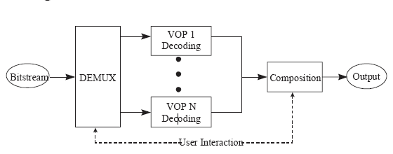
图2 VM解码器的高级水平结构
- VM编码工具
在二进制情况下，α块被分成四个等级的QT结构，如图3所示。在最低水平（水平3），每个2*2块是由预先制定的α像素值所确定。这种方式是和周围像素的显示无关的。在水平2，块的索引以类似的方式说明(如有)的相关座低等高层次包含的信息。这个程序在水平1和水平0所重复。这每个α块就包含85（1+4+16+64）个索引值，通过QT结构，水平0就开始前进。该指数显示，一小部分含有等量块编码可以采用变长码字。
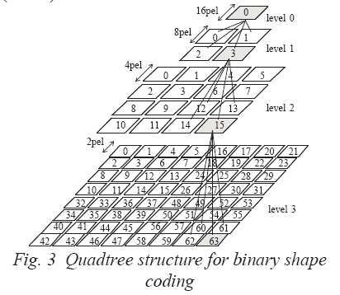
图3 图像质量的二进制分层编码
- 仿真结果
本节介绍其中一些VM平台上的编码成果，也说了独立视频物体平面编码方法的例子。我们有意初步的证明，MPEG-4将支持的功能种类。这些结果是通过建立的VM模型的MPEG-4 ANSI C软件的执行而得到的。在MoMuSys工程发展和MPEG-4小组鼓励大家用MPEG技术发展软件编码技术的的情况下得到了很好的执行效果。这里有四个关于MPEG新测试的结果给大家参考。这些结果由四个不同的视频物体平面的MPEG图像组成，它们已经在先前的实验中编码了（比如先对视频进行了预先的分割）。在表1中我们将描述结果
名字 | 描述 | 类型
视频物体平面1 | 背景视频 | 自然视频
视频物体平面2 | 芭蕾舞场景 | 自然视频
视频物体平面3 | 男人和女人 | 自然视频
视频物体平面4 | 文本 | 人工合成
表1 测试结果
每个视频物体平面都是在VM开启动作结构模型和高级自由动作模型功能开启的情况下进行编码的。每个视频物体平面是在10赫兹的情况下运行一百次，也没有引入比特率要求。每个视频物体平面的第一步是用内部编码模式（I-视频物体平面）并且成功的和P-视频物体平面编码模式编码（B-视频物体平面没有使用）。每个视频物体平面的编码的比特率如图标4-7所示，每个图表由三条曲线组成，分别是形状占用的比特率（i），动作和结构占用的比特率（ii）和总的比特率（iii），这样就能表示视频物体平面的在比特流中的要求（包括视频物体平面的构造和合成信息）。为了更好的介绍实验效果，在每个视频物体平面中比特率的值并没有完全表示出来。
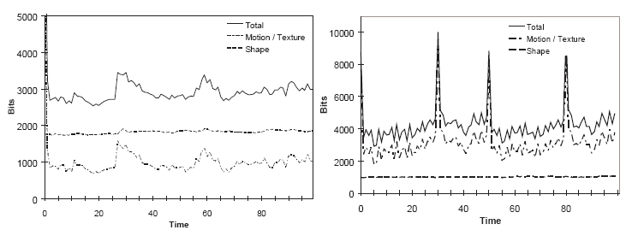
图4 VOP1的比特使用 图5 VOP2的比特使用
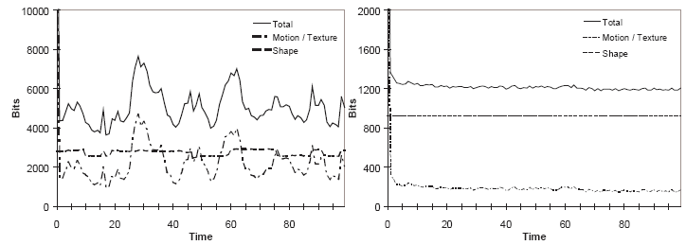
图6 VOP3的比特使用 图7 VOP4的比特使用
视频物体平面编码的例子在图8-11中表示出来了。这些图像都采用不同的大小限制的视频物体平面工具箱，从视频物体平面的形状和动作/结构独立的重新构建。在图8-11中，描述的是视频物体平面的原始白色外部区域。而图11描述的原始区域是黑色的。每个视频物体平面的合成信息也已经被编码，也包括那些在编码后缺失的交互信息。在这些信息中我们可以得到，这四个视频物体平面最终何在一起而重生了原始场景（图12）。

图8：VOP1编码结果 图9：VOP2编码结果 图10：VOP3编码结果 图11：VOP4编码结果 图12：合成效果
- 核心实验
核心实验的目的是用来测试一些将被引入MPEG-4标准的新技术的效果。现在的核心实验有9种类型，这些是预测（比如动作补偿的新方法），常规结构编码（比如微波，适应性填补和拉布拉斯变换编码），质量和码率控制，形状和阿尔法通道编码，物体/ 原始结构编码（例如形状适应性的离散余弦函数变换或者可变的原始结构微波编码），错误恢复能力（比如错误隐藏，返回通道信号化，单方向VLC编码），带宽和复杂性放缩（基于内容的时间和空间的可测量性），多面观察和交互式外形（比如声道编码和网格处理），预/ 进行/后期处理（噪音去除技术。新的核心实验被认为是标准化进程的标志。
- 总结
我们在这里总结了固定模型进程和核心实验对MPEG-4视频技术的发展的贡献。虽然这些技术细节正在被采纳中，但是视频物体合成技术已经有了很大进展，并且已经成功的在用户的控制下满足将来多媒体标准的完成物体还原要求。

参考文献
- F. Pereira, “MPEG4: a New Challenge for the Representation of Audio-Visual Information”, Proceedings of PCS’96, Melbourne, March 1996.
- MPEG Video Group, “MPEG 4 Video Verification Model Version 2.1”, Doc. ISO/IEC JTC1/SC29/WG11, Florence meeting, May 1996.
- MPEG AOE Group, “Proposal Package Description (PPD) - Revision 3”, Doc. ISO/IEC JTC1/SC29/WG11, Tokyo meeting, July 1995.
- I. Corset,“Proposal for a structure allowing wide range of core experiments”, contribution to the MPEG4 ad-hoc group on definition of VMs for content-based video representation, 20th December 1995.
- Draft ITU-T Recommendation H.263“Video coding for low bit rate communication”International Telecommunication Union, November, 1995.

Current Developments in MPEG-4 Video
Abstract: MPEG-4 promises to have a large impact on the transmission, storage and manipulation of multimedia objects. This paper describes the future technology in terms of its aspirations and intended functionalities. The current heart of MPEG-4 video is the Verification Model (VM), which is evolving through experimentation towards the goal of standardization. We describe the techniques employed within the VM at the present time, and provide examples of its use in the object- oriented compression of video sequences.

- Introduction
MPEG-4 aims to address the emerging requirements of a broad spectrum of applications. These range from interactive audio-visual (AV) services to advanced communications. To this end, MPEG-4 will include a number of functionalities that are not well supported by existing standards. Critically, MPEG-4 has adopted a representation of video content in terms of the objects present in each scene. In previous standards such as H.261, H.263 and MPEG-2 the basic coding unit was a video frame, while in MPEG-4 video, the basic coding unit is an arbitrary-shaped semantic object. There is therefore a requirement for new information streams to allow transmission of an objects shape and to control its rendering (composition with other objects). This information must be integrated with motion compensated luminance and chrominance data in such a way as to provide a highly efficient and flexible encoding.
In order to provide a common platform for independent experimentation, a well defined encoding and decoding environment is required - the Verification Model (VM). The MPEG-4 Video Group has recently defined the Video VM which is to be used in the MPEG-4 standard process. This specification and the underlying video coding philosophy are beginning to give a good indication of what can be expected from the final MPEG-4 International Standard (November 1998) in terms of coding methodology and architecture.
Within this VM framework, simulations, known as core experiments, may be carried out. In these simulations, different video coding techniques are substituted for those defined in the VM. A new technique is eventually integrated into the VM (possibly replacing an existing one) when the corresponding core experiment demonstrates that it provides improved performance or greater ease of implementation over a previously defined technique. In this way, the VM evolves incrementally throughout the standard process, leading to a toolbox of coding techniques which may be selectively used, depending upon the functionality to be addressed. Version 1.0 of the VM was defined at the MPEG meeting held in Munich during January 1996. The definition has since evolved via the core experiment process as well as an editorial process. This paper is intended as an overview of the current state of the MPEG-4 Video VM Version 2.1.
In the next section of this paper, MPEG-4 functionalities and example application areas are briefly described, together with the content-based approach to scene representation. After this, we describe the VM as an encoder and decoder based on this representation. In subsequent sections, the main coding techniques employed by the VM are presented. These are similar to those employed in previous standards, but also include new techniques for encoding the extra information unique to MPEG-4. Some coding results generated using a software implementation are then provided. Finally, a brief description is given of some ongoing core experiments within MPEG-4.
- MPEG-4 Functionalities
In addition to the usual functionalities which an AV coding standard must provide (e.g. synchronization, networking, security, etc.) eight new or improved functionalities have been identified [3], and MPEG-4 addresses these. The functionalities are grouped into three classes based on the application requirement they support.
The Compression class includes functionalities which are essential for the efficient storage and transmission of AV data. MPEG-4 will provide subjectively better AV quality (at comparable bit rates) than any existing or emerging standard. This requirement is termed Improved Coding Efficiency. Multiple views and soundtracks of an AV scene (along with the necessary synchronization) will be made available to the user by the requirement termed Coding of Multiple Concurrent Data Streams. This functionality will be used in application areas such as multimedia entertainment, flight simulators, etc.
The Universal Access class includes two functionalities which will ensure that MPEG-4 coded data will be accessible over a wide range of transmission and storage media. The Robustness in Error-Prone Environments requirement will allow access to low-bit rate applications under severe error conditions (e.g. accessing a database over a wireless network). The requirement for Content-Based Scalability necessitates that MPEG-4 will provide the ability to achieve scalability in terms of content, quality (e.g. spatial resolution, temporal resolution) and complexity. This functionality is important for applications which involve browsing a database at different content levels, scales, resolutions and qualities.
Perhaps the most interesting and innovative class of functionalities is Content Based Interactivity. This class includes Hybrid Natural and Synthetic Data Coding, Content- Based Manipulation and Bit stream Editing, Improved Temporal Random Access and Content-Based Multimedia Data Access Tools. These will allow the user to interact with meaningful objects in the scene. Traditionally these functions are associated with computer graphics, where the interaction occurs with synthetic objects. MPEG-4 will extend such interaction to include the natural content of a video scene. Applications which will benefit from some form of content-based interactivity include content-based retrieval from databases, interactive home-shopping, home-movie production and editing, computer games incorporating both natural video and synthetic animations, and user controlled insertion of digital effects or subtitles.
MPEG-4 is intended to support user interaction with the real world content of an AV scene in a flexible and efficient manner. For video, real world content corresponds to objects present in the scene which the user might find interesting in some way, such as a human speaker, a moving object, a removable logo, etc. To this end, a scene is considered to be a collection of independent arbitrarily shaped video objects. Each object has associated with it composition information which defines the objects temporal and spatial location within the scene. The required functionalities are provided by coding these objects and their associated composition information as efficiently as possible such that they are represented as independent entities in the bit stream which the user may access and manipulate.
- VM Architecture
In the following sections the high level structure of the video VM is explained.

3.1 Encoder Architecture
An outline structure of the VM encoder is illustrated in Figure 1. A layered coding methodology is adopted. In this approach, each VOP’s shape and texture information (YUVa) is independently coded as efficiently as possible. The coded VOP’s are multiplexed such that each VOP occupies an independent section of the bit stream. Although it is not shown in Figure 1, it is implicitly assumed that each VOP’s composition information is also coded and multiplexed into the relevant VOP layer.
Fig. 1 High level structure of VM Encoder

3.2 Decoder Architecture
The high level structure of the VM decoder is illustrated in Figure 2. The VOP layers in the bit stream are demultiplexed and independently decoded. The Composition block has the task of blending the decoded VOPs to produce an output display. VOPs are composted in a well defined order which is specified by their associated “composition information”. For two VOPs composition takes place by sequentially blending the YUV components based on the ⟨-channel of the obscuring VOP. In the case of more than two VOPs, the blending procedure is recursively applied, taking the output picture as background each time.
Fig. 2 High level structure of VM Decoder
- VM Coding Tools
In the binary case, the alpha-block is decomposed into a four-level QT structure as illustrated in Figure 3. At the lowest level (level 3) each 2 x 2 block of pixels is assigned an index computed as a predefined combination of the blocks alpha pixel values. This index indicates whether or not the block contains contour pixels. At level 2, blocks are assigned an index in a similar manner indicating which (if any) of the associated blocks at the lower level contain contour information. This procedure is repeated for level 1 and level 0. This leads to 85 (1+4+16+64) indices for each alpha block, starting at level 0 and progressing through the QT structure. The fraction of indices which indicate that a block contains contour points is encoded using variable length code-words (VLCs).
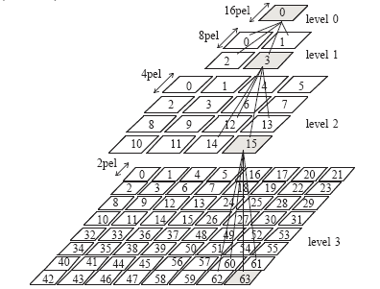
Fig. 3 Quad tree structure for binary shape coding
- Simulation Results
In this section some results are presented which are intended to indicate the coding performance of the VM and also to illustrate the underlying coding methodology in terms of coding VOPs independently. This in turn is intended to demonstrate, in a preliminary fashion, the nature of the functionalities to be supported. The results were obtained using the MPEG-4 ANSI C software implementation of the VM. This implementation was developed by the Mimesis project and distributed to the MPEG-4 group in order to encourage collaboration on software development within MPEG. Results were generated for an MPEG- 4 test sequence known as news. This sequence consists of four VOPs, which were available prior to coding (i.e. predefined segmentations were available). These VOPs are described in Table 1.

Name | Description | Type
VOP 1 | Background | Natural Video
VOP 2 | Ballet scene | Natural Video
VOP 3 | Man & woman | Natural Video
VOP 4 | Text | Synthetic
Table 1 test result
Each VOP was coded using the VM implementation in combined motion texture mode with both the advanced and unrestricted motion options turned on. One hundred occurrences of each VOP were coded at a frame rate of 10Hz. No bit rate regulation was employed. The first occurrence of each VOP was coded in intra mode (I-VOP) and successive occurrences were coded as P-VOPs (i.e. B-VOPs were not used). The number of bits required to code each VOP is shown in Figures 4 - 7. Each figure consists of three graphs indicating (i) the number of bits for shape (ii) the number of bits for motion/texture (iii) the total number of bits required to represent the VOP in the bit stream (incl. VOP syntax and composition information). For presentation purposes, the number of bits required to code the first occurrence of each VOP is not shown in full. occurrence of each VOP is not shown in full.
Fig. 4 Bit usage for VOP 1 Fig. 5 Bit usage for VOP 2
Fig. 6 Bit usage for VOP 3 Fig. 7 Bit usage for VOP 4
Examples of decoded VOPs for a particular time instant, are shown in Figures 8 - 11. These images, each of which are the size of the VOP bounding box, are independently reconstructed from the VOPs shape and motion/texture bit streams. In Figures 8 - 10 the white areas represent regions outside the VOP, while in Figure 11 these regions are represented as black regions. Composition information is also decoded for each VOP, and in the absence of user interaction at the decoder, this information specifies how the four VOPs are to be composed together to reproduce the original scene (Figure 12).

Fig. 8 Fig. 9 Fig. 10 Fig. 11 Fig.12
VOP 1 Decoded VOP 2 Decoded VOP 3 Decoded VOP 4 Decoded Composted scene
- Core Experiments
Core experiments are designed to test the effectiveness of new technologies that have been proposed as candidates for integration into the MPEG-4 standard. There are currently nine classes of core experiment, and these are: Prediction (e.g. new methods of motion compensation), General Texture Coding (e.g. wavelet, adaptive quad tree, or variable-sized lapped transform coding),Quantization and Rate Control, Shape and Alpha Channel Coding, Object/Region Texture Coding (e.g. shape adaptive DCT or wavelet/sub band coding for variable-sized region texture), Error Resilience (e.g. resynchronization, error concealment, back channel signaling, bi-directional VLC codes), Bandwidth and Complexity Scaling (e.g. content-based temporal or spatial scalability), Multi-View and Interactive Profiles (e.g. stereo coding, mesh manipulation),and Pre/Mid/Post-Processing (e.g. noise removal techniques). New core experiments are continually being identified as the standard process advances.
- Conclusion
We have reviewed here the progress of the Verification Model and briefly outlined the core experiments that are contributing to the development of MPEG-4 video. Although the technical details are still under consideration, the adoption of arbitrarily shaped video objects with composition parameters that are under user control has successfully begun to address the object-oriented requirements of a future multimedia standard.

References
- F. Pereira, “MPEG4: a New Challenge for the Representation of Audio-Visual Information”, Proceedings of PCS’96, Melbourne, March 1996.
- MPEG Video Group, “MPEG 4 Video Verification Model Version 2.1”, Doc. ISO/IEC JTC1/SC29/WG11, Florence meeting, May 1996.
- MPEG AOE Group, “Proposal Package Description (PPD) - Revision 3”, Doc. ISO/IEC JTC1/SC29/WG11, Tokyo meeting, July 1995.
- I. Corset,“Proposal for a structure allowing wide range of core experiments”, contribution to the MPEG4 ad-hoc group on definition of VMs for content-based video representation, 20th December 1995.
- Draft ITU-T Recommendation H.263“Video coding for low bit rate communication”International Telecommunication Union, November, 1995.

