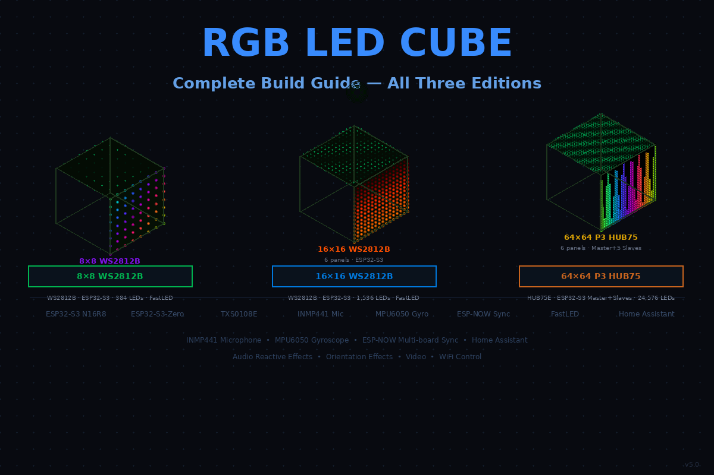
8×8 WS2812B • 16×16 WS2812B • 64×64 P3 HUB75
All editions use WiFi UDP • ESP32-S3 • Arduino C++ • No Linux
Version 17.0

Contents
Sections marked ALL apply to every edition. Edition-specific sections are clearly labelled.
1. What You Are Building
2. Choosing Your Edition
3. Shopping Lists
3.1 Shared — All Editions
3.2 8×8 WS2812B — Extra Items
3.3 16×16 WS2812B — Extra Items
3.4 64×64 P3 HUB75 — Extra Items
4. How the System Works (ALL)
4.1 WiFi Architecture
4.2 Effect Packets vs Video Packets
5. Wiring
5.1 WS2812B Editions — Panel Connections
5.2 HUB75 Edition — Panel Connections
5.3 Sensors — All Editions
5.4 Power
6. Building the Cube (ALL)
7. Arduino IDE Setup (ALL)
8. Master Board Code (ALL)
8.1 WiFi and UDP Setup
8.2 Packet Definitions
8.3 Sending Effects to All Slaves
8.4 Sending Video to Individual Slaves
8.5 Master Main Loop
9. Slave Board Code (ALL)
9.1 Connecting to Master Network
9.2 Receiving Packets
9.3 Slave Main Loop
10. WS2812B Panel Driver (8×8 and 16×16)
10.1 Edition Constants
10.2 Panel Setup and Test
11. HUB75 Panel Driver (64×64)
11.1 Panel Setup and Test
11.2 Drawing Pixels
12. Microphone (ALL)
12.1 Setup
12.2 Amplitude and Beat Detection
12.3 FFT Spectrum
13. Gyroscope (ALL)
13.1 Setup
13.2 Reading Orientation
14. Effects (ALL)
14.1 How Cross-Face Effects Work
14.2 Fire
14.3 Plasma Waves
14.4 Perlin Noise Clouds
14.5 Spectrum Analyser
14.6 Gravity Ball
14.7 Gravitational Spectrum
14.8 Sunrise Alarm
14.9 NTP Clock
14.10 Effect List
15. PC Video Streamer (ALL editions)
15.1 How the Split Works
15.2 Edition Settings
15.3 Video Streamer Script
15.4 Master Firmware — Receiving Video (WS2812B)
15.5 Slave Firmware — Receiving Video (HUB75)
15.6 Video Source Tips
16. Home Assistant (ALL)
17. Troubleshooting (ALL)
18. Edition Comparison
19. Portable Battery Power (64×64 HUB75 only)
19.1 Why HUB75 Works on Battery
19.2 How the Portable Power Circuit Works
19.3 Component Details
19.4 Setting Output Voltage on the Buck Converter
19.5 Runtime Estimates
19.6 Switching Between Mains and Battery
19.7 Cost Comparison

1. What You Are Building
A six-sided RGB LED cube where every face is a full-colour LED panel. The cube plays audio-reactive effects, responds to being tilted or shaken, shows cross-face animations that flow seamlessly between panels, and can play video. Everything is controlled over WiFi.

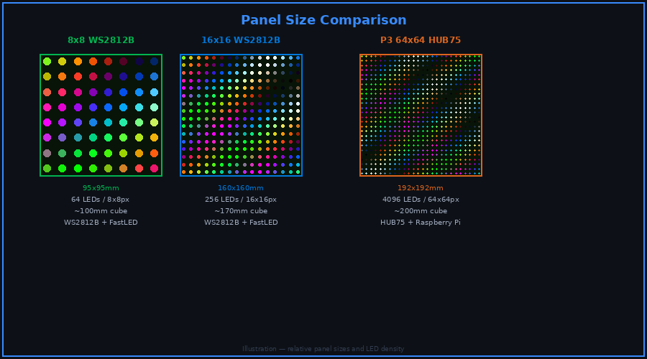
The three editions — 8×8, 16×16, and 64×64 — shown at relative scale with LED density

One master ESP32-S3 board handles the microphone, gyroscope, WiFi connection to your home network, and Home Assistant. For the 8×8 and 16×16 editions the master also drives all six panels directly. For the 64×64 edition, five additional slave boards each drive one panel, all receiving instructions from the master over WiFi.

All three editions use identical WiFi code, identical sensor code, and identical effect logic. The only differences are the LED panel type and the number of pixels per face.

2. Choosing Your Edition

 | 8×8 WS2812B | 16×16 WS2812B | 64×64 P3 HUB75
Pixels per face | 64 | 256 | 4,096
Total LEDs | 384 | 1,536 | 24,576
Cube size | ~100mm | ~170mm | ~200mm
Panel connection | Solder wires direct | JST-SM plug connector | 16-pin ribbon cable
Controller boards | 1 master only | 1 master only | 1 master + 5 slaves
Approximate cost | £90–130 | £130–200 | £260–340
Video quality | Abstract | Recognisable | Clear and watchable
Build difficulty | Easy | Easy | Medium
Best for | Desktop / first build | Room display | High quality video

Start with the 8×8 or 16×16 edition if this is your first build. The wiring is simpler and the software is identical. You can always build the 64×64 edition afterwards using the same code.

3. Shopping Lists

3.1 Shared — All Editions
These items are needed for every edition.

Item | Qty | Approx Cost | Notes
INMP441 I2S microphone breakout board | 1 | £2–4 | Model: INMP441. 3.3V only, draws ~1mA. Search: INMP441 breakout. Available from Amazon, AliExpress.
MPU6050 6-axis IMU breakout board | 1 | £2–3 | Model: MPU6050. 3.3V only, draws ~3.9mA. Search: MPU6050 GY-521 breakout. GY-521 is the most common board.
4.7kΩ resistors ¼W (any tolerance) | 2 | £0.20 | I2C pull-ups for MPU6050 SDA and SCL. Any standard ¼W through-hole resistor. Part: 4K7 ¼W.
1000µF 16V electrolytic capacitors | 6 | £2 | One per panel across V+ and GND at the panel VH4 power connector. Part: 1000µF 16V radial electrolytic. These absorb voltage spikes when the panel starts up. Observe polarity — long lead is positive.
Hookup wire 24AWG purple | 30cm | £0.50 | Microphone I2S wires
Hookup wire 24AWG yellow | 30cm | £0.50 | Gyroscope I2C wires
Screw terminal block 5mm pitch | 1 | £2 | Power distribution inside the cube frame
White frosted acrylic 3mm — A4 sheet | 2 | £6–10 | Cut to panel size for diffusion
M3 × 8mm screws | 20 | £1 | Frame assembly
M3 brass standoffs 10mm | 8 | £2 | Mounting ESP32 boards inside frame
Neodymium magnets 8mm disc | 8 | £2 | Removable bottom panel
Hot glue gun and sticks | 1 | £5 | Fitting diffuser panels
USB-C cable | 1 | £2 | Programming the ESP32 boards

3.2 8×8 WS2812B — Extra Items
Item | Qty | Approx Cost | Notes
ESP32-S3 N16R8 DevKitC-1 | 1 | £8–12 | Model: ESP32-S3-DevKitC-1-N16R8. 16MB flash, 8MB octal PSRAM. Draws ~0.5A typical. Official Espressif board — buy from Mouser, Digikey, or verified Amazon sellers.
WS2812B 8×8 LED matrix panels | 6 | £15–25 | Bare solder pads, JST pads, or directly soldered. Search: WS2812B 8x8 on Amazon or AliExpress. Ensure all 6 have the same colour temperature.
100W GaN USB-C wall charger | 1 | £20–30 | Powers cube via PD trigger board at 20V. Also charges portable power bank. Must list 20V/5A in PD spec. Recommended: Anker 736 Nano II, UGREEN Nexode 100W, Baseus 100W GaN.
USB-C PD trigger board — selectable voltage up to 20V | 1 | £2–4 | Set to 20V output. Search: USB-C PD trigger board 20V. Buy pack of 2–5 for spares.
DC-DC buck converter — 20V in, 5V/5A out | 1 | £3–5 | Handles 8×8 cube (~3A max). Search: LM2596HVS 5V 5A. Set trimmer to 5.00V before connecting. Get one with heatsink.
USB-C cable 1m — 5A E-Mark rated | 1 | £3–5 | 5A rated to unlock 20V/5A from charger. Often included with 100W chargers.
TXS0108E 8-channel level shifter breakout | 1 | £2–3 | IC: Texas Instruments TXS0108E. VCCA 1.4–3.6V, VCCB 1.65–5.5V. Search: TXS0108E breakout board. SparkFun BOB-14655 or AliExpress equivalent.
470Ω resistors ¼W (any tolerance) | 10 | £0.50 | One per LED data line. Part: 470R ¼W through-hole. Standard carbon film resistor, any supplier.
Hookup wire 1mm² red + black | 1m each | £3 | 5V runs from terminal block to panels and board
Hookup wire 24AWG green | 1m | £1 | LED data lines
3D printed or MDF frame | 1 set | £5–15 | ~105×105×105mm — see Section 6

3.3 16×16 WS2812B — Extra Items
Item | Qty | Approx Cost | Notes
ESP32-S3 N16R8 DevKitC-1 | 1 | £8–12 | Model: ESP32-S3-DevKitC-1-N16R8. Same board as 8x8 edition. Draws ~0.5A typical.
WS2812B 16×16 LED matrix panels | 6 | £20–40 | JST-SM 3-pin connectors pre-fitted. Search: WS2812B 16x16 LED panel. Buy all 6 from the same listing for consistent colours.
100W GaN USB-C wall charger | 1 | £20–30 | Same charger as 8×8 edition. Must list 20V/5A in PD spec. Anker 736, UGREEN Nexode, or Baseus 100W GaN.
USB-C PD trigger board — selectable voltage up to 20V | 1 | £2–4 | Set to 20V output. Same as 8×8 edition.
DC-DC buck converter — 20V in, 5V/10A out | 1 | £5–8 | 16×16 cube draws up to 10A at full brightness. Search: XL4016 5V 10A with heatsink. Set trimmer to 5.00V before connecting.
USB-C cable 1m — 5A E-Mark rated | 1 | £3–5 | 5A rated cable for charger to PD trigger board.
JST-SM 3-pin connector pairs | 12 | £5 | Connector: JST-SM 3-pin (2.54mm pitch). Pin order: V−, DIN, V+. Search: JST-SM 3-pin pigtail or JST-SM 3P connector pair. Verify pin order matches your panel.
TXS0108E 8-channel level shifter breakout | 1 | £2–3 | Same as 8×8 edition — TXS0108E breakout board.
470Ω resistors ¼W (any tolerance) | 10 | £0.50 | Part: 470R ¼W through-hole. One per data line.
Hookup wire 1.5mm² red + black | 1m each | £4 | Heavier gauge for the higher 5V current runs from terminal block to panels
Hookup wire 24AWG green | 1m | £1 | Data lines
3D printed or MDF frame | 1 set | £5–20 | ~170×170×170mm

3.4 64×64 P3 HUB75 — Extra Items
This edition uses one master board and five slave boards. The master drives Panel 1 and coordinates everything. Each slave drives one of the remaining five panels.

Item | Qty | Approx Cost | Notes
ESP32-S3 N16R8 DevKitC-1 — master | 1 | £8–12 | Model: ESP32-S3-DevKitC-1-N16R8. Drives Panel 1, all sensors, WiFi, HA. Draws ~0.5A. Official Espressif board.
Waveshare ESP32-S3-Zero or ESP32-S3-Mini — slaves | 5 | £3–5 each | Model: Waveshare ESP32-S3-Zero (24 GPIO) or Waveshare ESP32-S3-Mini. Draws ~0.3A each. Each slave drives one HUB75 panel via GPIO 1-14. Search: Waveshare ESP32-S3-Zero on Amazon UK.
P3 64×64 HUB75E LED matrix panels — 192×192mm | 6 | £15–22 each | Interface: HUB75E (requires E address pin). Panel power: 5V at up to 2.4A max per panel (12W). Buy all 6 from the same listing — batch differences are visible side by side.
100W GaN USB-C wall charger | 1 | £20–30 | Powers the cube via PD trigger board at 20V. Also charges the portable power bank when not in portable mode. Must list 20V/5A in its PD output profiles. Recommended: Anker 736 Nano II 100W, UGREEN Nexode 100W, or Baseus 100W GaN. No IEC socket, no fuse, no mains wiring needed — plugs straight into the wall.
USB-C cable 1m — 5A E-Mark rated (for wall charger to trigger board) | 1 | £3–5 | Same spec as the portable cable. Must be 5A rated to unlock 20V/5A. Often included with 100W chargers — check before buying separately.
DC-DC buck converter — 20–24V in, 5V/10A out | 1 | £5–8 | IC: XL4016 (8–40V in, up to 8A) or LM2596HVS (4.5–60V in, 3A — use parallel modules for 10A). Search: XL4016 5V 10A DC-DC buck with heatsink. Adjust trimmer to 5.00V before use. Cube draws max 5A so a 10A rated module gives 2× headroom.
JST VH 2-pin connector pairs (male + female) | 6 | £5–7 | Connector: JST VH series, 2-pin, 3.96mm pitch. Rated 10A per pin. Search: JST VH 2-pin connector or VH4 2-pin. Verify pin order (V+/GND) against your specific panel before connecting.
16-pin 2×8 IDC ribbon cable 30cm — spares | 3 | £3–4 | 2×8 IDC 2.54mm pitch ribbon cable. Usually one included with each panel. Buy 3 spares. Search: 16-pin IDC ribbon cable 2.54mm.
Hookup wire 1.5mm² red + black | 1m each | £5 | Panel power runs
Ferrule crimping tool + ferrule assortment kit | 1 | £10–14 | Tool: Ratcheting ferrule crimper (0.25–6mm²). Kit: assorted bootlace ferrules including 1mm² (for 5V rail wiring) and 1.5mm² (for heavier runs). Search: ferrule crimping kit on Amazon.
3D printed or MDF frame | 1 set | £10–20 | ~205×205×205mm — allow 40mm depth behind each panel

Buy all six P3 panels from the same listing at the same time. Different production batches can have different colour temperatures that are noticeable side by side.

Optional — Portable Battery Power (64×64 only)
To run the cube from a USB-C power bank instead of a mains PSU, add these items. They replace the Meanwell PSU — everything else stays the same.

Item | Qty | Approx Cost | Notes
USB-C PD power bank — 100W, 20,000mAh+ | 1 | £35–55 | Must support USB-PD at 20V/5A (100W). Cube draws max 1.25A at 20V. Recommended: UGREEN 100W 20000mAh (model PB204), INIU 100W 20000mAh, or Anker 737 PowerCore 24K. Include a 5A E-Mark rated USB-C cable.
USB-C PD trigger board — selectable voltage up to 20V | 1 | £2–4 | Sets power bank to output 20V. Search: USB-C PD trigger board 20V or PD decoy module. Buy packs of 2–5 for spares (~£3 for 5). Confirm the board supports 20V — most PD 3.0 boards do. Draws negligible current itself (~5mA).
USB-C cable 1m — E-Mark 5A rated (power bank to trigger board) | 1 | £3–5 | Must be 5A (E-Mark) rated to unlock full 20V/5A from the power bank. Standard cables may limit to 3A. Search: USB-C 5A 100W cable. Often included with 100W power banks.
Short hookup wire 1.5mm red + black | 50cm | £2 | From PD trigger board to large buck input, and from large buck output to terminal block 5V rail

The 100W USB-C wall charger serves three purposes: it powers the cube via the PD trigger board during normal use, it charges the portable power bank when the bank is not in use, and it can top up the bank while the cube runs from it simultaneously if the charger supports pass-through. To switch to portable, swap two wires at the buck converter input.

4. How the System Works (ALL editions)

4.1 WiFi Architecture
The master board creates its own private WiFi network. Slave boards connect to it. Your home network also connects to the master. No external router is needed for the cube to function.

Your home WiFi <──► Master ESP32-S3 <──► Private cube WiFi
| | |
Home Assistant Reads mic Slave boards
PC video stream Reads gyro (HUB75 only)
Phone control Drives Panel 1
Forwards video to slaves
Broadcasts effects to slaves

The master runs in APSTA mode — it connects to your home WiFi as a client while simultaneously hosting its own private access point for the slave boards. Slave boards only ever connect to the master's private network and never need your home WiFi password.

The master's private network always uses the address 192.168.4.1. Slaves are automatically assigned 192.168.4.2 through 192.168.4.6 when they connect.

4.2 Effect Packets vs Video Packets
All communication uses standard UDP over WiFi. There are just two packet types.

Packet type | Size | Sent to | Purpose
Effect state packet | ~50 bytes | All slaves at once via multicast | Tells every slave what effect to run and what the sensors read
Video frame packet | 12,290 bytes | One slave at a time via unicast | Sends one panel's worth of raw pixel data

For effects, the master sends one small packet to a multicast address and every slave receives it simultaneously. Each slave then uses its own face position in the cube to compute its slice of the effect mathematically — so a plasma wave or fire animation flows continuously across all faces with no visible seam.

For video, the master or a PC sends a separate full-frame packet directly to each board. Each board gets its own unique frame, so different content can appear on each face simultaneously.

5. Wiring

5.1 WS2812B Editions — Panel Connections
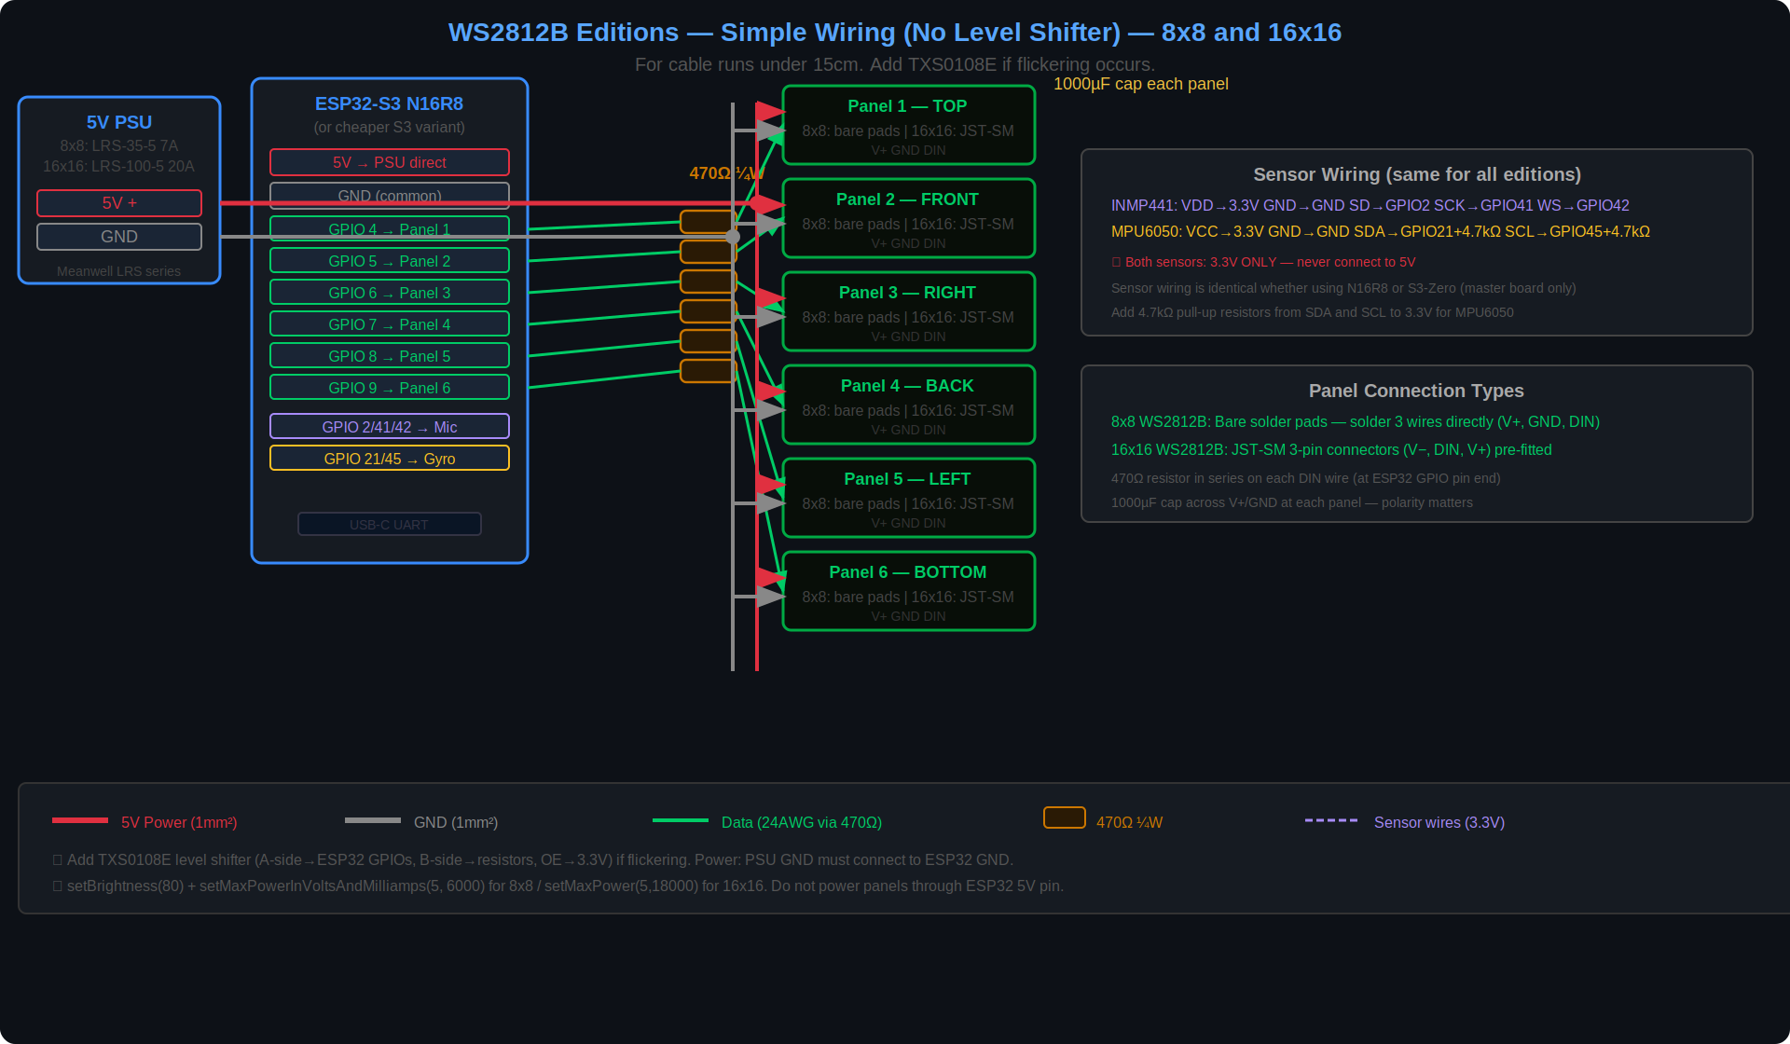
Figure 1 — WS2812B wiring diagram. One ESP32-S3 drives all 6 panels. The TXS0108E level shifter converts 3.3V data to 5V.

TXS0108E level shifter connections:
VCCA ──► 3.3V (ESP32 side — low voltage)
VCCB ──► 5V (LED panel side — high voltage)
GND ──► GND (common ground)
OE ──► 3.3V OE must be HIGH — board is disabled if left floating

A1 ──► GPIO 4 B1 ──► 470Ω ──► Panel 1 DIN (Top)
A2 ──► GPIO 5 B2 ──► 470Ω ──► Panel 2 DIN (Front)
A3 ──► GPIO 6 B3 ──► 470Ω ──► Panel 3 DIN (Right)
A4 ──► GPIO 7 B4 ──► 470Ω ──► Panel 4 DIN (Back)
A5 ──► GPIO 8 B5 ──► 470Ω ──► Panel 5 DIN (Left)
A6 ──► GPIO 9 B6 ──► 470Ω ──► Panel 6 DIN (Bottom)

8×8 panels — bare solder pads:
- Locate the V+, GND, and DIN pads on the back edge of each panel
- Tin each pad with a small amount of solder first
- Solder red wire to V+, black to GND, green to DIN
- Put the 470Ω resistor in-line on the green DIN wire close to the TXS0108E
- Leave DOUT unconnected

16×16 panels — JST-SM connectors:
- Each panel has an IN and an OUT JST-SM connector — connect to IN only
- Verify pin order before connecting: V− (GND) then DIN then V+
- Put the 470Ω resistor in-line on the DIN wire between TXS0108E and the connector

Reversed polarity on a JST-SM connector destroys the panel immediately. Check the voltage with a multimeter before plugging in each panel for the first time.

WS2812B Power — USB-C PD + Buck Converter:
- Connect the 100W USB-C wall charger via PD trigger board (set to 20V) to the buck converter input
- 8×8 edition: use a 5A rated buck (LM2596HVS 5V/5A). 16×16 edition: use a 10A rated buck (XL4016 5V/10A)
- Adjust the buck converter trimmer to exactly 5.0V with a multimeter before connecting anything to the output
- Connect the buck converter 5V output to the terminal block positive rail
- Connect the buck converter GND to the terminal block negative rail
- Run 5V and GND from the terminal block to each panel V+ and GND pad, and to the ESP32 5V pin
- All GNDs must be common — buck, all panels, and ESP32 board share the same GND rail
The 5A buck is sufficient for the 8×8 edition (~3A max). The 16×16 edition draws up to 10A at full brightness — use the 10A rated XL4016 only.

5.2 HUB75 Edition — Panel Connections
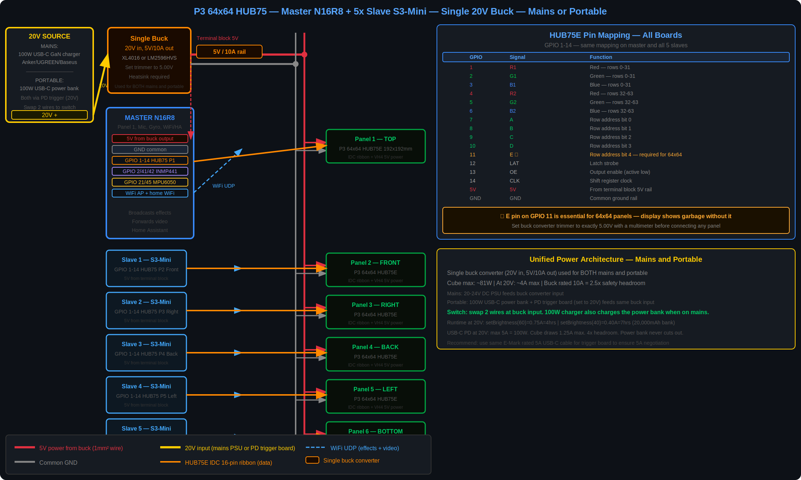
Figure 2 — HUB75 edition. Master N16R8 + 5 slave boards. Each board drives one panel via a 16-pin IDC ribbon cable.

Each board connects to its panel using the same pin mapping. The 16-pin IDC ribbon cable plugs directly from the board GPIO header to the HUB75E connector on the back of the panel.

GPIO to HUB75E pin mapping — same for master and all slaves:
GPIO | HUB75 signal | Function | GPIO | HUB75 signal | Function
1 | R1 | Red — rows 0–31 | 7 | A | Row address bit 0
2 | G1 | Green — rows 0–31 | 8 | B | Row address bit 1
3 | B1 | Blue — rows 0–31 | 9 | C | Row address bit 2
4 | R2 | Red — rows 32–63 | 10 | D | Row address bit 3
5 | G2 | Green — rows 32–63 | 11 | E ★ | Row address bit 4
6 | B2 | Blue — rows 32–63 | 12 | LAT | Latch
— | — | — | 13 | OE | Output enable
— | — | — | 14 | CLK | Clock

★ The E pin is essential for 64×64 panels. Connect GPIO 11 to pin 13 of the HUB75E connector. Without this connection the panel displays garbage. This is the most common mistake on first builds.

Power to each panel — single buck converter feeds 5V rail:
- Mount the single large buck converter (20V in, 5V/10A out) near the terminal block inside the cube
- Connect the USB-C charger via PD trigger board to the buck converter input terminals — the trigger board screw terminal outputs 20V DC
- Adjust the buck converter trimmer potentiometer to exactly 5.0V before connecting anything else
- Connect the buck converter 5V output to the terminal block positive rail
- Connect the buck converter GND to the terminal block negative rail
- Run 5V and GND wires from the terminal block to each panel VH4 connector and each slave board
- All grounds must connect back to the same terminal block GND — PSU, buck, panels, and all boards
- Check VH4 connector polarity with a multimeter before first power-on

5.3 Sensors — All Editions
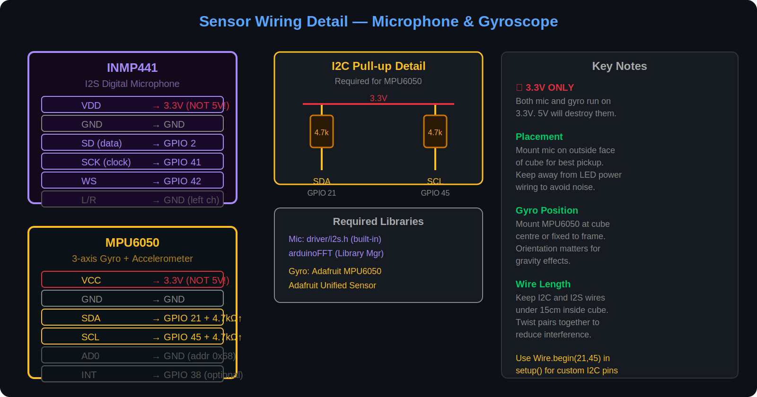
Figure 3 — Sensor wiring. Connect to the master board only. Identical for all three editions.

INMP441 microphone — master board only:
INMP441 pin | Connect to | Notes
VDD | 3.3V | 3.3V only — 5V will destroy this module
GND | GND
SD (data) | GPIO 2 | I2S serial data
SCK (clock) | GPIO 41 | I2S bit clock
WS (word select) | GPIO 42 | I2S left/right channel select
L/R | GND | Tie to GND to select the left channel

MPU6050 gyroscope — master board only:
MPU6050 pin | Connect to | Notes
VCC | 3.3V | 3.3V only — never connect to 5V
GND | GND
SDA | GPIO 21 + 4.7kΩ to 3.3V | The pull-up resistor is not optional
SCL | GPIO 45 + 4.7kΩ to 3.3V | The pull-up resistor is not optional
AD0 | GND | Sets the I2C address to 0x68
INT | GPIO 38 (optional) | Motion interrupt — can be left unconnected

Both sensors run on 3.3V only. Connecting either one to 5V will permanently destroy it.

5.4 Power — All Editions Use USB-C PD
All three editions use the same approach: a 100W GaN USB-C wall charger feeds a PD trigger board set to 20V, which feeds a DC-DC buck converter that outputs 5V to the terminal block. The only difference between editions is the buck converter current rating.

Edition | Power chain | Buck rating | Max draw at 20V
8×8 WS2812B | 100W USB-C charger + PD trigger (20V) + LM2596HVS buck | 5A output | ~0.6A typical
16×16 WS2812B | 100W USB-C charger + PD trigger (20V) + XL4016 buck | 10A output | ~2.5A max
64×64 HUB75 (mains) | 100W USB-C charger + PD trigger (20V) + XL4016 buck | 10A output | ~4A max
64×64 HUB75 (portable) | 100W USB-C power bank + PD trigger (20V) + same buck | 10A output | ~0.75A at setBrightness(60)

All editions use the same 100W GaN USB-C wall charger. The charger also charges the portable power bank when the 64×64 cube is on mains power. The PD trigger board is set to 20V for all editions — never change this setting.

All grounds must be common — buck converter GND, all panel GNDs, and all ESP32 board GNDs must connect to the same terminal block GND rail. Without this the data signals have no reference and panels will not work.

// Add to setup() on the master — WS2812B editions only
FastLED.setBrightness(80); // 31% of maximum
FastLED.setMaxPowerInVoltsAndMilliamps(5, 6000); // 8x8 edition
// FastLED.setMaxPowerInVoltsAndMilliamps(5, 18000); // 16x16 edition

6. Building the Cube (ALL editions)
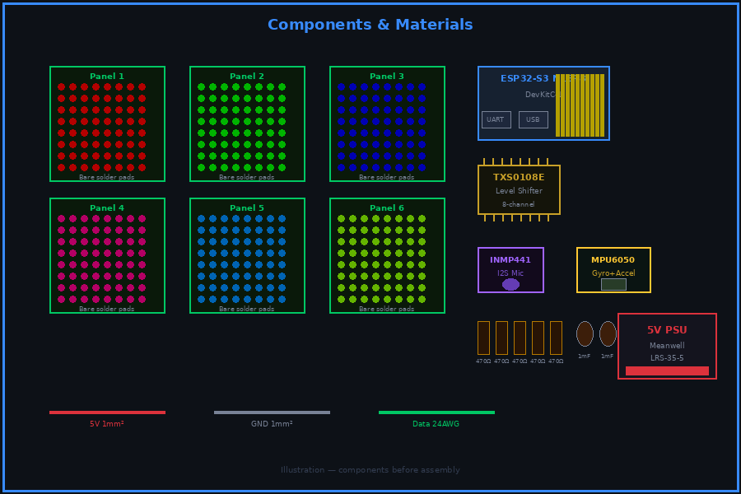
Figure 4 — Components laid out before assembly

Test each panel and each board before closing the cube. Once it is assembled it is very difficult to access the wiring.

- Test each panel individually with the test sketch in Section 10 or 11 before fitting anything into the frame
- Mount the master ESP32 board on standoffs inside the bottom panel frame
- WS2812B only: mount the TXS0108E level shifter beside the master board
- HUB75 only: mount one slave board and one buck converter behind each panel — connect IDC ribbon to slave board
- Fit the screw terminal block and barrel jack socket into the frame wall
- Mount the MPU6050 gyroscope at the centre of the cube interior
- Mount the INMP441 microphone capsule so it faces outward through a small hole in the frame
- Solder the two 4.7kΩ pull-up resistors from SDA to 3.3V and from SCL to 3.3V
- HUB75: connect the USB-C charger output (via PD trigger board) to the single buck converter input terminals — the trigger board outputs 20V DC at its screw terminals
- HUB75: adjust the buck converter trimmer to exactly 5.0V with a multimeter — do this before connecting anything to the output
- HUB75: connect the buck converter 5V and GND output to the terminal block rails
- WS2812B: wire 5V and GND from the terminal block to each panel
- Check all power connections and polarity before switching on for the first time
- Wire data lines from the ESP32 to the panels
- Flash and test all code before closing the cube — see Sections 8 and 9
- Fit the frosted acrylic diffuser into each panel face using hot glue at the edges
- Assemble the five fixed faces of the frame
- Attach the bottom panel with magnets so it can be removed later for access

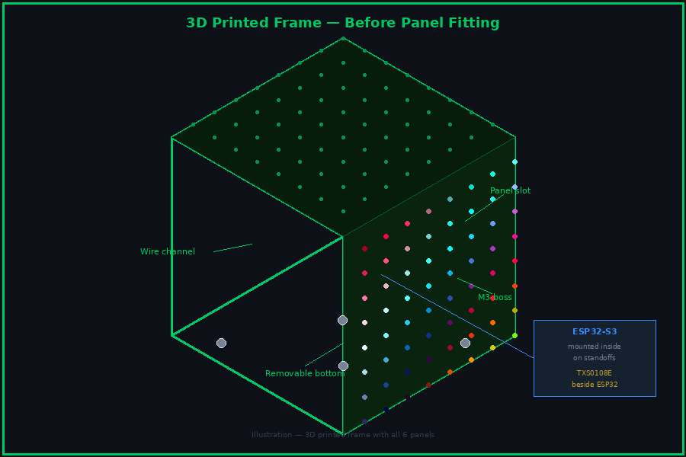
Figure 5 — 3D printed frame with panel slots, wire channels, and standoff mounts

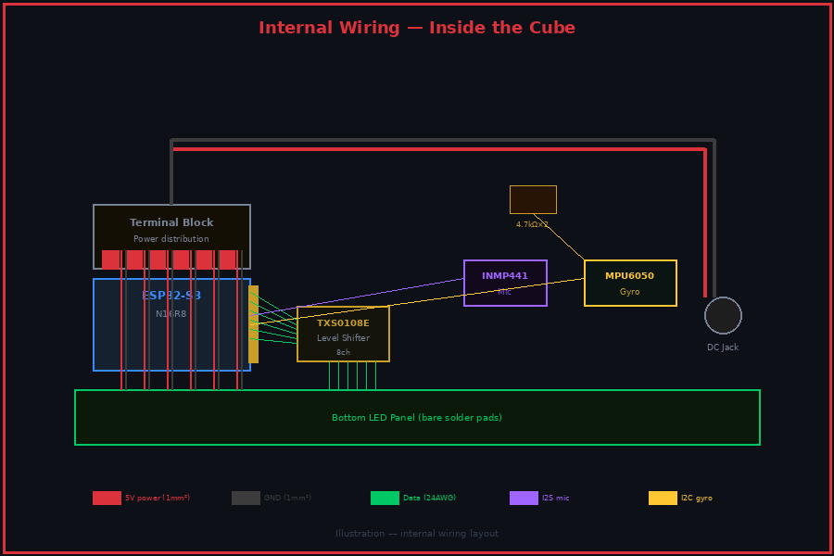
Figure 6 — Internal wiring showing ESP32, terminal block, and sensor connections

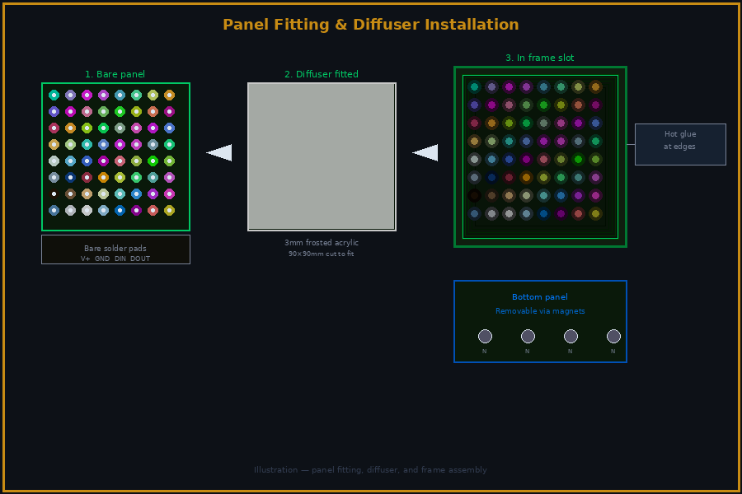
Figure 7 — Panel fitting with frosted acrylic diffuser in place

Diffusion
Without a diffuser, individual LEDs are clearly visible as a grid of dots. A piece of frosted acrylic in front of each panel blends the light into a smooth glow. Leave a 5–10mm air gap between the LEDs and the acrylic for the best result.

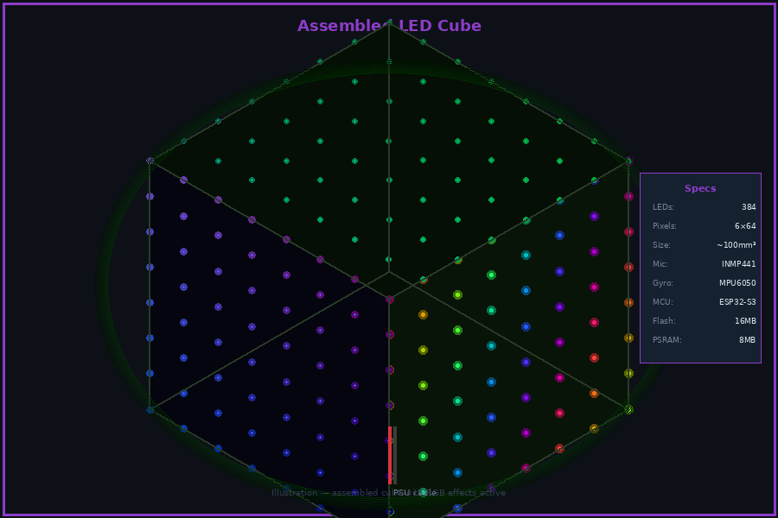
Figure 8 — Assembled cube with effects running

7. Arduino IDE Setup (ALL editions)
The master and all slave boards use the same Arduino IDE configuration.

- Download Arduino IDE 2 from arduino.cc
- Open Preferences and paste this URL into the Additional Board Manager URLs box:
https://raw.githubusercontent.com/espressif/arduino-esp32/gh-pages/package_esp32_index.json
- Open Board Manager, search for esp32 by Espressif, and install it
- Select: Tools → Board → ESP32 Arduino → ESP32S3 Dev Module
- Set PSRAM to OPI PSRAM for the master N16R8 board, or Disabled for slave boards
- Set Flash Size to 16MB for the master, 4MB for slave boards
- Set Upload Speed to 921600

Libraries — Install via Tools → Manage Libraries
Library name | Used for | Edition
FastLED | Controlling WS2812B LED panels | 8×8 and 16×16
ESP32-HUB75-MatrixPanel-I2S-DMA (by mrfaptastic) | Controlling HUB75 LED panels — v3.0 or later | 64×64 only
Adafruit MPU6050 (by Adafruit) | Reading the gyroscope — v2.2 or later | All editions
Adafruit Unified Sensor (by Adafruit) | Required by the MPU6050 library — v1.1.14 or later | All editions
arduinoFFT (by Enrique Condes) | FFT spectrum analyser — v1.9.2 or later | All editions
PubSubClient v2.8+ (by Nick O'Leary) | Home Assistant MQTT integration | All editions

The WiFi and WiFiUdp libraries are built into the ESP32 Arduino package. No separate installation is needed for WiFi or UDP.

8. Master Board Code (ALL editions)
The master board handles five things: it creates a private WiFi network for the slave boards, connects to your home WiFi, reads the microphone and gyroscope, drives its own panel, and sends instructions to the slave boards.

8.1 WiFi and UDP Setup
#include <WiFi.h>
#include <WiFiUdp.h>

// ── Change these to match your setup ──────────────────────
const char* HOME_SSID = "YourHomeWiFi";
const char* HOME_PASSWORD = "YourHomePassword";
const char* CUBE_SSID = "LED_CUBE";
const char* CUBE_PASSWORD = "cubepass123";

// Slave IP addresses on the cube network
// Slaves are automatically assigned these IPs when they connect
IPAddress slaveIPs[5] = {
IPAddress(192,168,4,2), // Slave 1 — Panel 2 Front
IPAddress(192,168,4,3), // Slave 2 — Panel 3 Right
IPAddress(192,168,4,4), // Slave 3 — Panel 4 Back
IPAddress(192,168,4,5), // Slave 4 — Panel 5 Left
IPAddress(192,168,4,6), // Slave 5 — Panel 6 Bottom
};

WiFiUdp udp;
const int UDP_PORT = 1234;
const char MULTICAST_IP[] = "239.1.1.1"; // all slaves listen here

void wifiSetup() {
WiFi.mode(WIFI_AP_STA);
WiFi.softAP(CUBE_SSID, CUBE_PASSWORD);
WiFi.begin(HOME_SSID, HOME_PASSWORD);
Serial.print("Cube AP ready. Address: ");
Serial.println(WiFi.softAPIP()); // always 192.168.4.1
udp.begin(UDP_PORT);
}

8.2 Packet Definitions
Both packet types are declared in a shared header file included by the master and all slaves.

// ── shared_packets.h ─────────────────────────────────────
#pragma once

// Packet type codes — first byte of every UDP packet
#define PKT_EFFECT 1
#define PKT_VIDEO 2

// Effect packet — sent from master to all slaves via multicast
// Contains everything a slave needs to render its face of the effect
struct EffectPacket {
uint8_t type; // always PKT_EFFECT
uint8_t effectID; // which effect to run
uint8_t hue; // primary colour 0-255
uint8_t brightness; // brightness 0-255
uint8_t speed; // animation speed 0-255
uint8_t beat; // 1 if a beat was detected this frame
uint8_t bands[8]; // FFT frequency band heights 0-63
float ax, ay, az; // accelerometer XYZ from gyroscope
float scrollX; // animation scroll X position
float scrollY; // animation scroll Y position
float scrollZ; // animation scroll Z position
uint8_t hours; // current hour for clock effect
uint8_t minutes; // current minute for clock effect
uint8_t seconds; // current second for clock effect
uint32_t frameTime; // millis() used for animation sync
};

// Video packet — sent from master (or PC) to one slave at a time
struct VideoPacket {
uint8_t type; // always PKT_VIDEO
uint8_t faceID; // which face this frame belongs to
uint8_t pixels[12288]; // raw RGB data — 64x64x3 bytes
};

8.3 Sending Effects to All Slaves
The master sends one effect packet to the multicast address. Every slave that has joined the multicast group receives it simultaneously.

#include "shared_packets.h"

EffectPacket pkt;

void broadcastEffect() {
pkt.type = PKT_EFFECT;
pkt.frameTime = millis();
// Fill in sensor values before calling this:
// pkt.beat, pkt.bands[], pkt.ax/ay/az, pkt.scrollX/Y/Z
udp.beginPacket(MULTICAST_IP, UDP_PORT);
udp.write((uint8_t*)&pkt, sizeof(pkt));
udp.endPacket();
}

8.4 Sending Video to Individual Slaves
For video, the master (or a PC) sends a separate frame to each board. The master drives its own panel directly. Slaves 1–5 receive their frame via UDP unicast.

VideoPacket vpkt;

void sendVideoFrame(uint8_t faceID, uint8_t* pixelData) {
if (faceID == 0) {
// Face 0 is the master — draw directly to its own panel
drawToPanel(pixelData);
return;
}
vpkt.type = PKT_VIDEO;
vpkt.faceID = faceID;
memcpy(vpkt.pixels, pixelData, 12288);
// Send to the slave that drives this face
udp.beginPacket(slaveIPs[faceID - 1], UDP_PORT);
udp.write((uint8_t*)&vpkt, sizeof(vpkt));
udp.endPacket();
}

8.5 Master Main Loop
A typical master loop reads sensors, computes the current effect state, and broadcasts it to all slaves at roughly 30 frames per second.

int currentEffect = 0;
const int NUM_EFFECTS = 10;

void loop() {
static uint32_t lastFrame = 0;
if (millis() - lastFrame < 33) return; // cap at ~30fps
lastFrame = millis();

// Read sensors
readGyro(pkt); // fills pkt.ax, pkt.ay, pkt.az
readMic(pkt); // fills pkt.beat and pkt.bands[]
checkShake(pkt); // may increment pkt.effectID

// Update animation scroll positions
pkt.scrollX += 0.05f;
pkt.scrollY += 0.03f;
pkt.scrollZ += 0.04f;

pkt.effectID = currentEffect;

// Draw master face (Panel 1 — Top)
renderEffect(pkt, 0);

// Send to slaves
broadcastEffect();

// Handle incoming video from PC (if any)
receiveAndForwardVideo();
}

9. Slave Board Code (ALL editions)
Each slave board connects to the master's private WiFi, listens for packets, and draws to its panel. All five slaves run identical code — the only difference is the MY_FACE_ID number set before flashing.

9.1 Connecting to Master Network
// ── Set this number differently for each slave ────────────
// 1 = Front, 2 = Right, 3 = Back, 4 = Left, 5 = Bottom
#define MY_FACE_ID 1

#include <WiFi.h>
#include <WiFiUdp.h>
#include "shared_packets.h"

const char* CUBE_SSID = "LED_CUBE"; // must match master
const char* CUBE_PASSWORD = "cubepass123"; // must match master
const int UDP_PORT = 1234;

WiFiUdp udp;

void wifiSetup() {
WiFi.begin(CUBE_SSID, CUBE_PASSWORD);
while (WiFi.status() != WL_CONNECTED) {
delay(500);
Serial.print(".");
}
Serial.println();
Serial.print("Connected. IP address: ");
Serial.println(WiFi.localIP());
// Join multicast group to receive effect broadcasts
udp.beginMulticast(IPAddress(239,1,1,1), UDP_PORT);
}

After flashing each slave, open Serial Monitor at 115200 baud and confirm it prints its IP address. Slave 1 should get 192.168.4.2, Slave 2 gets 192.168.4.3, and so on. If the IPs are wrong, power slaves on one at a time.

9.2 Receiving Packets
EffectPacket epkt;
VideoPacket vpkt;

void receivePackets() {
int size = udp.parsePacket();
if (size == 0) return;

// Read the first byte to find out what type of packet this is
uint8_t type = 0;
udp.read(&type, 1);

if (type == PKT_EFFECT && size == sizeof(EffectPacket)) {
// Effect packet — read the rest and render
udp.read((uint8_t*)&epkt + 1, sizeof(EffectPacket) - 1);
epkt.type = type;
renderEffect(epkt, MY_FACE_ID);
}

if (type == PKT_VIDEO && size == sizeof(VideoPacket)) {
// Video packet — only process if it is addressed to this face
udp.read((uint8_t*)&vpkt + 1, sizeof(VideoPacket) - 1);
vpkt.type = type;
if (vpkt.faceID == MY_FACE_ID) {
drawToPanel(vpkt.pixels);
}
}
}

9.3 Slave Main Loop
void loop() {
receivePackets();
// The panel display updates continuously via hardware DMA
// No additional work is needed between packet arrivals
}

10. WS2812B Panel Driver (8×8 and 16×16 editions)
The WS2812B editions use one master board with FastLED. All six panels connect directly to the master — no slave boards are used.

10.1 Edition Constants
Copy the right block into every sketch file. All effect code uses these constants so it works correctly for both editions.

// ── 8×8 edition ──────────────────────────────────────────
#define NUM_LEDS 384
#define LEDS_PER_FACE 64
#define FACE_W 8
#define FACE_TOP 0
#define FACE_FRONT 64
#define FACE_RIGHT 128
#define FACE_BACK 192
#define FACE_LEFT 256
#define FACE_BOTTOM 320

// ── 16×16 edition ────────────────────────────────────────
#define NUM_LEDS 1536
#define LEDS_PER_FACE 256
#define FACE_W 16
#define FACE_TOP 0
#define FACE_FRONT 256
#define FACE_RIGHT 512
#define FACE_BACK 768
#define FACE_LEFT 1024
#define FACE_BOTTOM 1280

10.2 Panel Setup and Test
#include <FastLED.h>
CRGB leds[NUM_LEDS];

// XY coordinate helper — converts face + x + y to LED array index
// WS2812B panels wire rows in alternating directions (serpentine layout)
int faceXY(int faceOffset, int x, int y) {
if (y % 2 == 0) return faceOffset + y * FACE_W + x;
else return faceOffset + y * FACE_W + (FACE_W - 1 - x);
}

void panelSetup() {
FastLED.addLeds<WS2812B, 4, GRB>(leds, 0, LEDS_PER_FACE); // Top
FastLED.addLeds<WS2812B, 5, GRB>(leds, LEDS_PER_FACE, LEDS_PER_FACE); // Front
FastLED.addLeds<WS2812B, 6, GRB>(leds, 2*LEDS_PER_FACE, LEDS_PER_FACE); // Right
FastLED.addLeds<WS2812B, 7, GRB>(leds, 3*LEDS_PER_FACE, LEDS_PER_FACE); // Back
FastLED.addLeds<WS2812B, 8, GRB>(leds, 4*LEDS_PER_FACE, LEDS_PER_FACE); // Left
FastLED.addLeds<WS2812B, 9, GRB>(leds, 5*LEDS_PER_FACE, LEDS_PER_FACE); // Bottom
FastLED.setBrightness(80);
FastLED.setMaxPowerInVoltsAndMilliamps(5, 6000); // change to 18000 for 16x16
}

// Test — each face lights a different colour
void panelTest() {
fill_solid(&leds[FACE_TOP], LEDS_PER_FACE, CRGB::Red);
fill_solid(&leds[FACE_FRONT], LEDS_PER_FACE, CRGB::Green);
fill_solid(&leds[FACE_RIGHT], LEDS_PER_FACE, CRGB::Blue);
fill_solid(&leds[FACE_BACK], LEDS_PER_FACE, CRGB::Yellow);
fill_solid(&leds[FACE_LEFT], LEDS_PER_FACE, CRGB::Magenta);
fill_solid(&leds[FACE_BOTTOM], LEDS_PER_FACE, CRGB::Cyan);
FastLED.show();
}

// Draw a raw pixel buffer to one face — used by video mode
void drawToPanel(uint8_t* pixels) {
for (int y = 0; y < FACE_W; y++)
for (int x = 0; x < FACE_W; x++) {
int i = (y * FACE_W + x) * 3;
leds[faceXY(0, x, y)] = CRGB(pixels[i], pixels[i+1], pixels[i+2]);
}
FastLED.show();
}

Run the panel test before doing anything else. Each face should show a solid different colour. A missing or flickering face means a problem with that panel's data wire or power connection.

11. HUB75 Panel Driver (64×64 edition)
Both the master and every slave use the same panel setup code. The HUB75 library drives the panel continuously via hardware DMA — no show() call is needed.

11.1 Panel Setup and Test
#include <ESP32-HUB75-MatrixPanel-I2S-DMA.h>

MatrixPanel_I2S_DMA* display = nullptr;

void panelSetup() {
HUB75_I2S_CFG cfg(64, 64, 1); // 64 wide, 64 tall, 1 panel
cfg.gpio.r1 = 1; cfg.gpio.g1 = 2; cfg.gpio.b1 = 3;
cfg.gpio.r2 = 4; cfg.gpio.g2 = 5; cfg.gpio.b2 = 6;
cfg.gpio.a = 7; cfg.gpio.b = 8; cfg.gpio.c = 9;
cfg.gpio.d = 10; cfg.gpio.e = 11; // E pin required for 64x64
cfg.gpio.lat = 12; cfg.gpio.oe = 13; cfg.gpio.clk = 14;
display = new MatrixPanel_I2S_DMA(cfg);
display->begin();
display->setBrightness8(80);
display->clearScreen();
}

// Test — fill the panel with red then green then blue
void panelTest() {
display->fillScreen(display->color565(255, 0, 0)); delay(500);
display->fillScreen(display->color565(0, 255, 0)); delay(500);
display->fillScreen(display->color565(0, 0, 255)); delay(500);
display->clearScreen();
}

11.2 Drawing Pixels
// Draw a raw RGB pixel buffer to the HUB75 panel
// Used by video mode and pre-rendered effects
void drawToPanel(uint8_t* pixels) {
for (int y = 0; y < 64; y++)
for (int x = 0; x < 64; x++) {
int i = (y * 64 + x) * 3;
display->drawPixelRGB888(x, y, pixels[i], pixels[i+1], pixels[i+2]);
}
}

// Draw a single pixel — used by procedural effects
void setPixel(int x, int y, uint8_t r, uint8_t g, uint8_t b) {
display->drawPixelRGB888(x, y, r, g, b);
}

void clearPanel() { display->clearScreen(); }

12. Microphone (ALL editions)
All microphone code runs on the master only. The master reads audio, computes amplitude and frequency data, and puts the results into the effect packet. Slave boards use the data from the packet to drive their visual effects — they do not have a microphone and do not need one.

12.1 Setup
#include <driver/i2s.h>

#define MIC_SD 2 // I2S data
#define MIC_SCK 41 // I2S clock
#define MIC_WS 42 // I2S word select

int32_t sampleBuffer[512];

void micSetup() {
i2s_config_t cfg = {
.mode = (i2s_mode_t)(I2S_MODE_MASTER | I2S_MODE_RX),
.sample_rate = 44100,
.bits_per_sample = I2S_BITS_PER_SAMPLE_32BIT,
.channel_format = I2S_CHANNEL_FMT_ONLY_LEFT,
.communication_format = I2S_COMM_FORMAT_STAND_I2S,
.dma_buf_count = 4,
.dma_buf_len = 64,
};
i2s_driver_install(I2S_NUM_0, &cfg, 0, NULL);
i2s_pin_config_t pins = {
.bck_io_num = MIC_SCK,
.ws_io_num = MIC_WS,
.data_out_num = I2S_PIN_NO_CHANGE,
.data_in_num = MIC_SD,
};
i2s_set_pin(I2S_NUM_0, &pins);
}

12.2 Amplitude and Beat Detection
uint8_t getAmplitude() {
size_t bytesRead;
i2s_read(I2S_NUM_0, sampleBuffer, sizeof(sampleBuffer), &bytesRead, 10);
int32_t peak = 0;
for (int i = 0; i < 512; i++) {
int32_t val = abs(sampleBuffer[i] >> 8);
if (val > peak) peak = val;
}
return (uint8_t)constrain(map(peak, 0, 50000, 0, 255), 0, 255);
}

// Reads amplitude, compares to recent average, returns true on a beat
bool detectBeat() {
float energy = getAmplitude();
energy *= energy;
static float history[20] = {};
static int idx = 0;
float avg = 0;
for (int i = 0; i < 20; i++) avg += history[i];
avg /= 20.0f;
history[idx++ % 20] = energy;
return (energy > avg * 1.4f);
}

// Fill beat into packet — call once per frame on master
void readMic(EffectPacket& pkt) {
pkt.beat = detectBeat() ? 1 : 0;
// bands[] is filled by computeFFT() below if using spectrum effects
}

12.3 FFT Spectrum
#include <arduinoFFT.h>

#define FFT_N 256
double vReal[FFT_N], vImag[FFT_N];
ArduinoFFT<double> FFT(vReal, vImag, FFT_N, 44100.0);

// Fill pkt.bands[] with 8 frequency band heights — call on master
void computeFFT(EffectPacket& pkt) {
size_t br;
i2s_read(I2S_NUM_0, sampleBuffer, FFT_N * 4, &br, 10);
for (int i = 0; i < FFT_N; i++) { vReal[i] = sampleBuffer[i] >> 8; vImag[i] = 0; }
FFT.windowing(FFT_WIN_TYP_HAMMING, FFT_FORWARD);
FFT.compute(FFT_FORWARD);
FFT.complexToMagnitude();
for (int band = 0; band < 8; band++) {
double mag = 0;
for (int b = band * 16; b < (band + 1) * 16; b++)
if (vReal[b] > mag) mag = vReal[b];
pkt.bands[band] = (uint8_t)constrain(map((long)mag, 0, 80000, 0, 63), 0, 63);
}
}

13. Gyroscope (ALL editions)
All gyroscope code runs on the master only. The master reads the accelerometer values and puts them into every effect packet. Slave boards use the ax, ay, az values from the packet to determine the cube's orientation and adjust their visual output accordingly.

13.1 Setup
#include <Adafruit_MPU6050.h>
#include <Adafruit_Sensor.h>
#include <Wire.h>

Adafruit_MPU6050 mpu;
sensors_event_t accel, gyroEvt, temp;

void gyroSetup() {
Wire.begin(21, 45); // SDA on GPIO 21, SCL on GPIO 45
if (!mpu.begin()) {
Serial.println("MPU6050 not found — check wiring and pull-up resistors");
while (1);
}
mpu.setAccelerometerRange(MPU6050_RANGE_2_G);
mpu.setFilterBandwidth(MPU6050_BAND_21_HZ);
}

// Fill ax/ay/az into packet — call once per frame on master
void readGyro(EffectPacket& pkt) {
mpu.getEvent(&accel, &gyroEvt, &temp);
pkt.ax = accel.acceleration.x;
pkt.ay = accel.acceleration.y;
pkt.az = accel.acceleration.z;
}

13.2 Reading Orientation
// Returns the FACE_* constant for whichever face is pointing down
// Used by gravity effects on WS2812B edition
// For HUB75 slaves: compare (faceIndex) against (result / LEDS_PER_FACE)
int getBottomFace(float ax, float ay, float az) {
int face = FACE_BOTTOM;
float mg = abs(az);
if (abs(ax) > mg) { mg = abs(ax); face = (ax > 0) ? FACE_RIGHT : FACE_LEFT; }
if (abs(ay) > mg) { face = (ay > 0) ? FACE_FRONT : FACE_BACK; }
return face;
}

// Detect shake — call on master, increment effect if shaken
void checkShake(EffectPacket& pkt) {
static uint32_t lastShake = 0;
float mag = sqrt(pkt.ax*pkt.ax + pkt.ay*pkt.ay + pkt.az*pkt.az);
if (mag > 20.0f && millis() - lastShake > 800) {
pkt.effectID = (pkt.effectID + 1) % NUM_EFFECTS;
lastShake = millis();
}
}

14. Effects (ALL editions)
All effects use the renderEffect() function on both master and slaves. The master calls it for Face 0 (Top). Each slave calls it with its own MY_FACE_ID. The faceID parameter is how each board knows which slice of the effect to render.

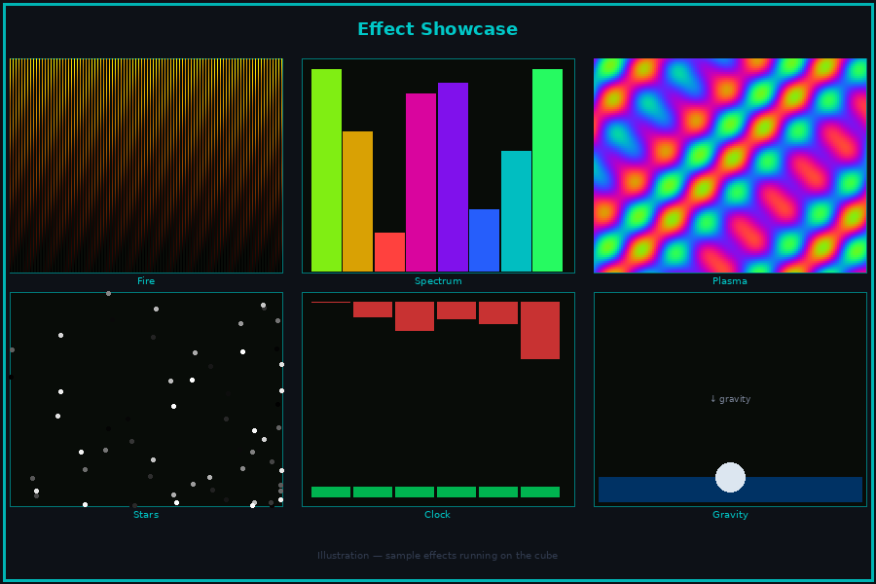
Figure 9 — Sample effects running across all six faces

14.1 How Cross-Face Effects Work
For effects like plasma, fire, and noise clouds to flow seamlessly across face boundaries, each slave uses its face position in the cube as a mathematical offset when computing its slice of the effect. All boards receive the same scroll positions in the packet — the faceID shifts each board's calculation so the result is continuous.

// This is how plasma stays seamless across all 6 faces.
// Each face adds its own angular offset so the field wraps correctly
// around the cube. All faces use the same pkt.scrollX/Y/Z.

void renderEffect(EffectPacket& pkt, int faceID) {
switch (pkt.effectID) {
case 0: fireFace(pkt, faceID); break;
case 1: plasmaFace(pkt, faceID); break;
case 2: noiseFace(pkt, faceID); break;
case 3: spectrumFace(pkt, faceID); break;
case 4: gravityBall(pkt, faceID); break;
case 5: gravSpectrum(pkt, faceID); break;
case 6: sunriseFace(pkt, faceID); break;
case 7: clockFace(pkt, faceID); break;
default: solidFace(pkt, faceID); break;
}
}

14.2 Fire
Fire rises upward on every face, always away from the face pointing down. The gravity vector from the gyroscope determines which way up is.

// WS2812B version — runs on master for all 6 faces
uint8_t heat[6][256] = {}; // 256 is max LEDS_PER_FACE (16x16)

void fireFace(EffectPacket& pkt, int faceID) {
int offset = faceID * LEDS_PER_FACE;
// Cool down every cell
for (int i = 0; i < LEDS_PER_FACE; i++)
heat[faceID][i] = qsub8(heat[faceID][i], random8(0, 60));
// Heat rises
for (int i = LEDS_PER_FACE - 1; i >= FACE_W; i--)
heat[faceID][i] = (heat[faceID][i-FACE_W]*2 + heat[faceID][i-2*FACE_W]) / 3;
// New sparks at base
if (random8() < 120)
heat[faceID][random8(FACE_W/2)] = qadd8(heat[faceID][random8(FACE_W/2)], random8(160,255));
// Draw
for (int i = 0; i < LEDS_PER_FACE; i++)
leds[offset + i] = HeatColor(heat[faceID][i]);
FastLED.show();
}

// HUB75 version — runs on each slave
uint8_t hubHeat[64][64] = {};

void fireFaceHUB75(EffectPacket& pkt) {
// Spark at base row
for (int x = 0; x < 64; x++)
hubHeat[0][x] = (uint8_t)min(255, (int)hubHeat[0][x] + random(80, 160));
// Heat rises — each row averages from the row below
for (int y = 63; y > 0; y--)
for (int x = 0; x < 64; x++)
hubHeat[y][x] = (uint8_t)max(0,
((int)hubHeat[y-1][x] +
(int)hubHeat[y-1][(x-1+64)%64] +
(int)hubHeat[y-1][(x+1)%64]) / 3 - 4);
// Draw
for (int y = 0; y < 64; y++)
for (int x = 0; x < 64; x++) {
uint8_t h = hubHeat[y][x];
display->drawPixelRGB888(x, 63-y, min(255,h*3), max(0,min(255,h*3-255)), 0);
}
}

14.3 Plasma Waves
A continuous colour field that flows across all six faces with no visible seam. The faceID offsets each board's calculation so the field wraps correctly around the cube.

// WS2812B version
void plasmaFace(EffectPacket& pkt, int faceID) {
int offset = faceID * LEDS_PER_FACE;
float faceOffset = faceID * (6.28f / 6.0f); // angular offset in cube
for (int y = 0; y < FACE_W; y++) {
for (int x = 0; x < FACE_W; x++) {
float v = sin(x * 0.4f + pkt.scrollX + faceOffset)
+ sin(y * 0.4f + pkt.scrollY)
+ sin((x+y) * 0.28f + pkt.scrollZ);
leds[faceXY(offset, x, y)] = CHSV((uint8_t)((v+3.0f)*42.0f), 255, 200);
}
}
FastLED.show();
}

// HUB75 version — same maths, different drawing API
void plasmaFaceHUB75(EffectPacket& pkt, int faceID) {
float faceOffset = faceID * (6.28f / 6.0f);
for (int y = 0; y < 64; y++) {
for (int x = 0; x < 64; x++) {
float v = sin(x*0.1f + pkt.scrollX + faceOffset)
+ sin(y*0.1f + pkt.scrollY)
+ sin((x+y)*0.07f + pkt.scrollZ);
uint8_t hue = (uint8_t)((v + 3.0f) * 42.0f);
display->drawPixelRGB888(x, y,
128 + 127*sin(hue*3.14f/128),
128 + 127*sin((hue+85)*3.14f/128),
128 + 127*sin((hue+170)*3.14f/128));
}
}
}

14.4 Perlin Noise Clouds
void noiseFace(EffectPacket& pkt, int faceID) {
int offset = faceID * LEDS_PER_FACE;
for (int y = 0; y < FACE_W; y++)
for (int x = 0; x < FACE_W; x++) {
uint8_t noise = inoise8(
(uint16_t)(pkt.scrollX * 100) + x * 32 + faceID * 200,
(uint16_t)(pkt.scrollY * 100) + y * 32,
(uint16_t)(pkt.scrollZ * 100));
leds[faceXY(offset, x, y)] = CHSV(noise, 220, 180);
}
FastLED.show();
}

14.5 Spectrum Analyser
Vertical bars driven by the FFT frequency data in the packet. Bars always rise from the face pointing downward so the effect looks correct in any orientation.

void spectrumFace(EffectPacket& pkt, int faceID) {
int offset = faceID * LEDS_PER_FACE;
int bottom = getBottomFace(pkt.ax, pkt.ay, pkt.az) / LEDS_PER_FACE;
fadeToBlackBy(&leds[offset], LEDS_PER_FACE, 40);
if (faceID != bottom) { FastLED.show(); return; }
int barW = FACE_W / 8; // 8 frequency bands
for (int band = 0; band < 8; band++) {
int barH = map(pkt.bands[band], 0, 63, 0, FACE_W);
for (int row = 0; row < barH; row++)
for (int col = 0; col < barW; col++)
leds[faceXY(offset, band*barW+col, FACE_W-1-row)] = CHSV(band*32, 255, 200);
}
FastLED.show();
}

14.6 Gravity Ball
A bright dot that falls to whichever face is pointing downward and stays there. Tilt the cube and the ball rolls to the new lowest face.

void gravityBall(EffectPacket& pkt, int faceID) {
int offset = faceID * LEDS_PER_FACE;
int bottom = getBottomFace(pkt.ax, pkt.ay, pkt.az) / LEDS_PER_FACE;
fadeToBlackBy(&leds[offset], LEDS_PER_FACE, 20);
if (faceID == bottom) {
int mid = FACE_W / 2 - 1;
leds[faceXY(offset, mid, mid )] = CRGB::White;
leds[faceXY(offset, mid+1, mid )] = CRGB::White;
leds[faceXY(offset, mid, mid+1)] = CRGB::White;
leds[faceXY(offset, mid+1, mid+1)] = CRGB::White;
}
FastLED.show();
}

14.7 Gravitational Spectrum
Combines the spectrum analyser and gravity. Frequency bars always rise away from the lowest face regardless of cube orientation.

void gravSpectrum(EffectPacket& pkt, int faceID) {
// Same as spectrumFace() but uses the gravity vector to determine
// which face shows the bars — whichever face is pointing down.
spectrumFace(pkt, faceID);
}

14.8 Sunrise Alarm
// Master controls progress via pkt.scrollX (0.0 to 1.0)
// Trigger from Home Assistant automation
void sunriseFace(EffectPacket& pkt, int faceID) {
float prog = constrain(pkt.scrollX, 0.0f, 1.0f);
uint8_t hue = (uint8_t)(prog * 60); // deep red to warm yellow
uint8_t sat = (uint8_t)(255 - prog * 200); // fades toward white
uint8_t val = (uint8_t)(prog * 220 + 10);
fill_solid(&leds[faceID * LEDS_PER_FACE], LEDS_PER_FACE, CHSV(hue, sat, val));
FastLED.show();
}

14.9 NTP Clock
// Master syncs time from internet and puts h/m/s in the packet
void syncNTP() { configTime(0, 3600, "pool.ntp.org"); }

// Master — fill clock values into packet once per second
void fillClockPacket(EffectPacket& pkt) {
struct tm t;
if (getLocalTime(&t)) {
pkt.hours = t.tm_hour;
pkt.minutes = t.tm_min;
pkt.seconds = t.tm_sec;
}
}

// Slave — draw time display on this face
void clockFace(EffectPacket& pkt, int faceID) {
int offset = faceID * LEDS_PER_FACE;
fill_solid(&leds[offset], LEDS_PER_FACE, CRGB::Black);
if (faceID == 0) { // Top — hours as red bar
int hp = map(pkt.hours, 0, 24, 0, LEDS_PER_FACE);
for (int i = 0; i < hp; i++) leds[offset + i] = CHSV(0, 255, 160);
}
if (faceID == 1) { // Front — minutes as green bar
int mp = map(pkt.minutes, 0, 60, 0, LEDS_PER_FACE);
for (int i = 0; i < mp; i++) leds[offset + i] = CHSV(96, 255, 160);
}
if (faceID == 5) { // Bottom — seconds pulsing blue
fill_solid(&leds[offset], LEDS_PER_FACE,
CHSV(160, 200, beatsin8(60, 40, 220)));
}
FastLED.show();
}

14.10 Effect List
Effect | Sensors used | Cross-face | Notes
Fire | None | Yes | Gravity-aware — rises from bottom face
Plasma waves | None | Yes | Continuous field across all faces
Perlin noise clouds | None | Yes | 3D noise field shared across faces
Rainbow rotation | None | Yes | Simple and reliable
FFT spectrum analyser | INMP441 | Yes | Bars on the lowest face
Beat flash | INMP441 | Yes | All faces flash white on a beat
Ambient reactive | INMP441 | Yes | Breathing when quiet, spectrum when loud
Gravity ball | MPU6050 | Yes | Ball falls to lowest face
Shake to change | MPU6050 | Yes | Shake cube to cycle effects
Tilt colour | MPU6050 | Yes | Tilt controls colour
Gravitational spectrum | INMP441 + MPU6050 | Yes | Spectrum always rises from bottom
Sunrise alarm | WiFi + HA | Yes | Red to warm white over 30 minutes
NTP clock | WiFi | Yes | Hours/minutes/seconds on different faces
Video — same frame all faces | PC stream | — | One frame broadcast to all
Video — different per face | PC stream | — | Unique frame unicast to each board

15. PC Video Streamer (ALL editions)
A Python script reads a video file and streams it to the cube over UDP. The approach is the same for all three editions — the only difference is the panel resolution and face IPs used.

The video is split across the four side panels (Front, Right, Back, Left). Top and bottom continue to show effects or static content from the master board. If the video source has a wide aspect ratio the four side panels together display a continuous horizontal strip of the video, which works very well for music videos, abstract visuals, and animations.

No hardware or firmware changes are needed for video playback. The cube receives video packets over the same UDP port used for effects. The master and slaves already handle both packet types.

Install the required Python libraries once:
pip install opencv-python numpy

15.1 How the Split Works
The video frame is resized to four panel widths wide and one panel height tall, then divided into four equal sections — one per side panel. Top and bottom panels are left to the master effects loop.

Video frame (any aspect ratio)
|
v cv2.resize(frame, (FACE_W * 4, FACE_W))
|
+-- section [0:FACE_W] --> Left panel
+-- section [FACE_W:FACE_W*2] --> Front panel
+-- section [FACE_W*2:FACE_W*3]--> Right panel
+-- section [FACE_W*3:FACE_W*4]--> Back panel

Top panel -- master effects loop (unaffected)
Bottom panel -- master effects loop (unaffected)

15.2 Edition Settings
Set these constants at the top of the script to match your cube edition:

# 8x8 WS2812B edition
FACE_W = 8
MASTER_IP = "192.168.1.50" # master IP on your home WiFi
FACE_IPS = {
1: "192.168.1.50", # Front (all go to master — single board edition)
2: "192.168.1.50", # Right
3: "192.168.1.50", # Back
4: "192.168.1.50", # Left
}

# 16x16 WS2812B edition
FACE_W = 16
FACE_IPS = {
1: "192.168.1.50", # Front (all go to master — single board edition)
2: "192.168.1.50", # Right
3: "192.168.1.50", # Back
4: "192.168.1.50", # Left
}

# 64x64 HUB75 edition
FACE_W = 64
FACE_IPS = {
1: "192.168.4.2", # Front — Slave 1 on cube private network
2: "192.168.4.3", # Right — Slave 2
3: "192.168.4.4", # Back — Slave 3
4: "192.168.4.5", # Left — Slave 4
}

For WS2812B editions there is only one board. All face IDs go to the same master IP. The master board reads each incoming video packet and uses the faceID byte to select which face to update in the LED array.

15.3 Video Streamer Script
This single script works for all three editions. Set the FACE_W and FACE_IPS constants in Section 15.2 before running.

import cv2, socket, struct, time

FACE_W = 64 # set from 15.2 above
UDP_PORT = 1234
FPS = 30 # target frame rate

FACE_IPS = { # set from 15.2 above
1: "192.168.4.2", # Front
2: "192.168.4.3", # Right
3: "192.168.4.4", # Back
4: "192.168.4.5", # Left
}

socks = {face_id: socket.socket(socket.AF_INET, socket.SOCK_DGRAM)
for face_id in FACE_IPS}

cap = cv2.VideoCapture("video.mp4")
frame_delay = 1.0 / FPS

while True:
ret, frame = cap.read()
if not ret:
cap.set(cv2.CAP_PROP_POS_FRAMES, 0) # loop video
continue

# Resize to 4 panels wide, 1 panel tall
strip = cv2.resize(frame, (FACE_W * 4, FACE_W))
strip = cv2.cvtColor(strip, cv2.COLOR_BGR2RGB)

# Send one section per side face
for i, face_id in enumerate(FACE_IPS):
section = strip[:, i * FACE_W : (i + 1) * FACE_W]
pixel_bytes = section.tobytes()
header = struct.pack("BB", 2, face_id)
ip = FACE_IPS[face_id]
socks[face_id].sendto(header + pixel_bytes, (ip, UDP_PORT))

time.sleep(frame_delay)

15.4 Master Firmware — Receiving Video (WS2812B editions)
For 8×8 and 16×16 editions, the single master board handles all video packets. Add this to the UDP receive loop in the master sketch:

void handleVideoPacket(uint8_t faceID, uint8_t* pixels, int len) {
// faceID 1=Front, 2=Right, 3=Back, 4=Left (sides only)
// Top and Bottom continue to show effects — not updated by video
if (faceID < 1 || faceID > 4) return;

int base = faceID * LEDS_PER_FACE; // offset into LED array
int numPixels = LEDS_PER_FACE;

for (int i = 0; i < numPixels; i++) {
leds[base + i] = CRGB(pixels[i*3], pixels[i*3+1], pixels[i*3+2]);
}
FastLED.show();
}

15.5 Slave Firmware — Receiving Video (HUB75 edition)
For the 64×64 HUB75 edition, each slave already handles video packets via the existing PKT_VIDEO handler. No firmware changes needed. The four side slaves (IDs 1–4) receive their section directly from the PC script. Top (master) and Bottom (Slave 5) continue to show effects.

Top and bottom panels show effects during video playback on all editions. The master effects loop runs independently of the video stream. This gives the cube a more dynamic look — continuous motion on all six faces simultaneously.

15.6 Video Source Tips
Best results come from source material that works well at low resolution and high contrast:

- 4:1 aspect ratio videos play across the four sides without stretching — search for LED wall or LED strip visualiser content on YouTube
- Music reactive videos, abstract loops, and plasma animations look excellent at 64×64 per panel
- Standard 16:9 video works fine — it is compressed horizontally but still readable at normal viewing distance
- 30fps is the practical maximum over WiFi UDP. 24fps is reliable and smooth.
- Use lossless or high bitrate source video — heavy compression artefacts become visible at low resolution
- HandBrake (free) can crop and resize video to 256×64 (HUB75) or 64×16 (8×8) for offline pre-processing

To stream directly to HUB75 slave boards from the PC, connect your PC to the cube private WiFi network (SSID: LED_CUBE). Slaves are on 192.168.4.2-4.5. Alternatively send all four streams to the master on your home WiFi and let the master forward frames to the slaves - simpler but adds one hop of latency.

16. Home Assistant (ALL editions)
The master board connects to Home Assistant over MQTT. You can control effects, brightness, and colour from the HA dashboard, automations, or voice assistants.

MQTT Setup on Master
#include <PubSubClient.h>

WiFiClient wifiClient;
PubSubClient mqtt(wifiClient);

int currentEffect = 0;
uint8_t masterBrightness = 80;
uint8_t masterHue = 0;

void mqttCallback(char* topic, byte* payload, unsigned int len) {
String msg = String((char*)payload).substring(0, len);
if (String(topic) == "cube/effect") currentEffect = msg.toInt();
if (String(topic) == "cube/brightness") masterBrightness = msg.toInt();
if (String(topic) == "cube/colour") masterHue = msg.toInt();
}

void mqttSetup() {
mqtt.setServer("homeassistant.local", 1883);
mqtt.setCallback(mqttCallback);
}

void mqttLoop() {
if (!mqtt.connected()) {
mqtt.connect("led_cube");
mqtt.subscribe("cube/#");
}
mqtt.loop();
}

Useful Automations
Automation | Trigger | What it does
Sunrise alarm | Time-based, 30 mins before wake time | Slowly fades from red to warm white over 30 minutes
Party mode | Media player changes to playing | Switches to audio reactive spectrum at full brightness
Sleep mode | Bedroom light turns off | Dims to slow breathing blue
Doorbell | Doorbell sensor triggers | White flash three times then returns to previous effect
Weather | Temperature reading changes | Hue shifts continuously — blue when cold, red when warm
Calendar reminder | 10 minutes before a calendar event | Amber pulse until dismissed

17. Troubleshooting (ALL editions)

Problem | Most likely cause | Fix
A panel does not light up at all | No common ground between PSU and ESP32 | Connect PSU GND to ESP32 GND — this is essential
WS2812B panel flickers or wrong colours | TXS0108E OE pin floating or tied to GND | Connect OE pin to 3.3V — the board is disabled without it
Wrong colour order on a WS2812B panel | GRB vs RGB order mismatch | Change GRB to RGB in that panel's addLeds() call
Panels reset when all LEDs are bright | Buck converter at current limit or charger insufficient | Confirm buck is rated 10A. Confirm charger is 100W and lists 20V/5A output. Check all GNDs connect to same terminal block rail.
Upload fails — no port appears | Board not in bootloader mode | Hold BOOT button then press RESET, then start upload
HUB75 panel shows scrambled output | E pin not connected | Connect GPIO 11 to pin 13 of the HUB75E connector
HUB75 panel completely dark | VH4 power connector reversed or buck not adjusted | Check VH4 polarity and verify buck converter outputs 5.0V with multimeter
HUB75 panel resets or flickers | Buck converter output voltage too low | Re-adjust buck trimmer to exactly 5.0V under load
Slave board does not appear on network | Wrong SSID or password in slave code | Check CUBE_SSID and CUBE_PASSWORD match the master
Slave shows wrong IP address | Booted before master AP was ready | Power master first, then slaves
Effects not appearing on slave | Multicast not working on your network | Try changing to UDP broadcast: 255.255.255.255
MPU6050 not found at startup | Missing I2C pull-up resistors | Add 4.7kΩ from SDA to 3.3V and from SCL to 3.3V
Microphone gives no signal | Incorrect I2S GPIO assignment | Verify GPIO 2 (SD), GPIO 41 (SCK), GPIO 42 (WS)
Microphone is very noisy | Mic wires near LED power cables | Re-route mic wires away from power. Cross at right angles.
Gravity ball on the wrong face | MPU6050 mounted at an angle | Swap ax, ay, az values in getBottomFace() to correct axis
Video looks laggy or frames drop | WiFi network congestion | Reduce to 20fps. Move router closer or use dedicated AP.

18. Edition Comparison

 | 8×8 WS2812B | 16×16 WS2812B | 64×64 P3 HUB75
Pixels per face | 64 | 256 | 4,096
Total LEDs | 384 | 1,536 | 24,576
Cube size | ~100mm | ~170mm | ~200mm
Panel connection | Bare solder pads | JST-SM connectors | 16-pin IDC ribbon
Controller boards | 1 master | 1 master | 1 master + 5 slaves
Controller cost | ~£10 | ~£10 | ~£35–45
PSU | 100W USB-C GaN + 5V/5A buck | 100W USB-C GaN + 5V/10A buck | 100W USB-C GaN + PD trigger + 5V/10A buck
Approximate total cost | £90–130 | £130–200 | £260–340
Video quality | Abstract | Recognisable | Clear and watchable
Boot time | 2 seconds | 2 seconds | 2 seconds all boards
Programming language | Arduino C++ | Arduino C++ | Arduino C++
Build difficulty | Easy | Easy | Medium
Best for | First build / desk | Room display | High resolution video

All three editions use identical WiFi code, identical sensor code, and identical effect logic. Copy the correct constants block for your edition into each sketch and everything works.

19. Portable Battery Power (64×64 HUB75 edition)
The 64×64 cube can run from a USB-C power bank with no mains connection — fully portable for exhibitions, events, and outdoor displays. The same 100W USB-C wall charger used for mains operation charges the power bank when the cube is at home. The WS2812B editions draw too much current for battery use to be practical, but HUB75 panels use scan multiplexing so actual power draw is much lower than it appears.

19.1 Why HUB75 Works on Battery
WS2812B LEDs are always fully on — every LED draws current simultaneously. HUB75 panels use 1/32 scan rate, meaning only two rows of LEDs are actually lit at any one moment. The eye sees a complete image due to persistence of vision, but the actual current drawn is a small fraction of the theoretical maximum.

Setting | Typical power | At 20V draws | Runtime — 20,000mAh bank
setBrightness(80) — full effects | ~25W | ~1.25A | ~2.5 hours
setBrightness(60) — recommended | ~15W | ~0.75A | ~4 hours
setBrightness(40) — long runtime | ~8W | ~0.40A | ~7 hours

At 20V the cube draws well under 2A even at setBrightness(80). This is far below the 5A limit of USB-C PD at 20V, giving a large safety margin and eliminating the power bank cutout problem entirely.

19.2 How the Power Circuit Works — Mains and Portable
The portable setup uses a single large buck converter taking 20V from the power bank and outputting 5V directly to the terminal block. This bypasses the 12V distribution rail and per-panel bucks entirely. The reason for using 20V rather than 12V is that USB-C PD only guarantees 3A at 12V (36W maximum) — not enough for the cube at normal brightness. At 20V the spec allows 5A (100W), giving a comfortable margin over the ~25W the cube actually draws.

MAINS and PORTABLE — identical wiring from the buck onward:

20V source (100W USB-C charger or power bank)
-- 20V in to single buck converter
-- 5V/10A out to terminal block 5V rail
-- Panel 1 VH4 + Board 1
-- Panel 2 VH4 + Board 2
-- Panel 3 VH4 + Board 3
-- Panel 4 VH4 + Board 4
-- Panel 5 VH4 + Board 5
-- Panel 6 VH4 + Board 6

To switch source: swap the two wires at the buck converter input
Everything from the buck output onward never changes

Mains and portable use exactly the same internal wiring. A single large buck converter takes 20V in and outputs 5V to the terminal block. The only difference is what provides the 20V — either the 100W USB-C wall charger or the USB-C power bank, both via the same PD trigger board. Everything from the buck converter onward is identical and never changes.

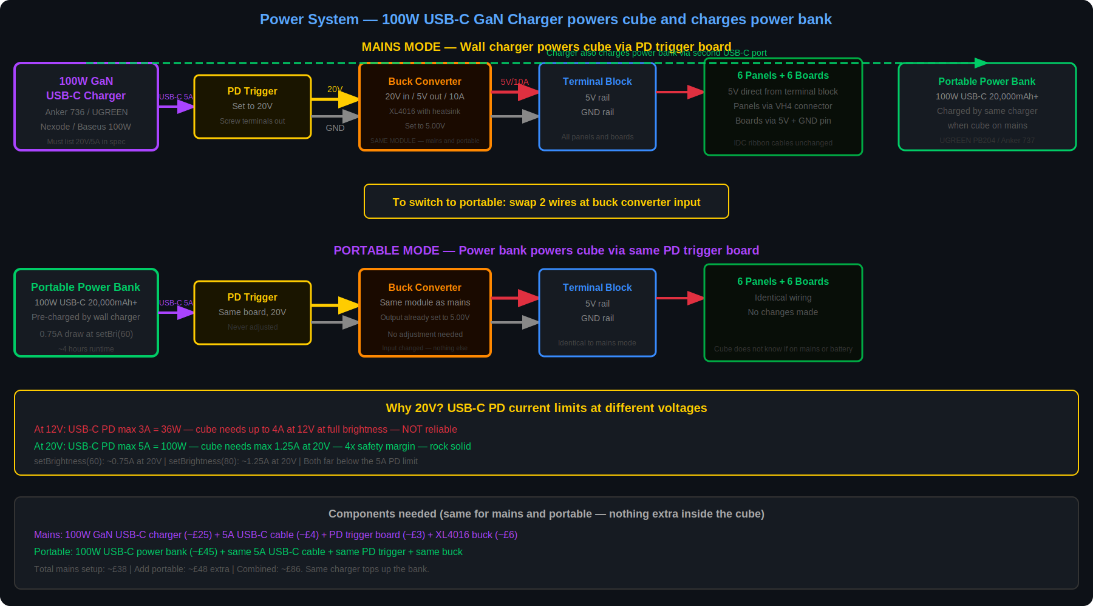
Figure 10 — Portable power circuit. Single 20V→5V/10A buck feeds the terminal block directly. Mains and portable comparison shown.

19.3 Component Details

USB-C PD power bank:
- Must support USB Power Delivery at 20V/5A (100W) — check the power bank spec sheet
- Charge the bank using the same 100W USB-C wall charger used for mains operation — plug the bank into the charger when the cube is on mains power
- 65W or 100W rated banks always support these voltages
- Recommended capacity: 20,000mAh (74Wh) — gives 3–4 hours at setBrightness(60)
- Good options: UGREEN 100W 20,000mAh, INIU 65W 20,000mAh, Anker 737
- Avoid power banks that only list Quick Charge 3.0 without USB-PD — QC does not support 20V output
- An E-Mark cable is required to unlock 5A at 20V — some 100W power banks include one, otherwise buy separately (~£3)

PD trigger board:
- A small module (roughly 20×10mm) that sits between the USB-C cable and your circuit
- Has a dip switch or button to select the output voltage — set it to 20V
- Output via two small screw terminals or solder pads — wire to the large buck converter input
- Available in packs of 2–5 on Amazon UK — search USB-C PD trigger board
- Confirm the trigger board supports 20V output — most modern ones do, some older boards only go to 12V

Buck converter — used for both mains and portable:
- One converter handles the full cube: 20V in, 5V out, rated at 10A minimum
- Search: XL4016 5V 10A DC-DC buck converter or LM2596HVS 5V 10A
- Must accept 20V input — most buck converters rated to 40V input handle this fine
- 10A rated output gives comfortable headroom — the cube draws at most 5A at setBrightness(80)
- Get one with a heatsink already fitted — it runs warm under sustained load
- Has a trimmer potentiometer to set output voltage — adjust to exactly 5.0V once and it stays set
- Input wires: from the PD trigger board in both cases — the trigger board connects to either the 100W USB-C wall charger or the power bank
- Output wires: always connected to the terminal block 5V and GND rails — never changed

Before connecting the cube for the first time, measure the buck converter output voltage with a multimeter and confirm it reads 5.0V. Too high will damage boards and panels. Too low will cause resets under load.

19.4 Setting the Large Buck Converter to 5V
- Connect the 100W USB-C charger to the PD trigger board via the 5A USB-C cable. Connect the trigger board screw terminal output to the buck converter input — do not connect anything to the buck output yet
- Power on and measure the voltage at the buck converter output terminals with a multimeter
- Turn the trimmer potentiometer slowly until the multimeter reads exactly 5.00V
- Switch off, then connect the buck output to the terminal block 5V and GND rails
- Power on with no panels connected — confirm 5V at the terminal block
- Connect panels and boards one at a time, measuring 5V at each VH4 connector before plugging in
- The buck output voltage stays set — no adjustment needed when switching to portable power

19.5 Portable Runtime Estimates
Power bank capacity | setBrightness setting | Current at 20V | Estimated runtime
20,000mAh (74Wh) | 40 — long runtime | ~0.40A | ~7 hours
20,000mAh (74Wh) | 60 — recommended | ~0.75A | ~4 hours
20,000mAh (74Wh) | 80 — full brightness | ~1.25A | ~2.5 hours
26,000mAh (96Wh) | 60 — recommended | ~0.75A | ~5 hours
50,000mAh (185Wh) | 60 — recommended | ~0.75A | ~10 hours

These estimates assume typical colourful effects. Video and full white effects draw more. Add 20–30% buffer when planning for an event. Charge the power bank beforehand using the same 100W USB-C wall charger — a full charge from empty takes roughly 2–3 hours.

19.6 Switching Between Mains and Battery
The portable and mains setups are completely interchangeable at the terminal block. No rewiring of panels or boards is needed.

- Mains and portable use the exact same buck converter, terminal block, and panel wiring
- The only thing that changes is what feeds the buck converter input: the 100W USB-C charger (via trigger board) for mains, the power bank (via same trigger board) for portable
- When on mains power, plug the power bank into the same 100W charger to keep it topped up ready for portable use
- Switching: loosen the two input terminals on the buck converter, swap wires, re-tighten — takes under a minute
- All panels, boards, IDC ribbon cables, and the terminal block remain completely untouched
- Tip: terminate both the PSU wires and the trigger board wires with ferrules so swapping them at the buck input is quick and clean

// No code changes needed — the cube does not know if it is on mains or battery
// Adjust brightness to control runtime:
display->setBrightness8(60); // ~15W typical — good for 3-4 hours
display->setBrightness8(40); // ~8W typical — good for 5-6 hours
display->setBrightness8(80); // ~25W typical — good for 2-2.5 hours

Some USB-C power banks shut off automatically if the current draw drops below a minimum threshold for a few seconds — this can happen between animation frames. If the bank keeps switching off, add a small constant load such as a USB LED or charging a phone simultaneously to keep the bank active.

19.7 Cost Comparison
Power option | Additional cost | Runtime | Notes
100W USB-C charger + PD trigger board + buck (mains) | £25–37 total | Unlimited (mains) | Charger also tops up the portable power bank
Add portable — 100W power bank | £35–55 extra | 2.5–10 hours per charge | Uses same charger, trigger board, and buck — nothing extra inside the cube
Both (recommended) | ~£60–92 total | Mains unlimited + portable | Swap two wires at the buck input to switch

The buck converter is bought once and serves both mains and portable use. Adding portable capability after the mains build is done costs only a power bank and a PD trigger board — no changes inside the cube at all.

20. Web Control Interface (ALL editions) — Version 20
The cube hosts its own control website directly on the ESP32 master. Connect any phone, tablet, or computer to your home WiFi and open http://ledcube.local — the interface provides a full-featured 3D simulator and live control panel. Effects, overlays, playlist, and video all transmit to the cube in real time via WebSocket.
No app installation, no cloud account, no additional hardware. The control interface is served from the cube itself and runs entirely on your local network.

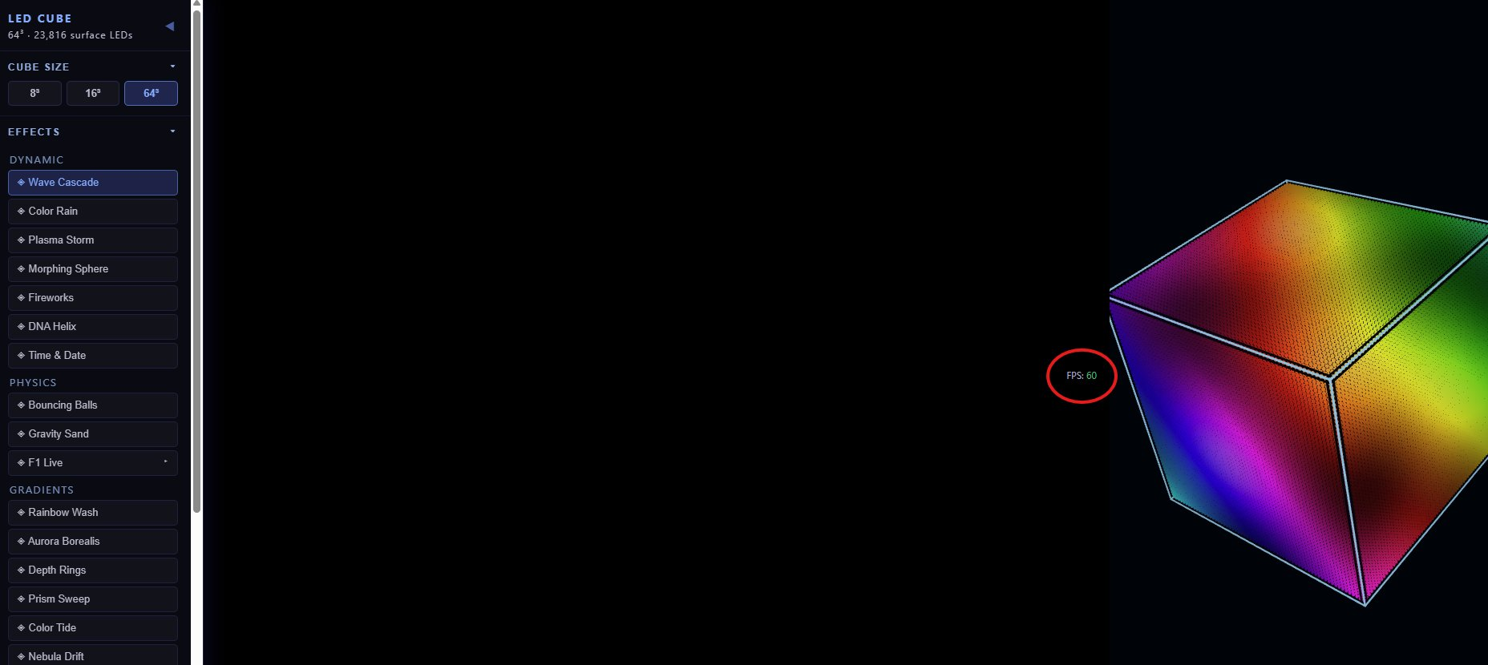
Figure 11 — Web interface showing the 3D cube simulator with Wave Cascade effect active. Left sidebar contains all controls.

20.1 Architecture Overview
The master ESP32 connects to your home WiFi as a standard client (STA mode) and simultaneously runs its own private WiFi access point (AP) for the slave boards.

Connection | Protocol | Purpose
Browser → master | HTTP GET / | Loads interface from master LittleFS
Browser → master | WebSocket ws://ledcube.local:81 | Real-time effect and state commands
Browser → master | HTTP POST /update | Uploads new interface file over WiFi
Master → slaves | UDP multicast | Effect state broadcast on private AP
Master → slaves | UDP unicast | Video frame forwarding on private AP

Two control buttons sit above the effects list:
● Effects ON / ○ Effects OFF — toggles all effects and overlays.
✕ CLEAR ALL — turns off all effects and all overlays and blanks the cube instantly.

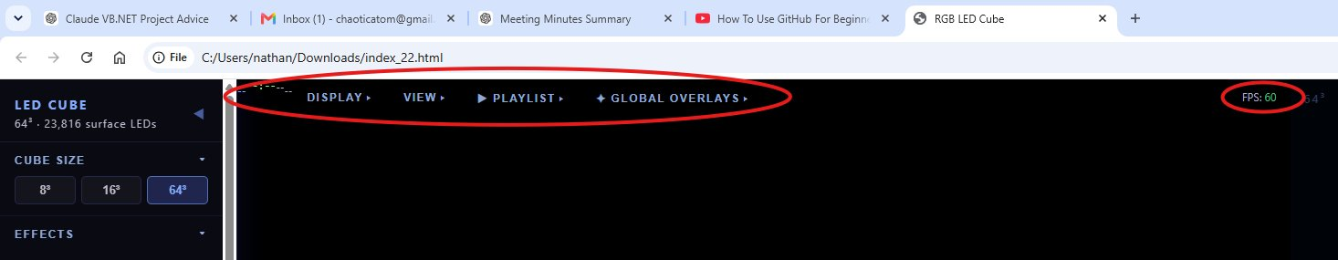
Figure 12 — Left sidebar showing Cube Size, Effects, Overlays, Playlist, and Panel Editor sections.

20.2 Effects
28 built-in effects organised into groups in the sidebar. All effects render only to surface LEDs. New in v20: Fireworks text overlay, Ghost Face, Light Speed.

Effect | Description
Wave Cascade | Sine wave ripple across all faces
Color Rain | Coloured droplets fall down each face. Matrix mode: green character streams top to bottom
Plasma Storm | Layered interference patterns in shifting colours
Morphing Sphere | Three concentric aurora-coloured shells rotating independently
Fireworks | Rockets burst across faces. Optional scrolling text in the top third of all 4 side panels
DNA Helix | Double helix with glowing rungs on side panels
Time & Date | Clock on front panel or scrolling across all 4 sides. Uses browser local clock
Bouncing Balls | Physics balls on the cube surface, responding to tilt via gyroscope
Gravity Sand | Pixel grains fall to the lowest face based on tilt. Settles to a flat level surface
F1 Live | Live race session display with flag colours, driver standings, and session timing
Rainbow Wash | Hue gradient wash cycling across all faces
Aurora Borealis | Curtain light effect with starfield
Depth Rings | Concentric rings pulsing from face centres
Prism Sweep | Rotating prism colour bands
Color Tide | Colour tide washing up and down faces
Nebula Drift | Deep-space cloud drift
Spectrum Analyser | Microphone FFT bars rising from the bottom of each face
Maze Runner | Animated maze with a runner traversing the passages
Tron Bikes | Light cycle game across all faces with flood-fill AI
Lightning Storm | Forking bolts with full-cube thunder flash and storm ambient
Warp Drive | Star-streak warp converging from face centres
Crystal Life | Conway's Game of Life with three-phase colour ageing
Liquid Crystal | Gravity-responsive fluid with iridescent interference colours
Video Display | Plays video from file, webcam, or screen capture across the faces
Strobe Flash | Rapid flash with 8 pattern modes and adjustable speed
Random Chaos | 10 generative visual modes cycling automatically
Ghost Face | Ghostly face emerges from a random panel with per-appearance personality
Light Speed | Objects race across all 6 faces at extreme speed with trail. Controls: speed, trail length, size, nudge angle, object count, colour

20.3 Overlays
13 overlays can be active simultaneously on top of any effect. Each has an independent toggle and controls. A global brightness slider scales all overlay output.

Overlay | Controls | Description
Twinkling Stars | Density, Speed, Colour | Bright points appearing and fading across all faces
Snowfall | Density, Speed, Colour | Soft flakes drifting downward
Meteor Shower | Rate, Trail, Colour | Bright streaks crossing faces with fading trails
Edge Glow | Intensity, Speed, Colour | Pulsing glow along all cube edges
Fire Border | Height, Intensity, Colour | Flames rising from the bottom of all 4 side faces. Modes: Fire, Plasma, Toxic, Arcane
Sparkle Rain | Density | Random bright pixel sparks across all faces
Color Wave | Speed, Colour | Sweeping colour band rolling across the surface
Breathe Pulse | Rate, Colour | Whole-cube brightness slowly pulsing in and out
Scan Line | Speed, Colour | Horizontal bar scanning up each face
Vignette | Intensity | Darkens the edges of each face toward the corners
Glitch | Rate, Intensity | Pixel scramble artefacts like a corrupted display
Mist | Density | Soft drifting cloud patches
Lightning | Rate, Width, Brightness | Lightning bolt overlay on top of any active effect

20.4 Playlist
The playlist editor queues effects with durations and overlays that play in sequence automatically.

Each playlist item contains: effect, duration (3–120 seconds), any combination of overlays, and speed multiplier. All 28 effects are available except F1 Live and Video Display. All 13 overlays are available per item. Transitions: Crossfade, Flash, or Implode. Named playlists save and load from browser localStorage.
Saved playlists from earlier versions that contained F1 Live or Video Display items are automatically removed on load.

20.5 Fireworks — Scrolling Text
The Fireworks effect includes an optional scrolling text band across the top third of all 4 side panels.

Open the Fireworks panel in the sidebar.
Type your message in the text field (up to 80 characters). Text pre-renders immediately as you type.
Check Show text on cube to display it on the physical LED panels.

The font auto-sizes to fill exactly one full revolution of the cube. The scroll loops seamlessly. Text is rainbow-coloured and correctly oriented on all faces.

20.6 Light Speed
Objects race across all 6 cube faces in straight lines at extreme speed, leaving a fading trail behind them.

Control | Range | Description
Speed | 1–20 | Travel speed. At maximum, objects complete a full revolution in under a second
Trail Length | 4–120 | Number of pixels in the fading trail behind each object
Size | 1–16 px | Width of the object head in pixels
Nudge | 0°–90° | Maximum angle change applied occasionally. 0° = perfectly straight lines forever
Objects | 1–12 | Number of simultaneously racing objects
Colour | Multi / solid | Multi cycles hue along the trail. Solid options: White, Cyan, Red, Green, Gold

Objects start at 0 degrees (going straight right). Nudges fire randomly every few seconds and rotate by up to the selected angle in either direction. Objects cross each other's paths without interaction.

20.7 Updating the Interface
To update the interface file on the cube without USB, add a dedicated update endpoint to the ESP32 firmware. Because this endpoint is compiled into the firmware rather than stored on LittleFS, it remains accessible even if the interface file is corrupted or missing.

Once added:
Open http://ledcube.local/update in a browser on the same network.
Select the new interface file and click Upload.
The ESP32 writes to LittleFS and restarts. The interface reloads automatically.

File | Location | Updated via
index.html | LittleFS | http://ledcube.local/update
Firmware logic | Compiled C++ | Arduino OTA or USB
/update endpoint | Compiled into firmware | Arduino OTA or USB only

The sidebar also has an UPLOAD FIRMWARE button that posts the current page HTML directly to the cube. Convenient for quick updates but requires the browser to be on the same local network.

20.8 HTTPS and Mixed Content
If the interface is hosted on an external HTTPS server, the browser blocks the cube WebSocket (ws://) as mixed content. The interface detects this automatically — WebSocket streaming is skipped silently and the 3D simulator runs normally in the browser.

To stream to the physical cube, open http://ledcube.local directly on the local network.

20.9 Connecting from Phone or PC
Connect your device to the same WiFi network as the ESP32.
Open a browser and navigate to http://ledcube.local.
The 3D cube simulator loads immediately — no installation required.
Select effects, enable overlays, and build playlists from the left sidebar.
LED data streams to the physical cube automatically via WebSocket.

On Windows, mDNS (ledcube.local) requires Bonjour, included with iTunes. Alternatively use the ESP32 IP address shown in the Serial monitor on boot.

