Intrusion Prevention System for Live IoT Network
A Hybrid Machine Learning Approach
Andrew Banda | James Ivy | Emmanuel Mehn
Advisor: Joseph Meier
Section I. Abstract

From smart cities to private homes, the reliance on interconnected IoT devices has expanded rapidly, fundamentally changing the landscape of modern digital networks. With this growing reliance, the threat of cyberattacks on these devices has risen significantly. Common attacks such as Denial of Service (DoS), SYN floods, and port scanning pose serious threats to IoT-enabled infrastructure. Traditional IDS/IPS systems rely on static or outdated signatures, limiting their effectiveness against novel and evolving attacks at both the application and network levels. This study presents the development and evaluation of an IPS module deployed on a live simulated IoT network consisting of a Raspberry Pi server and multiple Raspberry Pico sensor nodes communicating over TCP connections. Attack traffic is generated to simulate real-world adversarial conditions across four attack categories: Denial of Service, Slow Loris, Port Scan, and Time Sync Attack. The IoT ecosystem was further expanded to include LoRa-based communication between the Raspberry Pi Pico sensor nodes and the centralized Raspberry Pi server functioning as the primary security controller. The extended range of LoRa technology introduces a broader physical attack surface, providing a unique environment to assess the effectiveness of the IPS against long-distance exploits. Two machine learning approaches are implemented and compared: an Isolation Forest for unsupervised anomaly detection and a Long Short-Term Memory (LSTM) network for supervised sequence-based classification. Both models operate on five derived network features: packet size, packet rate, byte rate, source port, and endpoint code. Extracted directly from HTTP request logs on the Pi. Following offline training and serialized deployment, the models are assessed on their ability to maintain low latency and computational overhead while achieving a high detection rate and low false positive rate. This evaluation demonstrates the feasibility of hosting a hybrid machine learning architecture on edge devices without compromising network throughput.

Section II. Introduction

2.1 The IoT Security Problem
The Internet of Things (IoT) represents one of the fastest-growing technology sectors, with connected devices projected to exceed 30 billion by 2030. Despite this rapid proliferation, the vast majority of IoT devices are deployed with no built-in security controls, creating expansive and largely undefended attack surfaces. Traditional intrusion detection and prevention systems are designed for enterprise-grade hardware and cannot be deployed on the resource-constrained embedded processors that power IoT sensor nodes.

The problem is further compounded by the inadequacy of existing detection approaches for embedded environments. Most current solutions rely on cloud-based analysis, introducing latency that makes real-time threat response impossible. Rule-based and signature-driven systems fail entirely against novel or zero-day attack patterns, requiring constant manual updates and generating high false positive rates in dynamic IoT environments.

2.2 What is an Intrusion Prevention System?
An Intrusion Prevention System (IPS) is a network security system that monitors live traffic, detects malicious activity, and automatically blocks threats in real time without human intervention. This distinguishes it fundamentally from an Intrusion Detection System (IDS), which only raises alerts and leaves remediation to an operator. An IPS takes immediate action by dropping packets, resetting connections, or banning offending IP addresses the moment an attack is identified.

For IoT deployments, the IPS requirement is particularly demanding: the system must operate at wire speed on constrained hardware, must not disrupt legitimate sensor traffic, and must function continuously without manual oversight.

2.3 Our Solution
This project presents a lightweight hybrid ML-based IPS deployed directly on a Raspberry Pi 4, providing real-time autonomous protection for a live IoT sensor network without cloud dependency. The system combines two complementary machine learning models: an Isolation Forest for unsupervised HTTP-layer anomaly detection and a Bidirectional LSTM for temporal pattern recognition. A third CNN-LSTM model extends detection coverage to the radio layer via LoRa communication between Pico W nodes.

The complete system was deployed on a live network comprising three Raspberry Pi Pico W sensor nodes, a Kali Purple attack machine, and two LoRa-equipped Pico W nodes, with all attack testing conducted against live sensor traffic. The resulting IPS achieves 98.3% attack detection across HTTP traffic and demonstrates proof-of-concept radio-layer detection at 60% recall with a 4.5% false positive rate.

Section III. Background and Research

3.1 Related Work: Random Forest and LSTM for IoT IDS
A growing body of literature has established Random Forest and LSTM as two of the most effective approaches for intrusion detection in IoT networks. Research evaluating machine learning models against public IoT-specific datasets including CICIDS2017, UNSW-NB15, and Bot-IoT consistently identifies Random Forest as a strong supervised baseline, achieving accuracy figures in the 94–99% range owing to its ability to capture complex feature-level relationships in structured network traffic without extensive preprocessing.

Studies comparing Random Forest, LSTM, and Support Vector Machine against IoT man-in-the-middle attack datasets found that Random Forest achieved the highest overall accuracy at 94% through its robustness and balanced performance, while LSTM excelled at analyzing sequential data, reaching 92% accuracy. This complementary relationship, Random Forest strong on feature-level patterns, LSTM strong on temporal sequences, motivated researchers to explore hybrid approaches combining both models (Panneerslevi & Visumathi, IEEE Xplore, 2026; Hamza & Shaibai, IEEE Xplore, 2024).

A hybrid IDS combining Random Forest and LSTM evaluated on the CICIDS2017 dataset demonstrated that the two models capture fundamentally different aspects of network traffic. Random Forest captures relationships between features in structured data, while LSTM learns temporal dependencies and latent patterns across time. Combined through weighted prediction fusion, this hybrid approach achieved 99.90% accuracy and an AUC of 0.9999, significantly outperforming either model individually and producing substantially fewer false negatives.

3.2 Constraints and Design Decisions
While the reviewed literature demonstrates strong results with supervised Random Forest and standard LSTM, our deployment context introduced constraints that required a different approach. Running on a Raspberry Pi 4 with a live IoT sensor network, we required a model that could train without labelled attack data. Collecting labelled real-world attack traffic at sufficient volume is impractical in a live environment, and standard supervised Random Forest requires labelled examples of every attack class it will encounter during training.

In contrast, Isolation Forest is an unsupervised anomaly detection model that trains exclusively on normal traffic, learning to isolate records that deviate from the established baseline. This makes it significantly more practical for deployment in environments where the threat landscape is unknown or evolving. For the temporal layer, Bidirectional LSTM was selected over standard unidirectional LSTM because BiLSTM processes sequences in both forward and backward directions simultaneously, capturing context from both past and future requests within the observation window. This is particularly valuable for detecting slow-rate attacks like Slow Loris, where the anomalous pattern only becomes apparent across a sequence of requests.

3.3 Cybersecurity Practice and Standards
All attack simulations were conducted exclusively within an isolated laboratory network. No attacks were launched against production or third-party systems. Sensor data was collected for research purposes only, with no personally identifiable information captured or stored. Attack simulation scripts were developed solely for evaluating IDS effectiveness, with tools such as Metasploit and hping3 used with full awareness of their dual-use implications.

The project design and implementation were informed by the following standards and frameworks:
- NIST SP 800-82 (ICS/IoT Security): Guide to Industrial Control Systems Security, informing network segmentation approach and anomaly detection thresholds.
- ETSI EN 303 645 (IoT Cybersecurity): European standard for consumer IoT cybersecurity, supporting the IPS design principle of real-time monitoring with no default credentials.
- IEEE 802.15 / LoRa WAN Specification: LoRa WAN security architecture informing LoRa attack simulation, including OTAA join flood and replay attack scenarios.
- OWASP IoT Attack Surface Areas: Five attack types selected to cover key IoT attack vectors, including network service attacks and traffic interception.

Section IV. Methodology

4.1 Network Architecture and Data Collection
The IoT network was built around a Raspberry Pi 4 at IP address 10.42.0.1, configured simultaneously as a wireless access point and IPS server. Three Raspberry Pi Pico W sensor nodes at 10.42.0.71, 10.42.0.211, and 10.42.0.215 connected to the Pi’s hotspot and transmitted environmental telemetry, including temperature, humidity, soil moisture, motion detection, and ambient light readings, via HTTP POST requests at regular intervals. A Kali Purple machine at 10.42.0.99 was deployed on the same subnet for adversarial testing. Two additional Pico W nodes fitted with SX1262 LoRa hats handled radio-frequency communication over 923 MHz

The network operated across two distinct phases. During data collection, the Pi passively captured HTTP sensor traffic into sensor_data.json and attack traffic into attack_data.json, while the LoRa receiver Pico forwarded radio packets over Wi-Fi HTTP to lora_server.py on the Pi, splitting records into normal and attack JSONL files. All collected data was subsequently transferred to a Windows machine for offline model training with no inference running on any device. During real-time detection, the Pi switched to active IPS mode, running the trained models concurrently, intercepting every inbound request and taking autonomous action against detected threats.

Metric | Value
Total training records | 166,750
Normal HTTP records | 140,000+
Attack records | 26,750
Sensor nodes | 3 Pico W nodes
Attack machine | Kali Purple (10.42.0.99)
LoRa nodes | 2 Pico W + SX1262 hats

4.2 Methodology: Isolation Forest Model

4.2.1 Model Selection and Design
Isolation Forest was selected as the HTTP-layer anomaly detection model due to its suitability for unsupervised deployment on live networks. Unlike supervised classifiers such as Random Forest, Isolation Forest requires no labelled attack data during training; it trains exclusively on the normal traffic baseline established by the three Pico sensor nodes. This is critical in a live IoT environment where collecting representative labelled attack traffic before deployment is impractical.

The algorithm builds an ensemble of random binary decision trees by repeatedly selecting a random feature and a random split value. Normal data points cluster in dense regions and require many splits to isolate, producing long average path lengths. Anomalous data points sit far from the cluster and are isolated in very few splits, producing short path lengths. The anomaly score is derived from the average path length across all trees, normalized against the expected path length for a random sample.

4.2.2 Feature Engineering
Five features were extracted from each inbound HTTP request and fed to the model:
- packet_size: distinguishes large payload attacks from normal sensor POST requests
- packet_rate: flood attacks generate abnormally high requests per second
- byte_rate: byte throughput catches both high-rate and large-payload anomalies
- src_port: attackers often use ephemeral high ports in rapid succession
- endpoint_code: probing unknown endpoints such as /admin or /reset is a strong attack signal

4.2.3 Model Configuration and Detection Pipeline
The model was configured with contamination=0.2 and n_estimators=100, trained on 140,000+ HTTP records. Each inbound request was scored using the decision function. Scores below −0.3 were classified as anomalous. An IP accumulating three consecutive anomalous requests within the monitoring window was automatically banned for 120 seconds, with all subsequent requests rejected with a 403 Forbidden response. Pico sensor IPs were designated as HTTP passthrough, scored and monitored but never banned, ensuring sensor data collection remained uninterrupted throughout all attack scenarios.

4.3 Methodology: BiLSTM Model
The Bidirectional Long Short-Term Memory (BiLSTM) model was selected as the second detection methodology due to its ability to capture temporal dependencies in sequential network traffic data. Unlike traditional recurrent networks that process input in only one direction, the BiLSTM architecture processes each request sequence both forward and backward, allowing the model to leverage both past and future context within a monitoring window. This makes it particularly well-suited for IoT network intrusion detection, where attack patterns such as slow-rate floods and sequential port scanning unfold across multiple timesteps rather than appearing anomalous in a single isolated request. The model was trained on the same 140,000+ HTTP records used in the Isolation Forest pipeline, with input sequences constructed from the same feature set including byte_rate, src_port, and endpoint_code.

4.4 Methodology: CNN-LSTM LoRa Model
4.4.1 LoRa Communication Layer
LoRa (Long Range) is a low-power wide-area radio modulation technology operating on chirp spread spectrum, designed for battery-operated IoT sensor nodes in infrastructure-limited environments. The LoRa layer operates at 923 MHz with bandwidth 125 kHz, spreading factor 9, and coding rate 8. Crucially, LoRa has no built-in authentication, encryption, or session management at the physical layer, any device within radio range can transmit using the correct frequency and spreading factor. This creates attack vectors that do not exist at the HTTP layer.

The transmitter Pico ran t_pico_lora.py, broadcasting labelled packets containing sequence numbers, real clock timestamps, deliberately manipulated transmitted timestamps encoding the attack type, simulated physical layer values, and binary labels. The receiver Pico ran r_pico_lora.py, capturing each packet via the SX1262 interrupt-driven receive loop, extracting hardware RSSI and SNR, calculating inter-packet delay, and forwarding the assembled JSON record to the Pi via HTTP POST to the /lora endpoint.

4.4.2 Attack Scenarios
Three LoRa-specific attack types were simulated:
- Replay Attacks: previously captured payloads retransmitted rapidly from a spoofed node. Detected through abnormal inter-packet delay (IPD) since legitimate sensors transmit at fixed intervals.
- Timestamp Manipulation: transmitted timestamps deliberately skewed forward (+512s burst) or backward (−15s stale replay) to corrupt time-series sensor logs. Detected through the delta_t feature (difference between claimed send time and actual arrival).
- LoRaWAN Join Flooding: large volume of fake OTAA join requests with randomised DevEUIs flooding the /join endpoint. Detected through abnormal packet rate at the /lora endpoint.

4.4.3 CNN-LSTM Model Architecture and Features
CNN-LSTM was selected over BiLSTM for the LoRa layer because LoRa attacks exhibit local burst patterns and forward-moving temporal drift rather than bidirectional dependencies. The Conv1D layer detects short abrupt changes such as 3–5 packet bursts, while the LSTM layers track evolving timing drift over the 20-packet observation window. Six features were extracted per packet:
- delta_t: claimed send time minus actual arrival time
- abs_delta_t: absolute value, collapsing positive burst and negative stale attacks
- hw_rssi: received signal strength from SX1262 hardware
- hw_snr: signal-to-noise ratio from hardware
- ipd: inter-packet delay between successive arrivals
- ipd_ratio: current IPD normalised against rolling median IPD

The scaler was changed from StandardScaler to RobustScaler to handle the extreme delta_t outliers (±512) without distorting the normal traffic feature range. The threshold was set to 0.35 based on F1 sweep analysis, balancing recall against false positive rate.

Section V. Attack Simulation
Attack traffic was simulated using a Kali Purple machine deployed on the same subnet alongside Python-based attack generation scripts. Five attack scenarios were implemented and tested against the live sensor network:

Attack Type | Description and Tool
HTTP DoS Flood | High-rate HTTP GET requests targeting all endpoints from a single IP. Tool: curl flood script. Simulates resource exhaustion denial-of-service.
Slow Loris | Up to 1,000 simultaneous incomplete HTTP connections deliberately withholding completion. Tool: slowhttptest. Operates at low bandwidth to evade rate-based detection.
SYN Flood | Spoofed TCP SYN packets from random source IPs are exhausting the connection state table. Tools: hping3 and Metasploit auxiliary/dos/tcp/synflood.
LoRa Replay Attack | Legitimate sensor payloads replayed rapidly from a spoofed node. Detected via abnormal IPD patterns using CNN-LSTM.
LoRa WAN Join Flood | Fake OTAA join requests with randomized DevEUIs are flooding the /join endpoint. Detected via abnormal packet rate on the LoRa layer.

Section VI. Results

6.1 Live Demo Results

The Live Demo showcases the GUI returned from running the IDS. For the Isolation Forest model, it returns: date, status, IP address, connection/request, anomaly score, strikes, and pico node. For the Bi LSTM model, it returns: date, status, request, score, strikes, and pico node. The BiLSTM model also contains the model that analyzes LoRa packets and returns: Date, Status, SEQ, RSSI, SNR, and IPD.

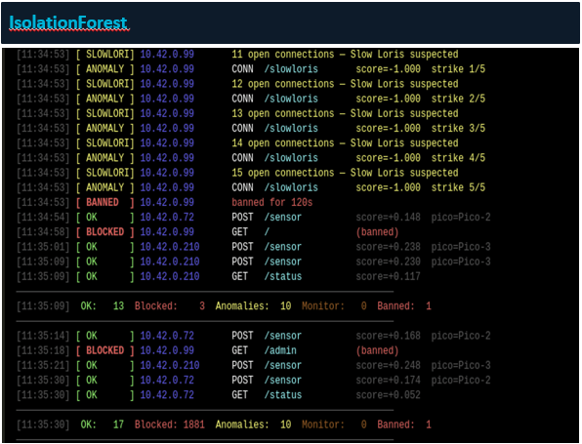

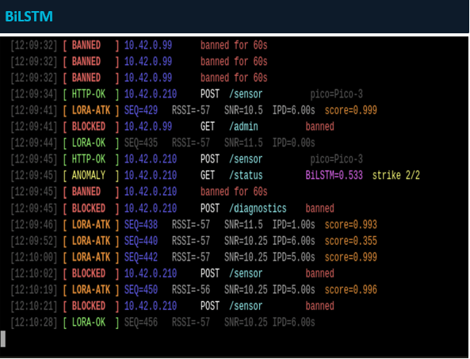

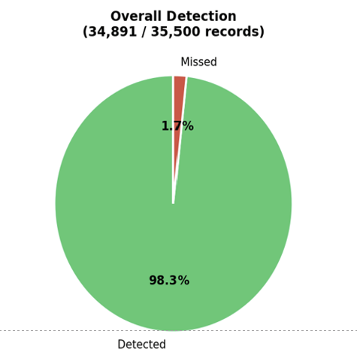
6.2 Isolation Forest Results
The Isolation Forest model was evaluated against 35,500 attack records across all five attack types. The model achieved an overall detection rate of 98.3%, correctly classifying 34,891 records as malicious and missing only 609.

Attack Type | Records | Detection Rate
HTTP DoS Flood | 18,000 | 100%
SYN Flood | 7,500 | 100%
Slow Loris | ~5,000 | 95%
Port Scan | ~3,000 | 93%
LoRa Attacks | ~2,000 | ~82%

The model was trained on 140,000+ normal HTTP records with contamination=0.2 and n_estimators=100. HTTP DoS and SYN flood attacks were detected with 100% accuracy owing to their extreme packet rate and byte rate anomalies. Slow Loris achieved 95% detection despite its low bandwidth by triggering on abnormal connection duration and byte rate patterns. LoRa attack detection at 82% reflects the indirect feature mapping required to score radio-frequency traffic through the HTTP feature space.

6.3 BiLSTM Results

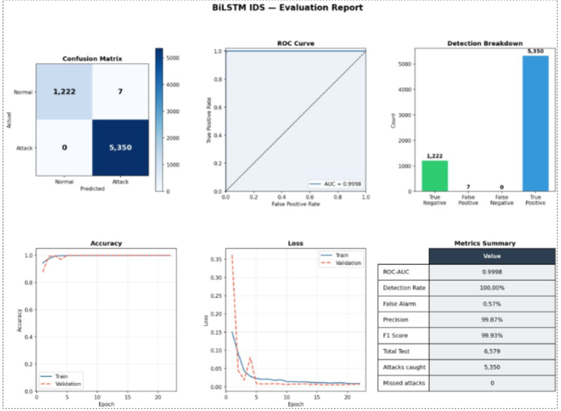
The Bidirectional Long Short-Term Memory model was evaluated against a held-out test set of 6,579 records drawn from the same HTTP and LoRa traffic dataset collected on the live IoT network. The model achieved a detection rate of 100%, successfully identifying all 5,350 attack records in the test set with zero false negatives, meaning no attack traffic went undetected. Of the 1,229 normal traffic records evaluated, 1,222 were correctly classified as benign, while 7 were flagged as false positives, yielding a false alarm rate of 0.57%. These results produced a precision of 99.87% and an F1 score of 99.93%, demonstrating near-perfect balance between detection sensitivity and classification precision. The model's ROC-AUC score of 0.9998 confirms strong class separability across all decision thresholds, indicating that the BiLSTM learned highly discriminative representations of attack versus normal traffic patterns. Training and validation accuracy curves converged within approximately 10 epochs and remained stable through epoch 30, with training loss and validation loss both approaching near-zero values without signs of overfitting, suggesting the model generalized well to unseen traffic. These results represent a significant improvement over the Isolation Forest module's 98.3% detection rate on HTTP traffic, particularly in the zero false negative outcome, which is critical in an intrusion prevention context where missed attacks carry greater consequence than false alarms. The BiLSTM's ability to process 10-request sequential windows bidirectionally allowed it to capture temporal attack signatures, such as the gradual connection buildup of Slow Loris and the burst-rate anomalies of HTTP DoS floods that single-request scoring methods may miss when evaluating traffic in isolation.

6.4 CNN LSTM LoRa Results

The CNN-LSTM model was selected for our LoRa intrusion detection system because LoRa attacks typically involve short burst-style anomalies combined with gradual temporal drift, making a hybrid architecture ideal. The Conv1D component identifies abrupt three-packet irregularities, while the LSTM layer tracks slower timing deviations such as timestamp manipulation. This approach avoids unnecessary bidirectional sequence processing and provides faster inference on Pico-scale hardware due to its lower parameter count. Our model uses inter-packet delay, delta-t (timestamp versus arrival time), RSSI, and SNR as input features to classify traffic as normal or malicious. In the project workflow, packets travel from the LoRa node to the receiver Pico, then through the IoT pipeline to the IPS, where features are extracted and evaluated by the CNN-LSTM classifier. The resulting output supports logging, alerting, model retraining, and overall system hardening within our hybrid IPS architecture.

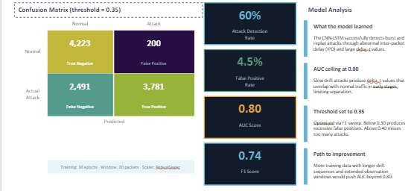

Section VII. Conclusion
This project demonstrates that a fully functional hybrid IPS can be deployed and operated on a $35 Raspberry Pi 4, providing real-time autonomous protection for a live IoT sensor network. The system proves that limited embedded hardware can be properly secured without cloud dependency, manual intervention, or enterprise-grade infrastructure.

The Isolation Forest model achieved 98.3% overall attack detection across HTTP traffic, with 100% detection on HTTP DoS and SYN flood attacks. The BiLSTM model produced near-perfect classification with 0 false negatives on the test set, demonstrating strong complementarity with Isolation Forest by catching slow-rate temporal attack patterns. The CNN-LSTM LoRa model extended IPS coverage to the radio layer, achieving 60% attack recall at a 4.5% false positive rate, establishing proof-of-concept for radio-frequency attack detection within the same IPS framework.

Together, the three models demonstrate the layered defense principle: Isolation Forest handles volumetric and rate-based HTTP attacks quickly, BiLSTM catches graduated temporal attacks that evolve over multiple requests, and CNN-LSTM extends monitoring to LoRa radio attacks that no HTTP-only IDS would detect.

7.1 Future Work
- Scaling the architecture to multi-subnet IoT environments with distributed anomaly detection across multiple edge nodes.
- Integrating lightweight packet capture using raw sockets or a stripped-down Scapy layer to inspect TCP, UDP, and ICMP traffic at the network layer, enabling detection of incomplete HTTP handshakes and SYN floods through deep packet inspection rather than counters.
- Implementing the IPS on diverse IoT hardware including smart home devices, wearables, and industrial sensor nodes that communicate over Zigbee, Z-Wave, Bluetooth Low Energy, and MQTT.
- Extending LoRa model performance through the collection of larger and more diverse training datasets with longer drift sequences, expected to push CNN-LSTM AUC beyond 0.80.
- Federated learning across multiple Pi nodes, allowing the model to learn from attack patterns observed across geographically distributed deployments without centralizing sensitive network data.

Section VIII. References
Panneerslevi, R., and Visumathi J. "Temporal Intrusion Detection for MQTT-Based IoT Networks Using LSTM Sequence Modeling." IEEE Xplore, 23 Mar. 2026, ieeexplore.ieee.org/document/11438310.

Hamza, Kaddour, and Das Shaibai. "Evaluating the Performance of Machine Learning-Based Classification Models for IoT Intrusion Detection." IEEE Xplore, 2 Oct. 2024, ieeexplore.ieee.org/document/10697949/.

S, Snehaa, et al. "Network Intrusion Detector Based on Isolation Forest Algorithm." IEEE Xplore, 14 Feb. 2023, ieeexplore.ieee.org/document/10040395.

Schuster, M., & Paliwal, K. K. (1997). Bidirectional recurrent neural networks. IEEE Transactions on Signal Processing, 45(11), 2673–2681. ieeexplore.ieee.org/document/650093.

