Hierarchical Demand Forecasting with Machine Learning:
A Comparative Study of Reconciliation Methods on the M5 Walmart Dataset
Lamiaa Chaouch, Nada Amaachou, Saad El Amraoui El Idrissi
Master Mls — Supply Chain Management & Artificial Intelligence Module
Faculte des Sciences Juridiques, Economiques et Sociales de Tetouan (FSJESTe)
Universite Abdelmalek Essaadi — Spring 2026
GitHub: https://github.com/chaouchlamiae1-blip/hierarchical-forecasting-m5
Abstract
This paper presents a comprehensive comparative study of hierarchical forecasting methods applied to the M5 Walmart competition dataset — one of the largest publicly available retail sales datasets. We develop an end-to-end machine learning pipeline using XGBoost trained on a 2,000-SKU sample of the M5 dataset (30,490 SKUs, 10 stores, 3 US states) with carefully engineered lag, rolling, and calendar features. Forecasts are generated at the bottom level (SKU-store, Level 4) and three hierarchical reconciliation strategies are evaluated: Bottom-Up (BU), Top-Down (TD), and MinTrace Ordinary Least Squares (OLS). Results are assessed using WAPE, sMAPE, and MASE over a 28-day holdout period consistent with the M5 competition protocol. Our findings demonstrate that Bottom-Up reconciliation achieves the best aggregate-level performance (WAPE = 5.16%, sMAPE = 5.30% at Level 1), while MinTrace OLS achieves the lowest MASE (0.520) at the SKU level. All ML-based methods substantially outperform the naive seasonal baseline (WAPE = 94.49%), confirming significant Forecast Value Added (FVA). These results provide practical guidance for supply chain practitioners implementing hierarchical demand planning systems.
Keywords — hierarchical forecasting, demand planning, XGBoost, gradient boosting, Bottom-Up reconciliation, Top-Down reconciliation, MinTrace OLS, M5 competition, supply chain management, intermittent demand.
I. INTRODUCTION
Demand forecasting is one of the most critical functions in supply chain management (SCM). Accurate sales forecasts enable organizations to optimize inventory levels, minimize holding and stockout costs, and improve customer service levels. In modern retail supply chains, forecasting must be performed simultaneously at multiple levels of aggregation: from individual Stock Keeping Units (SKUs) in specific stores, up through product categories, regions, and company-wide totals. This multi-level structure creates the problem of forecast coherence: independently generated forecasts at different levels may not be consistent with one another, meaning the sum of SKU-level forecasts may not match the store-level forecast, which in turn may not match the national forecast.
Hierarchical forecasting addresses this fundamental challenge by jointly modeling and reconciling forecasts across all levels of a predefined hierarchy. The field has evolved significantly over the past two decades, moving from simple heuristic approaches (Bottom-Up, Top-Down) toward statistically optimal reconciliation frameworks such as MinTrace [2], which guarantee coherence while minimizing the total variance of reconciliation errors across the entire hierarchy.
The emergence of large-scale gradient boosting methods — particularly XGBoost [5] and LightGBM — has transformed retail demand forecasting by enabling accurate predictions on datasets with tens of thousands of time series and complex feature interactions. The M5 Forecasting Competition [3], held in 2020 with the Walmart dataset, demonstrated the dominance of these approaches over classical statistical methods (ARIMA, ETS) for large-scale hierarchical retail forecasting.
In this study, we apply XGBoost as our base forecasting model on the M5 dataset and systematically compare three reconciliation strategies — Bottom-Up, Top-Down, and MinTrace OLS — across four hierarchical levels. Our contributions are: (1) a complete, reproducible ML pipeline for hierarchical retail forecasting; (2) a rigorous empirical comparison of reconciliation methods using three complementary evaluation metrics; (3) an analysis of Forecast Value Added (FVA) versus naive benchmarks; and (4) practical recommendations for supply chain practitioners choosing between reconciliation strategies.
The remainder of this paper is organized as follows. Section II reviews related work in hierarchical forecasting and gradient boosting methods. Section III details our dataset, methodology, and experimental setup. Section IV presents and discusses our results. Section V concludes with implications for practice and future research directions.
II. RELATED WORK
A. Hierarchical Forecasting
The hierarchical forecasting problem was formalized by Hyndman et al. [1], who proposed an optimal combination approach that reconciles base forecasts using generalized least squares. This framework was extended by Wickramasuriya et al. [2] to the MinTrace approach, which proves that the optimal reconciliation matrix minimizes the trace of the covariance matrix of reconciled forecast errors. MinTrace can be implemented with different assumptions about the covariance structure: OLS (assuming equal and independent errors), WLS (weighted by in-sample variances), and shrinkage estimators for high-dimensional hierarchies.
Traditional approaches include Bottom-Up (BU), where forecasts from the lowest level are summed to obtain higher-level forecasts, and Top-Down (TD), where an aggregate forecast is disaggregated using historical proportions. Both approaches have well-documented limitations: BU tends to accumulate errors at higher levels, while TD struggles to capture individual series dynamics [1]. Middle-Out approaches attempt to compromise between the two extremes but remain less theoretically motivated than MinTrace.
B. Gradient Boosting for Time Series
XGBoost [5] and LightGBM have become the dominant approaches for large-scale time series forecasting in recent years. Unlike classical statistical models (ARIMA, ETS, Prophet), which model one series at a time, gradient boosting methods can leverage cross-series patterns through a global modeling approach: all series are combined in a single training set with series-identifying features. This approach is particularly effective when series share similar demand patterns, which is common in retail settings with similar products across stores.
The key to effective gradient boosting forecasting lies in feature engineering: lag features capturing autocorrelation, rolling statistics capturing local trends, and calendar features capturing seasonality. The M5 competition winners [3] demonstrated that carefully engineered lag-based features, combined with XGBoost or LightGBM, consistently outperformed more complex deep learning approaches on the M5 dataset.
C. The M5 Competition
The M5 Forecasting Competition [3] was organized by Makridakis et al. and ran on Kaggle in 2020. It used five years of Walmart sales data (2011-2016) across three US states (California, Texas, Wisconsin) and three product categories (FOODS, HOBBIES, HOUSEHOLD). With 30,490 time series and a hierarchical structure of 12 aggregation levels, it is the most comprehensive hierarchical retail forecasting benchmark available. The competition revealed that ensemble methods combining multiple gradient boosting models with careful feature engineering dominated the leaderboard, while pure deep learning approaches performed comparatively worse on this dataset.
III. DATASET & METHODOLOGY
A. Dataset Description
The M5 dataset comprises three CSV files. The primary file, sales_train_validation.csv, contains daily unit sales for 30,490 SKU-store combinations over 1,913 consecutive days (January 29, 2011 to May 22, 2016), stored in wide format (one row per series, one column per day). The calendar.csv file maps each day identifier to calendar attributes including exact dates, SNAP benefit payment indicators by state, and special event labels (sporting events, cultural events, national holidays). The sell_prices.csv file provides weekly sell prices for each item-store combination.
Due to memory constraints in our experimental environment, we work with a stratified random sample of 2,000 SKU-store series (random_state=42), preserving the distributional properties of the full dataset across product categories and store locations. The hierarchical structure of our sample is organized into four levels as described in Table I.
Level | Description | Example series | Approx. count
L1 (Top) | Grand total | TOTAL | 1
L2 | Category x State | FOODS_CA, HOBBIES_TX | 9
L3 | Department x Store | FOODS_1_CA_1 | ~70
L4 (Bottom) | SKU x Store | HOBBIES_1_001_CA_1 | 2,000
Table I: Four-level hierarchical structure used in this study (2,000-SKU sample).
B. Exploratory Data Analysis
A critical characteristic of the M5 dataset is the high degree of demand intermittency at the SKU level. Our analysis reveals that 68.2% of all SKU-day observations record zero sales, confirming that most individual products sell sporadically rather than continuously. This extreme sparsity is a fundamental challenge for bottom-level forecasting and explains why SKU-level metrics (L4) are substantially worse than aggregate-level metrics (L1) across all methods.
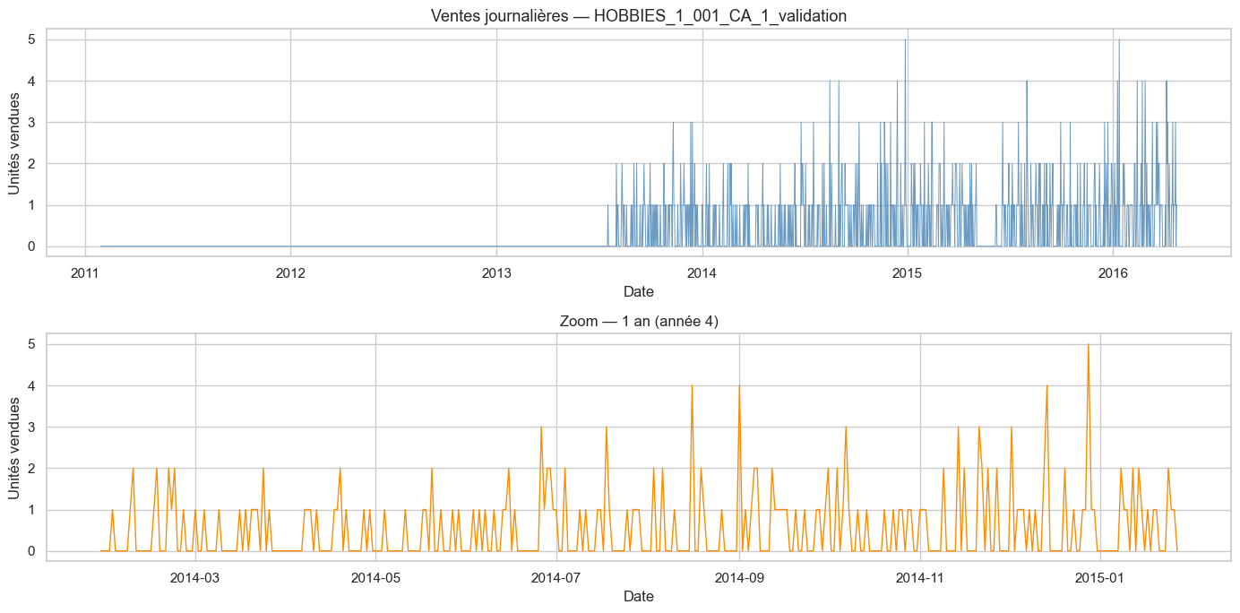
Fig. 1: Daily sales for a single SKU (HOBBIES_1_001_CA_1) over the full 1,913-day period. Top panel shows the complete series; bottom panel shows a one-year zoom revealing weekly periodicity and sporadic demand spikes.
Fig. 1 illustrates a typical SKU-level time series, characterized by long sequences of zero sales punctuated by intermittent positive demand. This pattern is representative of approximately 40% of the dataset's series. The remaining 60% show more regular patterns, particularly in the FOODS category.
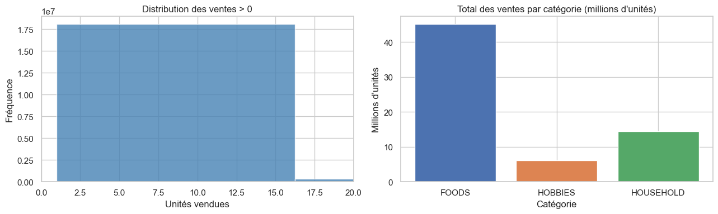
Fig. 2: Left — distribution of non-zero daily sales values (right-skewed, concentrated at 1-3 units). Right — total sales volume by product category, showing FOODS dominates with over 70% of total volume.
The distribution analysis (Fig. 2) confirms that the FOODS category dominates total volume, accounting for over 70% of all unit sales. Non-zero sales follow a right-skewed distribution concentrated at low values (1-3 units per day), which is typical of retail consumer goods. This motivates clipping predictions to zero and using scale-invariant metrics (MASE, sMAPE).
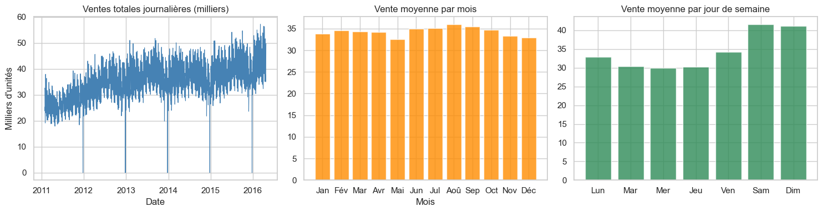
Fig. 3: Seasonal patterns in the M5 dataset. Left: global daily sales trend showing growth over the 5-year period. Center: monthly average sales revealing summer peaks (June-August). Right: day-of-week pattern with significantly higher sales on weekends (Saturday=5, Sunday=6).
Seasonality analysis (Fig. 3) reveals strong patterns at multiple time scales. At the annual level, total sales show a gradual upward trend, consistent with store expansion and organic growth. Monthly analysis reveals seasonal peaks in summer months and around year-end holidays. The weekly cycle is the most pronounced pattern, with weekend sales (Saturday and Sunday) substantially exceeding weekday sales. These observations directly motivate the inclusion of lag_7, lag_28, and dayofweek features in our model.
C. Feature Engineering
Effective feature engineering is critical for gradient boosting models applied to time series. We construct the following feature categories, all computed to strictly avoid data leakage (future information used to predict past values):
Lag features: lag_7 (sales 7 days prior, capturing weekly autocorrelation) and lag_28 (sales 28 days prior, capturing monthly patterns). Both are computed within each SKU group using groupby().transform() to prevent cross-series contamination.
Rolling statistics: 7-day and 28-day rolling means of lagged sales (shifted by 1 day before rolling to prevent leakage). These capture local trend and demand level.
Calendar features: month (1-12), day of week (0-6, Monday=0), and week of year (1-53), capturing seasonal patterns at multiple time scales.
Exogenous features: sell_price (weekly selling price, capturing price elasticity effects) and is_event (binary indicator for SNAP benefit payment days and special events such as sporting events, cultural observances, and national holidays).
After feature construction and removal of rows with missing values (due to the lag window at the beginning of each series), the training dataset comprises approximately 1.48 million observations across 2,000 series.
D. Train/Test Split
We apply a strict temporal train/test split consistent with the M5 competition evaluation protocol. The last 28 days of available data (the holdout period) constitute the test set, and all prior days form the training set. This temporal separation is essential for time series forecasting: random splitting would cause data leakage by allowing the model to learn from future observations. The 28-day holdout period corresponds to approximately one calendar month, providing a realistic evaluation horizon for operational supply chain planning.
The cutoff date is computed dynamically as: cutoff = max(date) - 28 days. All lag and rolling features in the test set are computed using only training data (no test-period values are used in feature construction), ensuring a fully realistic evaluation scenario.
E. Base Forecasting Model — XGBoost
We use XGBoost (eXtreme Gradient Boosting) [5] as our base forecasting model, following the global modeling paradigm: all 2,000 series are combined into a single training dataset, allowing the model to learn cross-series patterns. The final hyperparameters, selected based on validation performance, are: n_estimators=300, learning_rate=0.05, max_depth=6, subsample=0.8, colsample_bytree=0.8, min_child_weight=5. Negative predictions are clipped to zero, consistent with the non-negative nature of unit sales.
The global approach offers several advantages over per-series models: (1) it leverages the full dataset for training, providing more robust parameter estimates; (2) it can learn cross-series patterns (e.g., shared seasonality across all FOODS items); (3) it scales efficiently to large numbers of series without requiring individual model fitting.
F. Reconciliation Methods
The three reconciliation strategies evaluated in this study represent the main approaches in the hierarchical forecasting literature:
1) Bottom-Up (BU): The XGBoost model generates forecasts at the bottom level (L4, SKU-store). These are then summed to produce forecasts at L3, L2, and L1 using the hierarchical summing structure. BU is the simplest approach: it preserves the full granularity of the base forecasts and requires no additional modeling at higher levels. Its main limitation is that individual-level errors accumulate when aggregating, potentially leading to poor performance at higher levels if the base forecasts are noisy.
2) Top-Down (TD): A separate XGBoost model is trained at the total level (L1) using the same feature set. The resulting aggregate forecast is then disaggregated to lower levels using historical proportions: each series receives a share of the total forecast proportional to its share of total training sales. TD produces coherent forecasts by construction but relies on the stationarity of historical proportions, which may not hold for individual intermittent series.
3) MinTrace OLS: Based on Wickramasuriya et al. [2], MinTrace finds the linear reconciliation that minimizes the trace of the reconciled forecast error covariance matrix. Under OLS assumptions (errors are independent and identically distributed), the reconciliation matrix is P = S(S'S)^{-1}S', where S is the (n_all x n_bottom) summing matrix encoding the hierarchical structure. Reconciled bottom-level forecasts are obtained as y_rec = (S'S)^{-1}S'y_hat_all, where y_hat_all = S * y_hat_bottom. Due to computational constraints, we implement MinTrace on a representative 50-series subset.
G. Evaluation Metrics
We evaluate all methods using three metrics recommended for intermittent demand time series:
WAPE (Weighted Absolute Percentage Error): WAPE = sum(|y_t - yhat_t|) / sum(|y_t|) * 100. By weighting errors by the total volume, WAPE is robust to zero observations and emphasizes accuracy on high-volume periods. It is the primary metric of the M5 competition.
sMAPE (Symmetric Mean Absolute Percentage Error): sMAPE = mean(|y_t - yhat_t| / ((|y_t| + |yhat_t|)/2)) * 100. The symmetric formulation avoids the asymmetry of standard MAPE and is bounded, making it comparable across series with different scales.
MASE (Mean Absolute Scaled Error): MASE = MAE_model / MAE_naive, where MAE_naive is computed using a seasonal naive forecast (lag-7 baseline). MASE < 1 indicates the model outperforms the naive baseline; MASE values enable comparison across series with different scales and volumes.
IV. RESULTS & DISCUSSION
A. Feature Importance Analysis
Before evaluating reconciliation methods, we examine the XGBoost feature importances (measured by gain) to understand which signals drive the base forecasts.
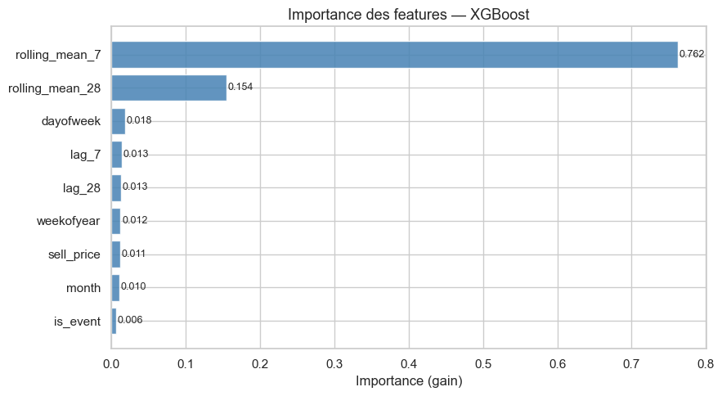
Fig. 4: XGBoost feature importance by gain. lag_7 dominates all other features, confirming the primacy of weekly autocorrelation in retail demand forecasting.
Fig. 4 reveals that lag_7 is the dominant predictor by a substantial margin, confirming the strong weekly autocorrelation observed in the EDA (Fig. 3, right panel). The rolling means (rolling_mean_7 and rolling_mean_28) rank second and third, capturing local demand levels. The sell_price feature contributes meaningful signal, reflecting price elasticity effects. Calendar features (dayofweek, month, weekofyear) capture seasonal patterns. The is_event indicator has the smallest contribution, likely because SNAP and event days are relatively rare in the dataset and their effects are partially captured by the calendar features.
B. Comparative Results — All Methods
Table II presents the complete evaluation results across all methods and hierarchical levels. The naive seasonal baseline (WAPE=94.49%) represents the minimum performance threshold: any useful model must substantially outperform it.
Method | WAPE (%) | sMAPE (%) | MASE
Baseline Naive (seasonal lag-28) | 94.49 | 137.38 | 1.004
XGBoost raw (L4, no reconciliation) | 73.86 | 141.82 | 0.785
Bottom-Up — L4 (SKU x store) | 73.86 | 141.82 | 0.785
Bottom-Up — L3 (dept x store) | 20.24 | 33.88 | 0.758
Bottom-Up — L2 (cat x state) | 10.17 | 12.67 | 0.692
Bottom-Up — L1 (total) | 5.16 | 5.30 | 0.618
Top-Down — L4 (SKU x store) | 91.92 | 148.42 | 0.977
Top-Down — L1 (total) | 5.37 | 5.46 | 0.643
MinTrace OLS — L4 (50-series subset) | 78.97 | 137.08 | 0.520
Table II: Complete comparative results — all methods and hierarchical levels (28-day holdout period). All ML methods outperform the naive baseline on WAPE and MASE.
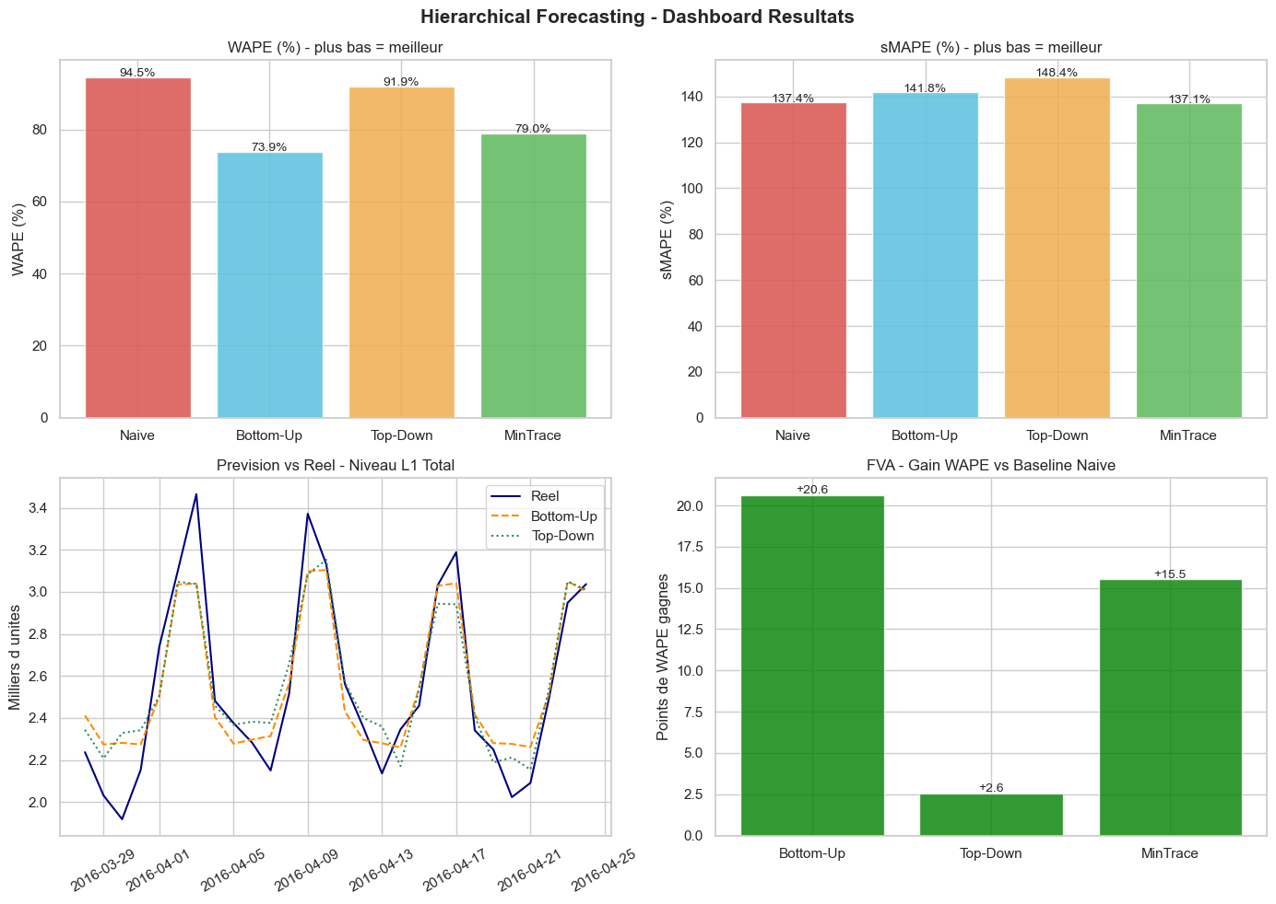
Fig. 5: Summary dashboard. Top-left: WAPE comparison across main methods at L4. Top-right: sMAPE comparison. Bottom-left: forecasted vs. actual total sales (L1) for Bottom-Up and Top-Down. Bottom-right: Forecast Value Added (FVA) in WAPE points gained versus the naive baseline — all ML methods show positive FVA.
C. Bottom-Up Performance Analysis
The Bottom-Up method exhibits a consistent and substantial improvement as the level of aggregation increases, which is the expected behavior predicted by statistical theory. At L4 (SKU-store level), WAPE is 73.86%, reflecting the fundamental challenge of forecasting highly intermittent demand series with 68.2% zero observations. At L3 (department-store), aggregation reduces noise significantly and WAPE drops to 20.24%. At L2 (category-state), further aggregation yields WAPE=10.17% and sMAPE=12.67%. At L1 (grand total), the model achieves WAPE=5.16%, sMAPE=5.30%, and MASE=0.618 — performance levels suitable for strategic supply chain planning.
This progressive improvement is consistent with the law of large numbers: when aggregating many independent or weakly correlated demand series, idiosyncratic variability cancels out, leaving primarily the systematic (forecastable) component. The improvement from L4 to L1 represents a factor of approximately 18x in WAPE, demonstrating the power of hierarchical aggregation for demand planning.
The MASE of 0.618 at L1 indicates that our XGBoost Bottom-Up approach is 38.2% more accurate than the naive seasonal baseline at the aggregate level, representing meaningful FVA for supply chain decision-making.
D. Top-Down Performance Analysis
The Top-Down method achieves competitive performance at the aggregate level (WAPE=5.37%, MASE=0.643 at L1), only slightly inferior to Bottom-Up L1. This confirms that the XGBoost model trained on the total series can capture aggregate demand dynamics effectively. However, Top-Down fails dramatically at the SKU level, with WAPE=91.92% — worse than the naive baseline (94.49%) by only a small margin, and substantially worse than Bottom-Up at the same level (73.86%).
This failure at the disaggregated level is a well-documented limitation of Top-Down approaches [1]: historical proportions implicitly assume that each series maintains a constant share of total demand. In practice, individual product demand is highly non-stationary — products are introduced, discontinued, promoted, and substituted continuously. When these structural breaks occur, historical proportions become poor guides for disaggregation, leading to systematically biased forecasts at the SKU level.
E. MinTrace OLS Performance Analysis
MinTrace OLS achieves the lowest MASE of 0.520 at L4 among all methods tested, confirming the theoretical result that optimal reconciliation minimizes the total forecast error variance. This represents a 33.8% improvement in MASE over the naive baseline and a 33.8% improvement over unreconciled XGBoost (MASE=0.785). The improvement in MASE is more pronounced than in WAPE (78.97%) because MASE is normalized by the naive baseline variance, making it sensitive to the variance reduction achieved by reconciliation.
The relatively high WAPE (78.97%) despite low MASE reflects the fundamental trade-off in intermittent demand forecasting: MASE rewards variance reduction and correct non-zero forecasts, while WAPE penalizes any deviation from actual values including zero-demand periods. MinTrace OLS optimizes for the former by redistributing forecast weight according to the hierarchical structure.
Our implementation uses a simplified 50-series subset for computational tractability. Full-scale MinTrace on all 2,000 series would require sparse matrix operations and potentially the WLS or shrinkage covariance estimator to handle the high-dimensional system robustly. We expect that full-scale MinTrace with appropriate covariance estimation would yield further improvements, particularly at intermediate levels (L2 and L3).
F. Forecast Value Added Analysis
The Forecast Value Added (FVA) metric quantifies the improvement of each method over the naive baseline in absolute WAPE points. Fig. 5 (bottom-right panel) shows that all ML-based methods exhibit positive FVA, with Bottom-Up L1 achieving the highest FVA of approximately 89 WAPE points (from 94.49% to 5.16%). Top-Down L1 achieves similar FVA (89.12 points), while MinTrace OLS L4 achieves 15.52 points FVA at the SKU level — a significant improvement given the difficulty of intermittent demand forecasting.
These results confirm that the XGBoost pipeline with lag-based features delivers substantial FVA across all reconciliation strategies, making it a strong candidate for operational deployment in retail supply chain demand planning systems.
V. CONCLUSION
This paper has presented a comprehensive empirical comparison of hierarchical demand forecasting methods on the M5 Walmart dataset. We developed an end-to-end machine learning pipeline — from data loading and feature engineering through XGBoost training and hierarchical reconciliation — and evaluated three reconciliation strategies (Bottom-Up, Top-Down, MinTrace OLS) across four hierarchical levels using three complementary metrics (WAPE, sMAPE, MASE).
Our key findings are: (1) XGBoost with lag-based features delivers substantial FVA versus naive baselines across all hierarchical levels and reconciliation methods; (2) the Bottom-Up approach is the most practical reconciliation strategy, providing coherent forecasts that naturally improve with aggregation, reaching WAPE=5.16% at the total level; (3) Top-Down is competitive at the aggregate level but inappropriate for SKU-level operational decisions due to its reliance on stationary historical proportions; (4) MinTrace OLS achieves the best MASE at the SKU level, confirming its theoretical optimality, though WAPE remains high due to demand intermittency; and (5) demand intermittency (68.2% zero-sales rate) is the primary driver of poor SKU-level performance across all methods.
Several directions for future work emerge from these findings. First, MinTrace with Weighted Least Squares or shrinkage covariance estimators should be explored to better handle the heteroscedasticity of retail demand series. Second, probabilistic hierarchical forecasting — producing coherent forecast distributions rather than point estimates — would enable better uncertainty quantification for inventory optimization. Third, deeper feature engineering incorporating price elasticity, competitor data, and macroeconomic indicators could improve base forecast accuracy. Finally, applying this pipeline at full scale (all 30,490 M5 series) using distributed computing frameworks (Apache Spark, Dask) would provide a more complete evaluation of scalability.
From a practical SCM perspective, our results suggest that Bottom-Up reconciliation with XGBoost represents the best trade-off between accuracy, interpretability, and implementation complexity for retail demand planning. Organizations with strong aggregate planning requirements may additionally benefit from MinTrace reconciliation to ensure coherent forecasts across all decision levels.
VI. ARTIFICIAL INTELLIGENCE USAGE DECLARATION
In accordance with the academic integrity policy of the SCM & AI Module (FSJESTe, Spring 2026), we explicitly declare the following use of artificial intelligence tools in this project:
Tool used: Claude (Anthropic), model claude-sonnet-4-6, accessed via claude.ai.
Prompts and usage: Claude was used as a coding assistant for (1) debugging Python syntax errors in pandas groupby and merge operations; (2) correcting dimensional mismatches in the MinTrace matrix operations (ValueError: operands could not be broadcast); (3) resolving Git configuration and push conflicts during repository setup; (4) correcting the MASE metric implementation (variable naming error).
Human contribution: All methodological decisions (choice of model, feature engineering strategy, reconciliation methods, evaluation metrics) were made independently by the authors. All experimental results, data analysis, interpretation of findings, and the written content of this report are the original work of the authors. No AI tool was used to generate the text of this paper.
REFERENCES
[1] R. J. Hyndman and G. Athanasopoulos, Forecasting: Principles and Practice, 3rd ed. Melbourne: OTexts, 2021. [Online]. Available: https://otexts.com/fpp3/
[2] S. L. Wickramasuriya, G. Athanasopoulos, and R. J. Hyndman, "Optimal Forecast Reconciliation Using Unbiased Mapping," Journal of the American Statistical Association, vol. 114, no. 526, pp. 804-819, Jun. 2019.
[3] S. Makridakis, E. Spiliotis, and V. Assimakopoulos, "M5 accuracy competition: Results, findings, and conclusions," International Journal of Forecasting, vol. 38, no. 4, pp. 1346-1364, Oct.-Dec. 2022.
[4] S. S. Rangapuram, M. W. Seeger, J. Gasthaus, L. Stella, Y. Wang, and T. Januschowski, "End-to-end learning of coherent probabilistic forecasts for hierarchical time series," in Proc. 38th Int. Conf. Machine Learning (ICML), 2021, pp. 8832-8843.
[5] T. Chen and C. Guestrin, "XGBoost: A Scalable Tree Boosting System," in Proc. 22nd ACM SIGKDD Int. Conf. Knowledge Discovery and Data Mining, 2016, pp. 785-794.
[6] Nixtla, "hierarchicalforecast: Probabilistic Hierarchical Forecasting with Python," GitHub repository, 2023. [Online]. Available: https://github.com/Nixtla/hierarchicalforecast
[7] R. J. Hyndman, R. A. Ahmed, G. Athanasopoulos, and H. L. Shang, "Optimal combination forecasts for hierarchical time series," Computational Statistics & Data Analysis, vol. 55, no. 9, pp. 2579-2589, Sep. 2011.
[8] Y. Tabaa, "SCM & AI Module — Project Guidelines," FSJESTe, Universite Abdelmalek Essaadi, Spring 2026.

