Workshop 4

Creating tables and adding constraints

Learning outcomes

Upon successful completion of this workshop, you will have demonstrated the abilities to:

1. Create a table given a table schema.
2. Define primary keys constraints for tables to ensure entity integrity
3. Define foreign key constraints to ensure referential integrity
4. Define not null, unique, and check constraints to place constraints on values of specific attributes in a table.

Required readings

Refer to M4_SQL_partII.doc to answer the questions in this workshop.

Student declaration form

Add this declaration on the top of your Workshop3.docx file.

1. We, ------------(mention your names), declare that the attached assignment is our own work in accordance with the Seneca Academic Policy. No part of this assignment has been copied manually or electronically from any other source (including web sites) **or distributed to other students.**
2. Specify what each member has done towards the completion of this work:

|  |  |  |
| --- | --- | --- |
|  | Name | Task(s) |
| 1 |  |  |
| 2 |  |  |
| 3 |  |  |

Instructions [65 pts]

You are given the following entity relationship diagram for a clinic database. Write the sql queries to answer each of the following questions. Your answer should consist of the SQL query and also the result of the query in a tabular format when applicable.

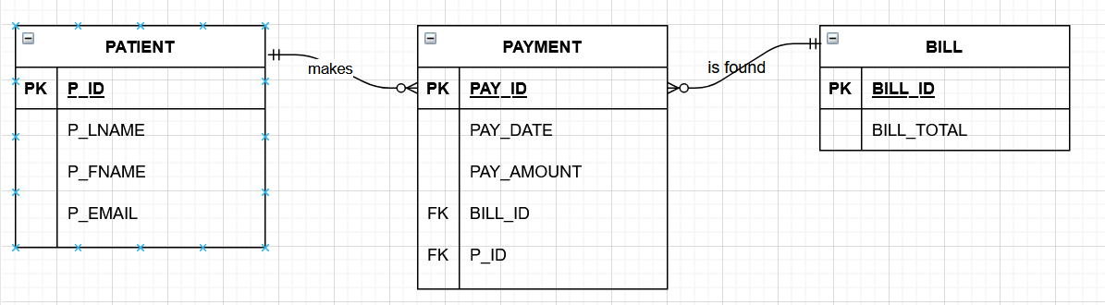

1. [3pts] Write the SQL query to create a new database named clinic.
2. [10pts] write a SQL query to create the Patient table along with the constraints defined below. Define the constraints that show in the table. Define and name the pk constraint as PK_PATIENT on a separate line after defining the columns. (refer to slide 7)

|  |  |  |  |  |  |
| --- | --- | --- | --- | --- | --- |
| **Table Name** | **Attribute** | **Type** | **Required** | **PK or FK** | **Constraint** |
| Patient | P_ID | int | Y | PK |  |
|  | P_LNAME | varchar(20) | Y |  |  |
|  | P_FNAME | varchar(20) | Y |  |  |
|  | P_EMAIL | varchar(50) |  |  | Unique |

1. [7pts] write a SQL query to create the BILL table along with the constraints defined below. Define the check constraint on BILL_TOTAL that allows only positive values under BILL_TOTAL column.

|  |  |  |  |  |  |
| --- | --- | --- | --- | --- | --- |
| **Table Name** | **Attribute** | **Type** | **Required** | **PK or FK** | **Constraint** |
| BILL | BILL_ID | int | Y | PK |  |
|  | BILL_TOTAL | real | Y |  | > 0 |

1. [15pts] Write a SQL query to create the payment table along with the constraints defined below.

|  |  |  |  |  |  |  |
| --- | --- | --- | --- | --- | --- | --- |
| **Table Name** | **Attribute** | **Type** | **Required** | **PK or FK** | **Constraint** | **FK referenced table** |
| PAYMENT | PAY_ID | int | Y | PK |  |  |
|  | PAY_DATE | date | Y |  |  |  |
|  | PAY_AMOUNT | real | Y |  | >0 |  |
|  | BILL_ID | Int | Y | FK |  | BILL |
|  | P_ID | Int | Y | FK |  | PATIENT |

1. [4pts] Show a screenshot of the created tables in the object explorer. Expand the columns list in each table, the keys and the constraints.
2. [3pts] Write insert commands to add the following rows in the PATIENT table. Show the data in the patient table.

|  |  |  |  |
| --- | --- | --- | --- |
| **P_ID** | **P_LNAME** | **P_FNAME** | **P_EMAIL** |
| 10011 | Dunne | Leonna | dunne.leonna@gmail.com |
| 10012 | Smith | Kathy | Smith.k@yahoo.com |
| 10013 | Ramas | Alfred | Ramas.Alfred@live.ca |

1. [3pts] Write insert commands to add the following rows in the BILL table. Show the data in the BILL table.

|  |  |
| --- | --- |
| **BILL_ID** | **BILL_TOTAL** |
| 100 | 5000 |
| 101 | 3000 |
| 103 | 1000 |

1. [5pts] Write insert commands to add the following rows in the PAYMENT table. Show the data in the PAYMENT table.

|  |  |  |  |  |
| --- | --- | --- | --- | --- |
| **PAY_ID** | **PAY_DATE** | **PAY_AMOUNT** | **BILL_ID** | **P_ID** |
| 5000 | 1-10-2020 | 1000.55 | 100 | 10011 |
| 5001 | 1-11-2020 | 1125.5 | 100 | 10011 |
| 5002 | 1-12-2020 | 1000 | 100 | 10011 |
| 5003 | 1-10-2020 | 500 | 101 | 10012 |
| 5004 | 1-11-2020 | 750 | 101 | 10012 |

1. [1pt ] Write the sql command to insert the following row in the PATIENT table. Show the message you get from the system.

|  |  |  |  |
| --- | --- | --- | --- |
| **P_ID** | **P_LNAME** | **P_FNAME** | **P_EMAIL** |
| 10011 | Brown | James | Brown.James@gmail.com |

[2pts] Explain why the query did not go through?

Answer: _________________________________________________

1. [1pt ] Write the sql command to insert the following row in the PATIENT table. Show the message you get from the system.

|  |  |  |  |
| --- | --- | --- | --- |
| **P_ID** | **P_LNAME** | **P_FNAME** | **P_EMAIL** |
| 10014 | Brown | James | dunne.leonna@gmail.com |

[2pts] Explain why the query did not go through?

Answer: _________________________________________________

1. [1pt ] Write the sql command to insert the following row in the PAYMENT table. Show the message you get from the system.

|  |  |  |  |  |
| --- | --- | --- | --- | --- |
| **PAY_ID** | **PAY_DATE** | **PAY_AMOUNT** | **BILL_ID** | **P_ID** |
| 5005 | 1-10-2020 | -800 | 100 | 10011 |

[2pts] Explain why the query did not go through?

Answer: _________________________________________________

1. [1pt ] Write the sql command to insert the following row in the PAYMENT table. Show the message you get from the system.

|  |  |  |  |  |
| --- | --- | --- | --- | --- |
| **PAY_ID** | **PAY_DATE** | **PAY_AMOUNT** | **BILL_ID** | **P_ID** |
| 5005 | 1-10-2020 | 800 | 104 | 10011 |

[2pts] Explain why the query did not go through?

Answer: _________________________________________________

SUBMISSION

Submit a word document, named “w04_groupX.doc” with your group number replacing X in the file name. You should include the question in text, the SQL query and the result set/screenshot as requested for each question.