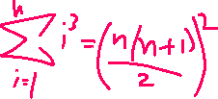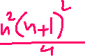



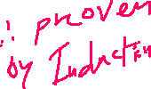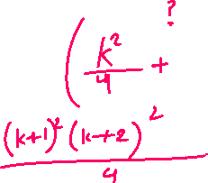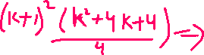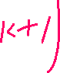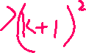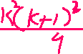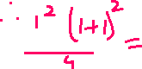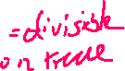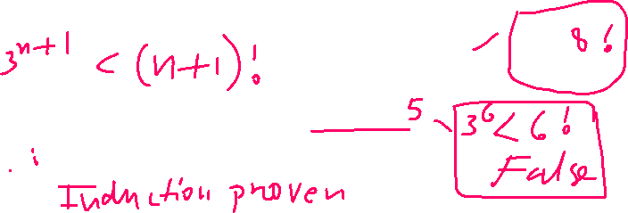



**2. Express T(n) as a recurrence expression. (hint: remember the definition of T(n)... what does it mean? use it in your expression)**

**3. Simplify T(n)**

**Unsigned long long factorial(unsigned int n) {**

**if(n > 1)**

**return n * factorial(n - 1);**

**else**

**return 1;**

**}**

**T(0) = 1 because n become s1 so by if statement value returned is 1**

**2) recursive factorial algorithm is T(n)=1 for n=0; T(n)=1+T(n-1) for n>0**

**3) T(n)=1 for n=0; T(n)=1+T(n-1) for n>0**



**Unsigned long long power(unsigned int base, unsigned int n)**

**{**

**if (n != 0)**

**return (base*power(base, n-1));**

**else**

**return 1;**

**}**

