1. [25 points] L1 vs. L2 Regularization
In this problem, we explore the differences between L1 and L2 regularization, discussed in lecture 2. You are given two data _les, hw2x.dat and hw2y.dat (containing inputs and outputs, respectively).
(a) [10 points] Split the data into a training set, containing 90% of the instances, and
a test set, containing 10% of the instances (since this is exploratory, we will not
do full cross-validation). Write Matlab code to perform L2 regularization. Plot
on one graph the root mean squared error on the training set, and the root mean
squared error on the test set, as a function of the regularization parameter .
Vary _ starting at 0, and go high enough that you can see an \interesting" range
of behavior. Plot, on a different graph, all of the weights, as a function of
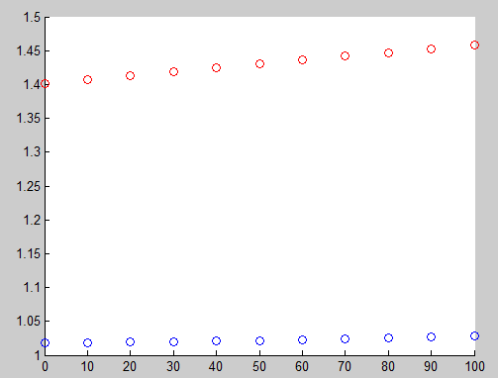
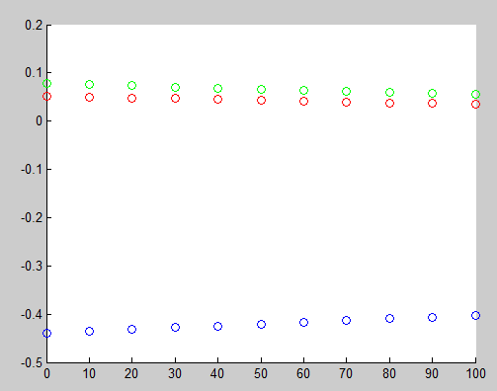

(b) [10 points] Using the quadprog function of Matlab, write a function that performs
L1 regularization

see the attached Q1.m

(c) [5 points] Plot the same graphs as above for the L1 regularization. Explain what
you observe, and comment on how you think the data was generated.

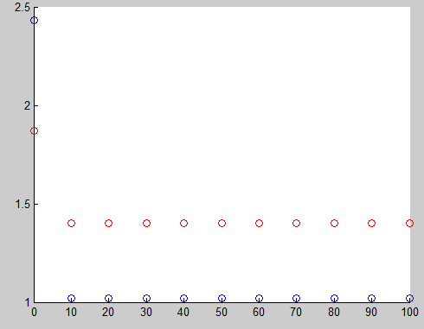
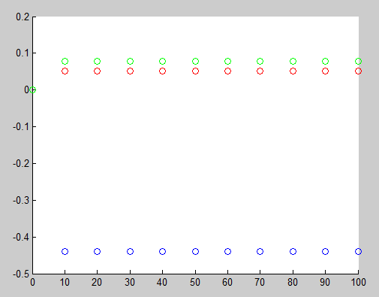

2. [10 points] Dealing with missing data
Suppose that you use a Gaussian discriminant classifier, in which you model explicitly P(y = 1) (using a binomial) and P(x|y = 0) and P(x|y = 1). The latter have
distinct means and , and a shared covariance matrix(a frequent assumption
in practice). Suppose that you are asked to classify an example for which you know
inputs x1; : : : xn􀀀1, but the value of xn is missing. In practice, a common approach
in this case is to fill in" the value of xn by its class-conditional means, E(xn|y = 0)
and E(xn|y = 1). Using the log-odds ratio, give a mathematical justification for this
approach.

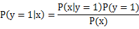
Since the latter have distinct means and , and a shared covariance matrix
We have the multivariate Gaussian form for P(x|y = 0) and P(x|y = 1)
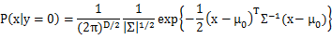

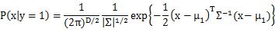

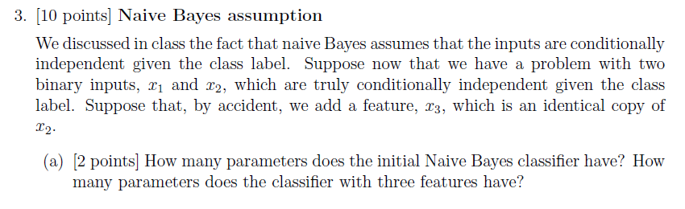
a) The parameters of the native Bayes are:
Hence for two binary input x1, x2, parameters are
,
There are 5 parameters.

For two input x1,x2 and duplicate x3, parameters are:
,
There are 7 parameters.

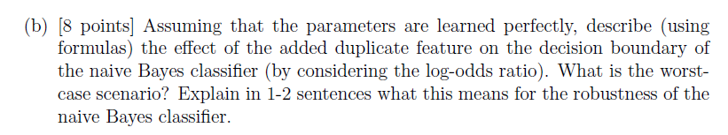
b)
due to x2, x3 are identical and

Class label has binomial distribution 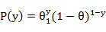 and class conditional distributions are multivariate Bernoulli
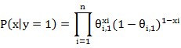
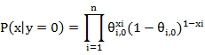

The decision surface:
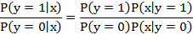
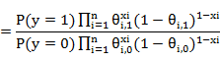
Use the lock trick, we get:
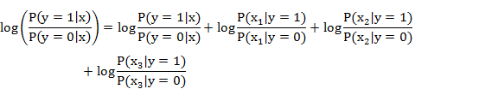

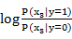 is the additional term added to decision surface, if when the distribution of feature is highly unbalanced, the additional term will impact on the decision surface. For example, the worst case is then 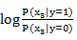reach infinity.

however, the x are conditional independent. Thus the additional term's influence would be very small.

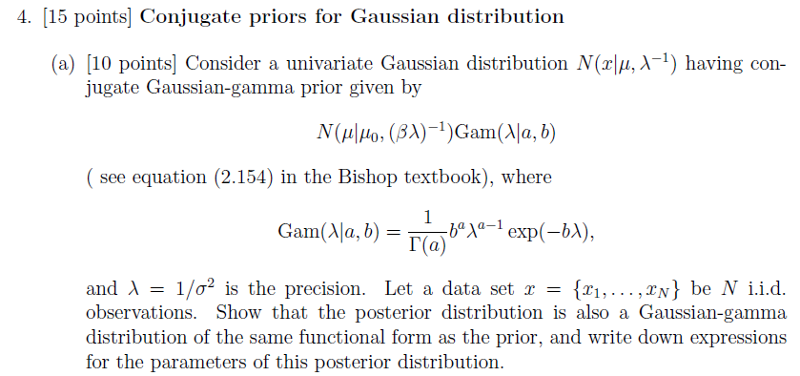
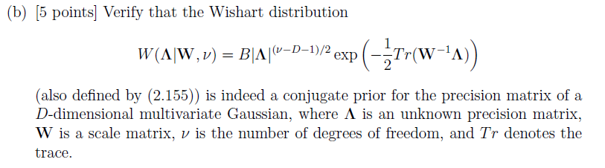

5. [40 points] Using discriminative vs. generative classifiers

For this problem, you will experiment with a version of the Wisconsin data set that we
use as an illustration in class. The data is available in files wpbcx.dat and wpbcy.dat.

(a) [10 points] Implement logistic regression. If you use a learning-rate version, you
will need to set up your code in such a way as to be able to search for a good learning rate. You can also use the iterative recursive least-squares version (whichever
you prefer).

(b) [10 points] In a first experiment, use just a bias term and the first feature (first
column in the wpbcx.dat _le). Set up a Gaussian naive Bayes classifier, and compare its results with logistic regression, using 10-fold cross-validation. Comment
on what you observe.

