**Amyloid burden, white matter change and Alzheimer’s disease**

**Red**

**Summary**

Researchers found that change in white matters might relate to Alzheimer’s disease (AD), a progressive, age-related neurodegenerative disorder. They collected data from a subset of over 1500 participants who were at high risk for AD. These participants received two neuroimaging scan: Pittsburgh Compound B (PiB) positron emission tomography (PET) and Diffusion Tensor Imaging (DTI). PET scans amyloid burden change and DIT scans white matter change. Our client is interested in knowing whether there is meaningful change from DTI measures and whether the change is affected by age, amyloid burden or other factors. With mixed effect model, we find variable “Age” has significant coefficients in several models, which indicates age is good predictor for white matter change in many cases. Based on the analysis result, changes in fornix, all white matter and splenium of corpus callosum are linear functions of age. Slope of change in cingulum (cingulate gyrus) left is affected by risk factor APOE4 and slope of change in cingulum (hippocampus) left is affected by amyloid burden change. Suggestion for further study is provided in discussion session.

**Background**

Alzheimer’s disease (AD) affects memory and is the most common cause of dementia. Researchers are interesting in searching for factors that can monitor this progressive, age-related neurodegenerative disorder. Amyloid deposition is hypothesized to initiate events leading to AD. Moreover, researchers find that white matter tissue in the brain is affected early in AD as well as gray matter. Degeneration in both white and grey matter can be detected, and white matter may have interaction with amyloid pathology which eventually leading to dementia. It is possible that there is significant interaction between amyloid burden and white matter in the early disease stage and finally leads to dementia.

Diffusion Tensor Imaging (DTI) has a powerful function in probing the effects of disease and aging on brain microstructure. There are two most commonly studied DTI measures: Mean diffusivity (MD) and fractional anisotropy (FA). MD is a measure of average of the three diffusion tensor eigenvalues and an inverse measure of membrane density and fluid viscosity in both gray and white matter. FA measures the directional coherence of water diffusion and considered to be highly sensitive to white matter feature. It has a range between 0 and 1.

Lower FA and higher MD characterize later stages of AD. Inspired by a previous study which found patterns of higher FA and lower MD in subjects with greater and more diffuse amyloid deposition, researchers suggests that white matter may have a gradual progression of disease pattern. This hypothesis needs to be tested by longitudinal data. The current dataset contain longitudinal data for both brain amyloid burden and DTI measures that could be used to discover the relationship between amyloid burden and change in white matter.

**Data Collection**

Data were collected from Wisconsin Registry of Alzheimer’s Prevention from a subset of 1500 participants who were at high risk for AD. Data included demographic information, AD’s risk factor and two summary measures from PET and DTI. Each participant had to PET scans and 2 to 5 DTI scans. Numbers of DTI scans were randomly assigned to participants. Baseline and follow-up PET scans were collected approximately. The intervals between DTI scans are difference but are also about 2 years. Participants start to receive these scans at different ages.

**Variables**

The original data frame contains 151 observations and 85 variables. For a more convenient analysis, I transformed the original data structure and created some new variables. Also, after talking to the client, I removed some variables that are not useful for the analysis. There are 755 observations and 24 variables in total. Moreover, variable “Age” is centralized before modeling process as most of the participants star the scan after 50.

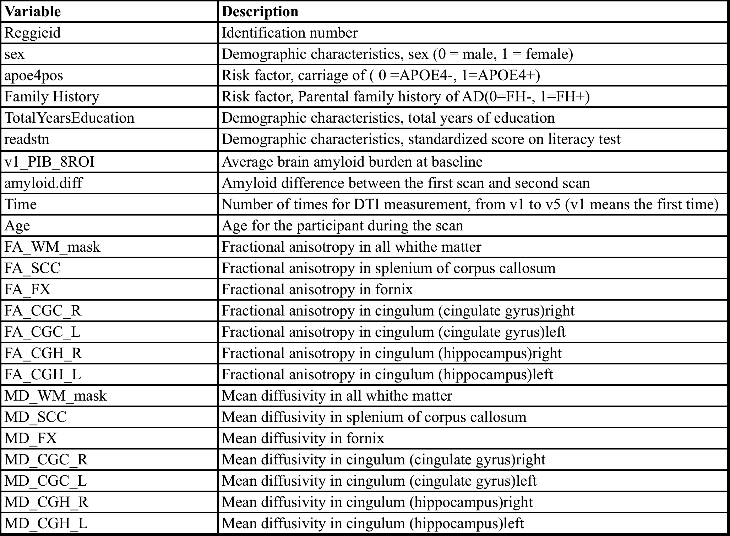

**Exploratory Analysis**

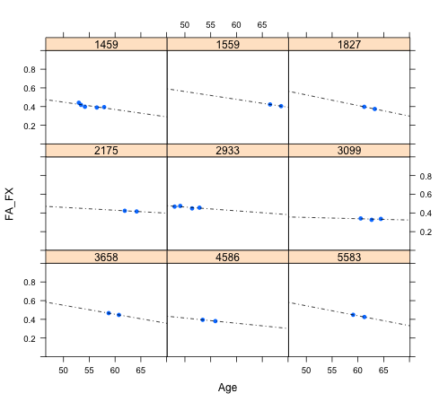

As the client is more interested in change in DTI measure, exploratory analysis will focus more on the time trend of responses rather than the exact amount. Plot above indicate that there is a trend in FA_FX value from 9 randomly selected participants. Blue points are observed values. Dash line is the fitted line across observed values. Solid line is fitted line for expectation. From the plot we can see, with age increases, participants are more likely to have a decline trend in FA_FX value. This conclusion matches the fact that these participants are at high risk for AD as lower FA characterizes later stages of AD. We will use model in the following section to verify whether such hypothesis is true.

Next, we are going to plotting FA_FX by demographic characters, risk factors and brain burden. The interaction plot between risk factors is listed below. The rest of exploratory plots are presented in Appendix.

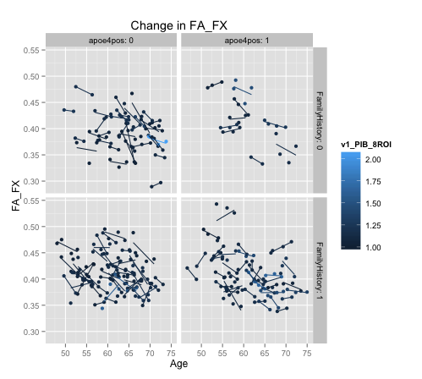

Lines’ colors represent the level of amyloid burden baseline. Darker line color represents a lower amyloid burden baseline. These lines are fitted line for each participant. If one participant only has two measurements, the line just simply connects these two points. From the plot, there is no obvious difference caused interactions between amyloid burden baseline and risk factors. Most of them have similar FA_FX trend. This may imply the effect of risk factors, amyloid burden and there interaction is weak. The following plots shows information about MD_FX:

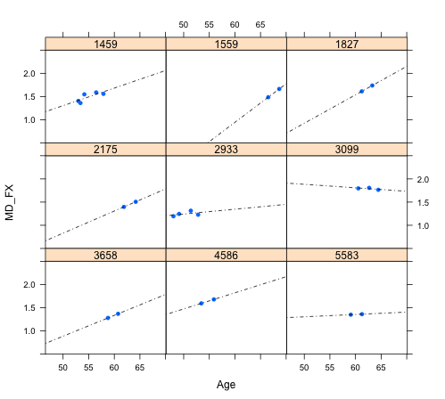

In contrast to the change in FA_FX, MD_FX increases as participants’ ages increase in a 7 out of 9 cases. Same as FA_FX, MD_FX has a pattern that matches the fact that these participants have high risk of AD as higher MD characterizes later stages of AD. Exploratory plots for MD_FX also show there is no obvious difference in trend caused by demographic characteristics, risk factors or amyloid burden.

There are many missing values in the original data. For DTI, patients are randomly selected for how many measurements they will receive. Number for measurement is between 2 and 5. The following table indicates missing data from each measurement.



Because v4 and v5 have too many missing data, we only compare the first three measurements. The following table presents correlation among values in FA_FX and MD_FX.

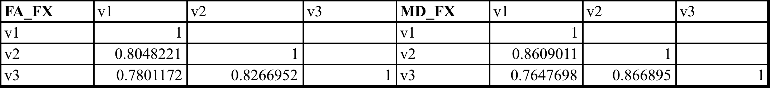

It can be observed that the measurements adjacent in time are strongly correlated. The correlation decreases with an increasing time gap. Notice that patients start the measurements at different ages and the time interval between each measurement is not constant. Therefore, scatterplot matrix is not provided, as it may not work well for longitudinal data with irregular time intervals.

**Modeling Process**

Mixed effect model is selected to fit these longitudinal data, and we will also use “Reggieid” and “Age” as random factor. As the client requires using fornix as a representative response for whiter matter tissue, we will build a model for FA_FX first. Model 1.1 is built as listed below:

In this model, coefficient of “Age” represents the difference in response variable caused by one unit change in age. In other word, it indicates the time trend of “FA_FX” change. In order to test whether this coefficient is significant, we will use likelihood ratio test, comparing Model 1.1 with a model without “Age”. Table for test result is in Appendix. The small P-value indicates that there is a significant difference between these two models. Add “Age” to the model will improve model performance significantly. Therefore, we should keep “Age” in the model. It also means there is a meaningful time trend on “FA_FX” and could be expressed as a function of age. With the same method, we can keep detecting whether there is insignificant variable in this model. The following model (Model 1.2) is the result

Next we are going to add an interaction to Model 1.2 and compare it with the original Model 1.2 with likelihood ration test. According to client’s questions, we need to test whether demographic variables (sex, readstn, TotalYearsEducation), risk factor (apoe4pos, FamilyHistory), amyloid burden (v1_PIB_8ROI and amyloid.diff), and the interaction between last two categories have significant interaction term with “Age”. We will still use likelihood ratio test as the tool. Table 3 in Appendix shows an example of interaction test. F test P-value is not significant. It means adding the interaction will not affect the model result. Therefore, change in “FA_FX” does not differ by “sex”. After testing all possible interaction, we find none of them will lead to significant difference. The final model we use to fit the data is Model 1.2. Residual plots and Q-Q plots show constant variance assumption and normal assumptions are met in this model. Age has a coefficient of -0.0026255. This means as age increases 1, FA_FX will decrease by -0.0026255.

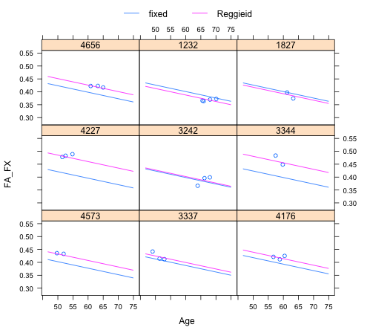

Plot above is an important diagnostic plot. It shows the observed and predicted values of “FA_FX” for some participants. Blue line is the prediction trend and purple line is the fitted line for observations. We can see the trend of predicted values is almost the same as fitted line for observations, which indicate the model has a good performance in describing time trend.

Here is the explanation for the random factor: By applying this formula in the random argument, we imply that for each “Reggieid” variable, a random intercept and a random slope for “Age” are to be considered. From the random effect part of summary table, we find the variation caused by “Age” is very small, which means the effect of random slope is very weak.

The second model is build for MD_FX. Basically we follow the same step as we did in the model for FA_FX. Her is model 2.1:

After likelihood ratio test, age is proved to be significant in this model. Also, no interaction between age and any other terms is significant. Model 2.2 for MD_FX is:

Coefficient for “Age” is 0.013306. As age increases by 1, MD_FX will increase 0.013306.

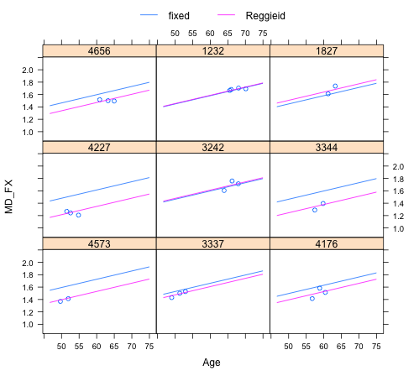

From preview analysis we find the mixed effect model works well to fit the data. Therefore, this model technique is applied to the rest responses. The result is addressed in the following table:

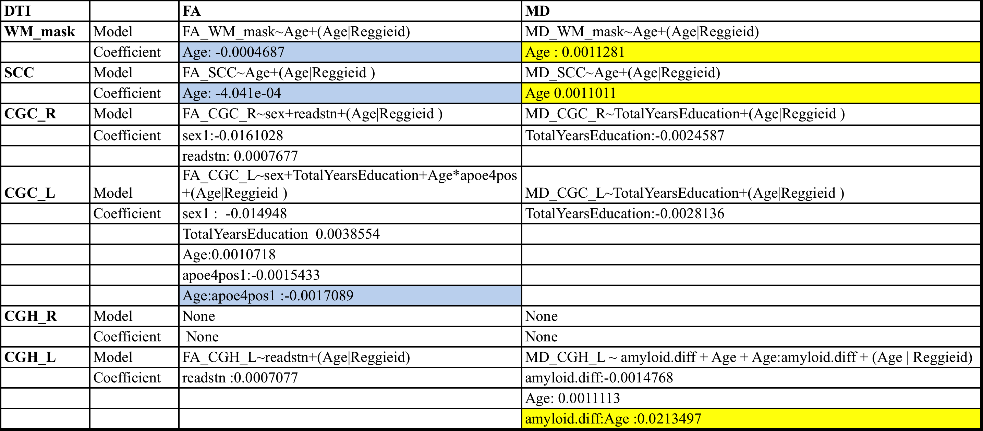

Table above is a summary for the rest of DTI’s. Significant coefficients are highlighted in the table. Blues represents a positive coefficient and yellow represents a negative coefficient. If “Age” has a significant coefficient, it means the corresponding DTI has a meaningful change in DTI and the slope is a function of age. If “Age” has a significant interaction with another variable, the coefficient of this interaction represents the change on slope caused by that variable.

**Discussion**

Client has five questions for each DTI. I will answer these questions by different DTI’s.

*Fornix*: There is meaningful change in both fractional anisotropy and mean diffusivity. Fractional anisotropy changes as a linear function of age with a negative slope because the coefficient of “Age” is significantly negative. Mean diffusivity also changes as a linear function of age, but with a positive slope. No other factors will affect change in this DTI.

*All white matter*: Same as Fornix, fractional anisotropy decreases as age increases, while mean diffusivity increase with age. Changes are both linear. No other factors will affect change in this DT.

*Splenium of corpus callosum*: Fractional anisotropy decreases as age increases, while mean diffusivity increase with age. Changes are both linear. No other factors will affect change in this DT

*Cingulum (cingulate gyrus) right*: There is significant difference in gender and literacy test score, but no meaningful change over time.

*Cingulum (cingulate gyrus) left*: Mean diffusivity for this DTI has meaningful change over time. Although the insignificant coefficient of “Age” implies the change is not a linear function of age, model for cingulum has a significantly interaction between “Age” and “apeo4pos”. Negative coefficient for “Age:apeo4pos1” means as age increases, participants carry APOE4+ will have a decline in slope. There mean diffusivity will either decline more or incline less than participants carry APOE4-. No other factors will affect change in this DTI.

*Cingulum (hippocampus) right*: No meaningful change over time.

*Cingulum (hippocampus) left*: There is meaningful change in Mean diffusivity but no linear relationship to age. Participants have larger increase in amyloid burden will have larger slope in DTI change as age increases.

For future study, my suggestion is to increase the number of DTI scans. In this report, nonlinear relationship between age and DTI measures is not tested because most of participants only have at most 3 measurements. In order to figure out a curvilinear relationship, more observations are required.

**Appendix**

**1. Exploratory plotting**

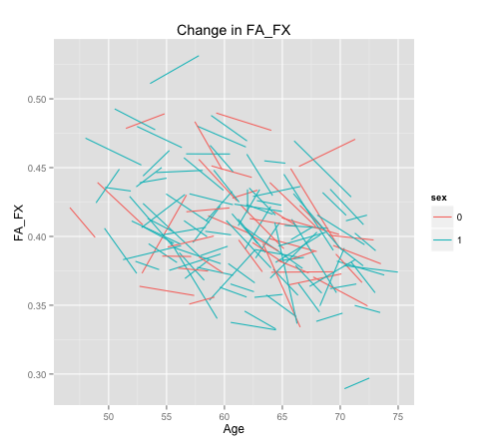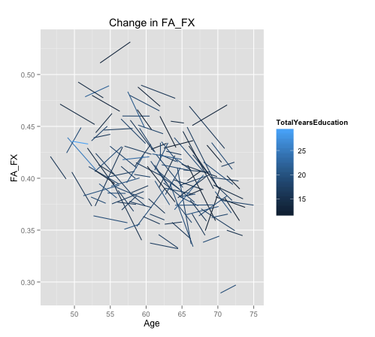

**2. Likelihood Ratio Test for Model 1.1**

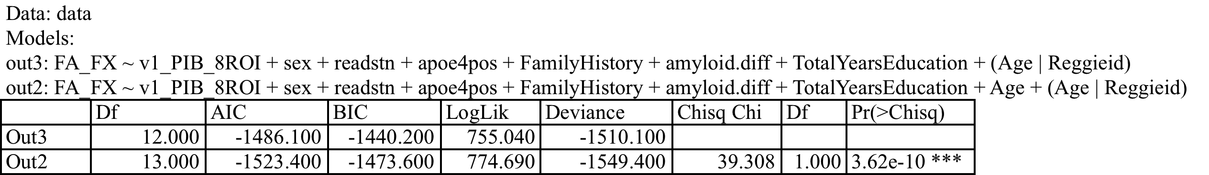

**3. LRT test for Interaction example**

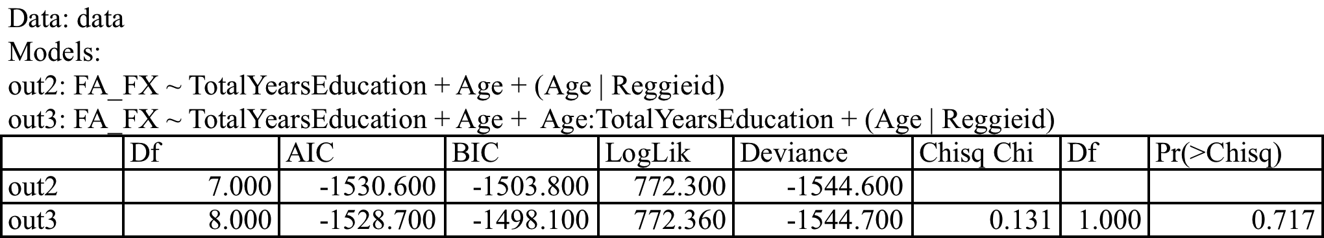

**4. Summary table for Model 1.2**

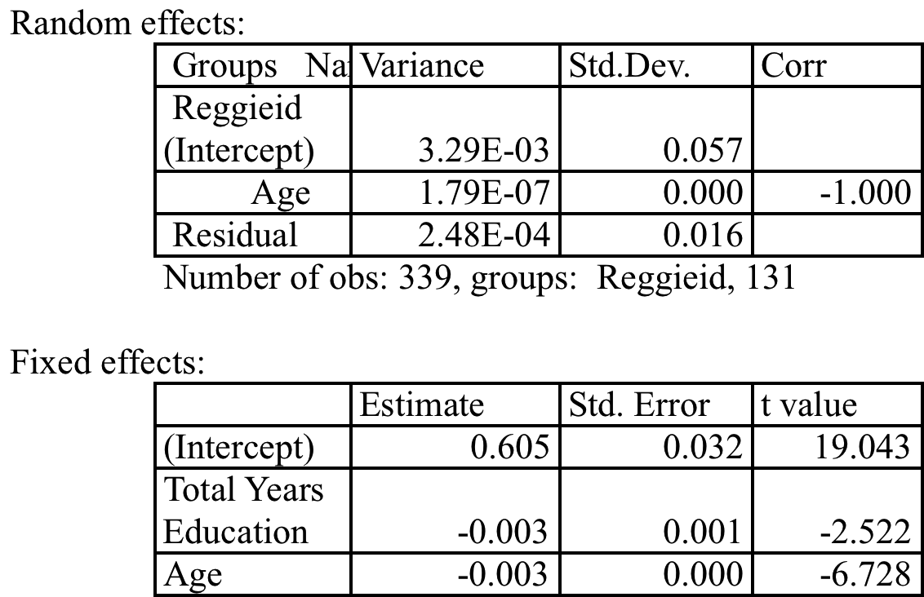

**5. Residual Plot and Q-Q Plot for Model 1.2**

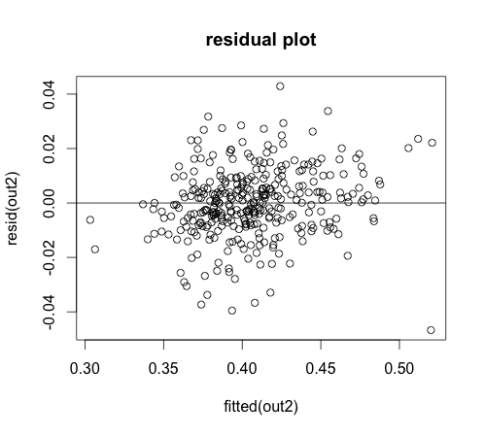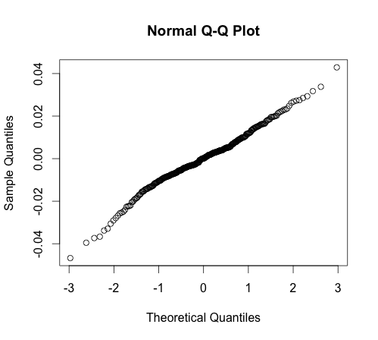

**6. Summary table for Model 2.2**

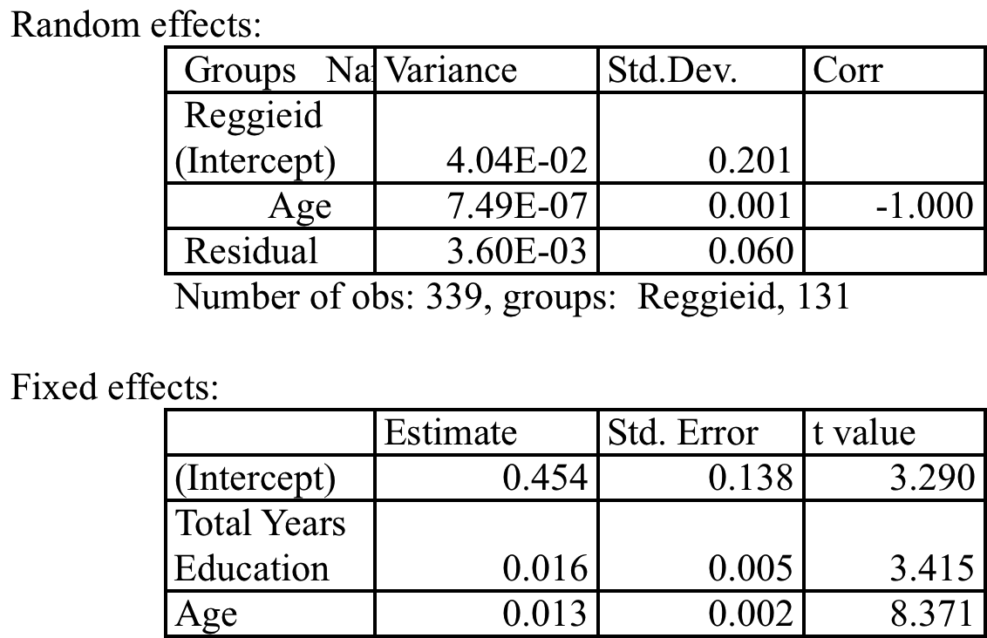

**7. Residual Plot and Q-Q Plot for Model 1.2**

