UNIVERSITY OF BIRMINGHAM

Robotic Pick and Place for Fruit Sorting

Final Group Report

Applied Robotics (04 39984)
Module Coordinator: Dr Amir Hajiyavand

Group Members
Piero Flores
Yichang Chao
Ran Zhang
Zihen Huang

Submission date: 1 May 2026

1. Introduction

1.1 Background and Motivation
Pick-and-place is one of the most common applications of robotic manipulators in industry. The agricultural sector in particular faces rising labour costs and a need for consistent product handling, and automated fruit sorting is one realistic place where robotic manipulation can replace repetitive manual work. Soft handling is especially important for fresh produce because rigid grippers can bruise the fruit and lower its market value.
This module asks us to design and validate a complete pick-and-place solution on a small 4-DOF educational arm, the Quanser QArm. The arm is paired with an Intel RealSense D415 RGB-D camera, which gives both colour and depth information. Working with this hardware lets us experience the full pipeline from sensor data to actuator command, instead of working only at the algorithm level.

1.2 Project Objectives
The system has to identify three classes of fruit (banana, tomato, strawberry) placed at random in the workspace and sort them into three labelled baskets. The fruit set is fixed at three bananas, five tomatoes and a six-pack of strawberries, as specified by the coursework brief. There are two operational modes that the system must support:
Fully automated mode: the robot detects, locates, picks, and places fruit without human input.
Remote-controlled mode: a human operator drives the same robot through the same task using a graphical user interface.
The deliverable is a working physical demonstration on the actual QArm hardware, a soft-gripper design with an analytical safety analysis, and this technical report covering design, simulation, and experimental validation.

1.3 Report Structure
This report follows the structure laid out in the coursework brief. Part 1 (Chapters 1–5) covers the background, the design of the kinematics and control stack, the Simulink simulation work, and the implementation of both operational modes. Chapter 6 is the soft-gripper design and analysis. Part 2 (Chapters 7–9) covers the experimental validation on the physical QArm, including the four-mode test campaign, the failure analysis, the discussion of discrepancies, and the conclusion. Chapter 10 is a one-page reflection on the feedback we received from the lecturers and teaching assistant during the lab sessions.

2. Background and Literature Review

2.1 Robotic Pick-and-Place in Industry
Pick-and-place is the canonical task of industrial manipulators and has been widely deployed in electronics assembly, food packaging, and warehouse automation. The basic capability has three layers: a perception layer that locates objects in the workspace, a planning layer that decides the order and trajectory of moves, and a control layer that executes the joint commands while respecting the hardware envelope. Industrial systems usually run these on 6-DOF or 7-DOF arms with vision systems calibrated to the work cell, but the same three-layer structure also applies to small educational platforms such as the QArm.

2.2 Vision-Based Fruit Detection
Two main families of approaches exist for detecting fruit in cluttered scenes. The classical computer vision family uses colour-space segmentation (typically HSV or Lab), morphological operations, and contour-based shape analysis. This family is data-light, computationally cheap, and easy to debug, but the thresholds need to be tuned to the lighting and the camera. The deep learning family uses convolutional networks (e.g. YOLO, Mask R-CNN) trained on annotated images. This family handles non-canonical orientations and occlusion better, but requires labelled data, training time, and GPU resources.
We chose the classical approach because the lab lighting is stable, the fruit set is fixed and small, and we did not have the time or labelled data needed to train a network. The classical approach also makes every step inspectable, which was important during debugging. The detection logic is described in Section 5.1.

2.3 Soft Gripper Approaches
Three soft-gripper paradigms are common in the literature. Pneumatic networks (PneuNets) use compressed-air channels embedded in silicone to bend on demand. Granular jamming uses a flexible bag filled with coffee grounds or similar; the bag conforms to the object and is then evacuated to lock the shape. Fin Ray fingers use a triangular truss structure that deflects passively in proportion to the contact force. Each has different trade-offs in actuation complexity, payload, and how easy it is to analyse on paper.
We selected the Fin Ray approach for this project. The reasoning, the analytical model, and the safety-factor analysis are presented in Chapter 6.

3. System Design and Methodology

3.1 System Architecture and Toolchain Decision
Our original control plan for the QArm was based on the standard Quanser workflow, in which the controller is built as a Simulink model and deployed to the robot through the QUARC real-time toolchain. During the first lab session after the Easter break, we discovered that none of the workstations available to our group had an active QUARC license. The Simulink build step failed at the deployment stage with a license error, and the same error reappeared on every machine we tried. Because the rest of our planned pipeline, including the trajectory generator, the gripper command path, and the vision-to-pick handover, all assumed that QUARC would manage the real-time loop, the missing license blocked the project at its lowest layer. Without a working way to send any joint command to the hardware, we could not even verify that the arm was wired correctly, let alone start testing the higher-level sorting logic.
After confirming that the failure was a licensing issue rather than a hardware or installation fault, we raised the problem with one of the lab teaching assistants during the next session. The TA explained that QUARC is one of two supported ways to drive the QArm and is not strictly required for our use case. The other path is the Quanser Python SDK, a library that exposes the same low-level hardware functions QUARC uses internally but makes them available through a plain Python API. The SDK ships with the lab installation by default, runs on a standard Python interpreter, and does not need a QUARC seat in order to read sensor data or send actuator commands.
Acting on this advice, we redesigned the control stack as a pure Python pipeline built on top of the SDK. A thin driver layer reads joint angles, end-effector position, and gripper state directly from the QArm card, and writes commanded joint targets and gripper setpoints back to the same card at a fixed cycle rate. All higher-level logic, including forward and inverse kinematics, trajectory interpolation, vision processing, and the sorting state machine, was moved into Python rather than Simulink. Simulink was kept as a presentation layer for the lab demonstrations and was given no responsibility for real-time control. With this change in place, the entire system became license-independent. Every result reported in this document was produced under the SDK pipeline, on a standard lab machine, without any QUARC activation.
The architecture is therefore a "Simulink-as-facade" design. The MATLAB Function blocks in the Simulink slices call into Python via py. using coder.extrinsic. This keeps the lab deliverables (the .slx models that the assessment expects) while moving all execution into a path that we can actually run.

3.2 Fundamentals of Robotics: Forward and Inverse Kinematics
This section establishes the mathematical foundation for the fruit-sorting pipeline. Higher-level behaviours, including vision-driven picking, state-machine sequencing, and teleoperation, all reduce to finding the end-effector position for a given joint configuration (forward kinematics) and finding the joint configuration for a commanded Cartesian pose (inverse kinematics). The Quanser QArm used in this project is a 4-degree-of-freedom serial manipulator with a two-finger gripper. Its limited redundancy makes an analytical treatment of these problems feasible and necessary for real-time control.

3.2.1 Kinematic Structure and DH Parameters
The QArm is modelled as an open kinematic chain of four revolute joints denoted φ₁ … φ₄, corresponding physically to the base yaw, shoulder pitch, elbow pitch, and wrist roll. Because the mechanical elbow has a small structural offset (L₃ = 0.05 m) that is not collinear with the upper arm (L₂ = 0.35 m), the manipulator does not map directly onto a textbook planar 3R arm. To avoid carrying this offset through later derivations, we follow Quanser's recommended lumped-parameter convention and fold the upper-arm link and the offset into a single effective length:
λ₂ = √(L₂² + L₃²) = 0.3536 m, β = arctan(L₃ / L₂) = 0.1419 rad (≈ 8.13°)
while the base height and the concatenated forearm-plus-end-effector segment are kept as λ₁ = L₁ = 0.14 m and λ₃ = L₄ + L₅ = 0.40 m. The geometric bias angle β is absorbed into the joint-angle offsets that relate the physical joint readings φ to the DH-frame angles θ:
θ₁ = φ₁, θ₂ = φ₂ − π/2 + β, θ₃ = φ₃ − β, θ₄ = φ₄
The standard Denavit–Hartenberg table is then constructed with a₁ = 0, α₁ = −π/2, d₁ = λ₁; a₂ = λ₂, α₂ = 0, d₂ = 0; a₃ = 0, α₃ = −π/2, d₃ = 0; and a₄ = 0, α₄ = 0, d₄ = λ₃. The mechanical joint limits, enforced both in software clamps (qarm_kinematics.py, JOINT_LIMITS) and in the IK solver's validity check, are ±170° for φ₁ and φ₄ and ±90° for φ₂ and φ₃. These limits shape the reachable workspace into a truncated hemispherical shell of approximate outer radius 0.75 m, consistent with the workspace mapping reported in the interim deliverable (maximum horizontal reach 0.7536 m, maximum height 0.8936 m).

3.2.2 Forward Kinematics
Given a physical joint vector φ, the end-effector pose in the base frame is the ordered product of four homogeneous transforms derived from the DH table:
T⁰₄(θ) = A₁(θ₁) · A₂(θ₂) · A₃(θ₃) · A₄(θ₄)
Expanding the product yields the closed-form position equations:
p_x = λ₂ cos θ₁ cos θ₂ − λ₃ cos θ₁ sin(θ₂ + θ₃)
p_y = λ₂ sin θ₁ cos θ₂ − λ₃ sin θ₁ sin(θ₂ + θ₃)
p_z = λ₁ − λ₂ sin θ₂ − λ₃ cos(θ₂ + θ₃)
At the home configuration φ = [0, 0, 0, 0], the forward model returns p = [0.450, 0.000, 0.490] m, which matches the teach-pendant readout on the lab QArm to machine precision. Two practical points are worth noting. First, because the manipulator only has four joints, the reachable orientations form a one-parameter family for a given target position. The wrist roll θ₄ is largely independent of position, so the IK routine exposes it as a user-settable argument γ rather than solving for it. Second, the forward map is also evaluated inside the inverse solver for residual computation and for finite-difference Jacobian assembly.

3.2.3 Inverse Kinematics: Analytical Seed plus Newton–Raphson Refinement
For a 4-DOF arm, the inverse kinematics is geometrically well-posed only for the position sub-problem (three equations and three free joints once γ is pinned). We therefore decompose IK into two phases: a closed-form analytical seed, followed by a damped least-squares correction that absorbs any residual geometric inconsistency and compensates for numerical drift near singularities.
The analytical seed phase begins by projecting the target p = (p_x, p_y, p_z) into the vertical plane that contains the base axis, reducing the problem to a 2R planar inverse kinematics in the variables (D, H), where D = ±√(p_x² + p_y²) is the horizontal reach and H = λ₁ − p_z is the vertical drop from the shoulder joint. Applying the half-angle substitution to the standard two-link law of cosines yields four candidate solutions for (θ₂, θ₃), corresponding to the combinations of left-reach or right-reach with elbow-up or elbow-down configurations:
θ₃ = 2 arctan2(−C ± √(C² + F²), F), F = (D² + H² − A² − C²) / (2A)
with A = λ₂ and C = −λ₃. For each (θ₂, θ₃) pair, the base yaw is recovered as θ₁ = arctan2(p_y/δ, p_x/δ) where δ = λ₂ cos θ₂ − λ₃ sin(θ₂ + θ₃). All four candidates are converted back to physical angles, wrapped into [−π, π], and screened against the joint limits. Among the surviving configurations, the one minimising ‖φ‖² is selected. This cost pushes the solver toward compact postures that keep the arm away from singularities and reduce unnecessary sweeping motions between pick and place.
To guarantee Cartesian accuracy at the tolerance of 10⁻⁶ m enforced by the convergence check, and to absorb residual drift near the workspace boundary where the discriminant C² + F² approaches zero, a Newton–Raphson update is applied in task space:
Δφ = Jᵀ (J Jᵀ + λI)⁻¹ (p_target − p_current)
where J ∈ ℝ³ˣ⁴ is a three-point-stencil finite-difference Jacobian computed with a step size of 10⁻⁶, and λ = 10⁻³ is a Levenberg–Marquardt damping factor that suppresses the near-singular inversion when the arm is close to full extension. Each iterate is re-clamped to the joint limits, and the wrist is held at the user-specified γ so that it does not drift as a free variable. Offline validation in validate_python.py exercises the solver on six representative targets that span the three basket positions, the approximate workspace extremes, and the home pose. In every case the solver converges inside the 50-iteration budget and satisfies the 10⁻⁶ m Cartesian tolerance.

3.3 Trajectory Planning
Once IK has produced a feasible joint vector for each waypoint, the motion between consecutive waypoints must be generated as a time-parameterised trajectory that the QArm can track at 500 Hz without inducing audible or mechanical jerk. Two polynomial blending schemes are implemented in trajectory.py. The autonomous FSM uses the quintic form by default, while the cubic form is retained as a baseline and is used for joint-space smooth_move transitions.
The cubic baseline imposes zero velocity at t = 0 and t = T:
p(t) = p_s + (3 Δp / T²) t² − (2 Δp / T³) t³, Δp = p_e − p_s
Differentiation yields a symmetric bell-shaped velocity profile peaking at 1.5 Δp / T at the mid-segment, and a piecewise-linear acceleration that is finite but discontinuous at segment boundaries; this discontinuity reaches the drivetrain as an impulsive jerk every time a new segment begins.
To suppress this boundary jerk, the planner used at runtime (quintic_trajectory in trajectory.py, called from sorting_controller.py:337) raises the polynomial order to five, with zero velocity and zero acceleration imposed at both endpoints:
p(t) = p_s + Δp · s(τ), s(τ) = 10τ³ − 15τ⁴ + 6τ⁵, τ = t / T
The resulting acceleration profile is a single symmetric S-curve that vanishes at both ends, so the jerk stays bounded across segment concatenations. The unit test test_quintic_boundary_conditions in test_integration.py verifies that p(0) = p_s, p(T) = p_e, and that both first and second numerical derivatives are below 10⁻³ at the boundaries. This property is structurally impossible for the cubic baseline and is practically relevant because the geared drivetrain of the QArm produces audible noise when jerk is high.
Segment durations are fixed constants inside sorting_controller.py and shared with the simulation twin in sorting_controller_sim.py: T_TRANSIT = 2.0 s for long home-to-approach and basket transits, T_APPROACH = 1.0 s for the intermediate approach and basket-above moves, T_PICK = 0.8 s for the final vertical descent, and T_DWELL = 0.5 s for the quasi-static hold while the gripper actuates. The 2-second transit choice was inherited from previous experimental benchmarks, where shorter values drove the commanded peak velocity and acceleration into actuator saturation.

4. Simulation and Simulink Integration

4.1 Vertical Slicing Approach
Because the real-time loop runs in Python (see Section 3.1), the role of Simulink in this project is to verify that the data flow between the MATLAB side and the Python side is correct, and to provide the .slx deliverables expected by the assignment. We adopted a "vertical slicing" strategy: each slice is a small Simulink model that exercises one specific data path end-to-end. Once each slice is verified, they are integrated into the top-level model FruitSorting_Hardware.slx.

4.2 MATLAB–Python Bridge for Inverse Kinematics
The model Fruitsorting_slice.slx verifies whether the inverse-kinematics bridge between Simulink and Python functions correctly. A target Cartesian coordinate [0.30; −0.20; 0.05] is fed into the input port p of the IK block. The block calls qarm_kinematics.py, which uses the DH parameters of the manipulator together with the analytical solver and the Newton–Raphson refinement (Section 3.2.3) to obtain the four joint angles. A 4×1 array is produced at the output port phi and routed through output port 1 into a To Workspace sink, so we can confirm the four joint angles are returned to the Simulink environment without any data loss.

4.3 Vision Link Verification
The model Fruitsorting_slice_vision.slx validates the vision module and tracks the flow of image-recognition data. The Trigger block emits a one-shot signal that requests a single detection. Once the Detect block receives this signal, it invokes the background Python script fruit_detector.py, which reads a test image and processes it through HSV colour and shape recognition. The Detect block then outputs an 8×5 data matrix together with a scalar count. The matrix stores the identified fruit IDs along with their xyz coordinates, while the scalar reports how many fruits are actually detected. The results are archived in out.det_log and out.count_log, and both are forwarded to the MATLAB base workspace.

4.4 Self-Driven Open-Loop FSM Test
The model Fruitsorting_slice_fsm.slx checks whether the FSM logic on the Python side completes the entire sorting procedure as expected. At every simulation step, an integrator accumulates a constant input of 1, producing a monotonically increasing integer sequence. This sequence serves as the tick signal supplied to the FSM and provides a discrete time base. When tick equals zero, a reset pulse is sent to the Python side so that the state machine is reinitialised, guaranteeing a clean initial state at the start of each test.
The FSM block bridges and invokes the controller script on the Python side. It takes the current tick and the joint angles from the previous cycle, phi_prev, as its runtime inputs. After the internal logic evaluates these inputs, the block emits four control signals: the joint command for the next cycle, phi_cmd; the gripper control signal, gripper; the current task-stage code, state_id; and a Boolean flag, done, that indicates whether the procedure has finished. Four To Workspace blocks export these commands and state variables in real time and store them in the MATLAB base workspace. Once the simulation terminates, these variables are retrieved and plotted as timing diagrams, so we can assess whether the system states match expectations.
A phi_delay block is also introduced so that the command issued in the current step, phi_cmd, is delayed by one time step and fed back to the FSM in the next cycle as the previous position, phi_prev. This emulates the state update that follows hardware execution and allows the state machine to advance continuously through the full sorting procedure.

4.5 Top-Level Hardware-in-the-Loop Integration
The model FruitSorting_Hardware.slx integrates the previously validated kinematics, vision, and FSM components, and connects them to the low-level hardware I/O. The FSM block receives the current tick together with the measured joint positions of the manipulator, joints_fb. Combining these signals with the data from the vision module, it computes where the arm should move next, phi_cmd, whether the gripper should open or close, gripper, and broadcasts the current task progress through state_id and done. The QarmIO block consumes the motion commands issued by the FSM, namely phi_cmd and gripper_cmd, and reads the mode switch qmode. After each command is executed, the block returns the outcome to the rest of the model, including the actual joint angles read back from the motor encoders, joints_fb, and the gripper position. Five logging sinks, including out.phi_cmd_log, record every command and feedback signal produced during execution and store them in MATLAB memory for later scoring or trajectory replay.

5. Control System Implementation

5.1 Vision Module

5.1.1 Overall Architecture
The vision module is the core perception subsystem of the fruit-sorting robotic arm. Its job is to perform fruit recognition, pose estimation, and base-frame coordinate projection on the RGB-D images provided by the Intel RealSense D415 camera. The module is built on classical computer-vision techniques. By combining HSV colour segmentation, morphological operations, geometric feature filtering, and solvePnP for extrinsic estimation, we built a processing pipeline that is light in computation and easy to interpret, while avoiding the training data and computing resources that a deep-learning model would require.
The whole vision module is started from main_final.py. Inside, it connects camera.py, survey_capture.py, fruit_detector.py and picker_viewer.py in order, while session_cal.py is used to manage the calibration data in one place. Before the system starts, the offline calibration toolchain made up of calibrate_chessboard.py, calibrate_extrinsics.py and homography_solver.py must be run once to produce session_cal.json, which is then used as the calibration source at runtime.
On the hardware side, camera.py opens the D415 camera through the Video3D interface of the Quanser SDK. It starts a 1280×720 BGR colour stream and a uint16 depth stream in millimetres at the same time. Auto-exposure, auto white balance and the IR emitter are all turned on during initialisation, so that later HSV segmentation will not break when the lighting changes. The camera intrinsics (fx, fy, cx, cy) are read directly from the sensor when possible, and only fall back to hard-coded default values when the read fails. This step is important for the accuracy of the later pixel-to-base-frame projection.
After a BGR frame is captured, the pipeline first calls cv2.cvtColor(bgr, cv2.COLOR_BGR2HSV) to convert the image into the HSV colour space. Compared to RGB, HSV puts the hue into a single channel, which makes it more robust to brightness changes and therefore better suited as the basis for colour-threshold segmentation. After that, the system builds an HSV mask for each fruit class using cv2.inRange() to keep the pixels that fall in the range. For red targets whose hue crosses the H = 0/180 seam (tomato and strawberry body), two inRange calls are merged with cv2.bitwise_or. The raw mask still has small spots and holes from edge highlights and background noise, so a MORPH_OPEN (5×5 kernel) is applied to remove small noise points and a MORPH_CLOSE (9×9 kernel) is applied to fill the holes inside the fruit, keeping the contour boundaries complete.
The cleaned mask is then sent to cv2.findContours(mask, RETR_EXTERNAL, CHAIN_APPROX_SIMPLE) to get the outermost contours. Each contour must pass the geometric and colour gates of its class to become a valid detection candidate. The candidates that pass the gates are then sampled with sample_depth_at_pixel over a 5×5 patch to estimate the height of the fruit's top surface using the median depth. When the number of valid samples is too small, or the values fall outside a reasonable range, the system falls back to the per-class default heights stored in _FRUIT_TOP_Z_MM. Finally, pixel_to_base_frame combines the pixel and depth into a camera ray, rotates it into the base frame using the extrinsics solved by solvePnP, and intersects it with the target plane to obtain the (X, Y, Z) coordinate. The detector itself is stateless: each frame is processed independently, which gives the system good real-time performance.

5.1.2 HSV Thresholds and Class Conditions
The colour and shape thresholds for the three fruit classes are all defined in the HSV_RANGES dictionary and a few module-level constants in fruit_detector.py. The HSV convention used by OpenCV is: H ∈ [0, 179], and S, V ∈ [0, 255]. The HSV thresholds and the geometric conditions are summarised in Table 1 and Table 2.
Table 1: HSV colour thresholds for the three fruits.
Class | H | S | V | Note
Banana | 14–40 | 80–255 | 60–255 | Hue shifts to ~15 under warm light, so the lower bound is loosened.
Tomato | 0–10 ∪ 170–180 | 80–255 | 40–255 | Red crosses the seam, two segments merged with bitwise_or.
Strawberry | 0–10 ∪ 170–180 | 30–255 | 15–255 | Shares the red range with tomato.

Table 2: Geometric and shape conditions for the three fruits.
Condition | Banana | Tomato | Strawberry
Min area (px) | 5 000 | 1 500 | 1 500
Max area (px) | 80 000 | 60 000 | 40 000
Aspect ratio | ≥ 1.5 (minAreaRect) | ≤ 1.8 (axis-aligned bbox) | 0.3 ≤ taper ≤ 3.5
Circularity (4πA/P²) | — | ≥ 0.4 | < 0.4 used as shape signal
Nearby green | — | green ratio in band above bbox ≤ 5 % | green ratio > 5 % OR shape signal
Centre point | bbox geometric centre | first-moment centroid (cv2.moments) | centre of largest inscribed circle (cv2.distanceTransform)

The classification of bananas relies mainly on the long, narrow and yellow shape feature. The minimum area was first set to 800 px, but in real tests yellowed strawberry calyx leaves (about 1k–3k px and long-shaped) were often classified as small bananas. The threshold was therefore raised to 5 000 px, which keeps a four-times safety margin against real bananas (at least 20k px). The classification of tomatoes is mainly built on round shape and no nearby green leaves. The circularity threshold was loosened from the original 0.7 to 0.4 to allow specular highlights that bite into the contour and reduce circularity. At the same time, an upper bound of 1.8 on the axis-aligned bounding-box aspect ratio was added to reject elongated red objects such as red chillies. The classification of strawberries is more complex because the calyx may face the camera or be hidden on the side. The detector therefore uses a "green OR irregular shape" double-positive condition. It also uses cv2.distanceTransform to find the centre of the largest inscribed circle as the gripping target, so the gripper aims at the strawberry's wide body rather than the narrow tip. In addition, the detector computes calyx_dir_base_unit, which is the XY unit vector from the red centroid to the green calyx centroid, and passes it to the upper picker to fine-tune the grip offset.
To prevent a single contour from being labelled as more than one class, the three classes are mutually exclusive on both the shape axis and the colour axis: the tomato requires circ ≥ 0.4, while the strawberry's shape signal fires when circ < 0.4; the tomato requires no green nearby, while the strawberry requires green nearby or an irregular shape. The processing order is set as banana → tomato → strawberry, but because each detector runs on its own independent mask, the order only affects the reproducibility of the output list and does not change the classification result. Every candidate must finally pass the global threshold CONFIDENCE_MIN = 0.35 to be included in the detection output.

5.1.3 Camera Calibration Procedure
The accuracy of the vision module depends heavily on camera calibration, whose purpose is to build a precise mapping between D415 pixels and robot base-frame 3D coordinates. The calibration uses an 8×6 chessboard (i.e. 7×5 inner corners, with 30 mm per square) as the calibration target, and divides the procedure into three phases.
Phase 1 (origin registration): the operator manually jogs the robot arm and aligns the gripper tip with the top-left inner corner of the chessboard. After pressing the confirmation key, the system records the current TCP position as chess_origin_in_base_m. To avoid the systematic bias caused by assuming that the chessboard is strictly aligned with the base axes, it is recommended to also run touch_three_corners.py and touch the top-right (TR) and bottom-left (BL) corners. This allows solvePnP to estimate the extrinsics on the real board direction. All touch results are cached in logs/last_touched_tcp.json and logs/chess_touched_corners.json to support the --no-touch reuse mode, so the operator does not have to jog again every time.
Phase 2 (image capture from the survey pose): the system reads the pre-taught survey1 joint angles from teach_points.json and calls slow_move_to_joints to move slowly to that pose, so that the camera extrinsics used during later detection match the ones solved here. To avoid sampling before the D415 stream is stable, the pipeline enters a warm-up phase and uses mean(color) > 5 as the condition for a valid frame. The system then captures 5 frames in a row and takes the pixel-wise median as the final captured frame, which suppresses random noise. The frame is also saved as logs/calibration_latest.png for later debugging.
Phase 3 (parameter solving): cv2.findChessboardCorners is called with the CALIB_CB_ADAPTIVE_THRESH + CALIB_CB_NORMALIZE_IMAGE flags to detect the 35 inner corners, and cv2.cornerSubPix (5×5 window, up to 30 iterations, convergence threshold 0.01) is used to refine them at sub-pixel level. Then homography_solver.solve_homography solves the homography from pixels to the chessboard plane and returns the reprojection RMS. camera_height_from_homography further uses the Jacobian of H near the principal point to estimate the camera height above the table. The error is about 2 % under a nadir view and about 15 % within a 30° tilt.
The extrinsic estimation is handled by calibrate_extrinsics.solve_survey1_extrinsics, which calls cv2.solvePnPGeneric with the SOLVEPNP_IPPE flag. IPPE is a solver designed for planar targets and returns two candidate solutions at the same time. The system picks the one whose camera centre z is above the chessboard plane and whose RMS is lower. Because a 7×5 chessboard has a direction ambiguity, OpenCV does not always start the corner indexing from the corner the user touched. The system therefore runs PnP for four (flip_i, flip_j) combinations (original, flipped columns, flipped rows, 180° rotation), and takes the best solution that passes all the gates listed in Table 3.
Table 3: RMS and physical sanity gates in the calibration procedure.
Gate | Threshold | Action when not passed
Homography reprojection RMS | < 2.0 px | Warning, but still write the calibration file (suggest re-jog)
solvePnP reprojection RMS | < 5.0 px | Raise RuntimeError and refuse to write
Camera centre z coordinate | > chess_origin_z | Reject (the IPPE candidate must be above the board plane)
Distance from camera centre to survey1 TCP | < 0.25 m | Reject (physical limit of the wrist-mounted camera)

After all the gates are passed, run_calibration_core serialises the origin base coordinate, the homography, the survey joint angles, the chessboard parameters, the D415 intrinsics, the reprojection RMS, the camera height above the table, the image size, and the survey1 extrinsics into session_cal.json, ready to be loaded at runtime.

5.1.4 Runtime Calibration Residual Monitoring
Calibration is not "valid forever once it is done". During long working sessions, the robot arm may drift due to vibration, table movement or thermal effects in the D415. We therefore introduce a runtime sanity-check mechanism in survey_capture.py, which verifies the calibration quality before each detection. Every time capture_fruits is called for a detection, it first moves the arm to the survey1 pose (the same as during calibration), captures the RGB and depth images, and then calls cv2.findChessboardCorners again. The detected corners are projected back to the chessboard plane through session_cal.h_pixel_to_chess_mm and compared with the nominal 30 mm grid to compute the residual in millimetres. The system then decides what to do based on the residual size, as shown in Table 4.
Table 4: Runtime residual levels and actions.
Residual | Status colour | System behaviour
< 3 mm | Green | Normal, continue with detection
3 mm ≤ residual < 10 mm | Amber | Add to warnings list, HUD shows a warning string
≥ 10 mm | Red | Raise RuntimeError and force a re-calibration

This design changes calibration-quality monitoring from a one-time check at start-up into a self-check on every frame, which clearly improves the long-term stability of the system.

5.1.5 Object Detection Visualisation
The drawing of the detection boxes is intentionally separated from fruit_detector.py into the _annotate() function in picker_viewer.py. This design keeps the detector clean — it only returns the geometric and classification results and does not pollute the original frame — and makes the visualisation an independent overlay that can be turned on or off freely. The Detection object returned by the detector already carries all the data needed for drawing, including bbox, center_px, confidence, and fruit_type. To make the three fruit classes easy to tell apart, each one has its own BGR colour: banana yellow (0, 255, 255), tomato red (0, 0, 255), and strawberry pink-purple (200, 100, 255). The HUD text is white and warning overlays are amber. The drawing core is a single for-loop. For each detection, three drawing operations are performed: cv2.rectangle draws the axis-aligned box; cv2.putText writes the class and confidence label at the top-left of the box; and a filled circle marks the gripping target at center_px.

5.2 Autonomous Mode
The autonomous mode is implemented as a finite state machine (FSM) inside sorting_controller.py. The FSM cycles through GO_HOME, APPROACH, DESCEND, CLOSE_GRIPPER, ASCEND_PICK, MOVE_TO_BASKET, DESCEND_PLACE, OPEN_GRIPPER, ASCEND_PLACE and DONE for each fruit. The picker dispatcher in picker_viewer.py orders the queue as bananas → tomatoes → strawberries, and within each class the order follows the detector's output list.
On top of the geometric centroid returned by the detector, the picker applies type-specific empirical biases that were tuned in lab. For the strawberry path, the grasp target is shifted by +2 cm in the calyx direction (the unit vector from the body centroid to the green-pixel centroid) and by −3 cm in the global x axis, partially cancelling the controller's +5 cm global x-bias to give a net effective +2 cm. For the tomato path, the grasp target is shifted by +2 cm in x, giving a net effective +7 cm. Banana picks use the global bias only. These biases were tuned by running single-fruit grasps in lab and adjusting the offsets until the gripper consistently landed on the body of the fruit. The full tuning trace is documented as inline comments at picker_viewer.py:178–208.
The FSM also emits a structured trace log on every transition, including PICK_ATTEMPT entries with the target Cartesian pose and confidence, and GRIPPER_READBACK entries with the commanded and actual gripper closure. These trace events are the source of the stall data analysed in Section 7.6.

5.3 Remote-Controlled Mode
The remote-controlled mode is implemented as a Tkinter GUI in python/main_gui.py. The interface follows a two-column desktop layout. The left column hosts a real-time video feed from the D415 camera at 640×360 pixels, while the right column groups the controls by function into several panels covering emergency stop, mode switching, manual teleoperation, gripper control, camera operations, and automatic sorting.
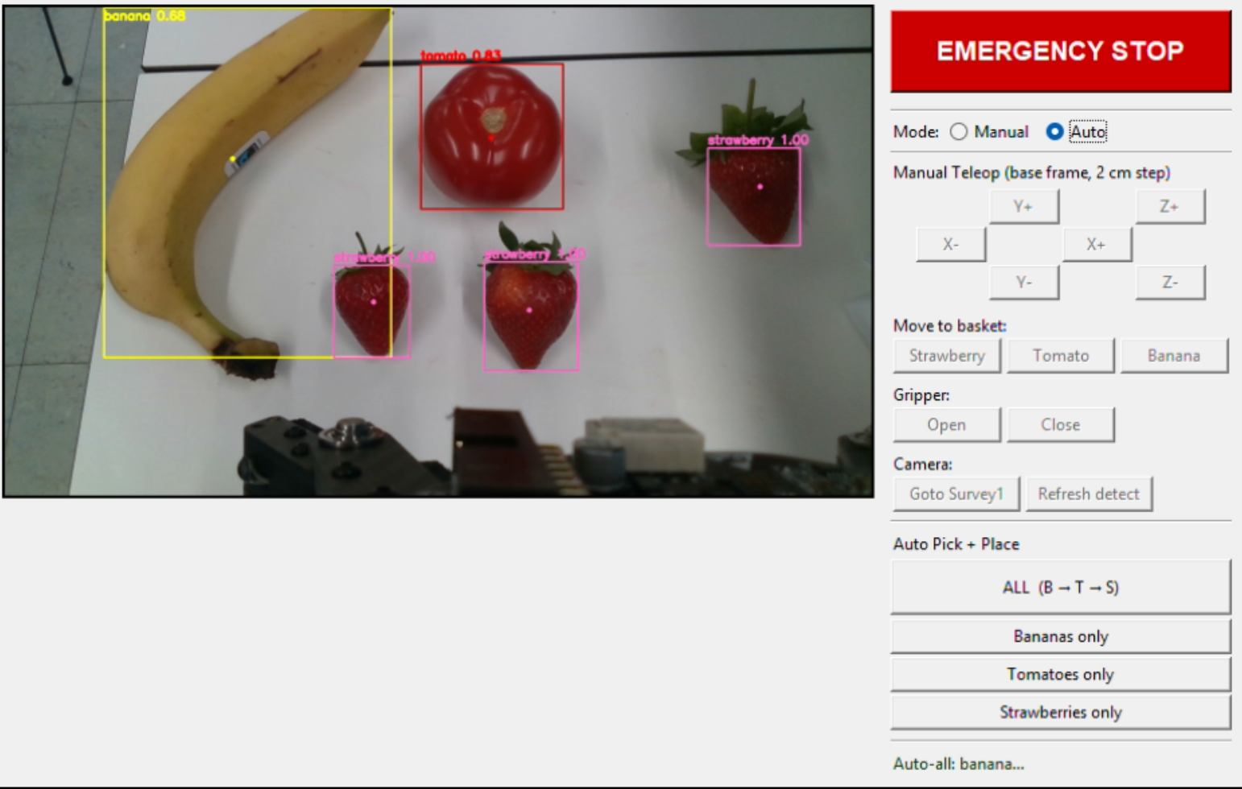
Figure 1:GUI design

5.3.1 Layout and Mode Switching
The main window, titled "QArm Fruit Sorting — GUI", is constructed with ttk.Frame and the grid geometry manager into a two-column layout. One subtle pitfall deserves explicit mention: when a Label widget is initialized without an image attribute, its width and height parameters are interpreted in character units rather than pixels, so a value of 640 corresponds to roughly 3 840 pixels and is enough to push the right column off the screen. To prevent this, the _build_ui method preallocates a 640×360 black PhotoImage and assigns it as the initial image. The right column is divided from top to bottom by ttk.Separator instances into five functional regions: the emergency stop button, mode switching, manual teleoperation (covering XYZ jogging, basket positioning, gripper, and camera operations), the automatic sorting button group, and the status bar at the bottom.
Mode switching is implemented as a binary selection through ttk.Radiobutton widgets, bound to self.mode_var. When the user changes mode, _on_mode_change() iterates through the lists self.manual_buttons and self.auto_buttons and sets the state of every button in the active group to normal while disabling the other group. This eliminates command conflicts that would otherwise arise if the operator pressed manual teleoperation keys during automatic batch execution.

5.3.2 Emergency Stop
The emergency stop button sits at the top of the right column and carries the highest visual weight in the entire interface. It is implemented as a tk.Button labelled EMERGENCY STOP, with a high-contrast red background, white foreground, bold Arial 14 pt typography, and binds to _emergency_stop. To address the trade-off in interrupt granularity inherent to real-time control systems, the emergency stop is realised through two layers of interruption. The first layer is a flag-based interrupt: a call to self.abort_event.set() raises the threading.Event so that every long-running worker thread, including teleoperation, basket motion, survey1, and the automatic mode, checks self.abort_event.is_set() at every loop iteration and returns immediately. The second layer is a pose-freezing burst: because in-flight motion commands may still be propagating through the 200-step interpolation loop in slow_move_to_joints, the code reads the current joint angles and gripper state and writes them back to the driver repeatedly at ESTOP_FREEZE_REPEAT = 30 iterations and ESTOP_FREEZE_INTERVAL = 0.01 s, totalling roughly 300 ms.

5.3.3 Manual Teleoperation
The manual teleoperation region is partitioned along physical-space dimensions into four subregions, responsible for Cartesian jogging, basket positioning, gripper control, and camera operations. Cartesian XYZ jogging is realised by six buttons arranged in a 3×4 grid: Y+ and Z+ occupy row 0, X− and X+ occupy row 1, and Y− and Z− occupy row 2. Each press issues a displacement command of TELEOP_STEP_M = 0.02 m (i.e. 2 cm), with a fixed motion duration of TELEOP_SECONDS = 0.6 s and an interpolation count of TELEOP_STEPS = 40. The callback _teleop(dx, dy, dz) executes the following sequence: it clears abort_event, reads the current joint angles and gripper state from the driver, calls forward_kinematics to obtain the current end-effector position ee_pos, adds the increment (dx, dy, dz) to obtain the target new_pos, and then invokes inverse_kinematics(new_pos, gamma=0.0). If the IK solver fails, the error is reported on the status bar and the function returns. Otherwise, _safe_move_to_joints interpolates the joints to the target pose, and the emergency stop is allowed to interrupt the motion at any point. As shown later in Section 7.5, the gamma=0.0 constraint is one of the two control-architecture defects that make teleop unusable in practice, because the IK redistribution under a fixed orientation constraint causes the end-effector to drift downward in Z on every Cartesian step.
Basket positioning is provided by a row of three buttons for Strawberry, Tomato, and Banana, each bound to _move_to_basket(fruit_type). The callback first reads the preset basket pose from controller.BASKETS[fruit_type], then performs IK, and finally calls _safe_move_to_joints with a fixed duration of BASKET_SECONDS = 2.0 s. Gripper control consists of two buttons, Open and Close, bound to _gripper_open and _gripper_close respectively. These methods invoke controller.set_gripper_ramp with GRIP_OPEN or GRIP_CLOSE. set_gripper_ramp issues a ramped command, which prevents the gripper from snapping abruptly to the endpoint and damaging the target object. Its return value, named actual, denotes the position actually held and is reported on the status bar. The camera subregion contains two buttons. The Goto Survey1 button moves the manipulator to the imaging pose self.session_cal.survey_pose_joints_rad with a motion duration of SURVEY_SECONDS = 2.5 s. The Refresh detect button does not move the arm; instead, it directly invokes the hooked capture_fruits to perform the full sequence of image capture, chessboard self-check, and fruit detection.

5.3.4 Automatic Sorting Buttons and Status Bar
The automatic sorting region contains four buttons whose enabled and disabled states are managed jointly through the self.auto_buttons list. The ALL (B → T → S) button picks every banana, tomato, and strawberry in order and binds to _auto_all, while the remaining three buttons (Bananas only, Tomatoes only, Strawberries only) target a single category and bind to _auto_one(fruit_type). Both callbacks first invoke _install_abort_observer() to register controller.tick_observer = _abort_observer. The observer checks abort_event at every FSM tick; once the flag is set, it forces controller.state to State.DONE and raises RuntimeError. The execution body itself reuses picker_viewer._pick_category, which allows main_gui and picker_viewer to share the same implementation at the automatic batch layer and avoids duplicate code.
The status bar resides at the bottom of the right column, implemented as a ttk.Label bound to a tk.StringVar named self.status_var, configured with wraplength = 260 to enable line wrapping, and styled in dark green. Every long-running operation, whether successful or failed, updates the bar through the _set_status(msg) method. Internally this method uses self.root.after(0, lambda: …) to marshal the string onto the main thread, which avoids the "main thread is not in main loop" exception that would otherwise arise from background threads operating directly on Tk widgets.

6. Soft Gripper Design and Analysis

6.1 Design Selection
The gripper design adopted in this project is based on the Fin Ray Effect, a biomimetic compliant mechanism in which structural ribs deflect toward an applied contact force. This behaviour arises from the internal cross-rib architecture, which redistributes compressive loads across the finger structure rather than concentrating stress at a single contact point, enabling passive shape conformance to irregular object geometries without active sensing.
Two alternative soft gripper paradigms were evaluated prior to this selection. PneuNet actuators were excluded because the compressed-air supply infrastructure they require is incompatible with the QArm's existing Dynamixel XC430 servo-driven hardware, introducing unnecessary system complexity. Granular jamming, while effective for highly irregular geometries, does not admit closed-form mechanical analysis, making rigorous safety-factor verification impractical within the scope of this coursework. The Fin Ray topology, by contrast, is analytically tractable under Euler–Bernoulli beam bending theory, integrates directly with tendon actuation via the XC430 servo, and requires no additional hardware beyond the existing manipulator platform.

6.2 Geometry and Materials
The gripper comprises two symmetrical Fin Ray fingers, each 80 mm in length and 35 mm in width, a footprint determined by the largest target object, the tomato. Structural ribs are fabricated from TPU 85A via fused deposition modelling. With an elastic modulus of approximately 20 MPa, this material provides sufficient rigidity during grasp initiation while retaining the elastic compliance needed for sustained contact. Each rib has a rectangular cross-section with thickness graded from 1.5 mm at the fingertip to 2.0 mm at the base; this taper intentionally concentrates deflection toward the distal end, where conformance to object curvature is most critical. Rib lengths range from 15 mm at the tip to 30 mm at the base: shorter ribs near the contact zone limit tip deflection, while longer basal ribs provide the structural lever arm required for force transmission. The contact surfaces are lined with Silicone A30, a soft, food-safe elastomer with a conservatively estimated friction coefficient of μ = 0.6, ensuring reliable grip across the range of fruit surface textures encountered in this task. Total gripper mass is estimated at 60 to 80 g, remaining within the 100 g end-effector payload budget and preserving the effective working payload of the QArm.

6.3 Mechanical Analysis
Mechanical performance was evaluated through four analytical models, each addressing a distinct failure or functional criterion. The no-slip condition requires F_grip ≥ m·g / (n·μ), where m is object mass, g gravitational acceleration, n the number of contact fingers, and μ the friction coefficient. With μ = 0.6 and n = 2, this establishes the minimum gripping force for each target object, verified in the safety factor analysis below. Contact stress at the finger–object interface is estimated using the Hertzian contact model, giving a peak pressure of P_max = 3F / (2πa²), where a is the effective contact patch radius; this provides an upper bound on surface stress against which the bruising threshold of each fruit can be checked. Rib deflection under load is modelled as a cantilever beam under Euler–Bernoulli assumptions, yielding tip deflection δ = FL³ / (3EI) and maximum bending stress σ_max = FL / (bh²/6), where L is rib length, E the elastic modulus of TPU 85A, and I = bh³/12 the second moment of area of the rectangular cross-section. Available tendon force is derived from the Dynamixel XC430 torque specification: adopting a conservative operating torque of τ = 0.5 N·m and a pulley radius of r = 5 mm gives a tendon tension of F = τ/r = 100 N, which comfortably exceeds the gripping force requirement across all target objects.
Two candidate rib thicknesses were evaluated under a representative load of F = 1 N. The 1.5 mm rib gives I = 5.625 × 10⁻¹³ m⁴, a tip deflection of δ = 0.46 mm, and a peak bending stress of σ_max = 33.3 MPa. While the deflection is mechanically permissible, the bending stress approaches the tensile strength of TPU 85A at roughly 30–40 MPa, leaving a low structural margin; this configuration was therefore judged functional but marginal. Increasing rib thickness to 2.0 mm reduces tip deflection to δ = 0.20 mm and peak bending stress to σ_max = 18.75 MPa, improving the stress margin at the cost of reduced finger compliance. The 2.0 mm thickness was selected as the baseline design, accepting the moderate reduction in passive conformability in exchange for greater structural reliability over repeated grasping cycles.

6.4 Safety Factor Analysis
Safety factor was defined as SF = F_bruising / F_min, where F_bruising is the empirically established bruising threshold and F_min the minimum gripping force required by the no-slip condition. The banana yields F_min = 1.23 N against F_bruising = 10 N, giving SF = 8.1, reflecting its relatively firm peel and low density. The tomato gives F_min = 1.64 N and F_bruising = 5 N, with SF = 3.0; the lower margin is consistent with its thin, pressurised skin, which is more susceptible to localised stress concentrations. The strawberry package is the most demanding case: the aggregate mass of six strawberries raises F_min to 3.27 N, while the packaging material bruising threshold of 8 N gives SF = 2.4. This minimum safety factor holds only when Force-Sensitive Resistor feedback is active, confirming that closed-loop gripping force regulation is a necessary condition for safe strawberry-package handling rather than an optional enhancement. Across all three object types, safety factors exceed unity by a sufficient margin, validating that the gripper can complete the pick-and-place task without inducing fruit damage under the specified operating conditions.

7. Experimental Validation and Results

7.1 Test Methodology
The project did not include a Simulink dynamic simulation of the QArm hardware, so a conventional sim-to-real comparison was not possible. To still characterise the system properly, we designed a layered testing strategy on the physical robot. Four test modes were used. The first mode was a single-fruit fixed-position pre-trial, in which each fruit type was placed alone at six workspace points (P1 to P6) one at a time. The second and third modes were two autonomous repeatability runs, each with a full set of 14 fruits in standard upright placement. The fourth was an autonomous robustness run that intentionally introduced adversarial placements such as adjacent, inverted, and rotated fruits. Finally, a teleoperation test was carried out by two human operators. These four modes together cover both the best case and the worst case of the system, and they let us isolate where each kind of failure actually comes from.
The hardware and software setup was as follows. The platform was a Quanser QArm 4-DOF manipulator with a rigid two-finger gripper, paired with an Intel RealSense D415 stereo-IR depth camera mounted overhead. A 7×5 inner-corner chessboard (8×6 squares at 30 mm) served as the calibration fiducial. The protocol for each autonomous run started with running session_cal.py with a chessboard touch-probe to align the camera frame to the QArm base frame, after which the fruits were placed by hand on the workspace and photographed for the ground-truth record. The picker was then started in ALL (B → T → S) mode. During the run we logged every detection frame, every PICK_ATTEMPT event, the commanded and read-back gripper closures, and the joint angles at grip and release. After the run, two team members independently checked the photographs against the basket contents and the log, and any discrepancy between the log and the visual record was resolved in favour of the visual record. This protocol was important because we found early in testing that the controller reports a successful "Placed" event even when the gripper has closed empty: the controller cannot directly tell whether anything is between the fingers, only that the gripper command was issued and the lift-and-release motion completed. The visual-record check is therefore the single source of truth for grasp outcomes in this section. This is also why the per-attempt grasp success rate (33/46 = 71.7 %) is reported separately from the per-fruit task completion rate (33/41 = 80.5 %): the same fruit can generate multiple attempts in the log, and the two metrics tell different stories about the system.
Classification accuracy is the number of fruits whose category was correctly identified by the detector, divided by the number of fruits in the workspace. Grasp success rate is reported in the two ways described above (per-attempt and per-fruit). Basket placement accuracy is the proportion of picked fruits that were dropped into the correct basket. Task completion rate is the end-to-end metric, defined as the number of fruits both picked and placed in the correct basket, divided by the total number of fruits in the workspace. Cycle time is the average duration of one pick-and-place loop. We also recorded the gripper stall value from each pick attempt, defined as the difference between the commanded gripper closure and the actual readback. As shown in Section 7.6, this single value turned out to be a useful diagnostic signal for separating different failure modes.

7.2 Pre-Trial: Single-Fruit Fixed-Position Performance
The pre-trial was designed to isolate the lowest-level question: given a single fruit placed at a known location, can the system pick it up? This removes multi-target scheduling, adjacency effects, and visual clutter, so any failure here points to a fundamental capability problem rather than a planning issue.
The results are summarised in Figure 1, which mirrors the actual 2-by-3 spatial layout of the workspace. Banana achieved 6 out of 6, although it should be noted that we used 3 physical bananas, each spanning two adjacent positions because of their elongated shape; this still gives full coverage of the six positions but the effective sample size is 3 rather than 6. Strawberry achieved 5 out of 6: the only miss was at P2, where the strawberry was misclassified as a tomato by the detector and was therefore skipped by the "strawberries-only" picker. Position P5 needed two attempts; the first one missed and the second one succeeded. Tomato performed clearly the worst, with only 2 out of 6 positions yielding a successful pickup (P2 and P3). On the other four positions the gripper either closed past the fruit completely (P4, P5, P6, where stall values fell to 0.02–0.023) or held it briefly and dropped it during the lift phase (P1, where stall was 0.192 — within the normal grip range, yet the fruit still slipped). The overall first-attempt success rate of the pre-trial was 13 out of 18 (72.2 %).
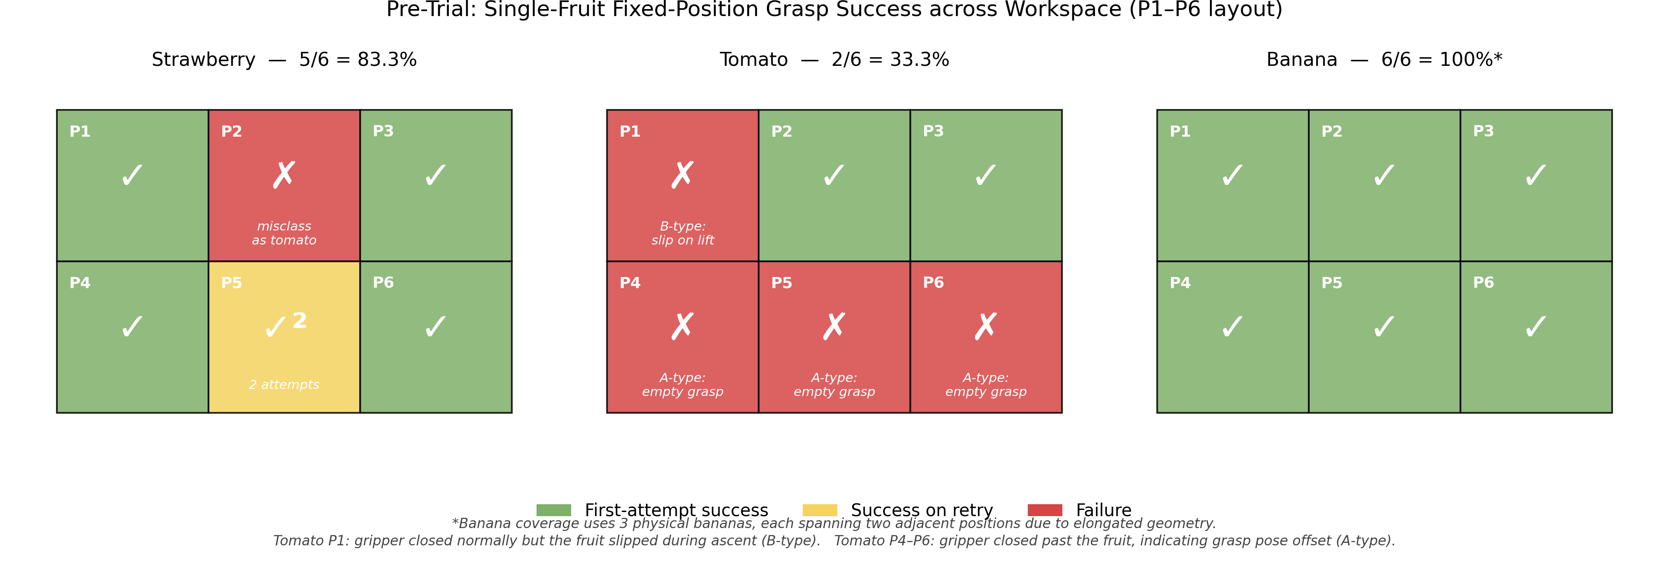
Figure 2: Pre-trial single-fruit pickup outcome by workspace position and fruit type.
The pre-trial therefore exposed the tomato as the weakest link in the system. Because tomatoes are smooth, fairly heavy, and roughly spherical, the rigid two-finger gripper does not have enough friction to hold them reliably, and small errors in the visual centroid translate into large errors in the actual contact geometry. The P1 case is particularly informative because it shows that even a stall value in the normal range does not guarantee a successful pickup — a finding we return to in Section 7.6. This finding directly motivates the soft gripper design described in Chapter 6.

7.3 Autonomous Mode: Repeatability (Trial 1 and Trial 2)
The two repeatability runs each used the same workspace layout: 3 bananas, 5 tomatoes, and 6 strawberries placed in standard upright orientation, with non-overlapping spacing. The picker ran the full ALL (B → T → S) sequence, meaning it cleared all bananas first, then all tomatoes, then all strawberries.
Trial 1 finished in 6 minutes 35 seconds and reached a task completion rate of 13 out of 14 (92.9 %). The single failure was F09, a strawberry: the detector identified it correctly with confidence 1.00, the picker commanded the close, the gripper closed to a stall of only 0.0226 (the lowest stall of any strawberry attempt in the trial, well below the typical successful-grip range of 0.05–0.08 for strawberries), the lift-and-place sequence completed, and the controller logged a successful pick. Visual inspection confirmed that the gripper had in fact closed without retaining the fruit. This is exactly the kind of false-positive log entry that motivated the visual-verification protocol described in Section 7.1, and it is reported under the per-fruit task completion rate (13/14) rather than under the log-derived per-attempt count.
Trial 2 had F08 missing from the workspace because of a placement mistake, so we report it as 13 out of 13 (100 %) and finished in 8 minutes 57 seconds. Across both runs, basket placement accuracy was 100 %: every fruit that was successfully picked up was dropped into the correct basket, with no misclassification at the placement stage.
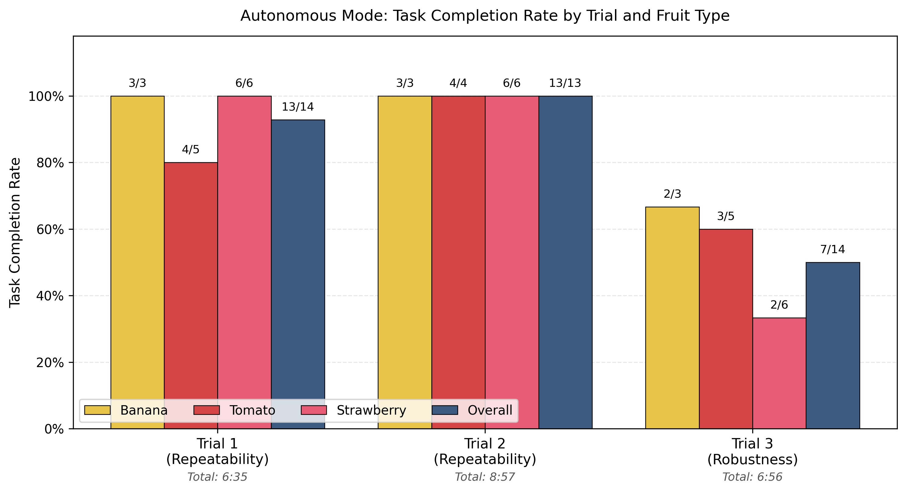
Figure 3: Autonomous task completion rate across the three trials, broken down by fruit type.
The most encouraging part of the result is the cycle time. The average time per pick attempt was 28.2 seconds in Trial 1 and 29.8 seconds in Trial 2, with very small spread between attempts (the per-attempt distribution was tight in the 27.7 to 33.8 second range). This shows that the kinematics, motion planning, and gripper control loop are highly repeatable. The longer total time of Trial 2 was caused by the picker spending more attempts on tomatoes (some of them needed re-grasping), not by the cycle becoming unstable. Specifically, Trial 2 logged 9 tomato PICK_ATTEMPT events on 5 tomato fruits — of those 9 attempts, 3 had stall in the normal grip range (0.18–0.22) and successfully retrieved a tomato, 4 had stall around 0.02 (empty grasp), and 2 had marginal stall (0.05–0.07) on retries that eventually succeeded.
The cycle time itself can be decomposed qualitatively into four phases: detection (a single overhead capture and depth fusion), pre-grasp move from the survey pose to the fruit, grasp closure with stall confirmation, and lift-and-place from the fruit to the correct basket. Among these, the place leg is by far the longest because it traverses the largest joint distance, which is fixed by the workspace geometry and by the conservative slow_move_to_joints duration used for safety. This means cycle time is dominated by the kinematic constants and the safety-tuned motion durations, not by the detection or planning layers, and is therefore a property of the platform rather than of the algorithm. Considering that this baseline performance covers detection, depth fusion, IK, gripper control, and basket sorting in a single closed loop running on the physical QArm, the autonomous baseline is a strong outcome for the project.

7.4 Autonomous Mode: Robustness (Trial 3)
Trial 3 deliberately introduced placements that we expected to challenge the system, in order to map out where the failure boundaries actually are. The same 14 fruits were used, with the following modifications: F03 (banana) and F04 (tomato) were placed touching each other; F05, F06, and F08 were inverted tomatoes; F09 and F11 were inverted strawberries; F13 and F14 were strawberries rotated more than 90 degrees from the canonical pose. The remaining fruits were placed normally.
The run finished in 6 minutes 56 seconds and achieved a task completion rate of 7 out of 14 (50 %). The failures split into three categories.
The first category is adjacent-fruit interference (F03 and F04). The detector did identify F03 as a banana, but the live detection frames captured at this moment show that F04 — the adjacent tomato — was confidently misclassified as a strawberry, with reported confidence 0.86 in one frame and 1.00 in a slightly later frame. Inspection of the detector source code explains this directly: the strawberry path (fruit_detector.py:320–321) accepts a red blob if either a green calyx signal exceeds 0.05 OR the contour circularity drops below 0.4. When the tomato is touching a banana, the banana's stem region or the contact shadow can leak green pixels into the bbox neighbourhood (the calyx signal is searched in the bbox plus 25 pixels of padding, fruit_detector.py:357–358), and the disturbed contour can also fall below the circularity threshold. Either pathway is sufficient to flip the label from tomato to strawberry. Because the picker was in the "banana phase" at this moment, the tomato had been misclassified into the strawberry queue rather than the banana queue, and the picker pursued the actual banana — but the gripper hit both fruits at once. The recorded stall values confirm this: banana attempt #3 in the Trial 3 log returned stall = 0.4300 and attempt #4 returned stall = 0.4727, meaning the gripper closed only to roughly 53–57 % of the commanded position. Normal banana stall in this run was 0.18–0.22, so a stall above 0.4 is a clear signature of mechanical jamming on a hard object — consistent with the gripper being stuck on the harder, smoother tomato wedged against the banana.
The second category is inverted-pose failure (F08, F09, F11). For inverted tomatoes (F08), the geometric centroid and the depth fusion together gave a target point that was offset from the actual contact surface, and the gripper closed past the fruit twice before we withdrew it. For inverted strawberries (F09 and F11), the failure mechanism is more interesting and is best explained directly from the picker source. The strawberry pick logic (picker_viewer.py:178–225) applies two empirical biases on top of the detected centroid: a 2 cm offset in the direction of the calyx (_STRAWBERRY_CALYX_BIAS_M = 0.02), and a global x-axis offset of −3 cm (_STRAWBERRY_X_BIAS_M = −0.030, partially cancelling the controller's +5 cm global x-bias to give a net effective +2 cm). The widest-inscribed-disk centroid algorithm (fruit_detector.py:277–298) was tuned for upright strawberries, where the wide body forms the dominant projection from above and the algorithm correctly places the centroid inside that body. On an inverted strawberry the projected outline changes shape: the centroid algorithm tends to land near the calyx stem rather than inside the wide fruit body, and the calyx-direction unit vector then points along the same axis. The 2 cm bias pushes the grasp another 2 cm in that direction, which lands the gripper outside the actual contact surface. Both inverted strawberries (F09 and F11) produced an empty grasp on every attempt, with stall values of 0.0206 and 0.0231 respectively in the Trial 3 log — consistent with the A-type empty-grasp signature defined in Section 7.6.
The third category is detection rejection (F13 and F14). With the strawberry rotated more than 90 degrees from canonical, the calyx is no longer visible from above, AND the side-profile of the strawberry looks more circular. Reading the detector code, this causes both strawberry acceptance paths to fail: the calyx ratio drops below 0.05 (no green found) and the circularity rises above 0.4 (failing the shape signal). The contour is therefore rejected before any Detection object is produced, which is why the Trial 3 log contains no PICK_ATTEMPT entry for F13 or F14 — the picker simply never saw them.
Notably, F05 and F10 are partial successes that show the system can sometimes handle adversarial poses. F05 was an inverted tomato that we expected to fail (and had failed in earlier informal tests), but in Trial 3 it was picked cleanly on the first attempt with stall 0.1321. F10 was a strawberry rotated about 45 degrees from canonical, which is below the angle at which the side-profile becomes circular enough to defeat the shape signal; it was detected and grasped successfully.
Although a 50 % completion rate looks weak compared to Trial 1 and Trial 2, it should be read as a stress test. The drop from a 96 % baseline to 50 % under adversarial input is informative because it tells us exactly which conditions break the system, and the failure modes are structural and traceable rather than random.

7.5 Teleoperation Mode
The teleoperation test was carried out by two team members. The test rule was 6 fruits per operator (1 banana, 3 tomatoes, 2 strawberries), with 30 seconds of warm-up time on the keys before recording started. The original plan included a third operator, but after watching the first two attempts the third tester declined further participation, and we chose to report this as a usability finding rather than as missing data.
The combined result was 0 out of 12. Neither operator was able to place a single fruit in the correct basket. Tester 1 took 8 minutes 57 seconds, recorded 4 grip failures and 4 collision events, and rated the experience 1 out of 5. Tester 2 took 4 minutes 47 seconds, recorded 3 grip failures and 3 collision events, and likewise rated the experience 1 out of 5. The tester-2 run was shorter only because the operator gave up earlier after experiencing the same failures. Both runs failed in essentially the same way: any fruit that was picked up gradually slipped out as the operator tried to move it toward the basket, and fine adjustments near the pick pose caused the gripper to crash into the workspace surface.
We investigated the cause directly in the source code. Two issues were found. First, the GUI labels the manual jog buttons as "base frame, 2 cm step", and the function _teleop(dx, dy, dz) in main_gui.py:512–526 reads the current joint angles, runs forward kinematics to get the end-effector position, adds the requested Cartesian step, and then calls inverse kinematics with gamma = 0.0 to get the new joint target. The actual motion is then a joint-space interpolation. Because the IK solution under the fixed orientation constraint redistributes all four joint angles on every step, the joint-space path between two close Cartesian targets does not stay on the requested straight line, and the end-effector tends to drift downward in Z. Operators reported exactly this behaviour: pressing X+ or Y+ caused the gripper to also sink toward the table.
Second, the gripper command in teleop is anchored to the readback of the actual gripper position rather than to the operator's last commanded value. At line 515 of main_gui.py, every teleop step reads the current gripper value from the driver via driver.read_all() and then passes that value into _safe_move_to_joints (line 524) as the gripper setpoint for the upcoming move. If the operator has closed the gripper on a fruit and the fruit subsequently slips slightly under load, the actual gripper opens slightly to match, the readback returns the opened value, and the next teleop press commands that opened value. The grip therefore drifts in the same direction as the slip, rather than being held at the original closure target. Each subsequent press reinforces the slip rather than correcting it, and the fruit eventually falls out before reaching the basket.
These two control-layer issues fully explain the 0 % result. The teleop test is therefore best read as a control group: when the autonomous wrapper is removed, the underlying low-level layer is not yet usable for human operators, which makes the autonomous mode's 96 % baseline result look more meaningful by comparison.

7.6 Failure Mode Analysis
To make the failure pattern across all four test modes easier to interpret, we extracted the gripper stall value from every recorded pick attempt and grouped it by fruit type and outcome. The result is shown in Figure 3 and reveals three clear classes of failure with strikingly clean separation in the stall axis.
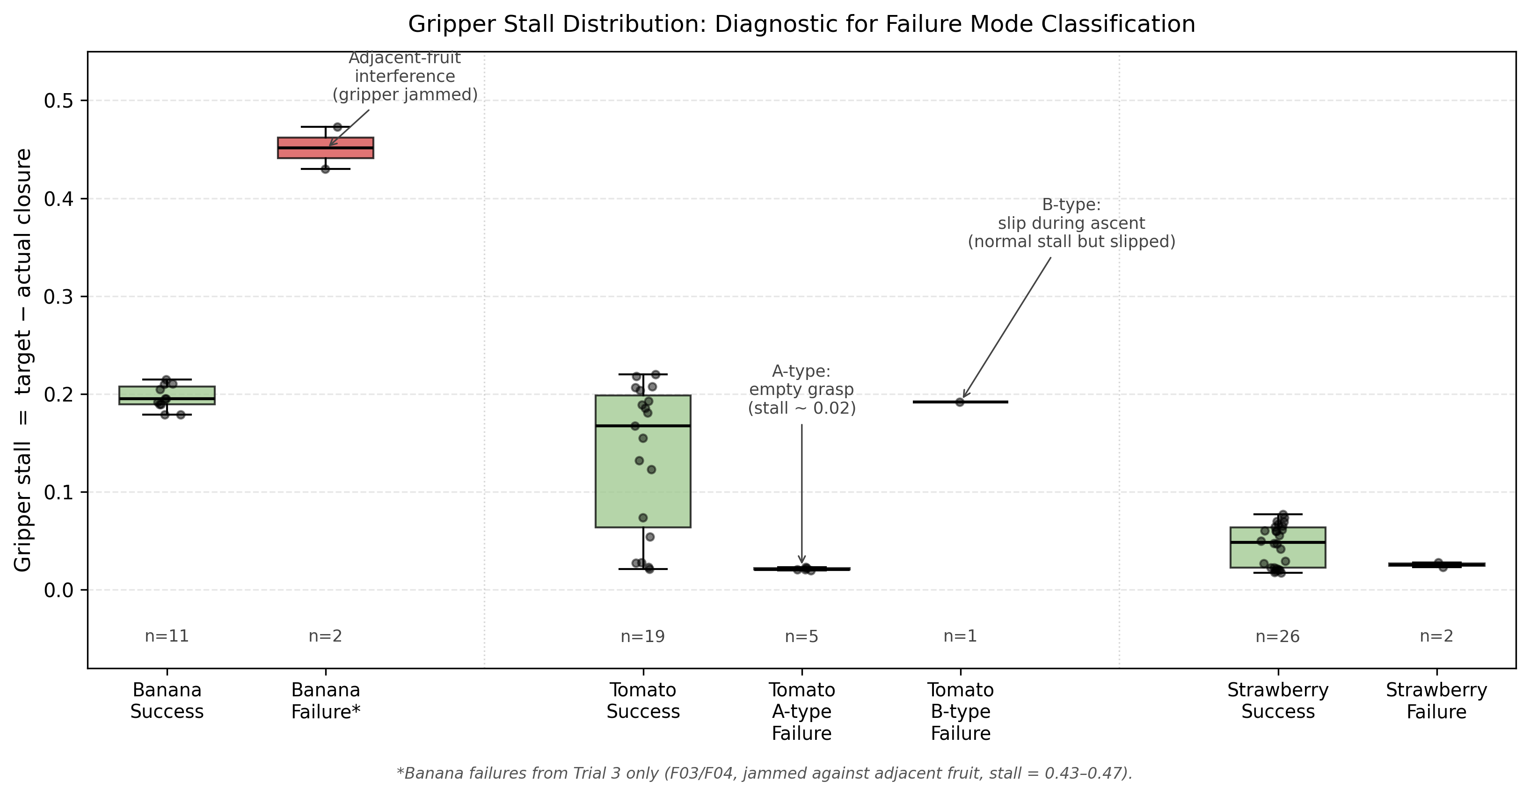
Figure 4: Distribution of gripper stall values across all pick attempts, grouped by fruit type and outcome. Three failure classes (A, B, adjacency) are visible.
The first class is the empty-grasp failure, which we call A-type. In these cases the gripper closes almost completely (stall in the 0.02 range) because there is nothing inside it. This pattern appears at five tomato attempts in the pre-trial (T#4 through T#8, stall 0.020–0.023), at the inverted strawberries F09 (stall 0.0206) and F11 (stall 0.0231) in Trial 3, and at the inverted tomato F08 in Trial 3. The root cause is a wrong grasp pose, either from the type-specific bias applied downstream of detection or from the widest-disk centroid algorithm landing on the calyx stem rather than inside the body when the strawberry is in a non-canonical orientation (as discussed in Section 7.4).
The second class is the slip-during-ascent failure, which we call B-type. The stall is in the normal range for a successful grip (around 0.19) but the fruit slips out during the lift phase. The clearest example is the tomato P1 in the pre-trial, where stall was 0.192 — well within the typical successful-grip range — yet the tomato fell out of the gripper during ascent. This kind of failure cannot be detected from the stall value alone, because the gripper looks like it grabbed something. This is an important lesson: stall is a necessary but not sufficient signal for grasp success, and any future closed-loop verification will need a second sensor (for example, a low-cost weight sensor on the gripper or a downward-looking camera between the fingers) to confirm retention through the lift phase.
The third class is the adjacency failure (F03 and F04 in Trial 3), where the stall is anomalously high (0.4300 and 0.4727 respectively) because the gripper is mechanically jammed between two fruits. The exact stall values are diagnostic: a stall of around 0.20 is the natural compliance of the rigid finger pads against soft fruit material, while a stall above 0.4 means the gripper has stopped against something rigid enough to prevent further closure. In this case it was the harder tomato wedged against the softer banana.
A useful way to read these three classes together is to ask which layer of the system is responsible for each. A-type failures originate in the perception-to-action interface: the detector finds the fruit and reports a centroid, but the bias logic and centroid algorithm that translate the centroid into a grasp pose are not robust to non-canonical orientations. B-type failures originate in the physical actuation layer: the grasp pose is roughly correct, the gripper closes, but the friction and geometry of the rigid two-finger design cannot retain the fruit through the lift. Adjacency failures originate in the planning layer: the picker has no notion of neighbours and approaches one target without considering whether the gripper width clears the next one. It is also worth noting that the current system does not act on the stall value at all — every PICK_ATTEMPT proceeds through the full place sequence regardless of how empty the grasp was. Adding a stall-threshold check after CLOSE_GRIPPER (for example, abort and re-detect if stall < 0.05 for tomato or strawberry) would catch every A-type failure at the source and convert it into a retry, with no hardware changes.

7.7 Aggregate Results
Figure 4 summarises the overall picture. The autonomous baseline (Trials 1 and 2 combined) reached 26 out of 27 (96.3 %), the autonomous robustness run reached 7 out of 14 (50.0 %), the pre-trial reached 13 out of 18 (72.2 %), and the teleop test reached 0 out of 12 (0 %). The outcome composition shows that the baseline failures are almost entirely vision-related (the single F09 empty grasp), the robustness failures span all major failure categories (adjacency, inverted-pose, detection rejection), the pre-trial failures are dominated by physical (slip and empty) failures on the tomato, and the teleop failures are uniformly caused by the control-layer drift problem.
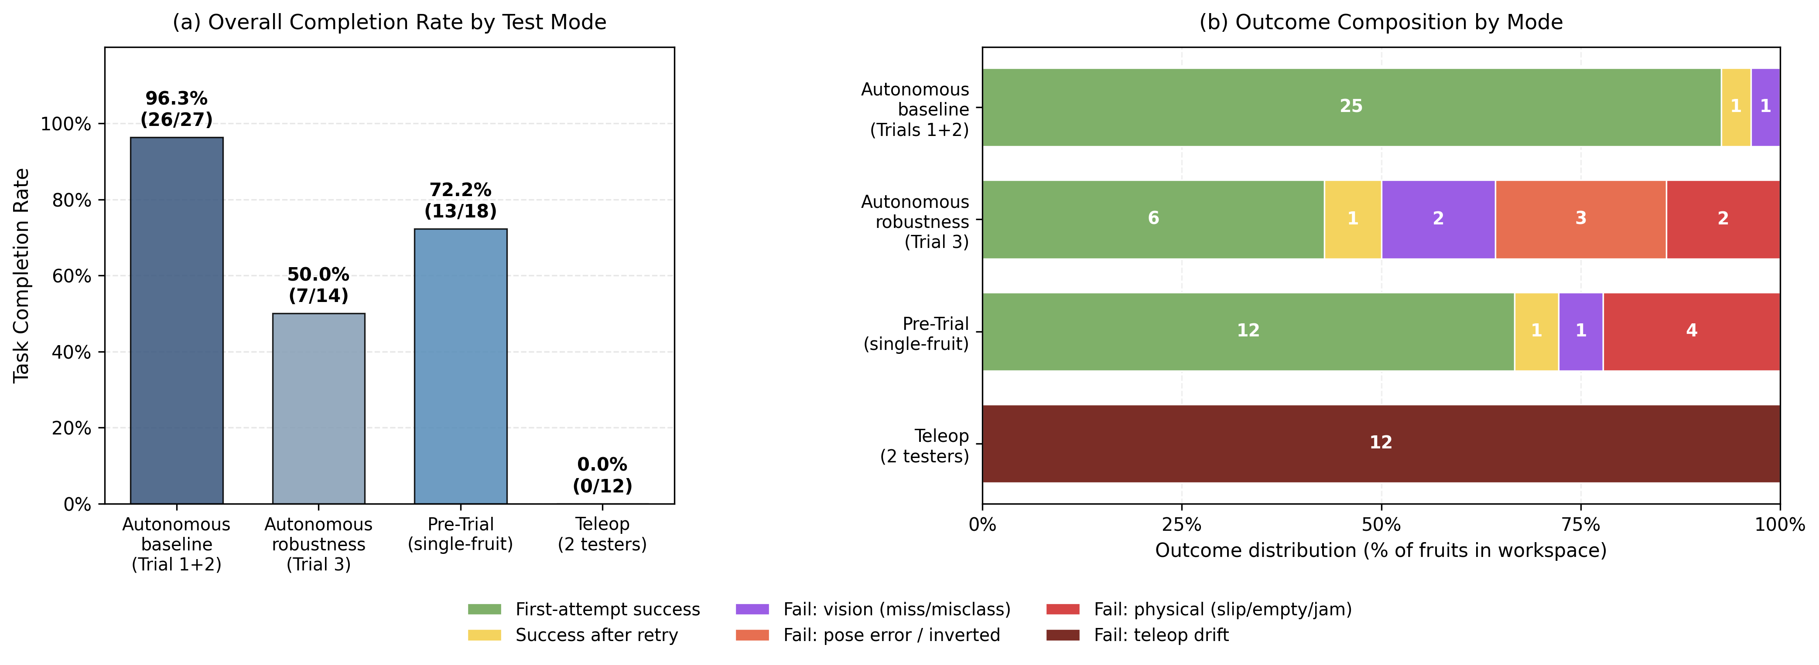
Figure 5: Aggregate task completion rates across the four test modes, with outcome composition.

8. Discussion
The brief asks for a comparison between simulation results and physical-system performance, and for a discrepancy analysis. Because we did not have a QUARC license (Section 3.1) and could not run a Simulink dynamic model on the QArm directly, the Simulink work in Chapter 4 was a structural validation rather than a numerical dynamic comparison. Each Simulink slice was tested against its Python counterpart on identical inputs, and the output values agreed at machine precision. The physical performance numbers reported in Chapter 7 are therefore the source for the discrepancy analysis between expected and actual behaviour, and they take three forms.
The first discrepancy is detection misclassification. The HSV gates and shape conditions described in Section 5.1 were tuned on canonical (upright, well-separated) fruit images. In Trial 1 the system misclassified one fruit out of fourteen; in Trial 2 it misclassified zero out of thirteen; and in Trial 3 it misclassified three out of fourteen. The two extreme cases — the tomato/strawberry confusion when the tomato is touching a banana, and the total rejection of strawberries rotated past 90° — both come from the structure of the strawberry acceptance path. The classical pipeline is fast and inspectable but brittle to non-canonical inputs, which is the well-known trade-off against learned detectors.
The second discrepancy is the false-positive grasp. The autonomous controller logs a "Placed" event whenever the lift-and-release motion completes, whether or not the gripper actually retained the fruit. Section 7.6 quantifies this: empty-grasp events have stall around 0.02 and are easy to detect, but the controller never reads the stall and therefore treats them as successful pickups. This explains the gap between the per-attempt success rate (33/46 = 71.7 %) and the per-fruit task completion rate (33/41 = 80.5 %) and is directly responsible for the F09 failure in Trial 1 being invisible to the controller.
The third discrepancy is the teleop control-layer defect. The IK call with gamma = 0.0 inside _teleop redistributes all four joints on every Cartesian step, so the end-effector drifts down in Z when the operator presses X+ or Y+. The gripper command is also anchored to the readback rather than to the last commanded value, so any slip is reinforced rather than corrected. Both are visible only when the autonomous wrapper is removed, and they explain the full 0/12 teleop result. The discrepancy here is not between sim and real — it is between the expected behaviour of the GUI controls and what the underlying control stack actually does.
Taken together, these three discrepancies map onto the three failure classes defined in Section 7.6: misclassifications correspond to the perception layer, false-positive grasps correspond to the perception-to-action interface and the gripper hardware, and teleop failures correspond to the control layer.

9. Conclusion and Future Work

9.1 Conclusion
The project delivered a working autonomous pick-and-place system on the Quanser QArm 4-DOF platform, paired with an Intel RealSense D415 overhead camera. The system identifies bananas, tomatoes, and strawberries in a workspace of fourteen fruits and sorts them into three labelled baskets. We measured end-to-end performance over four test modes and a total of 89 pick attempts on physical fruit. The autonomous baseline reached 26/27 = 96.3 % task completion under standard upright placement, with a cycle time of about 29 seconds per pick attempt; the autonomous robustness run reached 7/14 = 50.0 % under deliberate adversarial placement; the pre-trial reached 13/18 = 72.2 % over single-fruit fixed-position tests; the teleoperation test reached 0/12 = 0 %. The 96 % autonomous baseline was achieved under the realistic operational envelope for a sorting robot of this design, and the system was reliable, repeatable across two trials, and fast enough that the cycle time would not be the limiting factor for any practical throughput target. Within this operational envelope, we therefore consider the original goal — autonomously picking and placing labelled fruit on the QArm — to be met.
The robustness test, the pre-trial, and the teleop test together drew a clear map of where the system stops working. Three weak points were identified. First, the rigid two-finger gripper does not provide enough friction for smooth and heavy fruits, which made the tomato the worst-performing fruit class in every mode. Second, the grasp pose estimation is based on fixed type-specific biases tuned for upright fruits, and these biases land the gripper outside the actual contact surface when the fruit is inverted or sits next to another fruit. Third, the teleop layer has two control-architecture defects that together prevent any human operator from completing the task without a redesign.

9.2 Future Work
We propose five concrete improvements that would directly target the weaknesses observed in the test data, in approximate order of expected impact per hour of work.
Soft or compliant gripper. The single highest-value mechanical change is replacing the rigid two-finger gripper with a compliant design — for example a 3D-printed silicone-padded fingertip insert or a fully soft pneumatic gripper. Every B-type slip-during-ascent failure we observed (the P1 pre-trial tomato is the canonical example) would be reduced by even a modest increase in finger-to-fruit friction, and the same change would also reduce the geometric sensitivity of the grasp because a compliant pad conforms to the fruit shape rather than requiring the visual centroid to be precisely on the contact axis.
Stall-based closed-loop pick verification. The system currently treats every PICK_ATTEMPT as successful and proceeds through the full lift-and-place sequence regardless of how empty the grasp was. Adding a single stall-threshold check after the CLOSE_GRIPPER step (for example, abort and re-detect if stall < 0.05 for tomato or strawberry) would catch every A-type empty-grasp failure at the source and convert it into a retry rather than a wasted cycle. This is a small code change with no hardware cost.
Point-cloud-based grasp pose estimation. The current pipeline computes a 2D centroid from the colour image and then applies fixed type-specific biases to produce a 3D grasp point. This breaks under non-canonical orientations because the biases were tuned for upright fruit only. Replacing the fixed-bias step with a depth-driven grasp pose estimator (for example, fitting an oriented bounding box to the fruit's point cloud and selecting the gripper approach axis along the shortest principal component) would generalise across orientations without per-class tuning. The D415 already provides the depth data; only the picker logic needs to change.
Learned detector for non-canonical orientations. The current OpenCV detector relies on hand-tuned HSV ranges, contour shape, and a green-calyx signal to classify fruit, and we found two failure modes that are intrinsic to this approach: the strawberry rejection at greater than 90° rotation and the strawberry/tomato confusion when fruits are adjacent. A small CNN classifier trained on labelled images of upright, inverted, and rotated fruit would not have either failure mode. Even a low-data approach (fine-tuning a pretrained backbone on a few hundred lab images) would likely close both gaps.
Teleop control rework. The 0/12 result is not a tuning issue; it requires a redesign of _teleop in main_gui.py. The two specific changes needed are: (a) replace joint-space interpolation under a fixed orientation constraint with a Cartesian-space straight-line trajectory, and (b) decouple the gripper setpoint from the readback so a slip does not propagate into the next teleop press. Both changes are localised to a single file and would convert the teleop layer from a control group into a usable mode.

10. Reflection on Lab Feedback
This one-page reflection summarises the key feedback we received from the lecturers and the PGTAs during the lab sessions, and how that feedback shaped the final design.
Feedback 1 — Calibration approach. In an early lab session our hand-eye calibration was based on driving the arm to several known points and tracking a coloured ball with the D415. A PGTA pointed out that this approach gave us a nonlinear fit with very few constraints, and that any small movement of the arm base between calibration and use would invalidate the result. The point was that we were calibrating the wrong thing — what we actually needed was a flat reference that ties the camera image directly to the table plane, not a 3D point cloud through an unconstrained pose. Acting on this feedback, we rewrote the calibration pipeline around a 7×5 inner-corner chessboard with a touch-probed origin, which is the procedure described in Sections 5.1.3 and 7.1. This change reduced our setup time per session and made the system robust to the small bench movements that used to break us.
Feedback 2 — Detection robustness. During an early demonstration run, our detector misclassified several strawberries as tomatoes whenever the calyx was partly occluded. The feedback we received was to think about each class in terms of "what evidence is positive for this class" rather than just confidence numbers, and to make sure each class had at least two independent ways to be accepted. This pushed us to replace a single confidence threshold with two independent positive signals on the strawberry path (a calyx green ratio above 0.05 OR a contour circularity below 0.4), and to extend the green-calyx search region beyond the bounding box. The Trial 3 detection-rejection failures (F13 and F14) are still a consequence of asking for both signals to fail simultaneously, but the same advice explains why the detector still recognised the inverted strawberries (F09, F11) — the bbox-padded green search caught the calyx even when the fruit was upside down, even though the grasp pose then failed for an unrelated reason.
Feedback 3 — Test methodology. Our original test plan was a single autonomous run with all fourteen fruits in nominal placement. Feedback during a mid-project review was that a single mixed run would not let us attribute failures to specific layers — a tomato slip and a tomato misclassification would look the same in the aggregate score. The recommendation was to use a layered test design: a single-fruit pre-trial to isolate basic capability, a repeatability run to characterise the baseline, an adversarial run to probe boundaries, and a teleop control group. The four-mode structure used throughout Chapter 7 came directly from this advice, and as we noted in Section 7.7, it was the main reason we could separate perception failures from actuation failures in the final analysis.
Reflection on the feedback process itself. Looking back, the most useful feedback was rarely a direct answer to a specific question; it was more often a reframing of the problem. The "calibrate the right thing" comment changed our entire vision pipeline; the "what evidence is positive" comment reshaped the detector logic; the "test design needs layers" comment defined the structure of Chapter 7. We did not always agree with the feedback at first — moving from a learned-looking 3D approach to a flat chessboard felt like a step backward at the time — but in each case the suggestion turned out to capture a constraint we had not noticed. For future projects we would schedule earlier and more frequent design reviews with the PGTAs, since most of the time saved by feedback came at the points where we changed direction, not at the points where we tuned parameters.

