**Task**

Develop a python program that takes in a max hold count and raw IQ file path, performs FFT/PSD calculation, plots a max hold (persistence) of the FFT/PSD, and displays (on the graph) and records (to a list in a file) the max peak and its frequency.

**Big Picture**

Allow a user to develop a list of max peaks for different test parameters to characterize an SDR using raw IQ files. The long-term program goal would be for the program to read in a list of raw IQ files and append the max peaks to a file. The max peaks will be appended in association with the test parameter (i.e., pulse period, pulse width, center frequency, max peak, etc.)

**Background**

Some of the original max peak tests were done without knowing if the SDR captured the max peak of a signal or not. This will us to have the SDR record for a period, transfer the raw IQ files off the device, and calculate the max peaks. The program will allow the user to enter the count. The count is the number of samples at a particular frequency that the program will pick out the maximum value from. The graph (FFT/PSD vs Frequency) should be a graph of maximum values within the same count window. For example, in a window of ten samples (count = 10), the graph will be the max of the same ten IQ grabs for that frequency. The graph below is an example of a power vs frequency graph. The blue line is a max hold. The red line is the instantaneous plot (equivalent to count = 1).

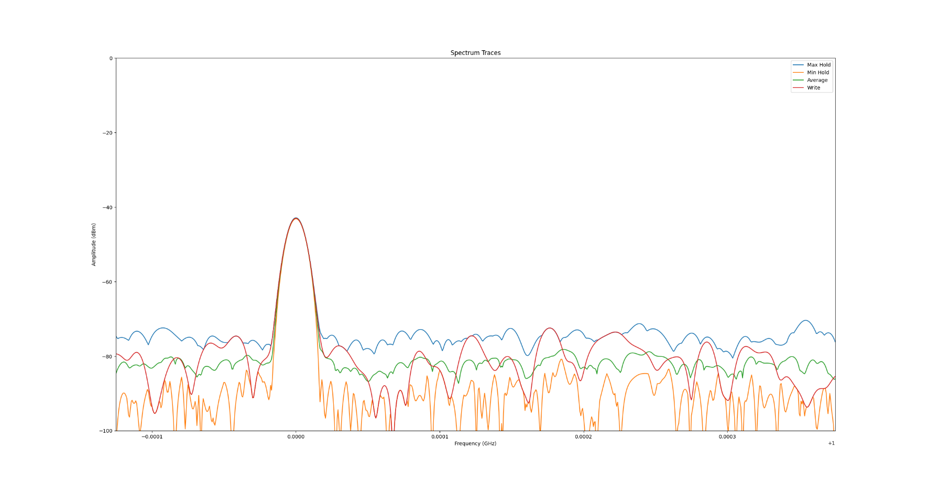

**Example Code:**

The code samples assume that a list of amplitude values (dBm) and associated frequency [Hz] lists have already been provided. See appendix for reading in raw IQ values.

This function takes in a list of lists. Each element in the list is a list of dBm/DBFS values at a particular frequency.

C:\Users\berrios1\Documents\ARMR\Tektronix\RSA_automate\myFunctions.py

The code below is an example of a program that gets a list of frequencies and amplitude values from a real-time spectrum analyzer. A list of lists is created. The list is the length equal to “count”, described earlier. Each element is a list of amplitude values. Think of the list of lists as a matrix with dimensions count X amplitudeListLength. Each column of the matrix is a list of amplitude values a particular frequency.

C:\Users\berrios1\Documents\ARMR\Tektronix\RSA_automate\rsa_automate.py

The below table is an example of the matrix. The below matrix (list of lists) has a count = 4. The number of columns is the number of frequencies in the sweep. Each value in the columns is an amplitude value at a particular frequency. The number of rows is the count; the window length and number of values to consider for a max hold. The list of amplitude values must remain in order because they are associated with a list of frequencies, shown in the code snippet above.

|  |  |  |  |  |
| --- | --- | --- | --- | --- |
|  | Freq1 | Freq2 | Freq3 | Freq4 |
| Amplitudes | 5 | 7 | 6 | 3 |
| Amplitudes | 2 | 5 | 6 | 1 |
| Amplitudes | 3 | 12 | 3 | 21 |
| Amplitudes | 9 | 6 | 1 | 3 |
| **Max Amplitudfe** | **Max 9** | **Max 12** | **Max 6** | **Max 21** |

**Appendix**

The plot_spectrum.py program reads in S12 and E310 raw IQ values and plots a FFT/PSD. It will give you access to the amplitude list (bin_mag) and associated frequency list (bin_freq):

plot_spectrum.py

Note: The above snippet requires the SDR configuration as command arguments to properly calculate the FFT/PSD. See the examples in the comments at the top of the file.

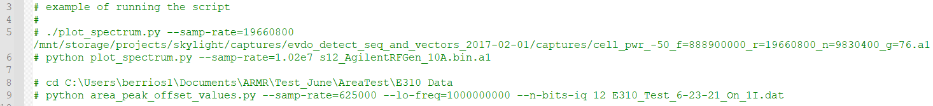

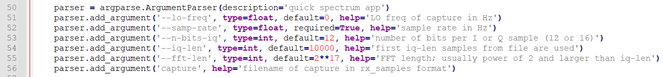

plot_spectrum.py