**How to easily deploy our website online ?**

**Step 1: Finish your code**

Finish your index.html file

**Step 2: Sign up an account**

Go to netlify website:

[https://www.netlify.com](https://www.netlify.com/)

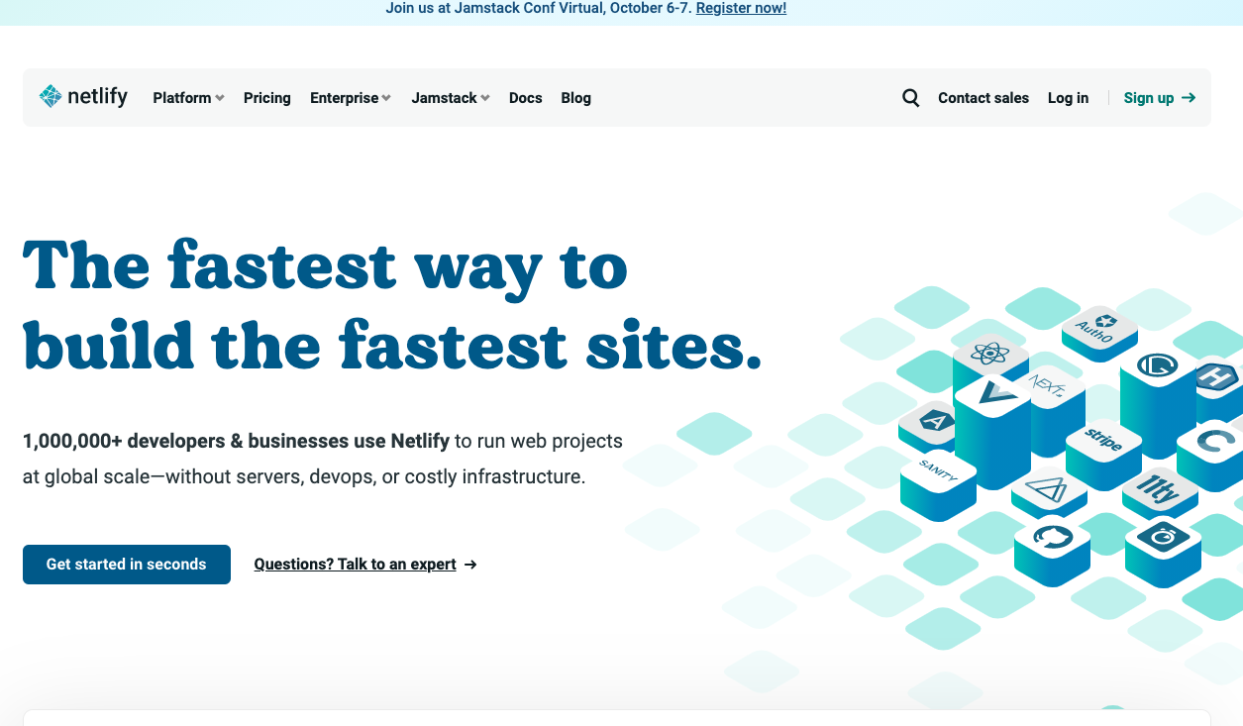

Go to sign up an account



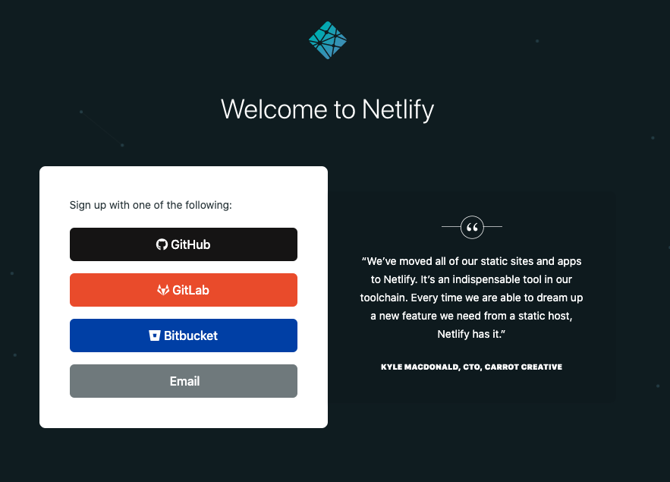

Click email:

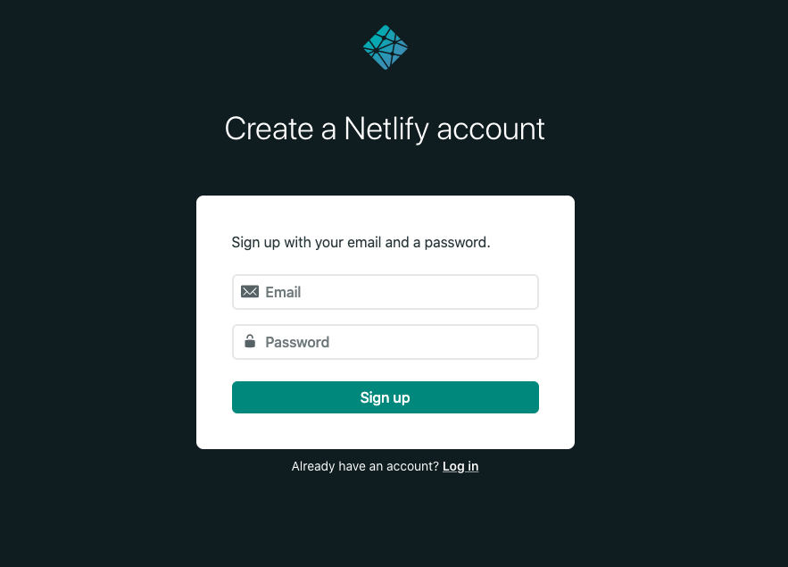

Create your account by input email and password



Check your email inbox and verify your email

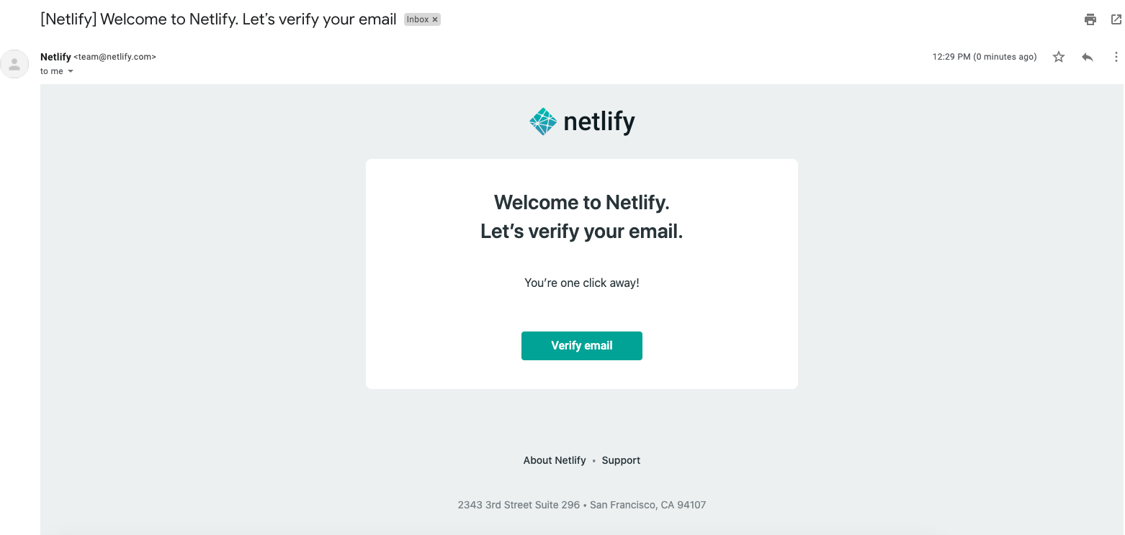

**Step 3: Deployment**

Go back to netlify website:

[https://www.netlify.com](https://www.netlify.com/)



Log in, then

Drag the folder in your local disk containing index.html and other files into the website blank area.

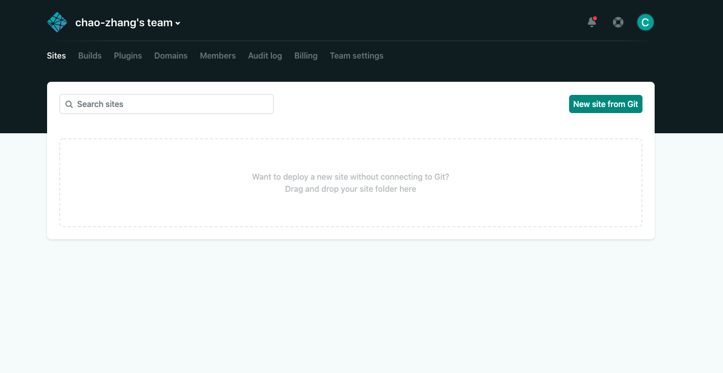

Deploy successfully !

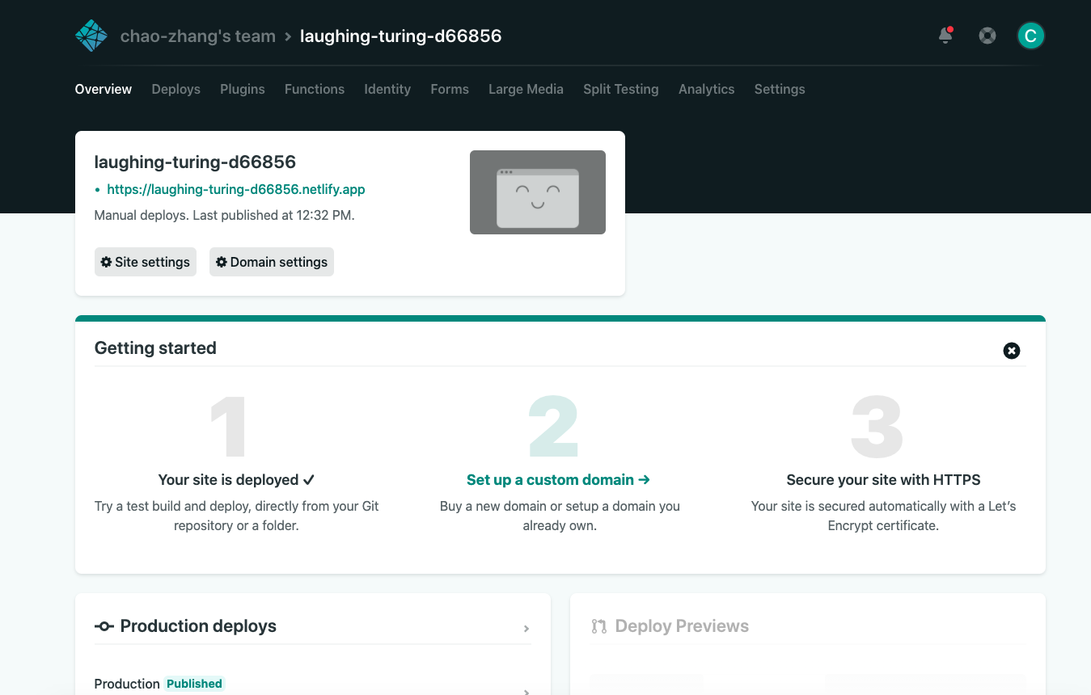

The green link is your website url. You can share the link with others.

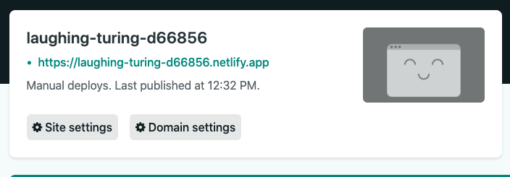

**Step 4: Change the site name**

Click the site settings

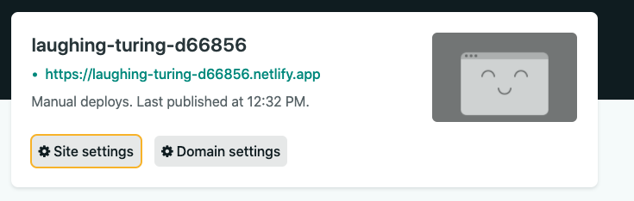

Click change site name:

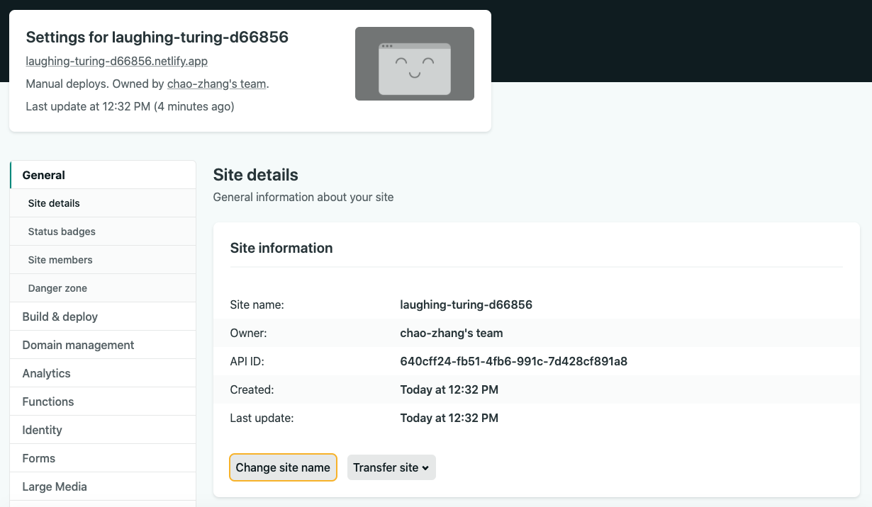

Change your site name and save it.

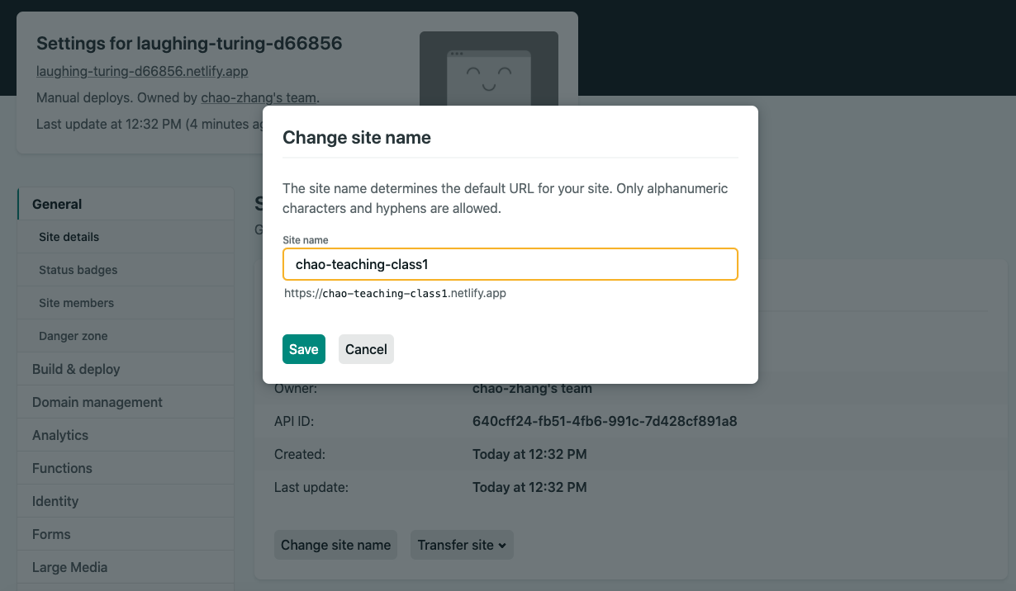

Now it is your new site name.

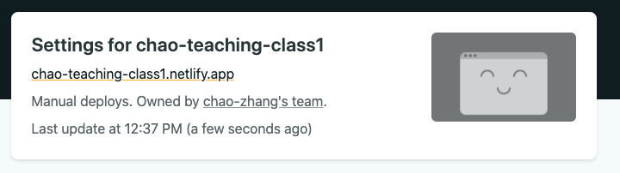

Notes: your site name must end with .netlify.app because you use free domain name provided by netlify service. If you want to use your own designed site name, please check the section: [costume domain name].