Parallel Programming

CS575

Chao Zhang

Project #0

1. Source listings

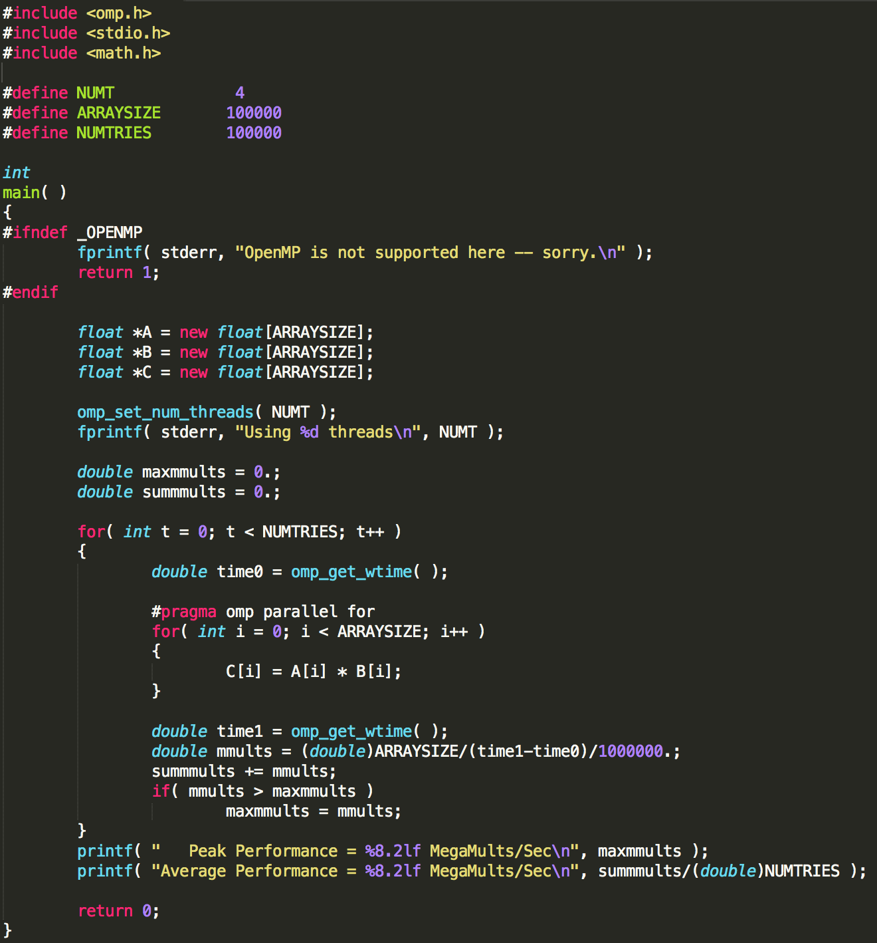

I give the array size as 100000 and it will loop 100000 times. The function double time1 = omp_get_wtime() will gives me the wall clock time in second.

1. Results

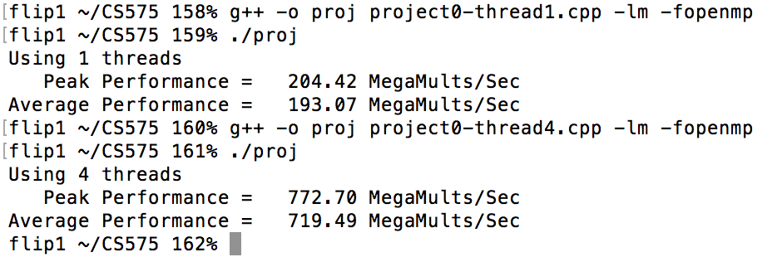

This result I got was running on the flip server. It is the Linux system. From the result, I can see that the speed of 4 thread is almost 4 times than 1 thread. The 1 thread time is 204.42 MegaMults/Sec and the 4 thread time is 772.70. The reason of this is because the thread of 4 is 4 times than 1 thread, so the speed should be near the 4 times. For each result of the 1 and 4 thread, the peak performance is near the average performance. So the timing can be considered as reliable.