DOCKPROOF
Evidence-First AI Receiving Manager
CUBE Buildathon • Round 2 • RCV
Design principle
AI observes. Rules decide. Evidence proves. Uncertainty is a valid result.

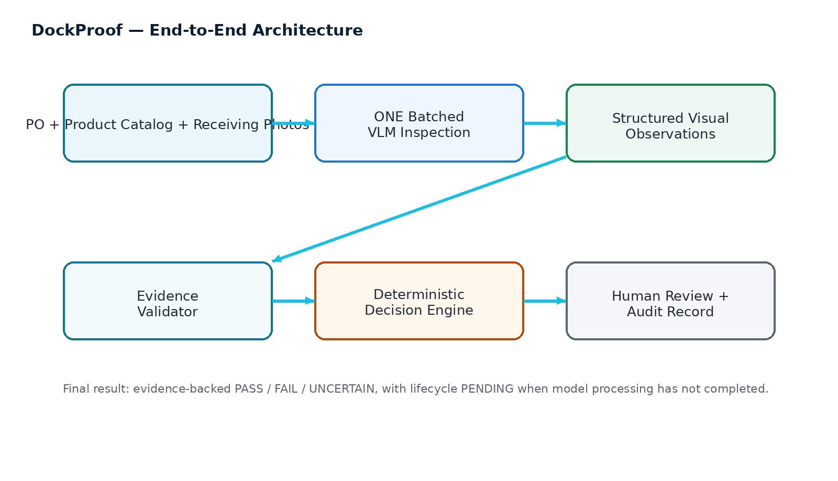
Master implementation specification for Codex, Cursor, Antigravity and other AI coding agents

1. Source of Truth and Document Purpose
This document is the implementation source of truth for DockProof, a production-oriented Receiving Manager for the CUBE Buildathon. It was restructured from scratch using the official Participant Handbook, the assigned RCV repository, and the organizer-provided receiving_sample.csv. External technical references are included only where they support implementation choices.
Authority hierarchy
1) CUBE handbook + selected track statement → 2) assigned RCV repository and RULES.md → 3) organizer sample dataset schema → 4) external technical research → 5) implementation inference. When sources conflict, preserve the organizer source and raise a finding rather than silently rewriting it.

1.1 Reviewed organizer assets
- Participant Handbook — Round 2 rules, 100-point rubric, evidence contract, held-out evaluation guidance, submission requirements and Round 3 integration expectations.
- Assigned repository — chapalaumesh209/cube26-rcv-0068-chapalaumesh209; README.md, RULES.md, GITHUB-GUIDE.md and data/README.md.
- receiving_sample.csv — 100 synthetic reference rows used to design the application schema and workflow. It is not the visual image dataset and is not ground truth for model training.
- External research — Kaputt, Amazon Berkeley Objects (ABO), RPC, Gemini multimodal/structured-output documentation, and OWASP LLM security guidance.

1.2 What this document does not assume
- No camera hardware, IoT device, barcode scanner or warehouse automation hardware is required for Round 2.
- The repository does not ship the actual receiving photographs; photo_refs are placeholders.
- The 100-row sample CSV is synthetic and must not be treated as real Amazon rules, fees or visual ground truth.
- The system does not claim that a VLM can perfectly recognize every long-tail SKU; it must measure performance and return UNCERTAIN when evidence is insufficient.
- The application does not solve the other four Managers in Round 2; it only exposes a clean evidence contract for future Pod integration.

1.3 Product statement
DockProof
A software-only receiving inspection agent that combines purchase-order facts, catalogue references and receiving photographs to determine what arrived, what is wrong, what is uncertain, and what evidence supports the result.

2. CUBE Requirements and Score Alignment
The handbook makes five scoring areas explicit. The system is designed backwards from those criteria so the product is measurable and defensible instead of merely visually impressive.
Criterion | Points | Implementation response
Problem Understanding & Solution Relevance | 15 | Explicit receiving workflow, assumptions, operator roles, problem boundaries, operational rationale.
Agent Functionality & Decision Quality | 25 | All RCV checks, multimodal ingestion, structured outputs, edge cases, deterministic final decision.
Evaluation, Accuracy & Uncertainty Handling | 25 | 50 unseen units where applicable, two human labels, per-check metrics, FP/FN, UNCERTAIN rate, failure modes.
Evidence, Traceability & Engineering Quality | 20 | Fixed evidence contract, image regions, model/version, timestamps, latency, overrides, content hash, RLS, fail-open path.
UX, Demo & Documentation | 15 | Operator-first UI, input→decision→evidence flow, deployment, README, ARCHITECTURE.md, demo and LinkedIn submission artifacts.

2.1 Non-negotiable organizer engineering rules
1. Tenant isolation first — every table must be scoped to organization; test both data rows and image access.
2. One model call per unit — batch all visual checks in one multimodal inference request.
3. Fail open — persist the receipt even if model inference fails or times out; mark the inspection pending and keep the operator moving.
4. UNCERTAIN is first-class — never turn insufficient evidence into PASS.
5. Use authoritative rules — do not let the model invent external operational requirements; for RCV, facts are primarily PO/catalogue facts and visual evidence.
Build rule
Do not optimize for an attractive green PASS screen. Optimize for a defensible chain: expected state → observed state → evidence → check verdict → overall outcome → human action.

3. Product Definition

3.1 Primary users
Role | Purpose | Permissions
Receiving Operator | Capture/inspect a shipment and resolve exceptions | Create shipments, upload photos, start inspections, view results, accept or request review.
Receiving Lead / Reviewer | Handle ambiguous or high-risk cases | All operator actions plus override, adjudication, evidence correction with audit trail.
Operations Admin | Manage tenant data and configuration | Manage users/roles, catalogue, organization settings, policies and integrations.
Evaluator / Demo User | Inspect product behavior without operational mutations | Read-only access to seeded demo and evaluation views.
System Worker | Run asynchronous inspection jobs | No interactive login; service identity only, scoped to job execution.

3.2 Core jobs to be done
- Verify whether inbound goods match the purchase order.
- Quantify what is visibly present and distinguish shortage/overage from incomplete visual evidence.
- Verify colour/variant without collapsing “same family” and “same SKU” into one concept.
- Detect visible carton and unit damage, with image-grounded evidence.
- Verify components only where their presence or absence is visually supportable.
- Create a durable evidence record that can later be consumed by Prep and Recovery in Round 3.

3.3 Explicit non-goals
- No autonomous supplier claims or financial recovery in Round 2.
- No WMS/ERP integration required for the core submission.
- No physical conveyor/camera/robotics integration.
- No fine-tuning pipeline required for the MVP.
- No hidden inference about obscured units or components.

4. Operational Workflow
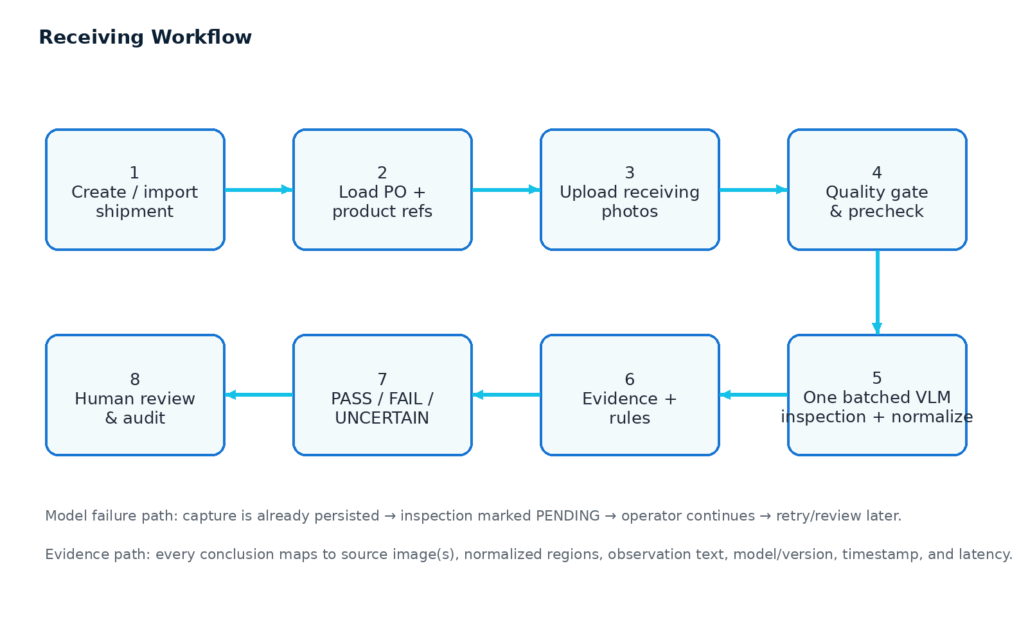

4.1 End-to-end flow
1. Create/import shipment — operator selects an existing PO or imports a structured receiving record.
2. Resolve expected state — system assembles PO line, SKU, product title, expected quantity, carton structure, variant/colour and required components.
3. Capture evidence — operator uploads one or more receiving photographs; the system validates file type, size, readability and tenancy.
4. Run a single batched inspection — VLM analyzes all supplied images against the expected state and catalogue references; its output is immediately normalized into schema-validated facts.
5. Apply deterministic rules — quantity and carton math, variant matching thresholds, evidence sufficiency gates and overall decision are computed in application code.
6. Review when needed — UNCERTAIN, high-risk or failed checks can be accepted, resolved or overridden by an authorized human.
7. Persist and publish evidence — inspection record, evidence references, model metadata, content hash and overrides are retained, and the stable versioned evidence record is exposed to downstream Round-3 agents.

5. Canonical Data Architecture

5.1 Organizer CSV is the starting schema
The organizer-provided receiving_sample.csv contains 100 synthetic rows and 25 columns. The application should preserve these meanings rather than inventing a disconnected internal record model. Operational tables can normalize the data, but the imported source mapping must remain explicit.
CSV field | Application meaning | Required? | Primary use
record_id | RCV inspection record identifier | Yes | Audit and evidence contract
unit_id | Cross-manager unit identity | Yes | Round-3 join key
org_id | Tenant identifier | Yes | RLS / authorization
po_number / po_line | Expected purchase-order line | Yes | Expected state
supplier | Supplier name | Yes | Operational context
sku / asin / product_title | Expected product identity | Yes | Identity check
spec_colour | Expected colour | No | Variant check
spec_variant | Expected variant | No | Variant check
spec_components | Required components | No | Completeness check
cartons_ordered / cartons_received | Carton expectation vs observation | Yes | Carton reconciliation
units_per_carton_ordered / units_per_carton_counted | Pack structure | Yes | Units/carton check
qty_ordered / qty_received | Total quantity | Yes | Quantity check
identity_match | Synthetic/reference identity state | Yes | Baseline fixture / eval mapping
carton_damage | Carton damage label | Yes | Damage fixture / eval mapping
unit_damage | Unit damage label | Yes | Damage fixture / eval mapping
quality_flags | Quality exceptions | No | Variant/components/defect mapping
photo_refs | Receiving image references | No | Image ingestion
operator_id | Actor label | Yes | Audit
captured_at | Capture timestamp | Yes | Audit / traceability

5.2 Data model
Entity | Core fields | Notes
organizations | id, name, status, created_at | Tenant boundary; RLS enabled and forced.
users | id, organization_id, email, role, status | Role-based access.
products | id, organization_id, sku, asin, title, variant, colour, components_json | Product catalogue in tenant scope.
product_references | id, product_id, image_object_key, source, checksum | Reference images for visual matching.
purchase_orders | id, organization_id, po_number, supplier, status | Expected state.
purchase_order_lines | id, po_id, sku, expected_qty, cartons, units_per_carton, spec_json | One or more SKU lines.
shipments | id, organization_id, shipment_ref, po_id, status | Receiving event container.
units | id, shipment_id, unit_id, sku, status | Cross-manager unit identity.
receiving_images | id, organization_id, shipment_id, unit_id, object_key, sha256, mime, width, height, captured_at | Private image asset metadata.
inspections | id, organization_id, unit_id, status, overall_verdict, started_at, completed_at, model_version | Inspection lifecycle.
inspection_checks | id, inspection_id, check_key, verdict, confidence, detail_json, latency_ms, model_version | Per-check evidence and outcome.
evidence_items | id, inspection_id, image_id, region, observation, source_type | Traceability layer.
overrides | id, inspection_id, actor_id, original_verdict, new_verdict, reason, created_at | Never overwrite history.
audit_events | id, organization_id, actor_id, event_type, object_type, object_id, payload_hash, created_at | Security and operational audit.
eval_cases | id, suite_version, unit_id, inputs, gold_labels, agent_output | Held-out evaluation.

6. Authentication, Authorization and Tenant Isolation

6.1 Login model
- Email + password or an OAuth/OIDC provider may be used. The build should prefer a managed identity provider rather than custom password handling.
- Every authenticated session resolves to exactly one user and one organization.
- The backend must derive organization_id from the authenticated session/claims, never from a client-supplied hidden field.
- Unverified/inactive users must not access operational data.
- Role is checked server-side for every mutation; UI hiding is not a security control.

6.2 Login flow
Browser
-> Auth provider login
-> access/ID token established
-> backend session validation
-> resolve user + organization_id + role
-> load tenant-scoped dashboard

6.3 Logout
1. User selects profile menu → Sign out.
2. Client clears local session state and redirects to /login.
3. Server-side session/cookie is invalidated where applicable.
4. Long-lived refresh tokens are revoked or rotated according to the identity provider.
5. Pending asynchronous jobs are not deleted; they continue under the service identity and remain associated with the original tenant.

6.4 Authorization matrix
Capability | Operator | Reviewer | Admin | Evaluator
View own tenant receiving records | Yes | Yes | Yes | Read-only demo
Create/import PO/shipment | Yes | Yes | Yes | No
Upload receiving images | Yes | Yes | Yes | No
Run inspection | Yes | Yes | Yes | Demo only
Accept AI decision | Yes | Yes | Yes | No
Override decision | No | Yes | Yes | No
Edit catalogue | No | Limited | Yes | No
Run evaluation suite | No | Yes | Yes | Read-only results
Manage users | No | No | Yes | No
View other organization | Never | Never | Never | Never

Tenant isolation test
Seed org_demo_alpha and org_demo_bravo. A user from Alpha must see zero Bravo rows and receive no image bytes even when guessing a Bravo object key.

7. Receiving Input and Ingestion

7.1 Input modes
Mode | Input | Use
PO selection | Existing PO number + line | Recommended production path
Structured import | CSV/JSON matching internal schema | Fast demo and batch onboarding
Photo upload | JPEG/PNG/WebP receiving image(s) | Vision evidence
Fixture playback | Pre-linked test scenario | Evaluation/demo only

7.2 Image ingestion rules
- Accept only approved image MIME types; reject executable or double-extension files.
- Enforce maximum size and pixel dimensions at the API boundary.
- Compute SHA-256 at ingestion and persist it as content_hash/image checksum.
- Store images privately under a tenant-scoped object key; use short-lived signed URLs for viewing.
- Generate a perceptual hash only as a duplicate hint; it is not a security boundary.
- Persist upload metadata before invoking the model.
- Run an image-quality precheck for severe blur, extreme darkness, invalid orientation and insufficient resolution.
- Do not automatically delete the original image after processing.

7.3 Image-quality gate
Signal | PASS | UNCERTAIN / REVIEW
Resolution | Enough pixels to inspect product/label/defect | Too small to establish the requested check
Exposure | Details visible | Major clipping or extreme darkness
Blur | Edges/details readable | Motion blur hides identity/damage
Occlusion | Relevant surfaces visible | Required units/components hidden
Coverage | All referenced cartons/areas represented | One or more expected evidence views absent

8. AI/VLM Inspection Architecture
The organizer rule is one model call per unit carrying all checks. The implementation therefore uses one multimodal observation call followed by deterministic adjudication.

8.1 One batched call
INPUT
- PO line / expected state
- Relevant product metadata
- Top-K catalogue/reference candidates
- All receiving images for the unit
ONE VLM CALL
- identity observation
- quantity observation
- carton count
- units/carton observation
- colour / variant observation
- carton damage
- unit damage
- component visibility / presence
- evidence regions
- uncertainty reasons
OUTPUT
Schema-validated JSON only

8.2 Model responsibilities vs application responsibilities
Component | AI/VLM does | Application does
Identity | Describe observed product/label cues; compare with references | Resolve catalogue candidates, enforce SKU rules, compute final match status
Quantity | Identify visible units/pack counts; state occlusion | Compare expected vs confirmed, apply visible-vs-total logic
Cartons | Count visible cartons; describe damage | Compare expected/observed carton counts
Variant | Read visible colour/variant cues | Match against expected attributes and catalogue
Damage | Describe visible crush/water/tear/defect regions | Map observations to verdict, preserve evidence
Components | Report visibly present/absent components and occlusion | Decide PASS/FAIL/UNCERTAIN based on visibility
Overall | Never own final business verdict | Deterministic decision engine owns final outcome

8.3 Structured output schema
{
"unit_id": "UNIT-0042",
"observations": {
"identity": {...},
"quantity": {...},
"cartons": {...},
"units_per_carton": {...},
"variant": {...},
"carton_damage": {...},
"unit_damage": {...},
"components": {...}
},
"evidence": [ ... ],
"quality": {"image_quality":"good", "occluded":true},
"model_metadata": {"model_version":"..."}
}

8.4 Prompting policy
- Tell the model to report only visible/explicitly provided evidence.
- Do not ask it to infer hidden inventory or assume unseen components are absent.
- Require a reason whenever a check is UNCERTAIN.
- Require image identifiers and normalized regions for visual findings.
- Use enumerated verdicts and JSON schema; reject schema-invalid responses.
- Keep system instructions free of secrets, privileged role data or tenant internals.
Google Gemini image understanding documentation — https://ai.google.dev/gemini-api/docs/image-understanding
Current documentation describes image input, object detection/segmentation and structured JSON responses.
Google Gemini structured outputs — https://ai.google.dev/gemini-api/docs/structured-output
Use JSON Schema/Pydantic/Zod for predictable output; validate semantics in application code.

9. Product / SKU / Variant Matching

9.1 Reference hierarchy
1. Exact identifier evidence — barcode/label text, if readable and explicitly present.
2. Catalogue metadata — SKU, ASIN, product title, variant and colour constraints.
3. Reference imagery — visual comparison against known catalogue images.
4. Top-K retrieval — retrieve a small candidate set before the batched VLM call; do not send the entire catalogue.
5. Human review — required when candidates are visually similar and evidence does not separate them reliably.

9.2 Matching states
State | Meaning | Action
PASS | Evidence supports the expected SKU/variant | Continue
FAIL | Evidence supports a mismatch | Exception
UNCERTAIN | Evidence cannot reliably separate candidates | Review / request more evidence
PENDING | Inspection not completed | Operator continues; retry later

9.3 Variant logic
- Do not equate “similar appearance” with exact variant match.
- Colour and variant are separate checks when the PO specifies both.
- If a variant attribute is not visible and no explicit structured evidence is provided, return UNCERTAIN.
- If the product family is correct but the ordered colour/size/model is wrong, identity can PASS while variant FAILS.
Guardrail
The model can propose candidates. Only the application can declare that a received SKU is the exact SKU ordered.

10. Quantity, Carton Count and Units-per-Carton Logic
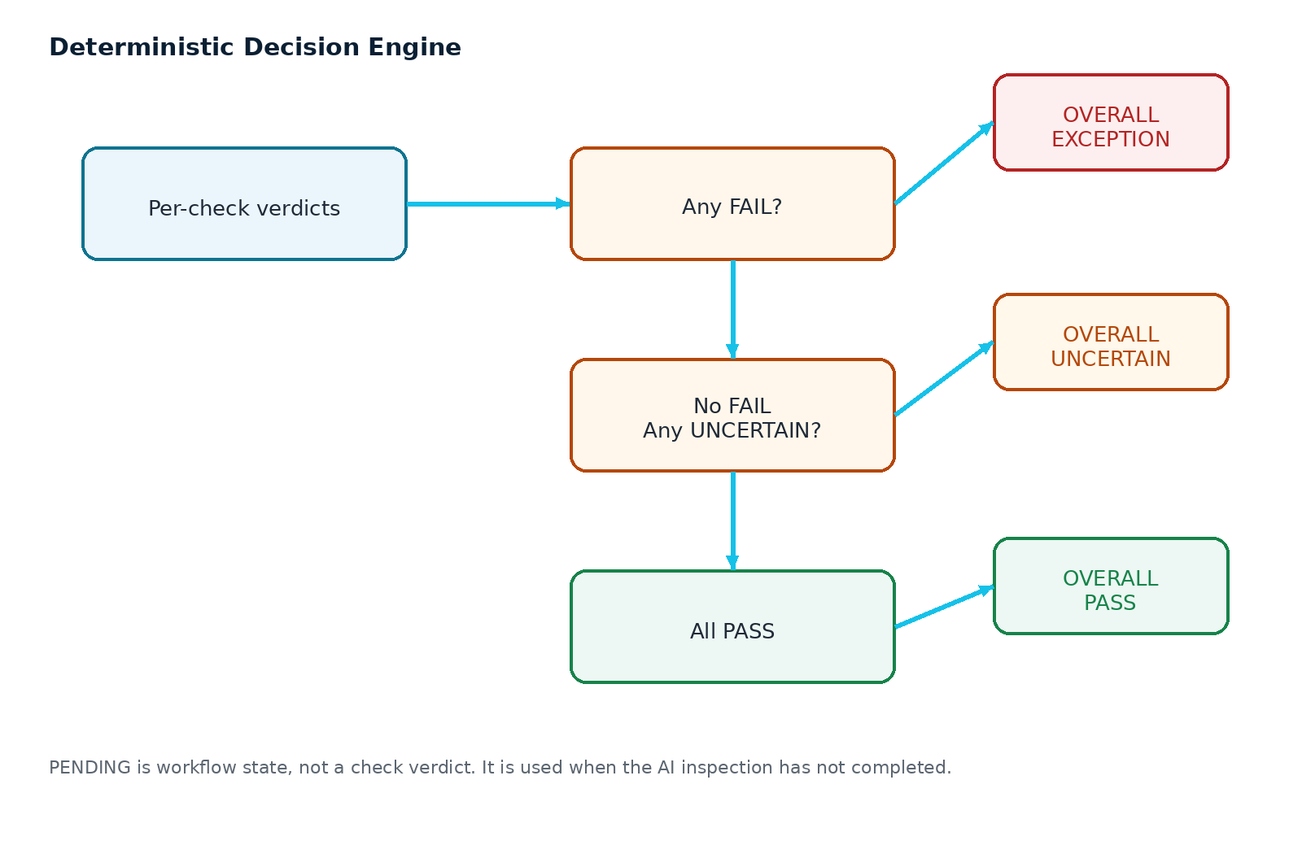

10.1 Quantitative reconciliation
expected_total = sum(po_line.expected_qty)
observed_total = confirmed_visible_units + explicitly_verified_hidden_units
quantity_delta = observed_total - expected_total
carton_delta = cartons_received - cartons_ordered
unit_per_carton_delta = units_per_carton_counted - units_per_carton_ordered

10.2 Visibility rule
- Visible count is not automatically total count.
- When cartons are closed and internal units cannot be seen, count cartons and use documented pack structure only if the structure is explicitly provided and the workflow permits it.
- If the model cannot establish whether hidden units exist, the affected quantity check is UNCERTAIN.
- Never subtract/assume hidden items merely because the model cannot see them.
- The provided organizer sample contains quantity mismatches but no received>ordered overage rows; therefore an explicit overage fixture must be added to the independent evaluation set.

10.3 Overall quantity decision examples
Expected | Visible/verified | Condition | Verdict
24 | 24 | All required areas visible | PASS
24 | 22 | Two units clearly missing | FAIL
24 | 26 | Two extra units clearly visible | FAIL
24 | 18 | Six units may be hidden by occlusion | UNCERTAIN
24 | 22 | Image quality too poor to establish exact count | UNCERTAIN

11. Damage and Quality Inspection

11.1 Required damage categories
Check | Examples of visible evidence | Verdict principle
Crushing | Collapsed corner, deformation, compression | FAIL only when the image supports visible damage
Water damage | Visible wetting, water staining, leakage, swelling | FAIL only for visible water-related evidence
Tears | Rips, open seams, punctures, torn packaging | FAIL only when visible
Other obvious defects | Broken/open/visibly defective item | FAIL if defect is clear and within scope
Ambiguous condition | Insufficient view, blur, occlusion | UNCERTAIN

11.2 Evidence requirements for damage
- Each visual damage finding should reference one or more source image IDs.
- Store a normalized region or bounding box whenever the model can provide it.
- Store an observation phrase describing what is actually visible, not a causal story.
- Do not claim severity, root cause or supplier fault unless such facts are separately supplied by structured evidence.

11.3 Public development data
- Kaputt — highly relevant retail-logistics defect benchmark for development/evaluation of visual defect capabilities. Its published benchmark includes 238,421 images, 48,376 unique items and 29,316 defective instances.
- ABO — catalogue/reference imagery and metadata for product identification.
- RPC — multi-product retail scenes useful for detection/counting development.
Dataset licensing and terms must be checked before any production/commercial use. For the hackathon, document external datasets as development/evaluation inputs, not as a blanket production data license.

12. Missing Components Logic

12.1 Components are a visibility problem, not an inference problem
The system should reason from the component checklist supplied by the PO/catalogue. It must not assume that an item is absent merely because the component is not visible in one image.
Situation | Result | Why
Component compartment clearly visible and empty | FAIL | Absence is visually established.
Component visibly present | PASS | Presence is visually established.
Component area hidden/occluded | UNCERTAIN | Absence cannot be established.
Component requirement missing from expected state | UNCERTAIN / NOT_APPLICABLE | System lacks a defined expected component set.
Multiple views collectively establish absence | FAIL | Evidence may be sufficient across images.

Rule
A missing component claim must identify the visual evidence that establishes absence; “not seen” is not enough when the area is hidden.

13. PASS / FAIL / UNCERTAIN / PENDING Decision Engine

13.1 Status model
Layer | Values
Inspection lifecycle | pending, running, completed, failed_retryable
Check verdict | pass, fail, uncertain
Overall outcome | pass, exception, uncertain
Review state | not_required, pending_review, accepted, overridden

13.2 Overall decision rule
IF inspection is not complete:
overall = PENDING
ELSE IF any check.verdict == FAIL:
overall = EXCEPTION
ELSE IF any check.verdict == UNCERTAIN:
overall = UNCERTAIN
ELSE:
overall = PASS

13.3 No masked failures
- A single failed quantity, identity, variant, carton damage or component check prevents overall PASS.
- A single UNCERTAIN check prevents overall PASS unless the business rule explicitly marks that check not applicable; RCV should default to conservative handling.
- PENDING is not a final decision and must never be presented as PASS.

14. Evidence Contract and Auditability

14.1 Fixed evidence contract
{
"record_id": "RCV-...",
"schema_version": "rcv.v1",
"organization_id": "org_demo_alpha",
"client_id": "...",
"agent": {"name":"DockProof","version":"..."},
"subject": {"unit_id":"UNIT-...","sku":"..."},
"captured_at": "...",
"operator_label": "...",
"images": [ ... ],
"checks": [
{
"check_key":"quantity",
"verdict":"fail",
"confidence":0.94,
"detail":{...},
"model_version":"...",
"latency_ms":1234
}
],
"outcome": {
"decision":"exception",
"decided_by":"system",
"decided_at":"..."
},
"overrides": [ ... ],
"status":"completed",
"content_hash":"sha256:..."
}

14.2 Evidence quality rules
- Every important decision must be reproducible from stored expected state + observations + evidence references.
- Model version and latency are recorded per inspection/check.
- Overrides are additive audit rows, never destructive edits.
- Content hash proves integrity of the stored record bytes; do not describe it as immutable or blockchain-anchored unless such technology is actually implemented.
- Evidence image access must be authorization-checked independently of record visibility.

15. Human Review and Override

15.1 Review triggers
- Any UNCERTAIN check.
- High-impact FAIL such as identity mismatch.
- Low-quality photo or occlusion that prevents required inspection.
- Model error/timeout resulting in PENDING.
- Two competing catalogue candidates with small visual separation.

15.2 Review workflow
1. Reviewer opens inspection detail page.
2. System shows expected state, AI observations, evidence regions and original timestamps.
3. Reviewer selects accept/resolve/override.
4. Override requires a reason.
5. Original AI outcome remains unchanged in history.
6. New operator outcome is stored as a separate override event.
7. Final downstream record clearly exposes both AI and human decisions.
AI outcome: UNCERTAIN
Human action: OVERRIDE → PASS
Reason: "Second receiving image confirms the remaining units."
Audit history preserves both records.

16. Reliability, Fail-Open Behavior and Recovery
Failure | System behavior | Operator experience
VLM timeout | Persist capture; mark inspection pending; retry asynchronously | Can continue other receiving work
Malformed model JSON | Persist raw diagnostic metadata; do not consume invalid output; mark retryable | Sees “Inspection pending”
Catalogue unavailable | Use cached tenant catalogue snapshot if valid; otherwise mark identity pending/uncertain | Other checks may still complete if safe
Object storage read failure | Do not fabricate evidence; retain record and mark evidence unavailable | Review later
Database transient failure | Retry transaction; surface explicit error if persistence cannot be guaranteed | Never report success without persisted record
Unauthorized image request | Return 403/404 without revealing existence | No data leakage
Duplicate upload | Detect via checksum; link or reject according to policy | Avoid repeated model work

16.1 Queue model
POST /inspections
1. persist inspection(status=pending)
2. enqueue job
3. return inspection_id
worker
4. lock job
5. assemble all inputs
6. one VLM call
7. validate JSON
8. deterministic adjudication
9. write evidence/checks/outcome
10. mark completed

17. API Contracts
Method | Endpoint | Purpose
POST | /api/v1/auth/session | Resolve authenticated user/org context
GET | /api/v1/shipments | Tenant-scoped receiving inbox
POST | /api/v1/shipments | Create/import shipment
GET | /api/v1/shipments/{id} | Shipment detail
POST | /api/v1/shipments/{id}/images | Upload receiving image metadata + object
POST | /api/v1/inspections | Create inspection + enqueue AI job
GET | /api/v1/inspections/{id} | Inspection status/result
POST | /api/v1/inspections/{id}/review | Human review/override
GET | /api/v1/inspections/{id}/evidence | Evidence bundle
GET | /api/v1/catalog/products | Tenant catalogue
POST | /api/v1/catalog/import | Import catalogue
POST | /api/v1/evaluations/run | Run held-out suite
GET | /api/v1/evaluations/{id} | Evaluation result
GET | /api/v1/audit | Tenant-scoped audit log

17.1 API invariants
- Every route derives organization_id from authenticated context.
- Every object lookup checks tenant ownership before data is returned.
- No API accepts “org_id” from an untrusted browser as the authority.
- LLM output is never passed directly to SQL, shell commands, HTML or privileged actions without validation.
- All state transitions are server-authoritative.

18. UX / UI Specification

18.1 Navigation
Receiving
Shipments
Inspections
Review Queue
Evidence
Evaluation
Catalogue
Settings

18.2 Receiving inbox
UI block | Behavior
KPI strip | Awaiting review, Pass, Exceptions, Uncertain/Pending
Filter bar | Supplier, PO, SKU, date, status, reviewer
Shipment table | Shipment, supplier, PO, status, captured time, issue count
Quick actions | Open, review, retry pending, export evidence

18.3 Inspection detail page
- Left: expected PO state — SKU, title, colour, variant, quantity, cartons, units/carton, components.
- Center: receiving evidence gallery with zoom and evidence regions.
- Right: per-check verdicts with confidence and concise explanation.
- Bottom: evidence timeline, model metadata, latency, content hash and human actions.
- Primary action changes with status: Analyze, Review, Accept, Override, Retry.
UX principle
The first 10 seconds of the demo should answer: What was expected? What arrived? What failed? What evidence proves it? What should the operator do now?

19. Dataset Strategy and Evaluation Architecture

19.1 Organizer-provided dataset: what it is
The current receiving_sample.csv is a synthetic 100-row reference dataset. It provides the operational vocabulary and a useful spread of statuses, but it contains no actual receiving images. It should drive schema/UI fixtures, not model training ground truth.
Observed property | Current sample finding
Rows | 100
Columns | 25
Organizations | 2: org_demo_alpha / org_demo_bravo
Unique SKUs | 10
Purchase orders | 26
Suppliers | 3
Operators | 6
Identity match | 94 yes / 3 no / 3 uncertain
Carton damage | 74 none / 11 crushing / 6 tears / 4 water / 5 uncertain
Unit damage | 89 none / 3 crushing / 2 tears / 2 water / 4 uncertain
Quality flags | 90 empty; remaining include missing_components, obvious_defect, wrong_colour, wrong_variant and a combined wrong_colour;obvious_defect
Quantity mismatches | 15; current sample has shortages only
Received > ordered | 0 in current sample
Carton count mismatches | 7
Units/carton mismatches | 8

Critical dataset gap
The organizer sample does not provide actual photos and does not include a received>ordered overage row. We must add explicit overage and photo fixtures to the held-out evaluation design rather than pretending the CSV already covers them.

19.2 Public development datasets
Dataset | Use in DockProof | Caution
Kaputt | Retail-logistics defect development: crushing/deformation, spillage/water-like damage, tears/penetration and reference-based defect reasoning. | Check current access and license/terms before use outside research/hackathon.
Amazon Berkeley Objects (ABO) | Product catalogue/reference imagery and metadata for identity/variant matching. | Use only according to dataset license; current official page states CC BY 4.0.
RPC | Multi-product recognition/counting development. | Official page states CC BY-NC-SA 4.0; treat as research/development data.

Kaputt — Amazon Science — https://www.amazon.science/blog/novel-kaputt-dataset-sets-new-benchmark-for-large-scale-visual-defect-detection
Amazon Berkeley Objects — https://amazon-berkeley-objects.s3.amazonaws.com/index.html
Retail Product Checkout (RPC) — https://rpc-dataset.github.io/

20. 50-Unit Held-Out Evaluation Plan
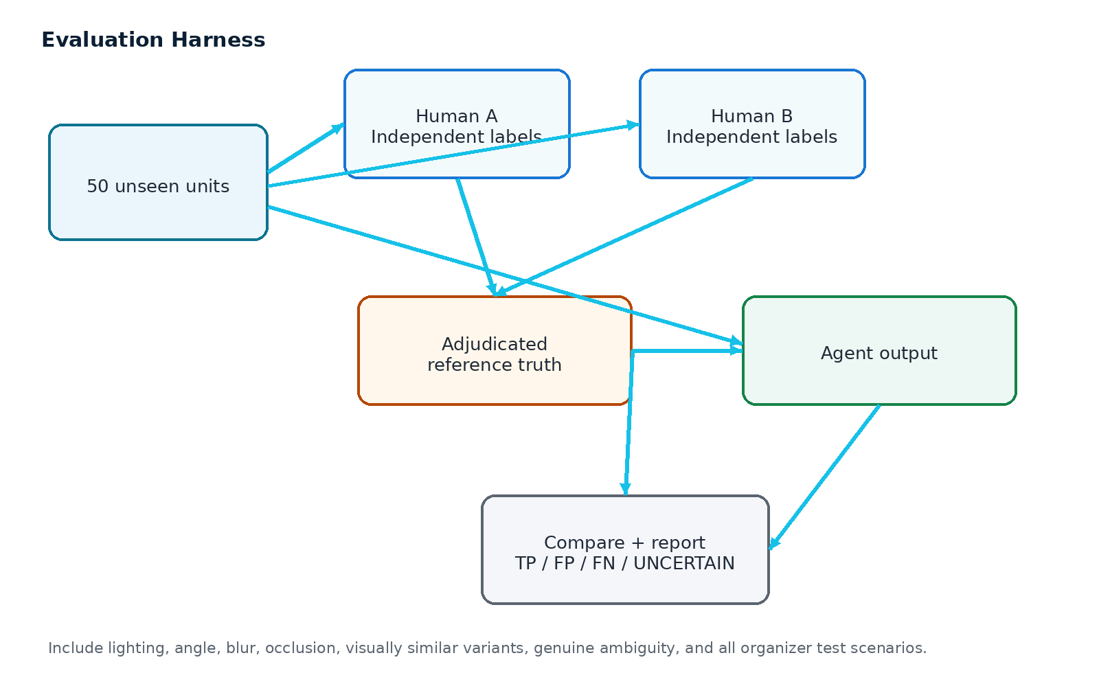

20.1 Unit selection
- At least 50 unseen units for the vision evaluation where applicable, as instructed by the handbook.
- No unit in the held-out set may have been used to tune thresholds or prompts after labeling is frozen.
- Balance the set across identity, quantity, variant, carton damage, unit damage, components and ambiguity.
- Include good/poor lighting, different angles, slight blur, occlusion and visually similar products.
- Include at least one explicit extra-units scenario, which the current sample CSV lacks.

20.2 Human labeling
1. Human A labels independently from the agent and without seeing Human B labels.
2. Human B labels independently using the same rubric.
3. Compute agreement such as Cohen’s kappa where applicable.
4. Adjudicate disagreements before agent predictions are compared to the final gold label.
5. Freeze gold labels and record labeler guidance/version.

20.3 Evaluation outputs
Metric | Why it matters
Per-check accuracy | Shows whether each required capability actually works.
Precision / false positives | Measures overcalling defects/mismatches.
Recall / false negatives | Measures missed discrepancies.
UNCERTAIN rate | Shows how often the system appropriately abstains.
Coverage | Shows how much of the test set receives a non-pending decision.
Latency / unit | Operational usability and cost signal.
Cost / unit | Model economics and future scale.
Failure modes | Explains where and why the system breaks.

21. Complete RCV Test Matrix
ID | Scenario | Expected checks | Expected overall | Primary evidence
RCV-01 | Correct shipment | Identity/qty/cartons/variant/damage/components all pass | PASS | Clear PO + complete photos
RCV-02 | Short shipment | Quantity fail; other checks may pass | EXCEPTION | Countable units / carton evidence
RCV-03 | Extra units | Quantity fail; extra units identified | EXCEPTION | Clearly visible overage
RCV-04 | Wrong SKU | Identity fail | EXCEPTION | Reference/candidate mismatch
RCV-05 | Wrong variant | Variant fail; identity may pass | EXCEPTION | Colour/size/model evidence
RCV-06 | Crushed carton | Carton damage fail | EXCEPTION | Highlighted crushed region
RCV-07 | Water-damaged carton | Carton damage fail | EXCEPTION | Visible staining/liquid evidence
RCV-08 | Torn packaging | Carton/unit damage fail as applicable | EXCEPTION | Visible tear/open seam
RCV-09 | Missing component | Fail only if absence established; otherwise uncertain | EXCEPTION or UNCERTAIN | Component area visible/occluded
RCV-10 | Ambiguous case | Affected checks uncertain | UNCERTAIN | Low-quality/occluded/visually similar case

21.1 Additional adversarial tests
- Two visually similar SKUs with near-identical packaging.
- Correct SKU label but wrong physical colour.
- Two cartons, one damaged and one clean.
- Closed carton where internal count is not visible.
- Open carton with partial occlusion.
- Duplicate photo upload.
- Image with severe blur.
- Model timeout after image upload.
- Model returns schema-valid but semantically impossible quantity.
- Cross-tenant attempt to access another organization’s image.

22. Automated Test and Evaluation Harness

22.1 Suggested structure
tests/
unit/
decision_engine.test.*
quantity_rules.test.*
evidence_schema.test.*
integration/
tenant_isolation.test.*
image_access.test.*
inspection_pipeline.test.*
evaluation/
heldout_50/
cases.json
labels_human_a.json
labels_human_b.json
adjudicated.json
predictions.json
report.json

22.2 Regression gates
- Every required RCV scenario has a fixture and expected state.
- Decision engine unit tests pass before UI deployment.
- Tenant isolation tests pass before release.
- No schema-invalid model output reaches the decision engine.
- A VLM timeout still leaves a persisted pending record.
- Override events preserve original AI outcomes.
- Held-out evaluation results are generated from code, not manually entered.

23. Security and AI Safety

23.1 Application security
- Use managed authentication; never store plaintext passwords.
- Use strict tenant-scoped queries and row-level security/authorization at the database layer.
- Store images privately and serve through signed, expiring URLs after authorization.
- Validate file type, size, and content before persistence.
- Use parameterized queries and ORM protections.
- Keep API keys only in environment variables/secrets manager; never commit .env.
- Rate-limit upload and model endpoints.
- Log security events without logging secrets or raw credentials.

23.2 LLM-specific safeguards
- Treat model output as untrusted input.
- Validate all output against JSON Schema and semantic constraints.
- Never pass model text directly into SQL, shell, URL fetchers or privileged actions.
- Keep secrets, role data and system prompts outside model-visible evidence unless required.
- Detect prompt injection in uploaded textual artifacts where relevant; treat external OCR/catalogue text as untrusted content.
OWASP Top 10 for LLM Applications 2025 — https://owasp.org/www-project-top-10-for-large-language-model-applications/assets/PDF/OWASP-Top-10-for-LLMs-v2025.pdf
Relevant guidance includes prompt injection, sensitive information disclosure, and improper output handling.

24. Observability and Production Telemetry
Metric | Definition | Target use
inspection_latency_ms | Upload-to-result latency | UX and capacity
vlm_latency_ms | Model call duration | Provider performance
vlm_error_rate | Timeout/error/schema-invalid rate | Reliability
uncertain_rate | Share of checks/units marked uncertain | Calibration
human_override_rate | Share of AI decisions overridden | Quality signal
false_negative_rate | Missed documented discrepancy rate | Safety/accuracy
false_positive_rate | Incorrect exception rate | Operator workload
cost_per_unit | Provider cost per inspection | Economic feasibility
image_quality_fail_rate | Inputs failing quality gate | Training/input improvement

24.1 Trace IDs
request_id → upload_id → inspection_id → model_call_id → evidence_id → audit_event_id

25. Deployment Architecture

25.1 Recommended stack
Layer | Recommended choice | Why
Frontend | Next.js + TypeScript + Tailwind | Fast, clean, deployable operator UI
Backend | FastAPI + Pydantic | Strong typed contracts and easy AI integration
Database | PostgreSQL | RLS, JSONB, reliable transactions
Object storage | S3-compatible private bucket | Scalable image storage + signed URLs
Queue | Managed queue / Redis-based worker | Fail-open async processing
VLM | Provider abstraction; Gemini or equivalent | Swap model without rewriting the application
Vector retrieval | pgvector or managed vector store | Product reference search
Observability | OpenTelemetry + structured logs | Latency/error tracing
Deployment | Vercel/managed frontend + managed backend/container runtime | Simple production-like deployment

25.2 Environment separation
Environment | Purpose
local | Development with synthetic fixtures
staging | End-to-end tests, deployment validation, evaluator rehearsal
production/demo | Public demo with rate limits and safe seed data

25.3 Secrets
- .env.example contains variable names only.
- .env remains gitignored.
- Deployment uses platform secret storage.
- Rotate a credential immediately if it is ever committed accidentally.

26. Repository Implementation Structure
cube26-rcv-0068-chapalaumesh209/
├── app/ # Next.js UI
│ ├── receiving/
│ ├── inspections/
│ ├── review/
│ ├── evidence/
│ └── evaluation/
├── backend/ # API + services
│ ├── api/
│ ├── auth/
│ ├── agents/
│ ├── rules/
│ ├── evidence/
│ ├── storage/
│ └── workers/
├── data/
│ ├── organizer/ # reference CSV/docs; do not alter official meaning
│ ├── fixtures/ # demo images/scenarios
│ └── eval/ # held-out data; keep isolated
├── tests/
│ ├── unit/
│ ├── integration/
│ ├── security/
│ └── evaluation/
├── docs/
│ ├── DATASET.md
│ ├── EVALUATION.md
│ └── MODEL_CARD.md
├── README.md
├── ARCHITECTURE.md
├── .env.example
└── docker-compose.yml

Repository rule
Do not rename or rewrite organizer-provided shared files to hide contradictions. Record a finding in GitHub when something is inconsistent.

27. Round-3 Integration Contract
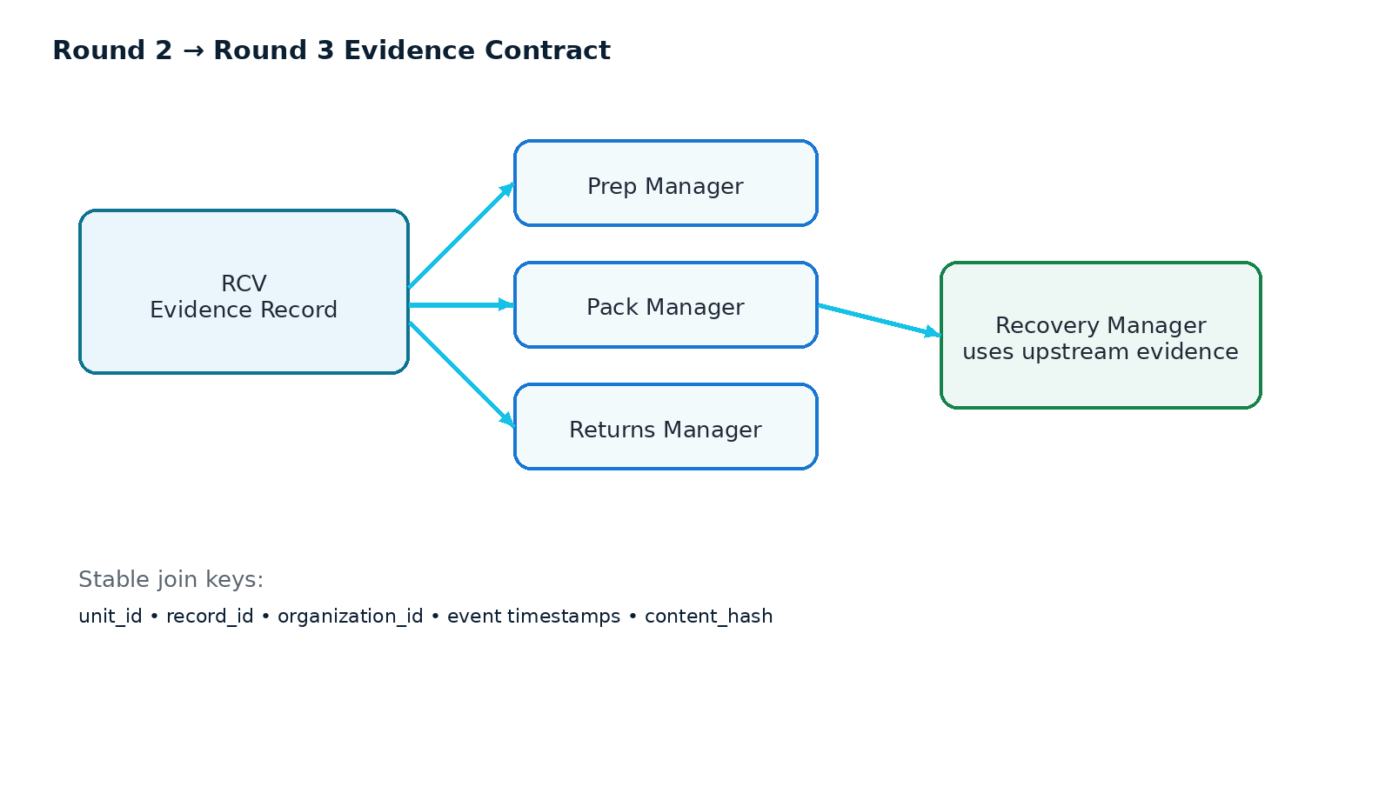

27.1 Stable identifiers
- unit_id is the cross-manager join key.
- record_id identifies the RCV evidence record.
- organization_id protects tenancy in the shared system.
- timestamps establish sequence across managers.
- content_hash identifies the exact evidence record payload.

27.2 Downstream consumers
Consumer | RCV provides
Prep Manager | What was received, identity, quantity, damage and component evidence before prep.
Pack Manager | Receiving baseline that can be compared to outbound discrepancies.
Returns Manager | Original condition evidence for later return investigations.
Recovery Manager | Supplier/inbound evidence that can support or contradict downstream financial events.

Round-3 principle
Expose a stable, versioned evidence record now. Do not make Round-3 agents scrape the RCV UI.

28. Documentation and Submission Package
Artifact | Required content | Acceptance check
README.md | Problem, solution, setup, usage, assumptions, limitations | Fresh clone can run using documented steps
ARCHITECTURE.md | Architecture, components, data flow, model usage, decisions | Matches actual implementation
Evaluation report | Methodology, 50-unit protocol, metrics, FP/FN, UNCERTAIN, failure modes | Numbers reproducible from code
Demo video | Problem setup, working agent, evidence, edge cases | Live working flow; not slides only
Deployment URL | Working public/allowed deployment where applicable | Opens and completes core flow
LinkedIn post URL | Track, problem, agent, meaningful technical result/learning, tags | Correct URL in submission form

28.1 Demo script
1. Start from a PO: show expected SKU, quantity, variant and cartons.
2. Upload receiving photographs.
3. Run inspection and show the one-call agent result.
4. Open evidence and show a successful finding.
5. Show a short shipment or extra-unit case.
6. Show wrong variant or wrong SKU.
7. Show visible crush/water/tear damage.
8. Show a missing-component ambiguity that correctly becomes UNCERTAIN.
9. Demonstrate human override and the preserved original AI outcome.
10. Finish on the evaluation dashboard with measured results and failure modes.

29. Master Prompt for Codex / Cursor / Antigravity
You are implementing DockProof, a production-oriented AI Receiving Manager for the CUBE Buildathon.
SOURCE OF TRUTH
1. Official CUBE Participant Handbook
2. Assigned repository README.md, RULES.md, GITHUB-GUIDE.md, data/README.md
3. Organizer receiving_sample.csv schema
4. This architecture specification
NON-NEGOTIABLE REQUIREMENTS
- Round 2 scope is Receiving Manager only.
- Multimodal inputs: PO/order data, product catalogue/reference images, receiving photographs.
- One VLM call per unit; batch all visual checks together.
- Final decisions are deterministic; the model provides observations, not the final business verdict.
- Check verdicts: PASS, FAIL, UNCERTAIN. Inspection lifecycle additionally uses PENDING.
- Overall decision: any FAIL => EXCEPTION; else any UNCERTAIN => UNCERTAIN; else PASS.
- Never infer hidden units/components.
- Every visual claim must cite source image(s) and region when possible.
- Persist evidence before AI processing; model failures/timeouts must not block the operator.
- Human overrides must preserve original AI decisions and reasons.
- Every table/query must be tenant-scoped; prove org_demo_alpha cannot access org_demo_bravo rows or images.
- No secrets in git.
REQUIRED CHECKS
1. SKU/product identity
2. expected vs observed quantity
3. carton count
4. units per carton
5. colour/variant
6. visible carton damage
7. visible unit damage
8. missing components where visually verifiable
INPUT MODEL
Use receiving_sample.csv as the organizer schema reference. Preserve record_id, unit_id, org_id, po_number, po_line, supplier, sku, asin, product_title, spec_colour, spec_variant, spec_components, cartons_ordered, cartons_received, units_per_carton_ordered, units_per_carton_counted, qty_ordered, qty_received, identity_match, carton_damage, unit_damage, quality_flags, photo_refs, operator_id, captured_at.
AI PIPELINE
- Build a tenant-scoped expected-state object.
- Retrieve a small set of catalogue/reference candidates.
- Build one multimodal prompt containing expected state + candidate metadata + all unit images.
- Require strict JSON schema output.
- Validate schema AND semantic bounds.
- Create evidence objects.
- Run deterministic decision engine.
- Save inspection result and audit metadata.
QUALITY GATES
- Reject invalid images.
- Detect severe blur/low light/occlusion.
- Use UNCERTAIN where evidence cannot support a reliable conclusion.
EVALUATION
- Support a 50-unit held-out suite.
- Human A and Human B label independently.
- Compute agreement, per-check accuracy, FP, FN, UNCERTAIN rate, latency/cost, and failure modes.
- Include all organizer scenarios plus explicit overage and adversarial cases.
UI
- Receiving inbox
- Shipment/inspection detail
- Evidence viewer
- Review/override queue
- Evaluation dashboard
- Catalogue management
DELIVERABLES
- Working application
- README.md
- ARCHITECTURE.md
- Evaluation report
- Tests
- Demo-ready seed data
- Deployment-ready configuration
IMPLEMENTATION BEHAVIOR
Before coding, inspect the current repository files and preserve organizer intent. Do not silently overwrite conflicting organizer data. Build incrementally: data contract → auth/RLS → ingestion → single VLM pipeline → decision engine → evidence → review → evaluation → UI polish → deployment. After each milestone run tests and verify the working flow.

30. Build Sequence and Definition of Done

30.1 Recommended implementation sequence
1. Phase 0 — Repository audit: inspect all starter files, confirm runtime, preserve organizer resources, create findings for contradictions.
2. Phase 1 — Data contract: map the CSV into typed domain models and seed two tenants.
3. Phase 2 — Auth/RLS: implement login, roles, tenant isolation and image authorization.
4. Phase 3 — Ingestion: PO/shipment creation + private image upload + quality gate.
5. Phase 4 — Agent: catalog retrieval + one batched VLM call + strict schema.
6. Phase 5 — Decision: quantity/carton math, identity/variant logic, damage/component verdicts, overall outcome.
7. Phase 6 — Evidence/review: evidence viewer, override, audit trail, content hash.
8. Phase 7 — Evaluation: 50-unit harness, dual human labels, metrics and failure reports.
9. Phase 8 — UX/demo: operator workflow, scenario launcher, clean loading/error states.
10. Phase 9 — Hardening: security tests, retry behavior, deployment, docs, final demo video.

30.2 Definition of done
Area | Done when
Functionality | All ten required RCV scenarios have working fixtures and expected outcomes.
Decision quality | Final status comes from deterministic rules and cannot mask FAIL/UNCERTAIN.
Evidence | Every important check can show what was expected, what was observed and the supporting evidence.
Uncertainty | Ambiguous cases visibly become UNCERTAIN and are not silently converted to PASS.
Reliability | VLM failures preserve data and mark work pending/retryable.
Security | RLS + image authorization isolation tests pass for both demo organizations.
Evaluation | 50 unseen units, dual human labels, agreement and per-check metrics are documented.
UX | Operator can understand and complete a receiving inspection without reading the docs.
Round 3 | Versioned evidence record can be exported/consumed programmatically.

31. Known Risks, Findings and Mitigations
Risk / finding | Impact | Mitigation
Long-tail SKU recognition may be weak | Identity/variant errors | Reference retrieval + top-K candidates + human review + report false negatives.
Visual count under occlusion | Quantity errors | Visible-vs-total distinction; UNCERTAIN when hidden units cannot be established.
Damage-like graphics vs actual damage | False positives | Use reference image, multiple views, evidence regions and human review.
Sample CSV has no images | Cannot directly test vision from organizer data | Add dedicated visual fixtures and held-out evaluation set.
Sample CSV has no overage rows | Extra-unit scenario missing from reference | Create explicit extra-unit fixture and test.
External dataset licensing | Legal/usage risk | Keep dataset use documented as research/hackathon; follow license/terms.
VLM provider outage | Operational interruption | Fail-open queue and pending state.
Model output hallucination | False evidence | Schema + semantic validation + evidence-only prompt + deterministic rules.
Tenant image leakage | Critical security issue | Private storage, tenant-scoped object keys, authorization checks and security tests.

32. References
CUBE Official Participant Handbook — Provided in conversation as “Cube Buildathon Official Participant Handbook.pdf”
Primary source for Round 2 rules, scoring, evidence contract, held-out evaluation, submission and Round-3 expectations.
Assigned RCV Repository — https://github.com/chapalaumesh209/cube26-rcv-0068-chapalaumesh209
Primary implementation source for the participant’s fork, repository rules, data schema and engineering constraints.
Kaputt dataset / Amazon Science — https://www.amazon.science/blog/novel-kaputt-dataset-sets-new-benchmark-for-large-scale-visual-defect-detection
Retail-logistics visual defect dataset and research context.
Amazon Berkeley Objects — https://amazon-berkeley-objects.s3.amazonaws.com/index.html
Product catalogue/reference imagery and metadata; official page lists dataset license information.
RPC dataset — https://rpc-dataset.github.io/
Retail product recognition/counting benchmark; official page lists dataset statistics and license.
Gemini image understanding — https://ai.google.dev/gemini-api/docs/image-understanding
Multimodal image analysis, detection/segmentation examples.
Gemini structured outputs — https://ai.google.dev/gemini-api/docs/structured-output
Structured JSON Schema output and semantic validation guidance.
OWASP Top 10 for LLM Applications 2025 — https://owasp.org/www-project-top-10-for-large-language-model-applications/assets/PDF/OWASP-Top-10-for-LLMs-v2025.pdf
Prompt injection, sensitive information disclosure and improper output handling guidance.

33. Final Build Checklist
☐ Official starter repository preserved; implementation lives in the participant fork.
☐ All code commits occur within the authorized Round 2 build period.
☐ No secrets in repository.
☐ Login/logout and roles work.
☐ Tenant isolation works for both demo organizations.
☐ Private image access is tenant-safe.
☐ Organizer CSV mapping is implemented.
☐ PO/catalogue/shipment/photo ingestion works.
☐ One VLM call per unit is enforced.
☐ All required RCV checks are implemented.
☐ PASS/FAIL/UNCERTAIN and PENDING are modeled separately.
☐ Overall PASS cannot mask FAIL or UNCERTAIN.
☐ Fail-open behavior is verified.
☐ Human overrides preserve original AI outcomes.
☐ Evidence contract is complete and versioned.
☐ 50-unit held-out evaluation is frozen and reproducible.
☐ False positives, false negatives, uncertainty and failure modes reported.
☐ All ten RCV scenarios demonstrated.
☐ Extra-unit test explicitly covered.
☐ A demo video shows the working system rather than slides only.
☐ README.md and ARCHITECTURE.md match the actual code.
☐ Deployment URL tested.
☐ LinkedIn post published with required tags and URL.
☐ Final submission form checked before 1 Oct 2026 6:00 PM IST.
Final principle
Build → Test → Measure → Document → Publish → Submit. The strongest RCV submission is not the biggest codebase; it is the most focused, measured and defensible operational system.

