CompTIA A+ – Assessment AP-A1
Hardware Components & System Assembly

Section A – Concept Application

S1 – Selecting Compatible Hardware
I choose the parts in a fixed order, because each part limits the next one.
- Requirements: an office PC runs Word, Excel, a browser and email, so it needs to be reliable and affordable, not very powerful.
- CPU first: I pick a CPU like Intel Core i5 or Ryzen 5 and note its socket (for example LGA1700).
- Motherboard: it must have the same socket, a chipset and BIOS that support that CPU, the right size for the case, the right RAM type, and M.2/SATA connectors.
- RAM: it must match the board (DDR4 or DDR5, they are not interchangeable). 16 GB in dual channel is good for office work.
- Storage: an NVMe SSD needs an M.2 slot, and a SATA SSD needs a SATA port. 256–512 GB is enough.
To confirm they work together I check:
- the CPU support list and minimum BIOS version on the motherboard maker’s website;
- the motherboard manual for memory type, speed and M.2 type, and the RAM QVL list;
- a compatibility tool such as PCPartPicker, and the physical fit in the case;
- after building, that POST and BIOS show the correct CPU, RAM and storage.

S2 – HDD, SSD and NVMe Storage
 | HDD | SATA SSD | NVMe SSD
Technology | Spinning magnetic disks | Flash memory | Flash memory
Interface | SATA | SATA | PCIe (M.2 slot)
Speed | 80–160 MB/s | Up to 550 MB/s | 2,000–7,000 MB/s
Durability | Moving parts, fragile | No moving parts | No moving parts
Cost per GB | Lowest | Medium | Medium
Recommendation: an NVMe SSD (256–512 GB) for office use, or a SATA SSD if the board has no free M.2 slot.
- Office programs do many small reads and writes, and SSDs respond much faster than HDDs, so Windows boots and programs open quickly.
- No moving parts means it is quieter, uses less power and is more reliable.
- NVMe needs no cables, and office users do not need big storage, so the extra cost per GB does not matter.

S3 – GPU and Cooling System
The GPU handles graphics work. In design software it draws the screen, applies effects and renders previews, so the CPU is free for other tasks. It also has its own video memory and drives the monitor.
Every part produces heat, and after several hours of work the heat builds up. If it is not removed, the CPU and GPU slow themselves down to protect themselves (thermal throttling). This causes lag, and in worse cases crashes or shutdowns, and shortens the life of the parts.
The cooling system (CPU heatsink and fan with thermal paste, GPU fans, and case fans with good airflow) removes this heat. A good GPU gives the performance and good cooling lets it keep that performance without throttling, so the system stays fast and stable.

S4 – Hardware Compatibility
Parts from different vendors only work together if they match in size, power needs, connection type and BIOS support. If they do not match, the PC may not start, may be unstable, or the parts may get damaged. Possible problems are:
- CPU socket does not match the motherboard, so the CPU cannot be installed (forcing it bends pins).
- BIOS too old for the CPU, so the PC turns on but there is no display.
- Wrong RAM type (DDR4 in a DDR5 board), so it does not fit or is not detected.
- Motherboard size does not fit the case or the standoffs, which can cause short circuits.
- Weak PSU or missing connectors, causing random shutdowns.
- GPU too long or CPU cooler too tall for the case.

S5 – PSU Selection and Pre-Power Checks
Choosing the PSU: I add up the power use of the CPU (about 117 W peak), the GPU (125 W) and the other parts (about 60 W), which gives about 300 W. I then add 30–50% extra headroom and check the GPU maker’s recommendation (450 W for a GTX 1660 Super). So a 550 W PSU is a good choice. It must also have the needed connectors (24-pin, 8-pin CPU, PCIe power, SATA power), an 80 PLUS rating and protections like over-voltage and short-circuit protection.
Checks before powering on:
- Keep the PSU switched off and unplugged while connecting cables, and use an ESD wrist strap.
- Connect the 24-pin ATX cable and the 8-pin CPU cable fully until they click.
- Connect the PCIe power cable to the GPU and SATA power to the drives. Connectors are keyed, so I never force them.
- Check that no cable touches a fan and there are no loose screws in the case.
- Check the front-panel, USB and fan headers, and that the monitor cable is in the GPU port.
- Then plug in the power cable, switch on the PSU and press the power button.

S6 – POST Verification
POST (Power-On Self-Test) is the hardware check done by the BIOS at start-up. It passes if:
- fans spin, LEDs light up and there are no error beeps or error LEDs;
- the monitor shows the logo or BIOS screen;
- in BIOS, the CPU model, RAM size and the storage device are shown correctly;
- the system then boots into Windows or the installer.
If it does not pass, I do this:
- Switch off, unplug and use ESD protection.
- Check the power cable, PSU switch and the 24-pin and 8-pin connectors.
- Note the beep code or debug LED and look it up in the manual.
- Reseat the RAM (one stick at a time) and the GPU.
- Try a minimal boot with only CPU, one RAM, GPU and PSU, then add parts back one by one.
- Check the CPU seating and BIOS support, clear the CMOS, and replace the faulty part if found.

Section B – Practical Tasks

Task 1 – Component Identification & Functions
Component | Function | Make / Specification
Motherboard | Main board that connects all parts and gives them power and data paths. | B660, micro-ATX, LGA1700
CPU | The brain of the PC; runs instructions and does calculations. | Intel Core i5-12400, 6 cores
RAM | Fast temporary memory for running programs; data is lost when power is off. | 16 GB DDR4-3200
GPU | Processes graphics and sends the picture to the monitor. | GTX 1660 Super, 6 GB
Storage | Stores the operating system, programs and files permanently. | 512 GB NVMe M.2 SSD
Cooling | Removes heat from CPU and GPU to stop overheating. | Heatsink + PWM fan, case fans

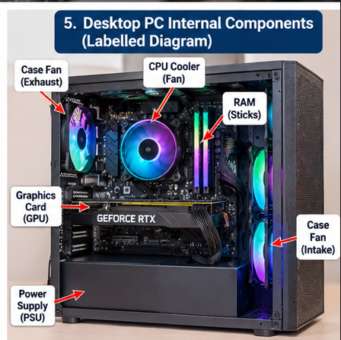

Task 2 – Motherboard Ports & Socket Identification
Ports and headers:
- SATA ports – connect SSDs, HDDs and optical drives.
- 24-pin ATX connector – main power. 8-pin connector – CPU power.
- CPU_FAN / SYS_FAN headers – power for the CPU cooler and case fans.
- USB 2.0 / USB 3.0 headers – front USB ports of the case.
- Front-panel header – power switch, reset switch and LEDs.
- HD audio header and rear I/O panel (USB, LAN, HDMI, audio).
Expansion slots:
- PCIe x16 – graphics card. PCIe x1 – Wi-Fi, sound or other small cards.
- M.2 – NVMe SSD. DIMM slots – RAM modules.
CPU socket: LGA1700. It supports Intel 12th Gen (Alder Lake) Core i3/i5/i7/i9, Pentium and Celeron CPUs, and 13th/14th Gen after a BIOS update. AMD CPUs do not fit this socket.

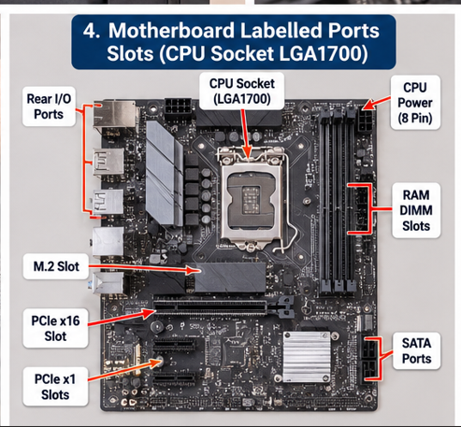

Task 3 – RAM & Storage Installation
ESD precautions: I shut down the PC, switched off the PSU and unplugged it, pressed the power button for 5 seconds to discharge, wore an anti-static wrist strap on bare metal, and held parts by their edges.
RAM:
- Push the clips on both ends of the slot outwards and pull the module straight out.
- Line up the notch of the module with the key in the slot.
- Press down evenly on both ends until both clips click.
- Check that the clips are locked and the module sits level.
Storage (NVMe M.2 connection):
- Remove the screw, then pull the SSD out of the slot at about 30°.
- Insert it back at about 30°, press it flat and fix it with the screw.
Detection check: BIOS shows 16 GB RAM and the SSD name and size; Task Manager shows the RAM total; Disk Management lists the SSD.
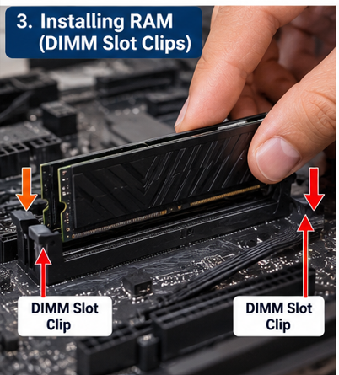

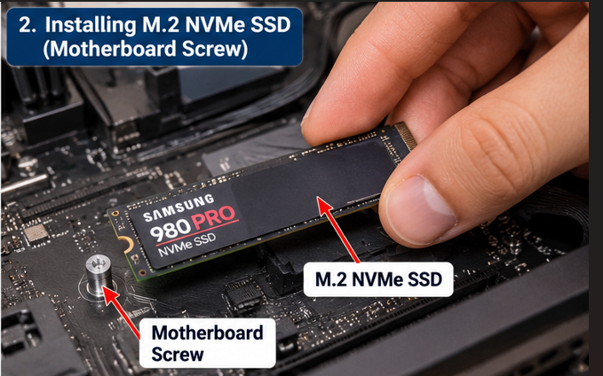

Task 4 – Full Desktop PC Assembly
I wore an ESD strap and kept the PSU unplugged during the whole build. Steps followed:
- Prepare the work area and tools.
- Install the CPU (match the triangle mark, lower the lever).
- Fit the CPU cooler with thermal paste and connect the CPU_FAN cable.
- Install the RAM.
- Install the M.2 SSD on the motherboard.
- Fit the I/O shield and standoffs and mount the motherboard in the case.
- Mount the PSU.
- Connect the 24-pin and 8-pin CPU power cables.
- Install the GPU and connect its PCIe power cable.
- Connect front-panel, USB, audio and fan cables.
- Tidy the cables and check for loose screws.
- Connect monitor, keyboard and power, then switch on.
Result: the fans spin, the display comes on, and BIOS shows the i5-12400, 16 GB RAM and the NVMe SSD with no errors, so the system passes POST.

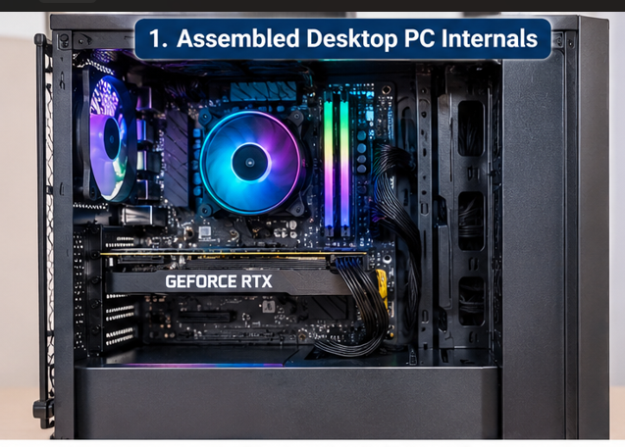

Section C – Mini Capstone Project

Workstation Deployment & Boot-Failure Diagnosis
ABC Solutions assembled several systems for a new lab. Some do not start and some show hardware detection errors. The system I inspected is the sample desktop listed at the start of this document.

1. Three Components to Check First
- PSU and power connections: if there are no fans or lights, the cause is usually power: switch off, loose cable, or the 24-pin or 8-pin connector not fully inserted. Nothing else works without power.
- RAM: badly seated RAM is the most common reason for a PC that powers on but does not show anything. It is also quick to reseat and test.
- CPU and motherboard: I check the CPU seating, the cooler, the BIOS support for the CPU and extra standoffs that could short the board. Storage is checked later because a missing drive does not stop POST.

2. Motherboard–CPU Compatibility
The CPU and motherboard must match in socket, chipset and BIOS support. In my system, the i5-12400 uses LGA1700 and the B660 board supports 12th Gen CPUs, so it works normally. If a 13th/14th Gen CPU were used with an old BIOS, the PC would turn on but not show anything. An AMD CPU would not even fit the socket. Such mismatches can explain the computers that fail to start in the ABC lab.

3. Verifying RAM and Storage
- Physically: RAM clips locked, M.2 SSD flat and screwed down, SATA cables firm.
- POST: no error beeps or LEDs and the BIOS screen appears.
- BIOS: total RAM is 16 GB at the right speed, and the SSD shows its model and size in the storage list and boot menu.
- Windows: Task Manager and Disk Management show the same, and a memory test shows no errors.

4. Hardware Installation Checklist
- Check compatibility before building (CPU socket and BIOS, RAM type, case size, PSU power).
- Use ESD protection and keep the PSU unplugged while working.
- Install CPU, cooler, RAM and M.2 SSD on the motherboard first, then mount it in the case.
- Press RAM until both clips click and screw the M.2 SSD down.
- Connect the 24-pin, 8-pin CPU and GPU power cables and the front-panel cables.
- Check for loose screws and cables touching fans.
- Power on and confirm POST and BIOS detection before installing Windows.

5. Why SSDs Instead of HDDs
In a lab, many users start and use office programs many times a day. An SSD has a response time of about 0.1 ms compared with 5–10 ms for an HDD, so PCs boot and open programs much faster. With no moving parts, SSDs fail less often, which means less downtime and fewer support calls. They also use less power, make no noise and produce less heat, which helps in a room full of PCs. Office files need little space, so a 256–512 GB SSD is enough and the higher cost per GB is acceptable.

Section D – AI-Augmented Learning

1. Prompt Given to the AI Tool
“I am a junior IT support technician. Create a step-by-step troubleshooting checklist for a desktop PC that fails to boot immediately after assembly. List the steps in the correct priority order, cover at least the motherboard, RAM, storage and PSU, and present it as a clear checklist that a technician can follow on-site. Then apply it to this scenario: ABC Solutions is setting up a new computer lab, and some computers fail to start while others show hardware detection errors. Show which step would have caught the problem.”

2. AI’s Original Checklist
- Check that the monitor is on and the cable is connected.
- Check the wall socket, power cable and PSU switch.
- Enter BIOS, reset to defaults and update the BIOS.
- Check the boot order and storage in BIOS; if no OS is found, reinstall the OS.
- Open the case and check the RAM is seated properly.
- Check the PSU cables (24-pin and 8-pin CPU).
- Check the storage connections (SATA or M.2).
- Check the motherboard for damage, loose screws or missing standoffs.
- Check the CPU and cooler seating.
- Replace parts one by one with known-good parts.
Applied to ABC Solutions: steps 2 and 6 would catch PCs that do not start, and steps 5 and 7 would catch the hardware detection errors.

3. My Corrected Checklist
- Safety: shut down, switch off the PSU, unplug, hold the power button 5 seconds, wear an ESD strap, open the case.
- Power and display: wall socket, power cable, PSU switch, and monitor connected to the GPU port.
- PSU cables: 24-pin, 8-pin CPU, GPU and SATA power fully inserted. Try a known-good PSU if available.
- Front-panel cable: power switch wires on the correct pins.
- Minimal boot: only CPU, cooler, one RAM, GPU and PSU connected.
- RAM: reseat, test each stick and slot, and check the beep code or debug LED.
- CPU and motherboard: CPU seating, standoffs, BIOS support for the CPU, clear CMOS.
- Storage: reseat the M.2 SSD or SATA cables and check it in BIOS.
- Software (last): boot order, then Windows install or repair. If it still fails, swap with known-good parts.
Applied to ABC Solutions:
- PCs that do not start at all: steps 2, 3 and 4 (power switch, loose 24-pin or 8-pin cable, front-panel wires).
- PCs that turn on but show nothing: steps 5, 6 and 7 (RAM, CPU or BIOS support).
- Hardware detection errors: steps 6 and 8 (RAM not seated, M.2 SSD loose or SATA cable loose).

4. Note on What I Changed
I added a safety step first because the AI told me to open the case with no ESD protection. I moved all physical checks (power, PSU cables, RAM, storage) before the BIOS and OS steps, since these cannot be reached if the PC does not POST. I also put the PSU check before RAM, added a minimal-boot step, and moved “reinstall the OS” to the end.

