Software Requirements Specification (SRS)
Drone Delivery Operations System (CLE_DDOS)
Simplified IEEE-Style SRS — 8-Week Agile Software Engineering Project
Project Information
Field | Value
Team Number | Team 1
Project Name | DroneDash CLE — Drone Delivery Operations System (CLE_DDOS)
Team Members | Software Engineering Project Team
Course / Section | Software Engineering (Fall 2026)
Instructor | Course Instructor
SRS Version | 1.0 (Release #1 Baseline)
Date | October 13, 2026

Revision History
Name | Date | Reason For Changes | Version
Project Team | October 07, 2026 | Initial requirements elicitation, domain analysis, and design baseline | 1.0

1. Introduction
This Software Requirements Specification (SRS) establishes the complete functional, behavioral, and quality requirements for the Drone Delivery Operations System (CLE_DDOS) developed for the DroneDash Cleveland Delivery Company. It serves as the authoritative technical contract between the client, development team, and course evaluators for Sprint 1 (Release #1) and provides the architectural foundation for subsequent development sprints.
1.1 Purpose
The purpose of this document is to specify the software requirements for modeling, managing, scheduling, and tracking autonomous commercial drone deliveries across the Cleveland metropolitan area. This specification is intended for the development team, project stakeholders, system architects, and course evaluators to guide implementation, verification, and sprint acceptance testing.
1.2 Scope
CLE_DDOS is a centralized logistics and fleet management platform. The system automates:
• Customer account and multi-address management.
• Package delivery order intake and validation.
• Multi-station drone fleet telemetry tracking and state management.
• Constraint-based delivery scheduling (payload capacity, flight distance, weather, airspace clearance, and battery reserve thresholds).
• Autonomous drone assignment and flight lifecycle execution.
• In-flight exception detection and recovery (Return-to-Base aborts and station reassignments).
• Comprehensive operational auditing, customer status tracking, and administrative reporting.
Out of Scope for MVP: Physical drone flight hardware manufacture, third-party payment gateway processing, FAA regulatory air-traffic clearance negotiation APIs, and physical package loading robotics. Hardware telemetry and physical flights are simulated via internal time-stepped simulation models.
1.3 Definitions, Acronyms, and Abbreviations
Term / Acronym | Definition
CLE_DDOS | Cleveland Drone Delivery Operations System.
DroneDash | The commercial drone delivery enterprise operating within Greater Cleveland.
Drone Station | A ground facility equipped with docking pads, charging infrastructure, and maintenance bays where drones originate, dock, and recharge.
Delivery Zone | A defined geographic quadrant within Cleveland (Commercial, Residential, Industrial) governing flight boundaries.
Airspace Restriction | A temporary or permanent geographic boundary (e.g., stadium TFR, airport airspace, severe weather cell) prohibiting drone flight.
Payload Capacity | The maximum package weight (in pounds) a specific drone airframe can safely transport.
State of Charge (SoC) | The current battery percentage (0–100%) available on a delivery drone.
Reserve Margin | A mandatory minimum battery buffer (20%) reserved strictly for emergency maneuvers and station diversion.
Return-to-Base (RTB) | An automated safety abort protocol directing an in-flight drone to divert to the nearest safe station.
Haversine Distance | Mathematical formula calculating great-circle geographic distance between GPS coordinate pairs on Earth.
MVP | Minimum Viable Product delivered by the conclusion of Sprint 4.

2. Problem and System Description
2.1 Problem Statement
Urban delivery services face severe vehicular congestion, elevated carbon emissions, and high costs associated with last-mile road transit. DroneDash aims to deliver small packages rapidly across the Cleveland metropolitan area using autonomous aerial drones. However, operating an autonomous aerial fleet introduces complex logistical challenges: strict FAA payload ceilings, variable battery discharge rates, no-fly zone restrictions (e.g., Cleveland Hopkins Airport, sports arenas), dynamic Great Lakes weather changes, and unpredictable mid-flight hardware anomalies. Without an automated, constraint-driven operations management platform, manual dispatching is prone to scheduling conflicts, battery exhaustion incidents, and regulatory violations.
2.2 Proposed System
CLE_DDOS provides an end-to-end software platform that centralizes and automates delivery operations. Customers submit package orders specifying pickup and drop-off coordinates, package specifications, and delivery urgency. The dispatch engine cross-references real-time fleet statuses across distributed Cleveland drone stations, evaluating package dimensions against drone payload capacities and flight paths against active airspace restrictions. Flights are dispatched only when strict mathematical feasibility (including a 20% emergency battery reserve) is proven. During transit, continuous telemetry monitoring enables instant Return-to-Base aborts and hot-swap reassignments when exceptions occur, providing transparent status reporting to customers and administrators.
2.3 System Boundary
• Inside System Boundary: Customer account/address repository, package order management, fleet status tracking, station dock allocations, scheduling engine, proximity-first drone assigner, airspace restriction registry, telemetry simulation loop, exception recovery coordinators, and reporting modules.
• Outside System Boundary: Physical drone flight controllers/hardware motors, external banking/credit card payment gateways, external civil aviation radar systems, and physical package placement robotics.
2.4 Assumptions
1. Simulation Model: Physical drone telemetry, GPS movement, wind resistance, and battery consumption are simulated internally via time-stepped logic.
2. Geographic Coordinates: Locations are represented by valid WGS84 GPS latitude and longitude coordinates within the greater Cleveland metropolitan bounding box (approx. 41.2°N to 41.7°N, -81.9°W to -81.4°W).
3. Multi-Station Relocation: Drones are not bound to a single home station; they may land, dock, recharge, and redeploy from any station with available docking capacity.
4. Package Specifications: Each order transports exactly one package with verified dimensions and weight.
5. Single Concurrent Assignment: A drone may service at most one active delivery assignment at any given time.
2.5 Constraints
1. Timeline: 8-week agile academic lifecycle divided into weekly iterations.
2. No Physical Hardware: All flight dynamics and environmental interactions must be purely software-modeled.
3. Strict Release Deadlines: Sprint 1 requirements and design artifacts are bound to an absolute deadline (October 13, 2026, 11:59 PM).
4. Platform Portability: System architecture must operate across Linux, macOS, and Windows environments without platform-specific dependencies.
3. Stakeholders and User Roles
Stakeholder / Role | Goals / Responsibilities | Permissions / Access | Major Interactions
Demo / Guest Customer (Evaluation Persona) | Place simulated test orders without requiring account registration, physical address verification, or financial payment. Exists strictly for demonstration and grading evaluation (deprecated in commercial production). | Restricted to self-owned demo session; zero access to dispatcher controls or other customers' orders. | One-click demo order intake, canonical Cleveland destination picker, live tracking stepper, pre-transit cancellation testing.
Customer | Place delivery orders, manage pickup/destination addresses, track live status, view historical delivery logs, cancel pre-transit orders. | Restricted to self-owned account, addresses, and placed orders. | Address management, order submission, real-time tracking portal, order cancellation.
Dispatcher / Operations Admin | Supervise fleet health, station dock availability, manual schedule overrides, airspace restrictions, and review operational audit logs. | Full administrative read/write access to fleet, zones, orders, stations, and reports. | Fleet dashboard, drone assignment overrides, restriction management, audit reporting.
Maintenance Technician | Inspect flagged drones, perform physical/battery repairs, record maintenance logs, and clear drones for return to service. | Read/write access to drone maintenance status and maintenance history logs. | Taking drones offline, logging service actions, clearing drones back to `AVAILABLE`/`CHARGING`.
Airspace / Safety Authority | Define temporary flight restrictions (TFRs), severe weather boundaries, and emergency airspace shutdowns. | Administrative access to zone restrictions and emergency fleet recall controls. | Defining restricted geographic zones, activating emergency ground-stop orders.

4. Functional Requirements
Requirements are classified by priority: M (Must have for MVP), S (Should have), C (Could have).
ID | Functional Requirement | Priority | Related Use Case | Sprint
FR-01 | The system shall allow customers to register accounts with contact details and maintain one or more delivery addresses with GPS coordinates. | M | UC-01 | Sprint 2
FR-02 | The system shall allow customers to submit delivery orders specifying pickup location, destination, package specifications, requested delivery time, and priority. | M | UC-02 | Sprint 2
FR-03 | The system shall enforce package size and weight constraints, rejecting orders exceeding maximum fleet thresholds at intake. | M | UC-02 | Sprint 2
FR-04 | The system shall maintain real-time status and operational metrics for all drones across all base stations. | M | UC-06 | Sprint 2
FR-05 | The system shall maintain geographic delivery zones and active/inactive temporary or permanent airspace restrictions. | M | UC-11 | Sprint 2
FR-06 | The system shall prevent delivery scheduling if the pickup, destination, or flight trajectory intersects an active restricted zone. | M | UC-06 | Sprint 2
FR-07 | The system shall verify drone payload capacity $\ge$ package weight prior to assigning a drone to an order. | M | UC-06 | Sprint 2
FR-08 | The system shall verify that candidate drone battery level $\ge$ calculated total mission energy consumption plus a mandatory 20% reserve margin. | M | UC-06 | Sprint 2
FR-09 | The system shall assign eligible drones using a Proximity-First strategy, selecting the qualified drone closest to the pickup location. | M | UC-06 | Sprint 3
FR-10 | The system shall prioritize Express delivery orders ahead of Standard orders in the unassigned scheduling queue. | M | UC-06 | Sprint 3
FR-11 | The system shall enforce an atomic assignment lock preventing any drone from having multiple concurrent delivery orders. | M | UC-06 | Sprint 2
FR-12 | The system shall execute pre-flight diagnostic checks immediately prior to dispatch and trigger automated hot-swap reassignment if checks fail. | M | UC-06, UC-09 | Sprint 3
FR-13 | The system shall record flight departure time, in-transit telemetry logs, and final completion timestamp upon delivery. | M | UC-07, UC-08 | Sprint 3
FR-14 | The system shall trigger an automated Return-to-Base (RTB) abort to the nearest available station dock upon detecting an in-flight anomaly. | M | UC-07 | Sprint 3
FR-15 | The system shall transition aborted deliveries to `RESCHEDULING_REQUIRED` and automatically re-queue them for reassignment once safe. | M | UC-09 | Sprint 3
FR-16 | The system shall allow customers to cancel orders while in `REQUESTED`, `ACCEPTED`, `SCHEDULED`, or `ASSIGNED` state, locking cancellation once `IN_TRANSIT`. | M | UC-05 | Sprint 2
FR-17 | The system shall log comprehensive maintenance records and prevent drones in `MAINTENANCE` status from receiving delivery assignments. | M | UC-12, UC-13 | Sprint 3
FR-18 | The system shall provide administrative reports summarizing active deliveries, available fleet count, failed deliveries, and customer histories. | S | UC-10 | Sprint 4
FR-19 | The system shall simulate battery recharge cycles when drones dock at stations with available charging bays. | S | UC-06 | Sprint 4
FR-20 | The system shall provide an audit trail preserving all historical delivery records and exception logs permanently. | M | UC-04, UC-10 | Sprint 3

5. Nonfunctional Requirements
ID | Category | Nonfunctional Requirement | Verification Method
NFR-01 | Safety & Reliability | The system shall never dispatch a drone with less than 20% calculated battery reserve remaining at the end of the mission. | Automated rule verification and flight simulation assertions.
NFR-02 | Performance | The scheduling engine shall evaluate fleet availability and return assignment decisions for an order in under 500 ms for fleets up to 100 drones. | Automated benchmark timing tests.
NFR-03 | Data Integrity | State transitions for orders and drones shall strictly adhere to validated lifecycle matrices, rejecting invalid transitions with descriptive errors. | Formal executable contract and state invariant verification.
NFR-04 | Availability | The system telemetry simulation loop shall execute continuously without deadlocks or unhandled exceptions during multi-drone concurrent flights. | Multi-drone concurrent simulation stress testing.
NFR-05 | Security & Privacy | Customer contact information and delivery addresses shall be isolated such that customers can only view and query their own delivery history. | Role-based authorization test scenarios.
NFR-06 | Maintainability | Domain logic, spatial math, and lifecycle state machines shall be decoupled from UI and storage layers to permit independent testing and evolution. | Code modularity and architectural review.
NFR-07 | Portability | The software shall execute identically on standard Python 3.10+ environments across Linux, macOS, and Windows without binary dependencies. | Cross-platform test execution.
NFR-08 | Auditability | Every status transition, exception event, and drone reassignment shall be stamped with an immutable UTC timestamp and causal reason. | Audit log inspection.

6. Business Rules
ID | Business Rule | Affected Functions / Entities | Related Requirement(s)
BR-01 | Payload Capacity Limit: A drone cannot be assigned to an order if the package weight exceeds the drone's rated maximum payload. | `Drone`, `Package`, Scheduler | FR-03, FR-07
BR-02 | Mandatory 20% Battery Reserve: Minimum required battery percentage = $(D_{\text{total}} \times \text{rate}) + 20\%$. Drones failing this threshold cannot be assigned. | `Drone`, `Flight`, Scheduler | FR-08, NFR-01
BR-03 | Airspace Clearance Invariant: No delivery may be scheduled or routed through any active airspace restriction zone. | `AirspaceRestriction`, `DeliveryZone` | FR-05, FR-06
BR-04 | Mutual Exclusion of Assignment: A drone cannot possess more than one active delivery assignment concurrently. | `Drone`, `DeliveryOrder` | FR-04, FR-11
BR-05 | Pre-Transit Cancellation Boundary: Customers may cancel orders only prior to departure (`REQUESTED`, `ACCEPTED`, `SCHEDULED`, `ASSIGNED`). Cancellation is prohibited once `IN_TRANSIT`. | `DeliveryOrder`, Customer Portal | FR-16
BR-06 | Proximity-First Tie-Breaking: When multiple available drones satisfy payload and energy constraints, the drone closest to the pickup point is selected. | Scheduler, Fleet Manager | FR-09
BR-07 | Express Priority Preemption: Express orders sort ahead of Standard orders in the unassigned queue; active in-flight missions cannot be aborted for preemption. | Scheduling Queue | FR-10
BR-08 | Station Dock Capacity Constraint: A drone cannot return to or divert to a station that has zero available docking bays. | `DroneStation`, Flight Director | FR-14
BR-09 | Maintenance Quarantine: Any drone flagged for maintenance or suffering an in-flight abort is quarantined from assignment until cleared by a technician. | `Drone`, Maintenance Manager | FR-17
BR-10 | Return-to-Base Safety Abort: Any in-flight exception triggers immediate diversion to the nearest available station, securing the package for rescheduling. | Flight Director, Exception Manager | FR-14, FR-15

7. Use Cases
7.1 Use Case Summary
ID | Use Case Name | Primary Actor | Goal | Related Requirement(s)
UC-01 | Register Account & Delivery Addresses | Customer | Create user profile and store valid Cleveland delivery locations. | FR-01
UC-02 | Submit Package Delivery Order | Customer | Submit a package delivery request with priority and handling specifications. | FR-02, FR-03
UC-03 | Track Real-Time Delivery Status | Customer | View the live state, assigned drone, and ETA of an active order. | FR-13
UC-04 | View Historical Delivery Records | Customer | Review completed, cancelled, and failed past deliveries. | FR-20
UC-05 | Cancel Order | Customer | Cancel an un-dispatched delivery order. | FR-16
UC-06 | Schedule Delivery & Assign Drone | Dispatcher / System | Match unassigned orders to optimal drones adhering to constraints. | FR-06, FR-07, FR-08, FR-09, FR-10, FR-11
UC-07 | Monitor Live Flight Telemetry | Dispatcher | Track in-flight drone coordinates, battery drain, and airspace alarms. | FR-04, FR-13, FR-14
UC-08 | Confirm Package Delivery Drop | System / Drone | Verify autonomous delivery drop and record completion timestamp. | FR-13
UC-09 | Reassign / Reschedule Delivery Order | Dispatcher / System | Reallocate aborted or pre-flight failed orders to new drones or times. | FR-12, FR-15
UC-10 | Generate Operational Audit Reports | Dispatcher | Produce summary reports on fleet utilization, failures, and restricted zones. | FR-18, FR-20
UC-11 | Define & Update Airspace Restrictions | Airspace Authority | Establish temporary or permanent no-fly zones across Cleveland. | FR-05, FR-06
UC-12 | Flag Drone for Maintenance | Tech / System | Remove degraded or faulted drone from available fleet for service. | FR-17
UC-13 | Log Maintenance Work & Release Drone | Maintenance Tech | Record service actions and restore drone to operational service. | FR-17

7.2 Detailed Use Case Specifications
Use Case: UC-06 — Schedule Delivery & Assign Drone
• Primary Actor: Dispatcher / System Scheduler
• Goal: Verify constraints and assign an optimal available drone to a pending delivery order.
• Preconditions:
1. Order exists in `ACCEPTED` status.
2. Pickup and destination addresses have valid GPS coordinates.
• Trigger: An order is accepted into the system or scheduling cycle executes.
• Main Success Scenario:
1. System checks destination against active `AirspaceRestriction` records; verifies no active violations exist.
2. System filters the fleet for drones currently in `AVAILABLE` status.
3. System calculates total mission distance: Station $\rightarrow$ Pickup $\rightarrow$ Destination $\rightarrow$ Nearest Recovery Station.
4. System computes required battery percentage: $(\text{Distance} \times \text{rate}) + 20\%$.
5. System identifies candidate drones whose payload capacity $\ge$ package weight and battery $\ge$ required threshold.
6. System applies Proximity-First tie-breaker, selecting the qualified drone nearest the pickup location.
7. System atomically transitions order status to `ASSIGNED` and drone status to `ASSIGNED`.
8. System schedules pre-flight diagnostic check.
• Alternative / Exception Flows:
• *3a. Destination in Restricted Airspace:* System flags order as `RESCHEDULING_REQUIRED`, logs reason, notifies dispatcher and customer, and halts assignment.
• *5a. No Qualified Drones Available:* System retains order in the prioritized queue to await the next available drone.
• *8a. Pre-flight Diagnostic Failure:* Assigned drone battery drops or error detected; drone marked `MAINTENANCE`; system attempts immediate hot-swap with backup drone at the same station; if unavailable, order marked `RESCHEDULING_REQUIRED`.
• Postconditions: Order and drone are locked in `ASSIGNED` status with recovery dock reserved.
• Related Requirements: FR-06, FR-07, FR-08, FR-09, FR-10, FR-11, BR-01, BR-02, BR-06.
Use Case: UC-07 — In-Flight Telemetry Monitoring & Exception Handling
• Primary Actor: System Flight Director / Telemetry Monitor
• Goal: Continuously monitor aerial transit and execute safety abort protocols upon anomaly detection.
• Preconditions: Drone is in `IN_FLIGHT` status with order in `IN_TRANSIT`.
• Trigger: Periodic telemetry update received from simulation loop.
• Main Success Scenario:
1. System samples drone GPS coordinates, speed, and battery depletion rate.
2. System confirms drone is on approved flight corridor and battery discharge matches predicted envelope.
3. Drone reaches destination coordinates; package delivery drop sequence initiated (UC-08).
• Alternative / Exception Flows:
• *2a. In-Flight Anomaly Detected (Battery drain surge, pop-up TFR restriction, sudden severe storm):*
1. System generates a `DeliveryException` record with current telemetry snapshot.
2. System triggers immediate Return-to-Base (RTB) protocol.
3. System calculates nearest accessible base station with open docking bay.
4. Drone diverts trajectory and safely lands at the recovery station.
5. Package is secured in station holding dock; order status set to `RESCHEDULING_REQUIRED`.
6. Drone status updated to `MAINTENANCE` or `CHARGING`; alert sent to dispatcher and customer.
• Postconditions: In-flight exception safely resolved with drone docked and order queued for reassignment.
• Related Requirements: FR-04, FR-13, FR-14, FR-15, BR-08, BR-09, BR-10.
8. Data Requirements
8.1 Major Data Entities
Entity | Purpose | Important Attributes | Related Entities
Customer | Stores customer identity and access credentials. | `customerId`, `name`, `email`, `phone`, `createdAt` | `DeliveryAddress`, `DeliveryOrder`
DeliveryAddress | Stores verified physical locations and GPS coordinates. | `addressId`, `street`, `city`, `state`, `zip`, `latitude`, `longitude` | `Customer`, `DeliveryOrder`
Package | Represents the cargo parcel to be transported. | `packageId`, `weightLbs`, `dimensions` (L, W, H), `type`, `specialHandling` | `DeliveryOrder`
Drone | Models physical aircraft specifications and live state. | `droneId`, `model`, `maxPayloadLbs`, `maxRangeMiles`, `batteryPct`, `status`, `lat`, `lon` | `DroneStation`, `DeliveryOrder`, `MaintenanceRecord`
DroneStation | Base infrastructure for landing, charging, and maintenance. | `stationId`, `name`, `latitude`, `longitude`, `dockCapacity`, `availableDocks` | `Drone`, `Flight`
DeliveryZone | Geographic boundaries across the Cleveland metropolitan service territory. | `zoneId`, `name`, `zoneType` (Commercial, Residential, Industrial) | `AirspaceRestriction`
AirspaceRestriction | Defines no-fly zones and hazards. | `restrictionId`, `zoneId`, `restrictionType`, `isActive`, `reason`, `startTime`, `endTime` | `DeliveryZone`
DeliveryOrder | Core commercial contract representing package transport. | `orderId`, `priority`, `requestedTime`, `status`, `createdAt` | `Customer`, `Package`, `Drone`, `Flight`, `DeliveryRecord`
Flight | Operational execution of an aerial delivery mission. | `flightId`, `originStationId`, `departureTime`, `arrivalTime`, `batteryConsumedPct`, `status` | `DeliveryOrder`, `Drone`, `DroneStation`
DeliveryRecord | Immutable historical audit record of completed/failed orders. | `recordId`, `orderId`, `completionTime`, `finalStatus`, `totalDistanceMiles` | `DeliveryOrder`
DeliveryException | Audit record of operational disruptions. | `exceptionId`, `orderId`, `droneId`, `type`, `timestamp`, `resolutionAction`, `notes` | `DeliveryOrder`, `Drone`
MaintenanceRecord | Logs maintenance work, component replacements, and technician sign-offs. | `recordId`, `droneId`, `startTime`, `endTime`, `workPerformed`, `technicianNotes` | `Drone`

8.2 Data Rules and Constraints
1. Identifiers: All entity IDs (`customerId`, `orderId`, `droneId`, etc.) must be non-empty, globally unique strings.
2. Coordinates: `latitude` must range between -90.0 and 90.0; `longitude` must range between -180.0 and 180.0. Cleveland bounding coordinates must satisfy $41.2 \le \text{lat} \le 41.7$ and $-81.9 \le \text{lon} \le -81.4$.
3. Weight & Battery Values: `weightLbs` must be $> 0.0$; `batteryLevelPct` must be bounded between $0.0\%$ and $100.0\%$.
4. Dock Invariant: For any station, $0 \le \text{availableDocks} \le \text{dockCapacity}$.
5. Referential Integrity: A `DeliveryOrder` must reference an existing `Customer`, exactly one `Package`, and two distinct `DeliveryAddress` records (pickup and destination).

9. System Models and Design References
The following UML diagrams represent the formal visual modeling artifacts for the Cleveland Drone Delivery Operations System (`CLE_DDOS`). Full visual models are presented as numbered figures below (Figures 1 through 6), and high-resolution standalone renderings are included in the submission archive (`diagrams_high_res/`).
Model | Required? | Purpose / What It Must Show | Cross-Reference
Use-Case Diagram | Yes | Actors, system boundaries, major use cases, `<<include>>`, `<<extend>>` | Figure 1
Class Diagram | Yes | Classes, attributes, operations, associations, multiplicities | Figure 2
Activity Diagram 1 | Yes | Normal flow: Order Scheduling & Drone Assignment | Figure 3
Activity Diagram 2 | Yes | Recovery flow: In-Flight Exception & Return-to-Base Reassignment | Figure 4
State Machine 1 | Yes | Order Lifecycle state transitions and invariants | Figure 5
State Machine 2 | Yes | Drone Operational Status lifecycle transitions | Figure 6

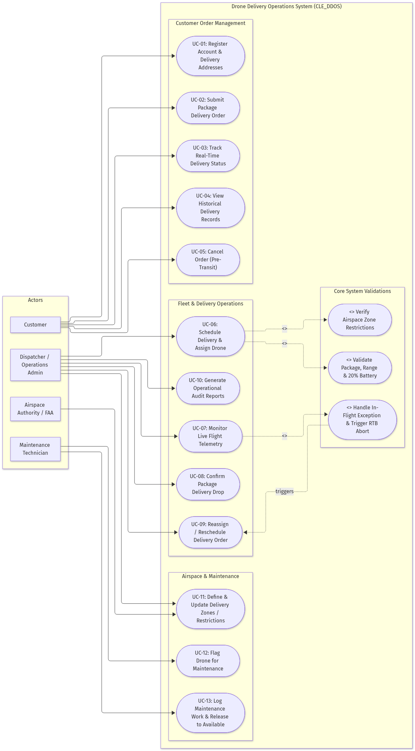
Figure 1: UML Use-Case Model — Actor Interactions and System Boundary

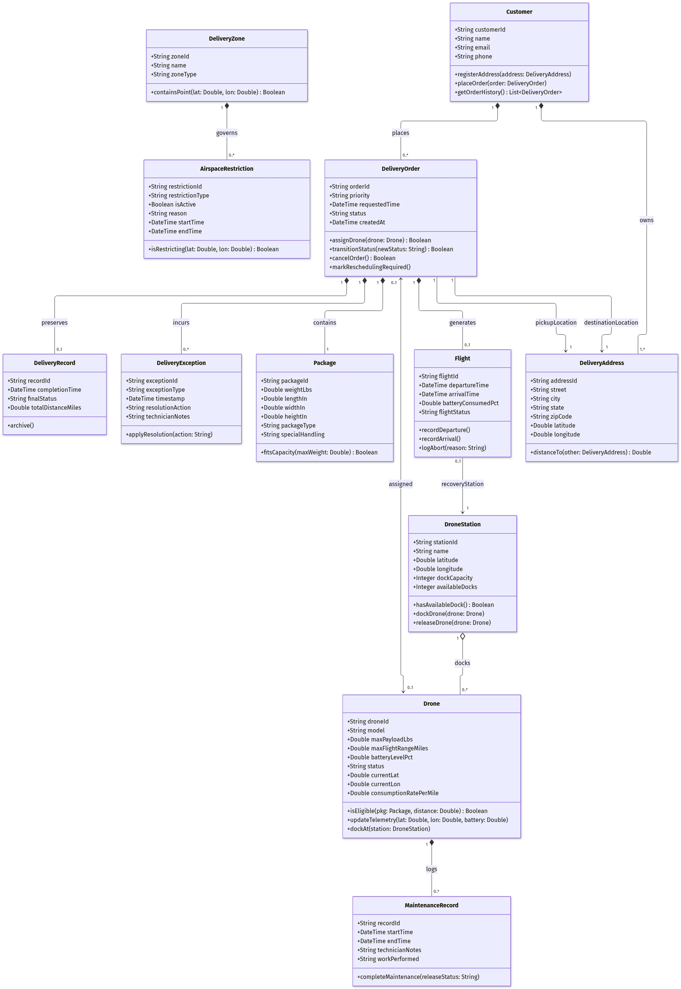
Figure 2: Initial UML Class Diagram — Core Domain Entities and Multiplicities

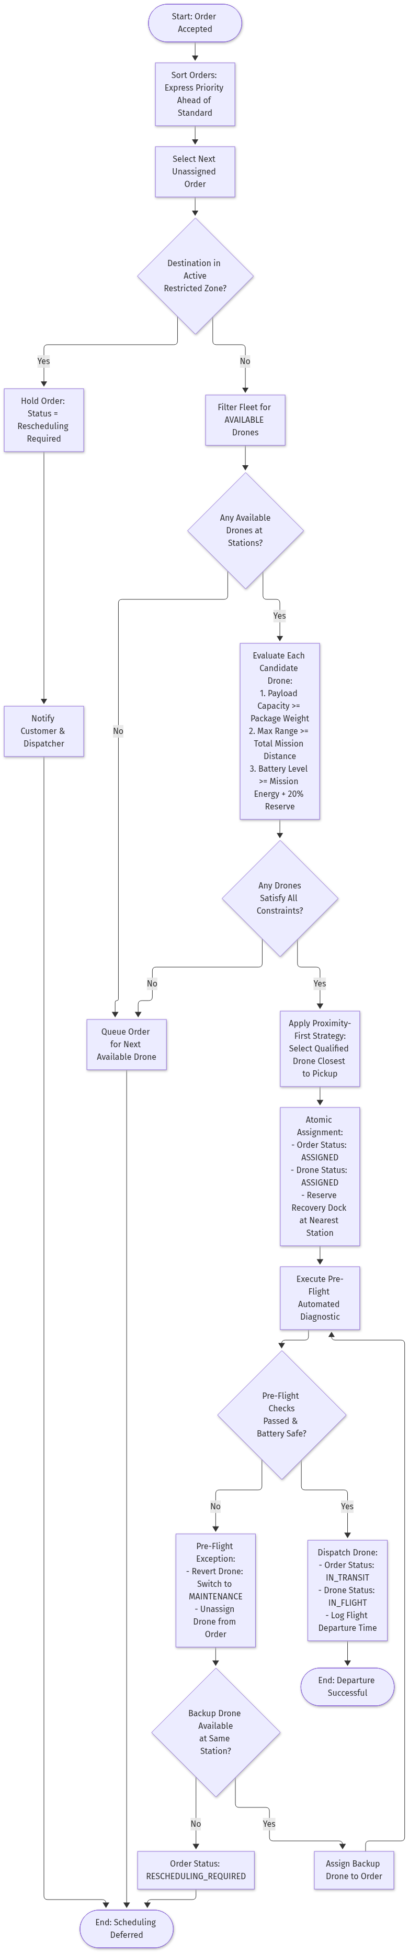
Figure 3: Activity Diagram — Order Scheduling and Drone Assignment Workflow

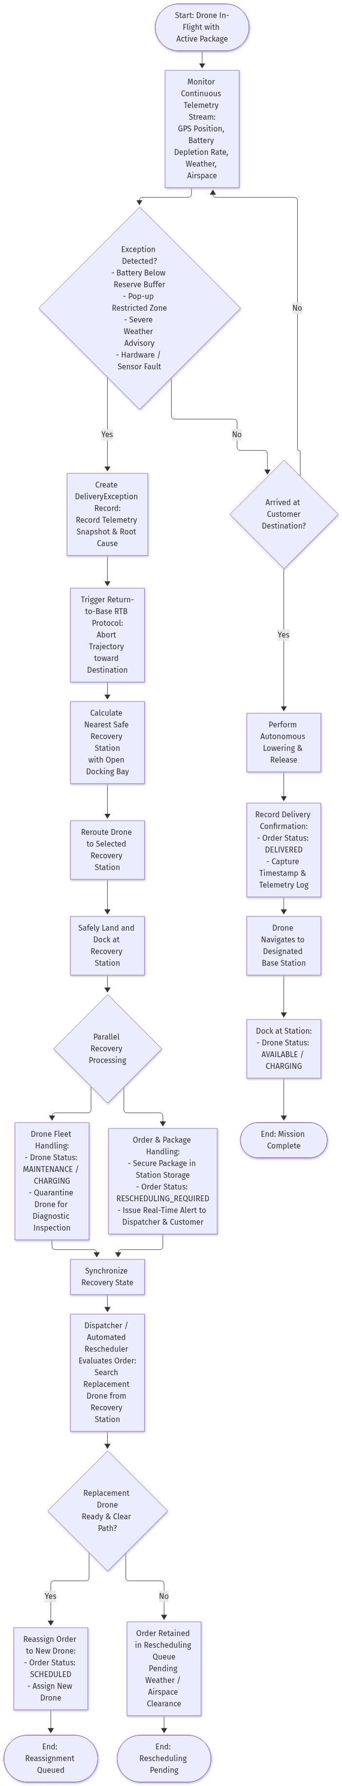
Figure 4: Activity Diagram — In-Flight Exception and Return-to-Base Recovery

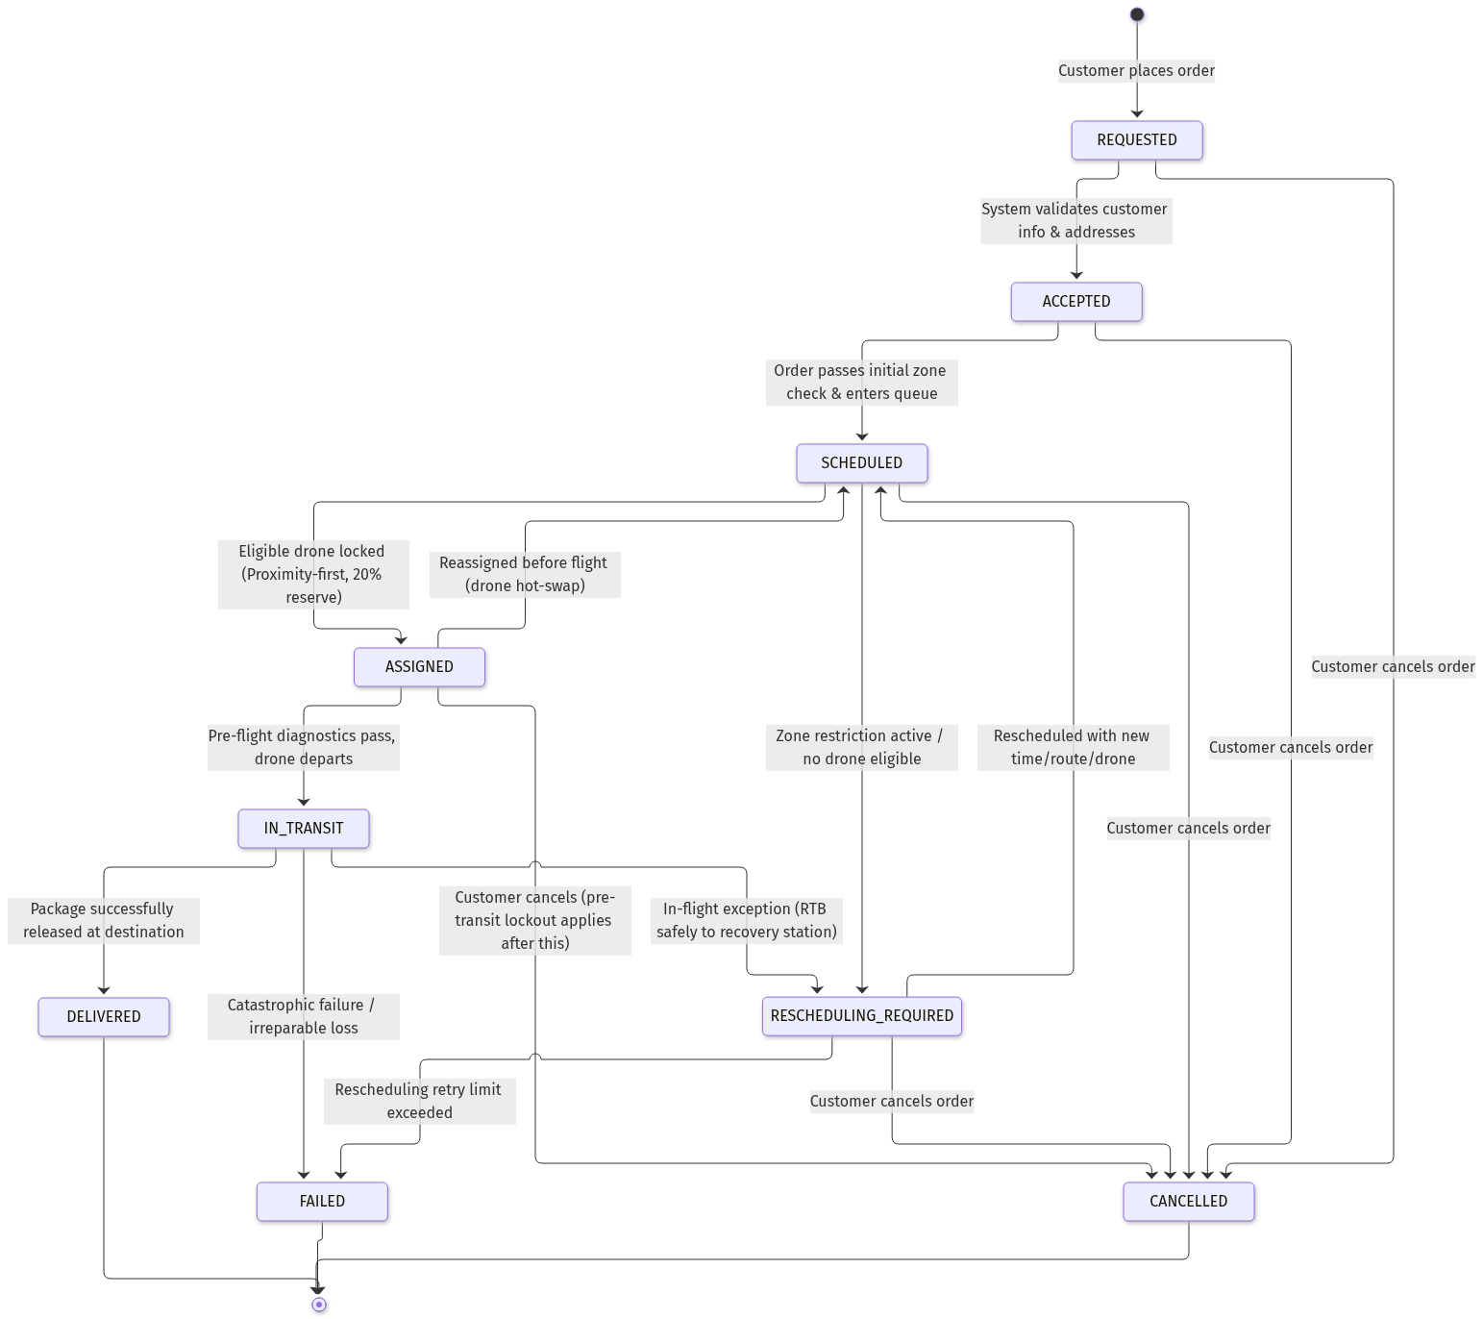
Figure 5: State Machine Diagram — Delivery Order Lifecycle

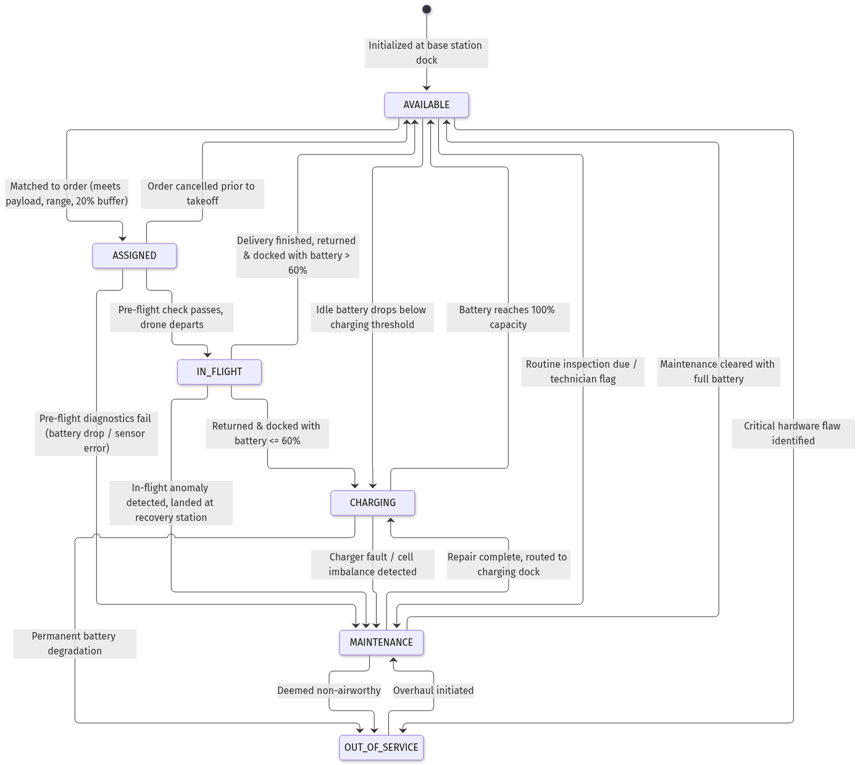
Figure 6: State Machine Diagram — Drone Operational Status Transitions

10. External Interfaces
10.1 User Interface
The system provides two role-segregated web experiences tailored for presentation, operational oversight, and zero-friction evaluator testing:
Suite A: Customer & Demo Order Portal (Mobile-Optimized)
Designed for frictionless audience participation during evaluations and customer self-service.
1. Screen 1: Demo / Customer Order Intake (`/customer/order`):
• One-Click Demo Session Initialization: Allows evaluators and classmates to tap *"Order as Demo Customer"* to generate an instant ephemeral customer session without requiring real-world street addresses, account credentials, or financial payments (strictly an evaluation facility; deprecated in commercial production).
• Package Specification Inputs: Numeric controls for package weight (lbs), dimensions ($L \times W \times H$), delivery priority (`STANDARD` vs `EXPRESS`), and special handling flags.
• Canonical Destination Selector: Interactive map pin-drop or quick-select dropdown of canonical Cleveland delivery landmarks (e.g., 1450 Euclid Ave, Cleveland Public Square, University Circle Hub, West Side Market).
• Instant Pre-Flight Feasibility Check: Immediate UI feedback calculating straight-line distance and pre-validating against active restricted airspace zones.
2. Screen 2: Live Delivery Tracking Stepper (`/customer/track/{order_id}`):
• Visual 6-State Stepper: Real-time state progression indicator (`REQUESTED` $\rightarrow$ `ACCEPTED` $\rightarrow$ `SCHEDULED` $\rightarrow$ `ASSIGNED` $\rightarrow$ `IN_TRANSIT` $\rightarrow$ `DELIVERED`).
• Customer-Scoped Map View: Interactive Leaflet canvas tracking the assigned drone airframe advancing toward destination in real time.
• Pre-Transit Cancellation Control: Action button to cancel order while pending or assigned; dynamically disabled with a visual lockout advisory once the flight enters `IN_TRANSIT`.
3. Screen 3: Delivery History & Digital Receipts (`/customer/history`):
• Chronological summary of customer-owned orders with status badges, timestamps, total miles flown, and digital delivery confirmation receipts.
Suite B: Dispatcher & Administrative Operations Console (Desktop / Projector-Optimized)
Authenticated cockpit accessible to verified administrators (authenticated via Google SSO matching `ADMIN_EMAILS`), optimized for full-screen projection.
4. Screen 4: Operations HUD & Live Cleveland Map Canvas (`/dispatcher/map`):
• Greater Cleveland Geospatial Canvas: Leaflet map with OpenStreetMap tiles bounded by Cleveland metropolitan coordinates.
• Base Station Hub Pins: Interactive station markers displaying station names and real-time dock capacity badges (`available_docks / total_docks`).
• Animated Drone Airframes: Directional SVG aircraft rotating to live flight heading with status color halos (Green = `AVAILABLE`, Blue = `IN_FLIGHT`, Amber = `CHARGING`, Orange = `MAINTENANCE`, Red = `OUT_OF_SERVICE`).
• Airspace Restriction Overlays: Hatched polygon shading over permanent (Burke Airport) and temporary (Stadium TFR) no-fly zones with click popups.
• Head-Up Display (HUD) Telemetry Overlay: Corner overlay displaying active aircraft ground speed ($30\text{ mph}$), altitude ($200\text{ ft}$ AGL), dynamic battery gauge, and current flight phase.
5. Screen 5: Dispatch Queue, Simulation Controls & Chaos Injection (`/dispatcher/orders`):
• Tabbed Order Queues: Real-time tables for *Pending Unassigned Queue* (Express orders preempting Standard), *Active Missions*, and *Rescheduling / Exception Queue*.
• Candidate Drone Ranking Inspector: Modal revealing eligible drones ranked deterministically by Proximity-First, payload capacity fit, and battery reserve.
• Simulation Control Toolbar: Interactive controls allowing administrators to Play/Pause the simulation clock, accelerate flight time ($1\times, 5\times, 10\times$), and inject live exceptions (*"Trigger Battery Drop"*, *"Activate Pop-Up Airspace Restriction"*) to demonstrate automated Return-to-Base aborts on demand.
6. Screen 6: Fleet Management & Maintenance Bay (`/dispatcher/fleet`):
• Comprehensive fleet roster table (10 drones) displaying battery %, assigned station, total flight hours, and operational status.
• Technician action modals to flag drones for maintenance, record inspection notes, and release serviced drones back to `AVAILABLE` with $100\%$ battery.
7. Screen 7: Operational KPI Summary & Audit Reporting (`/dispatcher/reports`):
• Executive KPI Cards: Real-time counters showing total deliveries, successful completion rate, active aborts, and average turnaround duration.
• One-Click CSV Data Exports: Download buttons for `deliveries.csv`, `exceptions.csv`, and `maintenance.csv`.
• Print-to-PDF Report Generator: Dedicated `@media print` formatted layout enabling clean browser PDF generation for course grading deliverables.
10.2 Software / API Interfaces
• Internal REST API: Exposes endpoints for order placement, fleet telemetry polling, station queries, and exception management.
• No External Cloud API Dependency: System operates standalone without external paid mapping or weather APIs.
10.3 Hardware / Device Interfaces
• Simulated Hardware Interface: In lieu of physical drone autopilot radios, the system connects to an internal Python simulation thread emitting standard MAVLink-style telemetry packets (lat, lon, altitude, battery voltage, speed) at 1 Hz intervals.
10.4 Communication Interfaces
• Internal client-server communication utilizes standard HTTP/1.1 JSON protocols over port 8000, with WebSocket streaming (`/ws/telemetry`) for live flight telemetry updates.
11. MVP and Project Scope
11.1 MVP Definition
By the conclusion of Sprint 4, the team will deliver a fully functional, demonstrable CLE_DDOS software platform providing:
1. Complete customer and multi-address management with frictionless Demo Customer order intake for classroom evaluation.
2. Full order intake and constraint validation engine (payload, range, battery, airspace).
3. Multi-station fleet management modeling 3 Cleveland base stations and 10 active drones.
4. Constraint-based scheduling with automated 20% battery reserve verification and proximity-first assignment.
5. Simulated real-time flight execution with time-acceleration ($1\times, 5\times, 10\times$) and visible departures, transit, and delivery completions.
6. In-flight exception simulation with interactive chaos fault injection demonstrating automated Return-to-Base aborts and station reassignments.
7. Administrative Operations Console featuring Google SSO, live Leaflet map HUD, and one-click CSV / Print-to-PDF audit reporting.
11.2 Deferred / Future Functionality
• Commercial Payment Gateway Integration: Financial credit-card transactions (e.g. Stripe) are deferred; zero-friction Demo Customer ordering is utilized for simulation and grading. (Demo Customer checkout will be deprecated/removed in a commercial production deployment).
• Physical Address KYC / Identity Verification: Real-world identity and physical postal verification are deferred; canonical Cleveland bounding coordinates are utilized.
• Dynamic In-Flight Wind Drift Compensation: Deferred due to simulation complexity.
• Customer Signature Biometric Verification: Deferred; simulated digital delivery confirmation used instead.
• Multi-Package Consolidated Delivery Hops: Deferred; single-package per delivery enforced for MVP.
11.3 Product Backlog
Backlog ID | User Story / Task | Priority | Estimate | Sprint | Status
US-01 | As a customer, I want to create an account and register delivery addresses so I can place orders. | High | 3 pts | Sprint 2 | Ready
US-02 | As a customer, I want to submit a package delivery order with priority so that DroneDash can transport it. | High | 5 pts | Sprint 2 | Ready
US-03 | As an admin, I want to register drone stations and fleet airframes so they can be dispatched. | High | 3 pts | Sprint 2 | Ready
US-04 | As a dispatcher, I want the system to automatically match available drones to orders using proximity and 20% reserve rules. | High | 8 pts | Sprint 2 | Ready
US-05 | As a customer, I want to cancel my delivery order prior to takeoff if my plans change. | Med | 2 pts | Sprint 2 | Ready
US-06 | As a dispatcher, I want an internal simulation loop that advances drone positions and drains battery realistically. | High | 8 pts | Sprint 3 | Ready
US-07 | As an admin, I want to define restricted airspace zones that prevent drones from flying through hazards. | High | 5 pts | Sprint 3 | Ready
US-08 | As a system, I want in-flight exceptions to trigger an automatic Return-to-Base abort to the nearest station. | High | 8 pts | Sprint 3 | Ready
US-09 | As a technician, I want to log repairs and return serviced drones back to available status. | Med | 3 pts | Sprint 3 | Ready
US-10 | As an admin, I want to view operational summary reports and delivery audit histories. | Med | 5 pts | Sprint 4 | Backlog
US-11 | As an operator, I want an interactive map interface visualizing Cleveland stations and drones. | Med | 8 pts | Sprint 4 | Backlog
US-12 | As a demo customer / grader, I want to place test delivery orders without payment or account registration for evaluation. | High | 3 pts | Sprint 2 | Ready
US-13 | As an admin, I want simulation time acceleration (5x/10x) and fault injection buttons to demonstrate abort workflows live. | High | 5 pts | Sprint 3 | Ready
US-14 | As an admin, I want to export delivery logs to CSV and generate printable PDF audit reports. | Med | 3 pts | Sprint 4 | Backlog

12. Sprint Plan and Incremental Delivery
Sprint | Weeks | Goal | Major Requirements / Features | Expected Increment | Team Review / Status
Sprint 1 | 1–2 | Requirements Analysis & Initial Design | Complete SRS, UML models (Use Case, Class, Activity, State), Design Decisions, Rubric mapping | Approved Requirements & Design Baseline (Release #1) | Joint Team Review Complete
Sprint 2 | 3–4 | Core Domain Models & Scheduling Engine | Entities, database schema, order intake, constraint validator, proximity-first scheduler | Working Backend Core & API Endpoints | Scheduled
Sprint 3 | 5–6 | Telemetry Simulation & Exception Handling | Flight simulation loop, RTB aborts, station reassignments, maintenance logs | Working Simulation & Flight Engine | Scheduled
Sprint 4 | 7–8 | Web UI, Analytics & Final System Delivery | Dispatcher console, customer portal, operational reports, end-to-end demonstration | Final MVP Release & Presentation | Scheduled

13. Requirements Traceability
Requirement ID | Use Case | Business Rule | Design / UML Element | Implementation / Backlog | Test / Verification Method | Status
FR-01 | UC-01 | — | `Customer`, `DeliveryAddress` | US-01 | Unit / API contract test | Specified
FR-02, FR-03 | UC-02 | BR-01 | `DeliveryOrder`, `Package` | US-02 | Validation logic check | Specified
FR-04 | UC-06 | BR-04 | `Drone`, `DroneStation` | US-03 | Status matrix verification | Specified
FR-05, FR-06 | UC-11 | BR-03 | `DeliveryZone`, `AirspaceRestriction` | US-07 | Haversine boundary test | Specified
FR-07, FR-08 | UC-06 | BR-01, BR-02 | `Drone.isEligible()` | US-04 | Energy formula assertion | Specified
FR-09, FR-10 | UC-06 | BR-06, BR-07 | `Scheduler.assign()` | US-04 | Priority queue sort test | Specified
FR-11 | UC-06 | BR-04 | Atomic lock in `DeliveryOrder` | US-04 | Concurrency lock test | Specified
FR-12 | UC-06 | BR-09 | Pre-flight diagnostic routine | US-04 | Fault injection test | Specified
FR-13 | UC-07, UC-08 | — | `Flight`, `DeliveryRecord` | US-06 | Telemetry logger test | Specified
FR-14, FR-15 | UC-07, UC-09 | BR-08, BR-10 | RTB Coordinator | US-08 | In-flight abort simulation | Specified
FR-16 | UC-05 | BR-05 | `can_cancel_order()` | US-05 | In-transit lockout test | Specified
FR-17 | UC-12, UC-13 | BR-09 | `MaintenanceRecord` | US-09 | Quarantine assertion | Specified
FR-18, FR-20 | UC-04, UC-10 | — | Reporting Service | US-10 | Audit log generation | Specified

14. Verification and Acceptance Criteria
Requirement / Feature | Acceptance Criteria | Test Method | Expected Result | Status
Payload Rejection | Orders with package weight $>$ drone max payload must be rejected. | Automated unit test | System returns validation rejection with payload error message. | Formally Verified
20% Battery Safety Margin | Drones with battery $<$ calculated mission energy + 20% must not be assigned. | Automated unit test | System rejects assignment and holds order in scheduling queue. | Formally Verified
Pre-Transit Cancellation | Orders in `REQUESTED` through `ASSIGNED` can cancel; `IN_TRANSIT` cannot. | State transition test | Cancellation succeeds pre-transit; throws invariant exception mid-transit. | Formally Verified
Airspace Restriction Enforcement | Flight trajectories intersecting active restricted zones must be halted. | Spatial intersection test | Order transitions to `RESCHEDULING_REQUIRED` without dispatch. | Specified
In-Flight RTB Abort | Low battery or airspace alerts mid-flight must route drone to nearest open dock. | Simulation fault injection | Drone diverts to closest station, docks safely, package re-queued. | Specified

15. Requirements Change History
Version | Date | Requirement(s) Changed | Description of Change | Reason / Impact | Approved By
1.0 | Oct 07, 2026 | All | Initial baseline creation for Release #1 | Sprint 1 milestone delivery | Project Team

16. Appendices
Appendix A: Key Design Decisions & Architectural Rationale
1. Pure Software Simulation Model: Rather than integrating physical drone hardware or complex external cloud APIs, all telemetry, flight coordinates, battery decay rates, and environmental conditions are simulated internally. This eliminates external points of failure while faithfully modeling all operational dynamics required by the client.
2. Real-World Cleveland Geospatial Representation: Deliveries, stations, and flight paths utilize actual WGS84 latitude and longitude coordinates across Greater Cleveland (e.g., Station 1 at Public Square, Station 2 at University Circle, destinations along Euclid Avenue). Distances are computed via the spherical Haversine formula, providing genuine spatial realism.
3. Mandatory 20% Battery Reserve Safety Invariant: Energy feasibility enforces an explicit safety buffer: $\text{Required Battery} = (D_{\text{total}} \times \text{consumption\_rate}) + 20\%$. Drones are barred from departure unless this threshold is verified, guaranteeing safe diversions during headwinds or delays.
4. Proximity-First Drone Assignment: When multiple available drones satisfy payload and battery constraints, the system selects the drone geographically closest to the package pickup location. This minimizes unladen ferry distance, optimizes battery utilization, and shortens turnaround times.
5. Express Priority Queue Preemption: Express packages sort to the top of the unassigned scheduling queue ahead of Standard orders, guaranteeing earliest dispatch without destabilizing active in-flight missions.
6. Pre-Transit Cancellation Boundary: Customers may cancel orders up through the `ASSIGNED` stage. Once an order enters `IN_TRANSIT`, cancellation is locked out to prevent hazardous aerial emergency landings in urban zones.
7. Return-to-Base (RTB) Abort Architecture: In-flight exceptions (weather alerts, sudden restricted airspace, sensor degradation) trigger an automated abort sequence redirecting the aircraft to the nearest available station dock. The package is preserved in station holding, and the order is transitioned to `RESCHEDULING_REQUIRED` for seamless reassignment.
8. Formal Architecture & Operational Invariants: System architecture enforces strict synchronization between the formal system specification and executable operational contracts, guaranteeing zero design drift between documented requirements and operational execution.
Appendix B: Operational State Transition Tables
Delivery Order Lifecycle Transitions
From Status | Permitted Target Statuses | Guard Condition / Trigger
`REQUESTED` | `ACCEPTED`, `CANCELLED` | Address validation passed OR customer cancels
`ACCEPTED` | `SCHEDULED`, `CANCELLED` | Airspace clear; queued for drone assignment
`SCHEDULED` | `ASSIGNED`, `RESCHEDULING_REQUIRED`, `CANCELLED` | Qualified drone locked OR no drone available
`ASSIGNED` | `IN_TRANSIT`, `SCHEDULED`, `CANCELLED` | Pre-flight diagnostics passed OR hot-swap reassignment
`IN_TRANSIT` | `DELIVERED`, `RESCHEDULING_REQUIRED`, `FAILED` | Delivery confirmed drop OR in-flight RTB abort OR crash
`RESCHEDULING_REQUIRED` | `SCHEDULED`, `CANCELLED`, `FAILED` | Re-queued for assignment OR customer cancels
`DELIVERED` | (Terminal State) | Package successfully received
`CANCELLED` | (Terminal State) | Order voided pre-transit
`FAILED` | (Terminal State) | Irreparable delivery failure

Drone Operational Status Transitions
From Status | Permitted Target Statuses | Guard Condition / Trigger
`AVAILABLE` | `ASSIGNED`, `CHARGING`, `MAINTENANCE`, `OUT_OF_SERVICE` | Order matched OR low battery OR routine service
`ASSIGNED` | `IN_FLIGHT`, `AVAILABLE`, `MAINTENANCE` | Dispatched OR order cancelled OR pre-flight fault
`IN_FLIGHT` | `AVAILABLE`, `CHARGING`, `MAINTENANCE` | Returned with battery $>60\%$ OR returned $\le 60\%$ OR RTB abort
`CHARGING` | `AVAILABLE`, `MAINTENANCE`, `OUT_OF_SERVICE` | Battery reaches $100\%$ OR charger hardware fault
`MAINTENANCE` | `CHARGING`, `AVAILABLE`, `OUT_OF_SERVICE` | Technician service completed and signed off
`OUT_OF_SERVICE` | `MAINTENANCE` | Overhaul initiated

Appendix C: SRS Submission Verification Checklist
• [x] Purpose and Scope: Fully defined without template instructional text.
• [x] Problem, Proposed System, Assumptions, Constraints: Formulated in original team language.
• [x] Stakeholders and User Roles: Detailed table with responsibilities and permissions.
• [x] Functional Requirements: 20 uniquely numbered, prioritized, testable requirements using *"The system shall..."*.
• [x] Nonfunctional Requirements: 8 measurable quality requirements spanning reliability, performance, data integrity, and security.
• [x] Business Rules: 10 numbered, domain-specific rules governing capacity, battery reserve, airspace, and cancellation.
• [x] Use Cases: Comprehensive summary table and two fully specified use cases with alternative flows.
• [x] Data Requirements: 12 major entities detailed with attributes, relationships, and data integrity rules.
• [x] System Models & Design References: Clear references to all UML diagrams and state machines.
• [x] External Interfaces: Complete specifications for user, software, simulated hardware, and network interfaces.
• [x] MVP & Product Backlog: Realistic 8-week scope definition, deferred features, and prioritized user stories.
• [x] Sprint Plan: Incremental delivery schedule across Sprints 1 through 4.
• [x] Traceability & Verification: Comprehensive traceability matrix connecting requirements to use cases, rules, design, and tests.
• [x] Appendices: Complete architectural design decisions and state transition matrices documented.

