

BDX0010-QGF-S2-2526
Research Methods

AI Readiness and Supply Chain Performance: A Cross-National Pilot Study Using
Structural Equation Modelling

Tewogbade Shakir Adeyemi [DBA Researcher]
2573172317
May 2026

Table of Contents
1.0 Introduction 3
1.1 Aim and Research Questions 4
1.3 Structure of the Study 5
2.0 Research Methodology: Data Collection and Analysis 5
2.1 Research Philosophy, Approach and Method 5
2.2 Research Technique: Structural Equation Modelling (SEM) 7
2.3 Pilot Study Design 8
2.4 Data Sources and Variables 10
2.5 Data Collection Instrument and Procedure 11
2.6 Ethical Considerations 11
3.0 Data Analysis and Results 11
3.1 Descriptive Statistics and Correlations 12
3.2 Reliability and Validity Checks 14
3.3 Structural Model: Path Coefficients 15
3.4 Mediation Analysis 17
3.5 Moderation Analysis with Regression 18
4.0 Findings and Discussion 19
4.1 RQ1: Effect of AI Readiness on SC Performance (H1a, H1b, H1c) 19
4.2 RQ2: Mediation Effect of SC Performance (H2a) 20
4.3 RQ3: Role of Institutional Quality (H1b, H1c) 21
4.4 Evaluation of Findings and Limitations 21
5.0 Conclusion 22
References 23
Appendix A: Analysis of Quantitative Method 26
Table 1: Strengths and acknowledged limitations 26
Appendix B: Data Sources, Constructs and Variables 27
Table 1: Comprehensive data source inventory 27
Table 2: Summary of Variables operationalised 29
Appendix C: Data Collection 31
Table 1: Python code for automated World Bank data extraction (WDI, WGI, LPI) via the wbgapi API 31
Table 2: Python code for PDF text extraction and parsing 33
Appendix D: Standardisation and Construct Formation 34
Table 1: Details of Standardisation in SPSS 34
Appendix E: SPSS Analysis 36
Figure 1: Extract of Descriptive Statistics Syntax 36
Figure 2: Extract of Pearson Correlation Syntax 37
Figure 3: Extract of Cronbach Syntax 37
Figure 4: Extract of Factor Analysis 38
Figure 5: Extract of Regression Analysis Syntax 39
Figure 6: Extract of Sobel Test for Mediation 40
Figure 7: Extract of Moderation Analysis Syntax 41
Appendix F: Form E0 Signed Off 42

1.0 Introduction
The integration of Artificial Intelligence (AI) into economic and industrial systems is causing shifts around the dynamics of global supply chains. As affirmed in many existing works like Choi, Wallace and Wang (2023), Ivanov (2023) and Queiroz et al. (2022), AI technologies improve demand forecasting, inventory optimisation, logistics routing, and decision making in real time. Thus, it is clear that supply chains are no longer considered as operational infrastructures but a data-driven ecosystems where technologies have capabilities to impact performance outcomes and resilience.
At the macro level, this transformation is embodied in government AI readiness. This readiness is described as capacity of a nation to develop, deploy, and govern AI technologies through infrastructure, human capital, and regulatory frameworks. Global indices like Oxford Insights AI Readiness Index position the AI capability of any nation as strategic determinant of competitiveness, particularly for logistics-intensive economies. On the other hand, supply chain performance which can be represented by World Bank’s Logistics Performance Index (LPI) (El-Nakib & Elzarka, 2026; Stevic et al. 2024) is a main driver of trade efficiency, cost reduction, and economic integration.
Despite growth in discourse around diffusion of AI, the empirical relationship between AI readiness and supply chain performance is underdeveloped at the cross-national level. Most of the existing works like Queiroz et al. (2022), Ivanov and Dolgui (2020) and Kache and Seuring (2017) often focus on firm-level adoption or sector-specific applications. This clearly limits the understanding of how macro-level technological capability translates into systemic logistics outcomes globally.
The major concern from body of literature is the disconnect between technological capability and achieved operational performance. While AI is considered as a transformative resource from literature and in practice, empirical evidence suggests that its benefits are not by default. Studies like Goldfarb, Taska and Teodoridis (2023), Bucci et al. (2022) and Brynjolfsson and Syverson (2021) show that digital and AI investments show deferred returns and are contingent on factors like organisational capabilities, skill accumulation, and effective institutional frameworks that support the use of the technology. This concern triggers an important question: does AI readiness improve supply chain performance, or are its effects conditional on systemic factors like institutional quality?
To address this gap, this study conducts a pilot cross-national analysis utilising Structural Equation Modelling (SEM) to examine the relationships between government AI readiness, supply chain performance, and economic outcomes. By incorporating both mediation and moderation effects, the study provides an initial empirical assessment of how macro-level technological capability translates into logistics performance considering different institutional contexts.

1.1 Aim and Research Questions
The aim of this study is to examine the effect of government AI readiness on supply chain logistics performance and to assess whether supply chain performance mediates the relationship between AI readiness and economic outcomes.
To achieve this aim, the study addresses the following research questions:
- RQ1: To what extent does government AI readiness influence supply chain logistics performance of a nation?
- RQ2: Does supply chain performance mediate the relationship between AI readiness and economic outcomes?
- RQ3: What role does institutional quality play in driving supply chain performance with AI readiness?

1.3 Structure of the Study
The pilot study is segmented into five sections. The first section is introduction, and it is discussed here. Section 2 is the research methodology and pilot study design. This section comprises the research philosophy, approach, and method. Also, section 2 discusses the sources of data, variable operationalisation, data collection procedures, and overarchial strategy that are employed in the study. Section 3 presents the complete results of all empirical analysis that were carried out. The section also discusses the findings of the mediation and moderation analyses based on the research objectives. Section 4 provides a discussion and critical evaluation of the findings, linking the empirical results to existing literature and theoretical perspectives on AI adoption, institutional quality, and supply chain performance. The section also provide reflection about the strengths and limitations of the research design, particularly in the context of the pilot study. The last section which is section 5 concludes the study by summarising the key findings, outlining the theoretical and practical implications of the findings. The section also identifies directions for future research.

2.0 Research Methodology: Data Collection and Analysis
This section provides details of the research philosophy, approach, method, data collection procedures, variable operationalisation and analytical techniques that are employed in this study. The overarching methodology is anchored in a post-positivist tradition while Structural Equation Modelling (SEM) is employed to test theorised relationships between government AI readiness, institutional quality, supply chain logistics performance and national economic outcomes across a cross-national sample of 109 countries.

2.1 Research Philosophy, Approach and Method
This study adopts a post-positivist, deductive, and quantitative research design to investigate the structural relationships between AI readiness, supply chain performance, institutional quality, and economic outcomes at a cross-national level. A post-positivist philosophical position assumes that an objective reality exists, but they can only be imperfectly observed and measured through empirical methods (Ryan, 2018). This position is particularly appropriate as the core constructs in this study (AI readiness and institutional context) are inherently latent and operationalised through composite indicators that are derived from secondary datasets. Post-positivism therefore justifies the use of proxy variables and statistical modelling while acknowledging the possibilities of measurement error, contextual heterogeneity, and data limitations (Bryman, 2021; Creswell & Creswell, 2018).
Based on the selected philosophical position, a deductive research approach is employed. With deductive approach, theoretical propositions from existing literature on digitalisation, institutional theory, and supply chain performance are empirically tested using observed data. Deduction is very appropriate in this context as it enables the methodological evaluation of hypothesised relationships from the panelised national sample, thereby facilitating theory refinement based on the aim of the research (Barrett & Younas, 2024; Saunders, Lewis & Thornhill, 2023).
In alignment with both the philosophical and methodological orientation, a quantitative method is adopted to enable statistical testing, comparability, and generalisation across countries (Baltagi, 2021; Wooldridge, 2019). However, this approach is not without limitations. The reliance on composite indices introduces potential measurement bias by aggregating multiple dimensions into single indicators, which possess the likelihood to obscure the underlying variation. Also, there is issue of endogeneity and reverse causality because of the cross-sectional nature of the data collected for the study. This affects causal inference. These limitations are mitigated with the implementation of robustness checks and proper model specification. The complete research design is summarised in Table 2.1.
Table 2.1: Research design summary
Dimension | Option Selected | Justification
Research philosophy | Post-Positivism | - It supports objective empirical testing and hypothesis validation  -Justifies use of proxy variables while maintaining rigour and objectivity (Bryman, 2021; Ryan, 2018)
Research approach | Deductive | -Hypotheses derived from established theory (Technology Adoption, Institutional Theory, Supply Chain Management) can be tested using numerical data (Barret and Younas, 2024; Fife and Gossner, 2024)
Research method | Quantitative | -It aids statistical testing, some comparability, and generalisation.  -It also align with research objectives that specifies identification of relationships (Baltagi, 2021; Wooldridge, 2019).  Other justifications of the method are summarised in Table 1 (Appendix A).
Research strategy | Cross-national comparative | -It allows examination of multiple countries simultaneously to identify generalisable relationships
Time horizon | Cross-sectional | -It supports the focus of the study to examine relationships between constructs at a single observation period.
Data type | -Secondary  -Macro-level data | -All sources are publicly accessible from credible databases.  -Appropriate for limited time available for this study
Analytical technique | Structural Equation Modelling (SEM) | -Ability to handle multiple latent constructs simultaneously.  -It can tests mediation and moderation.  -It is appropriate for complex multi-construct causal models (Hair et al., 2019)
Data collection software | Python (wbgapi, pdftotext, pandas) | -It is a free accessible programming language to automate data extraction process.  -It enables reproducibility and also save time and energy from manual downloading
Statistical analysis software | IBM SPSS v29 + IBM SPSS Amos | -They are recognised and robust software for reliability analysis, regression, SEM path estimation, CFA, descriptive statistics, and diagnostic check

2.2 Research Technique: Structural Equation Modelling (SEM)
Structural Equation Modelling (SEM) is utilised as the main research technique to examine the relationships between AI readiness, supply chain performance, institutional quality, and economic outcomes. Based on the aim of the research, SEM enables the simultaneous estimation of relationships between multiple latent constructs, each measured by different indicators. As the key variables, AI readiness and institutional quality are not directly observable, SEM provides a rigorous framework for modelling these constructs while explicitly accounting for measurement error (Kline, 2023; Hair et al., 2019).
Importantly, SEM is well suited to the analytical requirements of the pilot study, which involve testing complex causal structures, including both mediation and moderation effects. In this study, it is implemented to examine whether supply chain performance mediates the relationship between AI readiness and economic outcomes. It is used to assess whether institutional quality moderates the relationship (AI readiness and Supply Chain Performance). While a standalone regression technique can estimate relationships independently, SEM has extended capabilities to integrate both measurement and structural models in a unified framework to boost consistency of analysis and the explanatory power (Sarstedt et al., 2020).

2.3 Pilot Study Design
This study is carried out as a pilot investigation to evaluate the feasibility, validity, and analytical suitability of conceptual model linking AI readiness, institutional quality, supply chain performance, and economic outcomes at a cross-national level. The are valid reasons of carrying out this research as a pilot study. First, the study combines dataset from different sources (Oxford AI Readiness Index, World Bank WDI, WGI, and LPI). Because these datasets stand for different measurements with different structures, there are challenges around missing period, data harmonisation and consistency with the final constructs. Thus, it pertinent to carry out a preliminary study before a full-scale empirical investigation (Saunders, Lewis & Thornhill, 2023). Second, the study applies Structural Equation Modelling (SEM) to data at macro-level in emerging discourse where most existing works focus on applications at firm-level. Based on this, pilot study is required to assess whether the specified latent constructs are empirically valid and whether the structural relationships are stable and interpretable. Third, the study tests framework that combines mediation and moderation effects within a single model. This requires initial validation of both measurement and structural components (Creswell & Creswell, 2018).
The study is theoretically grounded in three main perspectives. First, Technology Adoption Theory (TOE framework) which underpins the expectation that technological capability (AI readiness) improves operational performance. The second lens is Institutional Theory which explains how governance quality influences efficiency and moderates technological outcomes. Third is how Supply Chain Performance Theory links logistics efficiency to broader economic outcomes.
From these theoretical lenses, propositions are developed for the pilot study. The main proposition is that AI readiness is a key macro-level driver of supply chain performance, but its effectiveness is conditional on institutional context. The second proposition suggests that supply chain performance acts as a transmission mechanism through which AI readiness influences economic performance. The third proposition in this study introduces interaction effects, proposing that institutional quality may either strengthen or weaken the AI–performance relationship. These propositions are formalised into testable hypotheses provided in Table 2.2 and Figure 2.1. The tests implemented in this pilot study for the four hypotheses provide initial empirical baseline for subsequent full-scale investigation.
Table 2.2 Theory, Propositions, and Hypotheses
Theory | Main Proposition | Hypotheses
Technology Adoption Theory (TOE Framework) | AI readiness is a primary macro-level driver of supply chain performance. | H1a: AI Readiness (ξ₁) positively influences Supply Chain Performance (η₁)
Institutional Theory | Institutional quality directly shapes supply chain efficiency and conditions technological outcomes. | H1b: Institutional Quality (ξ₂) positively influences Supply Chain Performance (η₁)
Institutional Theory (Moderation) | Institutional quality moderates — strengthening or weakening — the AI readiness–performance relationship. | H1c: Institutional Quality (ξ₂) moderates the relationship between AI Readiness (ξ₁) and SC Performance (η₁)
Supply Chain Performance Theory (Mediation) | SC performance is the transmission mechanism through which AI readiness converts into economic performance gains. | H2a: SC Performance (η₁) mediates the relationship between AI Readiness (ξ₁) and Economic Performance (η₂)

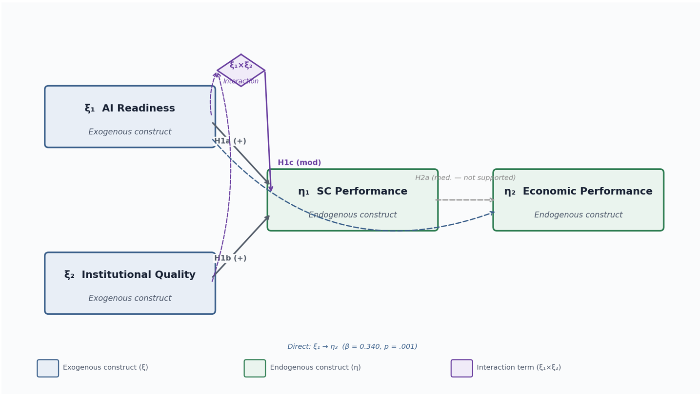
Figure 2.1: Conceptual Framework for the Pilot Study (By Author: Designed with Python)

2.4 Data Sources and Variables
The study utilises secondary macro-level data that were collected from multiple credible and publicly accessible sources (Table 1: Appendix B). The sources comprise Oxford Insights Government AI Readiness Index, the World Bank’s World Development Indicators (WDI), Worldwide Governance Indicators (WGI), and Logistics Performance Index (LPI). It also include data from the International Telecommunication Union (ITU) and Stanford HAI.
The variables tested in the study are broken down into four main latent constructs. These are AI Readiness (exogenous variable), Supply Chain Performance (mediator), Institutional Quality (moderator), and Economic Performance (endogenous variable) (Table 2: Appendix B). Each of the constructs is operationalised using multiple observable indicators to capture their multidimensional nature. For example, AI readiness is measured using indicators like AI readiness scores, internet penetration, and R&D expenditure, while supply chain performance is captured through LPI dimensions comprising infrastructure, timeliness, and customs efficiency.
The use of multiple data sources in this study improves construct validity and allows for a well detailed representation of complex macro-level phenomena. Importantly, it also necessitates meticulous harmonisation of country identifiers, time periods, and measurement scales, which are all addressed at the data preparation stage.

2.5 Data Collection Instrument and Procedure
The data collection instrument includes both the secondary data sources and automated data extraction pipeline that was scripted using Python programming language. The use of established databases ensures standardisation, comparability, and reliability of the data, while the computational pipeline built with Python improves reproducibility and minimises manual errors (Kitchin, 2021; Wilson et al., 2017).
Data were collected programmatically using the wbgapi library (from Python) to extract World Bank indicators, with PDF parsing techniques (pdftotext) for retrieving AI readiness scores from Oxford Insights reports (Table 1 and 2: Appendix C). Also, datasets were downloaded in CSV format from ITU repositories manually. The data were extracted for period between 2010 and 2025 while final harmonisation is anchored on the most recent observation period (2022–2023).
After extracting after targeted datasets, they were all merged using country identifiers. Missing values were addressed with use of imputation techniques (country-level averages and cross-sectional medians). All variables were subsequently standardised (z-scores) to ensure comparability for the different measurement scales before analyses and modelling (Table 1: Appendix D).

2.6 Ethical Considerations
This study uses exclusively macro-level secondary data that were sourced from publicly accessible databases. Ethical approval for collection of the secondary data is provided by researcher’s supervisor (Appendix E). No human participants are involved, and no primary data collection is carried out. All data are aggregated at the country level with no personal identifying information at any stage of analysis and the research. Data from the World Bank, Oxford Insights, ITU and Stanford HAI are used in full accordance with their respective open-access and academic use policies. Full attribution of all data sources is provided in the Appendix B. Also, the entire Python codebase and SPSS used for data extraction and modelling are fully reproducible and transparent.

3.0 Data Analysis and Results
This section discusses various analyses that were carried out to address the research questions specified in the introduction section. The analyses are implemented in a structured sequence: descriptive profiling, measurement model assessment, structural path estimation, mediation testing (Based on Baron and Kenny (1986)), and moderation analysis. All constructs are operationalised as composite z-score indices. Also, SEM notations are used in the analysis: ξ₁ denotes AI Readiness, η₁ Supply Chain Performance, η₂ Economic Performance, and ξ₂ Institutional Quality.

3.1 Descriptive Statistics and Correlations
Descriptive statistics for all four latent composite constructs were implemented (Figure 1: Appendix F) and the outcomes presented in Figure 3.1 and 3.2. Composite scores for ξ₁ and ξ₂ were derived from the z-standardised Oxford AI Readiness Index with Internet Users and four WGI governance indicators respectively, Supply Chain Performance η₁ from five LPI sub-scores and η₂ from GDP per capita, Exports (% GDP), and Trade Openness.

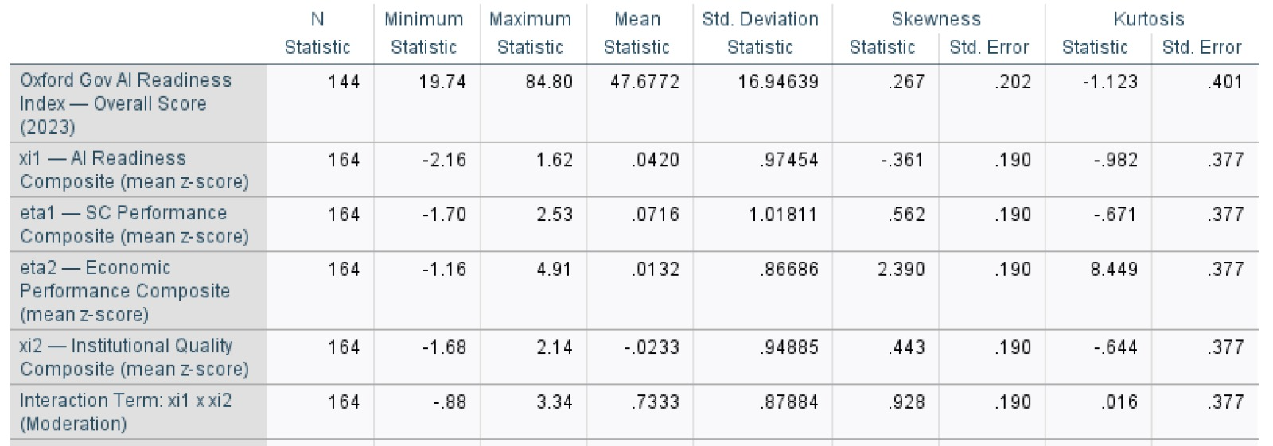
Figure 3.1 Descriptive Statistics: Latent Composite Constructs (Computed values after standardisation)(Generated with IBM SPSS)

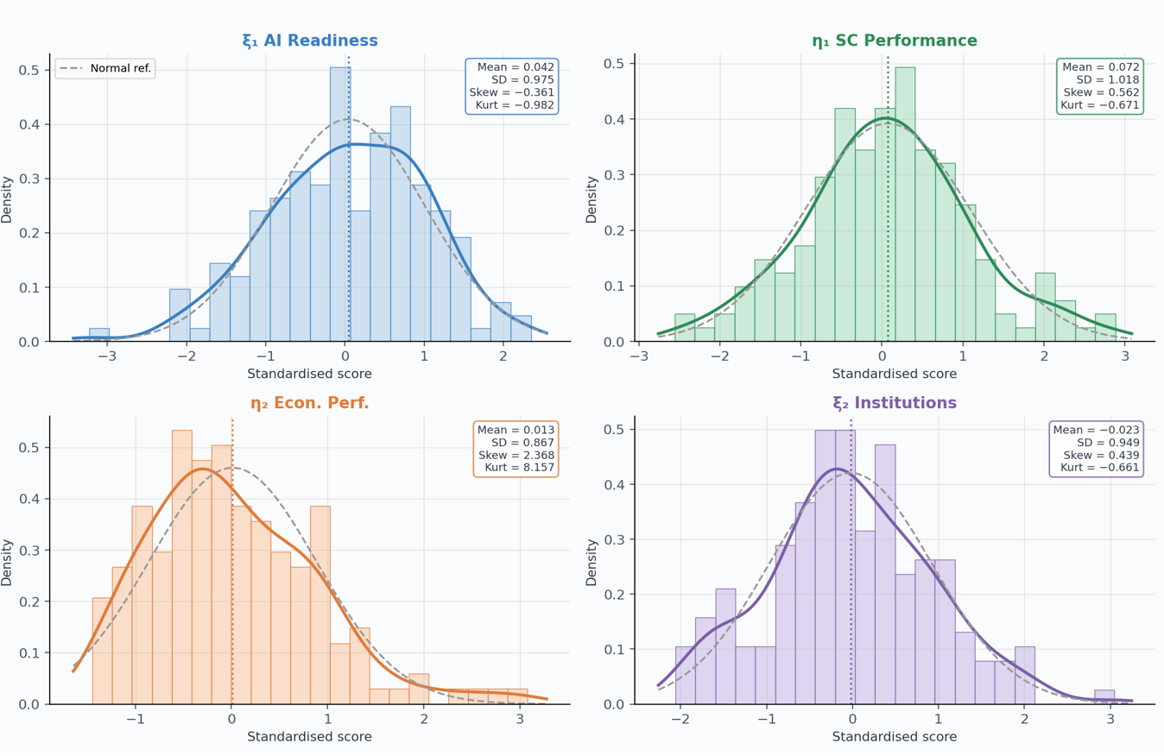
Figure 3.2: Distribution of Latent Composite Constructs (Implemented with Python)

The η₂ Economic Performance construct shows pronounced positive skew (2.368) and high excess kurtosis (8.157), caused by high-income outlier economies (Singapore, Luxembourg). All other constructs approximate normality. Pearson correlation for all the four constructs is implemented (Figure 2: Appendix F) and presented in Figure 3.3 and 3.4.
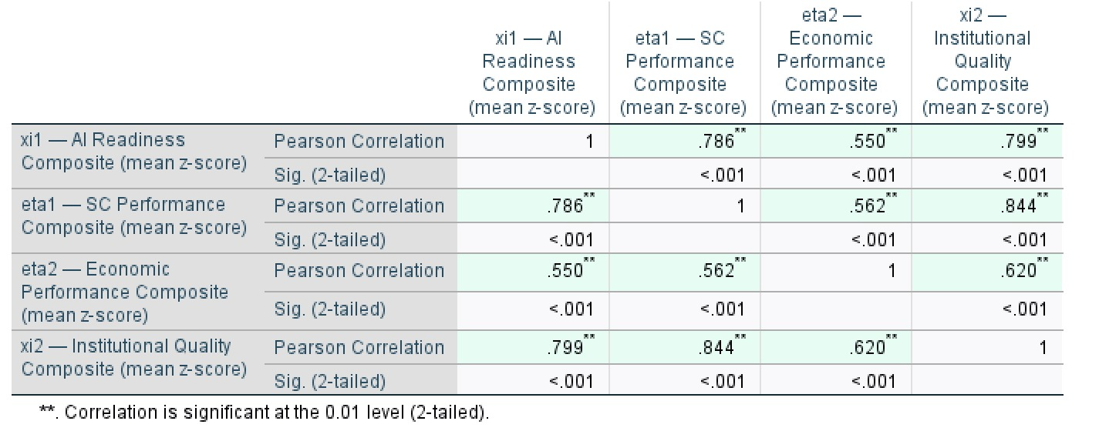
Figure 3.3: Pearson Correlation Matrix of Latent Constructs (Generated with IBM SPSS)

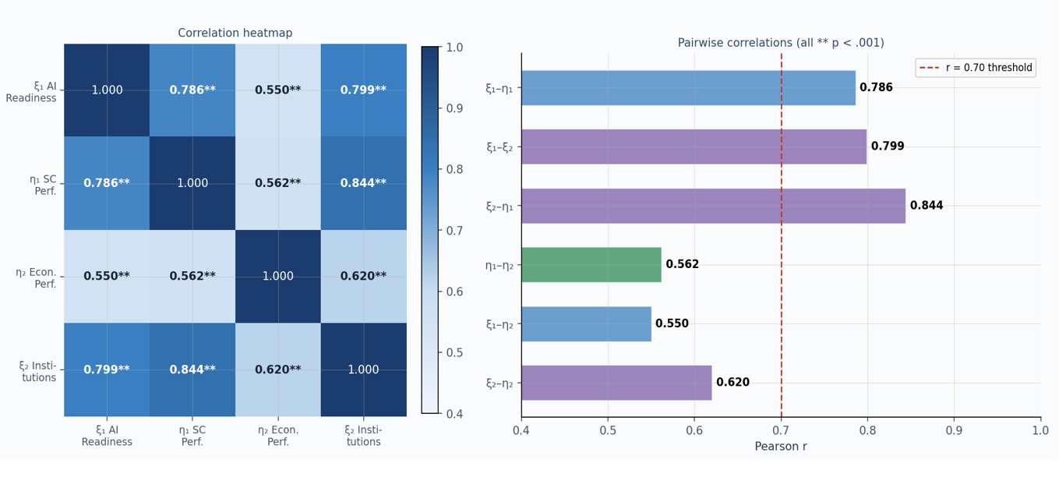
Figure 3.4: Pearson Correlation Matrix and Bar Chart for Pearson Coefficients (Implemented with Python)

Figures 3.3 and 3.4 show that AI Readiness (ξ₁), Supply Chain Performance (η₁), and Institutional Quality (ξ₂) are almost form a normal distribution (skewness between −0.361 and 0.562). Economic Performance (η₂) is highly skewed (2.368) with extreme kurtosis (8.157), reflecting structural global inequality. The results of the correlation analysis implemented show that there is strong and positive linkage between some constructs. AI Readiness with SC Performance has correlation coefficient (r) of 0.786, Institutional Quality with SC performance show r of 0.84, and AI Readiness with Institutions produced r of 0.799. Economic Performance shows moderate correlations with AI Readiness as both show r value of 0.550 while Economic Performance with SC Performance produced r of 0.562. These outcomes strongly imply that both AI capability and governance are key drivers of logistics performance. Notably from the outcomes, the magnitudes between AI–Economic (0.550) and SC–Economic (0.562) relationships suggest that AI influences economic outcomes both directly and through supply chains. This indicates partial connection rather than fully mediated relationship.

3.2 Reliability and Validity Checks
Cronbach's Alpha were computed to check for internal consistency of the measurement constructs before carrying out main SEM analysis (Figure 3: Appendix E). The values of α for each of the constructs is in Table 3.1 and Figure 3.5. Composite Reliability (CR) and Average Variance Extracted (AVE) were also calculated with the use factor loadings (Figure 4: Appendix E).

Table 3.1: Measurement Model: Reliability and Validity (Extracted from IBM SPSS)
 | Construct | Items | α | CR | AVE | √AVE | DV Status
ξ₁ | AI Readiness | 2 | 0.819 | 0.866 | 0.763 | 0.874 | Established
η₁ | SC Performance | 5 | 0.956 | 0.956 | 0.815 | 0.903 | Established
η₂ | Economic Performance | 3 | 0.850 | 0.750 | 0.501 | 0.708 | Borderline
ξ₂ | Institutional Quality | 4 | 0.982 | 0.967 | 0.879 | 0.938 | Established

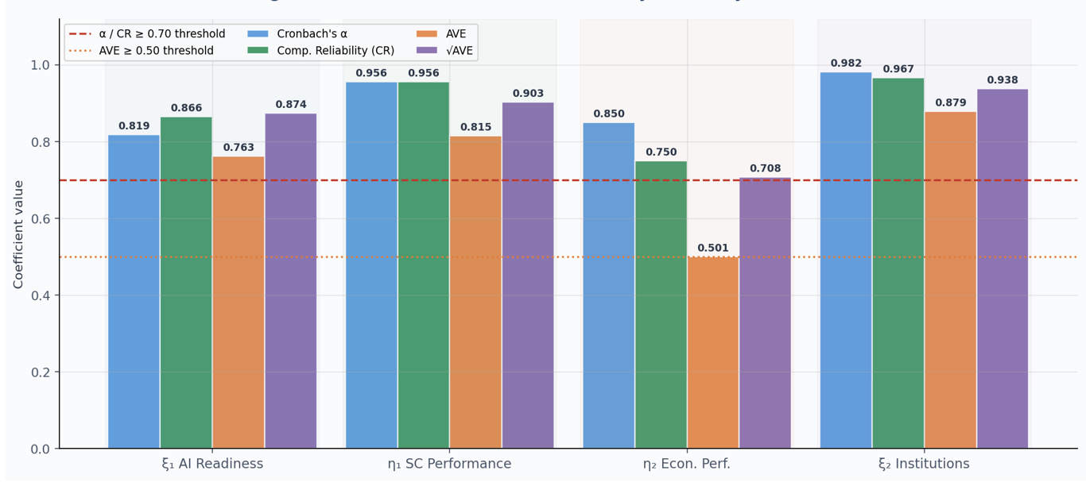
Figure 3.5: Measurement Model: Reliability and Validity Results (Implemented with Python)

As shown in Table 3.1 and Figure 3.5, three of four constructs achieved excellent reliability (α > 0.90), with ξ₂ Institutional Quality producing the highest alpha value (α = 0.982), reflecting the tightly intercorrelated WGI governance pillars. The η₂ Economic Performance construct produces α = 0.850, meeting the threshold. AVE exceeds 0.50 for all the constructs, confirming convergent validity. Discriminant validity is established where AVE (diagonal) exceeds all inter-construct correlations. This is satisfied for all constructs.

3.3 Structural Model: Path Coefficients
Two ordinary least squares regression equations were estimated in SPSS to test the hypothesised structural paths (Figure 5: Appendix F). Equation 1 is regressed η₁ (SC Performance) with ξ₁, ξ₂, and the interaction term to test H1a, H1b, and H1c simultaneously. Equation 2 is regressed η₂ (Economic Performance) onto ξ₁ and η₁ to test the direct and mediated pathways (Table 3.2 and Figure 3.6).

Table 3.2 Structural Path Coefficients (Extracted from IBM SPSS outputs)
Model / Eq. | Hyp. | Path | Relationship | B | SE | β | t | p | Decision | Model Fit
Equation 1 — Supply Chain Performance (η1)
Eq. 1 | H1a | ξ₁ → η₁ | AI readiness with SC performance | 0.437 | 0.078 | 0.462 | 5.60 | < .001 | Supported | R² = 0.780  Adj R² = 0.776  F(3,160) = 189.16*
Eq. 1 | H1b | ξ₂ → η₁ | Institutional quality with SC performance | 0.248 | 0.051 | 0.408 | 4.90 | < .001 | Supported | R² = 0.780  Adj R² = 0.776  F(3,160) = 189.16*
Eq. 1 | H1c | ξ₁ × ξ₂ → η₁ | Moderation with SC performance | −0.121 | 0.055 | −0.102 | −2.20 | .029 | Supported* | R² = 0.780  Adj R² = 0.776  F(3,160) = 189.16*
Equation 2 — Economic Performance (η2)
Eq. 2 | H2a | η₁ → η₂ | SC performance with Economic performance | −0.018 | 0.055 | ≈0.00 | −0.33 | .743 | Not Supported | R² = 0.347  Adj R² = 0.339  F(2,161) = 42.74*
Eq. 2 | — | ξ₁ → η₂ | AI readiness with Economic performance (direct) | 0.289 | 0.088 | 0.340 | 3.30 | .001 | Significant direct | R² = 0.347  Adj R² = 0.339  F(2,161) = 42.74*

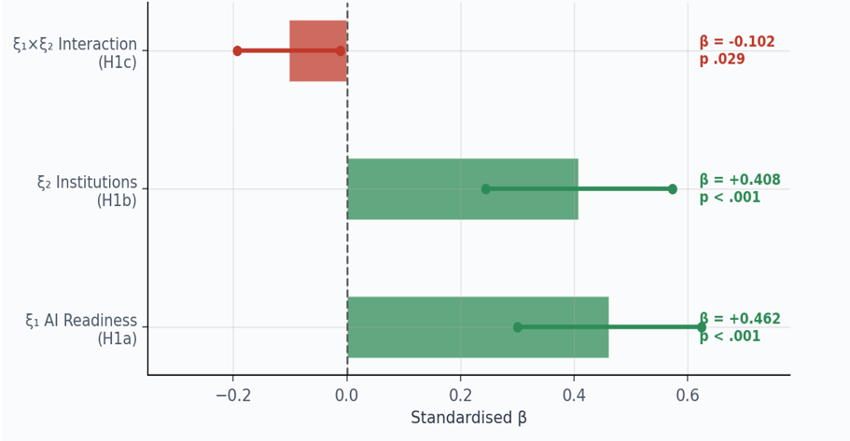

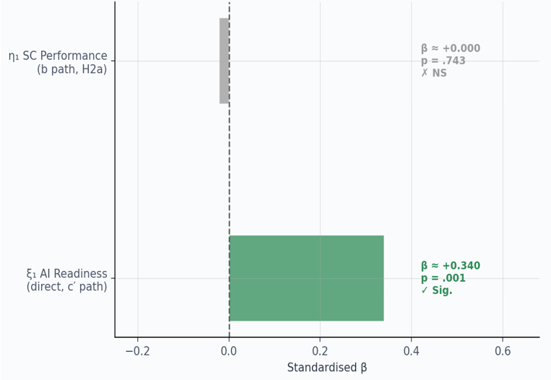
Figure 3.6: Plot of Coefficients of Regression Equation 1 and 2 (Implemented with Python)

From the results in Table 3.2, the first model (model 1) produces R² of 0.780. This means that AI Readiness, Institutional Quality, and their interaction explain 78.0% of variance in SC Performance. With the results for model 1, both hypothesis H1a (β = 0.462, p < .001) and hypothesis H1b (β = 0.408, p < .001) are supported. For the same model (model 1), the interaction term is significant and negative (B = −0.121, t = −2.20, p = .029). This outcome clearly confirms hypothesis H1c. This means that at higher combined levels of AI Readiness and Institutional Quality, their joint effect on SC performance is attenuated. For the second model (model 2), the direct path from ξ₁ to η₂ is significant (β = 0.340, t = 3.30, p = .001). for this model, η₁ predicts η₂ non-significantly when ξ₁ is controlled (B = −0.018, p = .743).

3.4 Mediation Analysis
Mediation was assessed adopting the four-step Baron and Kenny (1986) framework (Figure 6: Appendix F). The summaries of all the steps in shown in Table 3.3. The Sobel test value presented is based on the simple bivariate b-coefficient.

Table 3.3: Outcomes of Mediation Analysis (Extracted from IBM SPSS outputs)
Step | Path | B | SE | t / Z | p | Implication
Step 1 (c path) | ξ₁ → η₂ (total) | 0.489 | 0.058 | t = 8.39 | < .001 | Total effect confirmed
Step 2 (a path) | ξ₁ → η₁ | 0.437 | 0.078 | t = 5.60 | < .001 | a-path confirmed
Step 3 (b path) | η₁ → η₂ | ξ₁ | −0.018 | 0.055 | t = −0.33 | .743 | b-path not significant
Step 3 (c′ path) | ξ₁ → η₂ | η₁ | 0.289 | 0.088 | t = 3.30 | .001 | Direct effect remains
Sobel Test | Indirect (a×b) | 0.164 | 0.045 | Z = 3.621 | < .001 | Significant via simple b-path†

From Table 3.3, the outcome of mediation show that steps 1 (c path) and 2 (a path) are confirmed. The total effect of ξ₁ on η₂ (B = 0.489, p < .001) and the a-path (ξ₁ → η₁, B = 0.437, p < .001) are both significant. But the outcome of the analysis show that step 3 failed. When both ξ₁ and η₁ are regressed together with η₂, the b-path (η₁ → η₂ | ξ₁) becomes non-significant (B = −0.018, p = .743). Also at the same time, direct path (ξ₁ → η₂) remains significant (B = 0.289, p = .001). Under B&K criteria, this means no mediation (H2a not supported) is confirmed. The Sobel Z = 3.621 (p < .001) applies when b is estimated from the simple bivariate η₁–η₂ regression. With ξ₁ being controlled, the indirect pathway collapses. This implies that ξ₁ exerts a direct economic effect that does not route through SC Performance.

3.5 Moderation Analysis with Regression
Regression was used to test whether Institutional Quality moderates the AI–SC relationship. Block 1 entered ξ₁_c and ξ₂_c (mean-centred), Block 2 added the product term ξ₁_c × ξ₂_c (Figure 7: Appendix E). The results for Block 1 and Block 2 are shown in Table 3.4 and Figure 3.7 respectively.
Table 3.4: Hierarchical Moderation Regression (Extracted from IBM SPSS output)
Predictor | Block | B | β | t | p | Assessment
ξ₁_c AI Readiness (centred) | Block 1 | 0.448 | 0.456 | 9.05 | < .001 | Strong
ξ₂_c Institutional Quality (centred) | Block 1 | 0.248 | 0.417 | 4.70 | < .001 | Strong
ξ₁_c × ξ₂_c Interaction | Block 2 | −0.111 | −0.211 | −2.09 | .038 | H1c Supported
R² Block 1 |  |  |  |  |  | R² = 0.780
ΔR² Block 2 (adding interaction) |  |  |  | F = 23.98 | < .001 | ΔR² = 0.033

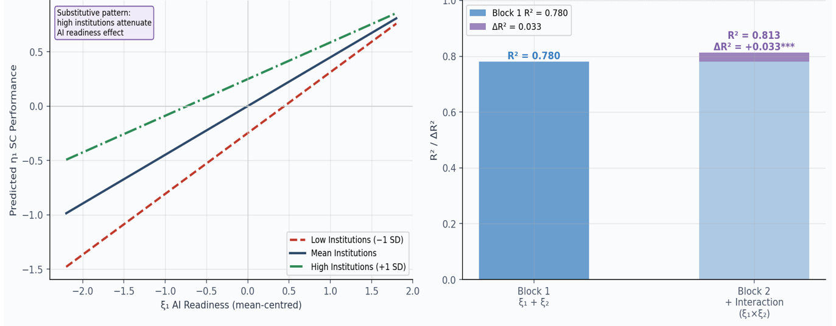
Figure 3.7: Plot of Institutional Quality against AI Readiness on SC Performance
The analysis in Table 3.4 confirms a significant moderation effect. The interaction adds ΔR² = 0.033 (F-change = 23.98, p < .001) when introduced, raising explained variance from 78.0% to 81.3%. The interaction coefficient is negative and significant (B = −0.111, t = −2.09, p = .038), indicating that at higher levels of Institutional Quality, the contribution of AI readiness to SC performance is reduced. H1c is therefore supported with a negative moderation direction. This substitutive pattern is further discussed in Section 4.

4.0 Findings and Discussion
This section interprets all the empirical results from the analyses in section 3 with respect to the three research questions (RQ1–RQ3).

4.1 RQ1: Effect of AI Readiness on SC Performance (H1a, H1b, H1c)
H1a is strongly supported (β = 0.462, p < .001) and the results confirm that AI readiness is a key macro-level determinant of supply chain (SC) performance. This aligns with the Technology–Organisation–Environment (TOE) framework, which posits that technological capacity improves operational efficiency (Maroufkhani et al., 2020). While a significant body of literature tends to view digital capability as a positive driver of logistics and supply chain performance (Quiroz et al., 2022; Wamba et al., 2017), this perspective is overly deterministic. Empirical studies like Ivanov (2023) emphasise that digital technologies improve supply chains mainly when it is complemented by organisational and institutional readiness. Thus, the strong effect observed in this study reflect the co-evolution of AI readiness with broader systemic capabilities that is beyond the single technological effect.
H1b (β = 0.408, p < .001) confirms institutional quality as also a strong predictor of SC performance. This outcome supports institutional theory but also introduces an important insight. While the literature most times considers institutions as enabling conditions (Rodgriguez-Pose & Ketterer, 2020; Acemoglu & Robinson, 2019; Dollar & Kraay, 2003), the comparable magnitude of ξ₁ and ξ₂ suggests that governance structures is as influential as technology itself. This challenges technology-centric narratives by indicating that logistics efficiency is not driven by digitalisation alone but by governance capacity.
H1c introduces a critical discord. The negative moderation effect (B = −0.111, p = .029) contradicts the dominant expectation of complementarity between institutions and technology. Instead, the results from the SEM analysis indicate substitutability. One plausible explanation is the clear diminishing marginal returns. In high-performing institutional environments, logistics systems are already optimised, and this leaves limited scope for AI to trigger any further improvements. This finding diverges from studies like Maroufkhani et al. (2022), Brynjolfsson, Rock and Syverson (2021) and Raisch and Krakowski (2021) that assume synergistic effects and instead suggests that the impact of AI is context-dependent, not universally amplifying.

4.2 RQ2: Mediation Effect of SC Performance (H2a)
The SEM analysis showed that the mediation hypothesis (H2a) is not supported. While AI readiness significantly influences both SC performance and economic performance, SC performance does not significantly predict economic outcomes when AI readiness is controlled (p = .743). This finding contradicts a substantial body of logistics literature which assumes that improvements in supply chain efficiency translate directly into macroeconomic gains like trade expansion and productivity growth (Hoekman & Shepherd, 2015; Marti, Puertas & Garcia, 2014; Portugal-Perez & Wilson, 2012).
A critical explanation for this lies in the multi-channel nature of AI impacts. Unlike traditional infrastructure improvements, AI technologies affect economic performance through diverse means, including productivity improvement, innovation diffusion, and digital services expansion. As argued by Brynjolfsson, Rock and Syverson (2021), the benefits of advanced technologies are often indirect and distributed across sectors rather than concentrated within operational systems such as logistics. Therefore, the assumed SC-mediated pathway may be basically narrow.
Also, the non-significant mediation effect also reflects model specification limitations. SC performance, as measured by LPI, captures logistics efficiency but does not fully map the broader mechanisms through which AI influences economic output. This suggests that the theoretical model tested requires expansion to include extra mediators like human capital or innovation systems.

4.3 RQ3: Role of Institutional Quality (H1b, H1c)
Institutional quality shows a dual role as both a direct determinant and a moderating factor in this study. While its direct effect reinforces existing institutional theory, the negative moderation introduces a more complex dynamic. Instead of amplifying the benefits of AI readiness, strong institutions appear to absorb or stabilise technological impact. This finding is consistent with arguments that institutions define the efficiency frontier within which technologies operate (Goldfarb, Taska & Teodoridis, 2023; Acemoglu & Johnson, 2019). In highly developed institutional contexts, governance systems already internalise efficiency through regulatory frameworks, reducing reliance on technological augmentation. But in weaker institutional environments, AI will act as a compensatory mechanism, delivering more marginal improvements.

This creates a theoretical disconnection with the dominant complementarity assumption in digital transformation literature. Instead of a linear amplification effect, the results suggest a non-linear and context-contingent relationship, where the effectiveness of AI depends on the existing institutional baseline.

4.4 Evaluation of Findings and Limitations
The overall findings produced three key insights. First, the pilot study provides cross-national evidence that AI readiness is a significant and direct determinant of both supply chain (SC) performance and economic performance. This directly extend technology adoption theory beyond its traditional firm-level focus. It also shows that national-level technological capability has capability to influence systemic logistics efficiency and macroeconomic outcomes. Second, the results reveal a substitutive relationship between institutional quality and AI readiness at higher levels. This challenges the conventional assumption of complementarity in institutional theory. Instead of triggering multiplicative gains, simultaneous improvements in governance and technology appear to exhibit diminishing marginal returns as countries approach an efficiency frontier. Third, the findings challenge the assumed mediation pathway, showing that SC performance does not significantly transmit the effect of AI readiness to economic outcomes. This strongly suggests that AI creates value through broader, multi-channel mechanisms that is beyond logistics systems.
However, few limitations needed to be considered in this study and its findings. The cross-sectional design of this study raises potential endogeneity concerns. This includes reverse causality between technological capability and economic performance. While construct validity is acceptable, the economic performance construct (η₂) exhibits borderline AVE (0.501), indicating potential measurement limitations. Also, the use of composite indices in this work introduced measurement bias. Future research should employ longitudinal data to better capture temporal dynamics and further mitigate issue of endogeneity and reverse causality among the operationalised constructs.

5.0 Conclusion
This pilot study carried out examine the relationship between AI readiness, institutional quality, supply chain performance, and economic performance using a cross-national Structural Equation Modelling (SEM) technique. This study contributes to the growing discourse on macro-level digital transformation as it directly extend TAM and Institutional theories. The findings from overall analysis show that AI readiness is a strong and significant predictor of supply chain performance, while institutional quality also exerts considerable positive effect on logistics performance. By implication, these outcomes confirm that both technological capability and governance structures are important determinants of national supply chain competitiveness.
The study also show that institutional quality negatively moderates the relationship between AI readiness and supply chain performance. This particular outcome shows that there is diminishing marginal returns at higher levels of institutional development. This finding challenges basic assumptions of complementarity between technology and governance as it indicates that the effectiveness of AI readiness is context-dependent. The mediation analysis shows that supply chain performance does not significantly transmit the effect of AI readiness to economic performance when direct AI effects are controlled. This clearly imply that AI influences economic outcomes through other mechanisms aside logistics.
Summarily, this pilot study methodologically provides solid foundation for future main investigations on how AI transform logistics at national level. Despite limitations that are linked to cross-sectional secondary data and composite indicators, the pilot study validates the analytical feasibility of integrating AI readiness, institutional quality, and supply chain constructs in a unified SEM framework. Future research should adopt longitudinal approaches and incorporate more mediating mechanisms to adequately capture the complex pathways through which AI capability influences economic performance of a nation.

References
Acemoglu, D., & Robinson, J. A. (2019). The narrow corridor: States, societies, and the fate of liberty. Penguin Press.
Baltagi, B. H. (2021). Econometric analysis of panel data (6th ed.). Springer. https://doi.org/10.1007/978-3-030-53953-5
Barrett, D., & Younas, A. (2024). Induction, deduction and abduction. Evidence-Based Nursing, 27(1), 6–7. https://doi.org/10.1136/ebnurs-2023-103873
Bryman, A. (2021). Social research methods (6th ed.). Oxford University Press.
Brynjolfsson, E., Rock, D., & Syverson, C. (2021). The productivity J-curve: How intangibles complement general purpose technologies. American Economic Journal: Macroeconomics, 13(1), 333–372. https://doi.org/10.1257/mac.20180386
Bucci, A., Aghion, P., Antonin, C., & Bunel, S. (2022). The power of creative destruction: Economic upheaval and the wealth of nations. Journal of Economics, 135, 299–306. https://doi.org/10.1007/s00712-021-00771-7
Choi, T. M., Wallace, S. W., & Wang, Y. (2023). Big data analytics in operations management. Production and Operations Management, 27, 1868–1883. https://doi.org/10.1111/poms.12838
Creswell, J. W., & Creswell, J. D. (2018). Research design: Qualitative, quantitative, and mixed methods approaches (5th ed.). Sage.
Dollar, D., & Kraay, A. (2003). Institutions, trade, and growth: Revisiting the evidence (Policy Research Working Paper No. 3004). World Bank.
El-Nakib, I., & Elzarka, S. (2026). An enhanced composite green logistics performance index for MENA: Methodology, drivers and hybrid forecasting to 2030. Logistics, 10(3), 56. https://doi.org/10.3390/logistics10030056
Fife, S. T., & Gossner, J. D. (2024). Deductive qualitative analysis: Evaluating, expanding, and refining theory. International Journal of Qualitative Methods, 23, 1–12. https://doi.org/10.1177/16094069241244856
Goldfarb, A., Taska, B., & Teodoridis, F. (2023). Could machine learning be a general purpose technology? A comparison of emerging technologies using data from online job postings. Research Policy, 52(1), 104653. https://doi.org/10.1016/j.respol.2022.104653
Hair, J. F., Black, W. C., Babin, B. J., & Anderson, R. E. (2019). Multivariate data analysis (8th ed.). Cengage Learning.
Hair, J. F., Hult, G. T. M., Ringle, C. M., & Sarstedt, M. (2022). A primer on partial least squares structural equation modeling (PLS-SEM) (3rd ed.). Sage.
Hoekman, B., & Shepherd, B. (2015). Who profits from trade facilitation initiatives? Implications for African countries. Journal of African Trade, 2(1–2), 51–70. https://doi.org/10.1016/j.joat.2015.08.001
Ivanov, D. (2023). The Industry 5.0 framework: Viability-based integration of resilience, sustainability, and human-centricity perspectives. International Journal of Production Research, 61(5), 1683–1695. https://doi.org/10.1080/00207543.2022.2118892
Ivanov, D., & Dolgui, A. (2020). A digital supply chain twin for managing the disruption risks and resilience in the era of Industry 4.0. Production Planning & Control, 32(9), 775–788. https://doi.org/10.1080/09537287.2020.1768450
Kache, F., & Seuring, S. (2017). Challenges and opportunities of digital information at the intersection of big data analytics and supply chain management. International Journal of Operations & Production Management, 37(1), 10–36. https://doi.org/10.1108/IJOPM-02-2015-0078
Kaufmann, D., Kraay, A., & Mastruzzi, M. (2011). The worldwide governance indicators: Methodology and analytical issues. Hague Journal on the Rule of Law, 3(2), 220–246. https://doi.org/10.1017/S1876404511200046
Kitchin, R. (2021). Data lives: How data are made and shape our world. Bristol University Press.
Kline, R. B. (2023). Principles and practice of structural equation modeling (5th ed.). Guilford Press.
Maroufkhani, P., Tseng, M. L., Iranmanesh, M., Ismail, W. K. W., & Khalid, H. (2020). Big data analytics adoption: Determinants and performances among small to medium-sized enterprises. International Journal of Information Management, 54, 102190. https://doi.org/10.1016/j.ijinfomgt.2020.102190
Martí, L., Puertas, R., & García, L. (2014). The importance of the logistics performance index in international trade. Applied Economics, 46(24), 2982–2992. https://doi.org/10.1080/00036846.2014.916394
Munim, Z. H., & Schramm, H.J. (2018). The impacts of port infrastructure and logistics performance on economic growth: The mediating role of seaborne trade. Journal of Shipping and Trade, 3(1), 1–19. https://doi.org/10.1186/s41072-018-0027-0
Myovella, G., Karacuka, M., & Haucap, J. (2020). Digitalization and economic growth: A comparative analysis of Sub-Saharan Africa and OECD economies. Telecommunications Policy, 44(2), 101856. https://doi.org/10.1016/j.telpol.2019.101856
Portugal-Perez, A., & Wilson, J. S. (2012). Export performance and trade facilitation reform: Hard and soft infrastructure. World Development, 40(7), 1295–1307. https://doi.org/10.1016/j.worlddev.2011.12.002
Queiroz, M. M., Ivanov, D., Dolgui, A., & Fosso Wamba, S. (2022). Impacts of epidemic outbreaks on supply chains: Mapping a research agenda amid the COVID-19 pandemic through a structured literature review. Annals of Operations Research, 319(1), 1159–1196. https://doi.org/10.1007/s10479-020-03685-7
Raisch, S., & Krakowski, S. (2021). Artificial intelligence and management: The automation–augmentation paradox. Academy of Management Review, 46(1), 192–210. https://doi.org/10.5465/amr.2018.0072
Rodríguez-Pose, A., & Ketterer, T. D. (2020). Institutional change and the development of lagging regions in Europe. Regional Studies, 54(7), 974–986. https://doi.org/10.1080/00343404.2019.1608356
Ryan, G. (2018). Introduction to positivism, interpretivism and critical theory. Nurse Researcher, 25(4), 41–49. https://doi.org/10.7748/nr.2018.e1466
Saunders, M. N. K., Lewis, P., & Thornhill, A. (2023). Research methods for business students (9th ed.). Pearson
Stević, Ž., Ersoy, N., Başar, E. E., & Baydaş, M. (2024). Addressing the global logistics performance index rankings with methodological insights and an innovative decision support framework. Applied Sciences, 14(22), 10334. https://doi.org/10.3390/app142210334
Wamba, S. F., Gunasekaran, A., Akter, S., Ren, S. J.-F., Dubey, R., & Childe, S. J. (2017). Big data analytics and firm performance: Effects of dynamic capabilities. Journal of Business Research, 70, 356–365. https://doi.org/10.1016/j.jbusres.2016.08.009
Wang, Q., Chen, L., Jia, F., Luo, Y., & Zhang, Z. (2024). The relationship between supply chain integration and sustainability performance: A meta-analysis. International Journal of Logistics Research and Applications, 27(8), 1388–1409. https://doi.org/10.1080/13675567.2022.2144812
Wilson, G., Bryan, J., Cranston, K., Kitzes, J., Nederbragt, L., & Teal, T. K. (2017). Good enough practices in scientific computing. PLoS Computational Biology, 13(6), e1005510. https://doi.org/10.1371/journal.pcbi.1005510
Wooldridge, J. M. (2021). Introductory econometrics: A modern approach (7th ed.). Cengage.
World Bank. (2023). Connecting to compete 2023: Trade logistics in an uncertain global economy—The logistics performance index and its indicators. World Bank. https://lpi.worldbank.org/
Zaninović, P. A., Zaninović, V., & Pavlic, H. (2021). The effects of logistics performance on international trade: EU15 vs CEMS. Economic Research-Ekonomska Istraživanja, 34(1), 1566–1582. https://doi.org/10.1080/1331677X.2020.1844582

Appendix A: Analysis of Quantitative Method

Table 1: Strengths and acknowledged limitations

Strengths of quantitative method in this study | Acknowledged limitations and mitigations
Enables systematic cross-national comparison across 109 heterogeneous countries | Composite indices may obscure within-country variation. This is mitigated by sub-group robustness analysis
Supports formal hypothesis testing and significance evaluation via SEM and OLS regression | Endogeneity and reverse causality are inherent risks in cross-sectional data. This is noted as a study limitation
Allows generalisation of structural relationships beyond the specific sample studied | Missing data for some country-indicator combinations. This is addressed through median imputation
Ensures reproducibility and transparency through open-source Python code pipeline | Cross-sectional design limits causal directional inference, future work should use longitudinal panel data
Consistent with established practice in macro-level supply chain and digitalisation research | Measurement error in proxy variables (e.g. LPI based on expert survey). This is acknowledged as inherent to secondary data studies

Appendix B: Data Sources, Constructs and Variables

Table 1: Comprehensive data source inventory

# | Source | Dataset / Index | Indicators used | WB Code / Series | Years used | SEM construct
1 | Oxford Insights | Government AI Readiness Index | AI Readiness Overall Score; Government Pillar; Technology Pillar; Data & Infrastructure Pillar | PDF extraction | 2021, 2022, 2023, 2025 | AI Readiness (xi1)
2 | World Bank | Logistics Performance Index (LPI) | LPI Overall; Timeliness; Infrastructure; Tracking & Tracing; Customs; Intl Shipments; Logistics Quality | LP.LPI.OVRL/TIME/INFR/TRAC/CUST/ITRN/LOGS.XQ | 2010-2022 | SC Performance (eta1)
3 | World Bank | World Development Indicators | R&D Expenditure (% GDP) | GB.XPD.RSDV.GD.ZS | 2010-2025 | AI Readiness (xi1)
4 | World Bank | World Development Indicators | Internet Users (% of population) | IT.NET.USER.ZS | 2010-2025 | AI Readiness (xi1)
5 | World Bank | World Development Indicators | Exports of Goods & Services (% GDP) | NE.EXP.GNFS.ZS | 2010-2025 | Economic Performance (eta2)
6 | World Bank | World Development Indicators | Trade Openness [(X+M)/GDP] | NE.TRD.GNFS.ZS | 2010-2025 | Economic Performance (eta2)
7 | World Bank | World Development Indicators | Manufacturing Value Added (% GDP) | NV.IND.MANF.ZS | 2010-2025 | Economic Performance (eta2)
8 | World Bank | World Development Indicators | FDI Net Inflows (% GDP) | BX.KLT.DINV.WD.GD.ZS | 2010-2025 | Economic Performance (eta2)
9 | World Bank | World Development Indicators | GDP per capita (constant 2015 USD) | NY.GDP.PCAP.KD | 2010-2025 | Control variable
10 | World Bank | Worldwide Governance Indicators | Government Effectiveness | GE.EST | 2010-2025 | Institutional Quality (xi2)
11 | World Bank | Worldwide Governance Indicators | Rule of Law | RL.EST | 2010-2025 | Institutional Quality (xi2)
12 | World Bank | Worldwide Governance Indicators | Regulatory Quality | RQ.EST | 2010-2025 | Institutional Quality (xi2)
13 | World Bank | Worldwide Governance Indicators | Control of Corruption | CC.EST | 2010-2025 | Institutional Quality (xi2)
14 | ITU | ICT Skills Statistics | ICT Skills: info on goods/services; health info; reading/downloading; verifying online information | HHU4212agg/ash/adn; HH%U781v | 2018-2025 | AI Readiness — supplementary
15 | Stanford HAI | AI Index Report 2025 | AI Patents per 100k; AI Skill Penetration (LinkedIn); Private AI Investment (USD bn) | PDF/chart extraction | 2023, 2024 | AI Readiness — supplementary

Table 2: Summary of Variables operationalised
Latent construct | SEM Function | Indicator | Scale | Source | Rationale
AI Readiness (xi1) | Exogenous | Oxford AI Readiness Overall Score | 0-100 | Oxford Insights | Primary composite proxy covering policy, infrastructure, governance and diffusion dimensions of national AI readiness
AI Readiness (xi1) | Exogenous | Internet Users (% of population) | % (0-100) | World Bank WDI | Digital infrastructure access prerequisite for AI adoption at population scale
AI Readiness (xi1) | Exogenous | R&D Expenditure (% of GDP) | % of GDP | World Bank WDI | National investment in knowledge and technology. Commonly used as AI/innovation readiness proxy
SC Performance (eta1) | Mediator | LPI Overall Score | Scale 1-5 | World Bank LPI | Holistic measure of national logistics system performance. Primary DV for Equation 1
SC Performance (eta1) | Mediator | LPI Timeliness | Scale 1-5 | World Bank LPI | Frequency of shipments reaching consignee on time. This is a core reliability indicator
SC Performance (eta1) | Mediator | LPI Infrastructure | Scale 1-5 | World Bank LPI | Quality of trade and transport infrastructure (ports, roads, rail, IT)
SC Performance (eta1) | Mediator | LPI Tracking and Tracing | Scale 1-5 | World Bank LPI | Ability to track and trace consignments. This is directly linked to digital technology adoption
SC Performance (eta1) | Mediator | LPI Customs | Scale 1-5 | World Bank LPI | Efficiency of customs clearance process. This captures regulatory and digital modernisation
Economic Perf (eta2) | Endogenous | Exports of Goods & Services (% GDP) | % of GDP | World Bank WDI | Measures external trade engagement and productive capacity
Economic Perf (eta2) | Endogenous | Trade Openness [(X+M)/GDP] | % of GDP | World Bank WDI | Standard measure of integration into global supply chains and trade flows
Economic Perf (eta2) | Endogenous | Manufacturing Value Added (% GDP) | % of GDP | World Bank WDI | Captures supply chain-intensive productive output
Economic Perf (eta2) | Endogenous | FDI Net Inflows (% GDP) | % of GDP | World Bank WDI | Signals investor confidence and supply chain attractiveness
Institutional Quality (xi2) | Moderator | Government Effectiveness (WGI) | -2.5/+2.5 | World Bank WGI | Public service quality, civil service competence and policy credibility
Institutional Quality (xi2) | Moderator | Rule of Law (WGI) | -2.5/+2.5 | World Bank WGI | Contract enforcement, property rights and judicial quality
Institutional Quality (xi2) | Moderator | Regulatory Quality (WGI) | -2.5/+2.5 | World Bank WGI | Government capacity to formulate sound policies enabling private sector development
Institutional Quality (xi2) | Moderator | Control of Corruption (WGI) | -2.5/+2.5 | World Bank WGI | Extent to which public power is exercised for private gain. This affects logistics efficiency
Control | Covariate | log(GDP per capita, const. 2015 USD) | USD (log) | World Bank WDI | Controls for economic development level to isolate AI readiness and institutional effects

Appendix C: Data Collection

Table 1: Python code for automated World Bank data extraction (WDI, WGI, LPI) via the wbgapi API

Code Block 3.1 — World Bank data extraction (WDI, WGI, LPI)
# !pip install wbgapi pandas openpyxl -q
import wbgapi as wb
import pandas as pd
import numpy as np
# ── Define all World Bank indicator codes ─────────────────────────────────────
WB_INDICATORS = {
'GB.XPD.RSDV.GD.ZS': 'RnD_expenditure_pct_GDP', # AI Readiness (xi1)
'IT.NET.USER.ZS': 'Internet_users_pct_pop', # AI Readiness (xi1)
'LP.LPI.OVRL.XQ': 'LPI_overall', # SC Performance (eta1)
'LP.LPI.TIME.XQ': 'LPI_timeliness',
'LP.LPI.INFR.XQ': 'LPI_infrastructure',
'LP.LPI.TRAC.XQ': 'LPI_tracking_tracing',
'LP.LPI.CUST.XQ': 'LPI_customs',
'LP.LPI.ITRN.XQ': 'LPI_intl_shipments',
'LP.LPI.LOGS.XQ': 'LPI_logistics_quality',
'NE.EXP.GNFS.ZS': 'Exports_pct_GDP', # Economic Performance (eta2)
'NE.TRD.GNFS.ZS': 'Trade_openness',
'NV.IND.MANF.ZS': 'Manufacturing_VA_pct_GDP',
'BX.KLT.DINV.WD.GD.ZS': 'FDI_inflows_pct_GDP',
'GE.EST': 'WGI_govt_effectiveness', # Institutional Quality (xi2)
'RL.EST': 'WGI_rule_of_law',
'RQ.EST': 'WGI_regulatory_quality',
'CC.EST': 'WGI_control_corruption',
'NY.GDP.PCAP.KD': 'GDP_per_capita_const2015', # Control variable
}
YEARS = list(range(2010, 2026))
def pull_wb_indicator(code, name):
df = wb.data.DataFrame(code, time=YEARS, skipBlanks=True, labels=False)
df = df.reset_index()
df.columns = [str(c).replace("YR","").strip() for c in df.columns]
yr_cols = [c for c in df.columns if str(c).isdigit()]
id_col = df.columns[0]
dl = df.melt(id_vars=[id_col], value_vars=yr_cols,
var_name="year", value_name=name)
dl = dl.rename(columns={id_col: "country_code"})
dl["year"] = dl["year"].astype(int)
return dl.dropna(subset=[name]).set_index(["country_code","year"])
frames = [pull_wb_indicator(c, n) for c, n in WB_INDICATORS.items()]
df_wb = pd.concat([f for f in frames if not f.empty], axis=1).reset_index()
# Attach country metadata (name, region, income level)
meta = wb.economy.DataFrame()[['name','region','incomeLevel']].reset_index()
meta.columns = ['country_code','country_name_wb','region','income_level']
df_wb = df_wb.merge(meta, on="country_code", how="left")
print(f'WB panel: {df_wb.shape[0]:,} rows | Countries: {df_wb.country_code.nunique()}')

Table 2: Python code for PDF text extraction and parsing

Code Block 3.2 — Oxford AI Readiness Index: PDF text extraction and parsing
import subprocess, re, pandas as pd
def pdf_to_text(pdf_path, txt_path):
"""Convert PDF to layout-preserving text file."""
subprocess.run(["pdftotext", "-layout", pdf_path, txt_path])
# Parse 2025 edition — 6-pillar format
def parse_oxford_2025(text_path):
with open(text_path) as f: text = f.read()
records, buffer = [], ""
pattern = re.compile(
r"^(.+?)\s{2,}(\d+)\s+([\d.]+)\s+([\d.]+)"
r"\s+([\d.]+)\s+([\d.]+)\s+([\d.]+)\s+([\d.]+)\s*$")
for line in text.split("\n"):
line = line.strip()
combined = (buffer + " " + line).strip() if buffer else line
m = pattern.match(combined)
if m:
records.append({
'Country': m.group(1).strip(), 'Rank': int(m.group(2)),
'Policy_Capacity': float(m.group(3)),
'AI_Infrastructure': float(m.group(4)),
'Governance': float(m.group(5)),
'Public_Sector_Adoption': float(m.group(6)),
'Development_Diffusion': float(m.group(7)),
'Resilience': float(m.group(8)), 'Year': 2025})
buffer = ""
elif line and len(line) < 60: buffer = combined
else: buffer = ""
df = pd.DataFrame(records)
df['Overall_Score'] = df[['Policy_Capacity','AI_Infrastructure','Governance',
'Public_Sector_Adoption','Development_Diffusion','Resilience']].mean(axis=1).round(2)
return df
# Parse 2021-2023 editions — 3-pillar format
def parse_oxford_3pillar(text_path, year):
with open(text_path) as f: text = f.read()
records, buffer = [], ""
pattern = re.compile(
r"^(\d+)\s{2,}(.+?)\s{2,}([\d.]+)\s+([\d.]+)\s+([\d.]+)\s+([\d.]+)\s*$")
for line in text.split("\n"):
line = line.strip()
combined = (buffer + " " + line).strip() if buffer else line
m = pattern.match(combined)
if m and int(m.group(1)) < 250:
records.append({
'Rank': int(m.group(1)), 'Country': m.group(2).strip(),
'Overall_Score': float(m.group(3)),
'Government_pillar': float(m.group(4)),
'Technology_pillar': float(m.group(5)),
'Data_Infrastructure_pillar': float(m.group(6)), 'Year': year})
buffer = ""
elif line and len(line) < 70: buffer = combined
else: buffer = ""
return pd.DataFrame(records)

Appendix D: Standardisation and Construct Formation

Table 1: Details of Standardisation in SPSS
SPSS Syntax 2.2 — Z-score standardisation and latent composite formation
* Z-score standardisation of all 16 observable indicators
* (Already computed in .sav file; run to verify)
DESCRIPTIVES VARIABLES =
Oxford_Overall_2023 Internet_users_pct_pop RnD_expenditure_pct_GDP
LPI_overall LPI_timeliness LPI_infrastructure LPI_tracking_tracing LPI_customs
Exports_pct_GDP Trade_openness Manufacturing_VA_pct_GDP FDI_inflows_pct_GDP
WGI_govt_effectiveness WGI_rule_of_law WGI_regulatory_quality WGI_control_corruption
/STATISTICS = MEAN STDDEV MIN MAX
/SAVE.
* Recompute standardised z-scores if needed (SPSS SAVE creates Z-prefix variables)
* Rename to match naming convention in dataset:
RENAME VARIABLES (ZOxford_Overall_2023 = ox23_z)
(ZInternet_users_pct_pop = inet_z)
(ZRnD_expenditure_pct_GDP = rnd_z).
* Form latent composite scores (mean of z-scored indicators)
COMPUTE xi1_AI_Readiness = MEAN(ox23_z, inet_z, rnd_z).
COMPUTE eta1_SC_Performance = MEAN(lpi_ov_z, lpi_ti_z, lpi_in_z, lpi_tr_z, lpi_cu_z).
COMPUTE eta2_Economic_Performance = MEAN(exp_z, trade_z, mva_z, fdi_z).
COMPUTE xi2_Institutions = MEAN(wgi_ge_z, wgi_rl_z, wgi_rq_z, wgi_cc_z).
* Create interaction term for moderation analysis (mean-centred: already z-scored)
COMPUTE interaction_xi1_xi2 = xi1_AI_Readiness * xi2_Institutions.
EXECUTE.
* Descriptive statistics for all latent constructs
DESCRIPTIVES VARIABLES =
xi1_AI_Readiness eta1_SC_Performance
eta2_Economic_Performance xi2_Institutions interaction_xi1_xi2
/STATISTICS = MEAN STDDEV MIN MAX KURTOSIS SKEWNESS.

Appendix E: SPSS Analysis

Figure 1: Extract of Descriptive Statistics Syntax
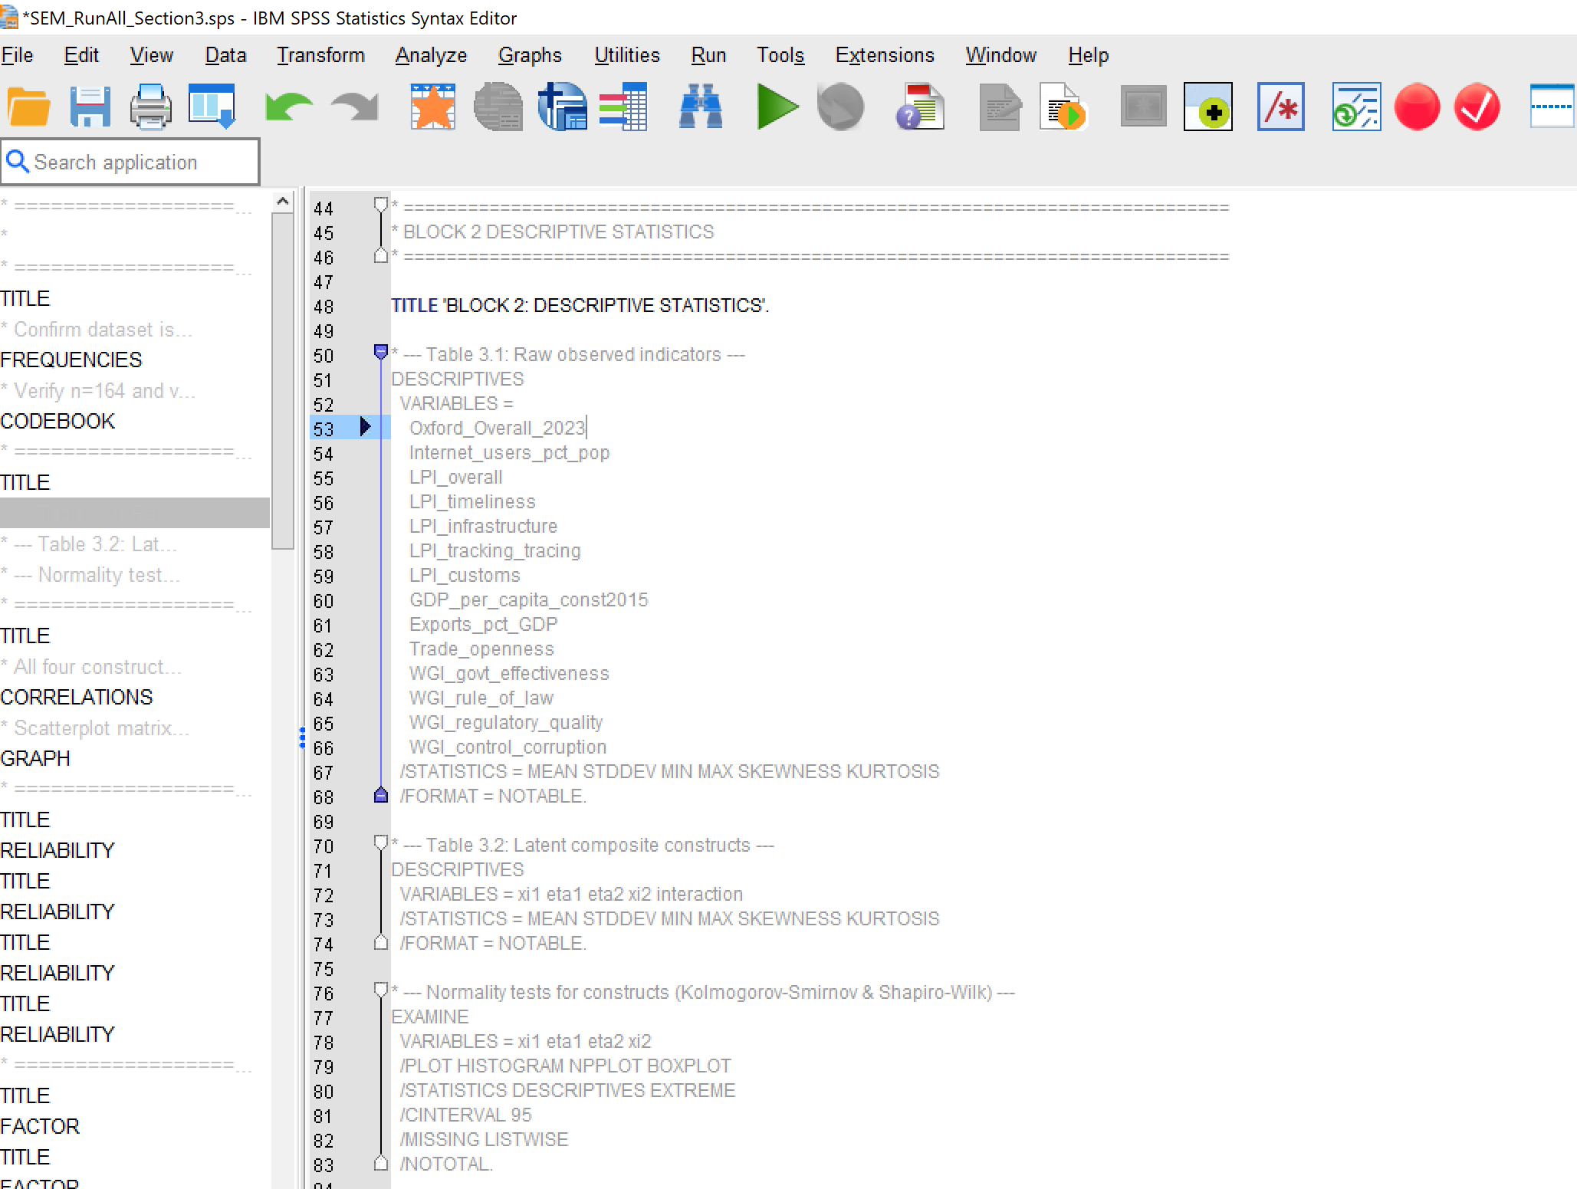

Figure 2: Extract of Pearson Correlation Syntax
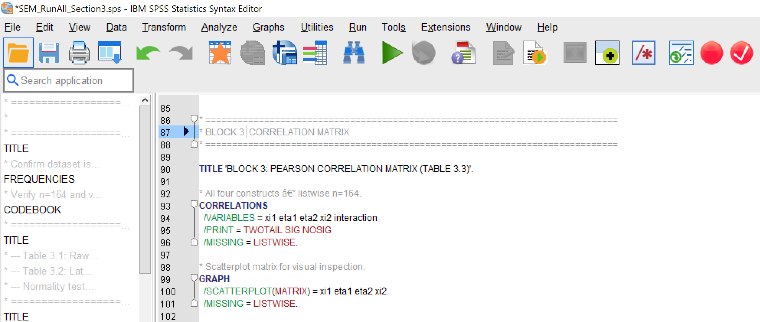

Figure 3: Extract of Cronbach Syntax

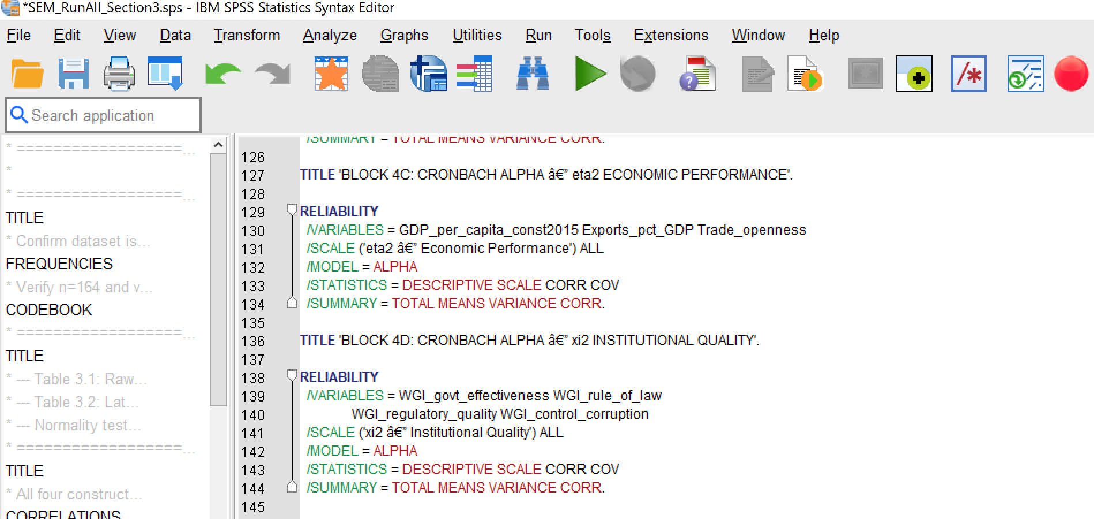

Figure 4: Extract of Factor Analysis
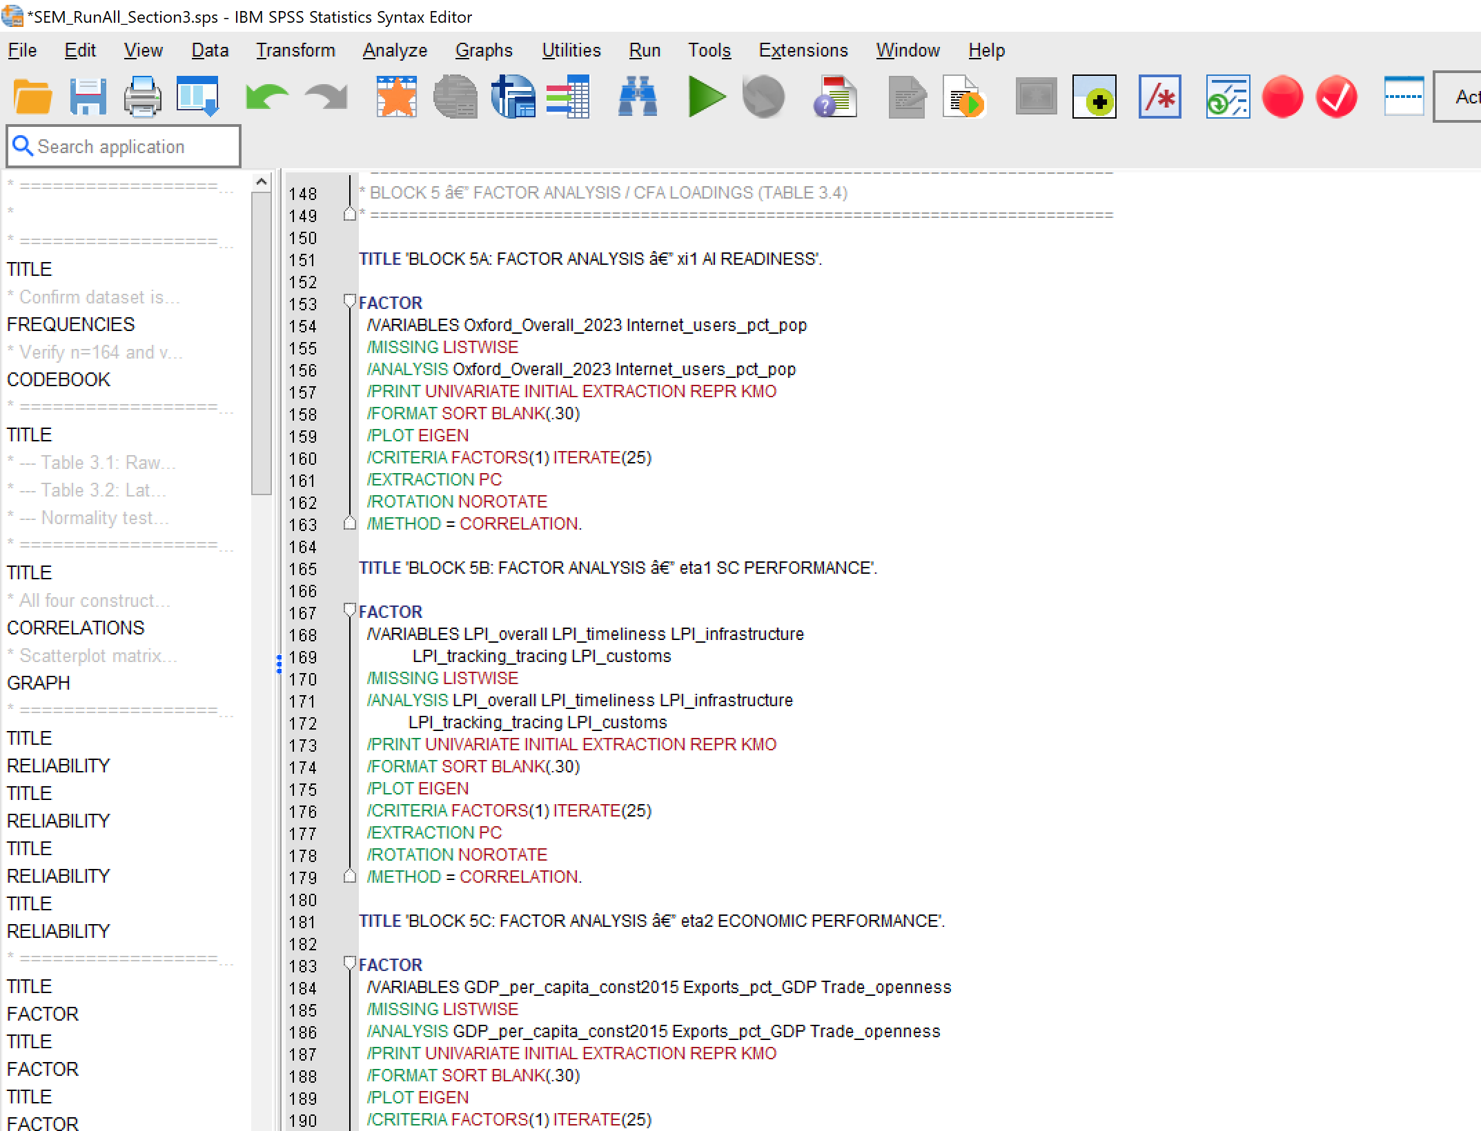

Figure 5: Extract of Regression Analysis Syntax

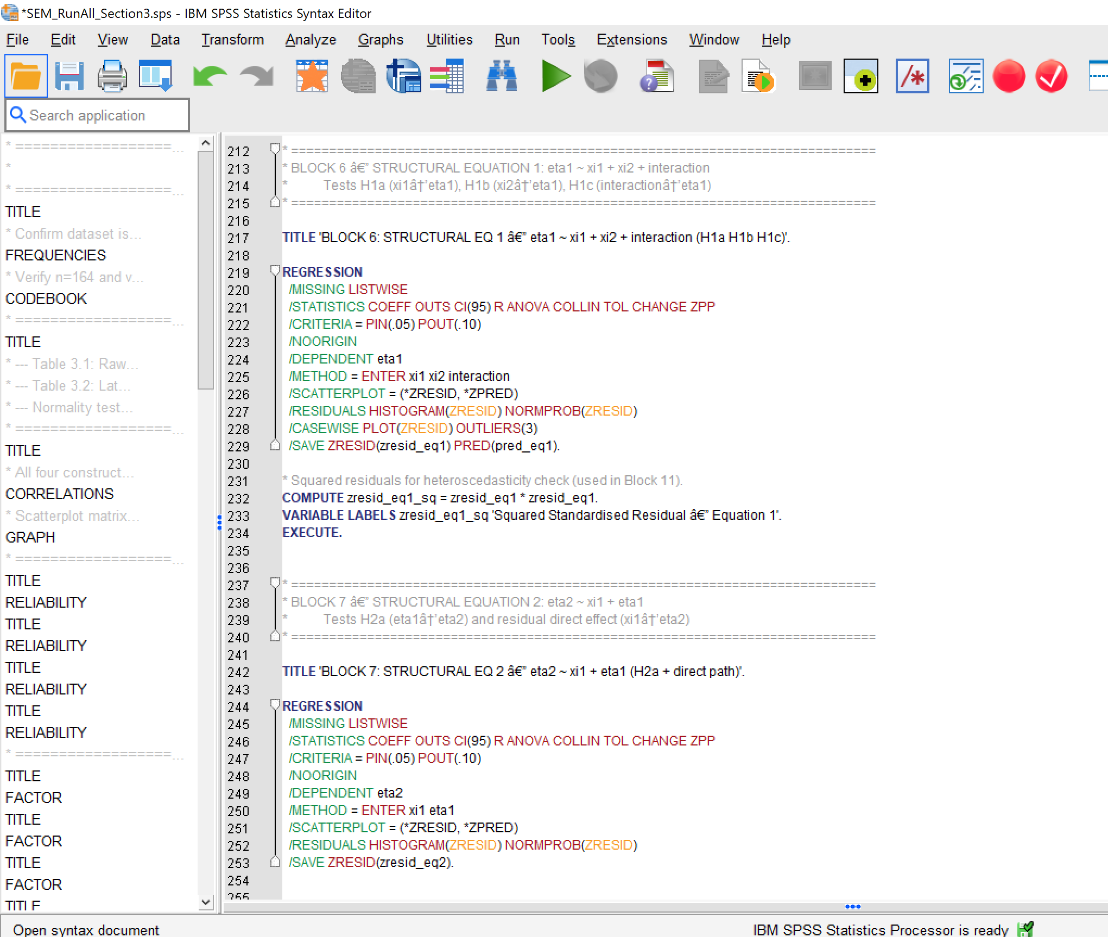

Figure 6: Extract of Sobel Test for Mediation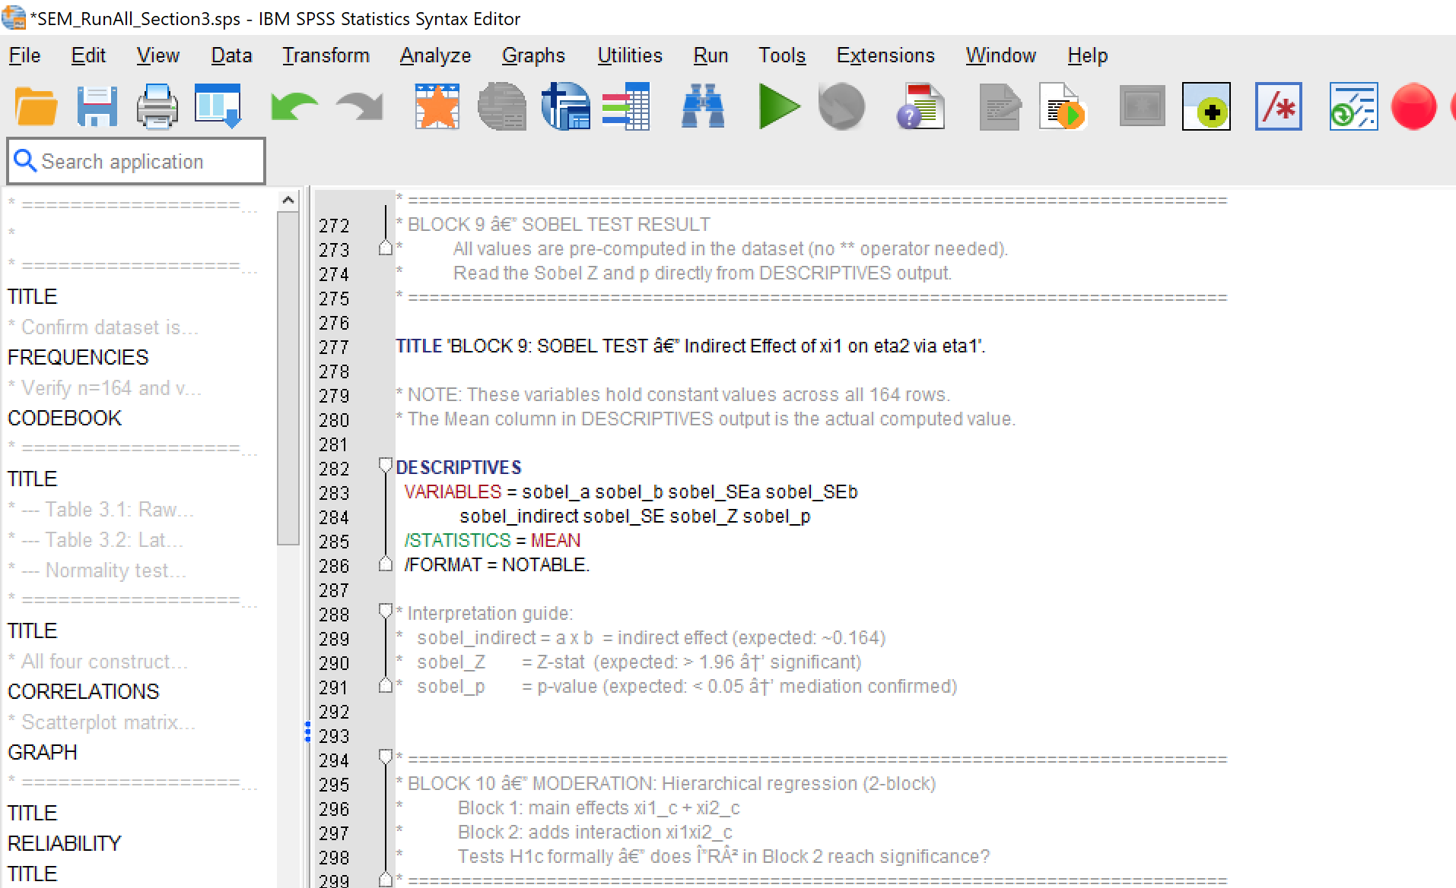

Figure 7: Extract of Moderation Analysis Syntax
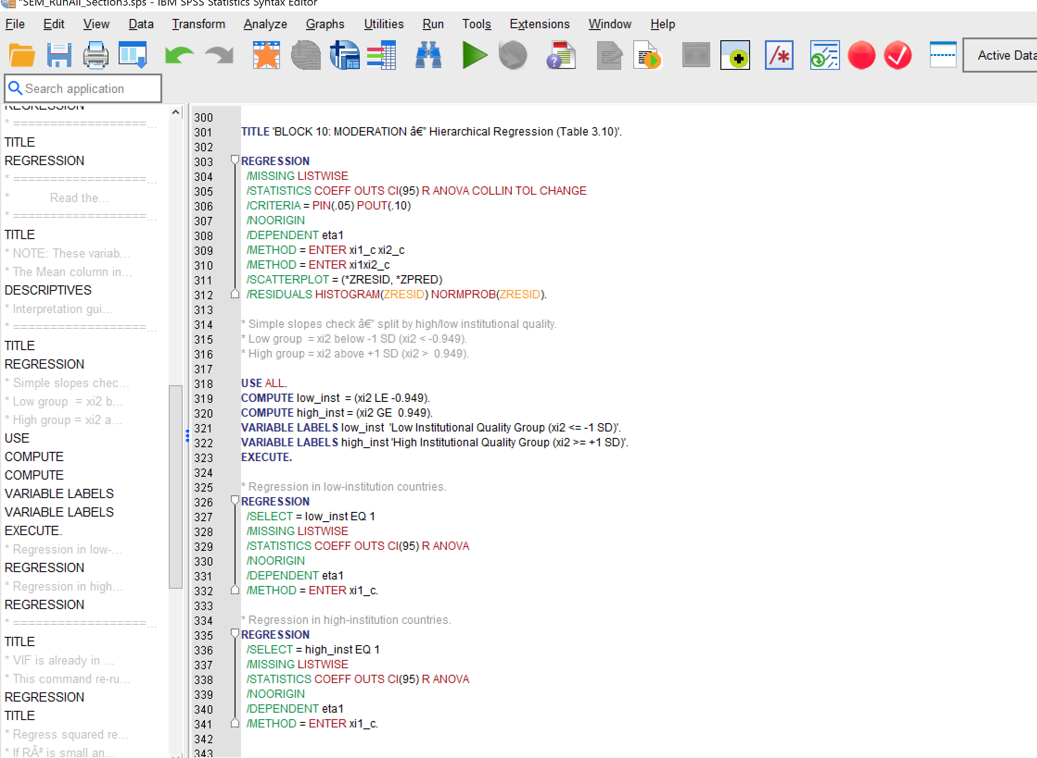

Appendix F: Form E0 Signed Off





