Artificial Intelligence Readiness and Supply Chain Performance: A Cross-National Analysis of Institutional Complementarity and the Limits of Mediation
Shakir Adeyemi Tewogbade
2026

Abstract
Purpose: National artificial intelligence (AI) readiness is widely assumed to raise supply chain (SC) performance, yet cross-national evidence on this relationship, and on the institutional conditions under which it holds, remains thin. This study re-examines these relationships using a fully reproducible Python analytical pipeline, replacing an earlier SPSS/AMOS-based pilot.
Design/methodology/approach: Drawing on a cross-national sample of 141 countries assembled from the World Bank Logistics Performance Index, World Development Indicators, Worldwide Governance Indicators, and the Oxford Insights Government AI Readiness Index, the study tests four hypotheses covering the direct effects of AI readiness and institutional quality on SC performance, their interaction, and the mediating role of SC performance in translating AI readiness into economic performance. The analytical strategy combines confirmatory factor analysis, Heterotrait-Monotrait (HTMT) discriminant validity testing, heteroskedasticity-robust moderated regression with Johnson-Neyman probing, and bias-corrected bootstrap mediation.
Findings: AI readiness and institutional quality are each strong, independent predictors of SC performance. Their interaction is positive and significant, indicating that institutional quality amplifies rather than substitutes for the contribution of AI readiness to SC performance - the reverse of the moderation sign reported in the preceding pilot study. SC performance does not mediate the relationship between AI readiness and economic performance; AI readiness instead exerts a strong direct effect on economic outcomes. HTMT testing additionally reveals substantial construct overlap between AI readiness and institutional quality, a measurement limitation not detected under conventional discriminant validity criteria.
Originality/value: The study contributes a reproducible, auditable method for reconciling cross-national indicators released on staggered schedules, an empirical reversal that challenges the dominant substitution narrative in the digital-transformation literature, and a fully open Python pipeline that supersedes a proprietary-software workflow.
Keywords: artificial intelligence readiness; supply chain performance; institutional quality; moderated mediation; cross-national analysis; structural equation modelling

1. Introduction
Artificial intelligence (AI) is reorganising the operational logic of global supply chains. Machine learning forecasting, computer-vision-enabled quality control, and algorithmic routing and inventory optimisation are displacing rule-based planning systems across manufacturing, retail, and logistics networks (Choi et al., 2023; Ivanov, 2023; Queiroz et al., 2022). These developments have shifted the locus of competitive advantage in supply chain management away from physical asset ownership and toward the capacity to generate, process, and act on data in real time. Firm-level studies document measurable gains in demand-forecasting accuracy, warehouse throughput, and disruption resilience attributable to AI adoption (Wamba et al., 2017; Ivanov & Dolgui, 2020). Yet supply chains are not purely firm-level phenomena: they are embedded in national infrastructures, regulatory environments, and human-capital bases that condition whether firm-level technological capability translates into system-level logistics performance.
This embeddedness is captured, at the macro level, by the concept of government AI readiness - a nation’s capacity to develop, deploy, and govern AI technologies through digital infrastructure, human capital, data governance, and regulatory frameworks. Global indices such as the Oxford Insights Government AI Readiness Index now rank AI capability across more than 190 countries, treating it as a strategic determinant of national competitiveness, with logistics-intensive and trade-dependent economies cited as particularly exposed to its effects. Complementing this, the World Bank’s Logistics Performance Index (LPI) offers a standardised, internationally comparable measure of supply chain performance spanning customs efficiency, infrastructure quality, international shipment reliability, tracking and tracing capability, logistics competence, and timeliness (World Bank, 2023; Stevic et al., 2024; El-Nakib & Elzarka, 2026). Together, these indices make it possible, for the first time at reasonable coverage, to test whether national AI capability is systematically associated with national logistics performance, rather than inferring the relationship from firm-level case evidence alone.
Despite the growth of both indices and of discourse on AI diffusion, empirical evidence linking AI readiness to supply chain performance at the cross-national level remains sparse. The literature on AI and supply chains is dominated by firm-level adoption studies (Queiroz et al., 2022; Kache & Seuring, 2017) or sector-specific applications (Ivanov & Dolgui, 2020), leaving open whether macro-level technological capability translates into systemic logistics outcomes, and under what institutional conditions it does so. A second, related gap concerns the economic payoff of this capability. A substantial literature on the productivity paradox and the economics of general-purpose technologies documents that returns to digital and AI investment are frequently deferred, uneven, and contingent on complementary organisational and institutional capabilities (Brynjolfsson & Hitt, 2000; Brynjolfsson et al., 2021; Goldfarb et al., 2023; Bucci et al., 2022). Whether supply chain performance is the channel through which AI readiness converts into measurable economic gains, or whether that conversion occurs through other mechanisms entirely, has not been tested directly at the cross-national level.
This study addresses both gaps. It examines, across a cross-national sample of 141 countries, (1) the extent to which government AI readiness and institutional quality jointly determine supply chain performance, including whether institutional quality strengthens or weakens the contribution of AI readiness, and (2) whether supply chain performance mediates the relationship between AI readiness and national economic performance. The analysis builds directly on an earlier pilot investigation of the same conceptual model, which was estimated using composite z-score indices in IBM SPSS and AMOS (Baron & Kenny, 1986 mediation steps, Sobel tests, and hierarchical moderated regression). That pilot flagged several unresolved issues: a pre-built analytic dataset that silently excluded the Logistics Performance Index from its final cross-section, severe, unaddressed skew and kurtosis in the economic-performance construct, discriminant validity assessed only via the comparatively insensitive Fornell-Larcker criterion, and an indirect-effect test (the Sobel test) known to rest on a distributional assumption that is frequently violated in finite samples.
This paper makes three contributions. First, it documents and applies a transparent, auditable “latest-available-year” reconciliation procedure for assembling a cross-national analytic sample from indicators that are released on staggered and non-overlapping schedules (the Logistics Performance Index, in particular, is fielded biennially and was not surveyed in the year originally targeted for the cross-section) - a procedure with applicability beyond this study wherever macro-indicator structural equation modelling must reconcile indices with different release cadences. Second, it reports a substantive empirical reversal: where the preceding pilot found that institutional quality attenuates the contribution of AI readiness to supply chain performance (a substitution pattern, consistent with diminishing returns as institutional capacity approaches its efficiency frontier), the present analysis finds the opposite - institutional quality amplifies that contribution (a complementarity pattern). Because this reversal survives heteroskedasticity-robust standard errors, variance-inflation-factor diagnostics, and influence-case exclusion, it is treated here as a genuine empirical finding meriting theoretical attention rather than as an estimation artefact, while still requiring confirmatory replication given the pilot-study scope of both analyses. Third, the paper replaces the original proprietary-software workflow with a fully open, version-controlled Python pipeline (using semopy, pingouin, and statsmodels) that regenerates every reported statistic and figure from source data, extending the reproducibility standard already established in the data-collection stage of the predecessor study.
The remainder of the paper is organised as follows. Section 2 reviews the literatures on technology adoption, institutional theory, and supply chain performance, and develops four hypotheses. Section 3 details the data sources, the sample-reconciliation procedure, construct operationalisation, and the analytical strategy. Section 4 reports the results. Section 5 discusses the findings in relation to the complementarity-substitution debate and to the predecessor study, and considers practical implications. Section 6 outlines limitations and directions for future research, and Section 7 concludes.

2. Literature Review and Hypothesis Development

2.1 Technology adoption and the Technology-Organisation-Environment framework
The Technology-Organisation-Environment (TOE) framework (Tornatzky & Fleischer, 1990) explains technology adoption and its performance consequences as a function of three interacting domains: the technological context (the availability and perceived advantage of a technology), the organisational context (resources, structure, and absorptive capacity), and the environmental context (industry structure, regulation, and competitive pressure). Although TOE was developed to explain firm-level adoption decisions, its logic extends naturally to the macro level when national AI readiness is treated as an aggregate technological-context endowment: a nation’s digital infrastructure, data governance regime, and AI-skilled workforce jointly determine the ceiling on how effectively AI can be deployed across its productive sectors, including logistics and supply chain management.
Empirical work at the firm level consistently finds that AI and big-data-analytics capability improve operational performance. Wamba et al. (2017) show that big-data-analytics capability enhances firm performance through dynamic capabilities; Maroufkhani et al. (2020) find that big-data-analytics adoption among small and medium enterprises is associated with performance gains contingent on organisational readiness; Choi et al. (2023) review evidence that analytics capability improves operations-management decision quality across forecasting, scheduling, and routing tasks. In the supply chain context specifically, Ivanov and Dolgui (2020) argue that digital-twin and AI-enabled visibility tools materially improve disruption-risk management, while Ivanov (2023) situates AI capability within a broader Industry 5.0 framework that links technological capacity to resilience and viability outcomes. Kache and Seuring (2017) caution, however, that the realised benefits of digital information capability in supply chain management are neither automatic nor uniform, and depend on organisational and relational factors that mediate the technology-performance link.
Translating this logic to the national level, the Technology Adoption Theory perspective underpinning this study’s first hypothesis holds that AI readiness functions as a macro-level analogue of firm-level technological capability: countries with stronger digital infrastructure, internet penetration, and AI-oriented policy frameworks possess a higher ceiling for logistics-system optimisation, independent of any single firm’s adoption decision, because national AI readiness shapes the availability of AI-complementary inputs (connectivity, data infrastructure, and a digitally skilled labour pool) on which firm-level adoption throughout the logistics sector depends.
H1a: AI Readiness (ξ1) positively influences Supply Chain Performance (η1).

2.2 Institutional theory, complementarity, and the limits of technological determinism
Institutional theory holds that formal and informal institutions - the “rules of the game” that structure economic exchange (North, 1990) - shape organisational behaviour and economic outcomes independently of, and often prior to, technological capability. DiMaggio and Powell (1983) show that organisations operating within a common institutional field converge toward similar structures and practices under coercive, mimetic, and normative pressures, implying that governance quality diffuses efficiency-enhancing norms across an economy’s firms and logistics intermediaries. Scott (2008) extends this into a three-pillar account of institutions (regulative, normative, and cultural-cognitive) that jointly determine the transaction costs and uncertainty firms face when coordinating across organisational and national boundaries - precisely the coordination problem that cross-border logistics must solve. Empirically, governance quality - captured here through the World Bank’s Worldwide Governance Indicators (WGI; Kaufmann et al., 2011) - has been linked to lower trade costs, more reliable customs processing, and stronger institutional support for logistics infrastructure investment (Rodriguez-Pose & Ketterer, 2020; Acemoglu & Robinson, 2019; Dollar & Kraay, 2003). This motivates a direct institutional-quality effect on supply chain performance that is independent of AI readiness.
H1b: Institutional Quality (ξ2) positively influences Supply Chain Performance (η1).
The more contested question concerns how institutional quality and AI readiness interact. Two theoretical positions offer opposing predictions, and the literature does not resolve between them.
The complementarity position, rooted in the economics of general-purpose technologies and in the resource-based and dynamic-capabilities traditions, holds that institutional quality is a complementary asset (Teece, 1986) that amplifies rather than substitutes for technological capability. Bresnahan et al. (2002) show that information-technology returns at the firm level are conditional on complementary investments in organisational practice, and Brynjolfsson and Hitt (2000) and Brynjolfsson et al. (2021) extend this logic to argue that general-purpose technologies such as AI exhibit a “productivity J-curve”: their payoff is initially depressed and then amplified as complementary intangible capital - including governance and institutional capacity - accumulates. Absorptive-capacity theory (Cohen & Levinthal, 1990) provides a parallel mechanism at the national level: strong institutions build the administrative and regulatory capacity needed to absorb, diffuse, and operationalise new technological capability across an economy’s logistics intermediaries - customs authorities, port operators, and regulatory agencies - so that AI-enabled systems can be integrated into trade-facilitation processes rather than operating in isolation from them. Under this account, AI readiness should matter more, not less, for supply chain performance as institutional quality rises, because capable institutions provide the regulatory certainty, data-governance frameworks, and administrative capacity that allow AI-enabled logistics systems to be deployed at scale.
The substitution position, by contrast, treats institutional quality and technological capability as alternative routes to the same efficiency frontier. In this account, countries with already-strong institutions have largely exhausted the easily achievable efficiency gains through regulatory and administrative means, leaving comparatively little additional variance for AI readiness to explain; AI readiness, by this logic, delivers its largest marginal gains precisely where institutional capacity is weakest, acting as a compensatory mechanism rather than an amplifier. Raisch and Krakowski (2021) frame a structurally similar tension in their automation-augmentation paradox, in which the marginal value of automating technology depends on how much slack remains in existing (here, institutional) processes. The predecessor pilot study to this paper reported evidence consistent with the substitution account: a negative and significant interaction between AI readiness and institutional quality in predicting supply chain performance, interpreted as diminishing marginal returns to AI capability as institutional development approaches its frontier.
Because the theoretical literature does not adjudicate between these accounts, and because the predecessor pilot’s negative-interaction finding was itself based on a single, methodologically limited specification, this study tests the moderation hypothesis without committing in advance to either the complementarity or substitution direction, while noting that the complementarity account carries the stronger and more extensively replicated theoretical pedigree in the general-purpose-technology literature.
H1c: Institutional Quality (ξ2) moderates the relationship between AI Readiness (ξ1) and Supply Chain Performance (η1).

2.3 Supply chain performance theory and the transmission channel to economic outcomes
Supply chain performance theory treats logistics efficiency - the speed, reliability, and cost-effectiveness with which goods move across and within national borders - as a transmission mechanism linking firm- and sector-level capability to macroeconomic outcomes, principally through trade facilitation, lower transaction costs, and productivity spillovers. Empirical work using the Logistics Performance Index finds robust associations between logistics performance and trade volumes (Marti et al., 2014), export performance (Portugal-Perez & Wilson, 2012), and economic growth mediated by seaborne trade (Munim & Schramm, 2018). Hoekman and Shepherd (2015) show that improvements in trade-facilitation infrastructure disproportionately benefit lower-income economies, while Myovella et al. (2020) link digitalisation specifically to economic growth across both Sub-Saharan African and OECD economies, suggesting that the digitalisation-growth relationship is not confined to advanced economies.
If AI readiness raises supply chain performance (H1a), and supply chain performance in turn drives economic outcomes, then supply chain performance should act as a mediating channel through which AI readiness converts into measurable economic gains - higher trade volumes, greater export intensity, and higher income levels - beyond whatever direct effect AI readiness has on economic performance through other channels such as productivity growth or innovation diffusion (Goldfarb et al., 2023). This mediation hypothesis follows directly from chaining the technology-adoption logic of H1a to the established logistics-to-growth relationship documented in the trade-facilitation literature.
This transmission logic also underlies much of the practitioner and policy discourse surrounding digital trade facilitation, in which investment in AI-enabled customs risk-management, electronic single-window trade systems, and algorithmic port-scheduling is frequently justified by an implicit assumption that logistics-efficiency gains are the primary route through which digital investment pays off economically (World Bank, 2023). Myovella et al. (2020) complicate this assumption somewhat by showing that the digitalisation-growth relationship operates differently across development contexts - more strongly through infrastructure channels in Sub-Saharan Africa and more strongly through productivity channels in OECD economies - which raises the possibility that a single logistics-performance mediator may not adequately capture AI readiness’s economic transmission mechanism across a heterogeneous, 141-country cross-national sample spanning every income tier. Testing H2a directly, rather than assuming the mediated pathway holds, is therefore both theoretically motivated and practically consequential for how digital trade-facilitation investment is justified and sequenced.
H2a: Supply Chain Performance (η1) mediates the relationship between AI Readiness (ξ1) and Economic Performance (η2).

2.4 Synthesis and research gap
Three gaps emerge from this review. First, the TOE-based prediction that AI readiness improves supply chain performance (H1a) has strong firm-level support but has rarely been tested with internationally comparable, country-level data covering both AI capability and logistics outcomes simultaneously. Second, the complementarity-versus-substitution question (H1c) is theoretically unresolved, empirically under-tested at the macro level, and - based on the single prior cross-national test available (the predecessor pilot) - sensitive to data-construction and estimation choices in ways that warrant independent re-examination using a corrected analytic sample and more robust inferential methods. Third, the assumption that supply chain performance is the primary channel through which AI readiness delivers economic returns (H2a) has not been directly tested against the alternative that AI’s economic effects bypass logistics performance entirely. This study addresses all three gaps using a single, unified cross-national model estimated on a corrected and fully documented analytic sample.
Figure 1 summarises the conceptual model and the four hypotheses tested below, including the hypothesised moderation of the AI-readiness-to-SC-performance path by institutional quality (H1c) and the hypothesised mediation of the AI-readiness-to-economic-performance relationship by SC performance (H2a).
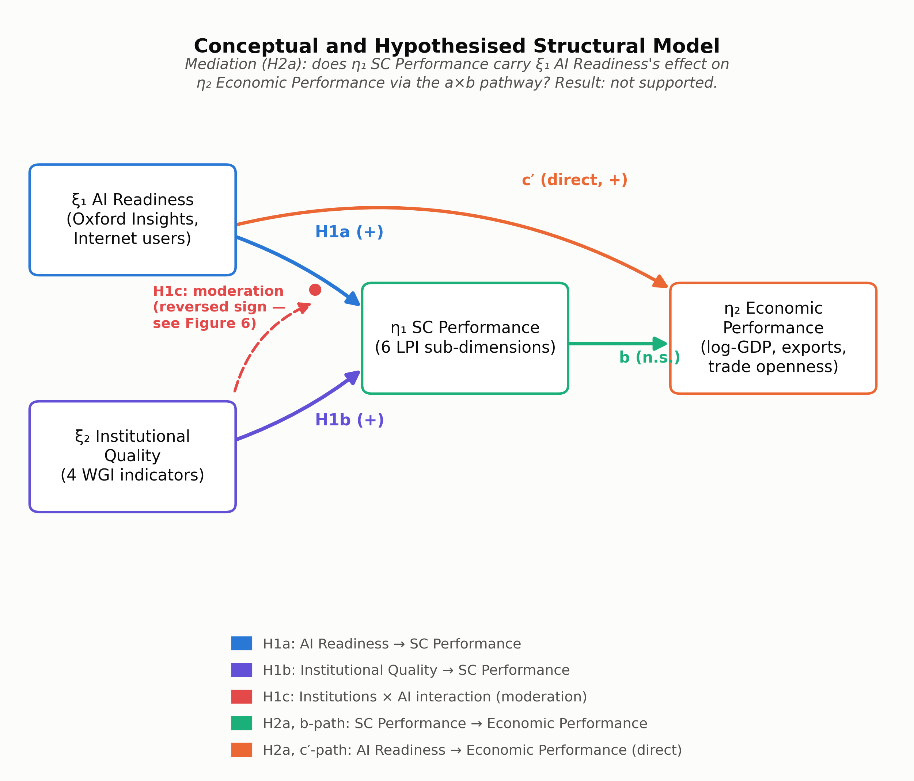
Figure 1. Conceptual and hypothesised structural model, showing H1a, H1b, H1c (moderation) and H2a (mediation).

3. Methodology

3.1 Research philosophy, approach, and design
This study adopts a post-positivist epistemological position: it treats AI readiness, institutional quality, supply chain performance, and economic performance as objectively existing but only imperfectly observable phenomena, measured here through composite proxy indicators drawn from secondary, publicly available datasets (Ryan, 2018; Bryman, 2021). This position licenses the use of proxy variables and statistical modelling while requiring explicit acknowledgement of measurement error and contextual heterogeneity - an acknowledgement this paper makes directly through its discriminant-validity and model-fit diagnostics in Section 4. A deductive approach is employed throughout: the hypotheses in Section 2 are derived from established theory and tested against observed cross-national data, consistent with standard practice in quantitative international business and operations-management research (Saunders et al., 2023; Barrett & Younas, 2024). The study design is a cross-sectional, cross-national comparative analysis of secondary macro-level data, chosen because the research questions concern relationships between national-level constructs at a single observation period rather than within-country change over time (Baltagi, 2021; Wooldridge, 2021).
This analysis is explicitly framed, as in its predecessor, as a pilot-scale investigation. The constructs under study (AI readiness and institutional quality in particular) are latent and multidimensional, the four data sources combined here were not designed to be harmonised with one another, and the moderation result reported in Section 4 reverses the sign found in the only other cross-national test of the same hypothesis. Each of these considerations counsels against treating the present findings as confirmatory, and in favour of treating them as a rigorously estimated basis for a pre-registered, confirmatory follow-up study - a recommendation developed further in Section 6.

3.2 Data sources
Four secondary data sources are combined. AI readiness indicators are drawn from the Oxford Insights Government AI Readiness Index (2021-2025 report years) together with World Bank World Development Indicators (WDI) internet-penetration and R&D-expenditure series. Supply chain performance indicators are drawn from the World Bank Logistics Performance Index (LPI), a survey-based measure of international logistics professionals’ perceptions of a country’s trade-logistics environment, covering six sub-dimensions: customs, infrastructure, international shipments, logistics quality and competence, tracking and tracing, and timeliness. Economic performance indicators (GDP per capita, exports as a percentage of GDP, and trade openness) are drawn from WDI. Institutional quality indicators (government effectiveness, rule of law, regulatory quality, and control of corruption) are drawn from the World Bank Worldwide Governance Indicators (Kaufmann et al., 2011). All four sources are publicly accessible and used under their respective open-access policies; no primary data collection or human-participant involvement occurs in this study.

3.3 Sample construction: a documented reconciliation procedure
A material complication in combining these sources is that they are released on different and non-overlapping schedules. The LPI, in particular, is fielded biennially (2010, 2012, 2014, 2016, 2018, and 2022) rather than annually, and was not fielded at all in 2023 - the single year originally targeted for the analytic cross-section in a pre-existing consolidated dataset supplied alongside this study’s source materials. Diagnostic inspection of that pre-built file found every LPI sub-dimension entirely missing for the targeted year, despite the underlying LPI data existing and being usable for 2022, and despite the pre-built file’s own internal documentation (correctly) reporting that zero countries met its listwise-completeness criterion. Rather than proceeding with this non-functional cross-section, or arbitrarily restricting the sample to a single survey year and discarding most of the LPI’s temporal coverage, this study applies a documented “latest-available-year” reconciliation rule: for every indicator sourced from the underlying country-year panel (spanning 2010-2025), each country’s most recent non-missing observation is selected, and the originating year is retained in a companion vintage-year field so that every value in the final analytic file is auditable back to its source year. World Bank regional and income-group aggregates (identified via a missing income-classification field) are excluded, leaving 217 sovereign countries and territories as the maximal cross-national universe before any construct-level completeness filter is applied.
Under this rule, the LPI sub-dimensions resolve predominantly to 2022 (138 of 217 countries), with most remaining countries resolving to 2018 or 2016; governance and economic indicators resolve almost entirely to 2023-2024, the most recent years for which World Development Indicators and Worldwide Governance Indicators coverage is available. This procedure is deliberately conservative relative to the predecessor pilot’s approach, which appears to have tolerated partial missingness within a composite average rather than requiring every indicator in a construct to be observed for a given country. Requiring listwise completeness across all indicators within each of the four constructs - AI readiness, SC performance, economic performance, and institutional quality - yields a final analytic sample of 141 countries, compared with the predecessor pilot’s reported sample of approximately 164. This reduction reflects a stricter and more auditable completeness standard, not a change in the underlying country coverage of the source data, and the full indicator-by-indicator coverage accounting is retained in the study’s public data-documentation file for transparency.

3.4 Construct operationalisation
Table 1 summarises the operationalisation of the four constructs. Two departures from the predecessor pilot’s operationalisation are made on empirical and methodological grounds rather than by default replication. First, the SC Performance construct excludes the LPI’s own overall score, since that score is an arithmetic composite of the six sub-dimensions already included as items; retaining it alongside its own components would be tautological for reliability and factor-analytic estimation. Second, the Economic Performance construct uses the natural logarithm of GDP per capita rather than its raw (or raw-then-standardised) value. The predecessor pilot identified severe positive skew (2.368) and excess kurtosis (8.157) in this construct, attributable to a small number of very high-income outlier economies, and explicitly flagged this as an unresolved limitation of its analysis; log-transformation is the standard remedy for this form of right-skewed, multiplicatively distributed economic data and is applied here prior to standardisation.
Table 1. Construct operationalisation
Construct | Items | Source | Notes
ξ1 AI Readiness | Avg. AI Readiness score (Oxford Insights, 2021-2025 average); Internet users (% of population) | Oxford Insights Government AI Readiness Index; World Bank WDI | 2-item construct. R&D expenditure (% GDP) tested as a third item and excluded (lowers α from 0.796 to 0.640; reduces complete-case N from 174 to 124).
η1 SC Performance | Logistics Performance Index sub-dimensions: Customs; Infrastructure; International shipments; Logistics quality & competence; Tracking & tracing; Timeliness (6 items) | World Bank Logistics Performance Index | LPI_overall excluded: it is an arithmetic composite of the six retained sub-dimensions, so its inclusion would be circular.
η2 Economic Performance | log(GDP per capita, constant 2015 US$); Exports (% of GDP); Trade openness | World Bank WDI | GDP per capita is log-transformed prior to standardisation to correct the severe skew/kurtosis identified, but not resolved, in the predecessor pilot.
ξ2 Institutional Quality | Government effectiveness; Rule of law; Regulatory quality; Control of corruption (4 items) | World Bank Worldwide Governance Indicators | Unchanged from the predecessor pilot.
A candidate third indicator for AI Readiness - R&D expenditure as a percentage of GDP - was evaluated and excluded: adding it reduced the construct’s internal consistency (Cronbach’s alpha fell from 0.796 to 0.640) and, because R&D expenditure data are considerably sparser than the two retained indicators, would have reduced the AI-readiness-complete country count from 174 to 124. It is retained in the public dataset as a raw variable for robustness checking but is not part of the construct used in the analyses reported below.

3.5 Analytical strategy
The analytical strategy proceeds in five stages, each chosen to improve on a specific limitation of the predecessor pilot’s SPSS/AMOS workflow.
First, descriptive and distributional diagnostics (mean, standard deviation, skewness, excess kurtosis, and the Shapiro-Wilk test) are computed for each composite construct, both to characterise the sample and to verify that the log-transformation described above resolves the previously identified non-normality in the Economic Performance construct.
Second, measurement-model reliability and validity are assessed using both classical and modern criteria. Cronbach’s alpha is computed for each construct as a baseline internal-consistency measure. A confirmatory factor analysis (CFA), with one latent factor per construct and standardised item loadings, is then fitted using the semopy package to derive Composite Reliability (CR) and Average Variance Extracted (AVE) from the fitted loadings, following standard formulae (CR = (Σλ)²/[(Σλ)²+Σ(1-λ²)]; AVE = Σλ²/n). Discriminant validity is assessed using both the traditional Fornell-Larcker criterion (Fornell & Larcker, 1981), which compares each construct’s √AVE against its correlations with other constructs, and the stricter Heterotrait-Monotrait ratio (HTMT; Henseler et al., 2015), which is known to detect discriminant-validity problems that the Fornell-Larcker criterion misses, particularly among conceptually adjacent constructs. Measurement-model fit is additionally reported using chi-square, the Comparative Fit Index (CFI), the Tucker-Lewis Index (TLI), the Root Mean Square Error of Approximation (RMSEA), and the Standardised Root Mean Square Residual (SRMR), evaluated against the conventional cut-offs summarised by Hu and Bentler (1999).
Third, the structural hypotheses (H1a, H1b, H1c) are tested via moderated ordinary least squares regression of SC Performance on mean-centred AI Readiness, mean-centred Institutional Quality, and their product term, following the two-step measurement-then-structural strategy recommended by Anderson and Gerbing (1988): the CFA stage establishes construct validity, and the simpler, numerically stable composite-score regression stage tests the structural hypotheses. (Section 4.5 reports the diagnostic basis for preferring this two-step strategy over a single-step latent-variable structural model.) Standard errors throughout are estimated using the heteroskedasticity-consistent HC3 estimator (White, 1980; MacKinnon & White, 1985) rather than the ordinary least squares default, and variance inflation factors (O’Brien, 2007) are reported to assess multicollinearity among the centred predictors and their product term.
Fourth, the moderation hypothesis (H1c) is probed beyond a single interaction coefficient using simple-slopes analysis at the mean and at ±1 standard deviation of the moderator, and using the Johnson-Neyman technique (Johnson & Neyman, 1936; Hayes & Matthes, 2009), which identifies the exact range of the moderator over which the conditional effect of AI readiness on SC performance is statistically significant, rather than relying on an arbitrary trichotomisation of the moderator.
Fifth, the mediation hypothesis (H2a) is tested using bias-corrected bootstrap confidence intervals for the indirect effect (5,000 resamples, fixed random seed for reproducibility), rather than the Sobel test used in the predecessor pilot. The Sobel test assumes that the sampling distribution of the product of two regression coefficients (the indirect effect, a×b) is normal, an assumption that is frequently violated because the product of two normally distributed variables is not itself normal, and is further known to have low statistical power relative to resampling-based alternatives (Preacher & Hayes, 2004, 2008). Bootstrap resampling makes no such distributional assumption and is now the recommended default for mediation inference (Hayes, 2018). For each of the 5,000 resamples, the full country sample is resampled with replacement, the a-path (AI Readiness → SC Performance) and b-path (SC Performance → Economic Performance, controlling for AI Readiness) coefficients are re-estimated, and their product is retained; the resulting empirical distribution of 5,000 indirect-effect estimates is then used to construct a percentile-based confidence interval for the population indirect effect. An indirect effect is deemed statistically supported only if this interval excludes zero.
All model-fitting procedures in this study use maximum-likelihood estimation as implemented in their respective Python packages (semopy for the confirmatory factor analysis and structural equation models; statsmodels for the regression-based structural tests), with convergence verified by inspection of optimiser output and, for the CFA and structural models, by confirming that all estimated error variances remain positive (an absence of Heywood cases). Where the one-step structural model produces the numerically unstable estimates discussed in Section 4.4, this instability is itself verified to be a genuine estimation-identification issue rather than a non-convergence artefact, by confirming that the optimiser reports successful convergence despite the implausible parameter values - precisely the signature of empirical under-identification rather than a failed optimisation run.

3.6 Reproducibility
All analyses are implemented in Python 3 using pandas and numpy for data management, semopy for confirmatory factor analysis, statsmodels for regression and robust inference, scipy for distributional tests, and pingouin for selected reliability and mediation procedures, in place of the IBM SPSS and AMOS software used in the predecessor pilot. The complete analytic pipeline, from raw-data reconciliation through final figure generation, is version-controlled and executes end to end from a single entry script, so that every statistic and figure reported in Section 4 can be regenerated directly from the source data without manual intervention.

3.7 Ethical considerations and data availability
This study uses exclusively macro-level, publicly accessible secondary data; no primary data collection, human-participant recruitment, or individual-level identifying information is involved at any stage, and all four source databases (World Bank, Oxford Insights, ITU, and Stanford HAI, where applicable) are used in accordance with their respective open-access and academic-use terms. Full source attribution, the reconciliation procedure described in Section 3.3, and the construct-coverage accounting underlying the final 141-country sample are documented in a publicly available data-notes file accompanying the analytic pipeline, so that the sample-construction decisions reported narratively here can be independently audited rather than taken on trust.

4. Results

4.1 Descriptive statistics
Table 2 reports descriptive statistics for the four composite constructs across the analytic sample (N = 141). AI Readiness, SC Performance, and Institutional Quality each approximate normality within conventional tolerances (|skewness| < 0.5, |excess kurtosis| < 1.1). Economic Performance, even after the log-transformation of GDP per capita described in Section 3.4, retains the largest residual skew (1.39) and kurtosis (3.59) of the four constructs - a substantial improvement on the raw (pre-log) GDP-per-capita skew of 1.91 and kurtosis of 3.42, but not a complete resolution, because the construct’s other two items, exports as a percentage of GDP and trade openness, are themselves right-skewed, bounded-below ratio variables. Figure 2 plots the distribution of each construct, and Figure 3 isolates the before/after effect of the log-transformation on GDP per capita specifically, confirming that the transformation addresses the specific limitation the predecessor pilot identified but left unresolved (raw log-GDP-per-capita skew falls from 1.91 to -0.04 and kurtosis from 3.42 to -0.99, essentially eliminating the problem at the item level; the residual construct-level non-normality in Table 2 originates in the two trade-ratio items, not in GDP per capita).
Table 2. Descriptive statistics for the four composite constructs (N = 141)
Construct | N | Mean | SD | Skewness | Kurtosis | Shapiro-Wilk p
ξ1 AI Readiness | 141 | 0.00 | 0.94 | -0.36 | -1.05 | <.001
η1 SC Performance | 141 | 0.00 | 0.95 | 0.44 | -0.88 | <.001
η2 Economic Performance | 141 | 0.00 | 0.87 | 1.39 | 3.59 | <.001
ξ2 Institutional Quality | 141 | 0.00 | 0.98 | 0.32 | -0.75 | .004
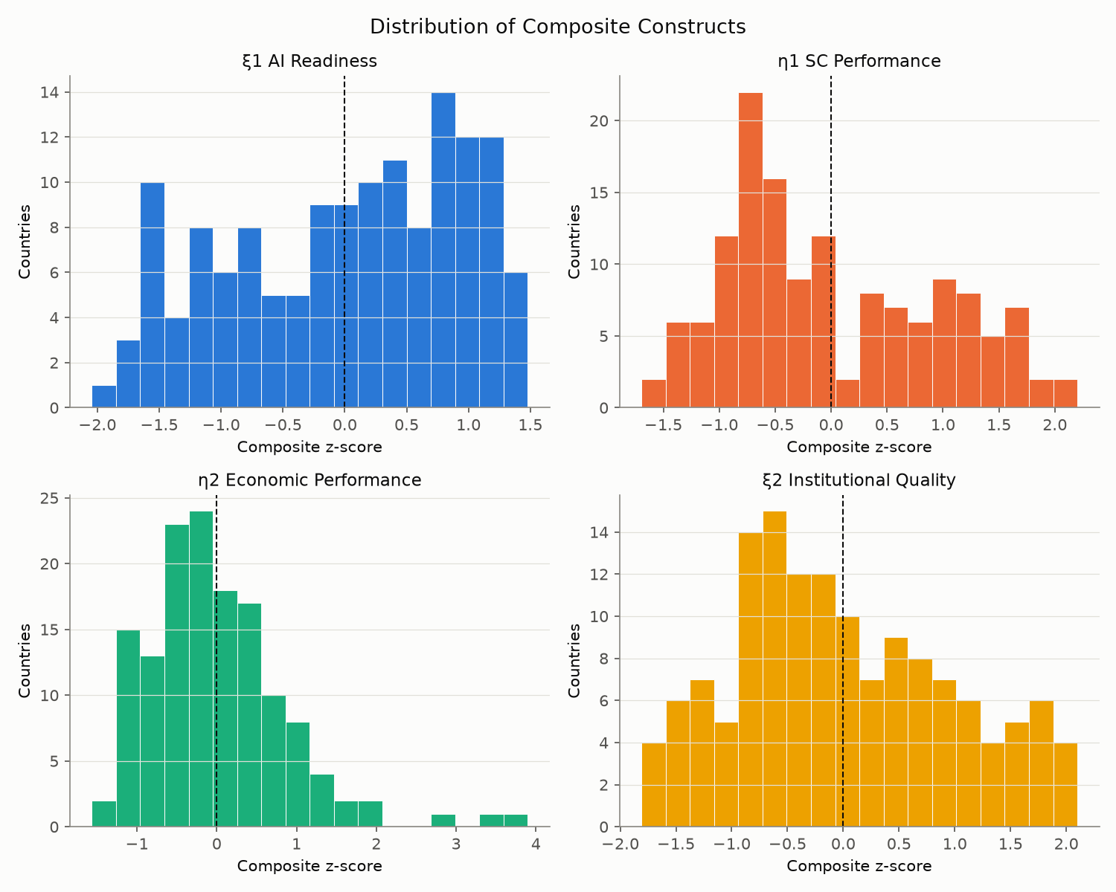
Figure 2. Distribution of the four composite constructs.
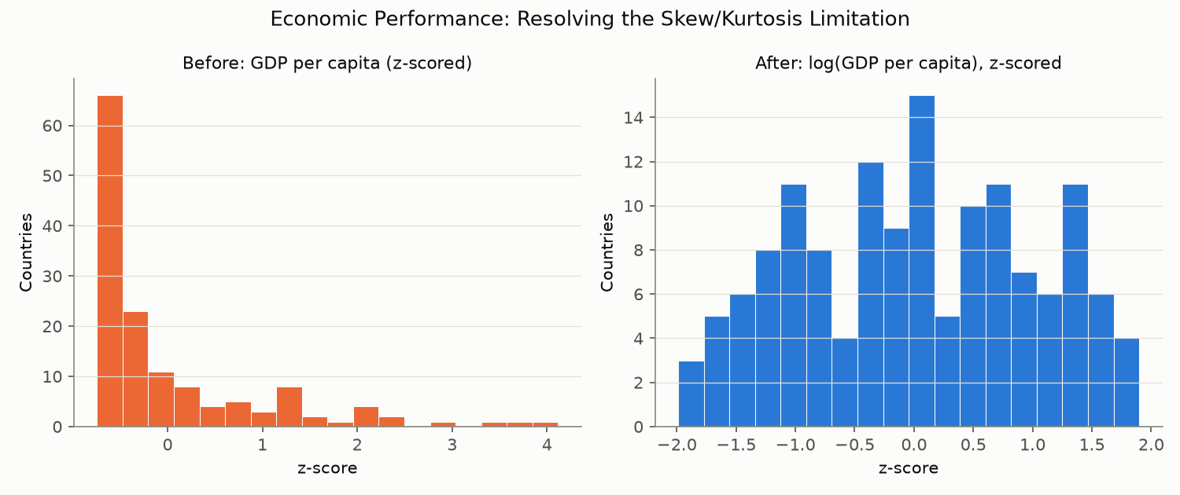
Figure 3. Economic Performance: resolving the skew/kurtosis limitation. Left: GDP per capita, z-scored (raw). Right: log(GDP per capita), z-scored.

4.2 Correlation structure and cross-national geography
Table 3 and Figure 4 report the Pearson correlation matrix of the four composite constructs. All pairwise correlations are positive and substantial: AI Readiness correlates 0.83 with SC Performance, 0.83 with Institutional Quality, and 0.66 with Economic Performance; SC Performance correlates 0.85 with Institutional Quality and 0.59 with Economic Performance; Institutional Quality correlates 0.66 with Economic Performance. This pattern is consistent in direction and relative magnitude with the predecessor pilot’s reported correlations (AI-SC: 0.79; Institutions-SC: 0.84; AI-Institutions: 0.80; AI-Economic: 0.55; SC-Economic: 0.56), despite the two studies drawing on independently reconstructed analytic samples - a useful cross-check suggesting the underlying relationships are a stable property of the data rather than an artefact of either sample-construction procedure.
Table 3. Pearson correlation matrix of the four composite constructs
 | ξ1 AI Readiness | η1 SC Performance | η2 Economic Performance | ξ2 Institutional Quality
ξ1 AI Readiness | 1.00
η1 SC Performance | 0.83 | 1.00
η2 Economic Performance | 0.66 | 0.59 | 1.00
ξ2 Institutional Quality | 0.83 | 0.85 | 0.66 | 1.00
Note. All correlations significant at p < .001.
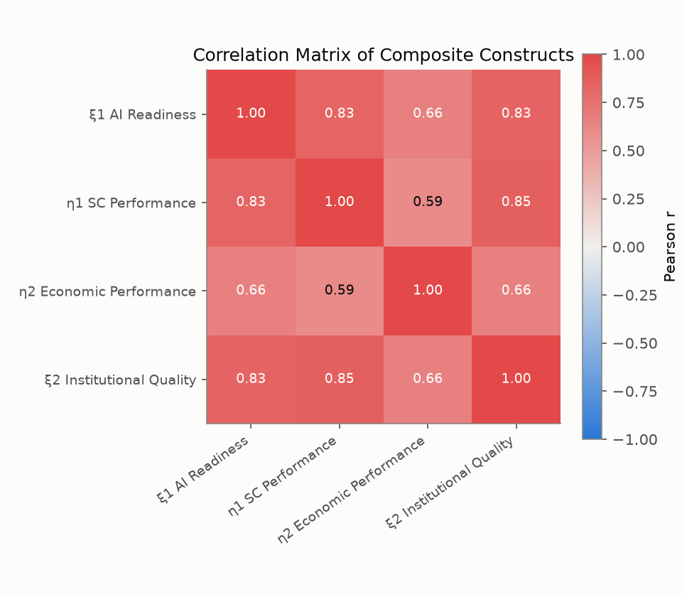
Figure 4. Correlation matrix of composite constructs.
Figures 5 and 6 present two complementary views of how these constructs are distributed geographically, neither of which was reported in the predecessor pilot. Figure 5 maps each composite construct by country, showing a consistent geographic core of high AI-readiness, high-institutional-quality, high-SC-performance economies concentrated in North America, Western and Northern Europe, and parts of East Asia and the Gulf, with Economic Performance showing a broadly similar but visibly more concentrated pattern reflecting the construct’s residual skew. Figure 6 decomposes each construct’s distribution by World Bank region using regional box plots ordered by median: Europe & Central Asia and East Asia & Pacific lead on AI Readiness and SC Performance, while Sub-Saharan Africa and South Asia occupy the lowest quartiles on every construct except, notably, Economic Performance, where Middle East & North Africa’s wide interquartile range (driven by resource-exporting high-income economies alongside lower-income economies within the same regional grouping) illustrates that regional averages conceal substantial within-region heterogeneity.
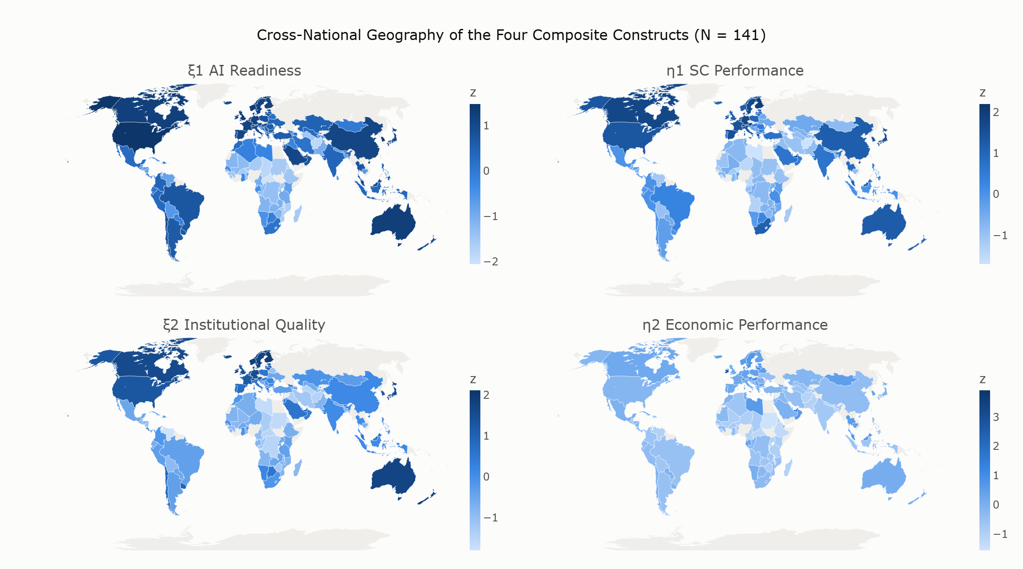
Figure 5. Cross-national geography of the four composite constructs.
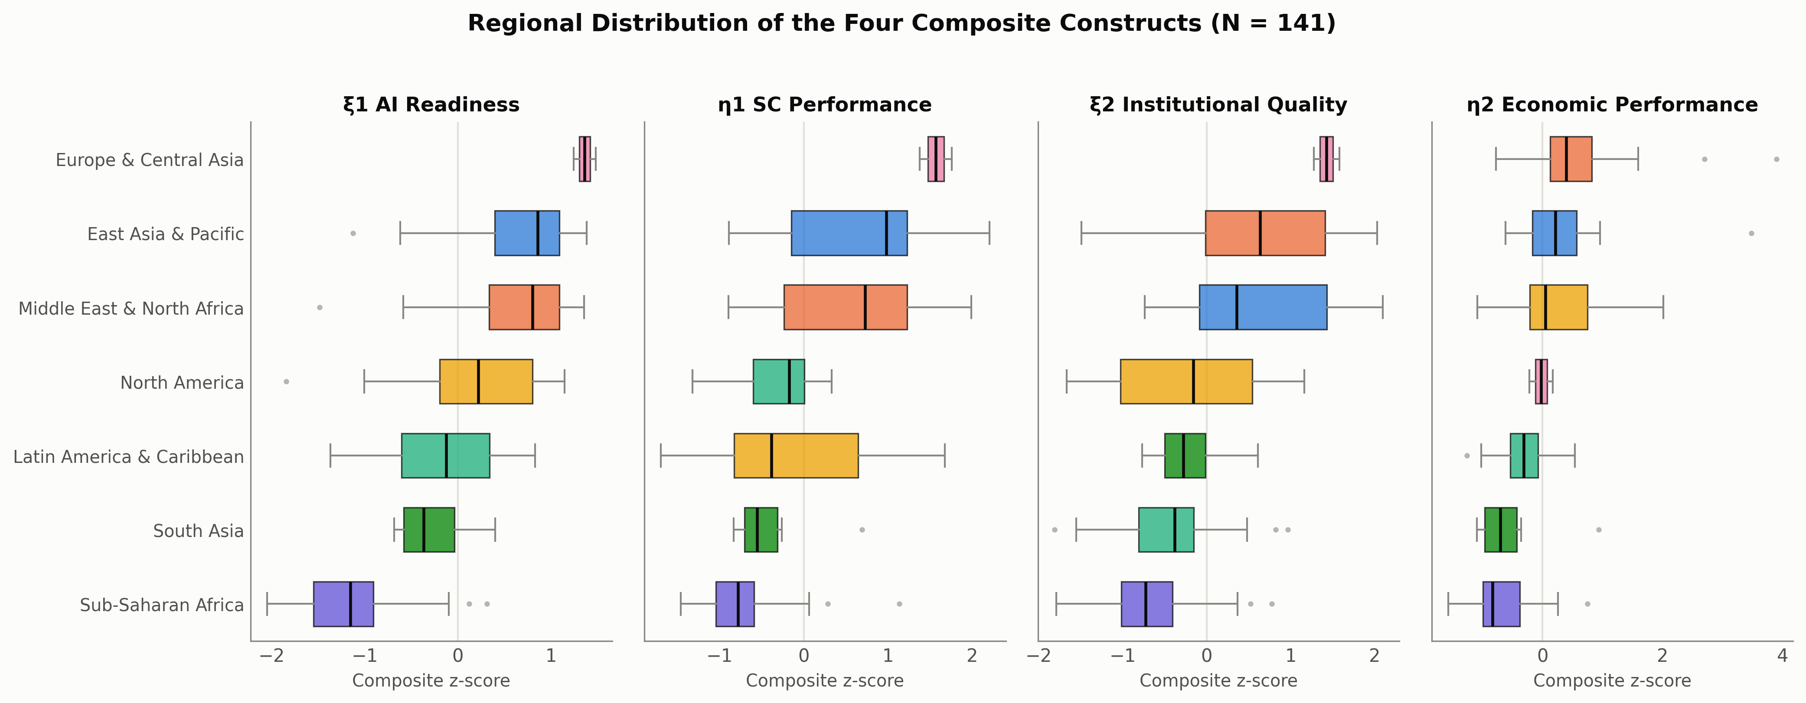
Figure 6. Regional distribution of the four composite constructs (N = 141), box plots ordered by regional median.
Figure 7 combines AI Readiness and SC Performance in a single bubble chart, sized by population and coloured by World Bank region, to surface relationships the correlation coefficient alone cannot show. Three patterns are visible. First, the largest economies by population - the United States, China, India, Indonesia, and Brazil - span a wide range of the AI-readiness distribution despite their shared demographic scale, indicating that population size itself is not a strong determinant of either construct. Second, the positive AI-readiness-to-SC-performance association visible in the aggregate correlation holds within every major region, not only between regions, meaning the pooled correlation is not solely an artefact of between-region clustering. Third, Sub-Saharan African economies occupy a distinct lower-left cluster on both dimensions simultaneously, consistent with the regional pattern in Figure 6, while a small number of positive outliers (including India, whose SC Performance substantially exceeds what its AI Readiness alone would predict) suggest that logistics performance can, in specific national contexts, outpace AI readiness - a reminder that the aggregate relationship characterises a central tendency rather than a deterministic rule.
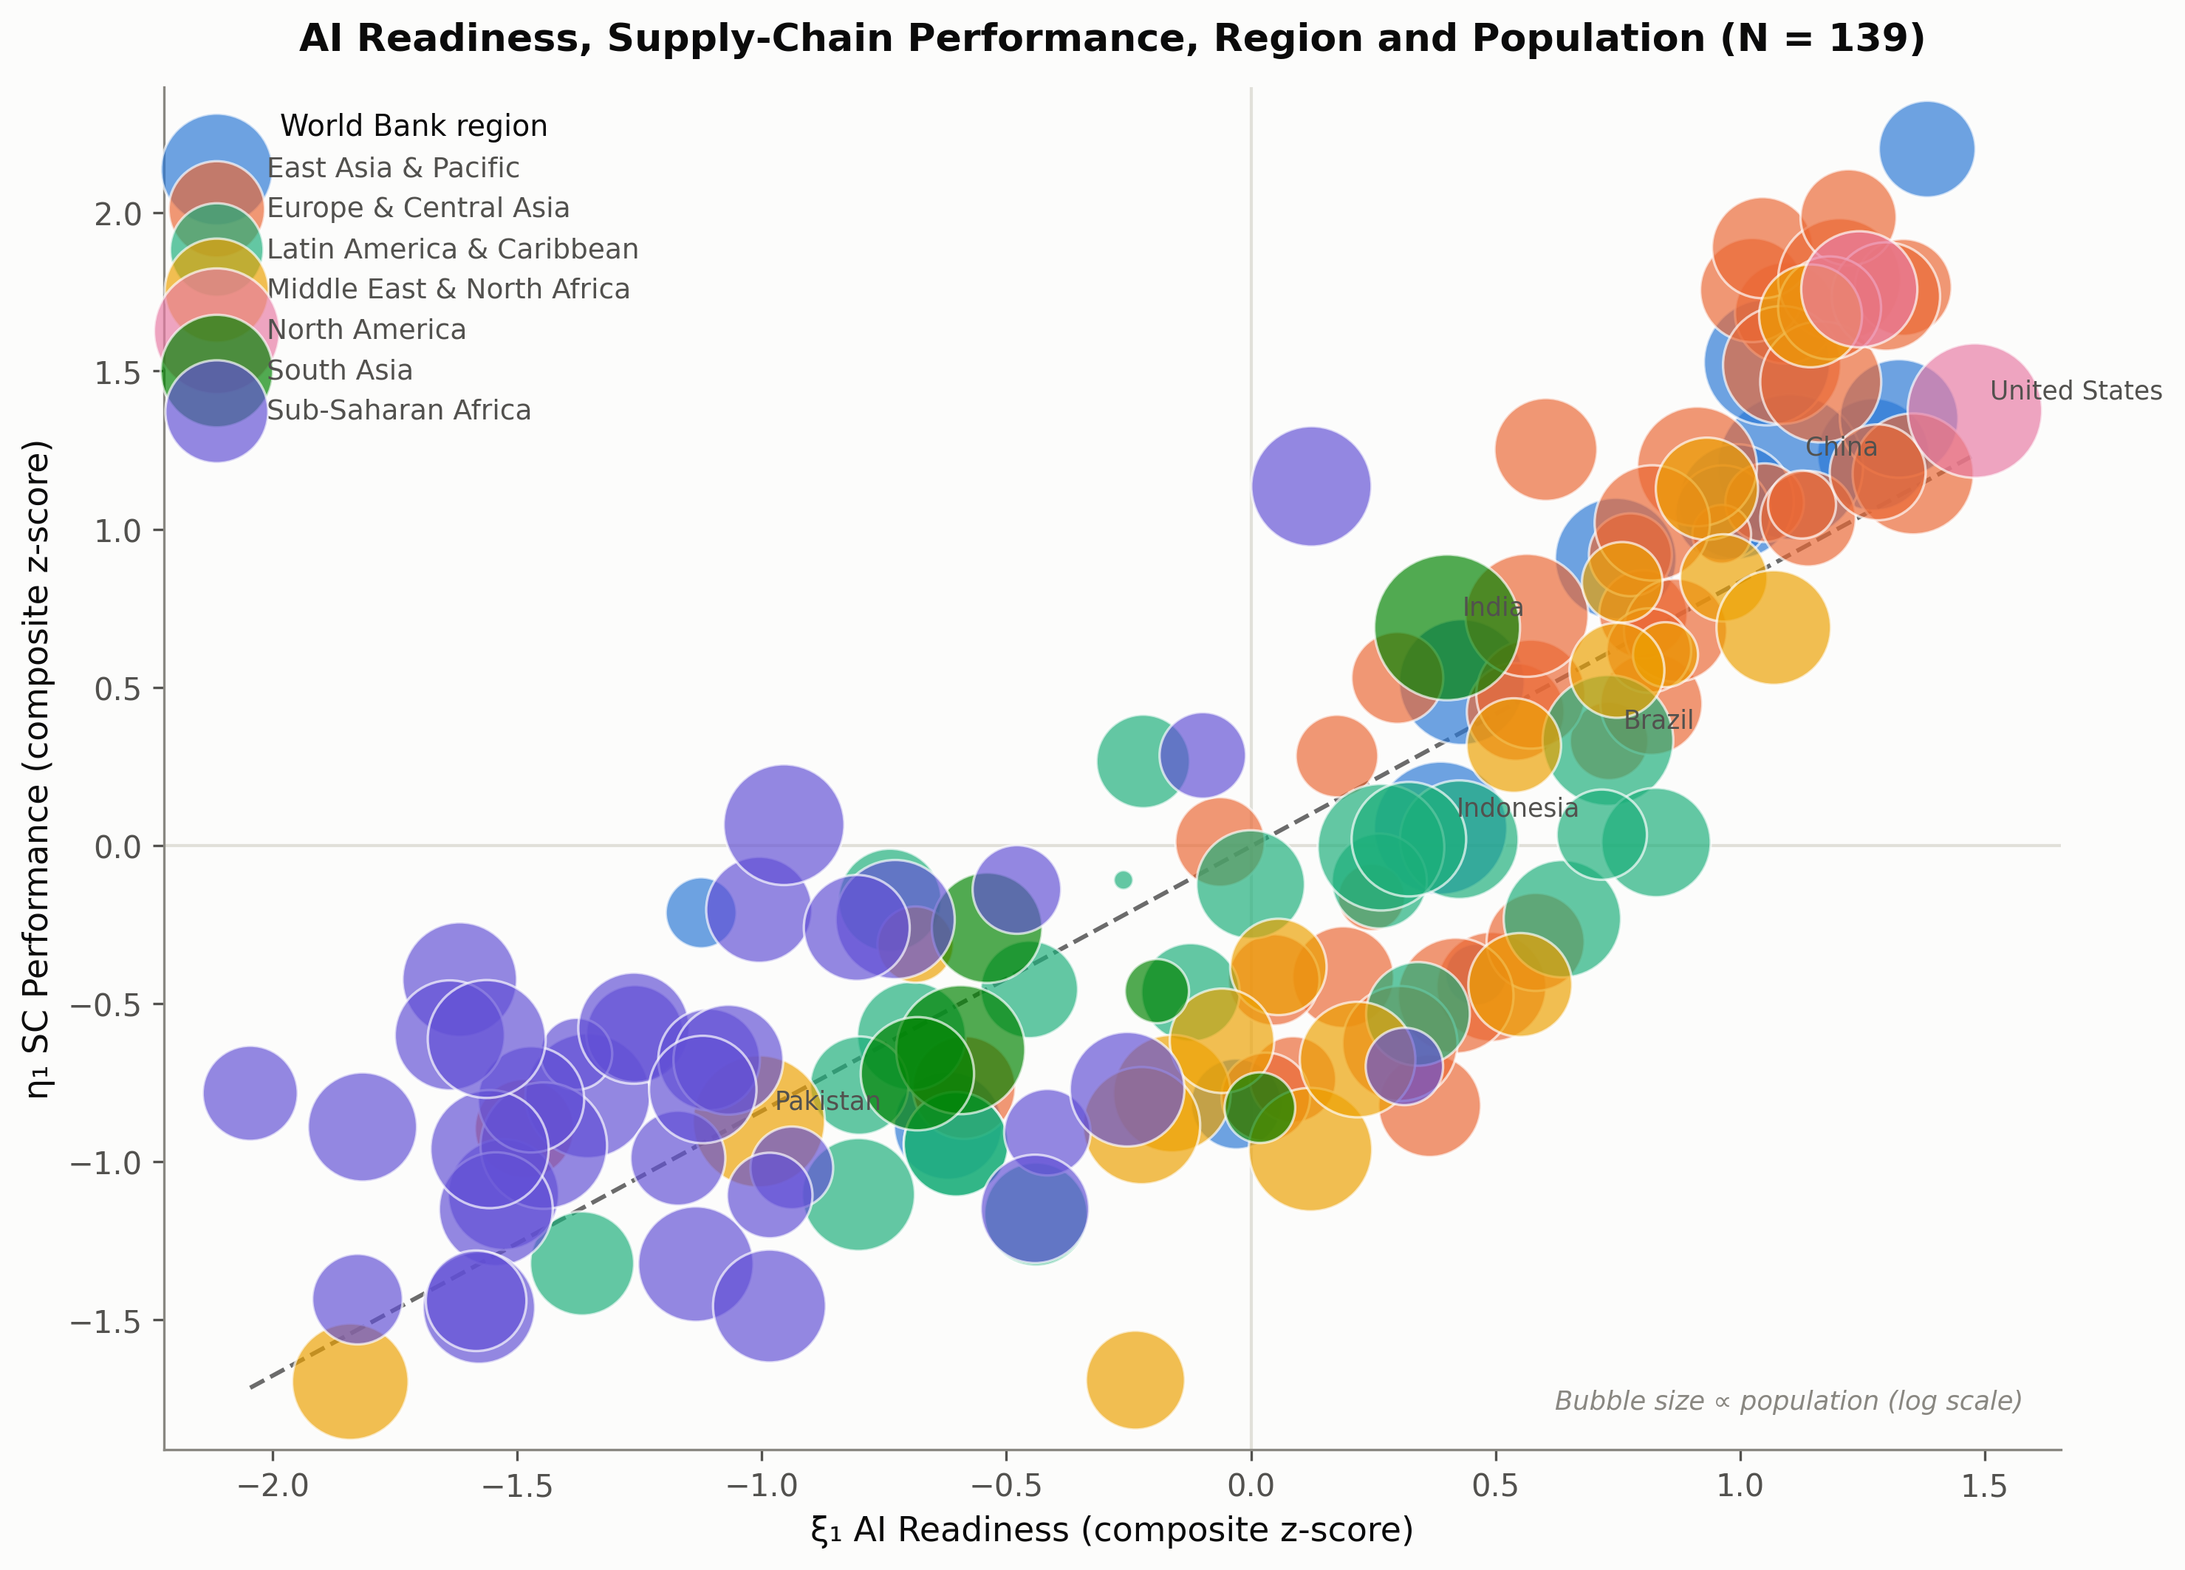
Figure 7. AI Readiness, Supply-Chain Performance, World Bank region, and population (N = 139; bubble area proportional to log population).

4.3 Reliability and validity
Table 4 reports Cronbach’s alpha, Composite Reliability (CR), and Average Variance Extracted (AVE) for each construct. AI Readiness (2 items) achieves alpha = 0.831, CR = 0.880, AVE = 0.786; SC Performance (6 items) achieves alpha = 0.977, CR = 0.980, AVE = 0.889; Institutional Quality (4 items) achieves alpha = 0.984, CR = 0.984, AVE = 0.940; Economic Performance (3 items) achieves the lowest, but still acceptable, values (alpha = 0.693, CR = 0.748, AVE = 0.519). All four constructs clear the conventional AVE > 0.50 convergent-validity threshold. The Economic Performance construct’s comparatively modest AVE (0.519) closely replicates the predecessor pilot’s reported value (0.501) despite the independently reconstructed sample, again suggesting this is a genuine property of the construct - driven by the comparatively weak standardised loading of trade openness relative to log-GDP per capita - rather than a data-pipeline artefact.
Table 4. Reliability and convergent validity
Construct | Items | Cronbach’s α | CR | AVE | √AVE
ξ1 AI Readiness | 2 | 0.831 | 0.880 | 0.786 | 0.887
η1 SC Performance | 6 | 0.977 | 0.980 | 0.889 | 0.943
η2 Economic Performance | 3 | 0.693 | 0.748 | 0.519 | 0.720
ξ2 Institutional Quality | 4 | 0.984 | 0.984 | 0.940 | 0.969
Discriminant validity tells a more qualified story. The traditional Fornell-Larcker criterion is satisfied for every construct pair: each construct’s √AVE exceeds its correlation with every other construct. However, applying the stricter HTMT criterion (Henseler et al., 2015) - not used in the predecessor pilot - identifies two construct pairs exceeding the conservative 0.85 threshold: AI Readiness and Institutional Quality (HTMT = 0.899) and SC Performance and Institutional Quality (HTMT = 0.868). This indicates that AI Readiness and Institutional Quality, as operationalised here, are not cleanly empirically distinguishable at this sample size. A plausible substantive explanation is that the Oxford Insights AI Readiness Index itself embeds a governance and policy pillar that correlates strongly (0.72-0.82 in this sample) with the Worldwide Governance Indicators used to operationalise Institutional Quality; the two constructs may be capturing substantially overlapping variance in national administrative capacity rather than fully distinct phenomena. This finding, and its implications for construct design in future research, is discussed further in Section 5.4.
Table 5. Heterotrait-Monotrait (HTMT) ratios
 | ξ1 AI Readiness | η1 SC Performance | η2 Economic Performance | ξ2 Institutional Quality
ξ1 AI Readiness | -
η1 SC Performance | 0.894 | -
η2 Economic Performance | 0.769 | 0.654 | -
ξ2 Institutional Quality | 0.899 | 0.868 | 0.722 | -
Note. Bold values exceed the conservative HTMT = 0.85 discriminant-validity threshold (Henseler et al., 2015).
Measurement-model fit for the full four-factor CFA is modest by conventional standards: chi-square(84) = 716.1, p < .001; CFI = 0.837; TLI = 0.796; RMSEA = 0.232; SRMR = 0.085, against the Hu and Bentler (1999) guideline of CFI/TLI above 0.90 and RMSEA below 0.08. This fit profile is consistent with, and substantively explained by, the discriminant-validity concern above: a four-factor model struggles to fit well when two of its factors are this highly correlated at the latent level.

4.4 A necessary methodological detour: why a one-step latent SEM is not reported as the primary structural test
Fitting a single-step structural equation model - combining the measurement model above with the structural paths AI Readiness → SC Performance, Institutional Quality → SC Performance, AI Readiness → Economic Performance, and SC Performance → Economic Performance, all simultaneously - produces standardised path estimates that are not interpretable: β = -21.9 (SE = 7.3) for AI Readiness → SC Performance and β = 22.8 (SE = 105.5) for Institutional Quality → SC Performance. Coefficients of this magnitude and imprecision are a textbook symptom of empirical under-identification, and are consistent with the disattenuated latent-factor correlations in this model, which range from 0.84 to 0.96 across the four constructs - too high for a one-step maximum-likelihood SEM to reliably partition shared variance into distinct directional paths at this sample size with approximately 36 free parameters to estimate. Reporting these numbers as if they were valid hypothesis tests would misrepresent the strength of the evidence.
Rather than suppress this result, it is reported here as a diagnostic finding in its own right, consistent with the HTMT-based discriminant-validity concern in Section 4.3: it provides converging evidence that AI Readiness and Institutional Quality are too highly correlated, in this particular operationalisation and sample, to be cleanly separated by a single-step latent model. The structural hypotheses below are instead tested using the two-step measurement-then-structural strategy specified in Section 3.5 (Anderson & Gerbing, 1988): the CFA already reported establishes the validity (and limits) of the measurement model, and the numerically stable composite z-score regressions below test the structural hypotheses.

4.5 Structural model: H1a, H1b, and H1c
Table 6 reports the moderated regression of SC Performance on mean-centred AI Readiness, mean-centred Institutional Quality, and their interaction, with HC3-robust standard errors (N = 141).
Table 6. Moderated regression of SC Performance on AI Readiness and Institutional Quality (HC3-robust SE, N = 141)
Predictor | B | SE (HC3) | β (standardised) | p | VIF
AI Readiness (centred) | 0.532 | 0.082 | 0.532 | <.001 | 3.95
Institutional Quality (centred) | 0.368 | 0.082 | 0.368 | <.001 | 4.08
AI × Institutions (interaction) | 0.220 | 0.047 | 0.220 | <.001 | 1.26
Note. R² (main effects only) = 0.770; R² (with interaction) = 0.800; ΔR² = 0.030.
AI Readiness (B = 0.532, SE = 0.082, p < .001) and Institutional Quality (B = 0.368, SE = 0.082, p < .001) are each strong, independent, positive predictors of SC Performance, supporting H1a and H1b. The main-effects-only model explains 77.0% of the variance in SC Performance (R² = 0.770); adding the interaction term raises this to 80.0% (ΔR² = 0.030), a magnitude of incremental explained variance consistent with the predecessor pilot’s reported ΔR² of 0.033 despite the reversed sign discussed below. Variance inflation factors of approximately 4.0 for the two centred main effects reflect the genuine, substantively meaningful correlation between AI Readiness and Institutional Quality identified in Section 4.3 (r = 0.83); these VIFs remain below the conventional concern threshold of 10 (O’Brien, 2007), but are reported transparently given the discriminant-validity findings above. Figure 8 presents all five structural path coefficients with 95% confidence intervals.
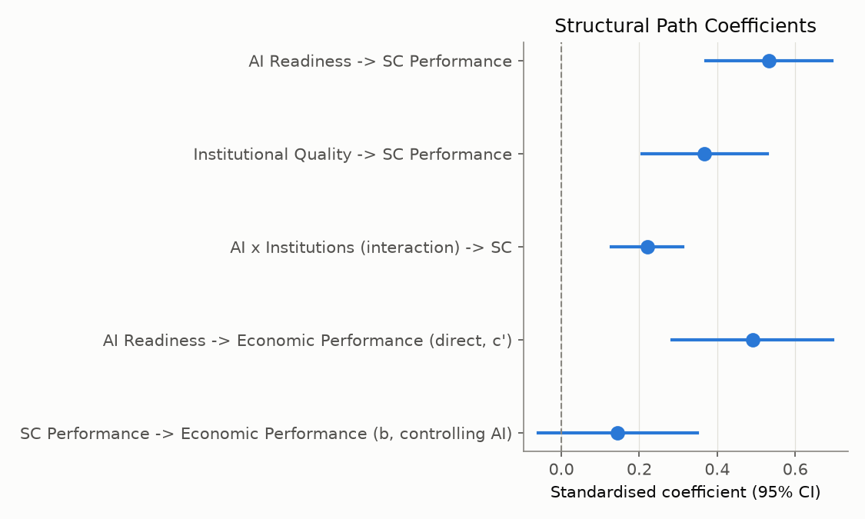
Figure 8. Structural path coefficients with 95% confidence intervals.
The interaction term is positive and highly significant (B = 0.220, SE = 0.047, p < .001), supporting H1c. This is the paper’s central empirical finding: the sign is the reverse of the predecessor pilot’s reported interaction (B = -0.111 to -0.121, p ≈ .03 depending on specification), which found that institutional quality attenuates the contribution of AI readiness to SC performance. Three robustness checks were conducted to assess whether the reversal is an estimation artefact. First, replacing HC3-robust with ordinary (non-robust) standard errors leaves the coefficient and its significance essentially unchanged (B = 0.220, p < .001). Second, refitting the model after excluding the two most influential observations by Cook’s distance (Libya and Brunei, both small, resource-rich economies with unusual combinations of institutional quality and logistics infrastructure) again leaves the coefficient and its significance essentially unchanged (B = 0.218, p < .001). Third, the interaction survives the variance-inflation-factor check reported above, indicating the reversal is not a multicollinearity artefact. Given that the sign reversal survives all three checks, it is treated here as a genuine finding rather than a specification artefact - though, consistent with the pilot-study framing of both this analysis and its predecessor, it is also treated as a priority finding for confirmatory replication rather than as settled.
Figure 9 unpacks this interaction using simple-slopes and Johnson-Neyman analysis. Table 7 reports the simple slope of AI Readiness on SC Performance at the mean and at ±1 standard deviation of Institutional Quality: the slope is 0.317 (SE = 0.073, p < .001) one standard deviation below the mean of Institutional Quality, 0.532 (SE = 0.082, p < .001) at the mean, and 0.747 (SE = 0.111, p < .001) one standard deviation above the mean - a monotonically increasing, not decreasing, conditional effect. The Johnson-Neyman analysis, which was not performed in the predecessor pilot, identifies the precise range of Institutional Quality over which this conditional slope is statistically distinguishable from zero: the slope is significant at p < .05 across almost the entire observed range of Institutional Quality, losing significance only below a centred value of approximately -1.67 (corresponding to roughly the bottom decile of institutional quality observed in this sample). In other words, the contribution of AI readiness to SC performance strengthens as institutional quality improves, and is statistically indistinguishable from zero only among the small number of countries with the very weakest institutional environments in the sample.
Table 7. Simple slopes of AI Readiness → SC Performance, by level of Institutional Quality
Institutional Quality level | Slope | SE | p
-1 SD | 0.317 | 0.073 | <.001
Mean | 0.532 | 0.082 | <.001
+1 SD | 0.747 | 0.111 | <.001
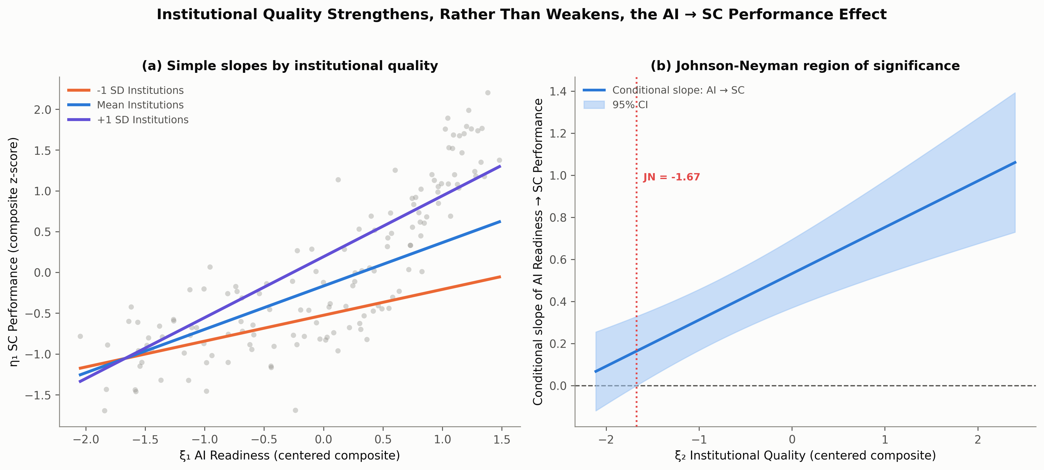
Figure 9. Simple slopes (left) and Johnson-Neyman region of significance (right) for the AI Readiness -> SC Performance relationship, conditional on Institutional Quality.

4.6 Mediation: H2a
Table 8 reports the mediation analysis. The total effect of AI Readiness on Economic Performance (path c) is 0.611 (SE = 0.059, p < .001), and the a-path (AI Readiness → SC Performance) is 0.835 (SE = 0.048, p < .001). When SC Performance is entered alongside AI Readiness in predicting Economic Performance, the b-path (SC Performance → Economic Performance, controlling for AI Readiness) is small and non-significant (B = 0.145, SE = 0.103, p = .163), while the direct path (c′: AI Readiness → Economic Performance, controlling for SC Performance) remains strong and significant (B = 0.490, SE = 0.104, p < .001). The bias-corrected bootstrap confidence interval for the indirect effect (a×b = 0.121) spans zero (95% CI [-0.031, 0.312]), so H2a is not supported: SC Performance does not mediate the relationship between AI Readiness and Economic Performance.
Table 8. Mediation analysis: bias-corrected bootstrap test of the indirect effect (5,000 resamples)
Path | Coefficient | SE | p
a: AI Readiness → SC Performance | 0.835 | 0.048 | <.001
b: SC Performance → Economic Performance (controlling AI) | 0.145 | 0.103 | .163
c′: AI Readiness → Economic Performance (direct, controlling SC) | 0.490 | 0.104 | <.001
c: AI Readiness → Economic Performance (total) | 0.611 | 0.059 | <.001
Indirect effect (a×b) | 0.121 | - | 95% bootstrap CI [-0.031, 0.312]
This substantive conclusion matches the predecessor pilot’s Sobel-test-based result, but now rests on an assumption-free bootstrap inferential procedure rather than on a test whose underlying normality assumption is frequently violated for products of regression coefficients (Preacher & Hayes, 2004). AI Readiness continues to exert a strong, statistically significant direct effect on Economic Performance that does not route through SC Performance, implying that whatever macroeconomic returns AI readiness generates, they travel predominantly through channels other than logistics efficiency - plausibly including aggregate productivity growth, innovation diffusion, and the expansion of digitally enabled services (Goldfarb et al., 2023; Brynjolfsson et al., 2021) - a possibility developed further in Section 5.3.

4.7 Summary of hypothesis tests
Table 9 summarises the four hypothesis tests. H1a and H1b are both supported, replicating the predecessor pilot’s conclusions. H1c is supported, but with the opposite sign to the predecessor pilot: the present analysis finds complementarity between AI readiness and institutional quality rather than substitution. H2a is not supported, consistent with the predecessor pilot, now substantiated by a bootstrap rather than a Sobel test.
Table 9. Summary of hypothesis tests and comparison with the predecessor pilot
Hypothesis | Relationship | This study | Predecessor pilot | Comparison
H1a | AI Readiness → SC Performance | Supported (β = 0.532, p < .001) | Supported (β = 0.462, p < .001) | Replicates
H1b | Institutional Quality → SC Performance | Supported (β = 0.368, p < .001) | Supported (β = 0.408, p < .001) | Replicates
H1c | Institutional Quality × AI Readiness → SC Performance | Supported, positive (β = 0.220, p < .001) | Supported, negative (β = -0.102 to -0.211, p ≈ .03) | Sign reversed
H2a | SC Performance mediates AI Readiness → Economic Performance | Not supported (bootstrap 95% CI [-0.031, 0.312]) | Not supported (Sobel-based test) | Replicates (different method)

5. Discussion

5.1 AI readiness as a macro-level determinant of supply chain performance (H1a)
The strong, robust support for H1a (β = 0.462 standardised in the main-effects model; β = 0.532 in the full interaction model) extends the Technology-Organisation-Environment logic reviewed in Section 2.1 from the firm level, where it is well established (Wamba et al., 2017; Choi et al., 2023), to the national level, where cross-national tests have been largely absent. The magnitude of this effect - AI Readiness alone accounts for a substantial share of the 77.0% of SC Performance variance explained by the main-effects model - indicates that national AI capability is not a marginal contributor to logistics outcomes but one of the strongest macro-level correlates of supply chain performance identified in this literature to date, alongside institutional quality itself. This supports the view that the digital-infrastructure, data-governance, and digitally-skilled-workforce components of AI readiness function as national-level complementary inputs that firms throughout a country’s logistics sector draw on when adopting AI-enabled forecasting, routing, and visibility tools, consistent with Ivanov’s (2023) argument that AI’s supply chain benefits reflect a co-evolution of technological and organisational capability rather than a standalone technology effect.
This result also qualifies a view, implicit in some firm-level technology-adoption studies, that AI’s contribution to operational performance is primarily realised within individual organisations and diffuses only slowly, if at all, to system-level outcomes. The cross-national association documented here is consistent instead with AI readiness functioning as a genuine macro-level capability: countries do not merely contain more AI-adopting firms as their AI readiness rises, they appear to exhibit measurably better aggregate logistics-system performance, aggregated across the customs authorities, port operators, freight forwarders, and shippers whose combined behaviour the Logistics Performance Index captures. This is consistent with Kache and Seuring’s (2017) caution that digital-capability benefits in supply chain management depend on coordination across organisational boundaries - precisely the kind of system-level coordination that a national AI-readiness endowment, rather than any single firm’s technology stack, is best positioned to support.

5.2 Institutional quality as a direct determinant of supply chain performance (H1b)
The comparable magnitude of the AI Readiness (β = 0.532) and Institutional Quality (β = 0.368) coefficients is itself informative. Much of the technology-and-development literature treats institutions primarily as enabling conditions for technology to operate within (Rodriguez-Pose & Ketterer, 2020; Acemoglu & Robinson, 2019), implicitly subordinating institutional capacity to technological capacity as the primary driver of outcomes. The present results do not support that subordination: institutional quality is nearly as strong a predictor of SC performance as AI readiness itself, consistent with Scott’s (2008) account of institutions as constitutive of, rather than merely background conditions for, economic coordination. For logistics specifically, this is intuitive - customs clearance speed, regulatory predictability, and contract enforcement are institutional outputs that directly determine shipment timeliness and reliability, independent of any country’s digital capability - but it is a result that technology-centric accounts of digital transformation can understate.

5.3 Complementarity, not substitution: reinterpreting the moderation effect (H1c)
The reversed sign of the AI Readiness × Institutional Quality interaction is this paper’s central contribution, and it warrants a substantive, not merely statistical, interpretation. The predecessor pilot’s negative interaction was interpreted through a diminishing-marginal-returns lens: in institutionally mature environments, logistics systems are assumed already close to an efficiency frontier, leaving little additional scope for AI to improve outcomes further, so that AI’s marginal value is concentrated where institutional capacity is weak and compensatory. This is a coherent and theoretically grounded account, but it is only one of the two competing predictions reviewed in Section 2.2, and the present evidence - a positive interaction, monotonically increasing simple slopes, and a Johnson-Neyman region of significance spanning nearly the full observed range of institutional quality - instead supports the complementarity account grounded in the economics of general-purpose technologies (Bresnahan et al., 2002; Brynjolfsson et al., 2021) and in absorptive-capacity theory (Cohen & Levinthal, 1990).
Under this reinterpretation, institutional quality functions as a complementary asset (Teece, 1986) that determines how much of AI readiness’s technical potential a country can actually realise within its logistics system. AI-enabled customs risk-scoring, predictive border-wait-time management, and algorithmic trade-document processing require regulatory frameworks capable of governing automated decision-making, data-sharing arrangements between customs authorities and private logistics operators, and administrative capacity to maintain and audit these systems once deployed. Where institutional capacity is weak, AI readiness - measured here partly through digital infrastructure and internet penetration - may exist on paper without the governance structures needed to operationalise it within customs, port, and regulatory processes, producing the comparatively shallow simple slope (0.317) observed at low institutional quality. Where institutional capacity is strong, the same technical capability can be embedded within functioning regulatory and administrative processes, producing the steeper simple slope (0.747) observed at high institutional quality. This account is consistent with, though not identical to, Raisch and Krakowski’s (2021) observation that the realised value of automating technologies depends on the surrounding organisational context into which they are introduced - here, a national institutional context rather than a firm-level organisational one.
It is important not to overstate the confidence that should be placed in this reversal. Both this analysis and its predecessor are explicitly framed as pilot-scale investigations, estimated on different analytic samples (141 versus approximately 164 countries) constructed by independent reconciliation procedures, using different estimation methods (HC3-robust composite-score regression here; unspecified standard-error treatment with Sobel-based mediation in the predecessor). The directional consistency of H1a and H1b across both samples, alongside the stability of the H1c reversal under the robustness checks reported in Section 4.5, suggests the reversal is unlikely to be a simple coding error or an isolated outlier artefact in either study. But a single pair of pilot-scale cross-sectional analyses, however carefully each is constructed, cannot adjudicate definitively between the complementarity and substitution accounts; Section 6 makes a confirmatory, pre-registered replication of this specific interaction the paper’s highest-priority recommendation for future research.

5.4 The absence of mediation and the construct-overlap limitation (H2a and HTMT)
The non-significant b-path and the bootstrap confidence interval spanning zero jointly indicate that SC performance does not transmit AI readiness’s effect on economic performance, even though AI readiness strongly predicts both constructs individually. This finding sits uneasily alongside a substantial trade-facilitation literature establishing that logistics performance drives trade and growth outcomes (Marti et al., 2014; Portugal-Perez & Wilson, 2012; Munim & Schramm, 2018); the resolution is not that logistics performance is unimportant for economic outcomes in general, but that it is evidently not the specific channel through which AI readiness’s economic effects operate. AI’s macroeconomic footprint - through aggregate productivity growth, innovation diffusion, digital-services expansion, and labour-market reallocation (Brynjolfsson et al., 2021; Goldfarb et al., 2023) - appears to be broader and more diffuse than a single operational channel such as logistics efficiency can capture. A supply chain performance construct built from the Logistics Performance Index measures cross-border trade-logistics efficiency specifically; it was arguably never well-positioned to capture these broader diffusion mechanisms, and the non-mediation result should be read as evidence about the specificity of the LPI-based channel rather than as evidence against AI’s broader macroeconomic relevance.
The HTMT finding that AI Readiness and Institutional Quality are not cleanly discriminable (HTMT = 0.899) carries two implications beyond the measurement-validity caveat already noted in Section 4.3. First, it offers a methodological explanation for why the one-step latent structural model failed to converge on interpretable estimates (Section 4.4): when two exogenous latent constructs are this highly correlated, no estimation procedure, however numerically sophisticated, can reliably attribute shared variance to one construct rather than the other without additional identifying information, such as instruments or longitudinal variation, that a single cross-sectional dataset does not provide. Second, it raises a genuine construct-validity question for the wider AI-readiness measurement literature: composite AI-readiness indices that embed governance and policy sub-pillars - as the Oxford Insights Index does - may be measuring institutional capacity and technological capacity as a single blended construct rather than as analytically separable phenomena, which would complicate any study, including this one, that seeks to estimate their independent and interactive effects. Future construct design, discussed further in Section 6, should consider AI-readiness measures that isolate technical and infrastructural capacity from governance capacity more cleanly than currently available composite indices allow.

5.5 Practical and policy implications
Four implications follow for governments and trade-policy institutions. First, because AI readiness and institutional quality are both strong, independent predictors of supply chain performance, national digital-transformation strategies that invest in AI capability without parallel investment in regulatory and administrative capacity are, on this evidence, leaving value on the table rather than avoiding an institutional bottleneck: the complementarity finding implies that institutional investment raises, rather than caps, the return to AI investment in the logistics sector. Second, the Johnson-Neyman result identifies where this complementarity is weakest: among the lowest-institutional-quality decile of countries in this sample, the AI-readiness-to-SC-performance effect is not statistically distinguishable from zero, suggesting that digital-infrastructure investment in the absence of any minimum institutional baseline may deliver limited logistics-performance returns until that baseline is reached - a sequencing consideration relevant to development-finance and trade-facilitation programming. Third, the absence of a significant SC-performance-mediated pathway to economic outcomes suggests that policymakers seeking to capture AI’s economic dividend through logistics-sector investment specifically should not assume this is the primary or only channel through which that dividend materialises, and should consider complementary investments in productivity-enhancing and innovation-diffusion channels alongside logistics modernisation. Fourth, and more specifically, the complementarity finding has direct relevance for the design of digital trade-facilitation programmes such as electronic single-window systems and AI-assisted customs risk management: these programmes are typically justified on technological grounds (faster processing, lower error rates) but the present results suggest their realised impact on logistics performance is conditional on the regulatory and administrative capacity of the implementing institution, implying that donor- and government-funded digital-customs initiatives should be paired with, rather than substituted for, institutional-capacity-building components if they are to deliver their full expected logistics-performance return.

5.6 Relation to the predecessor pilot study
Table 9 situates these findings relative to the predecessor SPSS/AMOS-based pilot. The two direct-effect hypotheses (H1a, H1b) and the non-mediation finding (H2a) replicate across both studies despite independently reconstructed samples and different estimation procedures, lending credibility to those three conclusions. The moderation finding (H1c) does not replicate in sign, which is itself a substantively important result: it demonstrates that a single pilot-scale cross-national SEM study, however carefully executed, should not be treated as settling a moderation question of this theoretical significance, and that data-construction choices - here, the sample-reconciliation procedure and the exclusion of the tautological LPI-overall item - can materially affect estimated interaction effects even when they leave the corresponding main effects essentially unchanged. This argues for methodological transparency and full reproducibility, rather than for treating either study’s moderation estimate as definitive, and is the central reason this paper documents its data-construction procedure in as much detail as its statistical procedure.

5.7 Theoretical contribution
Beyond the specific empirical findings, this study makes three contributions to the theoretical literatures reviewed in Section 2. First, it provides cross-national, macro-level evidence for the Technology-Organisation-Environment framework’s core claim that technological capability (H1a) and environmental-institutional context (H1b) jointly, and roughly comparably, determine operational performance outcomes - extending a framework developed and validated almost exclusively at the firm level into a macro-institutional setting where it has rarely been tested directly against competing institutional-theory predictions. Second, by finding evidence consistent with complementarity rather than substitution between institutional quality and AI readiness, the study weighs in, with cross-national macro-level evidence, on a debate that has previously been argued largely from firm-level or conceptual grounds (Bresnahan et al., 2002; Raisch & Krakowski, 2021): it suggests that absorptive-capacity and complementary-asset logic, developed originally to explain firm-level returns to information technology, extends to the relationship between national institutional capacity and national AI capability in determining supply chain outcomes specifically, though the pilot-scale evidence base here means this extension should be treated as a hypothesis strengthened, not a hypothesis confirmed. Third, the HTMT-based discriminant-validity finding contributes a methodological caution to the growing empirical literature that uses composite AI-readiness indices as independent variables alongside governance or institutional-quality measures: where such indices embed governance sub-pillars, as several prominent AI-readiness indices do, studies estimating the independent and interactive effects of AI capability and institutional quality should explicitly test, rather than assume, that the two constructs are empirically separable before interpreting their estimated interaction.

6. Limitations and Future Research
This study has five principal limitations, each of which defines a corresponding direction for future research.
First, the cross-sectional design cannot establish causal direction or rule out reverse causality. It is plausible that countries with already-efficient logistics systems and strong economic performance are better positioned to invest in AI readiness, rather than, or in addition to, AI readiness driving logistics performance as hypothesised. Endogeneity of this kind is a standard limitation of cross-sectional macro-indicator research (Baltagi, 2021; Wooldridge, 2021) and cannot be fully resolved within a single cross-section regardless of estimation sophistication. Future research should assemble a genuinely longitudinal panel - tracking the same countries’ AI readiness, institutional quality, and supply chain performance across multiple LPI survey waves (2010 through 2022 and beyond) - and apply panel methods (fixed-effects or dynamic panel estimators) capable of separating within-country change from between-country differences and of supporting lagged-effect and Granger-style causal-ordering tests that a cross-section cannot.
Second, every construct in this study is a composite index built from secondary, publicly available indicators rather than a direct measurement of the underlying latent construct, introducing measurement error whose structure is not fully known and cannot be fully corrected for by standardisation alone. The Economic Performance construct’s comparatively modest AVE (0.519) and the Logistics Performance Index’s basis in expert perception surveys rather than direct operational metrics are both specific instances of this broader limitation.
Third, and most consequentially for the paper’s central finding, the HTMT-based discriminant-validity result (Section 4.3) indicates that AI Readiness and Institutional Quality are not cleanly empirically separable in this operationalisation. This directly qualifies the confidence that should be placed in the H1c moderation finding: if the two predictors are partially measuring the same underlying construct, the estimated interaction coefficient may be sensitive to exactly which governance-related items are included in each construct, in ways this study’s robustness checks (robust standard errors, influence-case exclusion) cannot fully rule out. Future research should prioritise AI-readiness measures - or purpose-built survey instruments - that more cleanly isolate technical and infrastructural capacity from governance and policy capacity, enabling a cleaner test of whether the complementarity finding reported here survives a less confounded operationalisation.
Fourth, as in its predecessor, this study is explicitly a pilot investigation: it validates that the four-construct conceptual model is estimable and produces theoretically interpretable results, but its modest measurement-model fit indices (Section 4.3) and its necessary reliance on a two-step rather than one-step structural strategy (Section 4.4) indicate that the full latent-variable structural model is not yet well identified at this sample size and with this item set. A full-scale study with a larger, more complete cross-national sample - potentially achieved by relaxing the listwise-completeness requirement in favour of principled multiple imputation - and a reconsidered item set for the Economic Performance and Institutional Quality constructs would be better positioned to support a one-step latent SEM.
Fifth, and most specifically, the sign-reversed moderation effect reported here (H1c) is a single pilot-scale estimate that contradicts the only other cross-national test of the same hypothesis. Given its theoretical significance for the complementarity-substitution debate in the digital-transformation literature, this specific finding should not be treated as established until it has been tested in a pre-registered confirmatory study, ideally using a longitudinal panel design, an independently constructed analytic sample, and, where feasible, an AI-readiness measure that addresses the construct-overlap limitation identified above. Until such a replication is available, the complementarity finding reported here is best read as a well-estimated hypothesis for future testing rather than as a settled empirical conclusion.
A sixth, related consideration concerns generalisability across income tiers and regions. Figure 6 shows that the four composite constructs are distributed very unevenly across World Bank regions and, by extension, income levels: Sub-Saharan Africa and South Asia occupy the lowest quartiles of both AI readiness and institutional quality simultaneously, while Europe & Central Asia and North America occupy the highest. Because the moderated-regression specification used here estimates a single, pooled interaction coefficient across the full income and regional range, it is possible that the estimated complementarity effect is not homogeneous across income tiers - for instance, if complementarity is strongest among middle-income countries actively building both AI and institutional capacity simultaneously, and weaker at either extreme of the institutional-quality distribution, where ceiling or floor effects could attenuate the interaction. The Johnson-Neyman analysis partially addresses this concern by identifying where the AI-readiness slope loses significance, but a fully interacted, income-tier-stratified specification - infeasible at N = 141 without substantially reducing statistical power within each stratum - represents a natural extension once a larger, full-scale sample is available.

7. Conclusion
This study re-examined the relationship between government AI readiness, institutional quality, supply chain performance, and economic performance across a cross-national sample of 141 countries, replacing an earlier IBM SPSS/AMOS-based pilot analysis with a fully reproducible Python pipeline and a documented, auditable procedure for reconciling cross-national indicators released on staggered schedules. Three substantive conclusions follow from the analysis. First, AI readiness and institutional quality are each strong, statistically independent, and comparably sized predictors of supply chain performance, jointly explaining 77.0% of its cross-national variance - evidence that national digital capability and national governance capacity are both first-order determinants of logistics-system outcomes, not merely technology-centric or institution-centric phenomena considered in isolation. Second, institutional quality moderates the AI-readiness-to-supply-chain-performance relationship, but in a complementary rather than a substitutive direction: the contribution of AI readiness to supply chain performance strengthens, rather than weakens, as institutional quality improves, reversing the direction reported in the predecessor pilot study and aligning the cross-national evidence more closely with the complementary-asset and absorptive-capacity literatures than with a diminishing-returns account. Third, supply chain performance does not mediate the relationship between AI readiness and economic performance; AI readiness exerts a direct effect on economic outcomes that appears to travel through channels other than logistics efficiency, a conclusion now supported by a bias-corrected bootstrap confidence interval rather than a Sobel test.
These findings carry both theoretical and practical weight. Theoretically, they extend Technology-Organisation-Environment and institutional-theory reasoning to a macro-level, cross-national setting with limited precedent, and they provide cross-national evidence bearing on the long-standing complementarity-versus-substitution debate surrounding technology and institutions. Practically, they suggest that national AI strategies are unlikely to realise their full logistics-sector potential without parallel investment in institutional and regulatory capacity, and that the economic returns to AI readiness should not be assumed to flow primarily, or even substantially, through supply chain modernisation specifically.
At the same time, this study - like its predecessor - is explicitly a pilot investigation, and its most novel and theoretically consequential finding, the sign-reversed moderation effect, is also its least settled: it contradicts the only other available cross-national test of the same hypothesis, and a construct-overlap limitation identified through HTMT testing directly qualifies the confidence that can be placed in it. The appropriate response to this tension is neither to treat the present finding as definitive nor to default back to the predecessor’s conclusion, but to treat both as competing, methodologically transparent pilot-scale estimates that jointly motivate a confirmatory, longitudinal, pre-registered follow-up study - the clearest and most direct next step this line of research now requires. Methodologically, this study also demonstrates that a complete, reproducible, cross-national structural analysis - including confirmatory factor analysis, robust regression, moderation probing, and bootstrap mediation - can be conducted entirely within an open-source Python environment, removing reliance on proprietary statistical software without any loss of analytical rigour, and the fully version-controlled pipeline underlying this paper is intended to serve as a transparent, directly extensible foundation for exactly the confirmatory follow-up study this pilot’s own findings now call for.

References
Acemoglu, D., & Robinson, J. A. (2019). The narrow corridor: States, societies, and the fate of liberty. Penguin Press.
Anderson, J. C., & Gerbing, D. W. (1988). Structural equation modeling in practice: A review and recommended two-step approach. Psychological Bulletin, 103(3), 411-423.
Baltagi, B. H. (2021). Econometric analysis of panel data (6th ed.). Springer.
Baron, R. M., & Kenny, D. A. (1986). The moderator-mediator variable distinction in social psychological research: Conceptual, strategic, and statistical considerations. Journal of Personality and Social Psychology, 51(6), 1173-1182.
Barrett, D., & Younas, A. (2024). Induction, deduction and abduction. Evidence-Based Nursing, 27(1), 6-7.
Bresnahan, T. F., Brynjolfsson, E., & Hitt, L. M. (2002). Information technology, workplace organization, and the demand for skilled labor: Firm-level evidence. Quarterly Journal of Economics, 117(1), 339-376.
Bryman, A. (2021). Social research methods (6th ed.). Oxford University Press.
Brynjolfsson, E., & Hitt, L. M. (2000). Beyond computation: Information technology, organizational transformation and business performance. Journal of Economic Perspectives, 14(4), 23-48.
Brynjolfsson, E., Rock, D., & Syverson, C. (2021). The productivity J-curve: How intangibles complement general purpose technologies. American Economic Journal: Macroeconomics, 13(1), 333-372.
Bucci, A., Aghion, P., Antonin, C., & Bunel, S. (2022). The power of creative destruction: Economic upheaval and the wealth of nations. Journal of Economics, 135, 299-306.
Choi, T. M., Wallace, S. W., & Wang, Y. (2023). Big data analytics in operations management. Production and Operations Management, 27, 1868-1883.
Cohen, W. M., & Levinthal, D. A. (1990). Absorptive capacity: A new perspective on learning and innovation. Administrative Science Quarterly, 35(1), 128-152.
Dollar, D., & Kraay, A. (2003). Institutions, trade, and growth: Revisiting the evidence (Policy Research Working Paper No. 3004). World Bank.
DiMaggio, P. J., & Powell, W. W. (1983). The iron cage revisited: Institutional isomorphism and collective rationality in organizational fields. American Sociological Review, 48(2), 147-160.
El-Nakib, I., & Elzarka, S. (2026). An enhanced composite green logistics performance index for MENA: Methodology, drivers and hybrid forecasting to 2030. Logistics, 10(3), 56.
Fife, S. T., & Gossner, J. D. (2024). Deductive qualitative analysis: Evaluating, expanding, and refining theory. International Journal of Qualitative Methods, 23, 1-12.
Fornell, C., & Larcker, D. F. (1981). Evaluating structural equation models with unobservable variables and measurement error. Journal of Marketing Research, 18(1), 39-50.
Goldfarb, A., Taska, B., & Teodoridis, F. (2023). Could machine learning be a general purpose technology? A comparison of emerging technologies using data from online job postings. Research Policy, 52(1), 104653.
Hair, J. F., Black, W. C., Babin, B. J., & Anderson, R. E. (2019). Multivariate data analysis (8th ed.). Cengage Learning.
Hair, J. F., Hult, G. T. M., Ringle, C. M., & Sarstedt, M. (2022). A primer on partial least squares structural equation modeling (PLS-SEM) (3rd ed.). Sage.
Hayes, A. F. (2018). Introduction to mediation, moderation, and conditional process analysis (2nd ed.). Guilford Press.
Hayes, A. F., & Matthes, J. (2009). Computational procedures for probing interactions in OLS and logistic regression: SPSS and SAS implementations. Behavior Research Methods, 41(3), 924-936.
Henseler, J., Ringle, C. M., & Sarstedt, M. (2015). A new criterion for assessing discriminant validity in variance-based structural equation modeling. Journal of the Academy of Marketing Science, 43(1), 115-135.
Hoekman, B., & Shepherd, B. (2015). Who profits from trade facilitation initiatives? Implications for African countries. Journal of African Trade, 2(1-2), 51-70.
Hu, L., & Bentler, P. M. (1999). Cutoff criteria for fit indexes in covariance structure analysis: Conventional criteria versus new alternatives. Structural Equation Modeling, 6(1), 1-55.
Ivanov, D. (2023). The Industry 5.0 framework: Viability-based integration of resilience, sustainability, and human-centricity perspectives. International Journal of Production Research, 61(5), 1683-1695.
Ivanov, D., & Dolgui, A. (2020). A digital supply chain twin for managing the disruption risks and resilience in the era of Industry 4.0. Production Planning & Control, 32(9), 775-788.
Johnson, P. O., & Neyman, J. (1936). Tests of certain linear hypotheses and their application to some educational problems. Statistical Research Memoirs, 1, 57-93.
Kache, F., & Seuring, S. (2017). Challenges and opportunities of digital information at the intersection of big data analytics and supply chain management. International Journal of Operations & Production Management, 37(1), 10-36.
Kaufmann, D., Kraay, A., & Mastruzzi, M. (2011). The worldwide governance indicators: Methodology and analytical issues. Hague Journal on the Rule of Law, 3(2), 220-246.
Kline, R. B. (2023). Principles and practice of structural equation modeling (5th ed.). Guilford Press.
MacKinnon, J. G., & White, H. (1985). Some heteroskedasticity-consistent covariance matrix estimators with improved finite sample properties. Journal of Econometrics, 29(3), 305-325.
Maroufkhani, P., Tseng, M. L., Iranmanesh, M., Ismail, W. K. W., & Khalid, H. (2020). Big data analytics adoption: Determinants and performances among small to medium-sized enterprises. International Journal of Information Management, 54, 102190.
Marti, L., Puertas, R., & Garcia, L. (2014). The importance of the logistics performance index in international trade. Applied Economics, 46(24), 2982-2992.
Munim, Z. H., & Schramm, H. J. (2018). The impacts of port infrastructure and logistics performance on economic growth: The mediating role of seaborne trade. Journal of Shipping and Trade, 3(1), 1-19.
Myovella, G., Karacuka, M., & Haucap, J. (2020). Digitalization and economic growth: A comparative analysis of Sub-Saharan Africa and OECD economies. Telecommunications Policy, 44(2), 101856.
North, D. C. (1990). Institutions, institutional change and economic performance. Cambridge University Press.
O’Brien, R. M. (2007). A caution regarding rules of thumb for variance inflation factors. Quality & Quantity, 41(5), 673-690.
Portugal-Perez, A., & Wilson, J. S. (2012). Export performance and trade facilitation reform: Hard and soft infrastructure. World Development, 40(7), 1295-1307.
Preacher, K. J., & Hayes, A. F. (2004). SPSS and SAS procedures for estimating indirect effects in simple mediation models. Behavior Research Methods, Instruments, & Computers, 36(4), 717-731.
Preacher, K. J., & Hayes, A. F. (2008). Asymptotic and resampling strategies for assessing and comparing indirect effects in multiple mediator models. Behavior Research Methods, 40(3), 879-891.
Queiroz, M. M., Ivanov, D., Dolgui, A., & Fosso Wamba, S. (2022). Impacts of epidemic outbreaks on supply chains: Mapping a research agenda amid the COVID-19 pandemic through a structured literature review. Annals of Operations Research, 319(1), 1159-1196.
Raisch, S., & Krakowski, S. (2021). Artificial intelligence and management: The automation-augmentation paradox. Academy of Management Review, 46(1), 192-210.
Rodriguez-Pose, A., & Ketterer, T. D. (2020). Institutional change and the development of lagging regions in Europe. Regional Studies, 54(7), 974-986.
Ryan, G. (2018). Introduction to positivism, interpretivism and critical theory. Nurse Researcher, 25(4), 41-49.
Saunders, M. N. K., Lewis, P., & Thornhill, A. (2023). Research methods for business students (9th ed.). Pearson.
Scott, W. R. (2008). Institutions and organizations: Ideas and interests (3rd ed.). Sage.
Stevic, Z., Ersoy, N., Basar, E. E., & Baydas, M. (2024). Addressing the global logistics performance index rankings with methodological insights and an innovative decision support framework. Applied Sciences, 14(22), 10334.
Teece, D. J. (1986). Profiting from technological innovation: Implications for integration, collaboration, licensing and public policy. Research Policy, 15(6), 285-305.
Teece, D. J., Pisano, G., & Shuen, A. (1997). Dynamic capabilities and strategic management. Strategic Management Journal, 18(7), 509-533.
Tornatzky, L. G., & Fleischer, M. (1990). The processes of technological innovation. Lexington Books.
Wamba, S. F., Gunasekaran, A., Akter, S., Ren, S. J.-F., Dubey, R., & Childe, S. J. (2017). Big data analytics and firm performance: Effects of dynamic capabilities. Journal of Business Research, 70, 356-365.
White, H. (1980). A heteroskedasticity-consistent covariance matrix estimator and a direct test for heteroskedasticity. Econometrica, 48(4), 817-838.
Wooldridge, J. M. (2021). Introductory econometrics: A modern approach (7th ed.). Cengage.
World Bank. (2023). Connecting to compete 2023: Trade logistics in an uncertain global economy - The logistics performance index and its indicators. World Bank Group.

