Charles Chen

ECS 171

Homework Set #1

Q1. Low is between 0 and 18.5 mpg.

Medium is between 18.5 and 26.6 mpg.

High is over 26.6 mpg.

Q2. 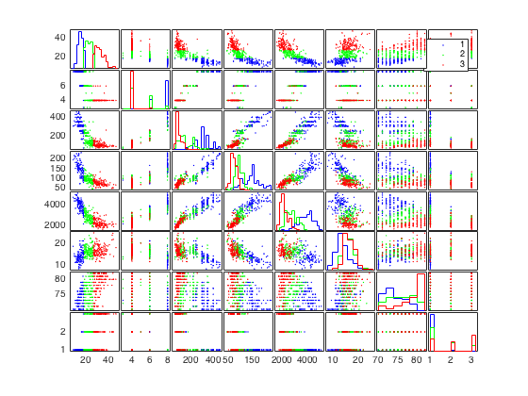

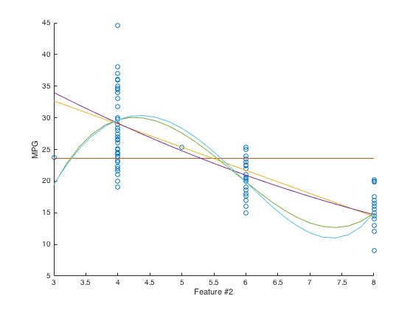

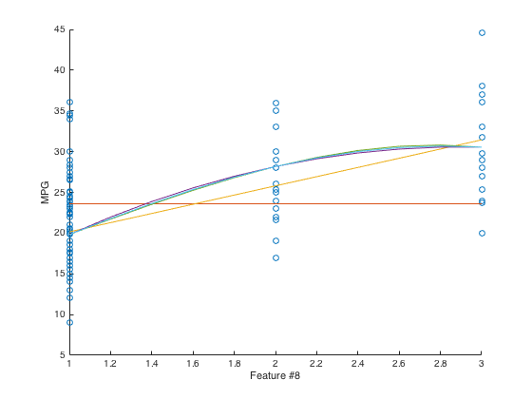

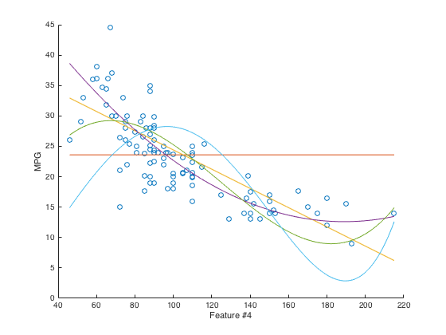

Q7.

Q8. Miles > 0, gallon = 0. Therefore mpg = ∞.