Charles Chen

ECS 171

Assignment #2

1. **hw2p1.m**

Error:

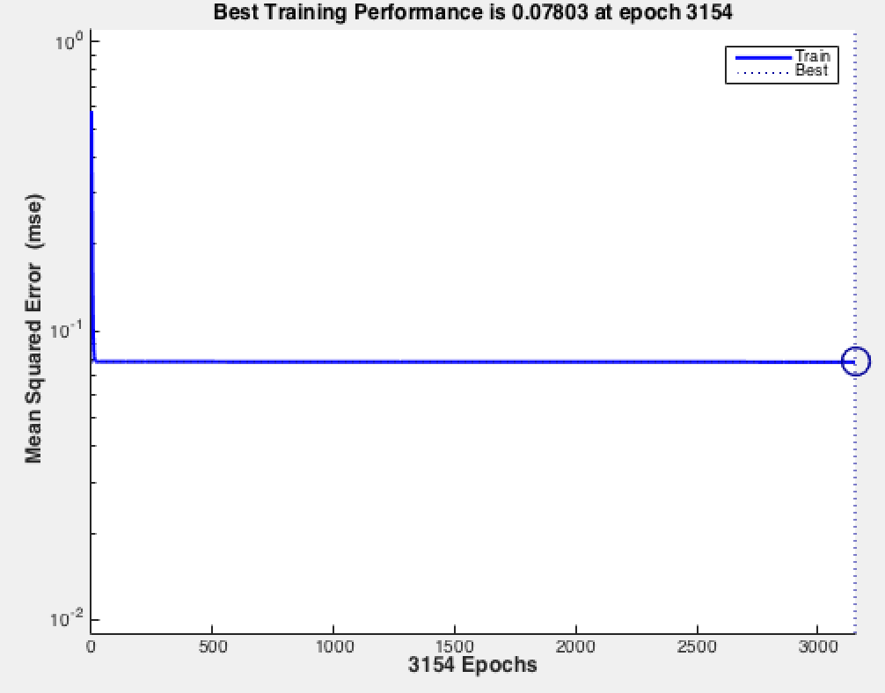

Weights, first node of hidden layer

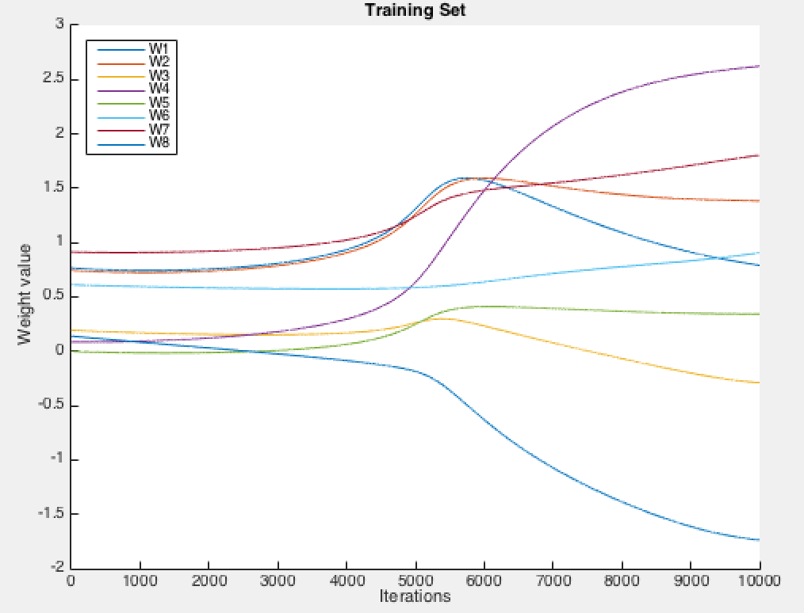

Weights of output layer

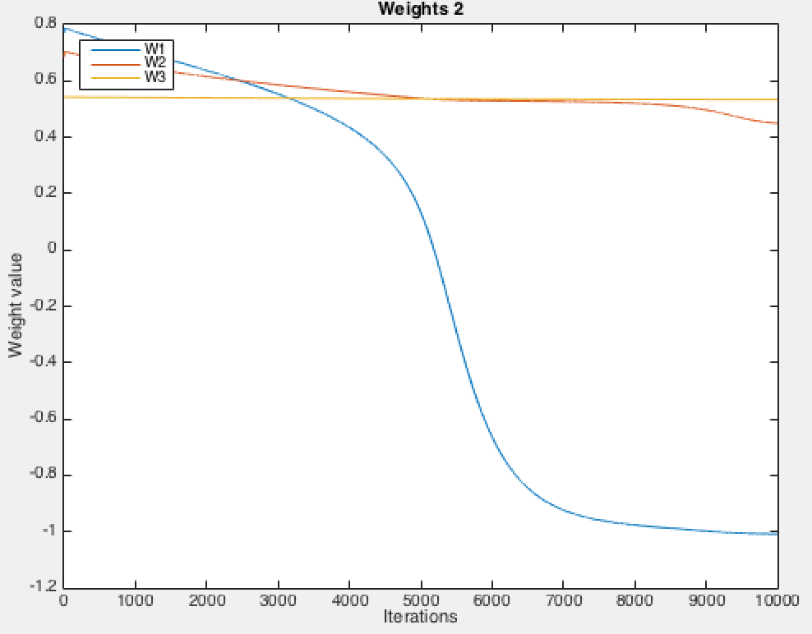

Output:

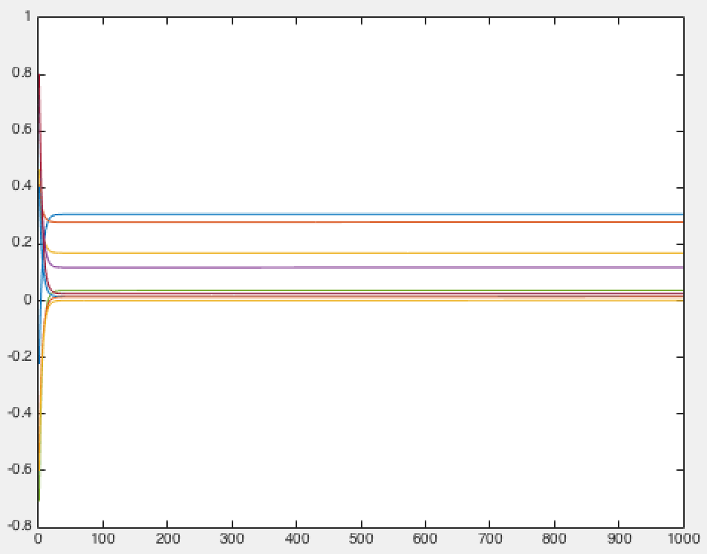

2. Performance (Mean Square Error): 0.0667

Accuracy: 47.8437%

My activation functions: sigmoid and purelin

Final weights:

Input to hidden:

0.7907 1.3838 -0.2890 2.6248 0.3430 0.9058 1.8059 -1.7374

0.4194 0.5169 2.2338 0.5243 0.9731 0.8321 0.9468 1.2073

0.6306 0.2222 0.1638 0.9493 0.8100 0.2921 0.5398 0.6691

Hidden to output:

-1.0082 0.4508 0.5338

-1.7842 1.8198 0.1422

1.5740 0.3098 0.3796

-0.2861 -1.2626 0.6684

0.3722 0.3009 0.4430

0.3951 0.2385 0.4352

0.2501 0.4532 0.6178

0.0014 0.1852 0.5122

-0.0050 1.0673 0.6499

-0.0016 0.6070 0.6021

3. First sample: [0.58 0.61 0.47 0.13 0.50 0.00 0.48 0.22]

Initial output_k:

-0.3554

0.4453

0.5391

0.8402

-0.8944

0.9060

0.9965

0.5004

-0.6742

-0.7516

Initial output_j (hidden):

1.4825 1.4439 1.5231

New weights (Wjk) between hidden and output:

-0.9606 -1.0015 -1.2368

2.1912 3.0673 2.3721

-1.6126 -2.1838 -1.9344

4.8436 4.5004 4.8811

-3.8603 -3.4327 -4.0364

4.6405 4.9133 4.9707

5.0549 5.4522 5.6077

3.1992 2.6670 3.0186

-3.1165 -2.2823 -2.7252

-3.5748 -2.8532 -3.1624

New weights (Wij) between input and hidden:

-102.6560 -108.0282 -83.6138 -23.0937 -89.1576 0.6125 -84.6773 -39.0889

-100.7140 -105.4467 -80.8694 -21.8931 -86.3281 0.7218 -82.6522 -37.8364

-105.6271 -111.5322 -85.9387 -22.8637 -90.7915 0.2919 -87.3974 -39.6317

4.

|  |  |  |  |
| --- | --- | --- | --- |
|  | 1 layer | 2 layers | 3 layers |
| 3 nodes | 0.0712 | 0.0756 | 0.0742 |
| 6 nodes | 0.0640 | 0.0723 | 0.0729 |
| 9 nodes | 0.0587 | 0.068 | 0.0679 |
| 12 nodes | 0.0581 | 0.0676 | 0.0699 |

Optimal: 1 hidden layer, 12 nodes

Error seems to increase when more layers are added. Error decreases when more nodes are added to hidden layer.

5. My prediction is NUC, probability of 47%