1. Open Terminal:
   1. **ssh -X ck00113@student01.eps.surrey.ac.uk**

> Enter surrey password

Note the error that appears: this is due to the ‘-X’ flag used instead of ‘-Y’ flag. ‘-Y’ flag enables trusted X11 forwarding. This error can be ignored.

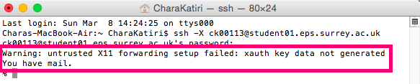

* 1. **mysql -h mysql0.ee.surrey.ac.uk -u ck00113 -D ck00113 -p ck00113**

> Enter database password

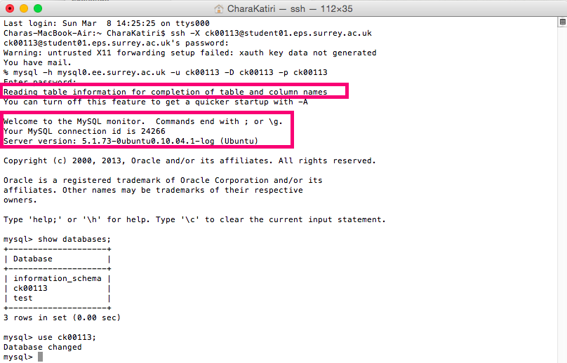

The terminal shows that you have now accessed the database.

1. Open NetBeans
   1. Build and run the application. 
   2. Navigate to Services tab.
   3. Navigate to Pinboard database > right click > connect.

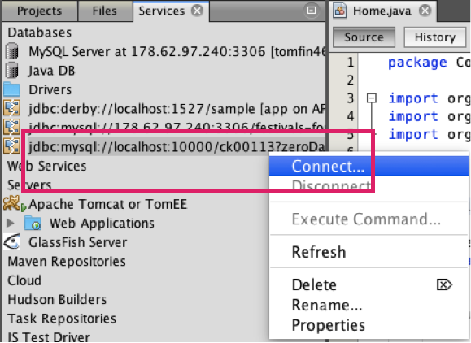

* 1. An error message appears. 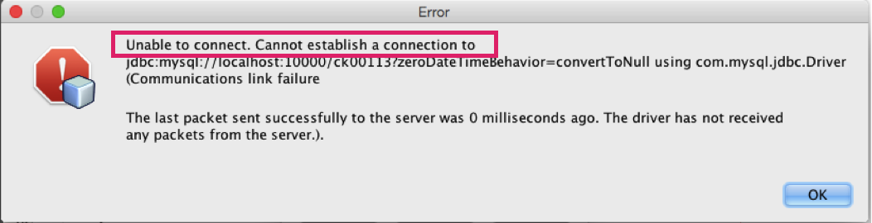
  2. Navigate to Servers > right click on Pinboard > start.

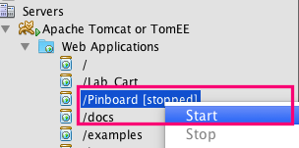

* 1. An error appears.

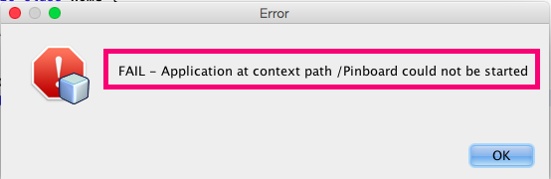

1. In your browser navigate to localhost:8085
   1. Click on ‘List Applications’, check whether the application is deployed on the server.
   2. Click ‘Start’ button for Pinboard. 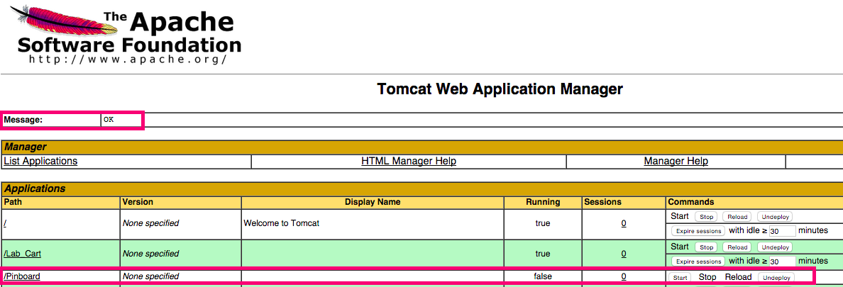

An error appears.

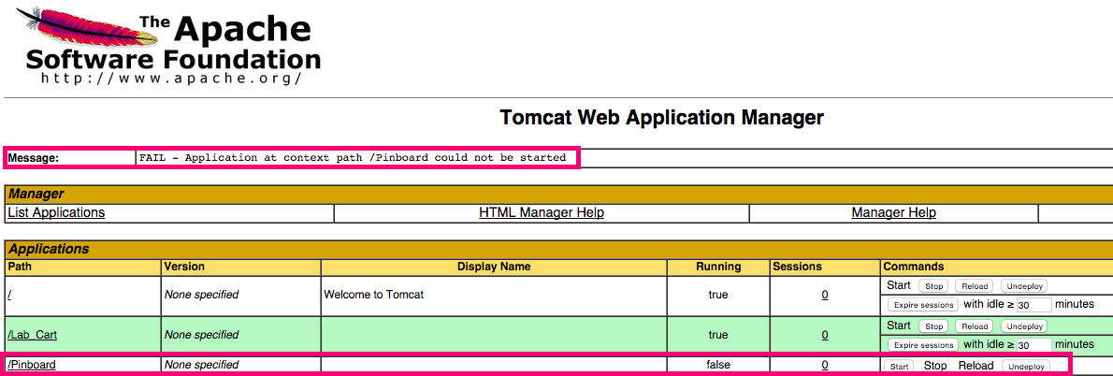

* 1. Navigate to NetBeans and restart the server.
  2. Try to build and run the application again. No change in status of the application in Tomcat window.

