Harnessing the potential of AI for LCI data compilation from company reporting
Charaf Bejjit, Diae Hennioui, Frédéric Lai, Andreas Kroiss, Aina Mas- Fons, Basile Guth, Stéphanie Muller, Daniel Monfort Climent, Stephan Lutter, Victor Maus, Antoine Beylot
1. Introduction
Life cycle assessment (LCA) is an internationally standardized method for quantifying the potential environmental impacts of products and services across their life cycle, and it is widely used to support ecodesign, environmental communication, and decision-making (ISO, 2006). The life cycle inventory (LCI) phase is often the most resource-intensive and time-consuming step, as it requires substantial effort for data collection and modelling (European Commission, 2010; Saavedra-Rubio et al., 2022). Consequently, LCA is inherently data-intensive, and the availability and quality of inventory data frequently determines the credibility, robustness, and interpretability of the results (European Commission, 2010; Wright et al., 2024).
Many LCA studies remain constrained by limited access to primary data, which can be defined as measurement-based information that is specific to a site, a company, or a particular supply chain (Zampori and Pant, 2019). As a result, LCA models often rely on secondary LCI datasets that may not adequately represent the technologies, locations, or time periods relevant to the case under study (Crenna et al., 2019; Meyer et al., 2021; Wright et al., 2024). Recent studies illustrate the implications of these gaps. In e-mobility, inventory compilation is frequently limited by insufficient primary data, which is detrimental to LCA accuracy, comparability and completeness (Eltohamy et al., 2024; Beylot et al., 2025), while database-oriented analyses continue to report obstacles to transparent linkage across sources, including gaps in traceability, identifier alignment, and interoperability (Xu et al., 2025). Collectively, these observations highlight the importance of expanding access to primary data and supporting its systematic integration into LCA models.
Company-issued documentation - including, but not limited to, sustainability / environmental reports (e.g., Northey et al. (2013)), technical reports (e.g., Chordia et al., (2022)), and Environmental Product Declarations (EPDs, e.g., (Strazza et al., 2016)) - has been discussed and used as a promising source of inventory-relevant information. These documents can provide quantified, organization- or product-specific parameters (e.g., energy use, fuel consumption, direct emissions, production volumes) that can be translated into foreground LCI flows. Their potential contribution is particularly relevant in supply-chain contexts where primary data are scarce; for example, Lai et al. (2026) highlight corporate reporting among the data sources that could help improve LCI coverage for metal and mineral supply chains.
At the same time, systematically leveraging such documentation for LCI compilation remains challenging. Relevant information is often fragmented across dispersed sources (typically individual corporate websites and PDF reports of several hundreds of pages), complicating identification, retrieval, and traceability. Moreover, reporting varies widely in structure, terminology, system boundaries, and levels of aggregation, increasing the effort required to interpret information and map it into unit-process-based inventories. Finally, much of this content is provided in non-machine-readable formats, which further limits efficient extraction and reuse. The work focused only on English text documents.
Against this background, the opportunities - and associated challenges - of applying artificial intelligence (AI) in industrial ecology, and LCA in particular, have received increasing attention (Donati et al., 2022; Plociennik et al., 2025). Across the LCA framework, AI methods are being explored to support multiple phases; within the LCI phase, they may facilitate data discovery, enable automated extraction from unstructured sources, and support systematic approaches to data-gap bridging (Wang, 2025; Zhao et al., 2025).
Recent applications illustrate these directions. Liao et al. (2020) developed a hybrid framework combining machine learning with kinetic-based process simulation to generate inventory data, showing how AI-enabled approaches can help parameterize inventories when direct measurements are sparse or costly. In a complementary direction, text-mining and language-processing approaches have been proposed to automate parts of LCI compilation by extracting inventory-relevant information from unstructured documents and mapping it into LCA models, thereby reducing manual effort in inventory construction (e.g., Gachkar et al. (2025)).
Despite this growing body of work, the use of AI to systematically unlock inventory- relevant “latent” information contained in company-issued documents - notably sustainability/environmental reports - remains comparatively underdeveloped as a route to build or enrich LCI datasets. In this context, this article develops an AI-based framework for large-scale extraction and structuring of environmental information from sustainability/environmental reports, including explicit procedures for provenance tracking and for converting reported quantities into a structured output file of LCI-relevant data. The framework is demonstrated through two case studies on metal raw materials (: copper and nickel production), and discussed in view of its capabilities (in particular, large-scale data identification and extraction to significantly improve State-of-the-Art LCIs) and perspectives for improvement.
2. AI-based framework for company data harvesting
2.1 Objectives of the semi-automated workflow
The objective of the proposed semi-automated workflow and associated operational tools is to enable large-scale harvesting, i.e. identification, extraction and classification of quantitative environmental and operational indicators from corporate sustainability and ESG reports published by mining companies.
The workflow was designed to meet several targets. First, the approach targets completeness in the harvesting, meaning that it captures all information relevant for the compilation of life-cycle inventory (LCI) datasets. Second, the extracted data shall be reliable, ensuring that numerical values and associated descriptors match exactly the information reported in the source documents. Third, the system shall preserve traceability, by keeping the contextual information needed to interpret and verify the extracted data, such as the unit, the reporting year, the page number of the original report, and when possible, the site or mine to which the data refers.
In addition, the extracted data should be easy to process for further LCI compilation, which requires a structured and machine-readable format. Finally, the workflow should remain efficient, limiting both processing time and computational cost while reducing the need for manual expert intervention.
The final output of the workflow consists of a structured “dataset per company report”, i.e. a machine-readable dataset containing the extracted quantitative indicators along with their associated metadata (e.g. units, reporting year, and source page), intended for subsequent expert validation and LCI compilation.
Based on these objectives, this study develops a semi-automated workflow composed of four main steps leading to the compilation of environmental data relevant for LCI development (Figure 1). First, companies operating in the copper and nickel sectors were identified, allowing the manual retrieval of publicly available reports (Section 2.1). Two AI-based modules were then developed. The first module performs an automated screening of the collected reports to identify documents that potentially contain relevant data (Section 2.2). The second module extracts quantitative information from the selected reports using a multimodal approach (Section 2.3).
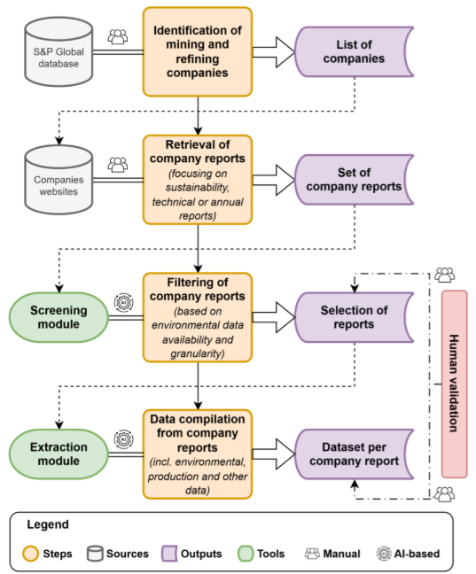
Figure 1: Overall workflow for environmental data compilation from company reports
2.2 Identifications of companies and report retrieval
To compile the set of company reports to be processed we followed a three-step procedure. First, we identified mining operators engaged in copper or nickel extraction using the global S&P Capital IQ Pro database (S&P Global, 2025). Second, we systematically retrieved publicly available documents from these operators’ websites, that could plausibly contain sustainability-related information, environmental performance indicators, or other non-financial reporting. For the retrieved documents, we undertook an expedited preliminary screening where clearly irrelevant material was excluded, to ensure an efficient application of the subsequent automated filtering and information-extraction procedures. This approach was designed to minimize manual review by experts while generating a sufficiently large and diverse sample for tuning and utilizing the AI-extraction tool. The analysis was limited to reports available in PDF format and written in English. Documents published in other formats (e.g. Excel databooks) or languages were not included in the automated processing.
2.3 Screening Framework
Processing hundreds of long-form industrial reports using multimodal LLM APIs is computationally intensive and financially costly. In the meantime, many reports contain only aggregated or narrative disclosures that are unsuitable for site-level LCI construction.
The screening framework therefore acts as a gatekeeper: it evaluates data availability, structural organization, and analytical granularity prior to launching the full extraction pipeline.
2.3.1 Structural Reconstruction and Classification
The screening logic combines sequential PDF parsing with schema-constrained LLM evaluation. The code used for the screening module is available in an open-source repository: https://github.com/####
- Structural Reconstruction:
Given the heterogeneity of industrial report layouts, a dual-layer extraction strategy is conceptually defined. First, a linear text extraction is performed using the python library pdfplumber, which efficiently retrieves flowing textual content. However, this approach may fail to preserve relational structure in dense or multi-page tables.
In the operational implementation used in this study, the structural reconstruction procedure is systematically applied to all documents to maximize the detection of structured quantitative information. This procedure analyzes vector line structures within the PDF to reconstruct row–column layouts, thereby restoring tabular integrity and ensuring that embedded metrics become accessible for screening.
Reports consisting solely of scanned images, and therefore lacking an extractable text layer, cannot be automatically screened and are flagged for manual evaluation.
- Controlled LLM screening:
The reconstructed textual content is submitted to a Gemini 2.5 Flash model using a constrained system prompt. This model was selected after preliminary testing of several multimodal LLMs because it showed good performance in interpreting complex tables and graphical elements commonly found in industrial reports. The model is required to return a single JSON object conforming to a predefined schema, which ensures structured outputs and reproducible results.
The screening step analyses several aspects of each report. It identifies the industrial context (e.g. companies, sites or assets), checks whether quantitative data are reported, verifies that values are associated with physical units, and evaluates the level of detail at which the information is provided (site level, product level, or aggregated company level). The objective of this step is to identify reports containing site-specific quantitative information that can be used for the construction of life cycle inventory (LCI) datasets.
The screening decision mainly depends on whether the report contains quantitative environmental or production data and whether these data are reported with sufficient detail (for example at site or product level). Based on this assessment, each report is assigned a preliminary classification:
GO: reports containing explicit site- or product-level production and/or environmental data. These reports proceed to the automated extraction stage.
MAYBE: reports containing partial information (for example limited granularity or predominantly financial indicators) that may still require manual inspection before extraction.
NO-GO: reports containing only aggregated company-level or group level indicators without LCI-usable quantitative data.
2.3.2 Screening Outputs and Human Validation
In addition to the preliminary decision, the screening code generates several structured outputs (Figure 2). For each report, three files are produced.
First, a human-readable diagnostic file summaring the identified sites, products, indicator families, and key numerical evidence with page references, allowing experts to review the results without rereading the entire report.
Second, a structured JSON file containing the normalized screening variables and the preliminary decision, ensuring reproducibility and interoperability with subsequent processing stages.
Third, a consolidated Excel overview aggregatinges report metadata, and screening results across all processed reports), facilitating coordinated validation and workflow tracking. Examples of the diagnostic file and the Excel overview are provided in the Supplementary Information.
All reports classified as GO or MAYBE undergo mandatory human verification, during which analysts assign a final decision (GO or NO-GO) and document the main exclusion reason when applicable. Reports initially classified as NO-GO are generally retained unless specific justification warrants reassessment. Each report is evaluated independently, and cross-year consolidation is handled in a subsequent step.
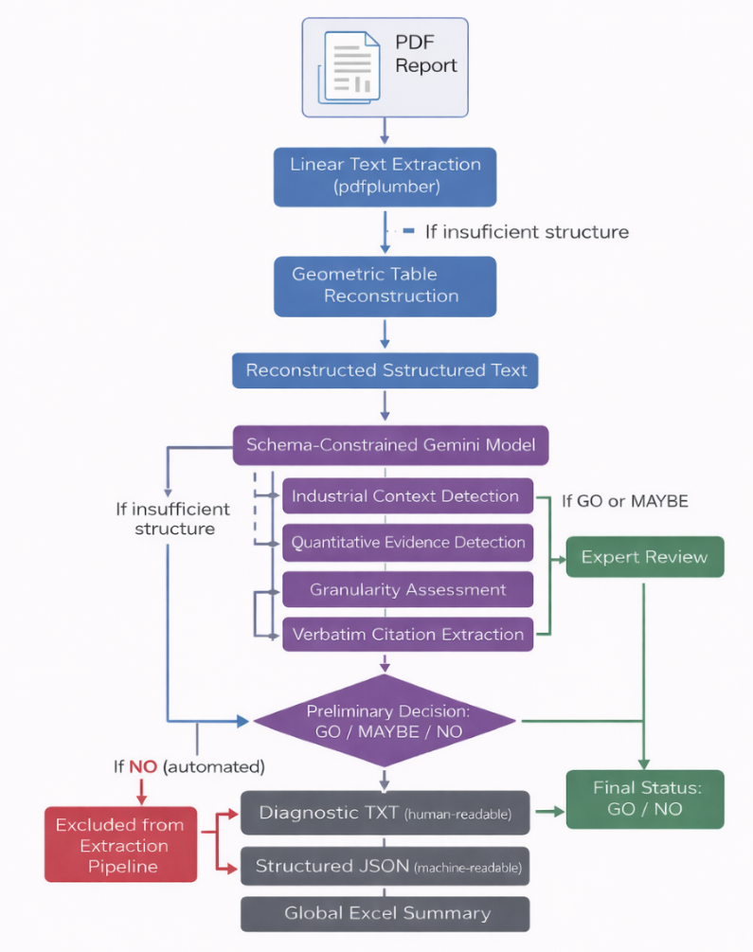
Figure 2: Workflow for automatic screening of industrial PDF reports
2.4 Multimodal Extraction Framework
The core of the methodology is a multimodal extraction module applied to reports classified as GO during the screening stage. This module retrieves quantitative metrics from industrial and ESG reports while preserving the context in which the values appear. The objective is to extract numerical values together with their units, qualifiers, and surrounding textual context, in a way that reflects how a human analyst would identify and interpret metrics in complex industrial documents.
2.4.1 Multimodal Vision-Language Architecture
Optical Character Recognition (OCR) is commonly used to convert text from scanned documents or PDFs into machine-readable content. However, traditional OCR pipelines often fail to preserve the spatial relationships between numerical values, column headers, units, and contextual qualifiers. This limitation is particularly problematic for industrial reports, where key indicators are frequently embedded in dense tables, multi-page layouts, charts, or composite visual panels.
To overcome this limitation, each PDF page is processed using a dual-modality representation. Pages are first rendered as high-resolution PNG images (typically 320–400 DPI), while the textual layer is extracted separately using deterministic tools such as pdfplumber. The rendered image and extracted text are then jointly provided as inputs to the Gemini 2.5 Flash Vision model.
The two modalities provide complementary information. The image input preserves spatial layout, enabling correct interpretation of table structures, column alignments, and graphical elements. The text input provides accurate character-level strings for metric names, numerical values, units, reporting years, and site identifiers. Combining these modalities allows the system to associate numerical values with their correct semantic and spatial context even in visually complex documents.
2.4.2 Deterministic Extraction via Constrained Prompting
To ensure reproducibility and avoid generative drift, the vision–language model operates under a zero-temperature configuration (T = 0). This setting forces deterministic behavior and prevents the model from generating inferred or summarized values. The extraction process is governed by a strictly constrained multimodal prompt enforcing several requirements:
- Exact unit transcription: units must be recorded exactly as written in the source document without conversion or normalization.
- No inference or aggregation: the model is forbidden from calculating totals or extrapolating values not explicitly reported.
- Atomic data representation: each metric is returned as an individual JSON object, ensuring a flat and machine-readable structure.
- Full tables extraction: when tabular structures are detected, all rows and numeric cells must be extracted in their entirety.
- Source modality tagging: each metric is labeled according to its origin (text, table, or graph).
- Contextual traceability: a short contextual snippet (≤200 characters) is captured for text-based metrics to preserve qualifiers such as site name, reporting year, or product.
The model output is constrained to a single minified JSON array, enabling robust downstream parsing and automated post-processing.
2.4.3 Anomaly Detection and Extraction Outputs
Multiple automated validation layers ensure data integrity and traceability. A dedicated anomaly-detection routine flags potential inconsistencies, including:
- percentage values exceeding plausible bounds,
- mismatches between metric type and page context,
- values extracted from graphical elements when explicit numeric labels are absent.
For each processed report, the system generates two primary outputs:
- an Excel extraction file containing all retrieved metrics with contextual snippets, page references, source modality tags (table/text/figure), and site identifiers when available.
- an optional flags file highlighting metrics that may require additional inspection.
Manual verification conducted on a representative sample confirms high reliability for text and table-based extractions. Most uncertainties arise from graphical content where exact numeric labels are absent. Despite these limitations, the system consistently captures reported values, units, and qualifiers with high accuracy.
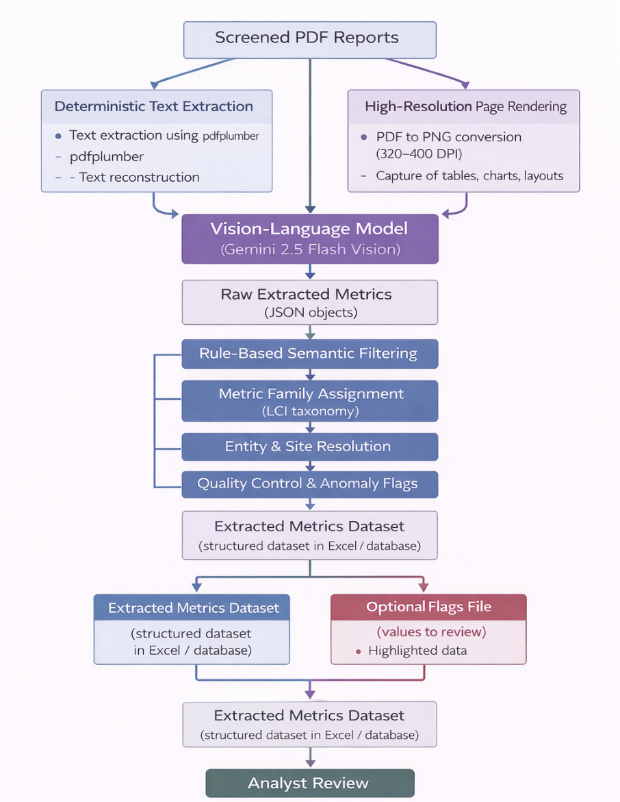
Figure 3: Multimodal extraction workflow for industrial PDF reports

3. From Company Data to LCIs: applications to Cu and Ni case studies
This section aims to showcase the applicability of the AI-based framework for large-scale data extraction from company reports to develop new LCIs, considering Cu and Ni mining activities as case studies.
3.1 Screening results
The screening workflow applied to the collected corpus of company reports is summarized in Figure 4. In total, 696 company reports respectively related to copper (354) and nickel (342) production (mining and processing) were compiled from corporate disclosures. These reports were processed through the automated screening module described in Section 2.2. The automated classification identified 107 GO, 34 MAYBE, and 82 NO-GO reports regarding Ni, and 218 GO, 69 MAYBE, and 50 NO-GO reports regarding Cu. Three Ni reports and 17 Cu reports could not be processed automatically. After human check to confirm relevance, 46 Ni reports and 129 Cu reports were retained for the subsequent extraction stage. Reports excluded during this check generally corresponded to documents lacking quantitative environmental information; reports presenting only aggregated corporate indicators, documents related to other commodities, or language constraints.
After an additional eligibility check (e.g., removal of technical reports and older reports), the final dataset entering the extraction stage consisted of 175 reports. A more detailed statistical analysis of the extracted data is provided for the Cu case study in the following section.
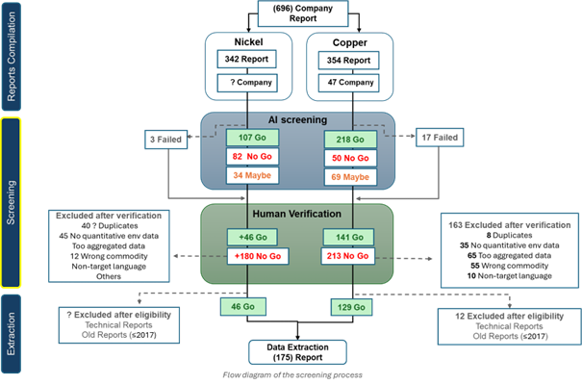
Figure 4 : Flow diagram of the screening and selection process for copper and nickel company reports.

3.2 Overview of extracted data from Cu and Ni company reports
3.2.1 Analysis of the company data extracted in the Cu and Ni case i) Cu case
For the Cu dataset, 129 reports were processed in the extraction stage, each company report resulting in one dataset containing various metrics as reported in the reports.
Production-related metrics represent the largest share of the dataset (17.2%), followed by geological indicators (15.0%), economic indicators (14.0%), emissions (13.9%), and water-related metrics (13.3%). Energy indicators account for 10.7% of the data extracted, while waste-related metrics represent 9.7%. Most values originate from structured tables (73.8%), followed by textual disclosures (19.6%) and graphical elements (6.6%).
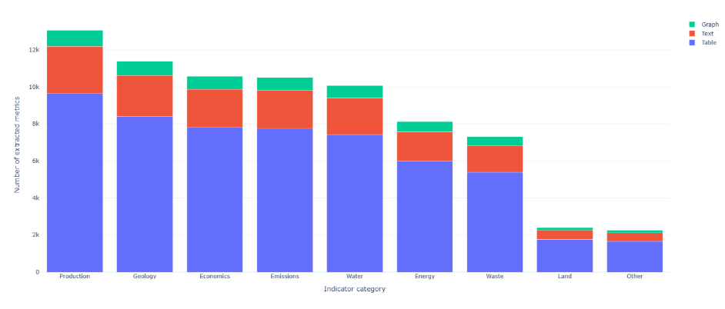
Figure 5: Distribution of extracted metrics, by categories and source type, for 129 sustainability reports from Cu mining and processing companies
It is noteworthy that among the 129 company reports here processed, several were found to cover similar companies, stemming from varying types of reports (e.g. sustainability, annual reports) or years of publication. A total of 35 different Cu companies were eventually identified within this set of reports. Moreover, each company report potentially distinguishes various production sites and years, thus resulting in metrics duplicated over different geographical and temporal scopes in each dataset.
ii) Ni case
For the Ni dataset, the distribution of extracted metrics across categories reveals that water-related indicators constitute the largest share (21.1%). Production (14.8%) and economic (14.1%) metrics also represent substantial portions of the dataset, followed by energy (11.6%) and emissions (11.5%). Geological indicators account for 9.6%, while waste (7.4%) and land (7.0%) categories contribute more moderately. The remaining metrics fall under other categories (3.0%).
Regarding source types, most extracted metrics originate from structured tables (70.4%), confirming their dominant role in sustainability disclosures. Textual sources account for 22.9%, while graphical elements contribute a smaller share (6.7%).
As shown in Figure 6, table-based data dominate across all categories, textual and graphical sources provide complementary contributions but remain secondary compared to structured tabular data.
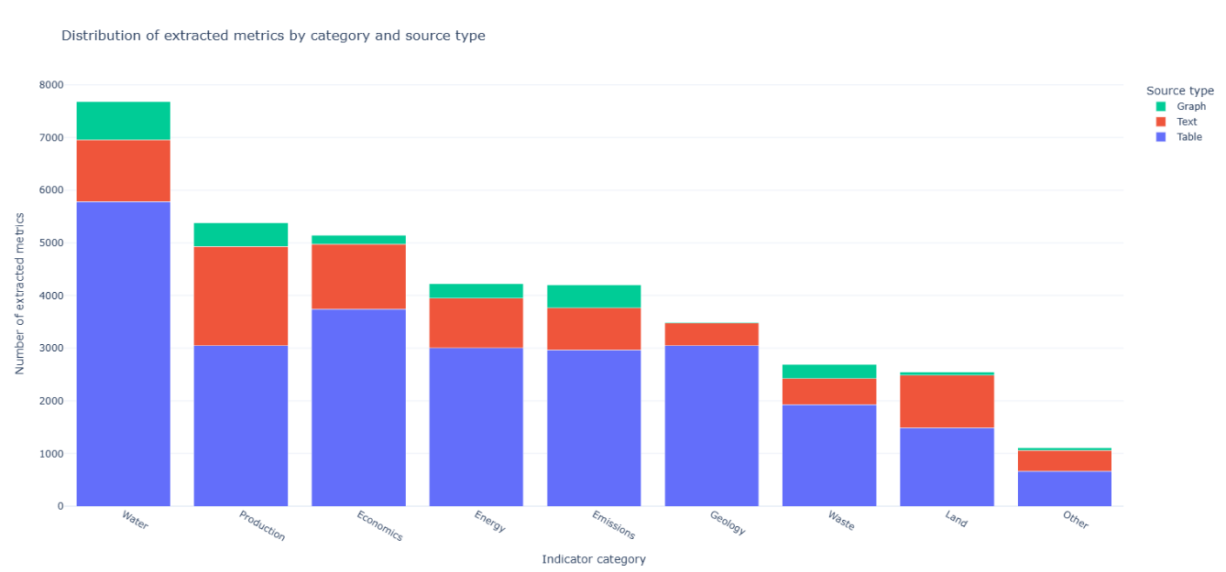
Figure 6: Distribution of extracted metrics, by categories and source type, for 45 sustainability reports from Ni mining and processing companies
3.2.2 Data processing towards LCI data generation
The extracted company datasets were first filtered according to the covered company and year of publication. For the sake of the present case studies, only one dataset per company was considered, prioritizing datasets resulting from sustainability/ESG reports and considering their most recent publication year, for developing LCI datasets. Other company datasets, from other types of reports or prior publication years, were here disregarded, despite their potential relevance to further derive relevant data for LCI generation (as data availability may vary from one type of report or one year to another). From this first filtering, XX company datasets (35 for Cu and XX for Ni) were eventually selected as a basis to develop LCI datasets.
A second filtering step was then implemented in each retained company dataset, to select the key data relevant to generate LCIs, especially in terms of environmental and production metrics (necessary to scale all environmental data generally provided on an annual basis to a given reference flow, e.g. 1 t of output). Other metrics (e.g. geology or economics) were disregarded in this study. Moreover, only site-specific data were here selected, while company-level data (i.e. aggregating data from various production sites) were excluded. It is however to be noted that data completeness potentially shows a large variability from one site to another, both in terms of environmental and production metrics. Regarding the latter, data gaps were filled with additional sources, such as company websites or the S&P Global database. Based on this filtering step, site-specific LCI datasets were developed, in an undefined format (see section 4.2.3).
As a more detailed showcase of the site-specific LCI data generated from company reports, further processing of energy data was performed to derive energy intensity data, which are key in LCIs. These energy intensity values were calculated only considering the Cu LCI datasets, where comprehensive sets of production data, including both Cu and its co-products, were eventually obtained. LCI datasets (associated with Cu and Ni) showing gaps in terms of production data were not considered in this processing step, which entailed: i) harmonization of energy units, ii) grouping of energy data into two categories, respectively electricity and fuel consumption, iii) allocation of energy consumption values to Cu (in the case of multi-products datasets). Economic allocation was here implemented, using price data for Cu and its co-products averaged over a three-years period drawn from the Shanghai metals market (SMM, 2026, https://www.metal.com/fr), with distinguishing prices of concentrates and refined forms.
3.2.3 Undefined LCI datasets
Following the approach as described in section 3.2.2, 40 inventory datasets have been compiled, gathering respectively, per site and for a given year (in most cases, 2023 or 2024): energy, reagents/intermediary flows, emissions, products and co-products, and waste (link to #SI Document 1). These datasets are reported in the form of so-called “undefined datasets” (i.e. unlinked, multi-product activity datasets), which is in particular “the way the datasets are obtained and entered by the data providers” in the ecoinvent database (Weidema et al., 2013). The 40 datasets cover sites from 16 companies, in most cases (35 out of 40) with copper as the primary commodity (in the form of a copper concentrate, or a copper cathode) and in many cases also with co-production of several other metallic elements (mainly precious: Au and Ag; and molybdenum). Major copper mining countries are covered, including Chile (8 sites), the USA (7), Australia (6) and Kazakhstan/Kyrgyzstan (5), Indonesia or Peru (3 sites each). Most sites correspond to the exploitation of Porphyry Deposits (24 out of 40), yet with other types of ore deposits also covered (e.g. Volcanogenic Massive Sulfide and Layered Mafic-Ultramafic Intrusion). This means a relatively large geographical and mineralogical diversity in the coverage of copper mining activities. Regarding these 40 inventory datasets, energy flows are reported in most cases (in 36 cases out of 40) along with air emissions (34) and to a lower extent waste flows (26). In most cases, air emissions include direct greenhouses gases emissions, in mass of CO2-eq., sometimes along with other air pollutants (NOx, particulate matter, etc.). Waste flows most often include tailings generated, sometimes distinguishing between potentially-acid-forming and non-acid-forming tailings. Other waste flows, including waste rock and other industrial waste, are also frequently included in the datasets. However, despite significant assets as to data completeness (for some flows, like energy) and representativeness (as to the number and diversity of sites covered), these datasets also suffer from a lack of completeness regarding some relevant flows; for example regarding the consumption of reagents and explosives, compiled only for a few sites, and regarding other emissions to the environment beyond air emissions.
3.2.4 Analysis of Cu energy intensity
Cu energy intensity values overall show a large variability, ranging from 9.8 to 72 GJ/t Cu in concentrate and from 7.7 to 60 GJ/t Cu cathode, respectively considering 18 sites producing concentrates and 11 sites producing cathodes (Figure 6). It is noteworthy that the average intensity is relatively similar between Cu concentrates and Cu cathode in the data sample here considered: 35 GJ/t Cu cathode against 36 GJ/t Cu in concentrate (energy intensity expressed per ton of Cu concentrate would be of lower magnitude). Energy intensity of Cu production may depend on several factors, potentially inducing lower or larger energy requirements: deposit types, process design, recovery of additional co-products. Co-productions within one site notably imply a distribution of the total energy consumption among the different products, which may result in varying energy intensities allocated to Cu, depending on the tonnage of the additional products. This is notably observable in the Mantos Blancos site, which exhibits the third largest Cu concentrate energy intensity, but the lowest Cu cathode energy intensity, in line with its respective concentrate and cathode distribution in its annual production.
The energy intensity does not necessarily correlate with production volumes; i.e. large production volumes do not imply large energy intensity. The Safford and El Abra sites for example, account for the largest Cu cathode productions among the considered sites, but show lower energy intensities than sites such as Tyrone or Mantoverde, where Cu cathode productions are lower.
In terms of energy sources, fuels appear as the predominant source in Cu cathode production sites, compared to electricity (22 GJ/t Cu cathode from fuel on average, against 15 GJ from electricity). Conversely, electricity accounts for a slightly superior contribution to energy intensity in Cu concentrate production sites (21 GJ/t Cu concentrate from electricity on average, against 19 GJ from fuel).

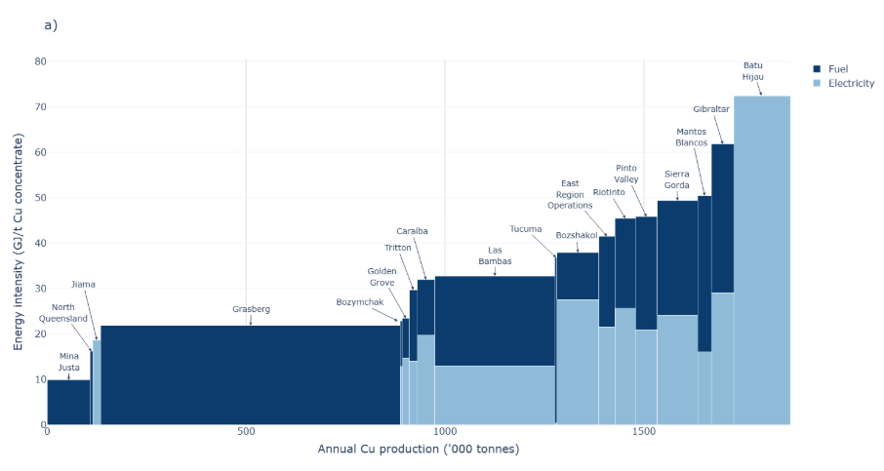
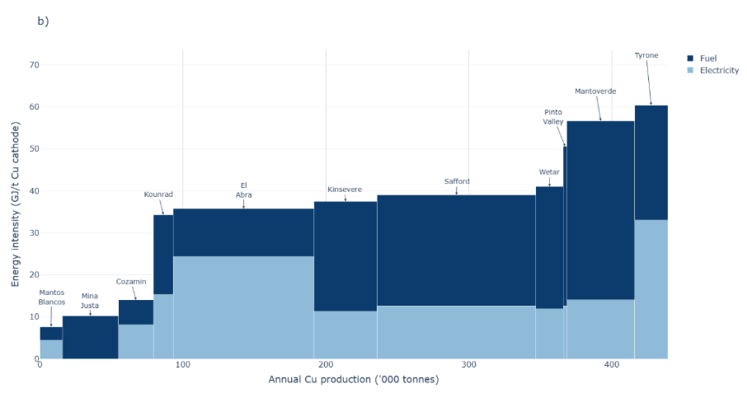
Figure 7: Energy intensity of Cu production as functions of annual Cu production tonnages per site, considering a) Cu concentrate production, b) Cu cathode production

4. Discussion
4.1 Completeness, reliability and traceability
The proposed framework demonstrates strong performance in extracting quantitative information from corporate reports, in line with the methodological objectives defined in Section 2. In particular, the system achieves a high level of reliability and traceability, as it systematically captures numerical values together with their associated units and contextual information (e.g. site name, reporting year, or product). In the copper case study, 5,490 data points were manually verified. Among these, 81.6% were classified as fully correct (GREEN), meaning that the value, unit, and contextual attribution were all correctly extracted. An additional 17.5% were classified as partially validated (YELLOW). In these cases, the numerical values were correct, but the system was unable to associate them with a specific production site or operational context. Importantly, these cases do not correspond to incorrect data, but rather to incomplete contextual attribution. Only 0.9% of the verified values were classified as incorrect (RED), with most errors arising from the extraction of values from graphical elements, where exact numerical information is not always explicitly reported. When considering numerical values alone, the accuracy therefore approaches approximately 99%. These results highlight the ability of the framework to reliably extract large volumes of quantitative data while preserving traceability, which directly supports the objectives of completeness, reliability, and processability for LCI dataset construction.
4.2 Efficiency in computing time and cost
An important practical aspect of the proposed framework is its computational efficiency. The workflow processes reports through two automated stages: a report-level screening module and a page-level multimodal extraction module. Because the extraction stage performs one model inference per page, it represents the main driver of both runtime and computational cost. Empirical observations indicate that the extraction module typically requires approximately 1–6 seconds per processed page, depending on page complexity. Pages containing dense tables, charts, or multiple numerical indicators generally require longer processing times than simpler text-dominated pages.
The monetary cost of the workflow is associated with the large language model (LLM) API requests issued during the screening and extraction stages. Based on the prompt structure and contextual inputs used in the system, a typical extraction request corresponds to approximately 2,000–2,500 input tokens and 300–400 output tokens. Using the official pricing of the Gemini 2.5 Flash model (Google Cloud, 2025), this corresponds to an estimated cost of roughly 0.0015–0.002 USD per processed page.
For the copper and nickel case studies analyzed in this work, the workflow initially processed a corpus of 696 company reports during the screening stage. Following automated screening and human verification, 175 reports were retained for detailed data extraction. Considering the total number of analyzed pages across these reports, the workflow processed on the order of several tens of thousands of pages. Based on the observed processing times and token usage, the total runtime is estimated to range from roughly 10 to 20 hours, while the associated LLM API cost is estimated to remain below approximately 40–60 USD for the full corpus. These results indicate that the proposed framework enables large-scale extraction of environmental metrics from corporate reports while maintaining a computational time and cost that remains modest relative to the scale of the analyzed dataset.
4.3 Possible extension to other types of data sources
Although the framework developed in this study focuses on the automated screening and extraction of quantitative information from sustainability reports, the methodological approach could be extended to other types of documents containing relevant industrial information. First, technical reports published by mining companies represent a particularly valuable source of operational data, as they often contain detailed information on production processes, energy consumption, emissions, and material flows relevant for LCA), as well as geological information such as resources and reserves classifications that can support other fields of research, including mineral intelligence and criticality assessments; however, these documents are typically much longer and more data-dense than sustainability reports. As a result, the extraction pipeline may retrieve very large numbers of values, sometimes thousands of data points per document, requiring additional filtering and post-processing steps to retain only the most relevant indicators. Improving the prioritization and structuring of extracted information therefore represents an important direction for future developments.
Second, the proposed framework could also be extended to other types of information sources. For example, web scraping approaches could be used to automatically retrieve scientific publications related to some specific fields (e.g. raw materials or energy transition) and improve the manual literature collection performed in this study. Similarly, automated extraction from patent databases (e.g., Google Patents) could provide complementary insights into technological developments and emerging industrial practices. More broadly, many other document sources could potentially be integrated into such automated data collection workflows.
Beyond the diversification of document sources, the extraction framework itself remains highly adaptable. The prompt used to guide the large language model can be modified to target different categories of information depending on the intended application. While the present study focuses on production and environmental indicators relevant for LCI development, the same approach could be adapted to extract other types of information reported in corporate documents, such as financial indicators, operational metrics, or technology-related parameters. Overall, extending the framework to additional document types and adapting the extraction targets would significantly expand the range of usable information sources and further improve the coverage and granularity of datasets supporting industrial and environmental analyses.
4.4 Limits and way forward
4.4.1 Potential for automatically scraping company reports
To further automate the proposed approach, reduce required expert-driven judgment and expand the scope of incorporated companies. The development of a targeted document-retrieval workflow would offer great potential. Such a workflow could combine targeted web-crawling on dedicated mining operators’ websites and web-scraping specifically designed for collecting potentially relevant corporate documents. Metadata such as file type, URL structure, directory depth, and contextual keywords could guide tool during retrieval.
While manual selection and downloading of reports inherently limits the number of documents that can be processed, automated scraping introduces a different challenge: The variability in website design, report naming, and subpage structure makes it difficult to apply strict rules without either missing relevant documents or retrieving large volumes of irrelevant material. The latter would result in unnecessary AI-processing and inefficient use of computational resources and associated environmental implications (Bashir et al. 2024).
To mitigate this trade-off, a pre-filtering step could be inserted between scraping and full AI-based analysis. After basic text extraction, documents could be screened using conventional text-processing methods (e.g., keyword scores or basic classifiers) to exclude clearly irrelevant materials before applying resource-intensive LLM tools. Modelled on the existing Two-step PDF parsing strategy, this low-cost filter would enable processing larger corpora while reducing the risk of overlooking relevant reports and improving the overall scalability of automated document collection.
4.4.2 Further improving the efficiency and robustness of the workflow
Despite the strong performance already achieved by the workflow (Sections 5.1 and 5.2), several aspects could still be improved to further enhance the efficiency and robustness of the workflow. First, the screening stage could be refined. Although it effectively filters large collections of reports, some documents initially classified as relevant are later excluded during manual verification. Improving the precision of this step would reduce false positives and further limit expert intervention. To support this process, the screening module generates a diagnostic file for each report, summarizing detected indicators, identified sites, and numerical excerpts with page references. These summaries allow analysts to quickly assess report relevance without reading the full document. An example of this diagnostic output is provided in the Supplementary Materials. Future work will aim to better structure these outputs and highlight the most relevant information.
Another limitation concerns the post-processing stage, which currently remains fully expert-driven. The extraction process can generate a large number of values per document, especially for technical reports. Developing automated routines to prioritize relevant indicators and filter redundant information would significantly reduce the time required for expert validation. In addition, further efficiency gains could be achieved by introducing page-level filtering prior to the multimodal extraction stage. Currently, the system may analyse pages that do not contain relevant quantitative information. Lightweight filtering methods could help identify relevant pages in advance, reducing unnecessary model calls. This is particularly important for very large reports, which may exceed several hundred pages.
4.4.3 LCI datasets generation from company reports
As showcased from the Cu and Ni case studies here considered, company reports such as sustainability or ESG reports show potential for large scale LCI data compilation, using the AI-based framework herein developed. This notably allows potential development of site-specific LCI datasets, towards high granularity modelling of raw materials mining activities (or potentially other types of activities). However, while energy data are generally comprehensively reported in these company reports, other types of data such as reagents, water, wastes or emissions to the environment, which constitute key input and output flows in LCIs, may not be systematically available in these reports. Filling these data gaps is crucial to develop LCI datasets with sufficient completeness to enable comprehensively capturing the environmental footprint through life cycle impact assessment. Potential sources for filling these gaps may reside in other types of reports such as technical company reports (e.g. NI 43-101 type reports), which offer comprehensive details about site-level mining activities that may enable complementing data drawn from e.g. sustainability or ESG reports. Another option for data gaps filling in LCIs resides in other available LCI datasets published in the literature, such as those from Lai et al. (2026) (https://www.sciencedirect.com/science/article/pii/S0921344925005865) who developed many LCI datasets relative to mineral and metal raw materials, from which relevant proxies may be derived.
Finally, while this AI-based framework enables automated data extraction from company reports on a large scale, further development of additional features remains possible to further automate data processing steps towards generation of LCI datasets, e.g. regarding harmonization of company data, scaling to given reference flows, background mapping (e.g. using the ecoinvent database).
5. Conclusions
One of the main challenges in life cycle assessment (LCA) remains the difficulty of accessing, extracting, and structuring reliable primary data for life cycle inventory (LCI) compilation. In this study, we developed a semi-automated framework based on artificial intelligence to address this issue by systematically harvesting quantitative environmental information from company sustainability and ESG reports.
The proposed approach combines two complementary AI modules: (i) a screening framework capable of filtering large corpora of heterogeneous reports based on their relevance and level of detail, and (ii) a multimodal extraction pipeline that integrates textual and visual information to retrieve quantitative indicators while preserving their contextual attributes (units, reporting year, site, and source location). This architecture directly addresses key challenges associated with corporate reporting, including fragmentation, lack of standardization, and non-machine-readable formats.
The application to copper and nickel mining sectors demonstrates the operational feasibility and scalability of the framework. From an initial corpus of 696 reports, the workflow efficiently identified and processed 175 relevant documents, ultimately generating thousands of structured data points and enabling the construction of XX site-specific LCI datasets. The resulting datasets include key inventory flows such as energy use, emissions, waste, and production volumes, and reveal significant variability across sites, particularly in terms of energy intensity. This variability highlights the importance of moving beyond generic datasets towards more site-specific modelling in LCA.
A key strength of the framework lies in its high level of reliability and traceability. Manual validation results on the Cu case show that more than 81% of extracted data points are fully correct, meaning that the numerical value, its unit, and its contextual attribution (e.g. site, reporting year, or product) were all correctly identified. An additional 17.5% of the entries contained correct numerical values but incomplete contextual attribution, typically due to missing or ambiguous references to specific sites or operational units in the original documents. Only 0.9% of the extracted entries were classified as incorrect. Importantly, when considering numerical values alone, independently of their contextual attribution, the extraction accuracy approaches ~99%, indicating that errors are primarily related to contextual linking rather than value extraction itself. These results confirm that the framework is highly reliable for capturing quantitative information, while highlighting that associating values with the correct operational context remains a key challenge.
Beyond methodological performance, the study provides concrete evidence of the potential of corporate reporting as a source of primary LCI data. The datasets generated reveal substantial variability in key parameters such as energy intensity across sites, highlighting the importance of site-specific modelling for accurately capturing environmental impacts. At the same time, the results underline persistent data gaps, particularly for certain flows such as reagents, detailed emissions, and waste streams, which remain inconsistently reported across companies.
Despite these strengths, the workflow still requires expert input at several stages, especially for data validation, filtering, and the construction of LCI datasets. In addition, some limitations remain linked to the heterogeneity of reports, the difficulty of extracting information from graphical elements, and the incomplete nature of corporate reporting, which can affect data completeness. To address these issues, further improvements to the workflow are needed. In particular, refining the screening step and introducing automated prioritization of relevant indicators could help reduce the need for manual intervention, while improving the handling of graphical content would enhance data coverage.
Looking ahead, the framework could be further developed to improve both its scale and level of automation. Automating document collection through web scraping would allow larger corpora to be processed more efficiently, while integrating additional sources such as technical reports or scientific publications could help fill existing data gaps. Finally, further automation of post-processing steps such as unit harmonization, allocation, and integration into LCI databases would make the overall workflow more streamlined and easier to apply.
Overall, this study demonstrates that AI-based approaches can significantly improve the way LCI data are collected and structured. By making better use of the large volume of quantitative information already available in company reports, the proposed framework shows strong potential to contribute to bridging existing data gaps in LCA.

Acknowledgements
C. Bejjit and D. Monfort received financial support from the French State managed by the National Research Agency under France 2030 - PEPR program, bearing the reference ProjetIA-22-EXSS-0004 (PEPR Sous-sol bien commun, Technical and economic foresight)
Beylot and C. Bejjit received financial support from the French State managed by the National Research Agency under France 2030 - PEPR program, bearing the reference ANR-22-EXSS-0007.
Hennioui, F. Lai, A. Beylot, A. Kroiss, S. Lutter, V. Maus, received financial support from the received funding from the European Union under the project RAWCLIC (Grant Agreement (GA) n°101183654).

References
[] Bashir, Noman, Priya Donti, James Cuff, Sydney Sroka, Marija Ilic, Vivienne Sze, Christina Delimitrou, and Elsa Olivetti. 2024. “The Climate and Sustainability Implications of Generative AI.” An MIT Exploration of Generative AI, March. https://doi.org/10.21428/e4baedd9.9070dfe7.
[] S&P Global, 2025. Capital IQ Pro. https://www.spglobal.com/marketintelligence/en/solutions/spcapital-iq-pro. Accessed September 2025.
[] European Commission, 2010. International Reference Life Cycle Data System (ILCD) Handbook: general guide for life cycle assessment: detailed guidance. European Commission - Joint Research Centre - Institute for Environment and Sustainability, LU.
[] ISO, 2006. ISO 14044:2006 Environmental management — Life cycle assessment — Requirements and guidelines. International Organization for Standardization.
[] Saavedra-Rubio, K., Thonemann, N., Crenna, E., Lemoine, B., Caliandro, P., Laurent, A., 2022. Stepwise guidance for data collection in the life cycle inventory (LCI) phase: Building technology-related LCI blocks. J. Clean. Prod. 366, 132903. https://doi.org/10.1016/j.jclepro.2022.132903
[] Wright, M., Tan, E.C.D., Tu, Q., Martins, A., Parvatker, A.G., Yao, Y., Sunol, A., Smith, R.L., 2024. Life Cycle Inventory Availability: Status and Prospects for Leveraging New Technologies. ACS Sustain. Chem. Eng. 12, 12708–12718. https://doi.org/10.1021/acssuschemeng.4c02519
[] Google Cloud (2025). Vertex AI pricing – Gemini models. https://cloud.google.com/vertex-ai/pricing

