RAPPORT FINAL

types des columns netwayer et columns ajouter :
Types des colonnes — DataFrame brut  Row ID str  Order ID str  Order Date str  Ship Date str  Ship Mode str  Customer ID str  Customer Name str  Segment str  Country str  City str  State str  Postal Code float64  Region str  Product ID str  Category str  Sub-Category str  Product Name str  Sales; str | Types des colonnes — DataFrame nettoyé  Row ID Int64  Order ID str  Order Date datetime64[us]  Ship Date datetime64[us]  Ship Mode str  Customer ID str  Customer Name str  Segment category  Country str  City str  State str  Postal Code Int64  Region category  Product ID str  Category category  Sub-Category category  Product Name str  Sales float64  Annees int32  mois int32  trimestre int32  Marge_relative float64  Taux_profit_estime float64  Quantity int64  Ratio_Qte_Sales float64  délais livraison timedelta64[us]

Les transformation :
Marge_relative Taux_profit_estime Ratio_Qte_Sales délais livraison
0 0.207254 0.000144 0.003817 3 days
1 0.095238 0.000008 0.068399 4 days
2 0.132212 0.000527 0.001044 7 days
3 0.074074 0.000012 0.044707 7 days
4 0.238095 0.000004 0.137363 5 days
Nombre de lignes = 7343

data anormalis :
Row ID Order ID Customer ID Product ID Sales
3 4 US-2016-108966 SO-20335 FUR-TA-10000577 957.5775
7 8 CA-2015-115812 BH-11710 TEC-PH-10002275 907.1520
10 11 CA-2015-115812 BH-11710 FUR-TA-10001539 1706.1840
11 12 CA-2015-115812 BH-11710 TEC-PH-10002033 911.4240
24 25 CA-2016-106320 EB-13870 FUR-TA-10000577 1044.6300
Nombre de lignes = 886

les ventes par catégorie :
Category Sales
0 furniture 139012.7868
1 office supplies 256859.8480
2 technology 223938.0900
Nombre de lignes = 3

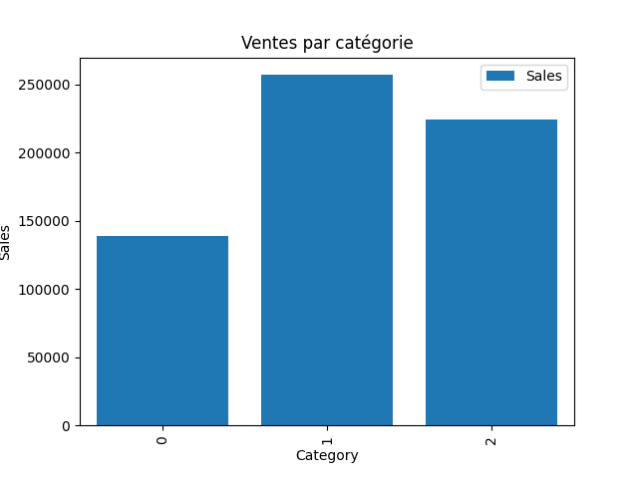

les ventes par region :
Region Sales
0 central 142243.3998
1 east 172143.1940
2 south 97122.3210
3 west 208301.8100
Nombre de lignes = 4

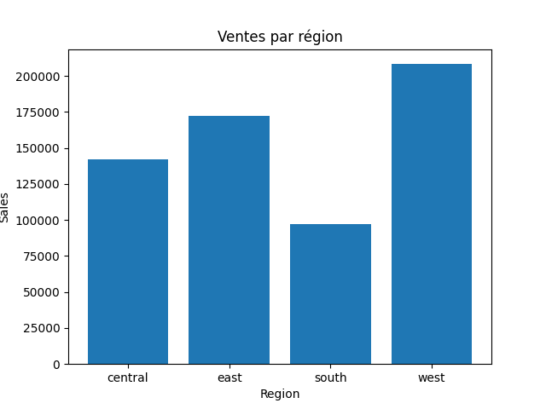

les profit par segment :
Segment Sales
0 consumer 332843.3929
1 corporate 176808.1251
2 home office 110159.2068
Nombre de lignes = 3

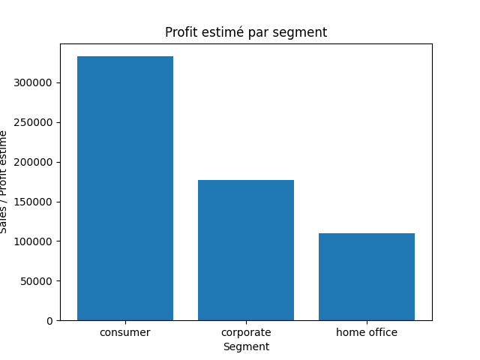

les top produit :
Product ID Sales
0 TEC-PH-10003012 2802.618
1 OFF-BI-10004632 2790.683
2 TEC-PH-10003505 2746.880
3 FUR-TA-10001039 2678.277
4 OFF-ST-10001809 2515.240
Nombre de lignes = 10

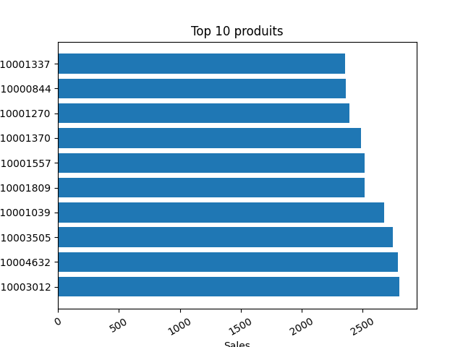

classement des moins
mois Sales
0 1 21681.6690
1 2 19228.3730
2 3 45412.4848
3 4 42390.3301
4 5 48212.1740
Nombre de lignes = 12

