IMPLEMENTATION OF 15th JDC PUBLIC DEFENDER’S OFFICE DATABASE

By

Erwin Kristel, Charaf Lachouri and Patrick Cardozo

**Contribution Breakdown**

**References**

* Erwin Kristel – experience as a public defender in the 15th JDC PDO
* 15th Judicial District Public Defenders Office of Louisiana, 15jdpdo.org
* District Attorney for the 15th Judicial Court, <https://districtattorney15thjdc.org/>
* 15th Judicial District Court Acadia, Lafayette, & Vermilion Parishises, Louisiana, https://www.15thjdc.org/

**Abstract**

We plan to develop a database for the 15th JDC Public Defender's Office (PDO), who is interested in a database aid their attorneys in tracking case information. It should be easy for attorneys to view and update case data and client information. For any instance of a case, only the attorney assigned to the case, the Section Chief of the district where the case is located, the First Defender, and Second Defender should be able to view and update case data.

**Mission Statement**

The Purpose of the PDO's database system is to maintain the data that is generated to support the public defenders in updating and tracking case and client information.

**Mission Objectives**

To maintain (enter, update and delete) data on attorneys

To maintain (enter, update and delete) data on districts

To maintain (enter, update and delete) data on prosecutors

To maintain (enter, update and delete) data on clients

To maintain (enter, update and delete) data on criminal cases

To perform searches on attorneys

To perform searches on districts

To perform searches on prosecutors

To perform searches on clients

To perform searches on cases

To track the status of cases

To track the status of clients (e.g. incarcerated, active warrants, bonded, etc.)

To report on attorneys

To report on districts

To report on prosecutors

To report on cases

**E/R Diagram**

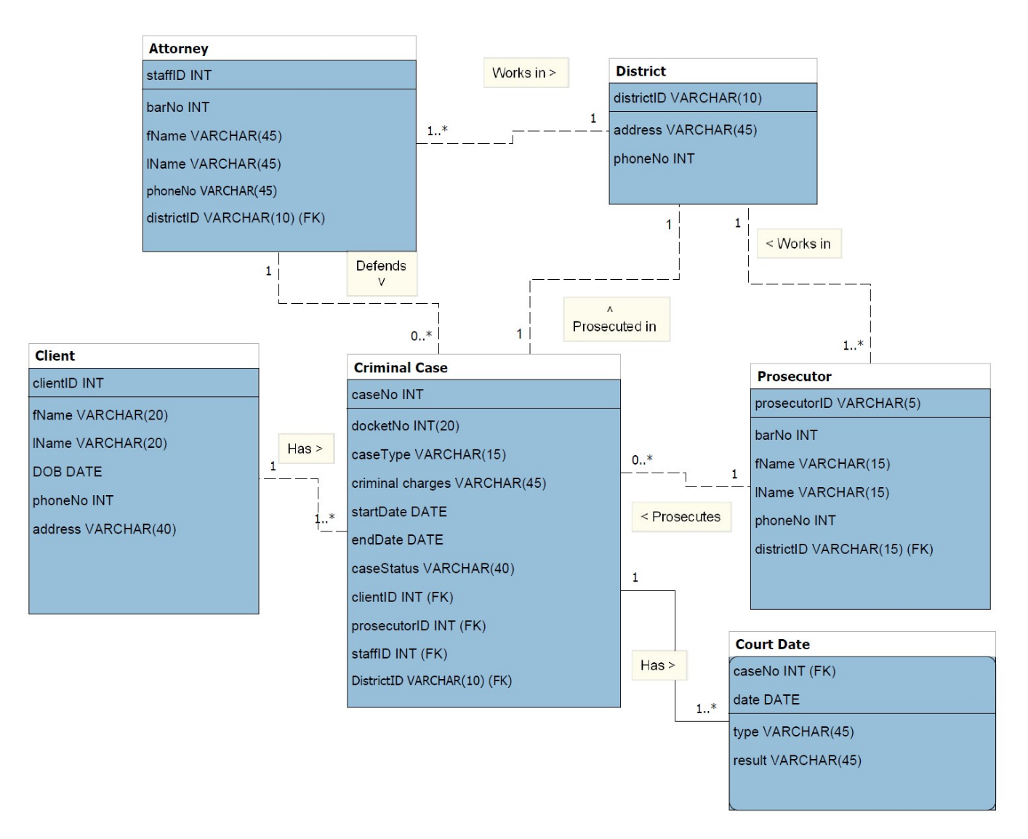

**Relational Model After Normalization**

**RELATIONS (primary key -> solid underline, foreign key -> dashed underline)**

**Attorney**(staffID, barNo, fName, lName, phoneNo, districtID)

**District**(districtID, address, phoneNo)

**Client**(clientID, fName, lName, DOB, phoneNo, address)

**Prosecutor**(prosecutorID, barNo, fName, lName, phoneNo, districtID)

**Criminal Case**(caseNo, docketNo, caseType, criminal charges, strtDate, endDate, caseStatus, clientID, prosecutorID, staffID, districtID)

**Court Date**(caseNo, date, type, result)

*note: caseNo is both a foreign key and part of the primary key

**DEPENDENCIES**

**Attorney**

staffID -> barNo, fName, lName, phoneNo, districtID

**District**

districtID -> address, phoneNo

**Client**

clientID -> fName, lName, DOB, phoneNo, address

**Prosecutor**

prosecutorID -> barNo, fName, lName, phoneNo, districtID

**Criminal Case**

caseNo -> docketNo, caseType, criminal charges, strtDate, endDate, caseStatus, clientID, prosecutorID, staffID, districtID

**Court Date**

caseNo, date -> type, result

**NORMAL FORM**

All the relations are in 3NF. They are in 3NF because they are in 2NF and no non-primary key attribute is transitively dependent on the primary key. They are in 2NF because every non-primary key attribute is fully functionally dependent on the primary key. They are in 1NF because the intersection of each row and column will contain one and only one value.

**Use Cases**

|  |  |  |  |
| --- | --- | --- | --- |
| **Use Case:** | **ENTER NEW ATTORNEY** | **ENTER NEW CLIENT** | **ENTER NEW CASE** |
| **Actor:** | 1st Defender, 2nd Defender | Attorney assigned to case | 1st Defender, 2nd Defender, Attorney assigned to case  Attorney assigned to case |
| **Steps:** | 1. Actor clicks on “New staff” button; 2. A new staff ID is shown; 3. Prompt to enter name, DOB, job title, salary, branch information 4. All information is displayed; ask for confirmation 5. User clicks on “Confirm” button | 1. Actor clicks on “New client” button; 2. New client ID is shown; 3. Prompt to enter name, DOB, address, phone, case number 4. All information is displayed; ask for confirmation 5. User clicks on “Confirm” button | 1. Actor clicks on “New case” button; 2. New case ID is shown; 3. Prompt to docket number, charge, date charged, bond amount, if bonded, attorney assigned 4. All information is displayed; ask for confirmation 5. User clicks on “Confirm” button |
| **Use Case:** | **SEARCH/UPDATE CASE** | **SEARCH/UPDATE CLIENT** | **SEARCH/UPDATE BRANCH** |
| **Actor:** | 1st Defender, 2nd Defender, Attorney assigned to case | 1st Defender, 2nd Defender, Attorney assigned to case | 1st Defender |
| **Steps:** | 1. Actor clicks “search cases” button; 2. Prompt to enter any of the attributes of case; 3. All search results are returned; 4. Actor clicks on desired search result to view instance; 5. All information is displayed; 6. Actor may update any field | 1. Actor clicks “search client” button; 2. Prompt to enter any of the attributes of client; 3. All search results are returned; 4. Actor clicks on desired search result to view instance; 5. All information is displayed; 6. Actor may update any field | 1. Actor clicks “search branches” button; 2. Prompt to enter branch no.; 3. All instance information is displayed; 4. Actor may update any field |

**Use Cases cont’d**

|  |  |  |  |
| --- | --- | --- | --- |
| **Use Case:** | **SEARCH/UPDATE ATTORNEY** | SEARCH/UPDATE DISTRICT | SEARCH/UPDATE PROSECUTOR |
| **Actor:** | 1st Defender, 2nd Defender |  |  |
| **Steps:** | 1. Actor clicks “search staff” button; 2. Prompt to enter any of the attributes of staff; 3. All search results are returned; 4. Actor clicks on desired search result to view instance information; 5. All information is displayed; 6. Actor may update any field |  |  |
| **Use Case:** |  |  |  |
| **Actor:** |  |  |  |
| **Steps:** |  |  |  |

**Use Case Implementation (SQL statements)**

Attorney

**How many attorneys are employed by the 15th JDC Public Defenders Office? (aggregate):**

SELECT COUNT(staffID) AS attorneyCount

FROM Attorney;

**Insert new attorney staff (insert):**

INSERT INTO Attorney

VALUES (7, 661093383, 'Philip', 'Fry', '337-342-8894', 'D1');

**Remove attorney with staffID 4 (delete):**

DELETE FROM Attorney

WHERE staffID = 4

**Update BarNo for attorney with staffID 2 (update):**

UPDATE Attorney

SET barNo = 3455197

WHERE staffID = 2

**For all attorneys, list staffID, lname, fname, districtID, and district address; sorted by lname, fname (join Attorney/District):**

SELECT a.staffID, lName, fName, a.districtID, address

FROM Attorney a, District d

WHERE a.districtID = d.districtID

ORDER BY lname, fname;

District

**How many districts are covered by the 15th JDC PDO? (aggregate):**

SELECT COUNT(districtID) AS districtCount

FROM District;

**Insert new district (insert):**

INSERT INTO District

VALUES (‘D4’, ‘123 Congress Street, Lafayette, LA 70507’, 33788900);

**Delete district with districtID D1 (delete):**

DELETE FROM District

WHERE districtID = ‘D1’;

**Update phoneNo for district with districtID D2 (update):**

UPDATE District

SET phoneNo = 3372230099

WHERE districtID = ‘D2’;

**List lName, fName, and districtID for all prosecutors that work in district with districtID D2 (join District/Prosecutor):**

SELECT lName, fName, p.districtID

FROM District d, Prosecutor p

WHERE p.districtID = ‘D2’ AND p.districtID = d.districtID;

Client

**How many clients does the 15th JDC PDO represent? (aggregate):**

SELECT COUNT (clientID) AS clientCount

FROM Client;

**Insert new client (insert):**

INSERT INTO Client

VALUES (20, 'Ryan', 'Sullivan', '1980-10-11', '337-333-3244', '123 Main St., Crowley, LA 76036')

**Delete client with clientID 1(delete):**

DELETE FROM Client

WHERE clientID = 1;

**Update phoneNo for client with clientID 2(update)**

UPDATE Client

SET phoneNo = 3378889388

WHERE clientID = 2;

**List ClientID, lName, fName, caseNo and docketNo for all cases belonging to client with clientID 2 (join Client/Criminal case)**

SELECT b.clientID, lName, fName, caseNo, docketNo

FROM Client a, Criminal_Case b

WHERE b.clientID = 2 AND b.clientID = a.clientID;

Prosecutor

**How many prosecutors work in District with districtID D2?(aggregate):**

SELECT COUNT(ProsecutorID) AS prosecutorCount

FROM Prosecutor

WHERE districtID = ‘D2’;

**Insert new prosecutor (insert):**

INSERT INTO Prosecutor

VALUES ('A3', '33344409', 'James', 'Franco', '337-455-9909', 'D2');

**Delete prosecutor with prosecutorID 1 (delete):**

DELETE FROM Prosecutor

Where prosecutorID = 1;

**Update phoneNo for prosecutor with prosecutor ID 2(update)**

UPDATE Prosecutor

SET phoneNo = 3374445545

WHERE prosecutorID = 2;

**List lName, fName, districtID, and address for all Prosecutors, sorted by districtID (join)**

SELECT lName, fName, d.districtID, address

FROM District d, Prosecutor p

WHERE d.districtID = p.districtID;

Criminal Case

**How many cases are assigned to the attorney with staffID 001? (aggregate)**

SELECT COUNT(caseNo) AS caseCount

FROM Criminal_Case

WHERE staffID = ‘001’;

**Insert new criminal case (insert):**

INSERT INTO Criminal_Case (CaseNo, docketNo, caseType, `criminal charges` , startDate, caseStatus, clientID, prosecutorID, staffID)

VALUES (20, 2022236345, 'felony', 'Armed Robbery', '2022-04-21' , 'open', 2, 'A2', 3);

**Delete all closed cases (delete)**

DELETE FROM Criminal_Case

WHERE caseStatus = ‘closed’;

**Update endDate and caseStatus for Criminal Case with caseNo 11(update):**

UPDATE Criminal_Case

SET endDate = ‘2022-04-21’, caseStatus = ‘closed’;

WHERE caseNo = 11;

**List ClientID, lName, fName, caseNo, and docketNo for all cases belonging to client with ClientID 20 (join):**

SELECT a.clientID, lName, fName, caseNo, docketNo

FROM Criminal_Case a, Client b

WHERE a.clientID = 20 AND a.clientID = b.clientID;

**List clientID, docketNo and district for all cases belonging to client with ClientID 20 (join):**

SELECT clientID, docketNo, b.districtID

FROM Criminal_Case a, District b

WHERE clientID = 20 AND districtID = b.districtID

Court Date

**How many court dates has Criminal Case with caseNo 5(aggregate)?**

SELECT COUNT(date) AS courtDateCount

FROM Court_Date

WHERE caseNo = 5;

**Insert new future Court Date for Criminal Case with caseNo 2 (insert):**

INSERT INTO court_date (caseNo, date, type)

VALUES (2 , '2022-07-09', 'trial')

**Delete Court Date for caseNo 4, date ‘2022-07-09’ (delete):**

DELETE FROM Court Date

WHERE caseNo = 4 AND date = ‘2022-07-09’;

**Update Court date with caseNo 11, date ‘2022-04-21’ (update)**

UPDATE Court Date

SET result = ‘pled 8 yrs HL’

WHERE caseNo = 11 AND date = ‘2022-04-21’;

**List caseNo, docketNo, date, type, and result for all Court Dates for caseNo 4 (join Criminal Case/Court Date):**

SELECT c.caseNo, docketNo, date, type, result

FROM Criminal Case c, Court Date d

WHERE c.caseNo = 4 AND c.caseNo = d.caseNo

**Test Plan and Records**

**Conclusion**

**Reference**