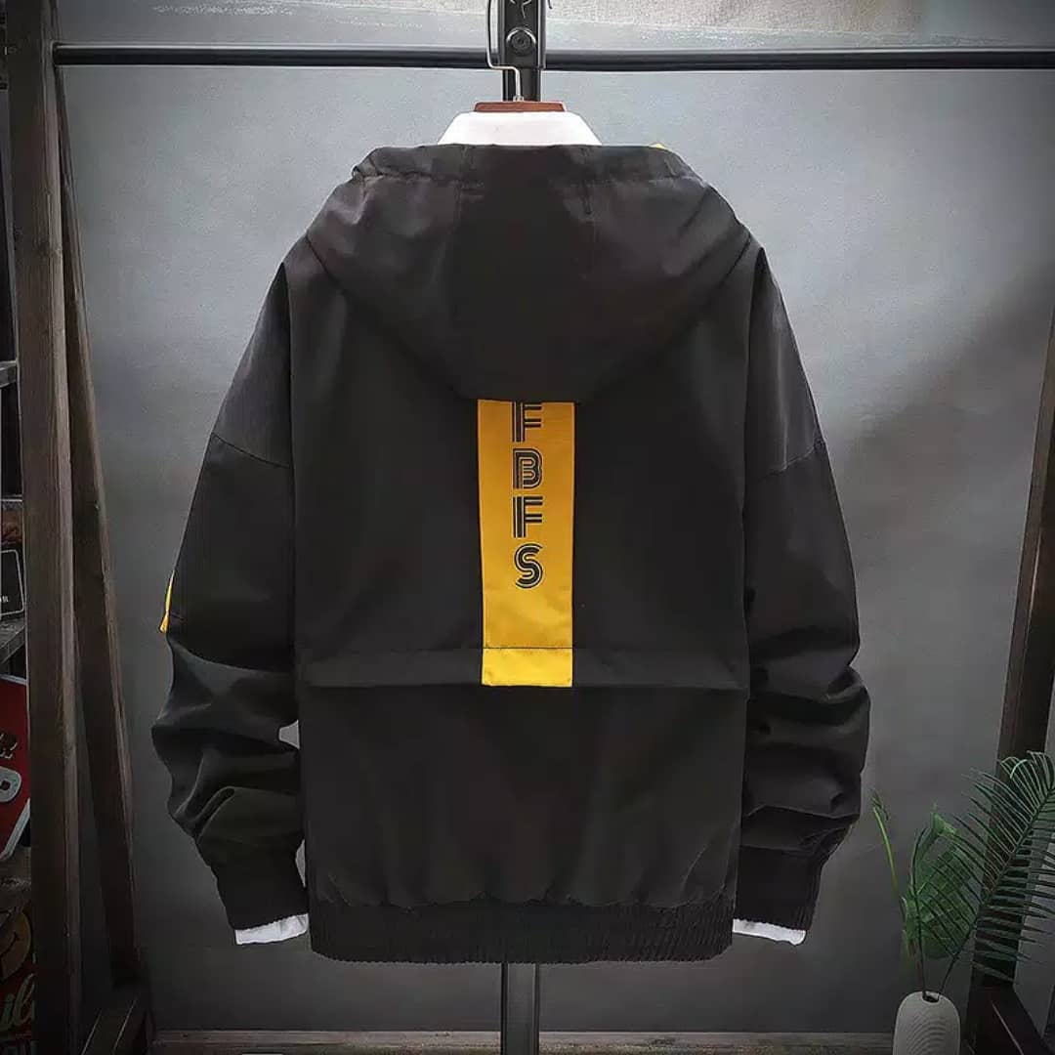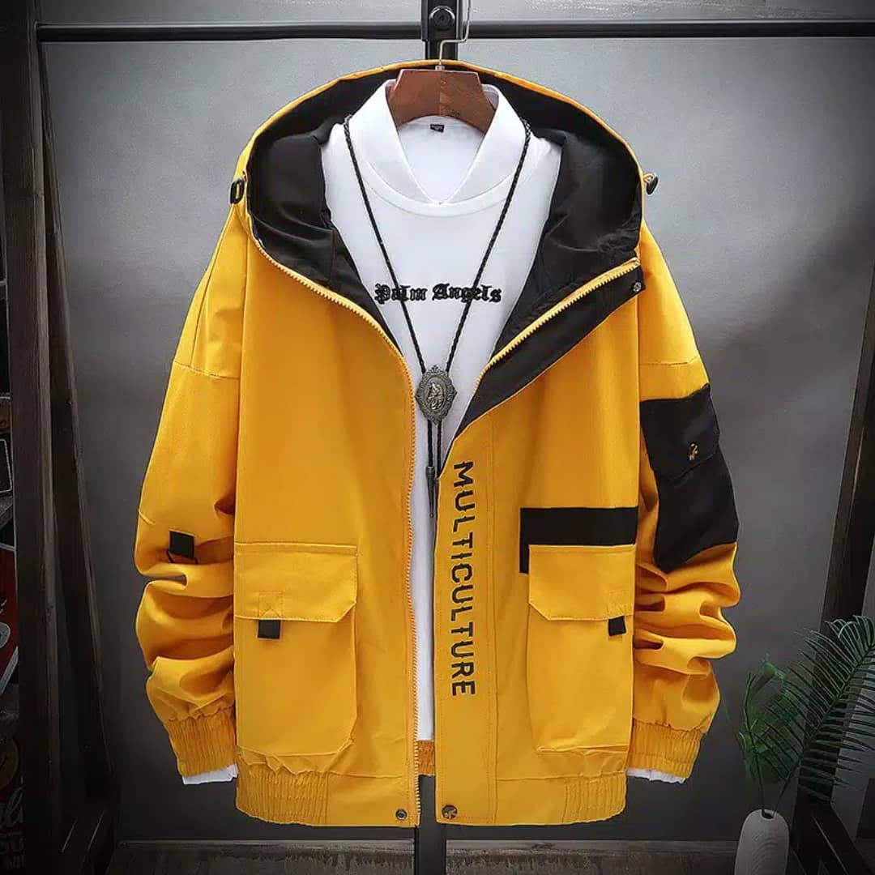DESIGN JAKET KELAS 6

HARAPAN MULIA ISLAMIC PRIMARY SCHOOL

ATAU

ISLAMIC PRIMARY SCHOOL OF HARAPAN MULIA

(Note: motif kuning bisa horizontal)

Warna dasar kuning, motif hitam

9TH GENERATION

NAMA