Image Classification Using Convolutional Neural Networks (CNNs)

A Project Report Submitted in the partial fulfillment of the requirements for the award of the degree of

BACHELOR OF TECHNOLOGY
In

DEPARTMENT OF CSE
By
L.Sreecharan | 2420030255
P.Lokesh Reddy | 2420030128
M.Bhargav Kumar | 2420030124

Under the Esteemed Guidance of

Dr.N.Sunanda
Associate Professor

Department of CSE

AY-2026-2027

Semester:odd




K L (Deemed to be) University DEPARTMENT OF CSE

Declaration

The Project Report entitled “Image Classification Using Convolutional Neural Networks (CNNs)”
is a record of Bonafide work of L.Sreecharan-2420030255,P.Lokesh Reddy-2420030128, M.Bhargav kumar-2420030124 submitted in partial fulfillment for the award of B. Tech in CSE to the K L University. The results embodied in this report have not been copied from any other departments/University/Institute.

L.Sreecharan-2420030255
P.Lokesh Reddy-2420030128
M.Bhargav Kumar-2420030124

K L (Deemed to be) University DEPARTMENT OF CSE

CERTIFICATE

This is certify that the mini project based report entitled “Image Classification Using Convolutional Neural Networks (CNNs)” is a bonafide work done and submitted by L.Sreecharan-2420030255, P.LokeshReddy-2420030128, M.BhargavKumar-2420030124 in partial fulfillment of the requirements for the award of the degree of BACHELOR OF TECHNOLOGY in Department of CSE, K L (Deemed to be University), during the academic year 2026-2027.

Signature of the Guide

Signature of the Course Coordinator Signature of the HOD

ACKNOWLEDGEMENT
The success in this project would not have been possible but for the timely help and guidance rendered by many people. Our wish to express my sincere thanks to all those who has assisted us in one way or the other for the completion of my project.

Our greatest appreciation to my Course Coordinator and my guide Dr.N.Sunanda, Department of CSE which cannot be expressed in words for his/her tremendous support, encouragement and guidance for this project.

We express our gratitude to Dr.Venkateswara Roa , Head of the Department for CSE for providing us with adequate facilities, ways and means by which we are able to complete this project-based Lab.

We thank all the members of teaching and non-teaching staff members, and also who have assisted me directly or indirectly for successful completion of this project. Finally, I sincerely thank my parents, friends and classmates for their kind help and cooperation during my work.

L.Sreecharan-2420030255
P.Lokesh Reddy-2420030128
M.Bhargav Kumar-2420030124

Abstract
Image classification is an important application of artificial intelligence and computer vision. It involves identifying and categorizing objects present in digital images. Traditional image classification techniques often depend on manually extracting features, which can be time-consuming and may not provide accurate results for complex images.
The project Image Classification Using Convolutional Neural Networks (CNNs) aims to develop an intelligent image classification system using deep learning techniques. The system uses Convolutional Neural Networks to automatically extract important features such as edges, shapes, textures, and patterns from input images. These features are processed through multiple convolutional and pooling layers to identify and classify images into predefined categories.
The proposed system uses Python, TensorFlow, Keras, NumPy, Matplotlib, and Streamlit. The model is trained and evaluated using an image dataset. Users can upload an image through the application, and the trained CNN model predicts its category and displays the prediction confidence.
The main objective is to improve image recognition through automated feature extraction and deep learning. This project demonstrates how CNNs can be used in image classification applications and provides a simple interface for testing image predictions.
Keywords: Image Classification, Convolutional Neural Networks, CNN, Deep Learning, Computer Vision, TensorFlow, Keras, Python.
.

Index
S. No. | Chapters | Topics | Page.no
 |  | Acknowledgement
 |  | Abstract
1 | Introduction | Background, problem statement, scope, objectives, importance, target users | 1-10
2 | System Requirements | Hardware, software, development tools and frameworks | 11-20
3 | Technology Stack | Front end, back end, database, version control, API | 21-30
4 | System Architecture | High-level architecture, layers, deployment architecture | 31-35
5 | Design | Wireframes, data-flow design, ER model and database schema | 36-42
6 | Implementation | Modules, front end, back end, database, API, authentication | 43-55
7 | Features | Main features and user/technical workflows | 56-60
8 | Testing | API, integration, test tools, test cases and results | 61-67
9 | Deployment | Deployment steps, configuration, hosting | 68-73
10 | Challenges and Limitations | Issues, solutions, known limitations | 74-80
11 | Future Enhancements | Planned features and optimizations | 81-88
12 | Conclusion | Summary, achievements, skills learned | 89-100
13 | References | Books, documentation and learning resources
14 | Appendices | Screenshots, sample API, setup guide and user manual

CHAPTER 1
Introduction

.1 Background of the Project
Image classification is a computer vision technique that enables computers to identify and categorize objects in digital images. It is widely used in applications such as medical image analysis, face recognition, agriculture, security systems, and object detection.
With the growth of digital images and artificial intelligence, automatic image recognition has become increasingly important. Traditional image classification methods require manual feature extraction, which can be difficult when images contain complex patterns and different visual characteristics.
Convolutional Neural Networks (CNNs) are deep learning models specially designed for image processing. They automatically learn important image features through convolutional and pooling operations. This project develops a CNN-based image classification system that accepts an image as input, processes it, and predicts its corresponding category.
1.2 Problem Statement
Traditional image classification techniques often depend on manually designed features and predefined rules. These methods may struggle to identify objects when images have different backgrounds, sizes, angles, lighting conditions, and visual patterns.
Manual image identification also requires time and human effort. Therefore, there is a need for an automated image classification system that can learn image features and classify images efficiently.
This project addresses the problem by developing a deep learning-based classification system using CNNs to automatically extract image features and predict the correct image category.
1.3 Scope of the Project
- Develop an image classification system using CNN architecture.
- Load and process image datasets for model training.
- Resize images into a standard input size.
- Normalize image pixel values before training.
- Automatically extract image features using convolutional layers.
- Train the model using labelled images.
- Evaluate model performance using accuracy and loss.
- Allow users to upload images for classification.
- Display predicted image categories and confidence scores.
- Visualize training and validation performance through graphs.
1.4 Objectives
- To understand and implement Convolutional Neural Networks.
- To develop an automated image classification model using Python.
- To perform image preprocessing and normalization.
- To extract image features automatically using CNN layers.
- To train and test the model using an image dataset.
- To evaluate the model using accuracy and loss metrics.
- To develop a user-friendly interface for image uploading and prediction.
- To improve image recognition through deep learning techniques.
1.5 Importance of the Application
The application reduces the need for manual image identification by automatically recognizing objects from digital images. CNNs learn important visual features directly from training data, making the classification process more efficient. The system can be useful in education, healthcare, agriculture, security, and other computer vision applications. It also provides practical knowledge of deep learning, image preprocessing, neural network training, and model evaluation.
1.6 Target Users / Audience
Target user | Purpose
Students | Learn and experiment with image classification and CNNs.
Researchers | Study deep learning models and image recognition techniques.
Developers | Understand and build computer vision applications.
Educational institutions | Demonstrate practical applications of artificial intelligence.
Computer vision learners | Experiment with image datasets and model predictions.

CHAPTER 2
Software Requirement

1 Software Requirements

Software | Purpose
Windows 10/11 | Operating system
Python 3.10 or later | Programming language
Visual Studio Code | Code development
TensorFlow | Deep learning framework
Keras | CNN model development
NumPy | Numerical operations
Matplotlib | Graph visualization
Streamlit | User interface
Pillow (PIL) | Image loading and processing
Web browser | Access the application

2 Development Tools and Frameworks
• Python: Used for implementing the complete image classification system.
• TensorFlow: Provides deep learning operations and model training.
• Keras: Used to create CNN layers and model architecture.
• NumPy: Performs numerical calculations and array operations.
• Matplotlib: Displays training accuracy and loss graphs.
• Streamlit: Creates the interactive web application.
• Pillow: Supports image loading, resizing, and preprocessing.
• VS Code: Used for writing and executing Python programs.

CHAPTER 3
Software Design
- User / Image Upload
- Input digital image
- Image Preprocessing
- Resize, normalize and prepare image
- CNN Model
- Convolution, ReLU, pooling and feature extraction
- Classification Layer
- Softmax and class prediction
- Prediction Result
- Predicted category and confidence score
- 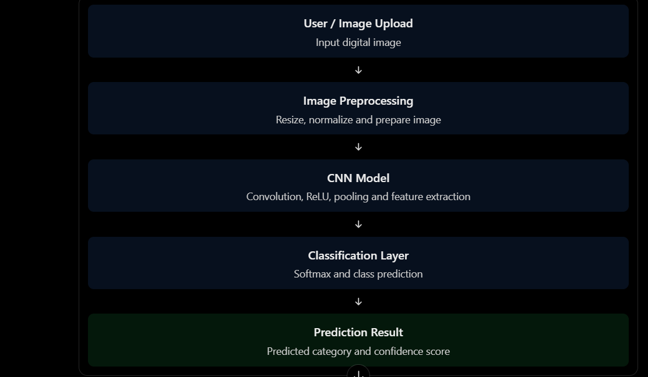

Description of Each Layer
1. User Interface Layer
Provides an interface where users can upload images and view classification results. Streamlit is used to develop the interface.
2. Image Preprocessing Layer
The input image is resized to the required dimensions and normalized. This ensures that images are provided to the CNN in a consistent format.
3. Feature Extraction Layer
Convolutional layers extract visual features such as edges, shapes, textures, and patterns from the input image.
4. Classification Layer
The extracted features are passed through fully connected layers. The Softmax activation function calculates the probability of each available class.
5. Output Layer
Displays the predicted image category and its confidence score.
3.3 CNN Architecture
The proposed CNN model consists of the following components:
Layer | Function
Input Layer | Accepts the input image
Convolution Layer | Extracts image features
ReLU Activation | Introduces non-linearity
Max Pooling | Reduces feature map dimensions
Flatten Layer | Converts feature maps into a vector
Dense Layer | Learns classification patterns
Dropout | Helps reduce overfitting
Softmax Layer | Predicts image categories
Workflow
- Start the application.
- Load the image dataset.
- Preprocess and normalize images.
- Divide the dataset into training and testing sets.
- Build the CNN architecture.
- Train the CNN model.
- Evaluate the trained model.
- Upload a new image.
- Preprocess the uploaded image.
- Generate the predicted category and confidence score.

CHAPTER 4
Implementation and User Interface

4.1 Web Page Details
- Home Page
- Model Training
- Accuracy and Loss Graph
- Image classification

4.2 Detailed Description
1. Home Page


Fig No. 4.1 Home Page

2.Model Training:.
- 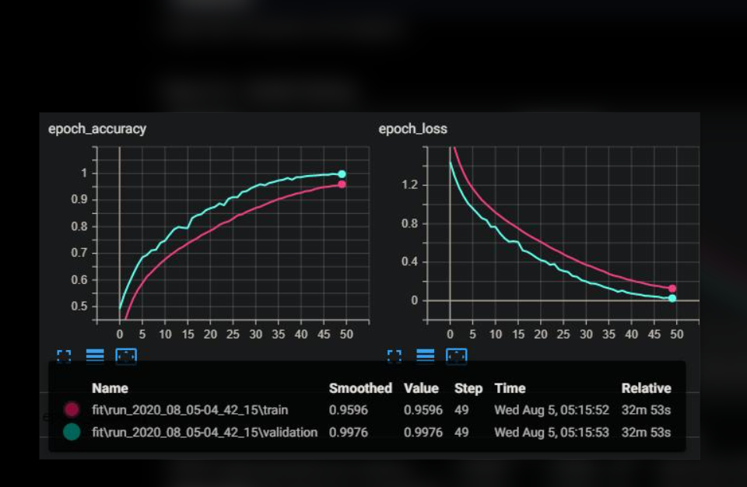

3.Accuracy and Loss Graphs
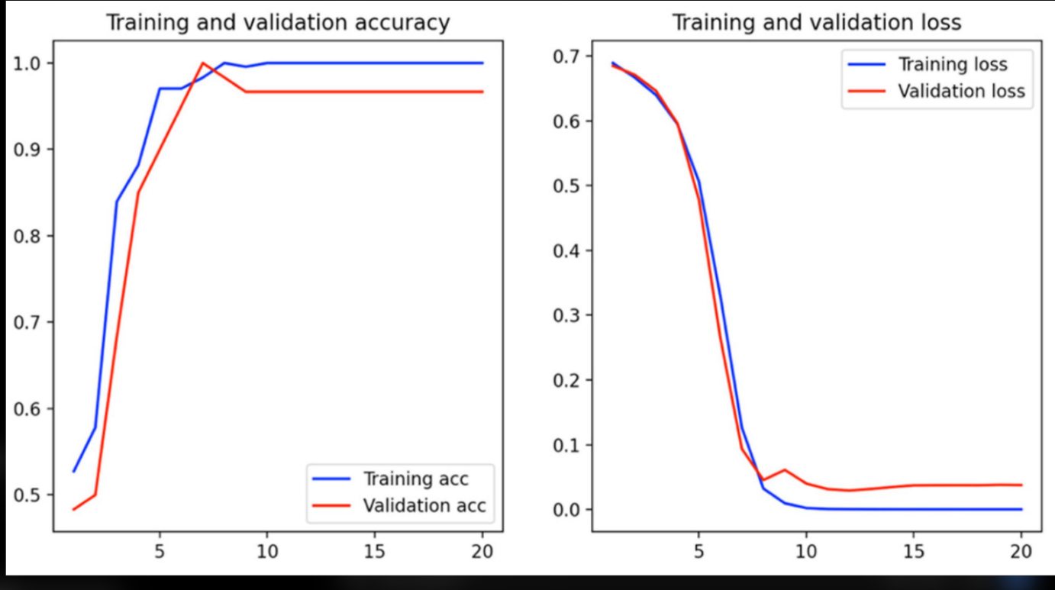

4.Image Classification Result: –

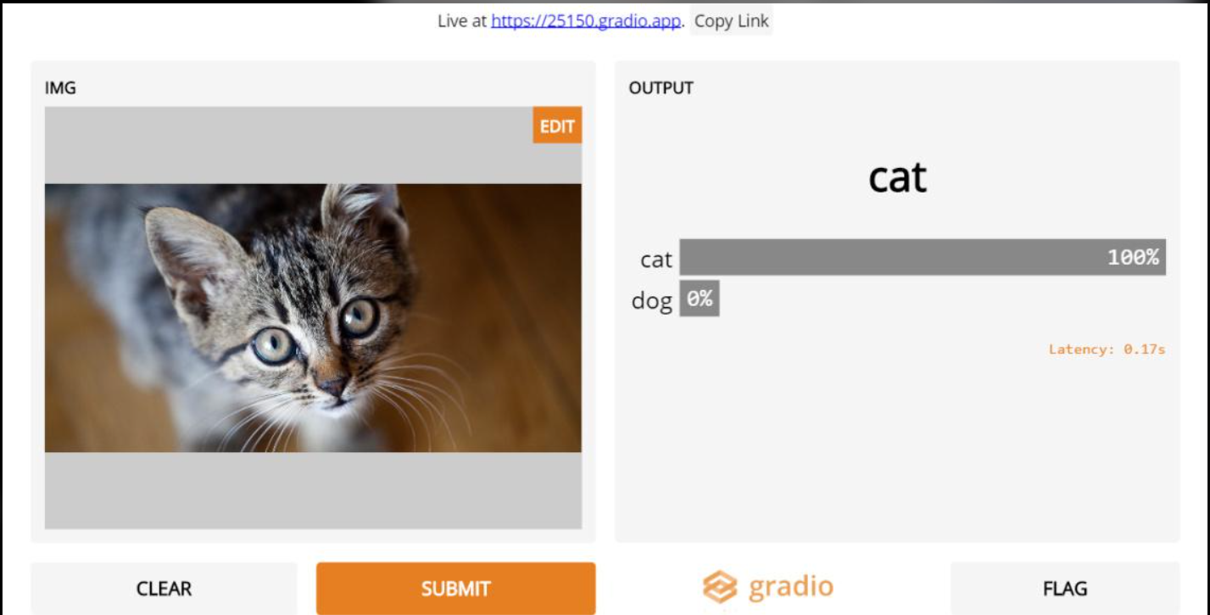

CHAPTER 5

Conclusion and Future Aspects

5.1 Conclusion
The project Image Classification Using Convolutional Neural Networks (CNNs) demonstrates the application of deep learning in automated image recognition. The system uses CNN architecture to extract important visual features from images and classify them into predefined categories. Image preprocessing, convolution, pooling, and classification operations help the model learn patterns from the training dataset. The application also provides an interface for uploading images and viewing prediction results. This project provides practical knowledge of Python programming, TensorFlow, Keras, computer vision, and deep learning. Overall, the system demonstrates how CNNs can simplify image classification and support the development of intelligent computer vision applications.
5.2 Future Aspects
- • Extend the model to support more image categories.
- • Use larger and more diverse image datasets.
- • Improve accuracy through hyperparameter tuning.
- • Implement transfer learning using VGG16, ResNet, or MobileNet.
- • Develop real-time image classification using a camera.
- • Deploy the application as a cloud-based service.
- • Add image classification for medical and agricultural applications.
- • Improve prediction speed using GPU acceleration.
- • Develop a mobile application for image recognition.

.
CHAPTER 6
CHALLENGES AND LIMITATIONS

.1 Issues Faced During Development
- Collecting and preparing a suitable image dataset.
- Handling images with different dimensions and formats.
- Selecting the appropriate CNN architecture.
- Reducing overfitting during model training.
- Managing training time and computational resources.
- Achieving good classification accuracy.
2 Solutions Applied / Recommended
- Resize images into a fixed input dimension.
- Normalize pixel values before training.
- Use data augmentation to improve image diversity.
- Apply dropout and pooling layers to reduce overfitting.
- Use suitable optimizers and learning rates.
- Evaluate the model using separate testing data.
3 Current Limitations
- Classification performance depends on the quality of the training dataset.
- The model can only recognize categories included in its training data.
- Images with poor lighting or unclear objects may produce incorrect predictions.
- Training large datasets may require high computational resources.
- The model may not perform well on completely different image types.

CHAPTER 7

Appendices

7.1 CSS
- import streamlit as st

- import pandas as pd
- import numpy as np
- import plotly.express as px
- import joblib
- from pathlib import Path

- # =========================================================
- # STUDENTIQ - STUDENT PERFORMANCE ANALYTICS
- # =========================================================

- st.set_page_config(
- page_title="StudentIQ | Analytics",
- page_icon="🎓",
- layout="wide",
- initial_sidebar_state="expanded"
- )

- BASE_DIR = Path(__file__).resolve().parent
- DATA_PATH = BASE_DIR / "data" / "student_performance_cleaned.csv"
- MODEL_PATH = BASE_DIR / "models" / "student_performance_model.pkl"

- # =========================================================
- # LOAD DATA AND MODEL
- # =========================================================

- @st.cache_data
- def load_data():
- if not DATA_PATH.exists():
- st.error(f"Dataset not found: {DATA_PATH}")
- st.stop()
- return pd.read_csv(DATA_PATH)

- @st.cache_resource
- def load_model():
- if MODEL_PATH.exists():
- return joblib.load(MODEL_PATH)
- return None

- df = load_data()
- model = load_model()

- if "Exam_Score" not in df.columns:
- st.error("The dataset must contain an Exam_Score column.")
- st.stop()

- # =========================================================
- # DESIGN SYSTEM
- # =========================================================

- st.markdown("""
- <style>
- @import url('https://fonts.googleapis.com/css2?family=DM+Sans:wght@400;500;600;700;800&family=Space+Grotesk:wght@500;600;700&display=swap');

- :root {
- --bg: #080b18;
- --surface: #111a30;
- --surface2: #151f39;
- --purple: #a78bfa;
- --blue: #60a5fa;
- --cyan: #67e8f9;
- --green: #5eead4;
- --text: #f4f5ff;
- --muted: #8998b8;
- --border: rgba(167,139,250,.17);
- }

- html, body, [class*="css"] {
- font-family: 'DM Sans', sans-serif;
- }

- .stApp {
- background:
- radial-gradient(ellipse at 5% 0%, rgba(111,65,230,.20), transparent 32%),
- radial-gradient(ellipse at 95% 5%, rgba(35,145,255,.14), transparent 30%),
- radial-gradient(ellipse at 50% 100%, rgba(92,55,180,.10), transparent 40%),
- var(--bg);
- color: var(--text);
- }

- [data-testid="stHeader"] {
- background: transparent;
- }

- .block-container {
- max-width: 1550px;
- padding-top: 2.1rem;
- padding-bottom: 3rem;
- }

- /* ---------------- SIDEBAR ---------------- */

- [data-testid="stSidebar"] {
- background: linear-gradient(180deg, #10162a, #0b1020 65%, #11112b);
- border-right: 1px solid rgba(167,139,250,.20);
- }

- [data-testid="stSidebar"] > div:first-child {
- padding: 1.6rem 1.15rem;
- }

- .brand {
- font-family: 'Space Grotesk', sans-serif;
- font-size: 27px;
- font-weight: 700;
- letter-spacing: -1px;
- color: white;
- margin-top: 8px;
- }

- .brand-iq {
- color: var(--purple);
- text-shadow: 0 0 18px rgba(167,139,250,.65);
- }

- .brand-caption {
- color: #8392b4;
- font-size: 9px;
- letter-spacing: 2.5px;
- margin-top: 5px;
- margin-bottom: 36px;
- }

- .side-heading {
- font-size: 9px;
- font-weight: 800;
- letter-spacing: 2.2px;
- color: #a78bfa;
- margin: 22px 0 12px;
- }

- /* Hide the radio circles completely */

- [data-testid="stRadio"] > label {
- display: none !important;
- }

- [data-testid="stRadio"] [role="radiogroup"] {
- gap: 8px !important;
- }

- [data-testid="stRadio"] [role="radiogroup"] label {
- display: flex !important;
- align-items: center !important;
- padding: 12px 13px !important;
- min-height: 43px !important;
- border: 1px solid transparent !important;
- border-radius: 10px !important;
- background: transparent !important;
- cursor: pointer !important;
- transition: all .22s ease !important;
- }

- /* Streamlit radio indicator */

- [data-testid="stRadio"] [role="radiogroup"] label > div:first-child {
- display: none !important;
- }

- [data-testid="stRadio"] [role="radiogroup"] label p {
- color: #aab6d0 !important;
- font-size: 12px !important;
- font-weight: 600 !important;
- margin: 0 !important;
- }

- /* Navigation hover */

- [data-testid="stRadio"] [role="radiogroup"] label:hover {
- background:
- rgba(167,139,250,.10) !important;
- border-color: rgba(167,139,250,.30) !important;
- transform: translateX(4px);
- box-shadow: 0 0 18px rgba(130,95,255,.12);
- }

- /* Active navigation */

- [data-testid="stRadio"] [role="radiogroup"] label:has(input:checked) {
- background: linear-gradient(
- 100deg,
- rgba(139,92,246,.25),
- rgba(59,130,246,.12)
- ) !important;
- border: 1px solid rgba(167,139,250,.48) !important;
- box-shadow:
- inset 3px 0 0 #a78bfa,
- 0 0 18px rgba(130,95,255,.13);
- }

- [data-testid="stRadio"] [role="radiogroup"] label:has(input:checked) p {
- color: #ffffff !important;
- font-weight: 700 !important;
- }

- /* Sidebar status */

- .status-card {
- display: flex;
- align-items: center;
- gap: 10px;
- padding: 12px;
- margin: 9px 0;
- border: 1px solid rgba(94,234,212,.18);
- border-radius: 10px;
- background: rgba(45,212,191,.055);
- color: #d4e8ed;
- font-size: 11px;
- transition: .25s ease;
- }

- .status-card:hover {
- border-color: rgba(94,234,212,.55);
- box-shadow: 0 0 18px rgba(45,212,191,.12);
- }

- .status-dot {
- color: #5eead4;
- font-size: 12px;
- text-shadow: 0 0 9px #5eead4;
- }

- .sidebar-footer {
- font-size: 10px;
- color: #71809e;
- line-height: 1.9;
- }

- /* ---------------- PAGE HEADER ---------------- */

- .eyebrow {
- color: #b6a2ff;
- font-size: 9px;
- font-weight: 800;
- letter-spacing: 2.5px;
- margin-bottom: 8px;
- }

- .page-title {
- font-family: 'Space Grotesk', sans-serif;
- color: white;
- font-size: 31px;
- font-weight: 700;
- letter-spacing: -1.1px;
- line-height: 1.2;
- }

- .page-description {
- color: var(--muted);
- font-size: 12px;
- margin-top: 9px;
- }

- .live-pill {
- display: inline-block;
- color: #5eead4;
- background: rgba(45,212,191,.08);
- border: 1px solid rgba(45,212,191,.25);
- padding: 8px 13px;
- border-radius: 30px;
- font-size: 10px;
- font-weight: 700;
- letter-spacing: .7px;
- }

- /* ---------------- SECTION TITLES ---------------- */

- .section-title {
- font-family: 'Space Grotesk', sans-serif;
- color: #f1efff;
- font-size: 17px;
- font-weight: 700;
- margin-top: 29px;
- margin-bottom: 4px;
- }

- .section-description {
- color: #8998b8;
- font-size: 10px;
- margin-bottom: 15px;
- }

- /* ---------------- KPI CARDS ---------------- */

- .kpi-card {
- position: relative;
- overflow: hidden;
- min-height: 137px;
- padding: 19px;
- border-radius: 15px;
- border: 1px solid rgba(167,139,250,.19);
- background: linear-gradient(140deg, #202747, #121b32 85%);
- box-shadow: 0 9px 25px rgba(0,0,0,.17);
- transition: all .28s ease;
- }

- .kpi-card:before {
- content: "";
- position: absolute;
- top: 0;
- left: 12%;
- width: 76%;
- height: 1px;
- background: linear-gradient(90deg, transparent, #a78bfa, #60a5fa, transparent);
- }

- .kpi-card:after {
- content: "";
- position: absolute;
- width: 110px;
- height: 110px;
- right: -55px;
- top: -55px;
- border-radius: 50%;
- background: rgba(167,139,250,.12);
- filter: blur(15px);
- }

- .kpi-card:hover {
- transform: translateY(-6px);
- border-color: rgba(167,139,250,.7);
- box-shadow:
- 0 14px 32px rgba(93,63,210,.20),
- 0 0 22px rgba(96,165,250,.10);
- }

- .kpi-top {
- display: flex;
- align-items: center;
- justify-content: space-between;
- }

- .kpi-label {
- color: #aab8d7;
- font-size: 9px;
- font-weight: 800;
- letter-spacing: 1.4px;
- }

- .kpi-icon {
- font-size: 20px;
- filter: drop-shadow(0 0 8px rgba(167,139,250,.6));
- }

- .kpi-value {
- color: white;
- font-family: 'Space Grotesk', sans-serif;
- font-size: 29px;
- font-weight: 700;
- margin-top: 13px;
- }

- .kpi-note {
- color: #8492b0;
- font-size: 10px;
- margin-top: 4px;
- }

- /* ---------------- CHART PANELS ---------------- */

- .chart-panel {
- padding: 17px 17px 9px;
- border-radius: 15px;
- border: 1px solid rgba(167,139,250,.15);
- background: linear-gradient(145deg, #151f39, #0e172c);
- box-shadow: 0 10px 27px rgba(0,0,0,.16);
- transition: all .25s
- STATUS</div>', unsafe_allow_html=True)

- st.markdown("""
- <div class="status-card">
- <span class="status-dot">●</span> Dataset connected
- </div>
- """, unsafe_allow_html=True)

- if model is not None:
- st.markdown("""
- <div class="status-card">
- <span class="status-dot">●</span> ML model loaded
- </div>
- """, unsafe_allow_html=True)
- else:
- st.markdown("""
- <div class="status-card">
- <span style="color:#fbbf24">●</span> ML model unavailable
- </div>
- """, unsafe_allow_html=True)

- st.markdown("""
- <div class="status-card">
- <span class="status-dot">●</span> Analytics active
- </div>
- """, unsafe_allow_html=True)

- st.markdown("---")

- st.markdown("""
- <div class="sidebar-footer">
- STUDENT PERFORMANCE ANALYTICS
- <br><br>
- Built with Python · Streamlit · Machine Learning
- <br><br>
- StudentIQ workspace
- </div>
- """, unsafe_allow_html=True)

- # =========================================================
- # PAGE HEADER
- # =========================================================

- page_info = {
- "Overview": (
- "ACADEMIC INTELLIGENCE PLATFORM",
- "Student Performance Overview",
- "Your complete snapshot of student outcomes, learning habits and academic indicators."
- ),
- "Performance Analytics": (
- "DISCOVER THE PATTERNS",
- "Performance Analytics",
- "Explore relationships between student factors and examination performance."
- ),
- "Score Prediction": (
- "MACHINE LEARNING / PREDICTION",
- "Student Score Prediction",
- "Estimate examination performance using the trained machine learning model."
- ),
- "Student Explorer": (
- "DATA / STUDENT DIRECTORY",
- "Student Explorer",
- "Search, filter and explore individual student performance records."
- )
- }

- eyebrow, title, description = page_info[page]

- head_left, head_right = st.columns([5, 1])

- with head_left:
- st.markdown(f"""
- <div class="eyebrow">{eyebrow}</div>
- <div class="page-title">{title}</div>
- <div class="page-description">{description}</div>
- """, unsafe_allow_html=True)

- with head_right:
- st.markdown(
- '<div class="live-pill">● LIVE WORKSPACE</div>',
- unsafe_allow_html=True
- )

- # =========================================================
- # PAGE 1: OVERVIEW
- # =========================================================

- if page == "Overview":

- section(
- "Performance at a glance",
- "Key indicators calculated directly from the student dataset."
- )

- c1, c2, c3, c4 = st.columns(4)

- with c1:
- metric_card(
- "TOTAL STUDENTS",
- f"{len(df):,}",
- "👥",
- "Student records available"
- )

- with c2:
- metric_card(
- "AVERAGE SCORE",
- f"{df['Exam_Score'].mean():.2f}",
- "🎯",
- "Average examination score"
- )

- with c3:
- metric_card(
- "AVG. ATTENDANCE",
- f"{df['Attendance'].mean():.1f}%",
- "📅",
- "Average attendance"
- )

- with c4:
- metric_card(
- "STUDY HOURS",
- f"{df['Hours_Studied'].mean():.1f} hrs",
- "📚",
- "Average study hours"
- )

- section(
- "Academic performance insights",
- "Visual summaries of student scores and learning factors."
- )

- left, right = st.columns(2)

- with left:

- chart_panel(
- "Exam Score Distribution",
- "How examination scores are distributed across students"
- )

- fig = px.histogram(
- df,
- x="Exam_Score",
- nbins=30,
- color_discrete_sequence=["#9b83ff"]
- )

- fig.update_traces(
- marker_line_width=0,
- opacity=.9
- )

- fig.update_xaxes(title="Exam Score")
- fig.update_yaxes(title="Number of Students")

- st.plotly_chart(
- style_chart(fig),
- use_container_width=True
- )

- chart_end()

- with right:

- chart_panel(
- "Attendance vs Exam Score",
- "Explore the relationship between attendance and scores"
- )

- fig = px.scatter(
- df,
- x="Attendance",
- y="Exam_Score",
- color="Exam_Score",
- color_continuous_scale=["#56658b", "#9b83ff", "#58b9ff"],
- opacity=.65
- )

- fig.update_traces(marker=dict(size=6))
- fig.update_xaxes(title="Attendance (%)")
- fig.update_yaxes(title="Exam Score")

- st.plotly_chart(
- style_chart(fig),
- use_container_width=True
- )

- chart_end()

- left, right = st.columns(2)

- with left:

- chart_panel(
- "Study Hours vs Exam Score",
- "Compare study time with examination performance"
- )

- fig = px.scatter(
- df,
- x="Hours_Studied",
- y="Exam_Score",
- color="Exam_Score",
- color_continuous_scale=["#56658b", "#9b83ff", "#58b9ff"],
- opacity=.65
- )

- fig.update_traces(marker=dict(size=6))
- fig.update_xaxes(title="Hours Studied")
- fig.update_yaxes(title="Exam Score")

- st.plotly_chart(
- style_chart(fig),
- use_container_width=True
- )

- chart_end()

- with right:

- chart_panel(
- "Numerical Feature Correlation",
- "Correlation between numerical dataset variables"
- )

- numeric_df = df.select_dtypes(include=np.number)

- fig = px.imshow(
- numeric_df.corr(),
- text_auto=".2f",
- aspect="auto",
- color_continuous_scale="Purples"
- )

- st.plotly_chart(
- style_chart(fig, 380),
- use_container_width=True
- )

- chart_end()

- # =========================================================
- # PAGE 2: PERFORMANCE ANALYTICS
- # =========================================================

- elif page == "Performance Analytics":

- section(
- "Explore student performance",
- "Select a factor to understand how it relates to examination scores."
- )

- col1, col2 = st.columns(2)

- with col1:
- factor = st.selectbox(
- "Select numerical factor",
- [
- "Hours_Studied",
- "Attendance",
- "Previous_Scores",
- "Sleep_Hours",
- "Tutoring_Sessions",
- "Physical_Activity"
- ]
- )

- with col2:
- category = st.selectbox(
- "Select category for comparison",
- [
- "Parental_Involvement",
- "Motivation_Level",
- "Access_to_Resources",
- "Internet_Access",
- "School_Type",
- "Peer_Influence",
- "Gender"
- ]
- )

- left, right = st.columns(2)

- with left:

- chart_panel(
- f"{factor.replace('_', ' ')} vs Exam Score",
- "Student-level comparison"
- )

- fig = px.scatter(
- df,
- x=factor,
- y="Exam_Score",
- color="Exam_Score",
- color_continuous_scale=["#56658b", "#9b83ff", "#58b9ff"],
- opacity=.6
- )

- fig.update_traces(marker=dict(size=6))
- fig.update_xaxes(title=factor.replace("_", " "))
- fig.update_yaxes(title="Exam Score")

- st.plotly_chart(
- style_chart(fig),
- use_container_width=True
- )

- chart_end()

- with right:

- chart_panel(
- f"Average Score by {category.replace('_', ' ')}",
- "Compare average examination scores across categories"
- )

- grouped = (
- df.groupby(category)["Exam_Score"]
- .mean()
- .reset_index()
- .sort_values("Exam_Score", ascending=False)
- )

- fig = px.bar(
- grouped,
- x=category,
- y="Exam_Score",
- color="Exam_Score",
- color_continuous_scale=["#56658b", "#9b83ff", "#58b9ff"],
- text_auto=".2f"
- )

- fig.update_layout(coloraxis_showscale=False)
- fig.update_xaxes(title=category.replace("_", " "))
- fig.update_yaxes(title="Average Exam Score")

- st.plotly_chart(
- style_chart(fig),
- use_container_width=True
- )

- chart_end()

- section(
- "Category breakdown",
- "Detailed summary of student performance for the selected category."
- )

- summary = (
- df.groupby(category)["Exam_Score"]
- .agg(["count", "mean", "min", "max"])
- .reset_index()
- )

- summary.columns = [
- category.replace("_", " "),
- "Number of Students",
- "Average Score",
- "Lowest Score",
- "Highest Score"
- ]

- st.dataframe(
- summary.round(2),
- use_container_width=True,
- hide_index=True
- )

- # =========================================================
- # PAGE 3: SCORE PREDICTION
- # =========================================================

- elif page == "Score Prediction":

- section(
- "Prediction workspace",
- "Enter student details and generate a machine learning score estimate."
- )

- if model is None:

- st.error(
- "The trained model was not found. "
- "Check models/student_performance_model.pkl."
- )

- else:

- features = [
- column for column in df.columns
- if column != "Exam_Score"
- ]

- with st.form("prediction_form"):

- st.markdown("##### Student information")

- columns = st.columns(3)
- values = {}

- for i, column in enumerate(features):

- with columns[i % 3]:

- if pd.api.types.is_numeric_dtype(df[column]):

- minimum = float(df[column].min())
- maximum = float(df[column].max())
- default = float(df[column].median())

- values[column] = st.number_input(
- column.replace("_", " "),
- min_value=minimum,
- max_value=maximum,
- value=default,
- step=1.0
- )

- else:

- options = sorted(
- df[column].dropna().astype(str).unique().tolist()
- )

- default_value = str(df[column].mode().iloc[0])

- default_index = (
- options.index(default_value)
- if default_value in options else 0
- )

- values[column] = st.selectbox(
- column.replace("_", " "),
- options,
- index=default_index
- )

- submitted = st.form_submit_button(
- "✦ Generate Prediction",
- use_container_width=True
- )

- if submitted:

- try:

- input_df = pd.DataFrame([values])

- prediction = float(model.predict(input_df)[0])

- section(
- "Prediction result",
- "Estimated examination score from the trained model."
- )

- left, right = st.columns([1, 2])

- with left:
- metric_card(
- "PREDICTED EXAM SCORE",
- f"{prediction:.2f}",
- "✦",
- "Machine learning estimate"
- )

- with right:

- if prediction >= 75:
- st.success(
- "The model estimates a relatively high examination score."
- )

- elif prediction >= 60:
- st.info(
- "The model estimates a moderate examination score."
- )

- else:
- st.warning(
- "The model estimates a lower examination score. "
- "Academic support may be useful."
- )

- st.caption(
- "This is an estimate generated by the model, "
- "not a guaranteed examination result."
- )

- except Exception as error:

- st.error(f"Prediction failed: {error}")

- # =========================================================
- # PAGE 4: STUDENT EXPLORER
- # =========================================================

- elif page == "Student Explorer":

- section(
- "Student record explorer",
- "Filter the dataset to find students matching your selected criteria."
- )

- col1, col2, col3 = st.columns(3)

- with col1:

- minimum_score = st.slider(
- "Minimum exam score",
- int(df["Exam_Score"].min()),
- int(df["Exam_Score"].max()),
- int(df["Exam_Score"].min())
- )

- with col2:

- minimum_attendance = st.slider(
- "Minimum attendance",
- int(df["Attendance"].min()),
- int(df["Attendance"].max()),
- int(df["Attendance"].min())
- )

- with col3:

- category_filter = st.selectbox(
- "Filter category",
- [
- "All",
- "Gender",
- "School_Type",
- "Motivation_Level",
- "Parental_Involvement"
- ]
- )

- filtered = df[
- (df["Exam_Score"] >= minimum_score) &
- (df["Attendance"] >= minimum_attendance)
- ].copy()

- if category_filter != "All":

- options = sorted(
- df[category_filter].dropna().astype(str).unique().tolist()
- )

- selected_value = st.selectbox(
- f"Choose {category_filter.replace('_', ' ')}",
- options
- )

- filtered = filtered[
- filtered[category_filter].astype(str) == selected_value
- ]

- section(
- "Filtered dataset summary",
- "Updated statistics based on the selected filters."
- )

- c1, c2, c3 = st.columns(3)

- with c1:
- metric_card(
- "MATCHING STUDENTS",
- f"{len(filtered):,}",
- "👥",
- "Filtered student records"
- )

- with c2:
- avg_score = (
- f"{filtered['Exam_Score'].mean():.2f}"
- if not filtered.empty else "—"
- )

- metric_card(
- "AVERAGE SCORE",
- avg_score,
- "🎯",
- "Filtered average"
- )

- with c3:
- avg_attendance = (
- f"{filtered['Attendance'].mean():.1f}%"
- if not filtered.empty else "—"
- )

- metric_card(
- "AVERAGE ATTENDANCE",
- avg_attendance,
- "📅",
- "Filtered average"
- )

- section(
- "Student records",
- "Explore the records below or download the filtered dataset."
- )

- st.dataframe(
- filtered,
- use_container_width=True,
- hide_index=True,
- height=430
- )

- st.download_button(
- "↓ Download filtered CSV",
- data=filtered.to_csv(index=False).encode("utf-8"),
- file_name="student_performance_records.csv",
- mime="text/csv"
- )

- # =========================================================
- # FOOTER
- # =========================================================

- st.markdown("---")

- st.markdown("""
- <div style="
- text-align:center;
- color:#71809e;
- font-size:9px;
- letter-spacing:1.5px;
- padding:10px;
- ">
- STUDENTIQ &nbsp; · &nbsp;
- ACADEMIC INTELLIGENCE PLATFORM &nbsp; · &nbsp;
- POWERED BY PYTHON AND MACHINE LEARNING
- </div>
- """, unsafe_allow_html=True)
- import pandas as pd
- import os

- file_path = r"C:\Users\tsusm\OneDrive\Documents\Student-Performance-Analytics\data\StudentPerformanceFactors.csv"

- print("STUDENT PERFORMANCE ANALYTICS")
- print("--------------------------------")

- if os.path.exists(file_path):

- df = pd.read_csv(file_path)

- print("\nSUCCESS! DATASET LOADED")

- print("\nDataset Shape:")
- print(df.shape)

- print("\nFirst 5 Student Records:")
- print(df.head())

- print("\nColumn Names:")
- for column in df.columns:
- print("-", column)

- print("\nMissing Values:")
- print(df.isnull().sum())

- print("\nDataset Statistics:")
- print(df.describe())

- else:
- print("\nERROR: Dataset not found!")
- print("Check your data folder and CSV filename.")
- import pandas as pd
- from pathlib import Path

- # Project directory
- BASE_DIR = Path(__file__).resolve().parents[1]

- # Dataset paths
- input_file = BASE_DIR / "data" / "StudentPerformanceFactors.csv"
- output_file = BASE_DIR / "data" / "student_performance_cleaned.csv"

- print("STUDENT PERFORMANCE DATA CLEANING")
- print("=" * 45)

- # Load dataset
- df = pd.read_csv(input_file)

- print("\nOriginal Dataset Shape:", df.shape)

- # Check missing values
- print("\nMissing Values Before Cleaning:")
- print(df.isnull().sum())

- # Fill missing numerical values with median
- numerical_columns = df.select_dtypes(include="number").columns

- for column in numerical_columns:
- df[column] = df[column].fillna(df[column].median())

- # Fill missing categorical values with mode
- categorical_columns = df.select_dtypes(include="object").columns

- for column in categorical_columns:
- df[column] = df[column].fillna(df[column].mode()[0])

- # Check duplicates
- duplicates = df.duplicated().sum()
- print("\nDuplicate Records:", duplicates)

- df = df.drop_duplicates()

- # Check missing values after cleaning
- print("\nMissing Values After Cleaning:")
- print(df.isnull().sum())

- # Save cleaned dataset
- df.to_csv(output_file, index=False)

- print("\nCleaned Dataset Shape:", df.shape)

- print("\nCLEANING COMPLETED SUCCESSFULLY!")
- print("Cleaned file saved at:", output_file)
- import pandas as pd
- import matplotlib.pyplot as plt
- import seaborn as sns
- from pathlib import Path

- # Project paths
- BASE_DIR = Path(__file__).resolve().parents[1]
- DATA_FILE = BASE_DIR / "data" / "student_performance_cleaned.csv"
- OUTPUT_DIR = BASE_DIR / "assets"

- OUTPUT_DIR.mkdir(exist_ok=True)

- # Load cleaned dataset
- df = pd.read_csv(DATA_FILE)

- sns.set_theme(style="darkgrid")

- print("STUDENT PERFORMANCE - DATA ANALYSIS")
- print("=" * 45)

- print("\nDataset Shape:", df.shape)

- print("\nStatistical Summary:")
- print(df.describe())

- print("\nAverage Exam Score:", round(df["Exam_Score"].mean(), 2))
- print("Highest Exam Score:", df["Exam_Score"].max())
- print("Lowest Exam Score:", df["Exam_Score"].min())

- # 1. Exam score distribution
- plt.figure(figsize=(9, 5))
- sns.histplot(df["Exam_Score"], bins=20, kde=True)
- plt.title("Distribution of Student Exam Scores")
- plt.xlabel("Exam Score")
- plt.ylabel("Number of Students")
- plt.tight_layout()
- plt.savefig(OUTPUT_DIR / "exam_score_distribution.png")
- plt.close()

- # 2. Attendance vs exam score
- plt.figure(figsize=(9, 5))
- sns.regplot(data=df, x="Attendance", y="Exam_Score",
- scatter_kws={"alpha": 0.3})
- plt.title("Attendance vs Exam Score")
- plt.tight_layout()
- plt.savefig(OUTPUT_DIR / "attendance_vs_score.png")
- plt.close()

- # 3. Study hours vs exam score
- plt.figure(figsize=(9, 5))
- sns.regplot(data=df, x="Hours_Studied", y="Exam_Score",
- scatter_kws={"alpha": 0.3})
- plt.title("Study Hours vs Exam Score")
- plt.tight_layout()
- plt.savefig(OUTPUT_DIR / "study_hours_vs_score.png")
- plt.close()

- # 4. Correlation heatmap
- numeric_df = df.select_dtypes(include="number")

- plt.figure(figsize=(11, 8))
- sns.heatmap(numeric_df.corr(), annot=True, cmap="coolwarm",
- fmt=".2f", linewidths=0.5)
- plt.title("Correlation Between Numerical Factors")
- plt.tight_layout()
- plt.savefig(OUTPUT_DIR / "correlation_heatmap.png")
- plt.close()

- print("\nEDA COMPLETED SUCCESSFULLY!")
- print("Graphs saved inside the assets folder.")
- import pandas as pd
- import joblib

- from pathlib import Path
- from sklearn.model_selection import train_test_split
- from sklearn.compose import ColumnTransformer
- from sklearn.preprocessing import OneHotEncoder
- from sklearn.pipeline import Pipeline
- from sklearn.ensemble import RandomForestRegressor
- from sklearn.metrics import mean_absolute_error, mean_squared_error, r2_score

- # Project paths
- BASE_DIR = Path(__file__).resolve().parents[1]

- DATA_FILE = BASE_DIR / "data" / "student_performance_cleaned.csv"
- MODEL_DIR = BASE_DIR / "models"
- MODEL_DIR.mkdir(exist_ok=True)

- MODEL_FILE = MODEL_DIR / "student_performance_model.pkl"

- print("STUDENT PERFORMANCE - MACHINE LEARNING")
- print("=" * 50)

- # Load cleaned dataset
- df = pd.read_csv(DATA_FILE)

- # Separate input features and target
- X = df.drop(columns=["Exam_Score"])
- y = df["Exam_Score"]

- # Identify numerical and categorical columns
- numerical_columns = X.select_dtypes(include="number").columns.tolist()
- categorical_columns = X.select_dtypes(exclude="number").columns.tolist()

- # Convert categorical data into numerical form
- preprocessor = ColumnTransformer(
- transformers=[
- ("categorical", OneHotEncoder(handle_unknown="ignore"), categorical_columns),
- ("numerical", "passthrough", numerical_columns)
- ]
- )

- # Create machine learning pipeline
- model = Pipeline(
- steps=[
- ("preprocessor", preprocessor),
- ("regressor", RandomForestRegressor(
- n_estimators=200,
- random_state=42,
- n_jobs=-1
- ))
- ]
- )

- # Split dataset into training and testing data
- X_train, X_test, y_train, y_test = train_test_split(
- X, y, test_size=0.2, random_state=42
- )

- print("\nTraining Records:", len(X_train))
- print("Testing Records:", len(X_test))

- # Train the model
- print("\nTraining Random Forest Model...")
- model.fit(X_train, y_train)

- # Make predictions
- predictions = model.predict(X_test)

- # Evaluate model
- mae = mean_absolute_error(y_test, predictions)
- mse = mean_squared_error(y_test, predictions)
- rmse = mse ** 0.5
- r2 = r2_score(y_test, predictions)

- print("\nMODEL EVALUATION RESULTS")
- print("-" * 35)
- print("Mean Absolute Error (MAE):", round(mae, 2))
- print("Root Mean Squared Error (RMSE):", round(rmse, 2))
- print("R2 Score:", round(r2, 4))

- # Save trained model
- joblib.dump(model, MODEL_FILE)

- print("\nMODEL TRAINING COMPLETED SUCCESSFULLY!")
- print("Model saved at:", MODEL_FILE)

