TransLegalSim: Transformer-Based Legal Document Similarity Analysis With Domain-Adaptive Embedding Refinement

Natra Charan
Dept of Computer Science and Engg
Amrita School of Computing
Amrita Vishwa Vidyapeetham Chennai, India
natracharan@gmail.com

Muli Likhith
Dept of Computer Science and Engg
Amrita School of Computing
Amrita Vishwa Vidyapeetham Chennai, India
likhithreddymuli@gmail.com
Nadimpalli Harshith Varma
Dept of Computer Science and Engg
Amrita School of Computing
Amrita Vishwa Vidyapeetham Chennai, India
harshithvarmanadimpalli27@gmail.com

BTPR.Nikhil
Dept of Computer Science and Engg
Amrita School of Computing
Amrita Vishwa Vidyapeetham Chennai, India
nikhilbetavalli0@gmail.com

Abstract

The legal document similarity has a great impact on legal precedent search and legal analysis. In this research, a new legal similarity framework is proposed using a transformer model and a new technique called Domain Adaptive Embedding Refinement Module (DAERM). The legal similarity framework is evaluated using a Brazilian Court Decision dataset. Another legal document similarity evaluation is done using Indian Supreme Court decisions. In this research, a Sentence Transformer model called 'all-MiniLM-L6-v2' is used as a baseline model to generate embeddings using clean legal document data. However, a new technique called DAERM improves the generated embeddings using legal metadata information before generating embeddings. Finally, legal document similarity is measured using a cosine similarity function and a clustering technique called K-Means and visualization using a UMAP technique. The experimental results clearly show that DAERM improves legal document similarity results compared to the baseline model and can be an efficient technique for legal document similarity analysis using a transformer model.
Keywords:
Legal Document Similarity, Transformer Embeddings, DAERM, Cosine Similarity, Semantic Retrieval, Legal Text Analysis.

1. Introduction

Currently, the Natural Language Processing technology has been extensively used in the legal domain, especially because the majority of the legal documents have already been digitalized. The legal documents, such as judgments, cases, and petitions, are extremely long and unstructured, containing complex legal terminologies. It is always a necessity for legal professionals and researchers to look for similar cases for legal research and legal analysis. This can be an extremely inefficient and time-consuming process. Hence, it is found that the need for legal documents' similarity is extremely high, particularly due to recent developments in transformer models for NLP, which have helped greatly in understanding the semantic meaning of legal documents [4].

Recent research has also been carried out to study the application of advanced NLP techniques in the analysis of legal document similarity. Recent research has identified that domain-aware transformer-based sentence embedding models can effectively identify the semantic structure of legal texts, thereby improving the process of unsupervised similarity detection and retrieval of relevant legal documents compared to other traditional bag-of-word-based techniques like TF-IDF [1]. Recent research has identified that sentence embedding models in conjunction with semantic similarity measures can be effectively used to improve the process of legal document retrieval and clustering without any need to use supervised annotations [2].

Further research on the application of textual similarity measures in the automatic identification of legal precedents has been conducted, emphasizing the role of semantic representations in legal research activities [3]. Survey studies have found that transformer architecture and large language models are increasingly used for various legal NLP tasks, such as document clustering, semantic search, and similarity analysis, in recent times [4]. Other studies have found that domain-specific pre-training plays an important role in improving the performance of the model for legal text understanding tasks [5].

However, in spite of their performance, the existing transformer-based approaches have some disadvantages. In fact, most of the existing approaches have not considered the legal terminology, the legal document structure, and the legal procedure in the legal documents. In addition, the existing approaches have handled all legal documents in the same way. However, the existing approaches have not considered the type of case, legal domain (criminal, civil, etc.), and legal terminology in the legal documents. Furthermore, the existing approaches have not considered the legal domain and legal terminology in the legal documents. In addition, the existing approaches have handled all legal documents in the same way. In fact, the existing approaches have not considered the type or the procedural labels. Therefore, the accuracy of the similarity calculation or the clustering of the legal documents is not good. In most cases, the accuracy of the similarity calculation or the clustering of the legal documents is not good, especially when the documents are from different legal domains [6].

Therefore, this project introduces the TransLegalSim, which is the transformer-based legal document similarity system with the Domain Adaptive Embedding Refinement Module (DAERM). The proposed TransLegalSim system can improve the accuracy of the similarity calculation or the clustering of the legal documents by using the information related to the type of case or the procedural context of the legal documents.

2. Literature Survey
The use of transformer-based NLP methods has shown that they are useful for analyzing semantic similarity in legal documents. The pioneering study on the similarity analysis of judicial decisions through transformer-based techniques reveals that the contextual embeddings indeed capture the semantic relations without supervision [7]. The study on unsupervised legal semantic textual similarity backs this up by showing that transformer embeddings perform better than all other kinds of text representations, even in the case of Brazilian Portuguese legal corpora [8]. Moreover, transformer-based models have been employed in summarizing legal documents for the purpose of overcoming the problems related to lengthy documents and low-resource languages [9]. The use of embedding-based NLP approaches has made the implementation of efficient and accurate key information extraction from legal and financial documents possible by similarity measures [10]. The results of the application of transformer-based strategies in the legal information retrieval and entailment tasks indicate their capability to deal with the complexities of legal semantics [11]. The domain-adaptive fine-tuning consumes better representation quality in specialized legal areas, for instance, climate-related financial disclosures [12]. The structure-aware transformer models also to a considerable degree smooth the legal case retrieval process by employing the document structure in representation skill [19]. The overview of legal NLP research has shown that transformer-based models are the leading techniques that have been used to prepare and analyze legal texts in contemporary times [20].

2.1 Transformer-Based Legal Text Representation
The use of transformer-based models to represent legal texts has become the preferred method since they are able to depict not only the contextual but also the semantic aspects of the legal texts. The basic research into the application of the transformer-based methodology for the similarity assessment between legal court documents has shown that contextual embeddings, indeed, represent legal documents well enough for the similarity analysis to be conducted without the supervision of any data [7]. Reviews of the NLP in law field emphasize even more that, by the skillful modeling of difficult legal language and terms, representations based on transformers actually outshine the classical approaches in the performance on a variety of legal tasks [20]. Furthermore, methods involving transformer-based representations have proven to be very effective in the retrieval of legal information as well as in the entailment tasks, thus, confirming their capability of discriminating fine semantic relationships within legal texts [11]. By these results, the use of transformer-based models as a trustworthy basis for the representation of legal texts in systems based on similarity has been established.
Table 2.1: Overview of Transformer-Based Approaches for Legal Text Representation
Citation | Paper Title | Model/Approach | Primary Task | Key Contribution
[7] | Analysing Similarities Between Legal Court Documents Using NLP Approaches Based on Transformers | Transformer-based embeddings | Legal document similarity | Establishes transformer embeddings as effective legal representations.
[20] | Natural Language Processing for the Legal Domain: A Survey of Tasks, Datasets, Models and Challenges | Transformer-based models (Survey) | Multiple legal NLP tasks | Highlights effectiveness of transformers for legal text representation.
[11] | Legal Information Retrieval and Entailment Using Transformer-based Approaches | Transformer models | Legal retrieval and entailment | Demonstrates strong contextual understanding of legal texts.

The research that is presented in Table 2.1 indicates that the use of the transformer-based approach for legal text representation is significantly improved by the contextual modeling and the awareness of the structure of the text. The models that are able to capture the semantic meaning of the text and its organization provide high-quality embeddings that are appropriate for the downstream tasks like legal document similarity. This ability of representation directly helps in the development of the proposed TransLegalSim framework, which is based on the transformer embeddings and aims at facilitating the legal document similarity analysis that is accurate and scalable.

  - Legal Semantic Textual Similarity and Document Matching
Legal semantic textual similarity is primarily concerned with quantifying the semantic distance among legal papers by means of the use of contextual representations. A study conducted in the area of unsupervised legal semantic textual similarity investigates several text representations and concludes that transformer-based embeddings are superior to the traditional methods in terms of similarity computation, particularly when it comes to Brazilian Portuguese legal texts [8]. The transformer-based methods facilitate the effective matching of documents because they can grasp the contextual meaning, which is beyond the scope of simple lexical overlap. Furthermore, embedding-based similarity techniques have been utilized to draw out and measure the semantic content of legal and financial documents, and it has been proven that cosine similarity over the learned embeddings offers document matching that is both efficient and scalable [10]. The above-mentioned methods point to the necessity of making strong semantic representations for legal document similarity to be accurate, which is the very requirement of the similarity module for the TransLegalSim framework.

Table 2.2: Legal Semantic Textual Similarity and Document Matching Approaches
Citation | Paper Title | Domain/Language | Similarity Method | Key Contribution
[8] | Evaluating Text Representations for Unsupervised Legal Semantic Textual Similarity in Brazilian Portugues | Brazilian Portuguese | Transformer embeddings | Shows effectiveness of unsupervised legal similarity.
[10] | NLP-Driven Summarization: Efficient Extraction of Key Information from Legal and Financial Documents | Legal & Financial | Embedding similarity + cosine similarity | Demonstrates scalable document matching.

Table 2.2 studies indicate that semantic similarity in legal writing could be overcome successfully by the use of transformer-based embeddings and similarity measures. These methods are characterized by the lack of dependence on labeled data and the use of contextual representations, which together offer a robust basis for legal document matching and are in perfect harmony with the proposed TransLegalSim framework's goals.

  - Domain-Adaptive Pretraining and Specialized Legal Embeddings

The use of domain-adaptive pretraining and fine-tuning techniques has become quite common in the development of transformer models for legal subdomains, particularly those that are difficult to interpret semantically. A notable example of such a case is the fine-tuning of ClimateBERT with the specific climate finance data, which has resulted in the model gaining a better semantic understanding of the concerned topics in the legal and regulatory texts in question [12]. Furthermore, transformer-based methods are simultaneously being tested in medical-legal documents where the integration of special architectures plays a crucial role in the processing of complex medical terminology in legal contexts [14]. The continuous domain-adaptive pretraining on medical texts leads to the production of better-quality contextual embeddings, which, however, can only be realized under the use of high-performance computing resources as they show 'significant performance gains' [15]. The various research works mentioned have collectively pointed out the need to use domain-specific corpora for the re-embedding of models in order to gain better semantic representation in legal NLP applications. Enhanced embedding techniques using Siamese Neural Networks have also been applied to public procurement documents, demonstrating improved similarity matching through domain-specific representation learning [18].

Table 2.3: Domain-Adaptive Pretraining and Specialized Legal Embeddings
Citation | Paper Title | Domain | Model/Technique | Key  Contribution
[12] | Fine-tuning ClimateBert Transformer with ClimaText | Climate finance | ClimateBERT fine-tuning | Improves climate-risk semantic representation.
[14] | Efficient Techniques for Processing Medical Texts in Legal Documents | Medical Legal | Transformer architecture | Handles complex medical-legal language
[15] | Indian Legal Judgment Summarization using LEGAL-BERT and BiLSTM model with Adaptive Length | Indian Legal Judgments | LEGAL-BERT + BiLSTM | Adaptive legal judgment summarization
[18] | Enhanced Embeddings for Public Procurement Utilizing Siamese Neural Networks for Improved Similarity Matching | Public Procurement | Siamese Neural Networks | Domain-specific similarity embeddings

The studies shown in Table 2.3 have proven that the application of pretraining specifically for a certain domain has a substantial positive effect on transformer embeddings in the context of specialized legal subdomains. The refined embeddings strategy that has been brought up in the proposed TransLegalSim framework is thus directly supported by these findings.

  - Legal Document Summarization, Ontologies, and Knowledge Modeling
The analysis of legal texts is enhanced by the integration of legal document summarization and knowledge modeling, since the former provides semantic abstraction and the latter structured understanding. Transformer-based abstractive summarization techniques are effective in legal texts even in low-resource languages [9]. Combining LEGAL-BERT with sequence models further boosts the summarization of judicial decisions by accommodating different document lengths [13]. Legal-Onto and similar ontology-based systems facilitate legal knowledge representation through structuring and automation of updates, thus going beyond legal document analysis that relies solely on text embeddings [16]. Cosine similarity measures in traditional embedding-based summarization methods yield baselines for assessment of the performance of transformer-based techniques [17]. Pretrained structure-aware models also show that the utilization of document structure brings about a substantial improvement in legal case retrieval performance [19]. Legal NLP research surveys bring together these different methods and underline transformers as the major approach for analyzing legal texts [20].

This section supplies a summary that brings together all the past research that is related to the topics of transformer-based legal document analysis, semantic similarity, domain adaptation, summarization and knowledge modeling, etc. The papers under review indicate the increasing use of transformer architectures for the analysis of complicated legal texts and confirm their efficiency in tasks like document similarity, retrieval, summarization, and domain-specific analysis. Nevertheless, the literature also points out some drawbacks, such as insufficient emphasis on document-level similarity, the non-existence of domain-adaptive embedding refinement, and meager linking of structured legal knowledge to contextual embeddings. These shortcomings taken together urge for a unified framework like TransLegalSim, which is designed to improve legal document similarity analysis by means of transformer-based representations enhanced through domain-adaptive techniques.

Table 2.4: Legal Summarization, Ontologies, and Knowledge Modeling Approaches
Citation | Paper Title | Focus Area | Approach | Key Contribution
[9] | Transformer-Based Abstractive Summarization of Legal Texts | Summarization | Transformer | Handles low-resource legal texts
[13] | LEGAL-BERT: The Muppets straight out of Law School | Summarization | Hybrid deep learning | Adaptive-length summaries
[16] | Improving Legal Document Analysis using Legal-Onto Ontology | Knowledge modelling | Ontology-based | Enables automated legal knowledge updates
[17] | Harnessing Advanced NLP Techniques via SpaCy Embeddings | Summarization | Embedding + cosine similarity | Baseline extraction method
[19] | SAILER: Structure-aware Pre-trained Language Model | Retrieval | Structure-aware transformer | Improves legal case retrieval
[20] | NLP for the Legal Domain: A Survey | Survey | Transformer-based NLP | Identifies trends and challenges

2.5 Summary of Existing Research in Legal NLP
This section supplies a summary that brings together all the past research that is related to the topics of transformer-based legal document analysis, semantic similarity, domain adaptation, summarization and knowledge modeling, etc. The papers under review indicate the increasing use of transformer architectures for the analysis of complicated legal texts and confirm their efficiency in tasks like document similarity, retrieval, summarization, and domain-specific analysis. Nevertheless, the literature also points out some drawbacks, such as insufficient emphasis on document-level similarity, the non-existence of domain-adaptive embedding refinement, and meager linking of structured legal knowledge to contextual embeddings. These shortcomings taken together urge for a unified framework like TransLegalSim, which is designed to improve legal document similarity analysis by means of transformer-based representations enhanced through domain-adaptive techniques.

Table 2.5: Summary of Literature Review Papers
Citation | Paper Title | Authors/  Year/  Journal | Methodology | Pros | Cons | Research Gap
[7] | Analysing similarities between legal court documents using NLP approaches based on transformers | Raphael Souza de Oliveira , Erick Giovani Sperandio Nascimento  2025  arXiv | Transformer embeddings with similarity metrics | Effective unsupervised similarity | No domain refinement | Lacks embedding refinement across domains
[8] | Evaluating text representations for unsupervised legal semantic textual similarity in Brazilian Portuguese | Daniel da Silva Junior, Daniel de Oliveira1, Aline Paes  2024  Artificial Intelligence and Law | Embedding comparison for STS | Strong multilingual evaluation | Sentence-level focus | No document-level similarity
[9] | Transformer-Based Abstractive Summarization of Legal Texts in Low-Resource Languages | Salman Masih, Mehdi Hassan, Labiba Gillani Fahad and Bilal Hassan  2025  International Conference on NLP | Transformer-based summarization | Handles low-resource texts | Task-specific | No similarity modeling
[10] | NLP-Driven Summarization: Efficient Extraction of Key Information from Legal and Financial Documents | Sai Srinivas Vellela, Singu Kavya, Kakarla Lakshmi Sravani, Tadikonda Poojitha, Sattenapalli Siva Nageswara  Rao  2025  Journal of Information Processing | Embedding-based extraction | Computationally efficient | Shallow semantics | Limited contextual similarity
[11] | Legal Information Retrieval and Entailment Using Transformer-based Approaches | Mi-Young Kim, Juliano Rabelo, Housam Khalifa Bashier Babiker, Md Abed Rahman, Randy Goebel  2024  Artificial Intelligence and Law | Transformer-based IR and entailment | Strong contextual modeling | High computation cost | No embedding refinement
[12] | Fine-tuning ClimateBert with ClimaText for climate-related financial risks | Eduardo C. Garrido-Merch´an, Cristina Gonz´alez-Barthe, Mar´ıa Coronado Vaca  2023  Sustainability | Domain-specific fine-tuning | Improved domain semantics | Narrow scope | Not applied to legal similarity
[13] | LEGAL-BERT: The Muppets straight out of Law School | Ilias Chalkidis, Manos Fergadiotis, Prodromos- Malakasiotis, Nikolaos Aletras, Ion Androutsopoulos  2020  Legal Domain | Hybrid deep learning | Handles long judgments | Summarization-focused | No similarity analysis
[14] | Domain-Adaptive Pretraining of Transformer-Based Language Models on Medical Texts: A High-Performance Computing Experiment | Charles Kinyua Gitonga, Lydia Gakii Mugao  2025  Journal of Biomedical Informatics | Transformer architecture | Handles medical–legal text | Domain-limited | No similarity evaluation
[15] | Indian Legal Judgment Summarization using LEGAL-BERT and BiLSTM model with Adaptive Length | Varsha Naik, K. Rajeswari  2025  International Conference on Computing, Communication and Networking Technologies | Hybrid architecture combining LEGAL-BERT | Effectively handles long legal documents | Focused only on summarization | Does not address semantic similarity
[16] | Improving Legal Document Analysis using Legal-Onto Ontology | Vuong T. Pham, Huy D. T. Do, Tri-Hai Nguyen & Hien D. Nguyen  2025  Journal of Web Semantics | Ontology-based modeling | Structured knowledge | Manual ontology | No embedding integration
[17] | Harnessing Advanced NLP Techniques via SpaCy Embeddings and Cosine Similarity | Janki Kanakia; Sachi Shah; Esha Shah; Tvisha Modi; Harsh Kanakia; Ishani Saha  2024  International Journal of Advanced Computer Science and Applications | Word embeddings + cosine similarity | Simple and fast | Weak context modeling | Inferior to transformers
[18] | Enhanced Embeddings for Public Procurement Utilizing Siamese Neural Networks for Improved Similarity Matching | JULIA DAMGARD EMELIE LÖFGREN  2025  IEEE Access | Siamese neural network–based similarity learning | Improved document similarity accuracy | High training complexity | No transformer-based embedding refinement
[19] | SAILER: Structure-aware Pre-trained Language Model for Legal Case Retrieval | Haitao Li, Qingyao Ai, Jia Chen, Qian Dong, Yueyue Wu, Yiqun Liu, Chong Chen, Qi TianAuthors Info & Claims  2023  Proceedings of ICAIL | Structure-aware transformer | Uses document structure | Retrieval-focused | No similarity refinement
[20] | Natural Language Processing for the Legal Domain: A Survey of Tasks, Datasets, Models and Challenges | FARID ARIAI, JOEL MACKENZIE, and GIANLUCA DEMARTINI  2025  Artificial Intelligence and Law | Systematic review | Comprehensive coverage | No experiments | Highlights gaps only

3. Problem Identification
Legal court documents are unstructured and lengthy texts that contain complex jargon related to the domain, making it extremely difficult to compare and analyze the texts. The legal fraternity has to compare similar cases for various reasons such as precedent analysis, legal research, and case categorization. However, it has been observed that using text similarity methods such as keyword-based methods and statistical methods is not useful because it does not consider the meaning of the text and hence it is difficult to determine the accuracy of the similarity.
It has been observed that although the usage of transformer-based language models has been successful in improving the contextual meaning of the text, it has not been able to consider the accuracy of the cases and the importance of the cases while using the legal texts, as it has been observed that the majority of the transformer-based language models consider all the legal texts as equal and do not consider the characteristics of the cases, such as the type of cases and the outcome of the judgments, making it difficult to determine the accuracy of the text similarity.
4.Problem Statement
Significantly, it has now emerged as a challenge to process and compare huge amounts of digital legal documents efficiently with the advent of digital legal archives. It is essential for legal practitioners and legal researchers to develop tools capable of recognizing semantically similar legal cases to assist in legal precedent discovery, legal case clustering, and legal decision analysis. However, existing approaches are either based on simple text similarity approaches or utilize simple language models, which are incapable of exploiting the structural and domain characteristics of legal documents efficiently.
The present project aims to address the challenge of measuring similarity between legal documents like court documents using transformer-based document embeddings and domain-specific adaptation approaches. The project aims to develop a system that is capable of understanding the context and adapting legal domain cues like legal case type and legal procedure structure for effective legal document similarity detection and clustering using legal document embeddings.
5.Dataset
5.1 Brazilian Court Decisions dataset:
The dataset for this project was chosen to be the Brazilian Court Decisions dataset, which is publicly available on the Hugging Face platform. This dataset has 3,000 judicial case entries, all of which have been retrieved from the decisions of state court judgments in Brazil. This dataset has 10 primary features, which are: process_number, orgao_julgador, publish_date, judge_relator, ementa_text, decision_description, judgment_text, judgment_label, unanimity_text, and unanimity_label. The textual features of this dataset have rich content, and it can be used for similarity analysis of legal documents. A portion of this dataset was chosen for the purpose of validating the proposed approach and for efficient visualization and processing for the first stage of the review.
5.2 Indian Supreme Court judgments:
The data that has been utilized for the project consists of Supreme Court judgments of India, specifically regarding cases of Civil Appellate Jurisdiction and Criminal Appellate Jurisdiction. The data consists of complete judgments of the courts, including both structured and unstructured information in the form of legal texts. The data set consists of different fields such as case id, petitioner, respondent, date of judgment, bench, relevant act, headnote, citation, and the actual judgment in a structured form, as well as unstructured text. The data set contains legal texts and terminology, making it suitable for semantic similarity analysis using the transformer model and refinement of domain embeddings.
6. Methodology
The proposed system will utilize a structured pipeline for legal document similarity analysis using transformer-based embeddings with and without domain refinement. The architecture will consist of a sequence of modules, starting from loading and preprocessing the data, moving towards embedding generation, domain refinement, similarity analysis, clustering, and finally visualization. The Domain-Adaptive Embedding Refinement Module (DAERM) is the main novelty of the proposed system.
6.1 Dataset Collection and Input Layer
The system utilizes the Brazilian Court Decisions dataset, which contains judicial decisions along with structed metadata. Each record includes attributes such as the process number, the judging body (orgo_julgador), the publication date, and the reporting judge (judge_relator). In addition to metadata, the dataset provides multiple textual components, including the legal summary (ementa_text), decision description, full judgment text, judgment label, unanimity text, and unanimity label. These structured and unstructured data elements combine to form the basis for the performance of legal document similarity analysis.
The data is imported into the system by the Hugging Face library, which converts it into a Pandas DataFrame for processing. The text data, such as the decision_description and ementa_text, is used as the basis for similarity analysis.

6.2 Data Preprocessing Module
At this stage, the original legal text is cleaned and normalized to enhance the quality of embedding. The procedural headers and repetitive court formatting are removed, along with the case identifiers embedded in the text. Special characters and white spaces are also removed, and the text is converted to lower case. This stage of preprocessing removes irrelevant formatting influences on the semantic representation while retaining the legal intent of each decision.
6.3 Transformer-Based Embedding Generation (Baseline Model)
The processed legal documents are then encoded into a dense vector representation using the Sentence Transformer pre-trained model named 'all-MiniLM-L6-v2.' This means that it is possible to obtain the representation of the semantic meaning of the legal decisions.
For the baseline model, the embeddings of the legal documents are computed based on the processed textual content of the legal documents, and the legal metadata is not included.
The similarity between the legal documents is computed using the cosine similarity method.
Each legal document d_i∈D is mapped into a vector space using an embedding function:$e_{i}=f(d_{i})$
where:
- $e_{i}∈R^{m}$
- $m$= embedding dimension (e.g., 384 for MiniLM)
The embedding matrix for N documents is:
$E=[e_{1},e_{2},…,e_{N}]$ eq (1)

6.4 Domain-Adaptive Embedding Refinement Module (DAERM)
The major contribution of this work is the DAERM module. Structured metadata injection is a domain adaptation method as contrasted with transformer architecture adaptation or end-to-end model refinement. Within the framework of this strategy, the prominent legal metadata characteristics are inserted in the purged legal text and document embeddings are produced. This effective representation enables the transformer model to consummate as much contextual information in the area that can be available in the judicial literature.

To eliminate redundant metadata attributes, the Mutual Information (MI) analysis has been conducted between the candidate metadata columns and semantic representation of the text in the decision description. The dependence between two variables is established with the help of Mutual Information that demonstrates the level of informative power of a metadata attribute in reference to the contents of the legal document. Columns that had MI scores above the threshold were considered more significant to domain-adaptive embedding.
The computed Mutual Information scores for the candidate metadata attributes are shown in Table 1

Table 1: Mutual Information scores

Rank | Metadata Column | MI Score
1 | orgao_julgador | 0.7331
2 | unanimity_label | 0.6147
3 | judge_relator | 0.3507
4 | judgment_label | 0.0989
5 | ementa_text | 0.0748
6 | publish_date | 0.0470
7 | judgment_text | 0.0140
8 | unanimity_text | 0.0087

On this analysis, the attributes with the highest ranking orgao_julgador, unanimity_label, judge_relator, judgment_label and ementa_text were chosen as metadata features and injected into the DAERM representation. These attributes give valuable contextual indicators like the court chamber where the case is being dealt with, the judge who has presided over the case, the type of decision agreement and the type of judgment and a legal synopsis of the case. The addition of these signals and the cleaned legal text makes the resulting embeddings more domain aware to obtain a better semantic representation of legal documents to perform tasks of semantic similarity retrieval and clustering.
For the refined model, structured legal metadata $M_{i}$is concatenated with the cleaned document:
$d_{i}^{*}=M_{i}⊕d_{i}$ eq (2)
where:
- $M_{i}$= injected metadata
- $⊕$= concatenation operator
The refined embedding becomes:
$e_{i}^{*}=f(d_{i}^{*})$ eq (3)
This structured enrichment shifts the document representation in embedding space toward a more domain-aware positioning. As a result, legally related cases from similar courts or procedural contexts are positioned closer together without requiring additional model retraining.

6.5 Similarity Computation and Clustering
The cosine similarity is used in determining the semantic closeness between document embeddings. The cosine similarity between two document embeddings $d_{i}$and $d_{j}$ can be determined using the equation below:
$Sim(d_{i},d_{j})=\frac{e_{i}⋅e_{j}}{∥e_{i}∥∥e_{j}∥}$ eq (4)
where:
- $⋅$= dot product
- $∥e_{i}∥$= Euclidean norm
Cosine Similarities ranges between:
$-1≤Sim(d_{i},d_{j})≤1$ eq (5)
As the value rises, so does the semantic similarity.
In large-scale grouping, a K-Means clustering technique is used. In using the K-Means clustering technique, similar documents are grouped into clusters using a matrix E that contains document embeddings as shown below:
$\underset{C}{min⁡}\sum_{k=1}^{K}{\sum_{e_{i}∈C_{k}}{∥}}e_{i}-μ_{k}∥^{2}$ eq(6)
where:
- $C_{k}$= cluster k
- $μ_{k}$= centroid of cluster k
The centroid is computed as:
$μ_{k}=\frac{1}{∣C_{k}∣}\sum_{e_{i}∈C_{k}}{e_{i}}$ eq (7)
The use of a K-Means clustering technique allows for case-based retrieval and structural grouping of Brazilian legal decisions.

6.6 Visualization and Comparative Analysis
To evaluate embedding quality, dimensionality reduction is performed using UMAP to project high-dimensional embeddings into two-dimensional space. These visualizations allow qualitative assessment of cluster separation. Both baseline embeddings and DAERM-enhanced embeddings are visualized and compared. Improved cluster compactness and clearer thematic grouping in the DAERM model indicate enhanced domain sensitivity and more coherent legal similarity representation.

6.7 Architecture Diagram

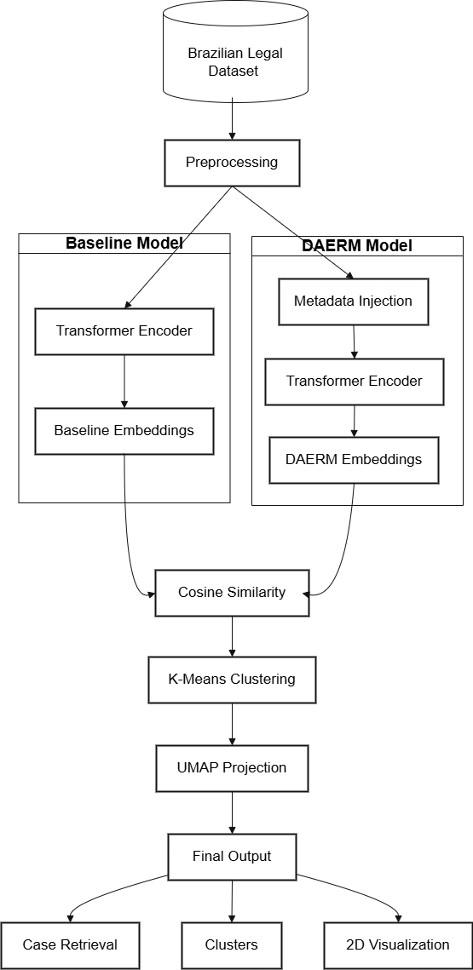
The proposed system will utilize a legal document similarity analysis system, utilizing transformer-based embeddings and a Domain-Adaptive Embedding Refinement Module (DAERM).
The proposed system will operate in the following way: The proposed system will utilize a legal dataset from Brazil, where legal decisions and their metadata will be loaded and cleaned to remove noise from the text.
Once this has been completed, two branches of the proposed system will operate. The first branch will utilize a transformer to encode the cleaned legal text, generating embeddings for the text. The second branch will utilize the cleaned legal text and enrich it with metadata, generating embeddings.
The proposed system will use the cosine similarity measure to compare the generated embeddings and use the K-Means algorithm and the UMAP algorithm for the clustering and visualization of the generated embeddings in two dimensions. The proposed DAERM branch represents the proposed contribution in the proposed system. It improves the domain awareness and the quality of the legal similarity analysis.
7. Results and Discussion
7.1 Experimental Setup
The proposed system was evaluated using two legal document datasets: Indian Supreme Court Judgments and Brazilian Court Decisions. For both legal document datasets, transformer-based embeddings were created using the all-MiniLM-L6-v2 model from the SentenceTransformer library.
The two pipelines created for evaluation are:
- Baseline Model: Embeddings created from clean legal documents.
- DAERM Model: Embeddings created after injecting legal metadata.
The cosine similarity method was used for similarity calculations, K-Means was used for clustering, and UMAP was used for visualization.
7.2 Similar Case Retrieval Analysis
To evaluate semantic retrieval quality, both models were tested using unseen legal queries. For example, when a motor vehicle accident compensation case was provided as input, the system retrieved top-ranked cases involving civil appeals, insurance disputes, injury claims, and compensation matters.
The baseline model successfully retrieved thematically related cases based on textual similarity. However, the DAERM model demonstrated improved contextual alignment by emphasizing legal structure and domain-specific signals in addition to semantic content.
The retrieved outputs confirm that transformer embeddings effectively capture legal meaning, while domain-adaptive refinement enhances structural coherence.

Table 2: Similar case retrieval using DAERM (Brazilian dataset)
NEW CASE SUMMARY:
trata se de recurso relacionado a indenização por danos morais decorrentes de acidente de trânsito com pedido de compensação financeira
English Translation : This is an appeal related to compensation for moral damages arising from a traffic accident, with a request for financial compensation.

Rank | Case No. | Similarity | Overlap | Key Terms | Preview
1 | 0004052-14.2012.8.02.0058 | 0.740 | 4 | acidente, trânsito, danos | Apelação cível – responsabilidade civil em acidente de trânsito ação indenizatória danos materiais e morais.
2 | 0101170-20.2003.8.02.0053 | 0.727 | 6 | indenização, morais, trânsito | Apelação cível – ação de indenização por danos materiais e morais acidente de trânsito responsabilidade objetiva.
3 | 0700261-93.2017.8.02.0066 | 0.719 | 3 | trânsito, pedido | Reexame necessário – mandado de segurança prestação de serviço público de transporte intermunicipal.
4 | 0712845-96.2017.8.02.0001 | 0.716 | 1 | trânsito | Remessa necessária – mandado de segurança agente de fiscalização de trânsito – progressão na carreira.
5 | 0719421-08.2017.8.02.0001 | 0.714 | 1 | trânsito | Remessa necessária – mandado de segurança servidor público municipal fiscalização de trânsito.

Table 3: Similar case retrieval using DAERM (Indian dataset)
NEW CASE SUMMARY
The present appeal arises from a motor vehicle accident claim The claimant suffered serious injuries due to rash and negligent driving Compensation awarded by the tribunal is challenged as inadequate The appellant seeks enhancement of compensation

Rank | Case ID | Similarity | Key Themes | Preview (Original)
1 | 9247-2021_C.A.No.-005926-005926-2021 | 0.647 | compensation, appeal, claimant, awarded | Civil Appeal of 2021 arising out of SLP (C) – Satya Prakash Dwivedi vs Munna alias Chandrabhan Yadav Judgment by B V Nagarathna J.
2 | 7071-2020_C.A.No.-004800-004800-2021 | 0.638 | compensation, accident, claim, injuries | Civil Appeal No. 4800 of 2021 – The Oriental Insurance Company Ltd vs Kahlon Jasmail Singh compensation dispute.
3 | 403-2019_C.A.No.-005970-005970-2021 | 0.587 | contextual similarity | Civil Appeal of 2021 – Rajeev Nohwar vs Chief Controlling Revenue Authority Judgment delivered.
4 | 7419-2020_Crl.A.No.-000006-000006-2021 | 0.576 | vehicle-related matter | Criminal Appeal No. 6 of 2021 – SREI Equipment Finance Ltd vs Ramjan Ali & Ors – Judgment by Ashok Bhushan J.
5 | 15206-2021_C.A.No.-004946-004946-2021 | 0.569 | appeal | Civil Appeal No. 4946 of 2021 – Gunasekaran vs Divisional Engineer National Highways & Ors.

These table illustrate that the retrieved cases share relevant legal themes and procedural context with the input query.

7.3 UMAP Visualization Analysis (Brazilian Dataset)
To further evaluate robustness, the same analysis was conducted on the Brazilian Court Decisions dataset.
The baseline embeddings showed general semantic grouping; however, clusters appeared moderately dispersed with some intermixing between procedural categories.
The DAERM-enhanced embeddings demonstrated:
- More compact cluster formation
- Clearer separation between semantic regions
- Improved grouping of legally related cases
These observations confirm that the refinement approach generalizes across different legal systems and languages.
Figure 1: UMAP visualization – Baseline (Brazilian dataset)
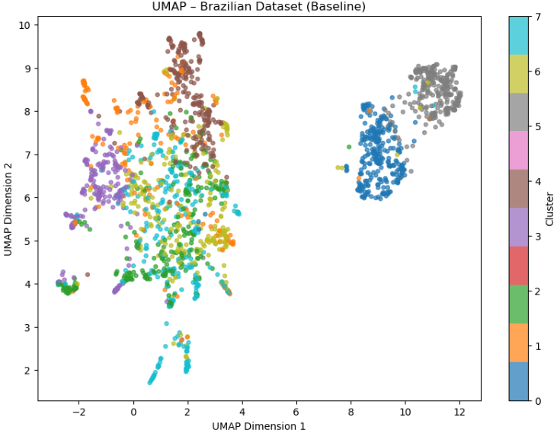

Figure 2: UMAP visualization – DAERM (Brazilian dataset)
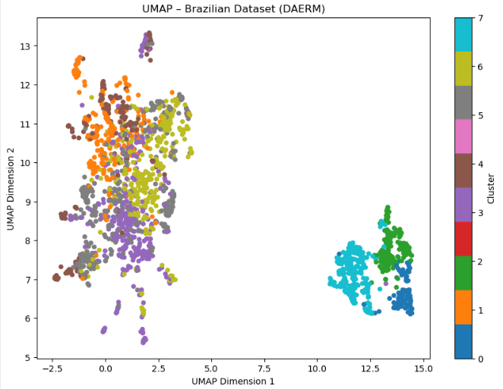
Figures 1 and 2 below illustrate the UMAP representation of the Brazilian legal documents' embeddings for the baseline model and the DAERM model.
From Figure 1 above illustrating the baseline model, it can be noticed that the clusters are created based on the similarity of the text used. However, it can be noticed that the clusters are not clear, with most of them being messy. The colors used in the central part of the figure appear to be similar, implying that the text-based embeddings did not effectively separate the different legal cases.
From Figure 2 above illustrating the DAERM model, it can be noticed that the clusters are well separated from each other. In addition, it can be noticed that the documents within each cluster are well packed together. This implies that the embeddings were effective due to the inclusion of the legal metadata.
From the above depiction of the UMAP representation of the embeddings for the baseline model and the DAERM model, it can be noticed that the DAERM model offers better grouping of the legal cases for Brazil in comparison to the baseline model.

Table 4: Baseline vs DAERM – Brazil Dataset (Qualitative Comparison):
Rank | Baseline Model (Top Results) | Relevance to Query (Traffic Accident Compensation) | DAERM Model (Top Results) | Relevance to Query
1 | DPVAT insurance accident case (death compensation) | Highly Relevant | Civil liability – traffic accident – compensation action | Highly Relevant
2 | Administrative appeal – Traffic Department fines | Partially Relevant (traffic but not indemnification focus) | Compensation for material & moral damages – traffic accident | Highly Relevant
3 | Administrative law – irregular passenger transport | Weakly Relevant | Public transport service regulation case | Partially Relevant
4 | Writ of mandamus – traffic inspection officer promotion | Not Relevant | Writ of mandamus – traffic inspection officer promotion | Not Relevant
5 | Civil liability – traffic accident compensation | Relevant | Writ of mandamus – traffic inspection officer promotion | Not Relevant

7.4 Clustering Performance (Indian Dataset)
K-Means clustering was applied to evaluate how well the embedding space organizes documents into coherent semantic groups.
In the baseline model, clusters were formed primarily based on textual similarity. While grouping was observed, certain clusters showed partial overlap due to shared procedural language across cases.
In contrast, the DAERM model demonstrated:
- Improved intra-cluster compactness
- Clearer inter-cluster separation
- Reduced overlap between semantically distinct groups
This suggests that metadata injection enhances domain-aware structuring of the embedding space.
Figure 3: UMAP visualization – Baseline (Indian dataset)
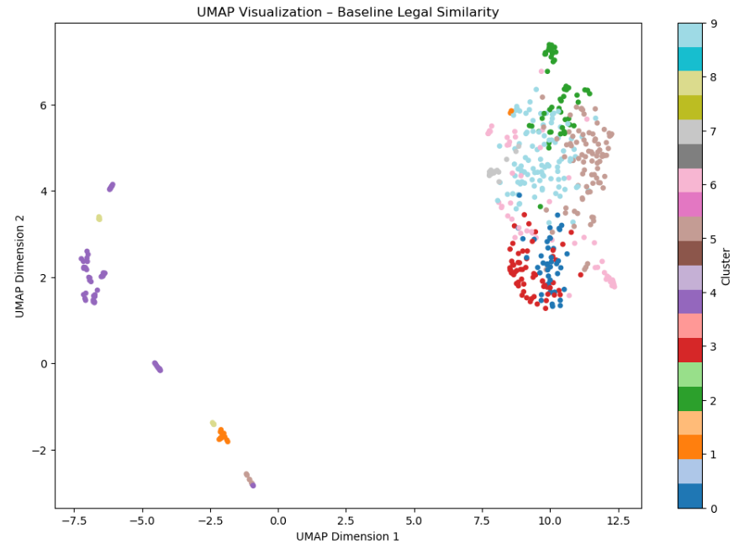

Figure 4: UMAP visualization – DAERM (Indian dataset)
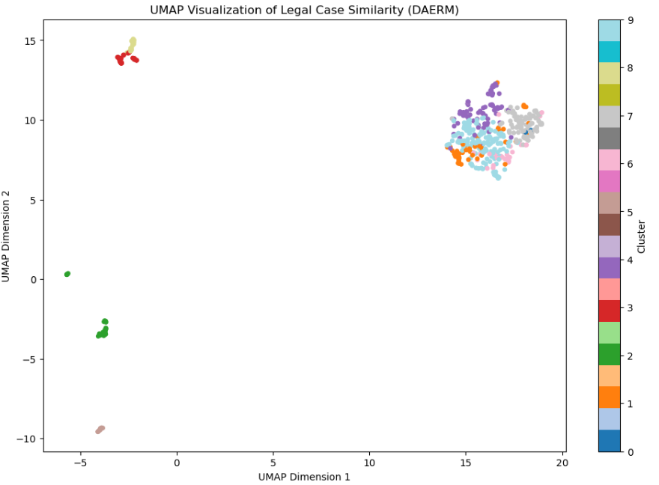
As shown in Figure 3 and Figure 4 below, we present how UMAP visualization for Indian legal document embeddings using both the Baseline model and DAERM model.
As shown in Figure 3 for the Baseline model, documents are grouped according to their similarity in terms of text. Although distinct groups are formed in the Baseline model, some groups are slightly separated and mixed with other groups. This implies that using text-based document embeddings can understand document meaning but cannot distinctly separate different legal documents.
As shown in Figure 4 for the DAERM model, distinct groups are formed in a compact manner. Documents within a particular group are closer to each other in the document embedding space, and different groups are distinctly separated. This implies that using legal metadata such as Act and Bench in document embeddings can understand legal document meaning in a better manner. The DAERM model can better organize legal cases in terms of document embeddings compared to the Baseline model.
Table 5: Baseline vs DAERM – Indian Dataset (Qualitative Comparison):
Rank | Baseline Model (Top Results) | Relevance to Query (Motor Accident Compensation) | DAERM Model (Top Results) | Relevance to Query
1 | Civil Appeal – Motor accident compensation case (9247-2021) | Highly Relevant | Civil Appeal – Motor accident compensation case (9247-2021) | Highly Relevant
2 | Civil Appeal – Insurance company compensation dispute (7071-2020) | Highly Relevant | Civil Appeal – Insurance company compensation dispute (7071-2020) | Highly Relevant
3 | Insurance dispute (Acme Cleantech vs United India Insurance) | Partially Relevant (insurance context, not core accident compensation) | Revenue authority appeal case | Partially Relevant
4 | Civil Appeal – Property/other civil matter | Weakly Relevant | Criminal Appeal – vehicle-related matter | Weakly Relevant
5 | Criminal Appeal – unrelated matter | Not Relevant | Civil Appeal – unrelated matter | Not Relevant

7.5 Overall Findings
The experimental results show that the semantic similarity in the legal documents can be well characterized by the transformer-based embedding method. While the baseline model mainly depends on the text semantics to compare the similarity, the DAERM method proposes a method to refine the document representation by utilizing the structured legal metadata, achieving better clustering compactness and distinction in the embedding space, thereby proving the effectiveness of the domain-adaptive embedding refinement method. Besides, the method is also applicable to different legal systems without the need to retrain the model, making it a successful method for legal document similarity analysis and clustering with qualitative improvements.

8. Conclusion
In this project, TransLegalSim, a transformer-based framework for legal document similarity analysis with a Domain Adaptive Embedding Refinement Module, was presented. It utilizes SentenceTransformer embeddings to compute semantic similarity between judicial decisions, enabling case retrieval, clustering, and visualization.
The baseline model proved the effectiveness of transformer embeddings in conveying context in legal texts. Nevertheless, by injecting structured legal metadata, such as Act, Bench, and court details, prior to embedding generation, the DAERM method enhanced the model’s domain awareness without requiring model retraining.
Experimental evaluation on both Indian Supreme Court and Brazilian Court datasets showed improved cluster compactness, clearer semantic grouping, and contextually relevant case retrieval using DAERM. The results confirm that lightweight domain-adaptive refinement enhances legal similarity analysis while maintaining computational efficiency.

References
[1] Xiao, C., Zhong, H., Guo, Z., Tu, C., Liu, Z., and Sun, M., 2023. Lawformer: A pre-trained language model for Chinese legal long documents. Artificial Intelligence and Law, 31(3), pp.1–25. https://doi.org/10.1007/s10506-023-09355-6.
[2] Bommarito, M. J., Katz, D. M., & Surdeanu, M. (2024). Semantic similarity and information retrieval in large-scale legal corpora using transformer-based sentence embeddings. Artificial Intelligence and Law, Springer.
[3] Mentzingen, H., António, N. & Bacao, F. Effectiveness in retrieving legal precedents: exploring text summarization and cutting-edge language models toward a cost-efficient approach. Artif Intell Law (2025). https://doi.org/10.1007/s10506-025-09440-2
[4] Ariai, F., Mackenzie, J. and Demartini, G., 2025. Natural language processing for the legal domain: A survey of tasks, datasets, models, and challenges. ACM Computing Surveys, 58(6), pp.1-37.
[5] Chalkidis, I., Fergadiotis, M., Malakasiotis, P., Aletras, N. and Androutsopoulos, I., 2020. LEGAL-BERT: The muppets straight out of law school. arXiv preprint arXiv:2010.02559.
[6] Zhong, H., Xiao, C., Tu, C., Zhang, T., Liu, Z. and Sun, M., 2020. How does NLP benefit legal system: A summary of legal artificial intelligence. arXiv preprint arXiv:2004.12158.

[7] Oliveira, R.S.D. and Sperandio Nascimento, E.G., 2025. Analysing similarities between legal court documents using natural language processing approaches based on transformers. PloS one, 20(4), p.e0320244.

[8] Silva Junior, D.d., Oliveira, D.d. & Paes, A. Evaluating text representations for unsupervised legal semantic textual similarity in Brazilian Portuguese. Discov Data 3, 23 (2025). https://doi.org/10.1007/s44248-025-00052-4

[9] Masih, Salman, Mehdi Hassan, Labiba Gillani Fahad, and Bilal Hassan. 2025. "Transformer-Based Abstractive Summarization of Legal Texts in Low-Resource Languages" Electronics 14, no. 12: 2320. https://doi.org/10.3390/electronics14122320

[10] S V, Sai & Kavya, Singu & Kavya, Kakarla & Sravani, Tadikonda & Poojitha, Sattenapalli & V, Sai. (2025). NLP-Driven Summarization: Efficient Extraction of Key Information from Legal and Financial Documents. SSRN Electronic Journal. 11. 341-349. 10.2139/ssrn.5250908.

[11] Kim, mi-young & Rabelo, Juliano & Babiker, Housam & Rahman, Md Abed & Goebel, Randy. (2024). Legal Information Retrieval and Entailment Using Transformer-based Approaches. The Review of Socionetwork Strategies. 18. 1-21. 10.1007/s12626-023-00153-z.

[12] Garrido-Merchán, E.C., González-Barthe, C. and Vaca, M.C., 2023. Fine-tuning ClimateBert transformer with ClimaText for the disclosure analysis of climate-related financial risks. arXiv preprint arXiv:2303.13373.

[13] Chalkidis, I., Fergadiotis, M., Malakasiotis, P., Aletras, N. and Androutsopoulos, I., 2020. LEGAL-BERT: The muppets straight out of law school. arXiv preprint arXiv:2010.02559.

[14] Gitonga, Charles & Mugao, Lydia. (2025). Domain-Adaptive Pretraining of Transformer-Based Language Models on Medical Texts: A High-Performance Computing Experiment. European Journal of Information Technologies and Computer Science. 5. 2736-5492. 10.24018/ejcompute.2025.5.2.149.

[15] Naik, Varsha & Kannan, Rajeswari. (2025). Indian Legal Judgment Summarization using LEGAL-BERT and BiLSTM model with Adaptive Length. EPJ Web of Conferences. 328. 10.1051/epjconf/202532801043.

[16] Pham, Vuong & Do, Huy & Nguyen, Tri-Hai & Nguyen, Hien. (2025). Improving Legal Document Analysis and Automatic Knowledge Updates with Legal-Onto Ontology. SN Computer Science. 6. 10.1007/s42979-025-04432-0.

[17] Kanakia, Janki & Shah, Sachi & Shah, Esha & Modi, Tvisha & Kanakia, Harsh & Saha, Ishani & Mishra, Payal. (2024). Harnessing Advanced NLP Techniques: Empirical Study on Automated Text Summarization via SpaCy Word Embeddings and Cosine Similarity. 98-102. 10.1109/OCIT65031.2024.00026.

[18] Alnajem, Nojoom & Binkhonain, Manal & Hossain, M. Shamim. (2024). Siamese Neural Networks Method for Semantic Requirements Similarity Detection. IEEE Access. PP. 1-1. 10.1109/ACCESS.2024.3469636.

[19] Li, H., Ai, Q., Chen, J., Dong, Q., Wu, Y., Liu, Y., Chen, C. and Tian, Q., 2023, July. SAILER: structure-aware pre-trained language model for legal case retrieval. In Proceedings of the 46th International ACM SIGIR Conference on Research and Development in Information Retrieval (pp. 1035-1044).

[20] Ariai, F., Mackenzie, J. and Demartini, G., 2025. Natural language processing for the legal domain: A survey of tasks, datasets, models, and challenges. ACM Computing Surveys, 58(6), pp.1-37.

