# **1. Introduction**

Mental health issues affect millions of people globally. However, access to personalized, timely, and empathetic mental health care remains limited. NeuroVerse emerges as an innovative mobile application that leverages pervasive computing to offer intelligent emotional support through chatbot interactions, mood tracking, guided journaling.

Throughout our development process, we explored multiple aspects of emotionally intelligent digital interfaces—evaluating how mood input, journaling practices, and dynamic questioning could simulate a personalized support system. We examined existing mental health technologies, analyzed their limitations, and identified the need for a conversational system that not only listens but adapts based on user history.

From these findings, we derived key design recommendations:

* Integrate emotionally responsive conversational agents (chatbots) that adapt to recent mood trends.
* Guide users through reflection using personalized journaling prompts.
* Keep the interface calming, distraction-free, and mobile-friendly.

By incorporating these principles into NeuroVerse’s architecture, we aimed to create not just an app, but a companion capable of supporting users through their unique emotional journeys.

# **2. Background / Related Work**

A growing body of research supports the use of digital platforms for mental health interventions. Insights from prior work include:

* **Emotional Regulation**: Chatbots can help users manage emotions through supportive, structured dialogue.
* **Web-based Personalization**: Interfaces that adjust content based on past interactions offer more engaging and relevant support.
* **Guided Interactions**: Daily journaling and structured survey check-ins have been shown to increase emotional clarity and mental stability.
* **Behavioral Feedback Loops**: Systems that adapt based on user behavior tend to foster long-term engagement and effectiveness.

These findings strongly influenced NeuroVerse’s design, emphasizing personalized emotional support through journaling and survey-based feedback.

# **3. Methods**

## **3.1 Participants**

| **Participant** | **Age** | **Role** | **Prototype Tested** |
| --- | --- | --- | --- |
| P1 | 20 | Undergraduate Student | Prototype 1 |
| P2 | 32 | Working Professional | Prototype 1 |
| P3 | 45 | UI/UX Designer | Prototype 2 |
| P4 | 26 | Graduate Researcher | Prototype 2 |
| P5 | 38 | Freelance Designer | Prototype 3 |

## **3.2 Study Design**

### **Phase 1: Needs Assessment**

We analyzed three key studies to identify common user needs:

* Emotional validation and understanding
* Journaling features to support self-expression
* Survey-based tools to capture emotional state and context

These insights shaped the design goals for each prototype.

### **Participant Quotes by Need**

* **Need for Emotional Intelligence**
  + “The chatbot felt too robotic at first. It needs to feel like it cares.” – P1
* **Personalized Interaction**
  + “It should remember how I’ve been feeling and respond based on that.” – P2
* **Emotionally Soothing Experience**
  + “Loved how it sent calming music right after I shared my stress.” – P3
* **Avoiding Repetition**
  + “The newer ones felt more in tune.” – P4
* **Mood Pattern Awareness**
  + “It finally felt like something was paying attention to my past emotions.” – P5

### **Phase 2: Design Studies / Prototyping**

#### **Prototype 1**

* **Features**: Emoji-based mood tracking with a basic chatbot only
* **Strengths**: Simple interaction, quick setup, intuitive chatbot starter flow
* **Weaknesses**: No journaling, no survey system, limited engagement depth

**User Feedback (Survey Results):**

* “The emoji interface was friendly but lacked depth.”
* “I wanted to write down how I felt, but there was no journaling feature.”
* “It felt too basic. I wanted more than one chat reply.”

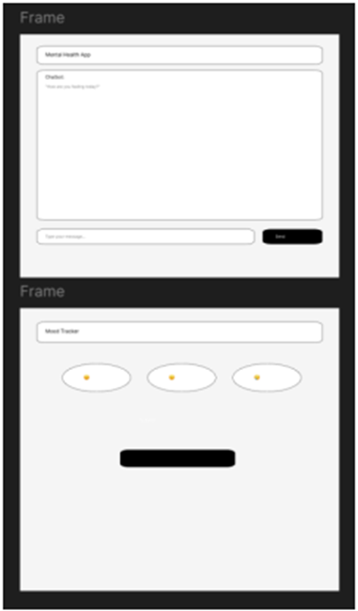

#### 

#### **Prototype 2**

* **Features**: Added journaling screen and static survey buttons for “Sad” moods
* **Strengths**: Better flow, allowed users to express and reflect
* **Weaknesses**: Survey was not dynamically generated, chatbot was static

**User Feedback (Survey Results):**

* “I loved the journaling part. Felt like I could vent.”
* “Static survey questions were helpful, but not personalized.”
* “Chat still felt scripted.”

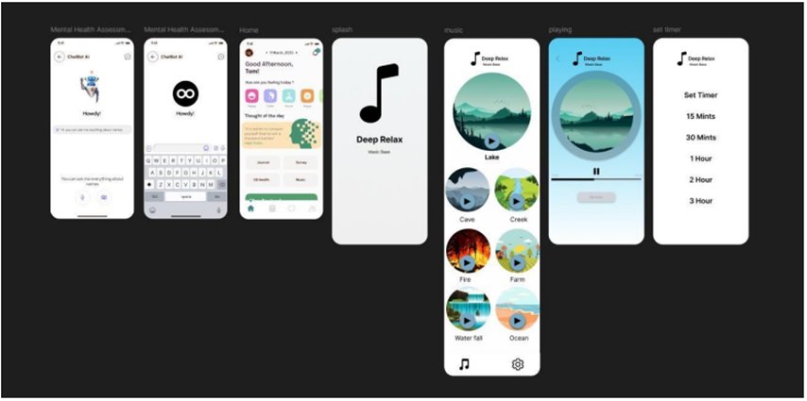

#### 

#### 

#### **Prototype 3**

* **Features**: GPT-based chatbot responses, mood-pattern recognition, and song suggestions via clickable YouTube links
* **Strengths**: Fully conversational, emotionally adaptive, dynamic prompts
* **Weaknesses**: Some bugs in mood pattern logic, occasional repeated responses

**User Feedback (Survey Results):**

* “This felt like an actual conversation. Very comforting.”
* “Loved the music suggestions when I was down.”
* “It’s smart. It asked me follow-up questions that made sense.”

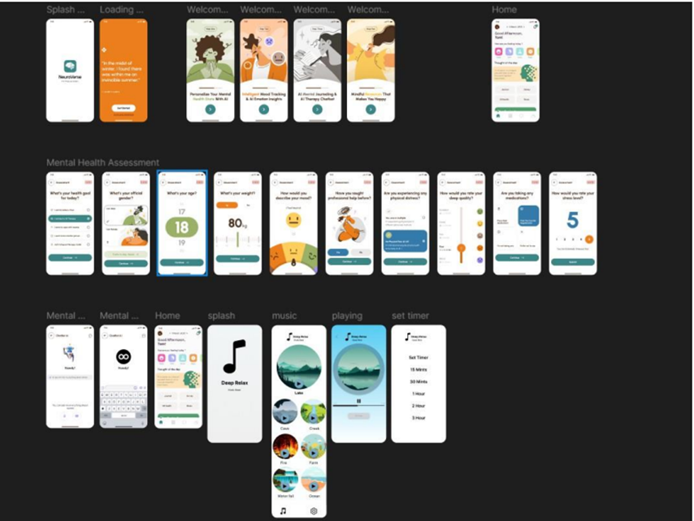

## **3.3 Framework**

### **Technologies Used**

* Flutter for mobile UI development
* Firebase for user authentication and mood data storage
* Flask for backend API services
* OpenAI for GPT-powered chatbot responses
* Figma for UI wireframes and prototype visualization

### **Development Lifecycle**

1. **Ideation and Research:** Defined goals based on emotional support gaps in digital tools.
2. **Needs Assessment:** Conducted surveys to extract emotional journaling and survey needs.
3. **Prototype Creation:** Built 3 iterative versions using feedback cycles.
4. **Implementation:** Integrated backend (Flask + GPT) and frontend (Flutter).
5. **Testing and Feedback:** Gathered user insights post each prototype test.
6. **Refinement:** Final prototype polished with all pervasive computing features.

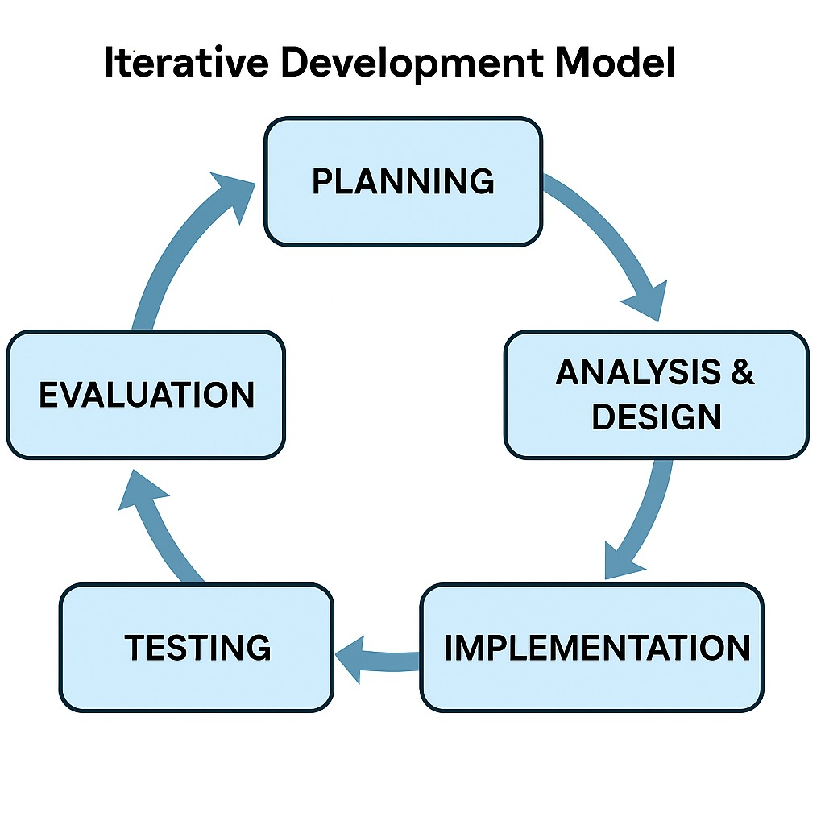

The Iterative Software Development Model is a cyclical approach to building software. Instead of delivering the full product at once, the project is broken into smaller parts (iterations), each of which is designed, developed, tested, and refined in cycles. Feedback is gathered at the end of every cycle, and that feedback fuels the next iteration.

## **Flow of the Iterative Model in NeuroVerse**

1. **Initial Plan** – Start with basic features (mood input, chatbot)
2. **Prototype 1** – Build and test early version (emoji + basic chatbot)

P4&P1 – “Needs journaling!” “Too robotic”

1. **Prototype 2** – Add journaling + static survey

P2&P3 – “Want smarter responses”

1. **Prototype 3** – Add GPT chatbot, mood patterns, dynamic survey

P5 – “Now it feels personal”

1. **Final Design** – Integrate everything, test the whole flow
2. **Reflect & Plan Future Work** – Consider biometric, NLP, and voice upgrades

### **Pervasive Computing Features & Needs Alignment**

| Feature | Code Snippet | User Need Addressed |
| --- | --- | --- |
| Mood-based Chatbot | response = get_chat_response(user_mood, mood_pattern) | Emotionally aware support |
| Dynamic Surveys | if mood == 'Sad': showSurvey(['What’s wrong?', 'Want to talk?']) | Personalized user prompts |
| Guided Journaling | journalPrompt = generatePrompt(mood_pattern) | Emotional self-expression |
| Mood History Tracking | db.collection('moods').where('user_id', '==', uid).get() | Behavioral trend awareness |
| Calm UI Design | theme: ThemeData(scaffoldBackgroundColor: Colors.grey[900]) | Low-stress, minimal interface |

## 

## **3.4 Final Prototype**

* **Features**: Combines all previous elements — mood selection, adaptive chatbot flow, dynamically generated survey questions, basic journaling, and mood-based music recommendations.
* **Strengths**:
  + Seamless integration of features into one smooth flow
  + Personalized conversation based on mood patterns
  + Song suggestions help reinforce emotional support
  + Simple UI with dark mode for a calming experience
* **Weaknesses**:
  + Journaling lacks intelligent analysis or suggestions
  + Occasional minor repetition in chatbot flow
  + Song links are hardcoded and not contextually generated

**User Feedback (Survey Results):**

* “The final version felt like a complete support system.”
* “I liked how it asked different questions every time I felt down.”
* “Could be better if journaling gave me feedback or ideas.”

### 

### 

### 

### 

### 

### 

### **Screenshots & Flow Visuals**

This final version captures our full design vision—blending emotional intelligence, personalization, and pervasive computing in a seamless mobile experience.

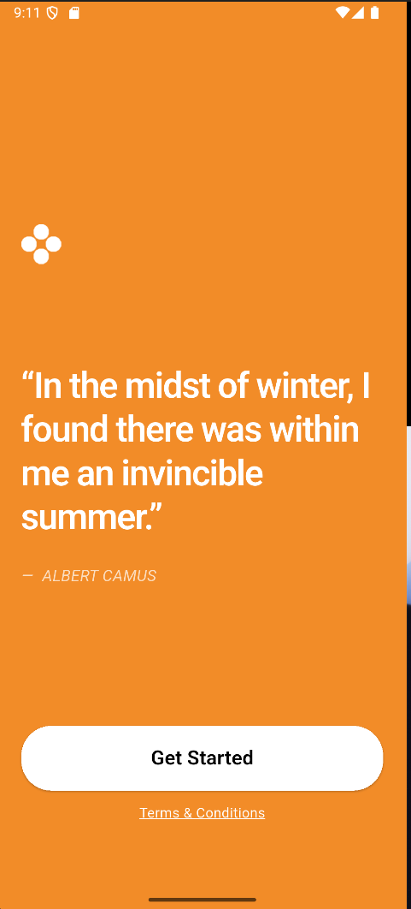 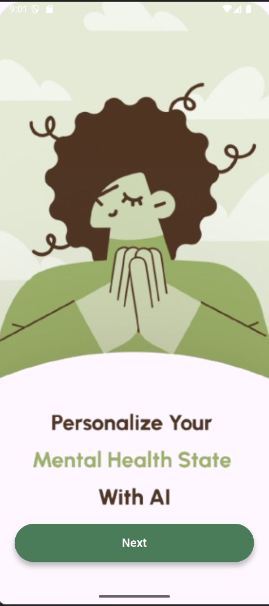 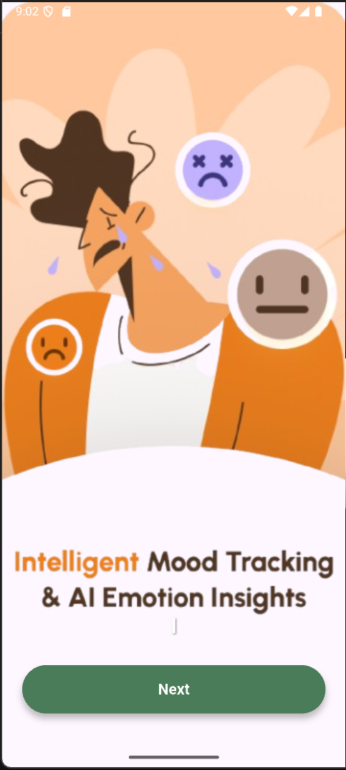    
  
  
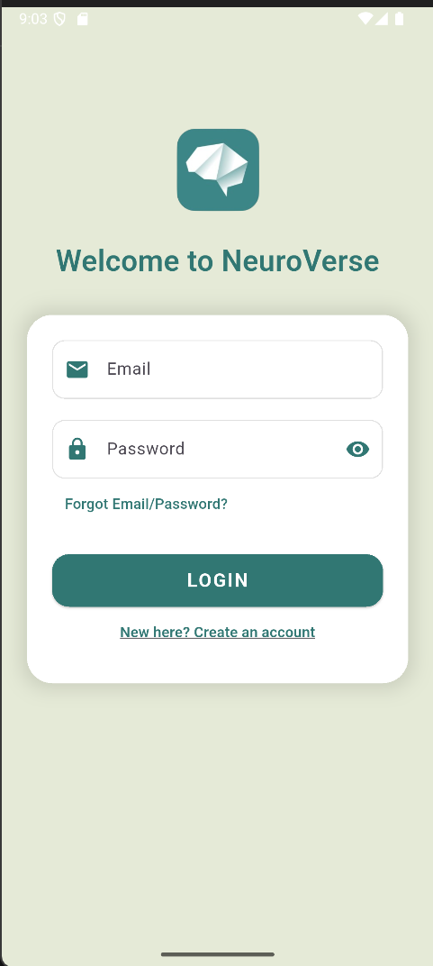 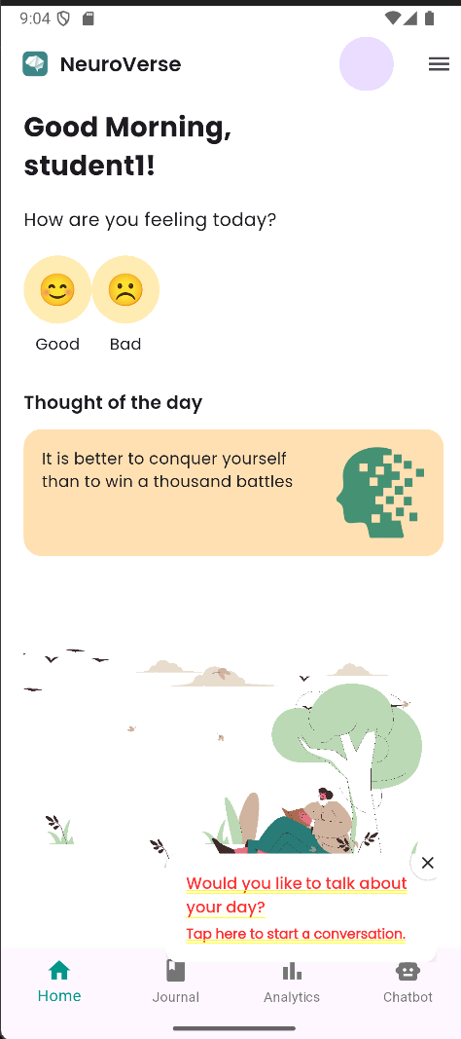 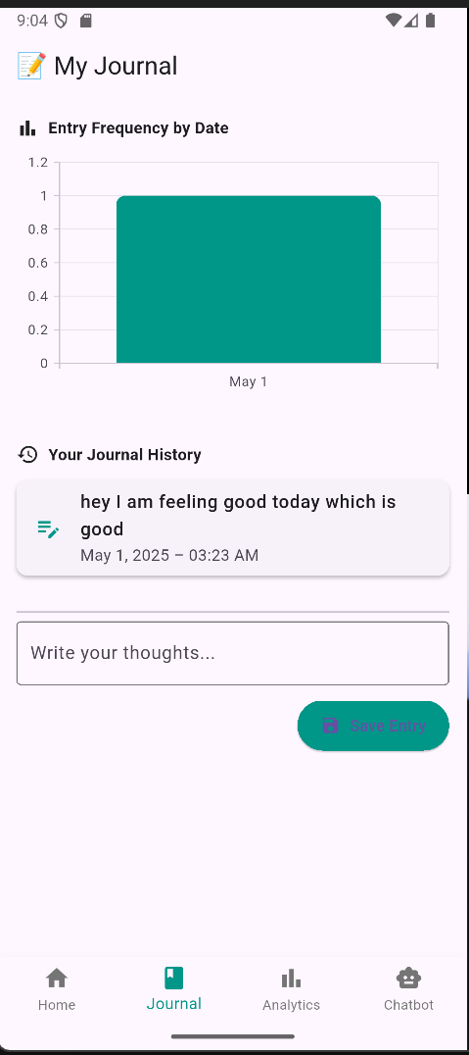 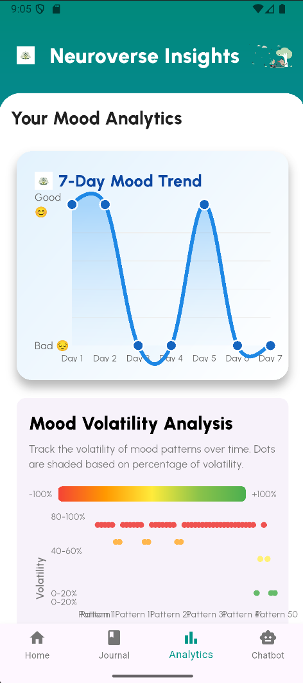 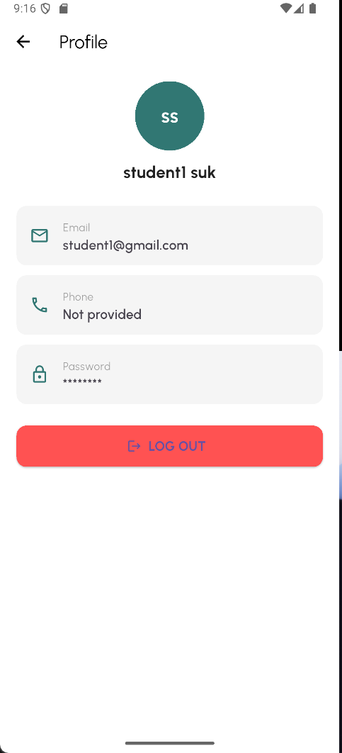

# 

# **4. Teamwork**

Collaboration played a central role in the successful development of NeuroVerse. Our team operated in a highly iterative, feedback-driven process, meeting weekly to evaluate progress, share challenges, and brainstorm solutions.

* **Collaborative Development**: Frontend and backend components were developed in parallel. Sarath and Sai Chaitanya maintained constant integration testing to ensure smooth API connections.
* **Design & Testing Feedback Loops**: Charan led the design reviews and testing coordination with participants. He compiled observations and shared feedback with the developers to improve the next prototype.
* **Presentation & Documentation**: Tasks such as slides, write-ups, and demo videos were split based on individual strengths, ensuring all members contributed equally to both development and delivery.

# **5. Team Contributions**

| **Team Member** | **Role** | **Contributions** |
| --- | --- | --- |
| Sai Chaitanya Undrakonda | Chatbot Logic & Design | Developed tone-aware GPT prompts, implemented Flask API for journaling + survey flow |
| Sarath Madala | Frontend Developer (Flutter) | Created UI for mood selection, journaling module, and dynamic survey question handling |
| Sri Charan Pagolu | Research Lead & Documentation | Conducted needs assessment, structured evaluation feedback, wrote final report & presentation |

# 

# **6. Conclusion**

NeuroVerse transforms journaling and emotional tracking into an adaptive, empathetic mobile support system. Designed for continuity, comfort, and context-awareness, it guides users from mood selection through surveys and reflective journaling—culminating in supportive chatbot conversations.

Each prototype cycle deepened emotional alignment, strengthened usability, and amplified personalization. Based on structured participant feedback, we evolved NeuroVerse into a tool that doesn’t just ask how you feel—but learns what to say next.

With future upgrades, NeuroVerse can grow into a powerful platform supporting proactive mental health for students, professionals, and vulnerable populations across cultures.

# **7. Future Work / Directions**

NeuroVerse transforms journaling and emotional tracking into an adaptive, empathetic mobile support system. Designed for continuity, comfort, and context-awareness, it guides users from mood selection through surveys and reflective journaling—culminating in supportive chatbot conversations.

Each prototype cycle deepened emotional alignment, strengthened usability, and amplified personalization. Based on structured participant feedback, we evolved NeuroVerse into a tool that doesn’t just ask how you feel—but learns what to say next.

With future upgrades, NeuroVerse can grow into a powerful platform supporting proactive mental health for students, professionals, and vulnerable populations across cultures.

### **Development / Implementations**

* **Biometric integration for smarter mood detection**

Future iterations can integrate biometric sensors (like heart rate, facial expressions, or voice tone analysis via mobile sensors) to automatically detect user stress or mood, triggering chatbot responses without requiring manual mood input.

* **Offline journaling and chat capability**

Currently, the journaling and chatbot features require internet access. Adding offline support would ensure that users can express themselves and reflect even during network downtime, syncing data once reconnected.

* **Visual analytics for personal mood trends**

By visualizing mood history with charts or word clouds (from journals), users could identify emotional patterns and triggers. This self-awareness could empower users to make proactive behavioral changes.

### **Improvements / Upgrades**

* **Smarter chatbot via fine-tuned LLM**

Rather than relying solely on GPT prompts, a custom fine-tuned LLM could better adapt to specific user personas, offering continuity in tone, avoiding repetitive prompts, and recognizing long-term mood trends for a more consistent emotional companion.

* **Voice-enabled journaling for accessibility**

Adding a speech-to-text journaling feature would benefit users with motor impairments, language difficulties, or simply those who find it easier to talk than type. It also adds a more natural, therapeutic expression format.

* **Multilingual conversation support**

Expanding language capabilities can help NeuroVerse reach a more global audience. The chatbot could offer comfort and journaling prompts in the user’s native language, improving emotional resonance.

* **Adaptive notifications based on habits**

By learning user behavior (e.g., preferred time to journal or recurring sad moods on specific days), NeuroVerse can send timely, personalized prompts or reminders that feel less like alerts and more like care.